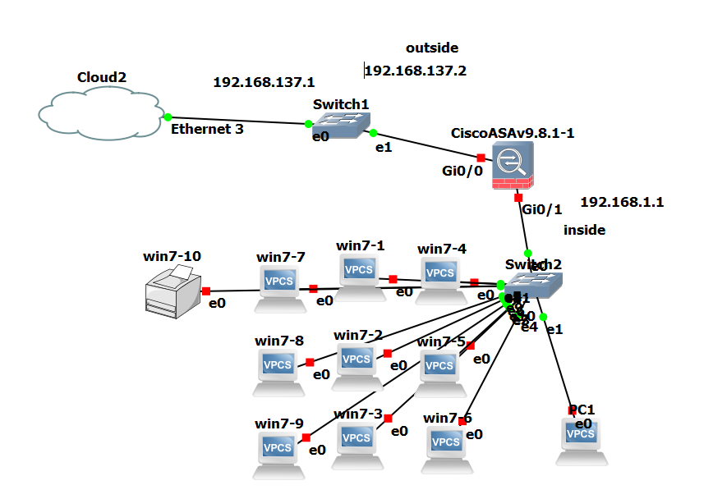

Real LAB : configure internet access on Cisco ASA firewall

ISP information:

Public gateway : 192.168.137.2

Gateway : 172.168.237.1

DNS: 8.8.8.8

1. **Assign IP and set interface inside and outeside**

ciscoASA>enable

ciscoASA# configure terminal

ciscoASA# Show interface ip brief

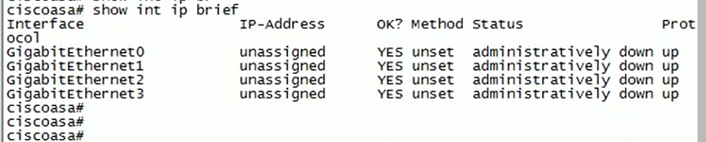

ciscoASA(config) # interface g0/1

ciscoASA(config-if) # ip address 172.16.1.1 255.255.255.0

ciscoASA(config-if) # no shutdown

ciscoASA(config-if) # nameif inside

ciscoASA(config-if) # interface g0/0

ciscoASA(config-if) # ip address 192.168.137.2 255.255.255.0

ciscoASA(config-if) # no shutdown

ciscoASA(config-if) # nameif outside

1. **Enable DHCP server and DNS server**

**172.16.1.10-172.16.1.20**

ciscoASA(config)# Int g0/0

CiscoASA(Config-if)#Dhcp address 172.16.1.10-172.16.1.15 inside

ciscoASA(config)# Dhcpd dns 8.8.8.8

ciscoASA(config)# Dhcpd enable inside

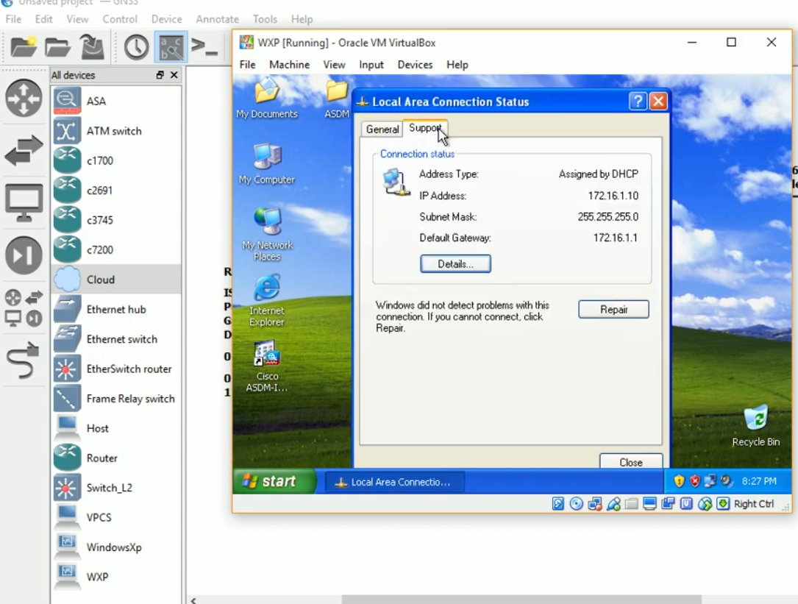

|  |  |
| --- | --- |
| PC2 | 172.16.1.11 |
| PC3 | 172.16.1.12 |
| PC4 | 172.16.1.13 |
| PC5 | 172.16.1.14 |
| PC6 | 172.16.1.15 |
| PC7 | 172.16.1.16 |
| PC8 | 172.16.1.17 |
| PC9 | 172.16.1.18 |
| PC10 | 172.16.1.19 |
| Printer | 172.16.1.20 |

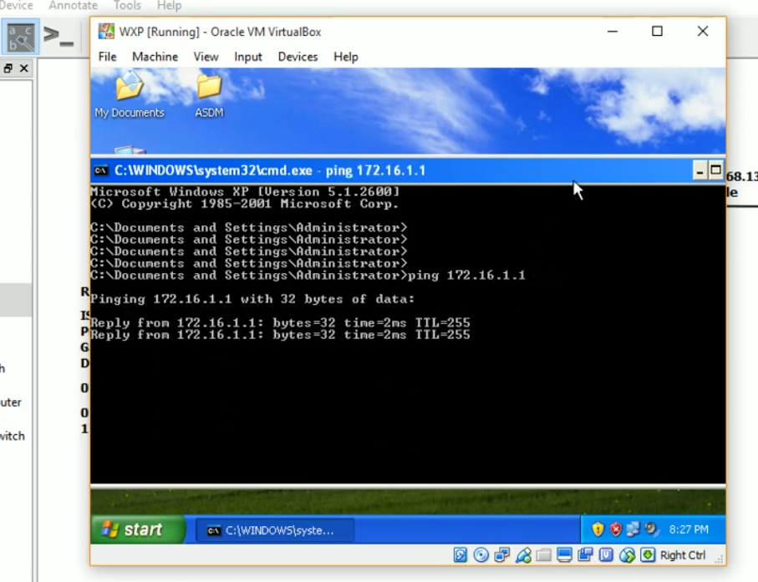

1. **Configure default on cisco ASA**

ciscoASA(config)# Route outside 0.0.0.0 0.0.0.0 172.168.137.2

1. **Create object network and enable NAT**

Object network LAN

Subnet 172.16.1.0 255.255.255.0

nat(inside, outside) dynamic interface

ciscoASA(config)# Object network LAN

CiscoASA(config-network-object)# Subnet 172.16.1.0 255.255.255.0

CiscoASA (config-network-object)# Nat(inside, outside) dynamic interface

CiscoASA (config-network-object)# end

CiscoASA #Show running config

1. **Create access-list**

CiscoASA (config )#Access-list in_to_internet extended permit ip any any

CiscoASA (config )#Access-list in_to_internet extended permit icmp any any

CiscoASA (config )#Access-group in_to_internet in interface outside

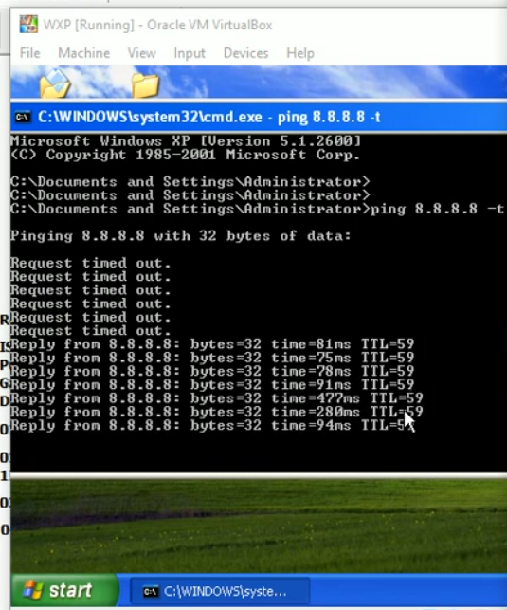

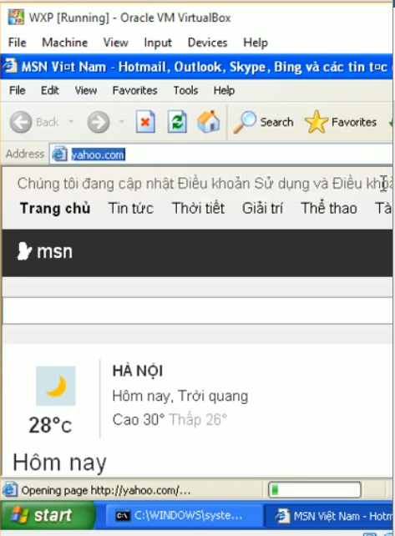

1. **Verify NAT**

CiscoASA# show Xlate

