Brittany Hancock

IT 420: Lenore Montalbano

Week 5: Lab

Building a Tabular SSRS Report

October 23, 2025

Grouped tabular reports are valuable for executives because, when datasets from data sources are processed to align with the insights leaders wish to be quickly informed about, they gain clarity, which can increase understanding. With a deeper understanding of specific aspects of company performance, they can use the insights to formulate actionable plans for where to focus and better understand which categories are driving performance. Executives have limited time to analyze data, and they must receive optimized data presentation through reports.

Figure 1. SSRS Report Preview (SalesByCategory.rdl)

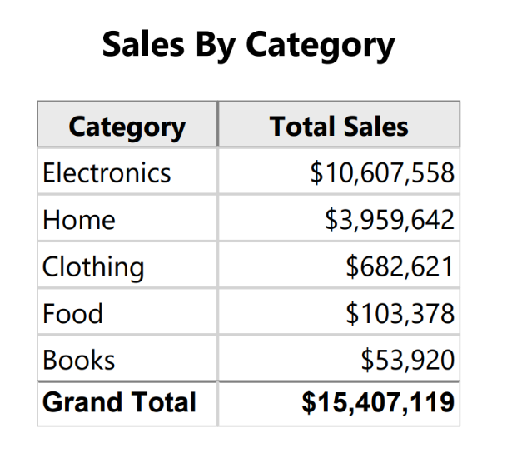

Figure 2. SSRS Design View (SalesByCategory.rdl)

