https://docs.confluent.io/platform/current/installation/installing_cp/zip-tar.html?_gl=1*1lnw2s8*_gcl_au*MTkyNzUyOTY0MS4xNzMxMjIwMjc2LjUwMDM2MjU1Mi4xNzMzMDI5MzIzLjE3MzMwMjkzMjQ.*_ga*MTExNzczMjQwNy4xNzMxMjIwMjc2*_ga_D2D3EGKSGD*MTczMzAyODU1Ny4yLjEuMTczMzAyOTMyNi41Ny4wLjA.&_ga=2.84083865.1809767119.1733028558-1117732407.1731220276

cd "C:\PROGRAMAS_DESARROLLO\
curl -O https://packages.confluent.io/archive/7.7/confluent-community-7.7.1.zip

Set-ExecutionPolicy Bypass -Scope Process -Force; [System.Net.ServicePointManager]::SecurityProtocol = [System.Net.ServicePointManager]::SecurityProtocol -bor 3072; iex ((New-Object System.Net.WebClient).DownloadString('https://community.chocolatey.org/install.ps1'))
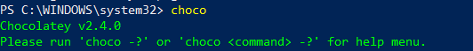
choco install 7zip.install
cd "C:\PROGRAMAS_DESARROLLO\confluent-community-7.7.1"
7z x -bsp1 confluent-community-7.7.1.zip

*****Configurar e iniciar Zookeeper (puerto de escucha - 2181)
PowerShell - ZOOKEEPER
cd "C:\PROGRAMAS_DESARROLLO\confluent-community-7.7.1\confluent-7.7.1\bin\windows"
./zookeeper-server-start.bat ../../etc/kafka/zookeeper.properties

https://medium.com/@praveenkumarsingh/confluent-kafka-on-windows-how-to-fix-classpath-is-empty-cf7c31d9c787
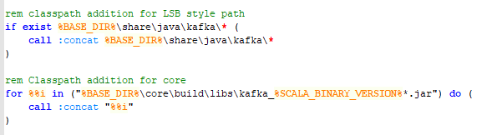

*****Configurar e iniciar Kafka server (puerto de escucha - 9092)
cd "C:\PROGRAMAS_DESARROLLO\confluent-community-7.7.1\confluent-7.7.1\bin\windows"
./kafka-server-start.bat ../../etc/kafka/server.properties
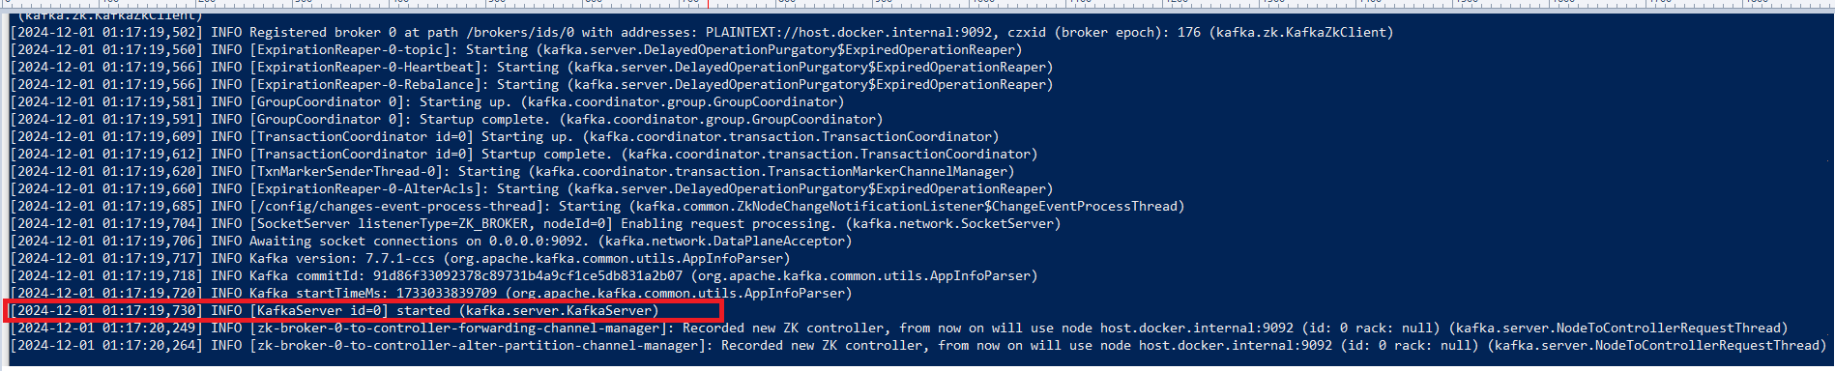

*****Configurar e iniciar Schema Registry (puerto de escucha - 8088)
git clone https://github.com/confluentinc/schema-registry.git
cd schema-registry
git checkout tags/v7.7.1
mvn clean package

https://github.com/confluentinc/schema-registry/tree/master/bin/windows
cd "C:\PROGRAMAS_DESARROLLO\confluent-community-7.7.1\confluent-7.7.1\bin\windows"
java -jar .\kafka-schema-registry-package-7.7.1.jar ../../etc/schema-registry/schema-registry.properties
./schema-registry-start.bat ../../etc/schema-registry/schema-registry.properties
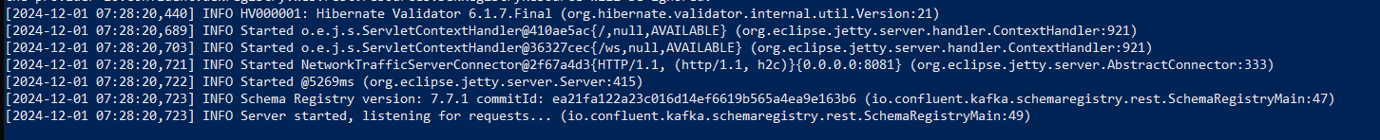

PASO 0
Detener y eliminar contenedores
docker-compose down

Detener y eliminar contenedores, redes y volúmenes
docker-compose down --volumes

Elimine cualquier volumen persistente (si existe)
docker volume prune -f

Limpiar imágenes y recursos no utilizados (opcional)
docker system prune -a

PASO 1
docker-compose up -d
docker-compose up --build

docker network inspect kafka_avro-main_microservices-network

PASO 2[MTTO Optional]
docker-compose up -d schema-registry
docker-compose up -d kafka
docker-compose up -d kafka_avro-main
docker-compose down kafka_avro-main
docker logs -f zookeeper
docker logs -f kafka
docker logs -f schema-registry
docker logs -f kafka_avro-main
docker stop kafka_avro-main
docker start kafka_avro-main
#docker rm kafka_avro-main
***Clear Consumer Group State
docker exec -it kafka kafka-consumer-groups \
--bootstrap-server localhost:9092 \
--group prueba-new \
--reset-offsets \
--to-earliest \
--topic order-topic \
--execute

PASO 3.1*****Registrar el schema registry del avro
curl -X POST http://localhost:8081/subjects/schema-test-value/versions \
-H "Content-Type: application/vnd.schemaregistry.v1+json" \
-d '{"schema":"{\"name\": \"orderRecord\", \"type\": \"record\", \"doc\": \"Sample schema to help you get started.\", \"fields\": [{\"name\": \"orderId\", \"type\": \"int\", \"doc\": \"The id of the order.\"}, {\"name\": \"orderDescription\", \"type\": \"string\", \"doc\": \"The description of the order.\"}, {\"name\": \"orderAddress\", \"type\": \"string\", \"doc\": \"The address of the order.\"}]}"}'

curl -X GET http://localhost:8081/subjects

PASO 3.2 *****Creación de tópico con contenedores

docker exec -it kafka kafka-topics \
--create \
--topic order-topic \
--bootstrap-server localhost:9092 \
--partitions 3 \
--replication-factor 1

docker exec -it kafka kafka-topics \
--list \
--bootstrap-server localhost:9092

docker exec -it kafka kafka-topics \
--delete \
--topic order-topic \
--bootstrap-server localhost:9092
// --force

docker exec -it kafka kafka-topics \
--describe \
--topic order-topic \
--bootstrap-server localhost:9092 \
--from-beginning

docker exec -it kafka kafka-console-consumer \
--topic order-topic \
--from-beginning \
--bootstrap-server localhost:9092 \
--property print.key=true \
--property print.partition=true \
--property print.offset=true \
--property print.timestamp=true

# Partición 0 docker exec -it kafka kafka-console-consumer \ --topic order-topic \ --partition 0 \ --from-beginning \ --bootstrap-server localhost:9092 \ --max-messages 50
docker exec -it kafka kafka-run-class kafka.tools.GetOffsetShell \ --broker-list localhost:9092 \ --topic order-topic
# Partición 1 docker exec -it kafka kafka-console-consumer \ --topic order-topic \ --partition 1 \ --from-beginning \ --bootstrap-server localhost:9092 \ --max-messages 50
# Partición 2 docker exec -it kafka kafka-console-consumer \ --topic order-topic \ --partition 2 \ --from-beginning \ --bootstrap-server localhost:9092 \ --max-messages 50

docker exec -it kafka kafka-console-consumer \
--topic order-topic \
--partition 1 \
--offset 0 \
--bootstrap-server localhost:9092
--timeout-ms 5000

*****Creación de tópico sin contenedores
cd "C:\PROGRAMAS_DESARROLLO\confluent-community-7.7.1\confluent-7.7.1\bin\windows"
./kafka-topics.bat --bootstrap-server localhost:9092 --create --replication-factor 1 --partitions 3 --topic order-topic
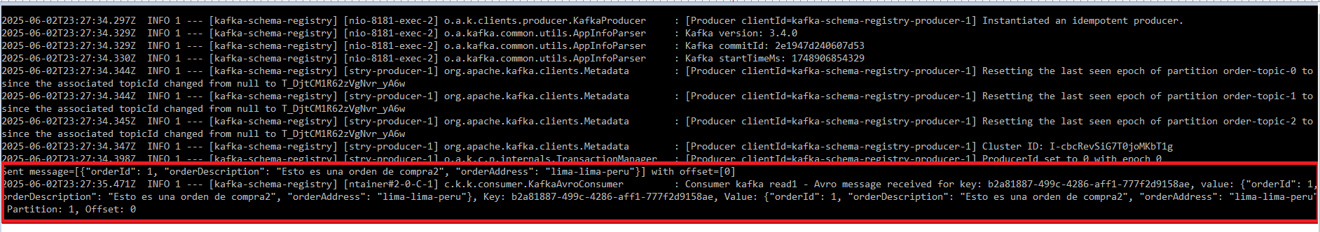

*****Listar tópicos registrados
cd "C:\PROGRAMAS_DESARROLLO\confluent-community-7.7.1\confluent-7.7.1\bin\windows"
.\kafka-topics.bat --list --bootstrap-server localhost:9092
docker exec -it kafka kafka-topics \
--list \
--bootstrap-server localhost:9092
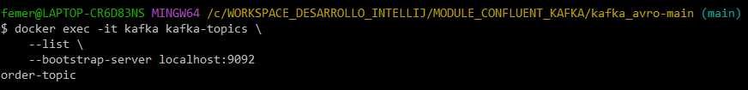

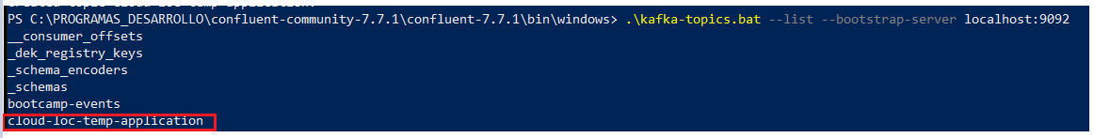

*****Eliminación de Tópico
cd "C:\PROGRAMAS_DESARROLLO\confluent-community-7.7.1\confluent-7.7.1\bin\windows"
.\kafka-topics.bat --bootstrap-server localhost:9092 -delete --topic order-topic
docker exec -it kafka kafka-topics \
--delete \
--topic order-topic \
--bootstrap-server localhost:9092

*****Descripcion de Tópico
cd "C:\PROGRAMAS_DESARROLLO\confluent-community-7.7.1\confluent-7.7.1\bin\windows"
./kafka-topics.bat --bootstrap-server localhost:9092 --describe --topic order-topic
docker exec -it kafka kafka-topics \
--describe \
--topic order-topic \
--bootstrap-server localhost:9092
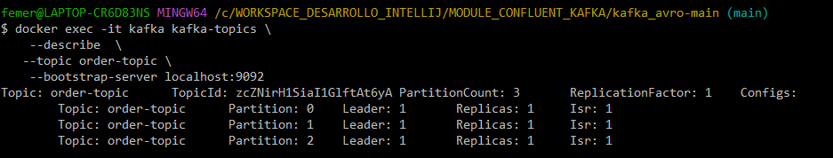

*****Contenido de Tópico
Se recomienda abrir 3 Power Shell para visualizar como se va registrando el contenido en el topico, ejecutar con --partition 0, --partition 1,--partition 2
cd "C:\PROGRAMAS_DESARROLLO\confluent-community-7.7.1\confluent-7.7.1\bin\windows"
./kafka-console-consumer.bat --bootstrap-server localhost:9092 --topic order-topic --partition 0 --offset 0
docker exec -it kafka kafka-console-consumer \
--topic order-topic \
--partition 0 \
--offset 0 \
--bootstrap-server localhost:9092

*****Registro de esquema avro
cd "C:\PROGRAMAS_DESARROLLO\confluent-community-7.7.1\confluent-7.7.1\bin\windows"
$headers = New-Object "System.Collections.Generic.Dictionary[[String],[String]]"
$headers.Add("Content-Type", "application/vnd.schemaregistry.v1+json")

$body = '{"schema":"{\"name\": \"orderRecord\", \"type\": \"record\", \"doc\": \"Sample schema to help you get started.\", \"fields\": [{\"name\": \"orderId\", \"type\": \"int\", \"doc\": \"The id of the order.\"}, {\"name\": \"orderDescription\", \"type\": \"string\", \"doc\": \"The description of the order.\"}, {\"name\": \"orderAddress\", \"type\": \"string\", \"doc\": \"The address of the order.\"}]}"}'
$response = Invoke-RestMethod 'http://localhost:8081/subjects/schema-test-value/versions' -Method 'POST' -Headers $headers -Body $body
$response | ConvertTo-Json

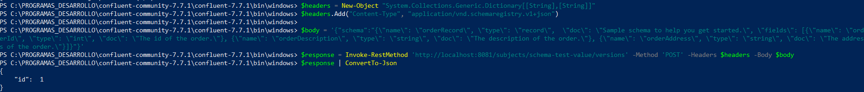

*****Empaquetado y subida de kafka_avro-main
cd "C:\WORKSPACE_DESARROLLO_INTELLIJ\MODULE_CONFLUENT_KAFKA\kafka_avro-main"
mvn clean install
mvn spring-boot:run
netstat -aon | findstr 8181
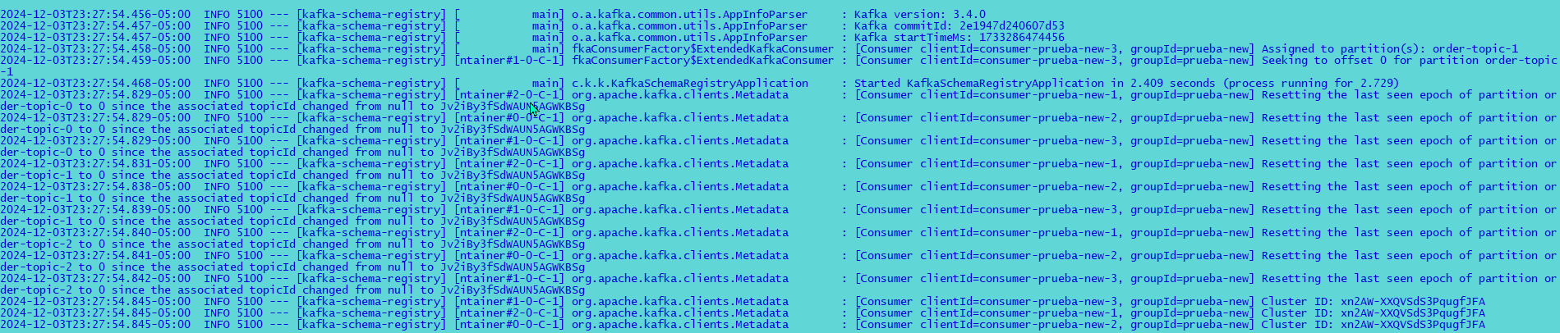

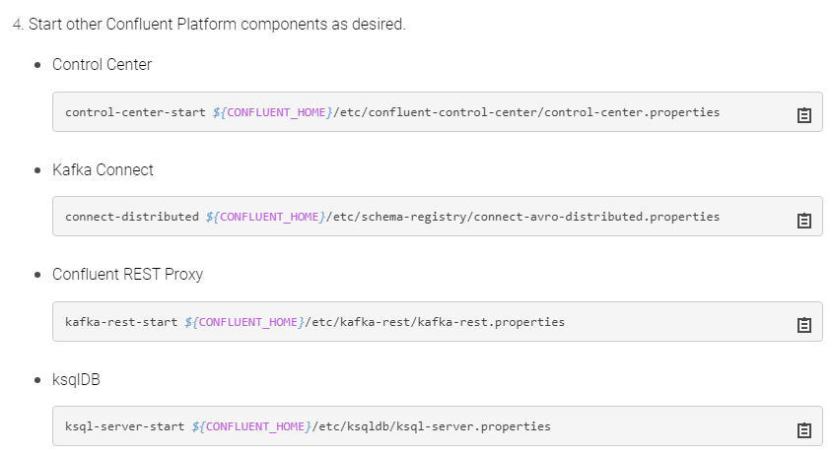

git init
git add .
git commit -m "Se agrega el proyecto"
git branch -M main
git remote add origin https://github.com/femero/PROJECTS_SPRING_CLOUD.git
git push -u origin main

--Troubleshooting

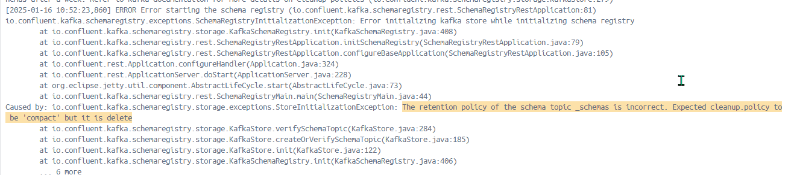

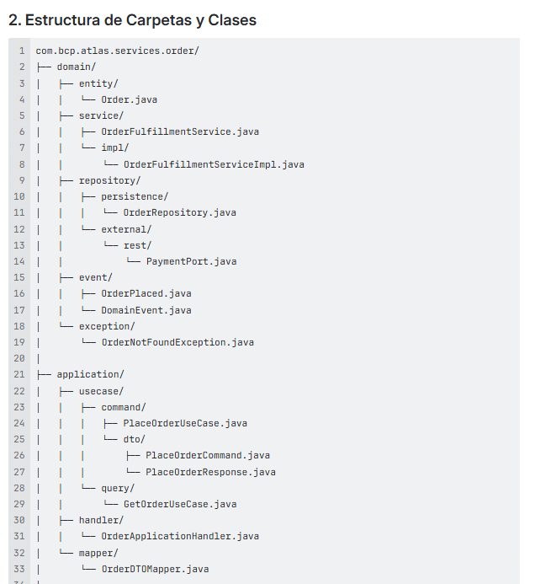 | 