|  |
| --- |
| Meteorology & ecoclimatology |
|  |
| Notes by student |

|  |
| --- |
| Faculteit Bio-ingenieurswetenschappen |
| Vakgroep Omgeving |
| CAVELAB |
|  |
|  |
|  |
|  |
|  |
|  |

# 8. Global climate & Köppen classification

**8.1 Definititions**

**Microclimate**: climate at small scales (leaf, forest) (see lecture 9).

**Mesoclimate:** between microclimate and macroclimate. This idevision is a quite arbitrary. (regional)

**Macroclimate**: large scale climate (e.g. Europe)

**Global climate**: climate at planetary scale

**8.2 Climatic controls**

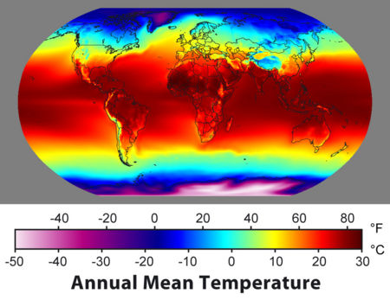

Seven key factors are determining the climate type on each location on earth:

1. Latitude

2. Distribution of land and water => continental or maritime (heat capacity of water)

3. Ocean currents (e.g.temperate climate in Europe dueto the gulf stream)

4. Dominant wind direction (e.g. westerlies for Belgian weather)

5. Position of dominant high and low pressure zones (e.g. Azores H, Icelandic L)

6. Mountain ranges orientation (e.g. east west oriented mountains in Europe: Alps, Pyrenees)

7.Altitude (Himalaya in map above)

**8.3 Global precipitation**

Global precipitation patterns are determined by the 3 cell model of global circulation. Wet regions at low pressure zones of the equator (ITCZ), and around 60° north or south. Very dry areas at the high pressure latitudes of 30° north and south and the poles. In between these wet and dry areas there are precipitation gradients.

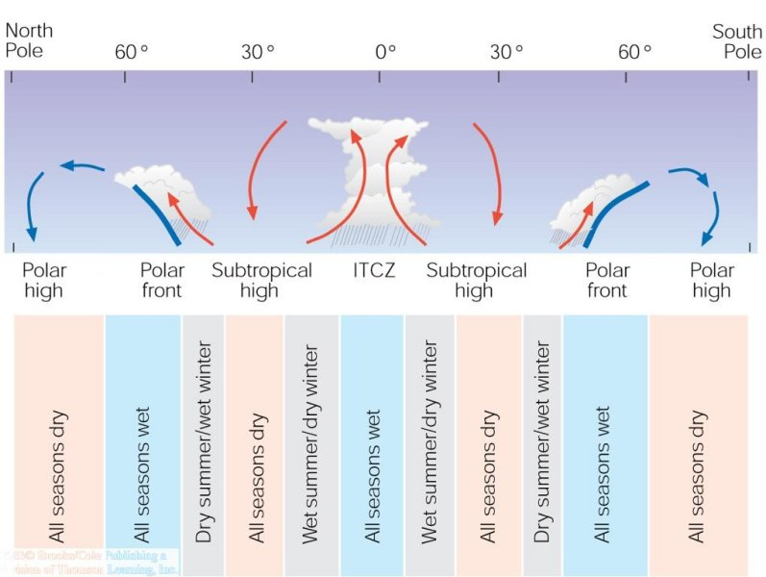

In addtion, we need to account fort he orografic cloud formation and preceipitation patterns that are linked to topography. In the figurebelow the precipitation pattern can perfectly be linked to the west-east topography in California.

**The effect of topography on average annual precipitation along a line running from the Pacific Ocean through central California into western Nevada. Santa Cruz on the windward side of Coast Range Mountains, experiences heavy precipitation of about 50 inches. San Jose and Los Banos on the leeward side are dry. Merced on the base, Mariposa and Yosemite on the walls and Ranger Station at the peak of Sierra Nevada's windward side. The higher the altitude of these places, the higher is the precipitation level.  Bishop and Tonopah Nevada both situated on the surface of the leeward side of Sierra Nevada receive less than 10 inches of precipitation and is rain shadow desert.**

* 1. **Climate classification – Köppen system**

The factors described in section 8.2 and 8.3 determine the global spatial distribution of climate types, which has been summarize in the Köppen climate classification. The Köppen clasiification is based on latitude (tropical, temperate, polar), the average temperature, precipitation (e.g. tropical wet vs. tropical dry) and topography (highland climate type). It has a letter code with 6 main climate types (capital letters) and a series of sub-types (small letters). See table 17.1 I the book Meteorology Today for an overview.

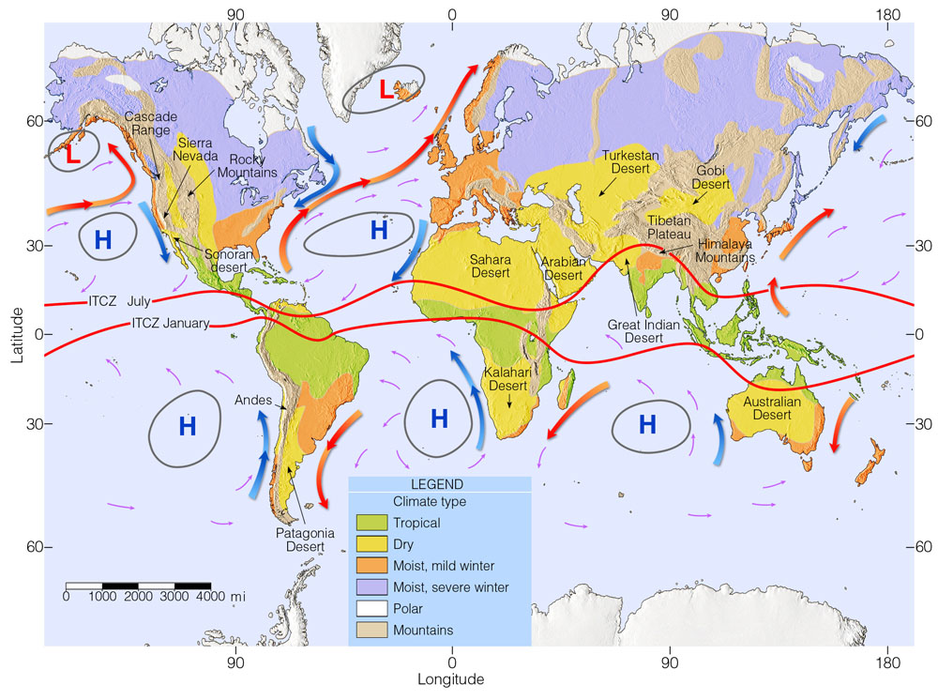

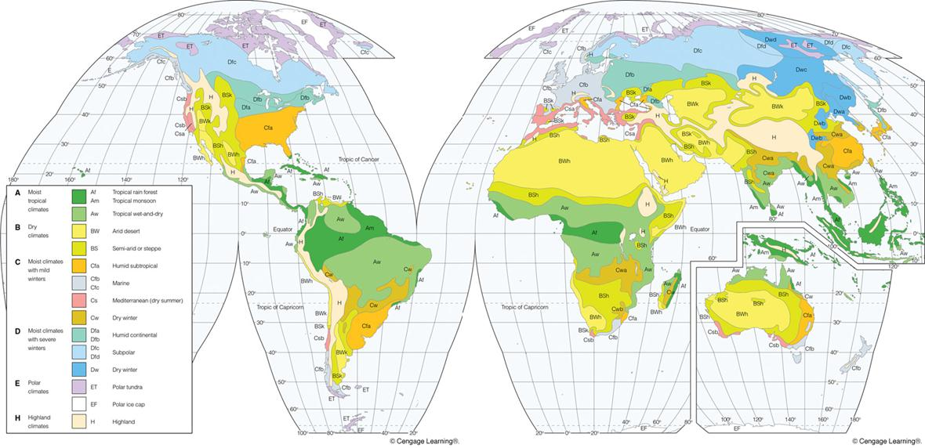

* 1. **Vegetation zones**

There is a clear link between climate types and vegetation types/zones.

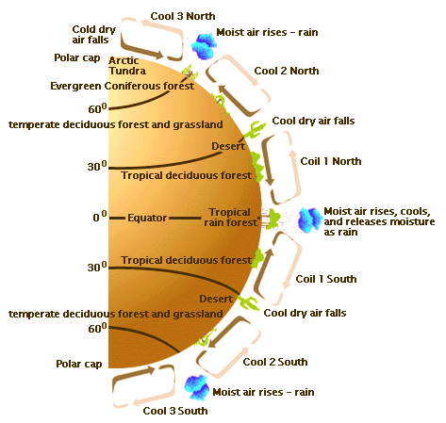

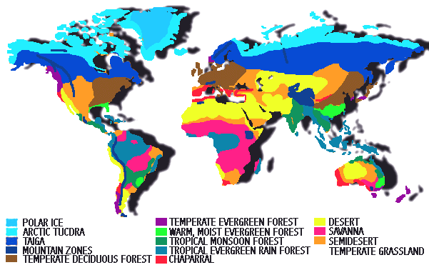

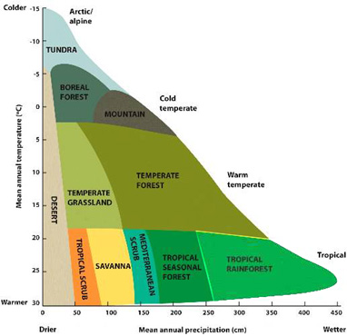

In the above figure the global biomes are situated on a temperature-precipitation plot. Remark that Tundra systems are very dry (very low annual precipitation), but they typically have very wet landscapes (ponds, lakes, …) due to the very low evaporation. These two axis allow to roughly determine the climax vegetation expected in a ertain region. But of course the actual climax vegetation type is also depending on soild type, local climate. And for the actual vegetation management, disturbance (fires), grazing, … play an important role too.

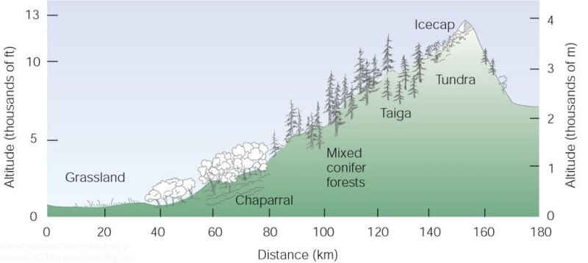

On mountain slopes, vegetation zones can be found at very short distance.

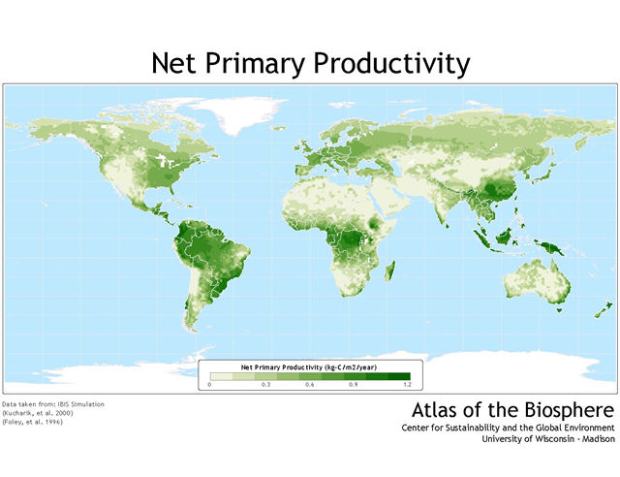

Not only the vegetation type but also vegetation functioning can be linked to global climate patterns. For example the map above shows the vegetation productivity (NPP). The global NPP patterns can clearly be linked to global temperature and precipitation patterns: precipitation will be limiting in the Sahara, and temperature will be limiting towards the North pole.

