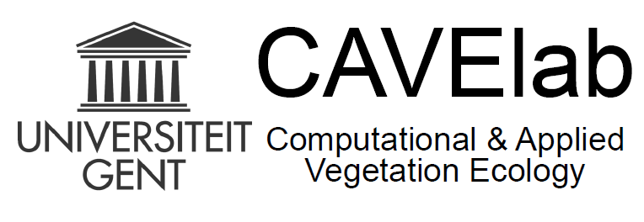**Passion/motivation**

* Which aspects make you passionate about your job?
* What gives you satisfaction in your job?
* What is de-motivating for you?
* Can you often do things you really like to do in your job?
* Can you do what you are good at?
* Do you get enough opportunities for development/training?

**Work/life**

* Can you do your job within office hours?
* Do you often feel pressure? Stress?
* Do you have enough energy/time for other things in life (e.g. hobbies, family, …)
* How do you specifically experience work/life during the COVID pandemic?

**Content**

* Is it clear what is expected from you in your job?
* What are your priorities?
* Are you satisfied with your job content?
* Are you satisfied with the work you deliver? (experiments, data, results, publications, presentations, …)

**Planning**

* How do you experience your planning?
* Are you meeting your deadlines?
* Are your plans realistic?

**Next year**

* Did you achieve the personal goals you had in mind for yourself for the past year (‘19-‘20)?
* What do you want to achieve next year?
* What worries you about the coming year?
* What do you want to learn?
* What do you want to change?

**Supervision**

* How is your cooperation with your supervisor(s) prof./post-doc?
* Are you adequately supported in your development?
* Are you sufficiently evaluated?
* What would you need to make your work better?

**Team (CAVElab):**

* What is your contribution to the team in general?
* Are you proud of the team?
* Goals for the team on the long term?
* Are the team meetings useful for you?
* How do you experience the atmosphere during work?
* How much appreciation do you get in your work from you colleagues?