# Derivation of exact solutions of the compensatory uptake term for two simplified root systems that represent two models that are used in physically based root water uptake models

## Set up of equations

The root system is represented by a network of Nroot nodes and in each node the xylem water potential is defined. Each node of the system is connected to the soil where the soil water potential is prescribed. The outlet of the network towards the plant is represented by an extra node that represents the root collar. The connections of the nodes in the system with other root nodes and with the soil nodes is described by the connectivity matrix **IM** (2Nroot x 2Nroot). The water potentials in the root system, **Hx** (Nroot x 1) can be obtained from the solving the flow equation in a network of conductances that represents the root system. The network is connected at one side to the soil, where the soil water potentials **Hsoil** (Nroot x 1) are prescribed, and at the other side to the root collar where the collar water potential, Hcollar, is prescribed.

The equation that is setup is:



where diag(**K)** (2Nroot x 2Nroot) is the diagonal conductance matrix with the first Nroot elements representing the axial conductances of the root segments and the last Nroot elements the radial root segment conductances (which could later include also the soil-root conductance). **IM**Tcollar is an (2Nroot x 2Nroot+1) matrix with the last 2Nroot columns equal to **IMT** and the first column represents the connectivities of the root nodes to the collar. **Q** (Nroot x 1) is the root water uptake vector. From this equation, the unknown pressure heads in the xylem and the root water uptake by the different nodes can be derived when the soil water potentials and the collar water potential are known. The xylem pressure heads are obtained from:



where



From the difference between the soil water potentials and the xylem water potentials, the water uptake by the root segments can be obtained as:



Kr= K(Nroot+1:2Nroot,Nroot+1:2Nroot)

When we consider the case of a uniform soil water potential, *Heff*, then we can write



When Heff = Hcollar, there is neither flow from the soil to the collar nor flow through the root system from one soil node to the other. From this follows that:



If we consider now the total root water uptake, then



From this follows that we can derive the root system conductance Krs directly from:



The standardized uptake fraction SUF[i], which is defined as the faction of the uptake by a root node to the total root water uptake under uniform soil water potential, is related to the matrix **C4** and vector **C5** as: :



So we can write for uniform water potentials:



For the general case that the soil water potentials are not uniform, we can define the effective soil water potential Heff as:



After adding and subtracting **C5** Heff=Krs **SUF** Heff=Krs **SUF**·**SUFT** **Hsoil**, we obtain the following equation for the root water uptake **Q**:



From the definitions of **C6**, **C4**, **SUF** and Krs follows that the sum of the elements in the rows of **C6** is zero for all rows. This implies that when **C6** is multiplied with an Nroot x 1 vector with constant elements, a zero vector is obtained. Therefore, we can reformulate the equation for the root water uptake as:



This equation has a similar form than the equation that was proposed by Couvreur et al. (2012) to describe water uptake by a root network except that the C6 is considered as a scalar value Kcomp.

In order to draw the analogy and identify differences between the two approaches, we will discuss the nature of the **C6** matrix and how it can be transformed or approximated. From the definition of **C6**, it also follows that the sum of all the elements in the vector is zero. Therefore, this vector represents the perturbations of the uptake **Q** at a certain depth due to the perturbation of the water potential at this depth compared to the uptake when the water potential is uniform in the root zone. When there is no net uptake, i.e. when Heff = Hcollar, then  represents the redistribution water fluxes through the root system due to spatial variations in Hsoil. When we consider now the case that in the root node i, the soil water potential is Heff+Hsoil,i and in all other root nodes, Hsoil,j = Heff-SUF[i] Hsoil,i /(1-SUF[i]), then we can define Qi = kcomp,i Hsoil,i/(1-SUF[i]). kcomp,i represents the compensatory root system conductance to transfer water towards node i when there is a water potential difference between the soil water potential at node i and the other nodes in the root system, which all have the same water potential. Q(i) and kcomp,i are related to the **C6** matrix and **SUF** vector as:



since



We assume now a root system in which all soil nodes are connected via one radial and one axial resistance to the collar node so that the overall resistance to flow from one soil-root node to the collar is equal to the sum of the axial plus radial resistances. We call this root system the ‘parallel root system’ (see Figure 1). The radial and axial resistances for each soil node can however be different. Also a root system in which there is no resistance to axial flow can be considered as a system in which all soil nodes are connected directly to the root collar. But, it is important to keep in mind that systems with a significant axial root resistance can also be considered, as long as there is a direct connection between the soil node and the root collar without additional intermediate nodes that connect to the soil. For instance fibrous root systems with only primary roots in which uptake takes only place near the root tip but not at the more basal ends of the primary roots can also be represented by this root system model. For such a root system, it follows that:



If we consider that kcomp,i represents the resistance to the flow from all the soil nodes to node i via the collar, then flow takes place from the soil to the collar through a fraction 1-SUF[i] of the system. Instead of freely flowing out at the root collar, the flow must return via root i to soil node i and leading to an extra resistance which is accounted for by the factor SUF[i].

In the same vein, it can be deduced that for such a root system:



The jth column of the **C6** matrix represents to what extent water from the jth node can flow to the other nodes in the system. For a parallel root system in which the flow must pass through the collar node, and the flow from node j to node i is proportional to the conductance for the flow from node j to the collar node and hence to SUF[j]. Based on this, we can write the **C6** matrix for this root system as:



Since **SUFT** **Hsoil** = Heff, it follows that for a parallel root system:



This implies that we can obtain the following equation to simulate root water uptake for the parallel root system:

,

which is identical to the equation proposed by Couvreur et al. 2012.

For a general root system, we can rewrite the general equation which takes a similar form as the equation that we obtained for the parallel root system.



For the parallel root system, C7 equals the identity matrix and Kcomp[i] equals Krs.

For the general root system, we find that Kcomp[i] is larger than Krs. This means that for a certain Hsoil,i in node i and a constant soil water potential in all other nodes j, Hsoil,j = -SUF[i] Hsoil,i /(1-SUF[i]), there is more redistribution in the general root system than in the parallel root system. In the general root system, the flow from one soil-root interface to another soil-root interface does not always have to pass through the collar but can take a shorter way. The diagonal terms of **C7** are equal to 1 and the off-diagonal terms of each row of **C7** sum up to 0. A negative value of the jth column for the ith row in **C7** means that there is more redistribution between node i and j in the general root system than in case the root system would be a parallel root system with the same uptake distribution under uniform soil water potential and the same Krs. This happens when the two nodes are more strongly connected with each other than with the other nodes in the system.

## Upscaling:

From the matrix equations it follows that the upscaling of the relations between the uptake rates Q and soil water potentials Hsoil is trivial for cases when the soil water potentials are uniform in certain regions of the soil. When we assume that the soil water potentials do not change in the horizontal direction, then we can simply group and sum up all SUF values for the soil root nodes that are in the same soil horizontal soil layer and derive an upscaled SUF vector that describes the relative uptake from each soil layer when the soil water potentials are uniformly distributed (Couvreur et al., 2014). The upscaled matrix ***C6*** that is multiplied by a vector of soil water potentials in the different soil layers is simply obtained by:



Based on the upscaled C6 and **SUF**, the upscaled **C7** and **Kcomp** can be derived. It must be noted that **C7** and **Kcomp** cannot be scaled up directly by summing up elements in the **C7** matrix and **Kcomp** vector.

The upscaling approach was illustrated here for the case of uniform water potentials in the horizontal direction. But, it can be applied for any region where water potentials can be assumed to be uniform.

## Demonstrations:

In order to demonstrate the model, we consider in a first step two different ‘abstract’ root systems that represent the two opposite simplified models: the ‘parallel root model’ and the ‘big root model’ (Figure 1). The purpose of this first step is to demonstrate how differences between these two opposite root systems emerge in the generalized root water uptake model and what the consequences of these differences are for water uptake from a profile with a non-uniform water content. In the big root model, we assume that there is basically one big root in which the root segments that are coupled with a soil node are connected in series to the root collar. The water flows from the basal root segments and from the soil into the segment are mixed and water potential differences are compensated. This is different for the parallel root system in which the root segments have a different length and axial resistance and are only connected with each other at the root collar. The water potentials at a certain height in the parallel root system may hence differ between the different root segments.

In a second step, a ‘hybrid’ root system which is a mixture of the parallel and big root systems will be discussed. It consists of parallel roots that each take up water along their length and not only at the root tip as supposed on the parallel root system. Therefore, it represents an intermediate model that does not match perfectly with one of the two simplified models. How this root system can be represented by the two simplified models will be evaluated. This root system also consists of more than one root node that is connected to the soil at a certain depth. This root system will therefore also be used to demonstrate the upscaling.

The root systems that are considered in step 1 and 2 are chosen to be very simple and using a dummy parameterization (i.e. the parameters were chosen to represent certain differences but the actual values of the parameters and their dimensions were not of central interest) with the primary goal to demonstrate the differences between model concepts. In the third step, the generalized root water uptake model and how it can be approximated by the two simplified models will be demonstrated for a few root systems that correspond in terms of complexity and parameterization to more realistic root systems.

### Simple big root and parallel root systems

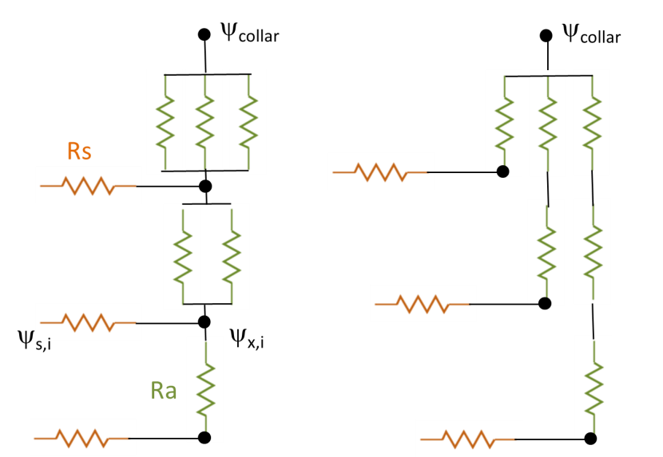

Figure 1: ‚Big root‘ (left) and ‚parallel‘ root systems (right).

We consider that the root system is made up of single resistors Ra (for the axial resistance) and Rs for the soil-root radial resistance. For both models, we use the same amount of axial resistances.

In order to calculate Doussan’s C matrix, the following equation needs to be computed:



where

 with  and 

and

 with  and 

See matlab code Comparison_big_para.m for solutions

Two cases with different axial resistances were considered: one with Ra=Rs=1 (kx=kr=1) and one with Ra=0.1 (kx=10). The root collar potential was assumed to be -1. The water potential was assumed to increase linearly with depth from -1 to 1. Since the weighting factors SUF for the parallel root system differ from those of the big root system, the effective mean soil water potentials for the parallel system differed.

For the systems with a higher kr, the Krs are higher. The Krs is also a bit higher for the big root system than for the parallel root system (Table 1). The different root systems also varied in terms of the SUF. Due to the axial resistance to flow, the SUF values decreased in general with distance from the root collar. The decrease was more outspoken for smaller kx values and was larger for the big root system with a serial connection of the root segments than for the parallel root system. For the parallel and big root system with a large kx, the distribution of SUF becomes more or less uniform with depth. Although the parallel root system had a lower Krs than the corresponding big root system, the root water uptake was larger for the parallel than for the big root system. Since the SUF values deeper in the soil profile were larger for the parallel root system than for the big root system, more water could be taken up from deeper in the soil profile where the water potentials were larger by the parallel root system than by the big root system.

However, the compensatory uptake in the big root system was larger than in the parallel root system. Both the kcomp and Kcomp values were larger for the big root than for the parallel root system. This means that water could be redistributed more easily via the root system between different depths in the soil profile with different soil water potentials in the big root than in the parallel root system. For the parallel root system, the compensatory water flow must pass via the root collar whereas it can be transferred more directly in the big root system. For the parallel root system Kcomp matches exactly with Krs. For the big-root system, Kcomp is larger than Krs. kcomp and Kcomp increase in both cases with increasing axial conductance (kx) and the difference between Kcomp and Krs for the big root system decreases with increasing axial conductance.

The larger redistribution and Kcomp in the big root system does not lead to more net water uptake but to a larger redistribution of water in the soil via the root system. The larger uptake in the lower part of the soil profile is compensated by larger release (more negative uptake rate) in the upper part of the profile.

Comparing the simplified approach with the exact approach, for the parallel root system both approaches match perfectly with Kcomp= Krs and **C7**=I. For the big root system with larger Kcomp than Krs, the compensatory uptake in the deeper part of the profile and the release in the upper part are underestimated by the simplified approach.

For the parallel root system, the compensatory uptake at a certain depth depends only on the deviation of the soil water potential at that depth from the effective soil water potential. Since the **C7** matrix differs for the big root system from the identity matrix, the compensatory uptake at a certain depth will depend on how the deviations from the effective soil water potential are distributed in the soil profile. For instance, for a certain deviation of the soil water potential at the deepest depth, the compensatory uptake at the deepest depth for the big root system will be larger when the deviation of the water potential is smaller at the middle depth and larger at the shallowest depth. The compensatory uptake in the middle depth will be larger when the deviation at the top of the soil profile is larger (more positive) and when the deviation in the bottom is smaller.

|  |  |
| --- | --- |
|  |  |
|  |  |
|  |  |
|  |  |

Figure 2: Standardized uptake fractions (SUF) and sink terms for parallel and big root systems and for a linearly increasing hydraulic head with depth. SUF and sink terms are calculated using the exact solutions and using the approximation by Couvreur (2012). The top two rows are for root systems with lower axial conductances, kx, and the lower two rows for root systems with higher axial conductances.

Table 1, Krs, SUF, kcomp, and Kcomp, mean soil water potential and total uptake for the different root systems

|  |  |  |  |  |
| --- | --- | --- | --- | --- |
|  | Big root |  | Parallel root |  |
|  | kr=1,kx=1 | kr=1, kx=10 | kr=1, kx=1 | kr=1, kx=10 |
|  | Krs | Krs | Krs | Krs |
|  | 1.1471 | 2.5130 | 1.0833 | 2.5117 |
| Depth | SUF | SUF | SUF | SUF |
| 1 | 0.538 | 0.365 | 0.461 | 0.362 |
| 2 | 0.308 | 0.333 | 0.308 | 0.332 |
| 3 | 0.154 | 0.302 | 0.231 | 0.306 |
| Depth | Kcomp | kcomp | kcomp | kcomp |
| 1 | 0.462 | 0.635 | 0.269 | 0.580 |
| 2 | 0.538 | 0.651 | 0.231 | 0.557 |
| 3 | 0.385 | 0.620 | 0.192 | 0.534 |
| Depth | Kcomp | Kcomp | Kcomp | Kcomp |
| 1 | 1.857 | 2.743 | 1.0833 | 2.5117 |
| 2 | 2.528 | 2.930 | 1.0833 | 2.5117 |
| 3 | 2.955 | 2.940 | 1.0833 | 2.5117 |
|  | Heff/qtot | Heff /qtot | Heff /qtot | Heff1 /qtot |
|  | -0.3846/0.706 | -0.0620/2.357 | -0.2308/0.833 | -0.0557/2.371 |

Table 2: C7 matrices for different root systems

*Big root, kr = 1, kx = 1*

|  |  |  |
| --- | --- | --- |
| 1 | 0 | 0 |
| 0.143 | 1 | -0.143 |
| 0.200 | -0.200 | 1 |

*Big root, kr = 1, kx = 10*

|  |  |  |
| --- | --- | --- |
| 1 | 0 | 0 |
| 0.023 | 1 | -0.023 |
| 0.024 | -0.024 | 1 |

*Parallel root: kr=1, kx=1 or kx =10*

|  |  |  |
| --- | --- | --- |
| 1 | 0 | 0 |
| 0 | 1 | 0 |
| 0 | 0 | 1 |

### Simple hybrid root system:

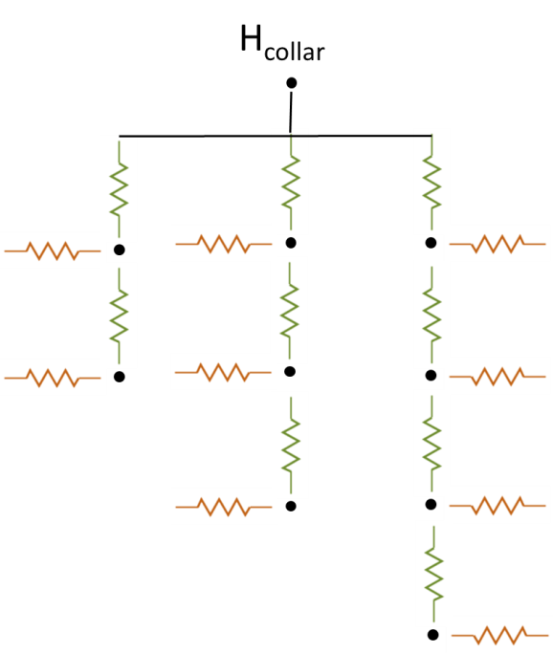 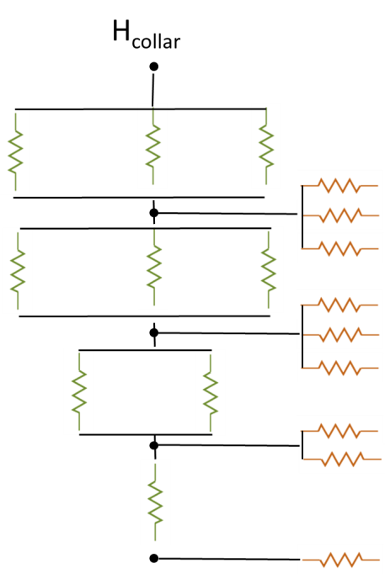

Figure 3: hybrid parallel-big root system (left) and corresponding big root system (right)

Figure 3 shows the hybrid parallel-big root system that consists of three primary roots of different length. This root system is either represented by a parallel roots system that has the same SUF and Krs or by a big root system. The upscaled big root system assumes that the axial and radial conductance in a certain layer is the sum of the axial and radial conductances of the individual root segments in that layer (see Figure 3 right).

We assume two parameterizations of the root hydraulic resistances. In the first case, the resistances are uniform: kx=10 and kr =1. In the second case, the radial root hydraulic resistance is smaller at the root tips (kr=1) than in the other parts along the primary roots (kr=0.1). The pressure head at the root collar is -1 and the soil water potentials at the 4 different depths are from top to bottom: -0.5, 0, 0.5, 1. For the root system with the homogeneous resistances, the effective soil water potential, Heff = -0.0296 and -0.0121 for the upscaled big root system. For the root system with the non-uniform radial resistances , Heff = 0.3455 and 0.3459 for the upscaled big root system. Figure 4 shows the SUFs and sink terms of upscaled root system with uniform resistances and of the upscaled and approximate parallel (Couvreur approx.) and big root systems. For this scenario, the parallel root system model tends to underestimate the redistribution whereas the big root system overestimates the redistribution.

The SUF, kcomp and Kcomp and their upscaled values are given in Table 3. Of note is that, as also illustrated in Figure 4, the Kcomp values are higher than Krs, which is used to calculate the compensatory uptake in the parallel root system. Also of interest is that the upscaled Kcomp values are not equal to the average of the Kcomp values of the root nodes in a soil layer. For the top layer, the upscaled Kcomp is even larger than the largest Kcomp value of thethree primary roots. But, the SUF values are simply the sum of the SUF values of the single root nodes in a soil layer.

Larger radial resistance away from the root tips led to a root system that behaves more like a parallel root system (Figure 5). The big root system tended to overestimate the compensatory uptake for this root system whereas the parallel root system still underestimated the compensatory uptake but to a smaller extent than in the previous case.





Figure 4: Upscaled standard uptake fractions (SUF) (upper figure) and sink terms (lower figure) (left axes) and soil water potential distributions (right axis, red lines) for the hybrid parallel-big root system using the exact and approximate solutions for parallel and big root systems.

Table 3: SUF, kcomp,, Kcomp and upscaled values for the hybrid parallel root system.

|  |  |  |  |  |  |
| --- | --- | --- | --- | --- | --- |
|  | Hybrid Parallel-Big root | | |  | Bigroot |
|  | rs=1, ra=0.1, Krs= 6.0147 | | |  | Krs= 6.1122 |
|  | Prim. root 1 | Prim. root 2 |  | Upscaled |  |
| Depth | SUF | SUF | SUFupscaled | SUFupscaled |  |
| 1 | 0.1396 | 0.1391 | 0.1273 | 0.3988 | 0.3908 |
| 2 | 0.1269 | 0.1108 | 0.1010 | 0.3387 | 0.3299 |
| 3 |  | 0.1007 | 0.0848 | 0.1855 | 0.1920 |
| 4 |  |  | 0.0771 | 0.0771 | 0.0873 |
|  | kcomp | kcomp | kcomp | kcompupscaled |  |
| 1 | 0.799 | 0.816 | 0.826 | 1.804 |  |
| 2 | 0.743 | 0.786 | 0.811 | 1.882 |  |
| 3 |  | 0.733 | 0.783 | 1.412 |  |
| 4 |  |  | 0.730 | 0.730 |  |
|  | Kcomp | Kcomp | Kcomp | Kcompupscaled |  |
| 1 | 6.65 | 7.13 | 7.44 | 7.52 |  |
| 2 | 6.70 | 7.98 | 8.94 | 8.41 |  |
| 3 |  | 8.09 | 10.09 | 9.35 |  |
| 4 |  |  | 10.26 | 10.26 |  |





Figure 5: Upscaled standard uptake fractions (SUF) and sink terms (lower figure) (left axes) and soil water potential distributions (right axis, red lines) for the hybrid parallel-big root system with variable radial conductance along the primary roots (radial conductance is 1 at root tips and 0.1 at other nodes) using the exact and approximate solutions.

Table 4: SUF, kcomp,, Kcomp and upscaled values for the hybrid parallel root system with variable radial resistance along the primary roots (radial conductance is 1 at root tips and 0.1 at other nodes).

|  |  |  |  |  |  |
| --- | --- | --- | --- | --- | --- |
|  | Hybrid Parallel-Big root | | |  | Bigroot |
|  | rs=1, ra=0.1, Krs= 2.7673 | | |  | Krs= 2.7673 |
|  | Prim. root 1 | Prim. root 2 | Prim. root 3 | Upscaled |  |
| Depth | SUF | SUF | SUF | SUFupscaled | SUFupscaled |
| -1 | 0.0328 | 0.0328 | 0.0328 | 0.0984 | 0.0984 |
| -2 | 0.2984 | 0.0298 | 0.0298 | 0.3580 | 0.3576 |
| -3 |  | 0.2709 | 0.0270 | 0.2979 | 0.2979 |
| -4 |  |  | 0.2457 | 0.2457 | 0.2462 |
|  | kcomp | kcomp | kcomp | kcompupscaled |  |
| -1 | 0.0961 | 0.0961 | 0.0961 | 0.2705 |  |
| -2 | 0.5876 | 0.0959 | 0.0959 | 0.6761 |  |
| -3 |  | 0.5691 | 0.0957 | 0.6243 |  |
| -4 |  |  | 0.5541 | 0.5541 |  |
|  | Kcomp | Kcomp | Kcomp | Kcompupscaled |  |
| -1 | 3.0274 | 3.0295 | 3.0313 | 3.0485 |  |
| -2 | 2.8067 | 3.3170 | 3.3213 | 2.9419 |  |
| -3 |  | 2.8815 | 3.6389 | 2.9847 |  |
| -4 |  |  | 2.9892 | 2.9892 |  |

### More complex and realistic root systems

Single root: 50 cm long, constant kx and kr parameters along the root

Krs, Krsbigroot: 0.02 cm³/cm/d





Single root: 50 cm long, variable kx and kr parameters along the root

Krs: 0.000498 cm³/cm/d; Krsbigroot: 0.000485







Maize:

Krs= 0.0563 cm³/cm/d

Krsbigroot = 0.0784 cm³/cm/d

Psicolar: -4000 cm

Psisoiltop: -3000 cm

Psoil bottom: 0 cm.

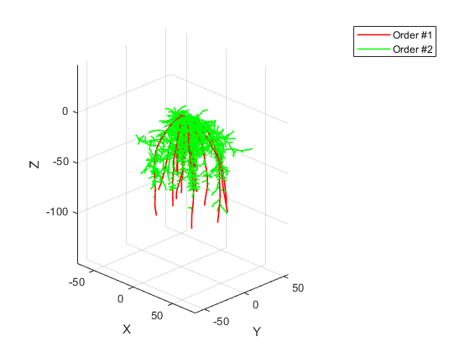







Sunflower

Krs= 0.00555 cm³/cm/d

Krsbigroot = 0.0068 cm³/cm/d

Psicolar: -4000 cm

Psisoiltop: -3000 cm

Psoil bottom: 0 cm.









Grass

Krs= 0.045 cm³/cm/d

Krsbigroot = 0.0489 cm³/cm/d

Psicolar: -4000 cm

Psisoiltop: -3000 cm

Psoil bottom: 0 cm.

Peffsoil: -1999 cm









Mixed grass-maize system

10 maize plants /m²

400 grass plants /m²

Psisoil top = -3100 cm; Psisoil bottom = 0 cm

Tpot=0.5 cm/d

Tmaize=0.3 cm/d

Tgrass=0.2 cm/d

Psileaf maize=-7515 cm

Psieffsoil_maize=--2189 cm

Psileaf grass= -3041 cm

Psieffsoil_grass= -2930 cm

Krs_mixed= 0.0019 1/d

Psileaf_mixed=-2755 cm

Psieffsoil_mixed= -2485 cm





Next steps:

Show examples for realistic root systems.

Show the impact on simulated root water uptake (therefore the approach should be implemented in Hydrus. Can we do that?).

Can we classify root systems into ‘big root’ or ‘parallel root’ systems? What would be the traits of the root system that define in which class the root systems fall? To address these questions, it would be good it the approach could be implemented in Marshal.

How upscaling works with two root systems? Is it just a sum for Kcomp/Krs?