TASK 1.1 - KAFKA CORE CONCEPTS SUMMARY

Apache Kafka is a distributed event streaming platform used for transferring real-time data between different applications. It acts like a messaging system where one application sends data and another application receives it. Kafka is mainly used in systems that handle large amounts of continuous data because it is fast, scalable, and reliable.
TOPIC
A topic is a category or channel where messages are stored in Kafka. Different types of data are usually separated into different topics. For example, an ecommerce application may have topics like orders, payments, and notifications. Producers send messages to topics, and consumers read messages from them.
PARTITION
A partition is a smaller division inside a topic. Kafka divides topics into partitions to improve performance and scalability. For example, a topic called orders may contain Partition 0, Partition 1, and Partition 2. Partitions help Kafka process multiple messages in parallel. Kafka guarantees message ordering only within the same partition.
OFFSET
An offset is the unique position number of a message inside a partition. Kafka automatically assigns offsets to messages in sequence. Consumers use offsets to track which messages they have already processed. If a consumer restarts after failure, it can continue reading from the last offset instead of starting again from the beginning.
BROKER
A broker is the Kafka server that receives, stores, and manages messages. Producers and consumers communicate with brokers to send and receive data. A Kafka system can contain multiple brokers working together as a cluster. In this setup, Kafka was configured using a single broker through Docker.
REPLICATION FACTOR
Replication factor refers to the number of copies maintained for each partition. Replication helps provide fault tolerance because if one broker fails, another replica can continue working without losing data. In this setup, the replication factor used was 1 because only one broker was configured.
ISR
ISR stands for In-Sync Replicas. These are replicas that are fully updated with the latest data from the leader partition. Kafka considers ISR replicas reliable enough to become leaders if the current leader broker fails. ISR helps maintain data consistency and reliability in Kafka clusters.
PRODUCER
A producer is an application or service that sends messages to Kafka topics. For example, an ecommerce application sending order details to the orders topic acts as a producer. Producers continuously publish data into Kafka.
CONSUMER
A consumer is an application or service that reads and processes messages from Kafka topics. Consumers subscribe to topics and receive messages continuously from Kafka brokers. Kafka consumers track offsets to remember their reading progress.
CONSUMER GROUP
A consumer group is a collection of consumers working together to process messages from a topic. Kafka distributes partitions among consumers within the same group to improve scalability and parallel processing. Inside a consumer group, one partition can only be handled by one consumer at a time.
ZOOKEEPER AND KRAFT
Older versions of Kafka used ZooKeeper for broker coordination, metadata management, and leader election. However, modern Kafka versions use KRaft mode, where Kafka manages metadata internally without depending on ZooKeeper. The current Docker-based setup uses KRaft mode because no separate ZooKeeper service was required.

CONCLUSION
Kafka provides an efficient and reliable platform for real-time data streaming using brokers, topics, partitions, producers, consumers, and consumer groups. Its distributed architecture helps applications process large amounts of data with better scalability and fault tolerance.

TASK 1.2 – KAFKA CLUSTER SETUP

KAFKA CLUSTER INITIALIZATION
The Kafka single-node cluster was started successfully using Docker Compose.
docker compose up -d

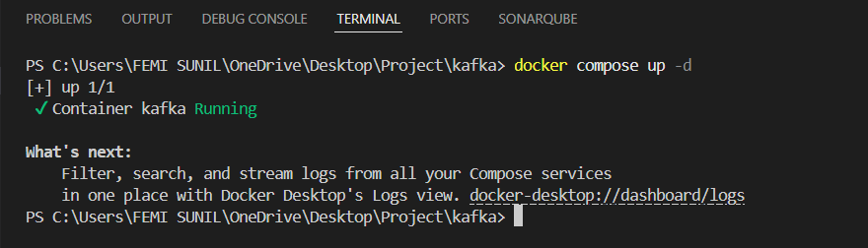

BROKER VERIFICATION
The Kafka broker was verified successfully using the Docker process list.
docker ps

TOPIC CREATION
A Kafka topic named ecommerce-orders was created with 3 partitions and replication factor1.
docker exec -it kafka bash

/opt/kafka/bin/kafka-topics.sh --create --topic ecommerce-orders --bootstrap-server localhost:9092 --partitions 3 --replication-factor 1

PRODUCING MESSAGES
Messages were successfully produced to the ecommerce-orders topic using the Kafka producer.
/opt/kafka/bin/kafka-console-producer.sh --topic ecommerce-orders --bootstrap-server localhost:9092

CONSUMING MESSAGES
The produced messages were successfully consumed from the Kafka topic using the Kafka consumer.
docker exec -it kafka bash

/opt/kafka/bin/kafka-console-consumer.sh --topic ecommerce-orders --from-beginning --bootstrap-server localhost:9092

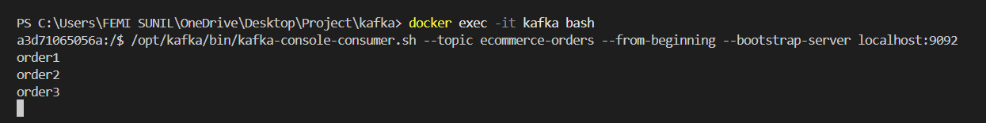

RESULT
The Kafka broker, topic creation, message production, and message consumption were successfully verified using the Docker-based Kafka setup in KRaft mode.

TASK 1.3 - TOPIC CREATION, MESSAGE PRODUCTION, AND PARTITION CONSUMPTION

TOPIC CREATION
A topic named orders was created with 3 partitions and replication factor 1 using the following command:
docker exec -it kafka bash

/opt/kafka/bin/kafka-topics.sh --create --topic orders --bootstrap-server localhost:9092 --partitions 3 --replication-factor 1

PRODUCING MESSAGES WITH DIFFERENT KEYS
The producer was started using the following command:

/opt/kafka/bin/kafka-console-producer.sh --topic orders --bootstrap-server localhost:9092 --property "parse.key=true" --property "key.separator=:"

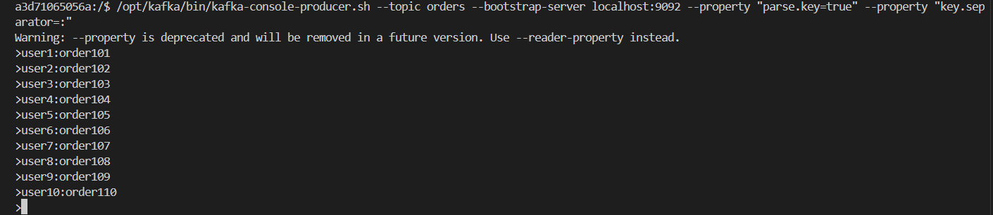

CONSUMING MESSAGES FROM PARTITION 0
The following command was used to consume messages only from Partition 0:
docker exec -it kafka bash

/opt/kafka/bin/kafka-console-consumer.sh --topic orders --partition 0 --from-beginning --bootstrap-server localhost:9092

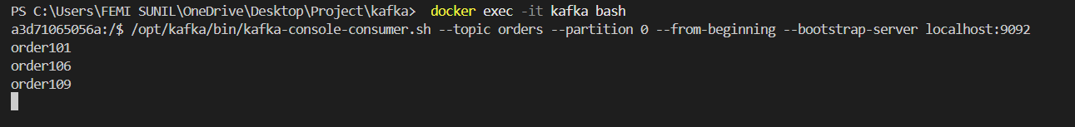

OBSERVATION
It was observed that only some messages appeared in Partition 0 because Kafka distributes messages across partitions based on the message key. Messages with different keys were automatically assigned to different partitions using Kafka’s hashing mechanism. As a result, only the messages mapped to Partition 0 were consumed in this step.

