## Introduction: Businesses are all too familiar with setting the right price for the right product. If the price is too high, a business will lose customers to the competition and if it is too low, businesses lose the much-needed revenue that is a pre-condition for running a profitable business. Big Mountain tasked Big Data consulting to crack this nut, whereby prices can be determined to avoid these risks. The right ticket price for their ski resort would be one that attracts the right number of customers and generate the profitable revenues. So setting the right price is one thing, but about investing in the right assets to generate the right returns? This was another area of concern for Big Mountain. The wrong investment will drain Big Mountain of its scare resources, which is exacerbated when the revenues don’t cover the original principal. Layer on top of this the added operating costs typical of new projects. Companies who do not have a way to assess their investments such that the principal and operating costs are covered inevitably suffer and risk failure. Big Mountain reviewed this issue and developed a new strategy to help Big Mountain’s management assess review their investment decisions to supplement traditional approaches.

# Analysis: Big Data Consulting supplemented the data provided by Big Mountain with external information that was useful in developing a compare Big Mountain’s adult ticket price to its competitors.

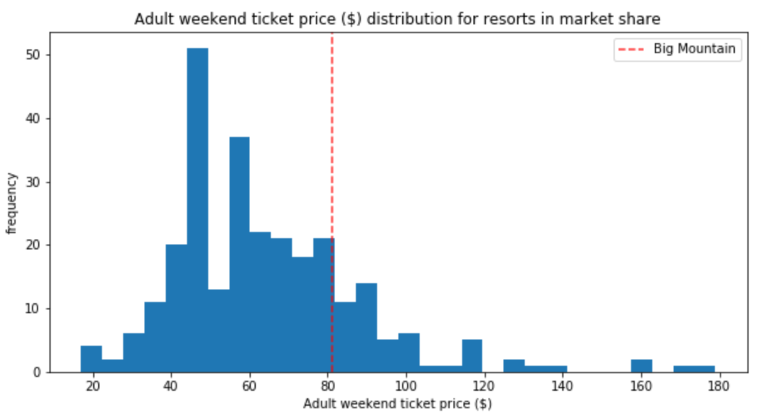 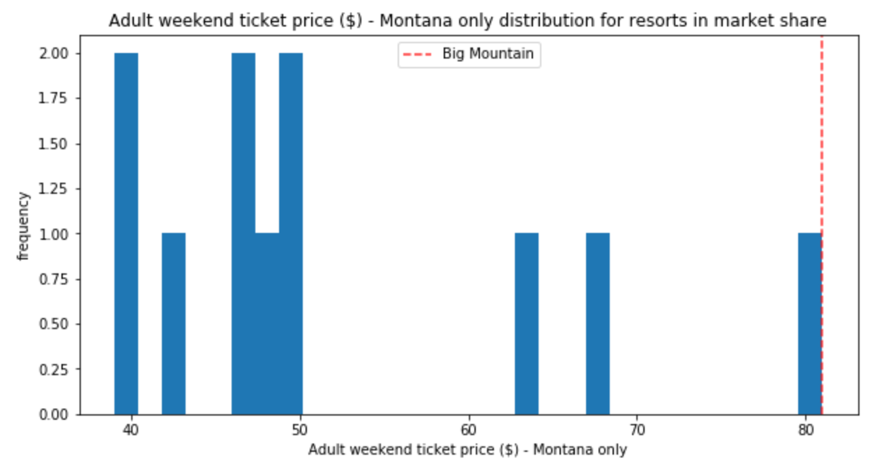

Our analhysis revealed that although Big Mountains ticket price ($81) was about half what was charged by the priciest resorts in the U.S., it was still on the high side in Montana. However, Big Mountain was one of the best resorts in terms of vertical drop, fast quads, and longest run – features that were previously determined to positively influence ticket prices.

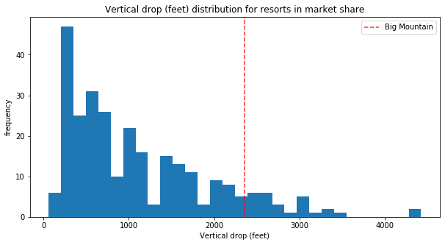 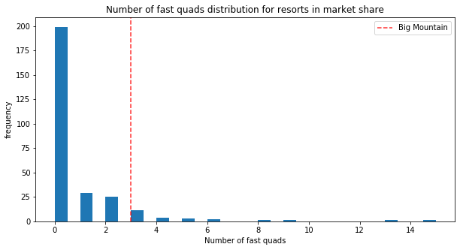

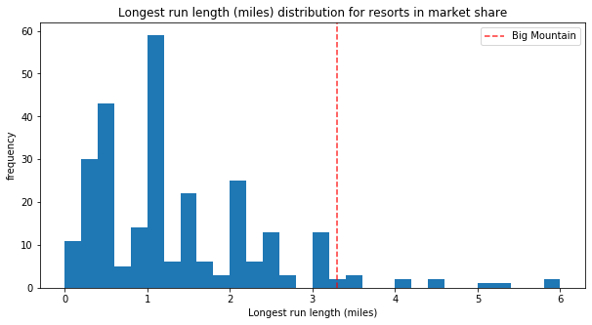

This analysis led us to the recommendation of a possible price increase, but by how much? This is where our model

# Modelling: Our model revealed that the Big Mountain’s features could accommodate an adult ticket price of $94.22, representing a price increase of 16% over the current price of $81. The upside for this price increase was very encouraging, but we were also wary of the results. The mean absolute error of $10.39 meant that Big Mountain would likely be better served by increasing it’s ticket price to $83.83 to accommodate this error.

# Recommendation: Our model revealed that Taking an even more conservative approach, we recommend that Big Mountain increase its adult ticket price by $2.50 over the season and do so using an incentive approach. Big Mountain should offer an early-bird special of $82 to encourage pre-orders before the ski season begins and increase the ticket price to $83.50 when the season begins. Even with an $82 sticker price during the season, and assuming 350,000 visitors at an average stay of 5 days, Big Mountain stands to increase its revenue by $1.75M throughout the year, which more than covers the additional $1.54M cost used to purchase an additional chair lift.

Looking Forward: Our model also revealed that Big Mountain might also want to invest in adding an extra run, increasing the vertical drop by 15 feet and installing another chair lift. By doing so, they could further increase their average ticket price by $1.99.