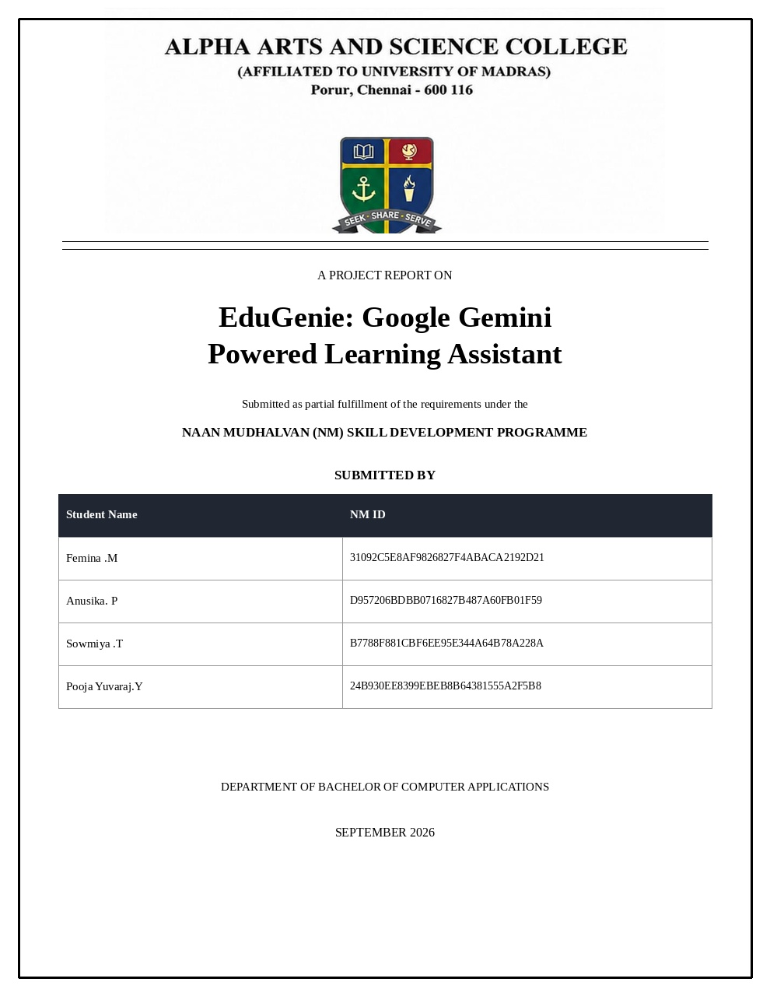

EduGenie AI
AI-Powered Personal Learning Assistant

1. Introduction
EduGenie AI is an educational web application designed to help students learn more effectively using artificial intelligence. The system provides interactive tools for asking questions, explaining topics, generating quizzes, summarizing study material, and creating personalized learning paths.

2. Objectives
- Provide students with a simple AI-based learning assistant.
- Explain difficult topics in clear and student-friendly language.
- Generate practice quizzes automatically.
- Summarize long study materials into useful revision notes.
- Create personalized learning plans based on topic, level, and duration.
- Provide all major learning features through one web interface.

3. Technologies Used
- Python – backend programming
- FastAPI – web application/API framework
- Google Gemini API – AI content generation
- HTML – frontend structure
- CSS – frontend styling
- JavaScript – frontend interaction and API calls
- Jinja2 – HTML template rendering
- python-dotenv – secure environment-variable loading
- Uvicorn – development server

4. Project Structure
EDUGENIE
│
├── static
│ └── style.css
│
├── templates
│ └── index.html
│
├── explanation_module.py
├── learning_path.py
├── main.py
├── qna.py
├── quiz_module.py
├── requirements.txt
├── summary_module.py
└── .env

5. Main Modules
main.py – Main FastAPI application. Defines the web page and API endpoints.
qna.py – Handles student questions and generates AI answers.
explanation_module.py – Explains educational topics according to the student's level.
quiz_module.py – Generates multiple-choice quizzes with answers and explanations.
summary_module.py – Summarizes educational text for quick revision.
learning_path.py – Creates personalized study plans.
templates/index.html – Frontend interface containing the EduGenie features.
static/style.css – Controls the appearance, layout, cards, buttons, and mobile responsiveness.
requirements.txt – Contains the Python packages required to run the project.
.env – Stores the Gemini API key and model configuration securely.

6. Features
Ask EduGenie: Students can enter an educational question and receive an AI-generated answer.
Explain a Topic: Students can choose a learning level and receive a structured explanation.
Generate Quiz: Students can select a topic, number of questions, and difficulty level.
Summarize Text: Students can paste study material and receive a concise summary.
Learning Path: Students can create a study plan using a topic, level, and duration.

7. Application Workflow
1. Student opens the EduGenie web application.
2. Student selects a learning feature.
3. The frontend sends the request to the FastAPI backend.
4. The relevant Python module prepares an AI prompt.
5. The Gemini API generates the requested educational content.
6. The backend returns the result to the frontend.
7. The student views the result in the browser.

8. API Endpoints
Method | Endpoint | Purpose
GET | / | Open the EduGenie interface
GET | /health | Check application status
POST | /qa | Answer a student question
POST | /explain | Explain a topic
POST | /quiz | Generate a quiz
POST | /summarize | Summarize text
POST | /learn/recommendations | Create a learning path

9. Running the Project
1. Open the EduGenie folder in VS Code.
2. Open Terminal → New Terminal.
3. Create a virtual environment using: py -m venv .venv
4. Activate it using: .\.venv\Scripts\Activate.ps1
5. Install packages using: pip install -r requirements.txt
6. Create a .env file and add the Gemini API key.
7. Start the server using: python -m uvicorn main:app --reload --port 5000
8. Open http://127.0.0.1:5000/ in the browser.

10. Expected Output
The browser displays a dashboard titled “EduGenie AI – Your Personal AI Learning Assistant”. It contains cards for Ask EduGenie, Explain a Topic, Generate Quiz, Summarize Text, and Learning Path. Each feature accepts student input and displays an AI-generated result.
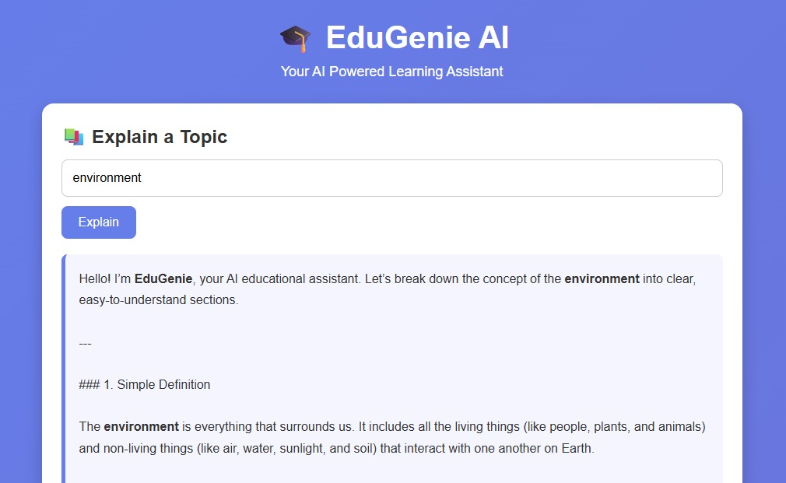
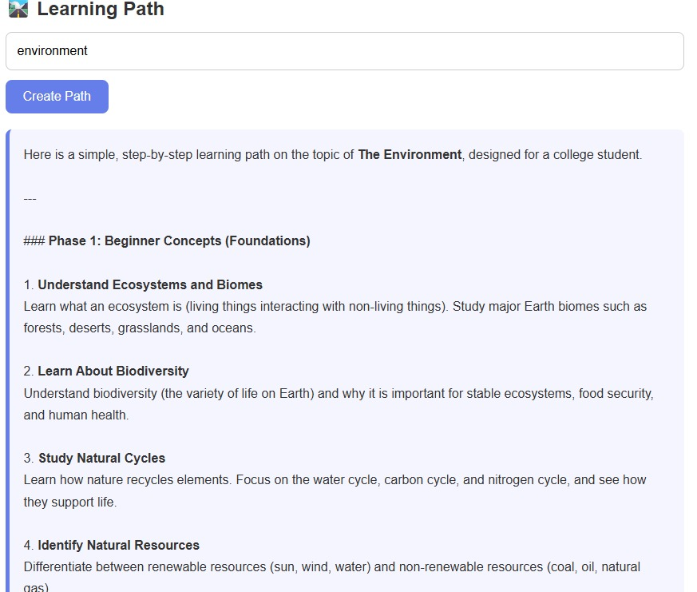
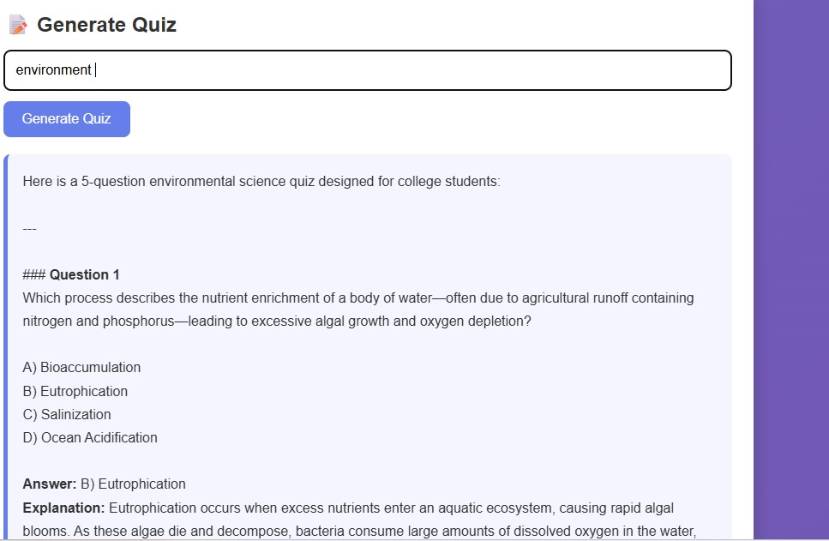
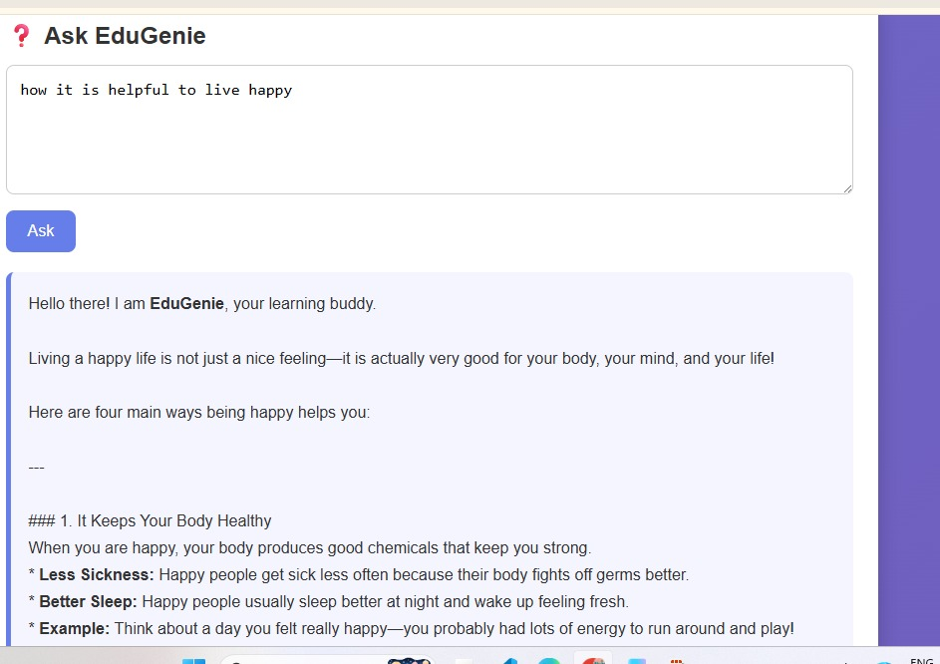
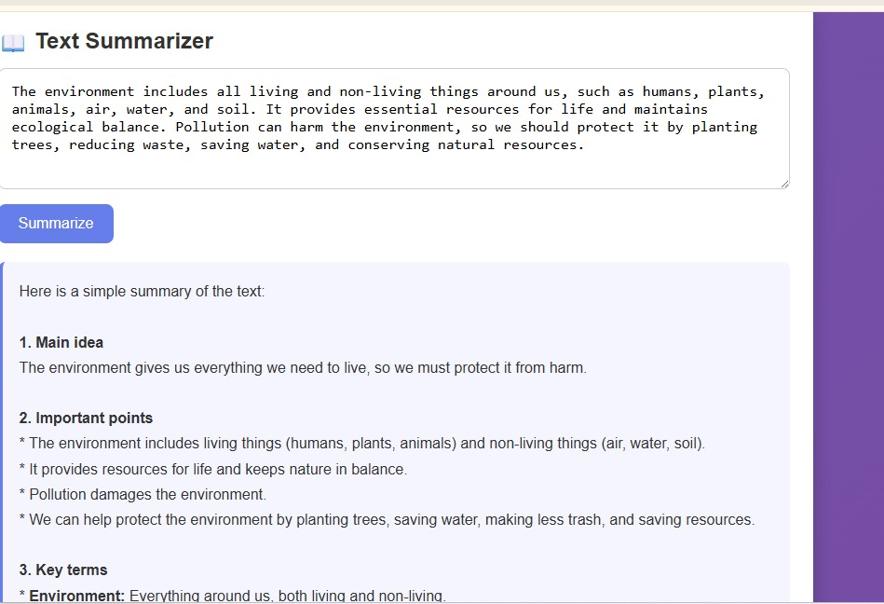
Project URL: http://127.0.0.1:5000/

11. Advantages
- Easy-to-use student interface.
- Multiple learning tools in one application.
- AI-generated explanations and practice content.
- Supports beginner, intermediate, and advanced learning levels.
- Useful for revision and self-learning.
- Responsive design suitable for different screen sizes.

12. Future Enhancements
- Student login and profile management.
- Progress tracking and learning history.
- Score dashboard for quizzes.
- Database integration.
- PDF/notes upload and document-based question answering.
- Voice-based questions and answers.
- Teacher/admin dashboard.
- Deployment to a public cloud server.

13. Conclusion
EduGenie AI combines a simple web interface with generative AI to create a personalized learning assistant. It can support students with explanations, question answering, quizzes, summaries, and structured learning paths. The modular Python design also makes the project easy to extend with additional educational features in the future.

