**Ajuwaya Connect**

**Installation**

1. Clone the project from <https://github.com/Ajuwaya-Connect/social-platform/tree/ajuwaya-module>
2. Run npm install
3. Run webpack –watch (To watch files and auto compile JS files)
4. If you have an error using the webpack commands. Install webpack globally by using (npm install webpack webpack-cli -g)
5. If you encounter security error in this webpack commands. Run (Set-ExecutionPolicy RemoteSigned) using PowerShell CMD
6. 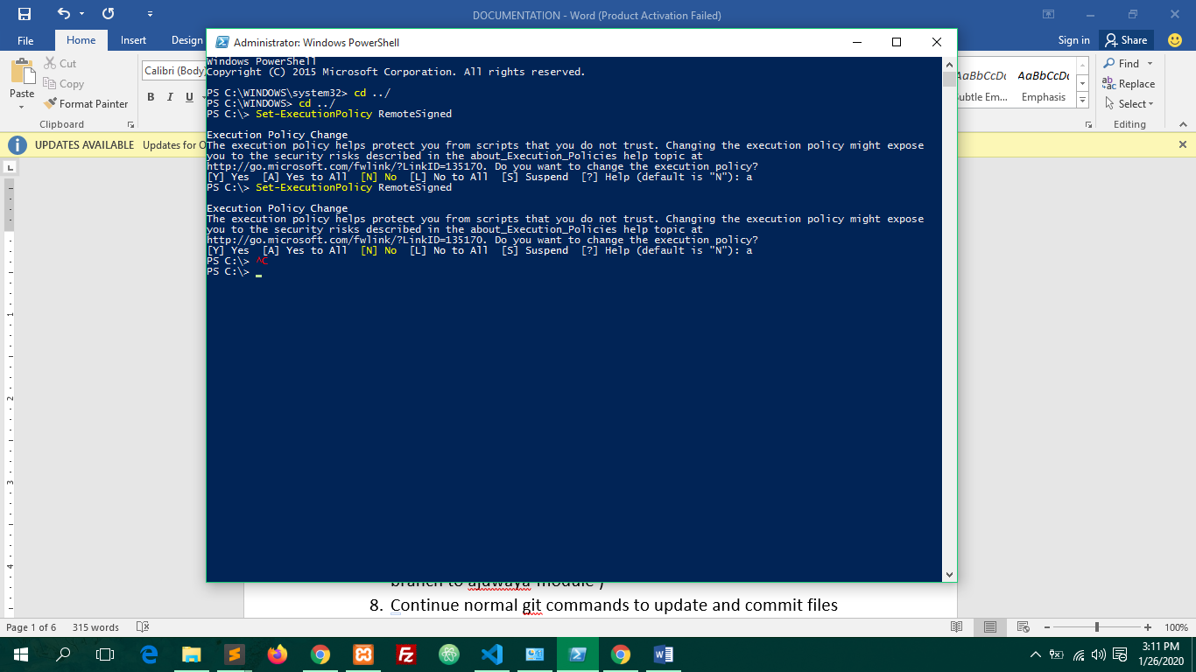
7. Initialize the git repository to the project on your local storage (<https://github.com/Ajuwaya-Connect/social-platform.git>)
8. Run git checkout –b ajuwaya-module ( To change from Master branch to ajuwaya-module )
9. Continue normal git commands to update and commit files

**Run**

1. Start your localhost server
2. Open the project on your editor ( Visual Study Code ) is recommended

**Structure**

1. **Front-end Developers**

The most targeted directore for front-end development are *src, public and build.*

1. Src folder: directory for Js Components. This is the targeted folder for webpack and babel for compiling.
2. Public folder: this is the directory for creating new pages
3. Build folder: This is the directory webpack push the compile file to and it is named app.bundle.js

**Note:** All the JavaScript components will be compiled to app.bundle.js and you can reference it in html tags by embedding

<script src="<?php echo BASE_URL ?>build/app.bundle.js"></script>

Also, always include

<footer ajuwaya-target="limit">

        <input type="hidden" id="BASE_URL" value="<?php echo BASE_URL ?>" />

        <input type="hidden" id="uid" value="<?php echo $this->sessionUid ?>"/>

        <input type="hidden" id="username" value="<?php echo $this->sessionUsername; ?>"/>

        <input type="hidden" id="name" value="<?php echo $this->sessionName; ?>"/>

        <input type="hidden" id="token" value="<?php echo $this->sessionToken; ?>"/>

        <input type="hidden" id="public_username" value="<?php echo $this->public_username; ?>" />

    </footer>

Before embedding app.bundle.js. This help in targeting Session User Id, Username, Session Token in JavaScript especially when calling api.

**How to create New Page**

To create new page. Open Public folder and the a folder and name the folder as the new page then create index.php in the folder.

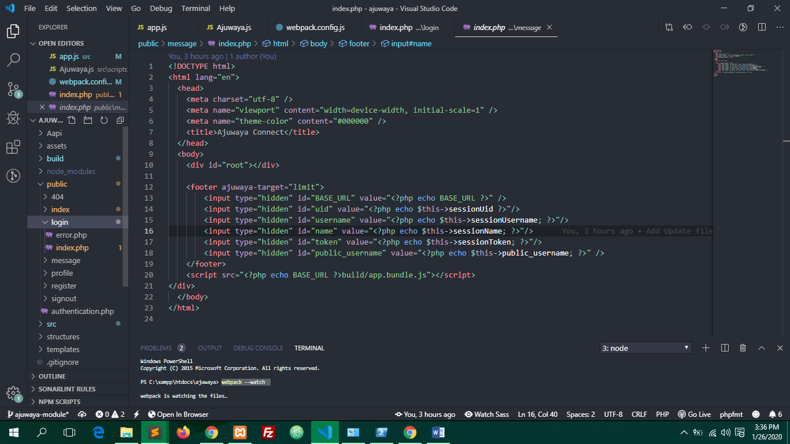

**How to create a Query Page**

Example: ajuwayaconnect.com/login/error

Create the query page in the main page folder



Then, Open PagesControl.php files in the root directory and add page Controller to the query page. To add Page Controller to query page, create a method and name it **pagename_queryname**

Example:

public function login_error($param1 = null, $param2 = null,$param3 = null){

        $this->view->render($this->PageName.'/error');

    }