eBankPlus
eBusiness Plus Back-Office Web Application
ADMINISTRATOR MANUAL
Item | Detail
Document | eBankPlus Administrator Manual
Version | 1.0
Date | November 2026
Application build | Branch ebizWorkingBr, run locally (http://localhost:8080)
Audience | System administrators (users with access to the Administration menu)

Contents

Right-click the table of contents and choose Update Field (or press F9) to refresh the page numbers.

1. Introduction

1.1 Purpose
This manual is for the people who administer eBankPlus (eBusiness Plus). It covers only the Administration menu: fees and terminals, transaction profiles, back-office users and roles, customer profiles and channels, online and customer account policies, security questions, billers and corporate customers. Day-to-day operations (cards, approvals, broadcasts, direct debit, reports) are covered in the eBankPlus User Manual.

1.2 Before you start
- You need a back-office user whose role includes the Administration menu items you will use (Administration > Roles & Permissions).
- Sign in on the sign-in page with your username, password and branch. Open Menu and click Administration to expand it.
- Several changes are maker-checker: what you capture here must be approved by a different authorised user under the Approval menu.
- Customer data in the screenshots is blurred.

1.3 How this manual is organised
Chapter 2 groups the administration tasks by what you want to achieve and explains the main life cycles (back-office users, customer profiles, policies). Chapter 3 describes every Administration screen in menu order: menu path, purpose, screenshot, fields, buttons and step-by-step instructions. The appendices give good-practice checklists and an index of the Administration menu.

1.4 Conventions
Convention | Meaning
Menu > Administration > Item | The path to open a screen from the main menu.
Field name * | A required field.
Note | Important information or a rule enforced by the system.
Blurred areas | Customer data hidden in screenshots for privacy.

2. Administration at a glance
The Administration menu has 17 screens. Use this table to find the one you need.
I want to… | Screen (Menu > Administration > …)
Create, change or disable a back-office user; set limits and roles | User Profile
Unlock a user or clear a stuck logon | Reset User Profile
Create a role and choose the screens it can use | Roles & Permissions
Create eTeller users and their limits | Setup eTeller Profile
Activate or deactivate customers and their channels | Profile Activation
Clear a customer’s device binding or security questions | Profile Maintenance
Link a mobile number to an account for USSD | USSD Onboarding
Change bank-wide limits (withdrawals, NIP transfers, hours) | Online Policy
Give one customer a different limit | Customer Account Policy (then Approval > Approve Account Policy)
Maintain the security questions customers choose from | Setup Application Security Questions
Set fees and rates by amount band | Setup Fees
Register a POS or ATM terminal | Terminal Registration
Link accounts to a funds-transfer description and type | Setup Transaction Profile
Add billers and their products for bill payments | Setup Biller, Setup Biller Product
Set up corporate internet-banking customers and their users | Setup Corporate Organization, Setup Corporate User Profile

2.1 Back-office user life cycle
- Create the roles first (Roles & Permissions): a role ID, description and the menu items and actions it may use.
- Create the user (User Profile): user ID, full names, permissions (amend, review, approve), data-posting and approval limits, and role memberships. Tellers are set up under Setup eTeller Profile instead.
- The user signs in with the username, password and branch.
- If the user is locked out or a logon is stuck, use Reset User Profile and choose the right reset option.
- When the user leaves or changes job, tick Disable user account on User Profile, or change the roles. Do not reuse user IDs.

2.2 Customer profile life cycle
- Customers register on the online, mobile or USSD channels; USSD customers can also be onboarded by staff (USSD Onboarding).
- New self-registrations are activated under eChannels Management > eChannels Activation; existing profiles are activated or deactivated, with their channels, under Profile Activation.
- When a customer changes phone or forgets security answers, use Profile Maintenance to clear the device binding or security questions (a reason is required).
- Deactivation always needs a reason, which is kept in the audit log.

2.3 Policies and approvals
- Online Policy holds the bank-wide values and takes effect when saved.
- Customer Account Policy captures a request for one account; it only applies after a second user approves it under Approval > Approve Account Policy.
- Fees (Setup Fees) apply to every transaction in the amount band; check bands do not overlap.

3. Administration
Set-up and maintenance screens for fees, terminals, users, roles, customer profiles, policies, security questions, billers and corporate customers. Usually restricted to administrators.

3.1 Setup Fees
Menu path: Menu > Administration > Setup Fees
Purpose: Sets up the rate and fee charged for each transaction amount range (charge setup).
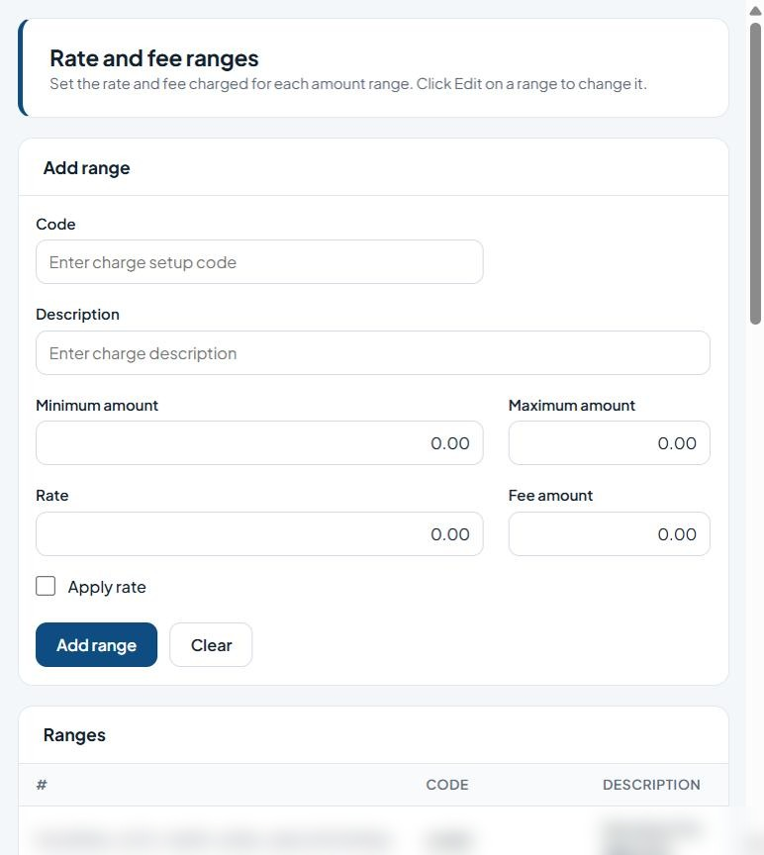
Figure 1: Rate and fee ranges

Fields
Field | Type | Description
Code | Text | Unique code/identifier.
Description | Text | Free-text description.
Minimum amount | Text | Amount in Naira (NGN).
Maximum amount | Text | Amount in Naira (NGN).
Rate | Text | Percentage rate.
Fee amount | Text | Amount in Naira (NGN).
Apply rate | Tick box | Percentage rate.
List columns: #, Code, Description, Minimum amount, Maximum amount, Rate, Fee amount, Apply.

Buttons and actions
Button | What it does
Add range | Save the new fee range.
Clear | Clear the form without saving.

How to use this screen
- Enter a Code and Description for the charge range.
- Enter the Minimum amount and Maximum amount the range covers.
- Enter the Rate and/or the flat Fee amount.
- Tick Apply rate if the percentage rate should be applied (otherwise the fee amount is used).
- Click Add range. The range appears in the Ranges list.
- To change a range, click Edit on its row, update the values and save. Click Clear to empty the form.

3.2 Terminal Registration
Menu path: Menu > Administration > Terminal Registration
Purpose: Registers POS and ATM terminals and links them to a customer account and branch.
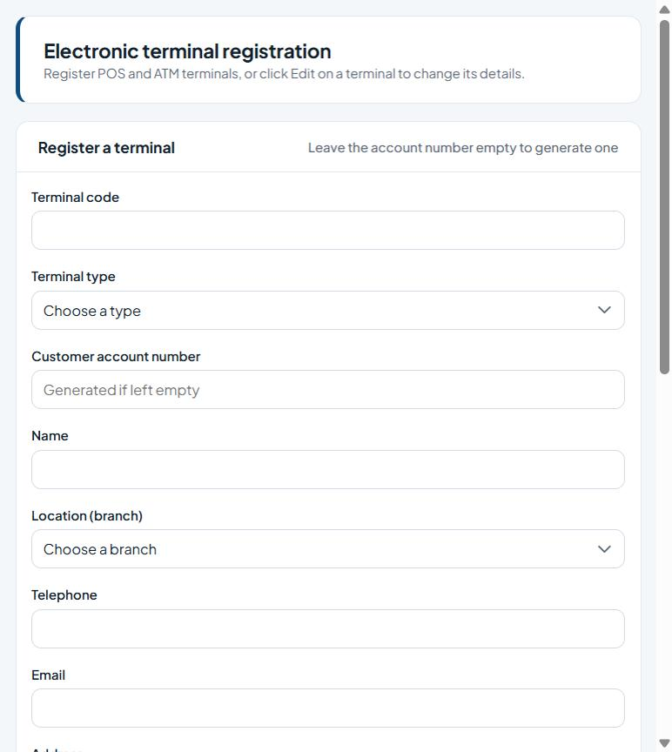
Figure 2: Terminal registration

Fields
Field | Type | Description
Terminal code | Text | Unique code/identifier.
Terminal type | Drop-down list | Choose the type from the list.
Customer account number | Text | The customer account number (validated against the core banking system).
Name | Text | Name to record.
Location (branch) | Drop-down list | The bank branch.
Telephone | Phone number | Contact phone number.
Email | E-mail address | Contact e-mail address.
Address | Text | Enter the address.
Terminal IP | Text | Enter the terminal IP.
Relationship officer | Text | Enter the relationship officer.
List columns: Terminal code, Type, Name, Account no, Balance, Branch, Telephone, Status.

Buttons and actions
Button | What it does
Register terminal | Save the new terminal.
Clear | Clear the form without saving.

How to use this screen
- Enter the Terminal code and choose the Terminal type (POS or ATM).
- Enter the Customer account number, or leave it empty to have one generated.
- Enter the terminal Name and choose the Location (branch).
- Enter Telephone, Email, Address, Terminal IP and the Relationship officer.
- Click Register terminal. The terminal appears in the Terminals list.
- To change a terminal, click Edit on its row.

3.3 Setup Transaction Profile
Menu path: Menu > Administration > Setup Transaction Profile
Purpose: Links accounts to a transaction description and type (Credit or Debit) for funds-transfer processing.
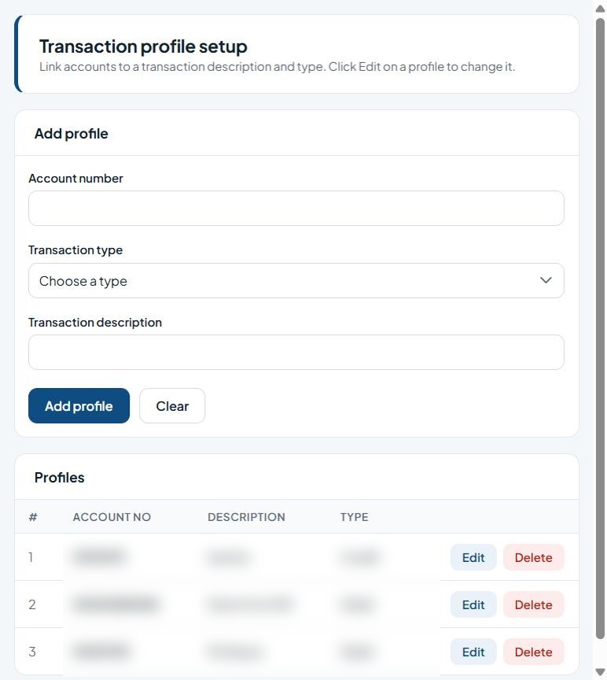
Figure 3: Transaction profile setup

Fields
Field | Type | Description
Account number | Text | The customer account number (validated against the core banking system).
Transaction type | Drop-down list | Choose the type from the list.
Transaction description | Text | Free-text description.
List columns: #, Account no, Description, Type.

Buttons and actions
Button | What it does
Add profile | Save the new transaction profile.
Clear | Clear the form without saving.
Edit | Edit the row.
Delete | Delete the record (cannot be undone).

How to use this screen
- Enter the Account number.
- Choose the Transaction type (Credit or Debit).
- Enter the Transaction description.
- Click Add profile.
- Use Edit or Delete on a row in the Profiles list to change or remove a profile.

3.4 USSD Onboarding
Menu path: Menu > Administration > USSD Onboarding
Purpose: Creates, updates or deletes a customer's USSD profile by linking a mobile number (MSISDN) to an account.
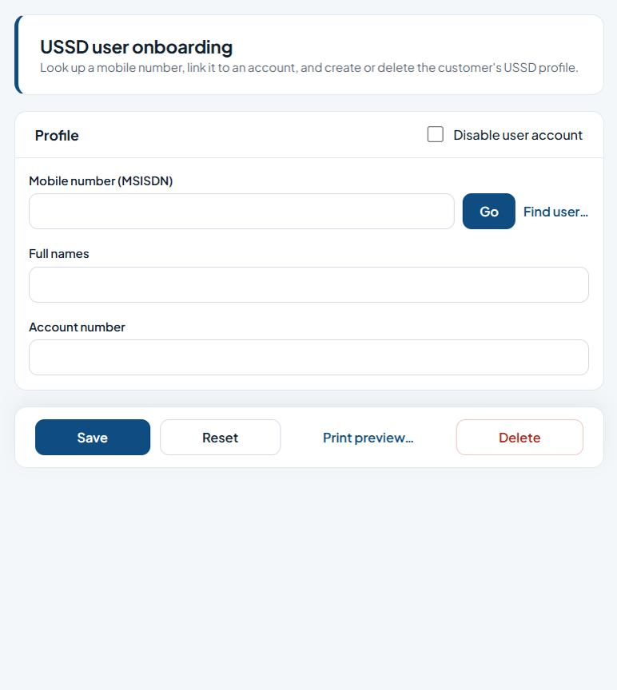
Figure 4: USSD user onboarding

Fields
Field | Type | Description
Disable user account | Tick box | Tick to block the account from signing in.
Mobile number (MSISDN) | Text | Customer's mobile number in international format.
Full names | Text | The person's full name.
Account number | Text | The customer account number (validated against the core banking system).

Buttons and actions
Button | What it does
Go | Load the record for the ID entered.
Find user… | Search for a user.
Save | Save the changes.
Reset | Clear the form, or apply the chosen reset to the ticked users.
Print preview… | Preview a printable copy.
Delete | Delete the record (cannot be undone).

How to use this screen
- Enter the customer's Mobile number (MSISDN) and click Go, or click Find user… to search.
- Check or enter the Full names and Account number.
- Tick Disable user account only if the USSD profile should be blocked.
- Click Save to create or update the profile.
- Use Delete to remove the profile, Reset to clear the form, or Print preview… to print it.

3.5 Profile Maintenance
Menu path: Menu > Administration > Profile Maintenance
Purpose: Maintains existing customer (internet/mobile/USSD) profiles: clears device bindings or security questions and sets eToken and channel options.
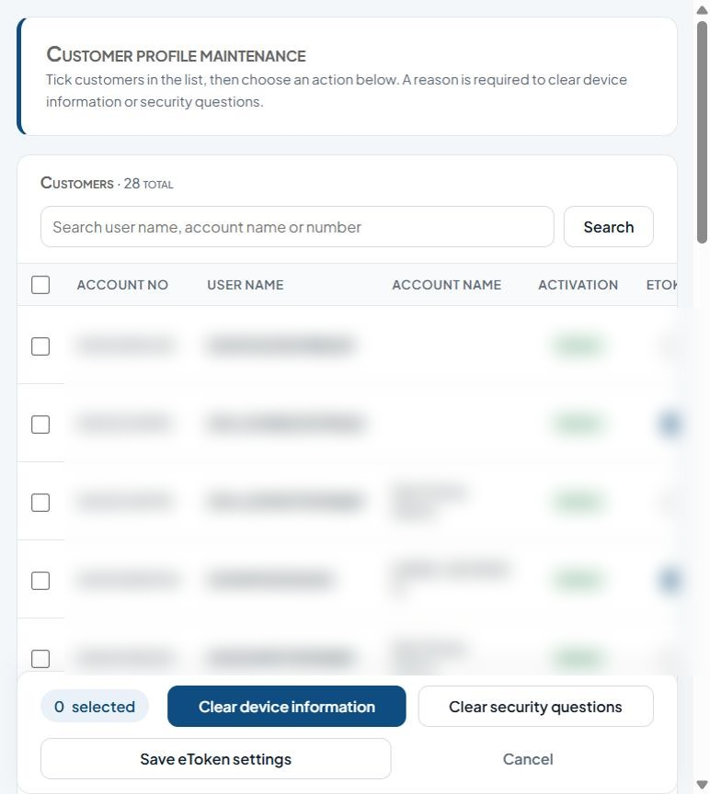
Figure 5: Customer profile maintenance

Fields
Field | Type | Description
Search user name, account name or number | Text | Text to search for.
Select (per customer) | Tick box | Tick to include the row(s) in the next action.
eToken / Mobile / iPortal / USSD (per customer) | Tick box | Tick to enable.
Reason (to deactivate or clear questions) | Multi-line text | Explanation for the action; required when rejecting, disapproving, deactivating or clearing settings.
List columns: Account no, User name, Account name, Activation, Etoken, Registration phone, Registration address, Mobile, Iportal, Ussd, Reason.

Buttons and actions
Button | What it does
Search | Run the search.
Clear device information | Unbind the ticked customers' registered devices (reason required).
Clear security questions | Make the ticked customers set new security questions (reason required).
Save eToken settings | Save the eToken and channel tick boxes for the listed customers.
Cancel | Discard and clear the selection.

How to use this screen
- Type a user name, account name or account number and click Search.
- Tick the customer(s) to work on.
- Enter a Reason in the row. A reason is required to clear device information or security questions.
- Click Clear device information to unbind the customer's device, or Clear security questions to make them set new ones.
- Tick or untick eToken, Mobile, iPortal and USSD for each customer and click Save eToken settings to save channel settings.
- Click Cancel to discard.

3.6 User Profile
Menu path: Menu > Administration > User Profile
Purpose: Creates and maintains back-office user accounts: permissions, data-posting limits, approval limits and role memberships.
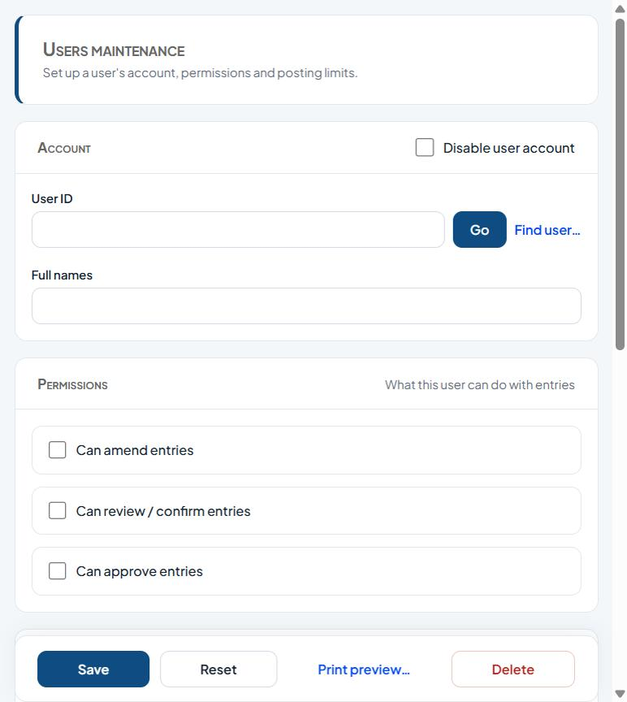
Figure 6: Users maintenance

Fields
Field | Type | Description
Disable user account | Tick box | Tick to block the account from signing in.
User ID | Text | The user's login ID. Click Go to load an existing user.
Full names | Text | The person's full name.
Can amend entries | Tick box | Permission granted to the user.
Can review / confirm entries | Tick box | Permission granted to the user.
Can approve entries | Tick box | Permission granted to the user.
Data posting limits - Cash receipts / Cash payments / Non-cash payments (minimum, maximum, ceiling) | Text | Amount limits per transaction category.
Posting approval limits - Cash receipts / Cash payments / Non-cash payments (minimum, maximum) | Text | Amount limits per transaction category.

Buttons and actions
Button | What it does
Go | Load the record for the ID entered.
Find user… | Search for a user.
Save | Save the changes.
Reset | Clear the form, or apply the chosen reset to the ticked users.
Print preview… | Preview a printable copy.
Delete | Delete the record (cannot be undone).

How to use this screen
- Enter the User ID and click Go, or click Find user… to search.
- Enter or check the Full names. Tick Disable user account to block the user.
- Under Permissions, tick what the user may do: amend, review/confirm, or approve entries.
- Under Data posting limits, enter the minimum, maximum and ceiling amounts for cash receipts, cash payments and non-cash payments.
- Under Posting approval limits, enter the minimum and maximum approval amounts.
- Under Memberships, assign the user's role(s).
- Click Save. Use Reset to clear, Delete to remove the user, or Print preview… to print.

3.7 Profile Activation
Menu path: Menu > Administration > Profile Activation
Purpose: Activates or deactivates customer profiles and sets the channels (eToken, Mobile, iPortal, USSD) each customer can use.
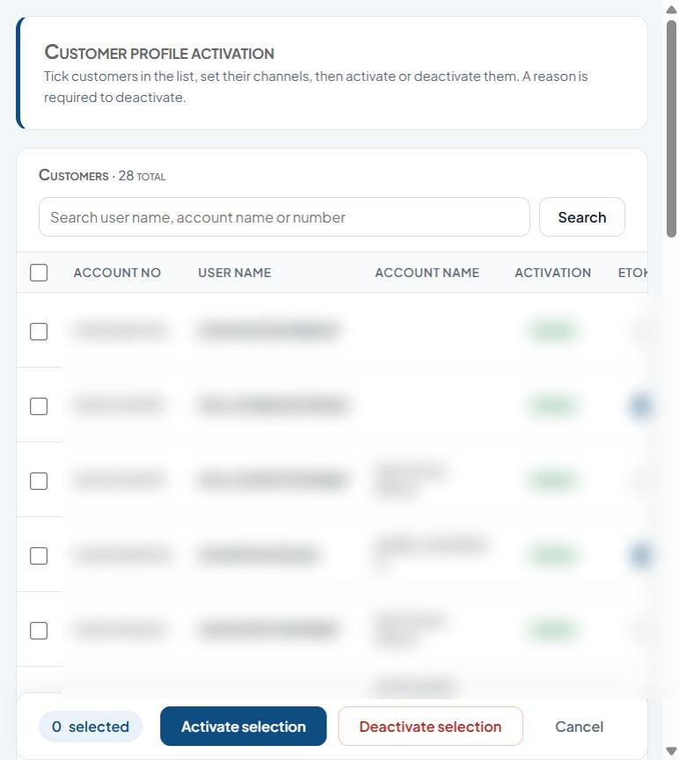
Figure 7: Customer profile activation

Fields
Field | Type | Description
Search user name, account name or number | Text | Text to search for.
Select (per customer) | Tick box | Tick to include the row(s) in the next action.
Active / eToken / Mobile / iPortal / USSD (per customer) | Tick box | Tick to enable.
Reason (required to deactivate) | Multi-line text | Explanation for the action; required when rejecting, disapproving, deactivating or clearing settings.
List columns: Account no, User name, Account name, Activation, Etoken, Registration phone, Registration address, Mobile, Iportal, Ussd, Reason.

Buttons and actions
Button | What it does
Search | Run the search.
Activate selection | Activate the ticked items.
Deactivate selection | Deactivate the ticked customers (reason required).
Cancel | Discard and clear the selection.

How to use this screen
- Search by user name, account name or number.
- Tick the customer(s) and set their channel tick boxes.
- Click Activate selection to activate them.
- To deactivate, enter a Reason on each row (required) and click Deactivate selection.
- Click Cancel to discard.

3.8 Online Policy
Menu path: Menu > Administration > Online Policy
Purpose: Bank-wide (general) online policies, such as the maximum withdrawal per week, non-working hours per day, and NIP local and inter-bank transfer limits.
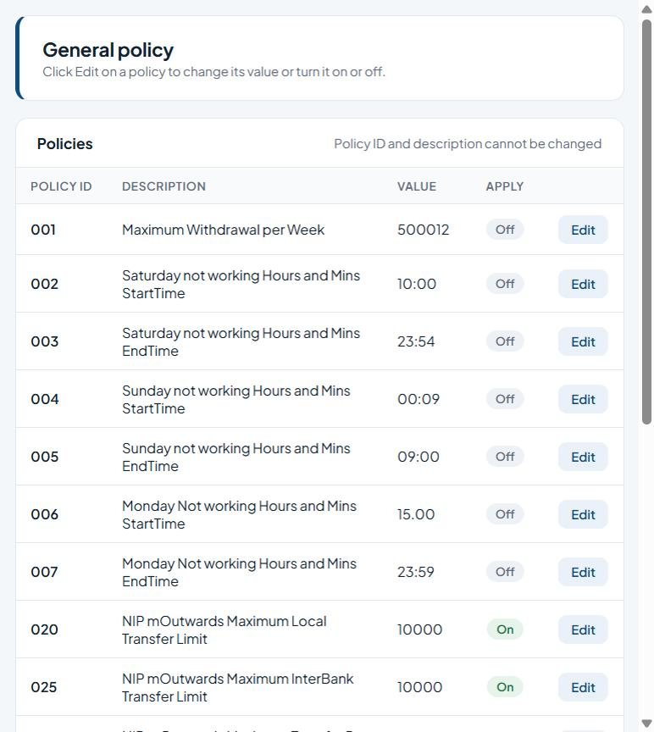
Figure 8: General policy
List columns: Policy id, Description, Value, Apply.

Buttons and actions
Button | What it does
Edit | Edit the row.

How to use this screen
- Find the policy in the Policies list (Policy ID, Description, Value, Apply).
- Click Edit on its row.
- Change the Value and/or switch Apply on or off. Policy ID and description cannot be changed.
- Save the change.
Note: Policy ID and description cannot be changed; click Edit to change a policy's value or turn it on/off (e.g. weekly withdrawal limit, non-working hours, NIP transfer limits).

3.9 Customer Account Policy
Menu path: Menu > Administration > Customer Account Policy
Purpose: Requests a customer-specific policy (for example a higher transfer limit) for an account. Requests go for approval under Approval > Approve Account Policy.
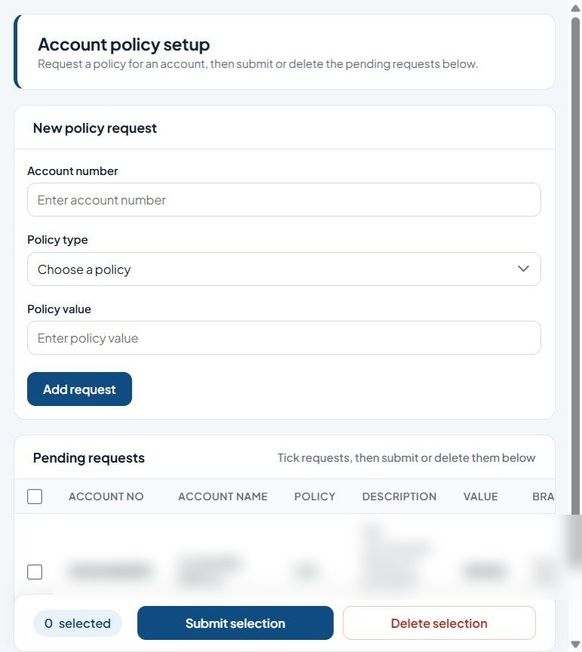
Figure 9: Account policy setup

Fields
Field | Type | Description
Account number | Text | The customer account number (validated against the core banking system).
Policy type | Drop-down list | The policy to apply.
Policy value | Text | The value for the policy (e.g. limit amount).
Select (per request) | Tick box | Tick to include the row(s) in the next action.
List columns: Account no, Account name, Policy, Description, Value, Branch, Requested.

Buttons and actions
Button | What it does
Add request | Add the request to the pending list.
Submit selection | Send the ticked items for approval.
Delete selection | Remove the ticked items.

How to use this screen
- Enter the Account number.
- Choose the Policy type and enter the Policy value.
- Click Add request. It appears under Pending requests.
- Tick the requests to send and click Submit selection to send them for approval, or Delete selection to remove them.

3.10 Roles & Permissions
Menu path: Menu > Administration > Roles & Permissions
Purpose: Creates and maintains user roles and the screens/actions each role is allowed to use.
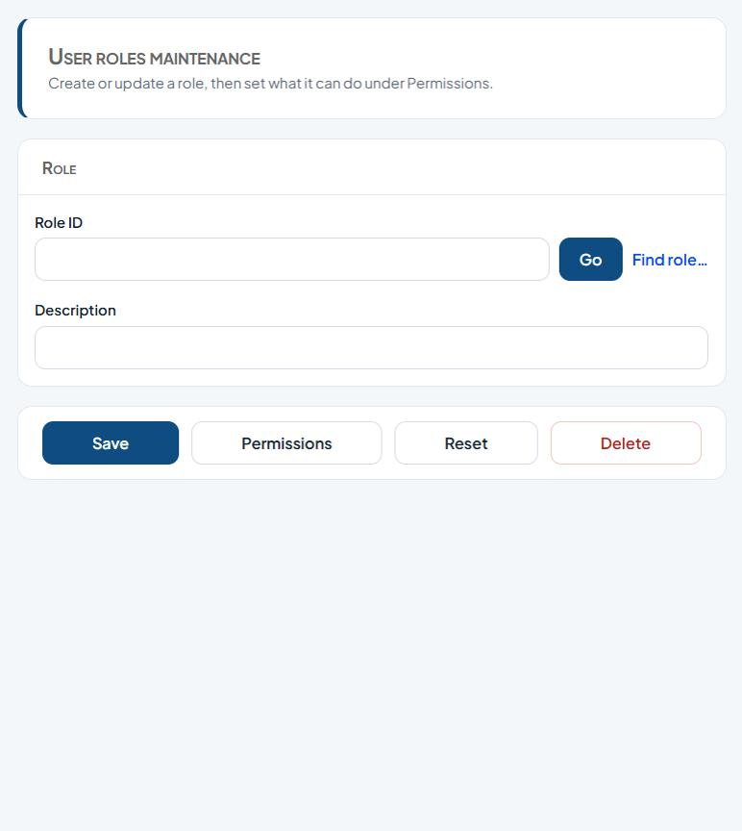
Figure 10: User roles maintenance

Fields
Field | Type | Description
Role ID | Text | Enter the role ID.
Description | Text | Free-text description.

Buttons and actions
Button | What it does
Go | Load the record for the ID entered.
Find role… | Search for a role.
Save | Save the changes.
Permissions | Set what the role can access.
Reset | Clear the form, or apply the chosen reset to the ticked users.
Delete | Delete the record (cannot be undone).

How to use this screen
- Enter a Role ID and click Go, or use Find role… to search.
- Enter the Description.
- Click Save.
- Click Permissions to choose the menu items and actions the role can access, then save.
- Use Delete to remove a role or Reset to clear the form.

3.11 Reset User Profile
Menu path: Menu > Administration > Reset User Profile
Purpose: Resets locked or disabled back-office users and clears logon problems.
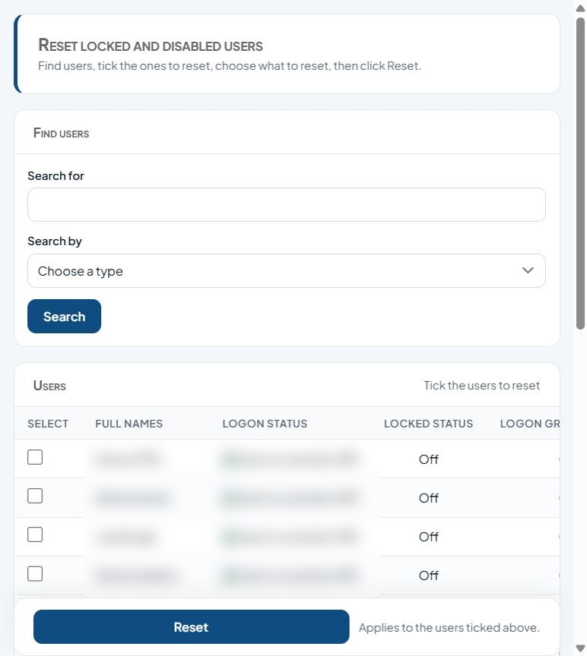
Figure 11: Reset locked and disabled users

Fields
Field | Type | Description
Search for | Text | Text to search for.
Search by | Drop-down list | Text to search for.
Select (per user) | Tick box | Tick to include the row(s) in the next action.
Reset locked users only | Tick box | Tick to enable.
Clear user from logon log | Tick box | Tick to enable.
Reset locked and disabled users | Tick box | Tick to enable.
Reset all | Tick box | Tick to enable.
Reset user's password only | Tick box | Tick to enable.
List columns: Select, Full names, Logon status, Locked status, Logon group.

Buttons and actions
Button | What it does
Search | Run the search.
Reset | Clear the form, or apply the chosen reset to the ticked users.

How to use this screen
- Enter a search value in Search for and choose Search by, then click Search.
- Tick the user(s) in the Users list.
- Under What to reset, choose one option: reset locked users only; clear user from logon log; reset locked and disabled users; reset all; or reset the user's password only.
- Click Reset. The action applies to all ticked users.

3.12 Setup Application Security Questions
Menu path: Menu > Administration > Setup Application Security Questions
Purpose: Maintains the list of security questions customers choose from when they set up their profile.
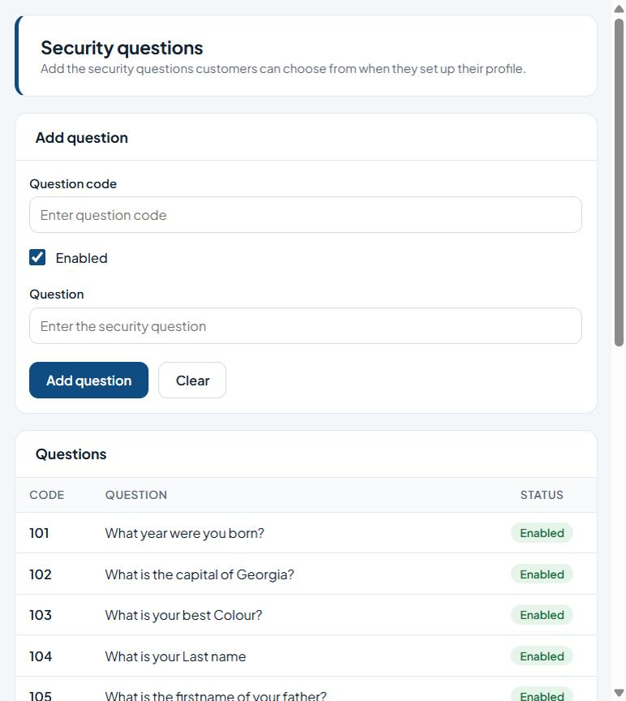
Figure 12: Security questions

Fields
Field | Type | Description
Question code | Text | Unique code/identifier.
Enabled | Tick box | Tick to enable.
Question | Text | Enter the question.
List columns: Code, Question, Status.

Buttons and actions
Button | What it does
Add question | Save the new security question.
Clear | Clear the form without saving.

How to use this screen
- Enter a Question code.
- Type the Question.
- Leave Enabled ticked so customers can choose it.
- Click Add question. It appears in the Questions list with its status.

3.13 Setup Biller
Menu path: Menu > Administration > Setup Biller
Purpose: Sets up billers (for example airtime, data, utilities) within a biller category for bill payments.
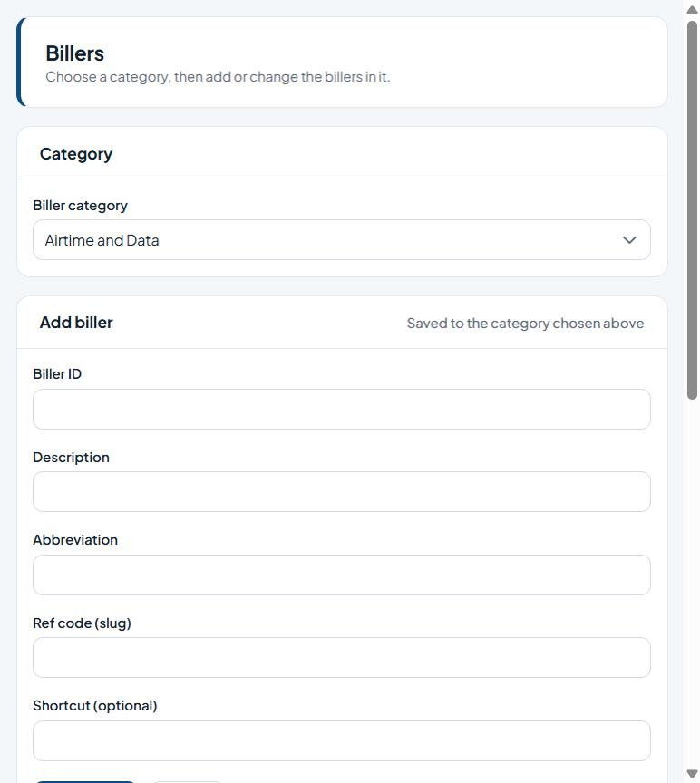
Figure 13: Billers

Fields
Field | Type | Description
Biller category | Drop-down list | Choose a value from the list.
Biller ID | Text | Enter the biller ID.
Description | Text | Free-text description.
Abbreviation | Text | Enter the abbreviation.
Ref code (slug) | Text | Enter the ref code (slug).
Shortcut (optional) | Text | Enter the shortcut (optional).
List columns: Biller id, Description, Abbreviation, Ref code, Category, Shortcut.

Buttons and actions
Button | What it does
Add biller | Save the new biller.
Clear | Clear the form without saving.

How to use this screen
- Choose the Biller category.
- Enter Biller ID, Description, Abbreviation, Ref code (slug) and, optionally, a Shortcut.
- Click Add biller. The biller is saved to the chosen category and appears under Billers in this category.
- Click Clear to empty the form.

3.14 Setup Biller Product
Menu path: Menu > Administration > Setup Biller Product
Purpose: Maintains the products (packages and price plans) offered by each biller.
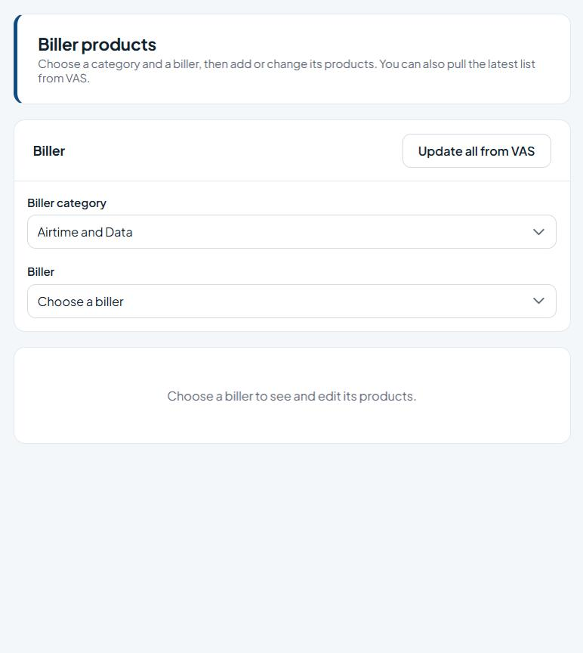
Figure 14: Biller products

Fields
Field | Type | Description
Biller category | Drop-down list | Choose a value from the list.
Biller | Drop-down list | Choose a value from the list.

Buttons and actions
Button | What it does
Update all from VAS | Download the latest products for all billers from the VAS provider.

How to use this screen
- Choose the Biller category, then the Biller.
- The biller's products are listed. Add or edit them as needed.
- Click Update all from VAS to pull the latest product list from the VAS provider.
Note: Choose a category and a biller to see and edit its products; Update all from VAS pulls the latest product list.

3.15 Setup Corporate Organization
Menu path: Menu > Administration > Setup Corporate Organization
Purpose: Sets up corporate organisations (corporate internet-banking customers) and their main account.
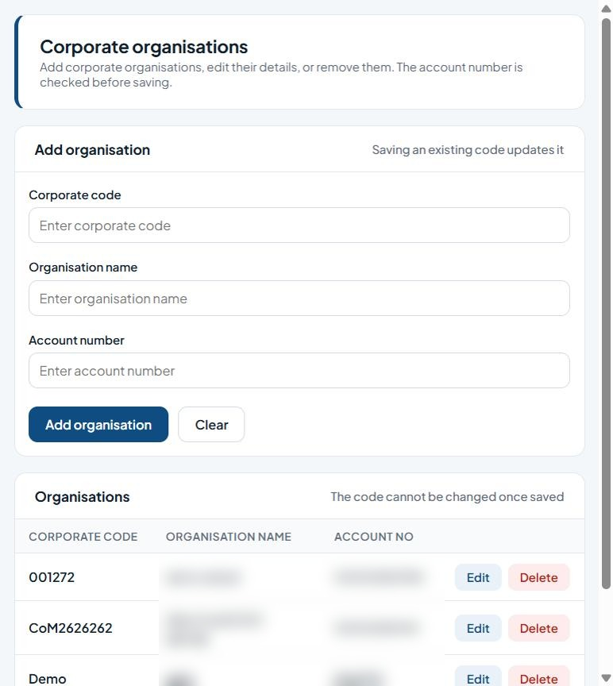
Figure 15: Corporate organisations

Fields
Field | Type | Description
Corporate code | Text | Unique code/identifier.
Organisation name | Text | Name to record.
Account number | Text | The customer account number (validated against the core banking system).
List columns: Corporate code, Organisation name, Account no.

Buttons and actions
Button | What it does
Add organisation | Save the organisation (updates it if the code exists).
Clear | Clear the form without saving.
Edit | Edit the row.
Delete | Delete the record (cannot be undone).

How to use this screen
- Enter the Corporate code, Organisation name and Account number.
- Click Add organisation. The account number is checked before saving.
- Saving an existing code updates that organisation. The code cannot be changed once saved.
- Use Edit or Delete on a row in the Organisations list.
Note: The account number is checked before saving. Saving an existing code updates it; the code cannot be changed once saved.

3.16 Setup Corporate User Profile
Menu path: Menu > Administration > Setup Corporate User Profile
Purpose: Creates and maintains users for corporate organisations, with their posting and approval rights.
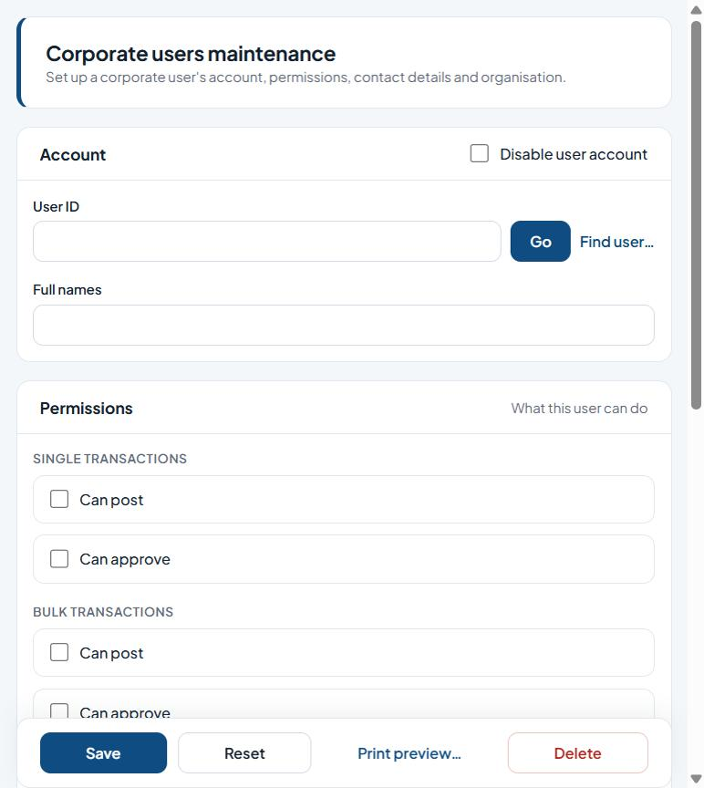
Figure 16: Corporate users maintenance

Fields
Field | Type | Description
Disable user account | Tick box | Tick to block the account from signing in.
User ID | Text | The user's login ID. Click Go to load an existing user.
Full names | Text | The person's full name.
Single transactions - Can post / Can approve | Tick box | Tick to enable.
Bulk transactions - Can post / Can approve | Tick box | Tick to enable.
Can view balance | Tick box | Permission granted to the user.
Is approving officer | Tick box | Permission granted to the user.
Can view status | Tick box | Permission granted to the user.
Contact phone number | Phone number | Contact phone number.
Contact email | E-mail address | Contact e-mail address.
Organisation name | Drop-down list | Name to record.

Buttons and actions
Button | What it does
Go | Load the record for the ID entered.
Find user… | Search for a user.
Save | Save the changes.
Reset | Clear the form, or apply the chosen reset to the ticked users.
Print preview… | Preview a printable copy.
Delete | Delete the record (cannot be undone).

How to use this screen
- Enter the User ID and click Go (or Find user…). Enter the Full names.
- Under Permissions, tick Can post / Can approve for single and bulk transactions, plus Can view balance, Is approving officer and Can view status as needed.
- Enter the Contact phone number and email and choose the Organisation name.
- Assign memberships and click Save.

3.17 Setup eTeller Profile
Menu path: Menu > Administration > Setup eTeller Profile
Purpose: Creates and maintains eTeller users: their teller account, permissions and posting/approval limits.
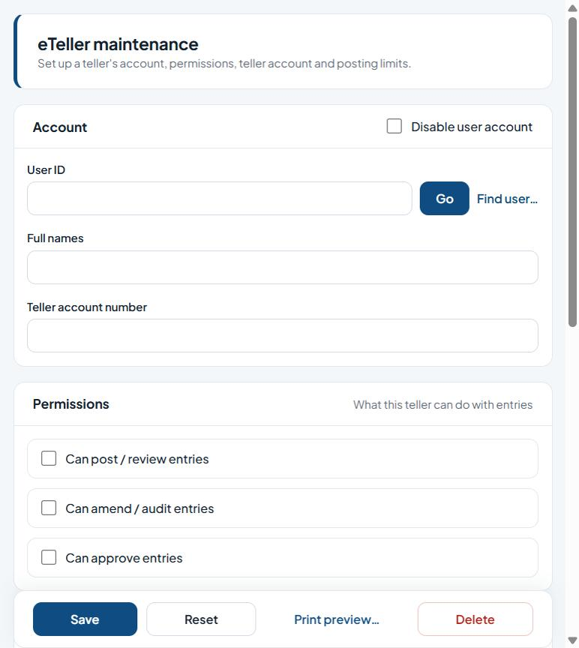
Figure 17: eTeller maintenance

Fields
Field | Type | Description
Disable user account | Tick box | Tick to block the account from signing in.
User ID | Text | The user's login ID. Click Go to load an existing user.
Full names | Text | The person's full name.
Teller account number | Text | Enter the teller account number.
Can post / review entries | Tick box | Permission granted to the user.
Can amend / audit entries | Tick box | Permission granted to the user.
Can approve entries | Tick box | Permission granted to the user.
Data posting limits - Cash receipts / Cash payments / Non-cash payments (minimum, maximum, ceiling) | Text | Amount limits per transaction category.
Posting approval limits - Cash receipts / Cash payments / Non-cash payments (minimum, maximum) | Text | Amount limits per transaction category.

Buttons and actions
Button | What it does
Go | Load the record for the ID entered.
Find user… | Search for a user.
Save | Save the changes.
Reset | Clear the form, or apply the chosen reset to the ticked users.
Print preview… | Preview a printable copy.
Delete | Delete the record (cannot be undone).

How to use this screen
- Enter the User ID and click Go (or Find user…). Enter the Full names and Teller account number.
- Tick permissions: post/review, amend/audit, approve entries.
- Enter the data posting limits and posting approval limits.
- Assign memberships and click Save.

Appendix A. Good practice for administrators

A.1 Users and roles
- Give each person their own user ID; never share IDs.
- Grant the smallest set of roles a person needs; review role memberships regularly.
- The person who captures a change (maker) must not be the one who approves it (checker). Do not give one user both permissions for the same work.
- Set approval limits deliberately; a zero limit means the user cannot approve that category.
- Disable users promptly when they leave.

A.2 Customer profiles and policies
- Always enter a clear reason when deactivating a customer or clearing devices or security questions; the reason is audited.
- Confirm the customer's identity before clearing a device binding.
- Check bank-wide policy changes with operations before saving; they affect every customer at once.

A.3 Audit
- Back-office user activity: Reports > User AuditLog Reports.
- Customer activity: Reports > Customer AuditLog Reports.
- Activity by users not yet profiled: Reports > Unprofiled User AuditLog Reports.

Appendix B. Administration menu index
Module | Menu item | Page
Administration | Setup Fees | /eOperations/ebankRatesSetup.aspx
Administration | Terminal Registration | /eOperations/TerminalRegForm.aspx
Administration | Setup Transaction Profile | /eOperations/FTTransTypeSetup.aspx
Administration | USSD Onboarding | /Processing/FrmUsersOnboard.aspx
Administration | Profile Maintenance | /Administration/eUserProfileMgt.aspx
Administration | User Profile | /Processing/Frm_Users.aspx
Administration | Profile Activation | /Administration/ActivateProfile.aspx
Administration | Online Policy | /Administration/FrmATMPolicyConsole.aspx
Administration | Customer Account Policy | /Processing/FrmAccountAppPolicy.aspx
Administration | Roles & Permissions | /Processing/Frm_Roles.aspx
Administration | Reset User Profile | /Processing/Frm_UserReset.aspx
Administration | Setup Application Security Questions | /Processing/FrmSecQuestion.aspx
Administration | Setup Biller | /Administration/BillerSetup.aspx
Administration | Setup Biller Product | /Administration/BillerProducts.aspx
Administration | Setup Corporate Organization | /Processing/FrmCorpOrgs.aspx
Administration | Setup Corporate User Profile | /Processing/FrmCorpAppUser.aspx
Administration | Setup eTeller Profile | /Processing/FrmTellerInfo.aspx

Appendix C. About this edition
- Screenshots were taken from the application running locally on branch ebizWorkingBr (http://localhost:8080), signed in as a user with full menu access, in November 2026.
- Customer data is blurred in the screenshots.
- Screens were viewed only: no records were saved, submitted or approved while this manual was prepared.
- For the rest of the application see the eBankPlus User Manual (version 2.0).

