eBankPlus
eBusiness Plus Back-Office Web Application
USER MANUAL
Item | Detail
Document | eBankPlus User Manual
Version | 2.0
Date | November 2026
Application build | Branch ebizWorkingBr, run locally (http://localhost:8080)
Audience | Bank operations staff, approvers and system administrators

Contents

Right-click the table of contents and choose Update Field (or press F9) to refresh the page numbers.

1. Introduction

1.1 Purpose
This manual explains how to use eBankPlus (eBusiness Plus), the bank's back-office web application for managing electronic channels: customer and staff profiles, policies and fees, cards, approvals, bulk notifications, direct debit (NDD), funds transfers, reconciliation and reports.

1.2 Who should use this manual
- Branch and operations staff who raise requests, onboard customers and process cards.
- Supervisors and approvers who authorise requests, payments, mandates and policy changes.
- System administrators who maintain users, roles, policies, fees and billers.

1.3 How this manual is organised
Chapter 2 covers signing in, the dashboard and the menu. Chapter 2 also introduces the new look. Chapters 3 to 13 follow the main menu, one chapter per module. For each screen you will find the menu path, its purpose, a screenshot, the fields and buttons, and step-by-step instructions. The appendices cover common controls, a menu index and notes on this edition.

1.4 Conventions
Convention | Meaning
Menu > Module > Item | The path to open a screen from the main menu.
Bold text | A button, field or menu name as it appears on screen.
Note | Important information or a rule enforced by the system.
Blurred areas | Customer data hidden in screenshots for privacy.

1.5 Maker-checker (approval) workflow
Most changes follow a maker-checker process: one user captures a request (maker) and a different, authorised user approves it (checker) under the Approval menu.
Captured under (maker) | Approved under (checker)
eBranch Management > eChannels Requistion | Approval > Approve eChannels Request
Administration > Customer Account Policy | Approval > Approve Account Policy
eOperations > Bulk FundsTransfer | Approval > Approve Bulk Payments
Card Management > Generate Cards Request | Approval > Approve Card Request
Direct Debit > Create eMandate (NDD) | Approval > Approve NDD e-mandate
Customer KYC uploads / QR merchant registration | Approval > Approve User KYC / Approve QRCode Information

1.6 What changed in this edition
- A new look throughout: the eBusiness Plus top bar (logo, Home, About, your name and Log out), a new home page with shortcut tiles, and a redesigned sign-in page.
- Card Management, Broadcast, Direct Debit (NDD) and the eOperations upload screens were rebuilt. They work the same way as before, but the screens, field names and buttons have changed; the sections for those screens have new screenshots and instructions.
- Lists now have a tick box on every row, a header box that ticks the whole page and, where useful, an option to include every page. A bar at the bottom shows how many rows are ticked, and actions that change or remove data ask you to confirm first.
- Results appear in a green (success) or red (problem) message at the top of the screen; when only some rows succeed, the failed rows are listed with the reason.
- Four statement screens and the external journal upload, which are not on the standard menu, are now documented (sections marked "Not on the menu").

2. Getting Started
How to open eBankPlus, sign in, read the dashboard, use the menu and sign out.

2.1 Sign-in page
Menu path: Open the site address in your browser and click Log In
Purpose: The sign-in page. It has been redesigned for this edition: a single card with Username, Password and a Branch / location list that fills in once your username is recognised.
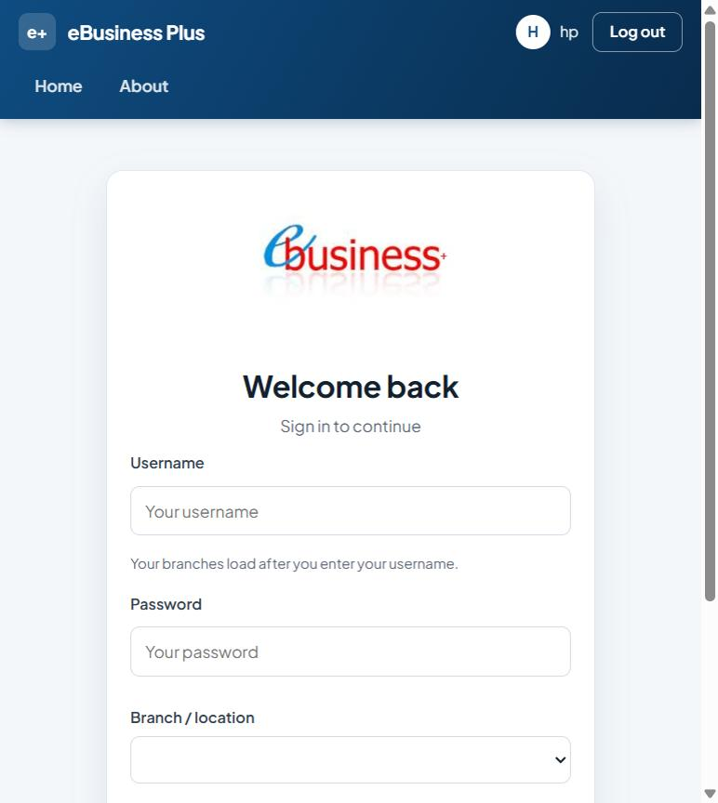
Figure 1: Log In

Fields
Field | Type | Description
Username | Text | Enter the username.
Password | Password | Enter the password.
Branch / location | Drop-down list | The bank branch.
Keep me signed in | Tick box | Tick to enable.

Buttons and actions
Button | What it does
Sign in | Sign in with the username, password and branch entered.

How to use this screen
- Open the eBankPlus address in your browser and click Log In (or go straight to Account/Auth.aspx).
- Enter your Username. Your branches load into Branch / location after you leave the field.
- Enter your Password.
- Choose the Branch / location you are working from.
- Tick Keep me signed in only on a computer you alone use.
- Click Sign in. You are taken to your dashboard.

2.2 Home page
Menu path: Click Home in the top bar
Purpose: The home page, in the new eBusiness Plus theme. The top bar carries the e+ logo, the Home and About links, your initials and user name, and Log out. The page greets you by name and shows shortcut tiles (Card requests, Direct debit (NDD), Approvals and more).
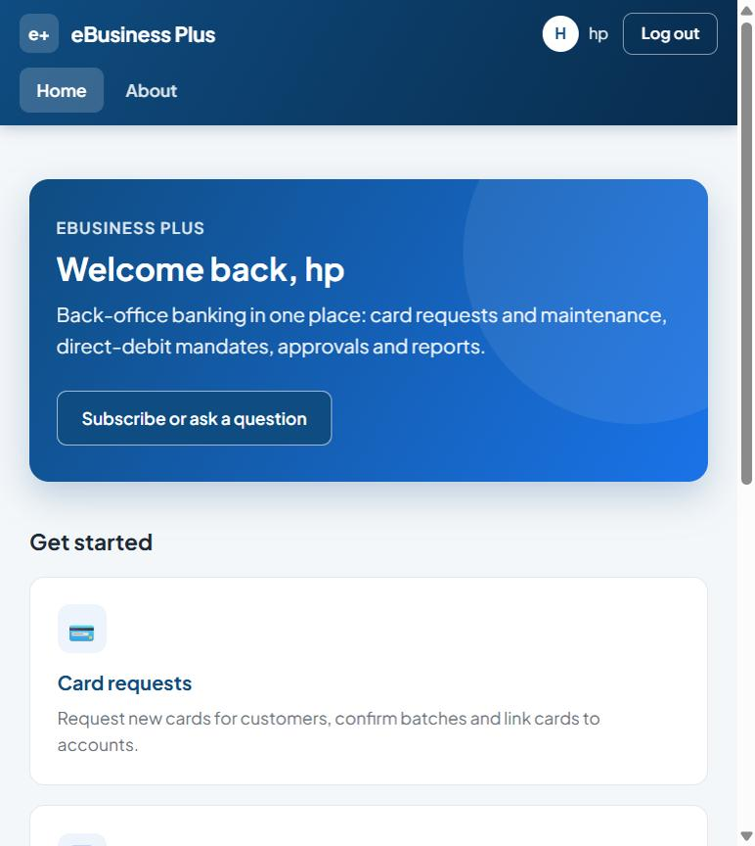
Figure 2: Home - eBusiness Plus

Buttons and actions
Button | What it does
Subscribe or ask a question | Open an e-mail to the support team.
Log out | Sign out of eBankPlus.

How to use this screen
- Click a tile under Get started to go to that area.
- Click Subscribe or ask a question to e-mail the support team.
- Click Log out (top right) when you finish.

2.3 Dashboard (after login)
Menu path: Shown after you sign in
Purpose: Your dashboard after signing in. It greets you, shows who you are signed in as and your branch, the number of requests pending approval, the system date and time, outstanding items and your recent activity.
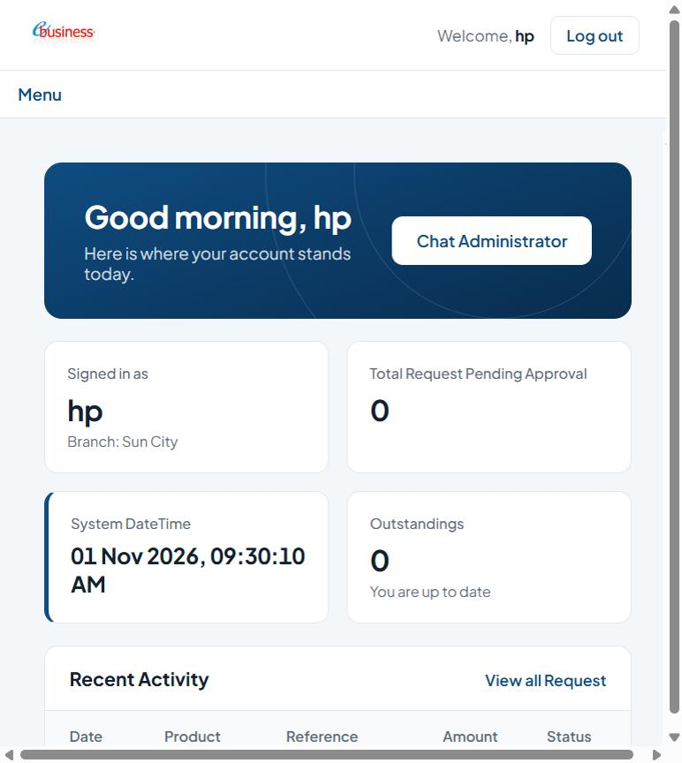
Figure 3: Web Registrar
List columns: Date, Product, Reference, Amount, Status.

Buttons and actions
Button | What it does
Log out | Sign out of eBankPlus.
Menu | Open or close the main menu.
Chat Administrator | Send a message to the system administrator.
View all Request | Show all your requests.

How to use this screen
- Check the Signed in as card to confirm your user ID and branch.
- Review Total Request Pending Approval and Outstandings to see work waiting for you.
- Use View all Request to see the full list of your recent requests.
- Use Chat Administrator to contact the system administrator.
- Click Log out (top right) when you finish.

2.4 Main menu
Menu path: Click Menu below the header
Purpose: The Menu button opens the main navigation. Functions are grouped into modules (Manage Account, Administration, Reports, Approval, Card Management, Broadcast, eBranch Management, eChannels Management, Revenue Collection, Direct Debit and eOperations). You only see the menu items your role allows.
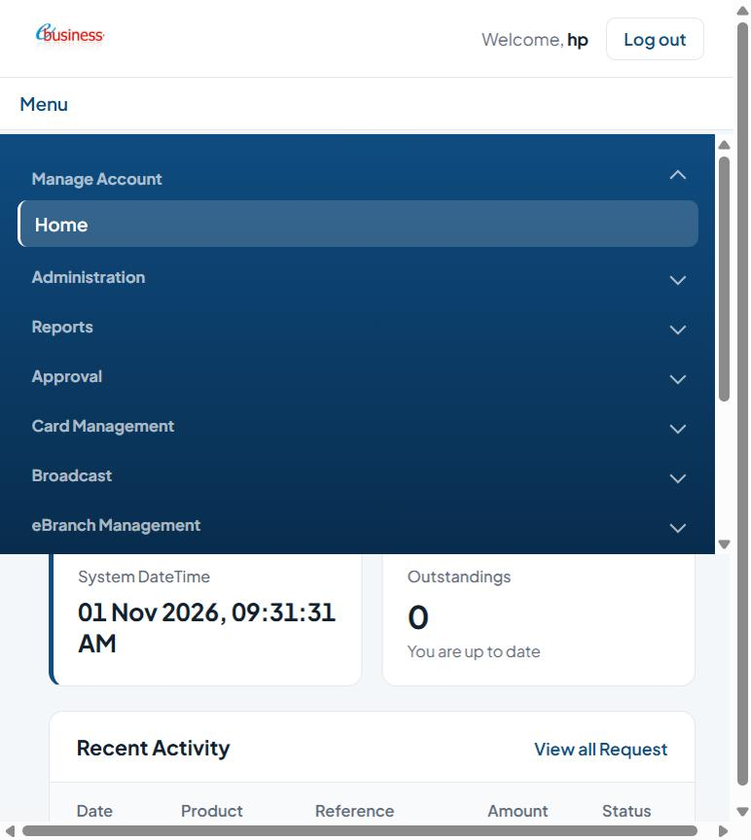
Figure 4: Menu

How to use this screen
- Click Menu below the header.
- Click a module name to expand it (the arrow turns up).
- Click the screen you need. It opens in the main area.
- Click the module name again to collapse it.

3. Manage Account
Your own account summary and activity.

3.1 Home (Subscribe to products / payment details)
Menu path: Menu > Manage Account > Home
Purpose: The Home screen (Manage Account > Subscribe to new products and view all existing payment details) summarises your account: pending approvals, outstanding items and recent activity, with a link to view all requests.
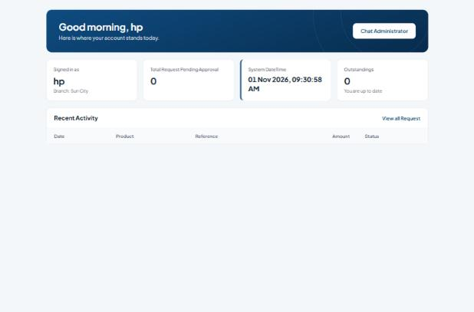
Figure 5: Home
List columns: Date, Product, Reference, Amount, Status.

Buttons and actions
Button | What it does
Chat Administrator | Send a message to the system administrator.

How to use this screen
- Open Menu > Manage Account > Home.
- Review the summary cards and the Recent Activity table (Date, Product, Reference, Amount, Status).
- Click View all Request to see every request.

4. Administration
Set-up and maintenance screens for fees, terminals, users, roles, customer profiles, policies, security questions, billers and corporate customers. Usually restricted to administrators.

4.1 Setup Fees
Menu path: Menu > Administration > Setup Fees
Purpose: Sets up the rate and fee charged for each transaction amount range (charge setup).
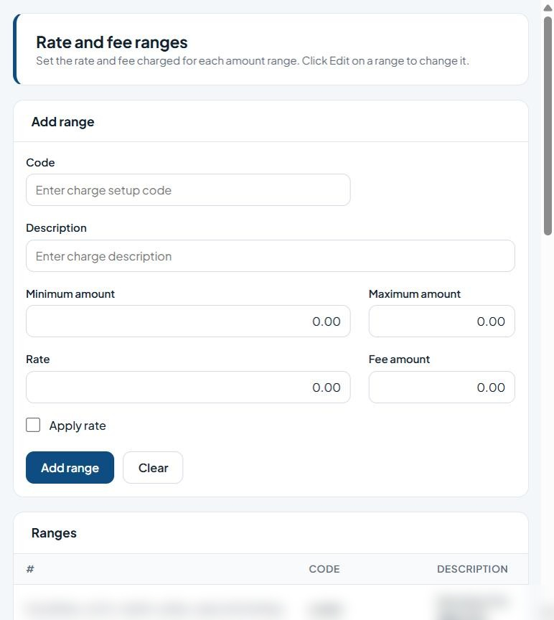
Figure 6: Rate and fee ranges

Fields
Field | Type | Description
Code | Text | Unique code/identifier.
Description | Text | Free-text description.
Minimum amount | Text | Amount in Naira (NGN).
Maximum amount | Text | Amount in Naira (NGN).
Rate | Text | Percentage rate.
Fee amount | Text | Amount in Naira (NGN).
Apply rate | Tick box | Percentage rate.
List columns: #, Code, Description, Minimum amount, Maximum amount, Rate, Fee amount, Apply.

Buttons and actions
Button | What it does
Add range | Save the new fee range.
Clear | Clear the form without saving.

How to use this screen
- Enter a Code and Description for the charge range.
- Enter the Minimum amount and Maximum amount the range covers.
- Enter the Rate and/or the flat Fee amount.
- Tick Apply rate if the percentage rate should be applied (otherwise the fee amount is used).
- Click Add range. The range appears in the Ranges list.
- To change a range, click Edit on its row, update the values and save. Click Clear to empty the form.

4.2 Terminal Registration
Menu path: Menu > Administration > Terminal Registration
Purpose: Registers POS and ATM terminals and links them to a customer account and branch.
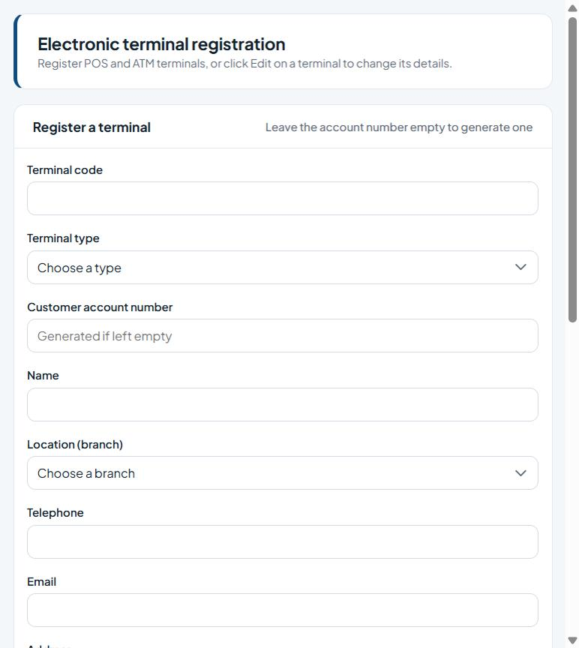
Figure 7: Terminal registration

Fields
Field | Type | Description
Terminal code | Text | Unique code/identifier.
Terminal type | Drop-down list | Choose the type from the list.
Customer account number | Text | The customer account number (validated against the core banking system).
Name | Text | Name to record.
Location (branch) | Drop-down list | The bank branch.
Telephone | Phone number | Contact phone number.
Email | E-mail address | Contact e-mail address.
Address | Text | Enter the address.
Terminal IP | Text | Enter the terminal IP.
Relationship officer | Text | Enter the relationship officer.
List columns: Terminal code, Type, Name, Account no, Balance, Branch, Telephone, Status.

Buttons and actions
Button | What it does
Register terminal | Save the new terminal.
Clear | Clear the form without saving.

How to use this screen
- Enter the Terminal code and choose the Terminal type (POS or ATM).
- Enter the Customer account number, or leave it empty to have one generated.
- Enter the terminal Name and choose the Location (branch).
- Enter Telephone, Email, Address, Terminal IP and the Relationship officer.
- Click Register terminal. The terminal appears in the Terminals list.
- To change a terminal, click Edit on its row.

4.3 Setup Transaction Profile
Menu path: Menu > Administration > Setup Transaction Profile
Purpose: Links accounts to a transaction description and type (Credit or Debit) for funds-transfer processing.
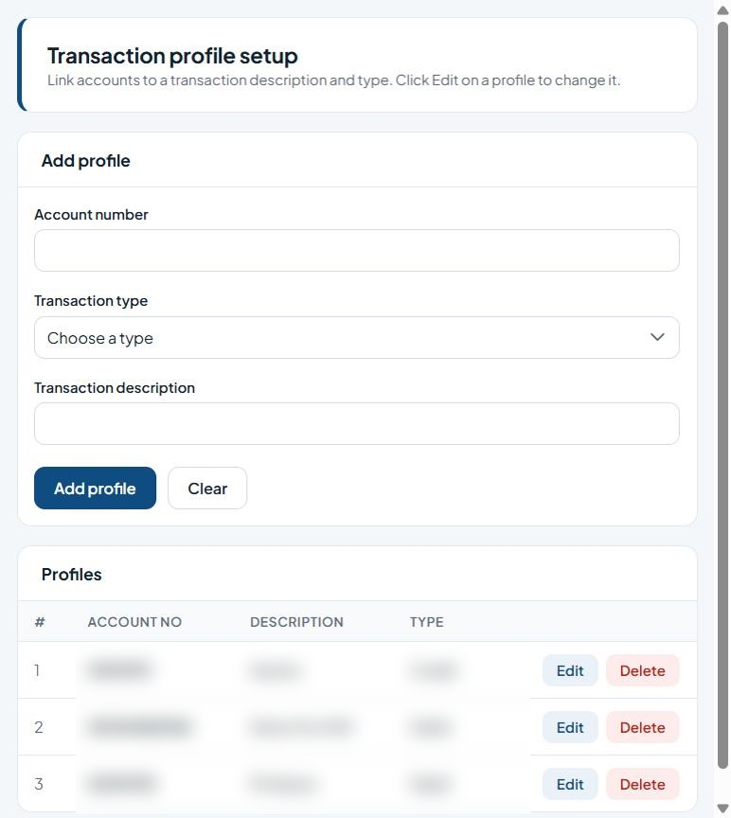
Figure 8: Transaction profile setup

Fields
Field | Type | Description
Account number | Text | The customer account number (validated against the core banking system).
Transaction type | Drop-down list | Choose the type from the list.
Transaction description | Text | Free-text description.
List columns: #, Account no, Description, Type.

Buttons and actions
Button | What it does
Add profile | Save the new transaction profile.
Clear | Clear the form without saving.
Edit | Edit the row.
Delete | Delete the record (cannot be undone).

How to use this screen
- Enter the Account number.
- Choose the Transaction type (Credit or Debit).
- Enter the Transaction description.
- Click Add profile.
- Use Edit or Delete on a row in the Profiles list to change or remove a profile.

4.4 USSD Onboarding
Menu path: Menu > Administration > USSD Onboarding
Purpose: Creates, updates or deletes a customer's USSD profile by linking a mobile number (MSISDN) to an account.
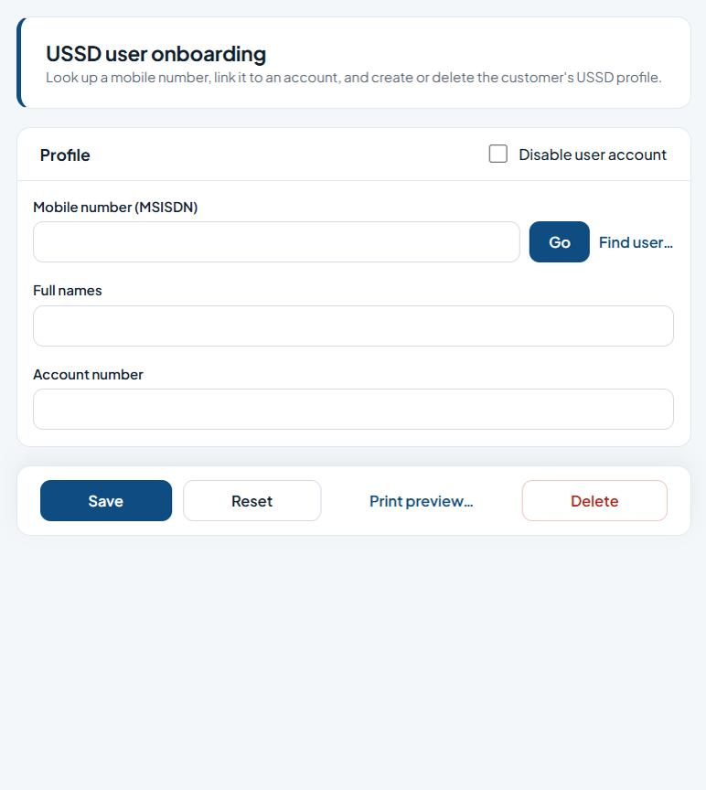
Figure 9: USSD user onboarding

Fields
Field | Type | Description
Disable user account | Tick box | Tick to block the account from signing in.
Mobile number (MSISDN) | Text | Customer's mobile number in international format.
Full names | Text | The person's full name.
Account number | Text | The customer account number (validated against the core banking system).

Buttons and actions
Button | What it does
Go | Load the record for the ID entered.
Find user… | Search for a user.
Save | Save the changes.
Reset | Clear the form, or apply the chosen reset to the ticked users.
Print preview… | Preview a printable copy.
Delete | Delete the record (cannot be undone).

How to use this screen
- Enter the customer's Mobile number (MSISDN) and click Go, or click Find user… to search.
- Check or enter the Full names and Account number.
- Tick Disable user account only if the USSD profile should be blocked.
- Click Save to create or update the profile.
- Use Delete to remove the profile, Reset to clear the form, or Print preview… to print it.

4.5 Profile Maintenance
Menu path: Menu > Administration > Profile Maintenance
Purpose: Maintains existing customer (internet/mobile/USSD) profiles: clears device bindings or security questions and sets eToken and channel options.
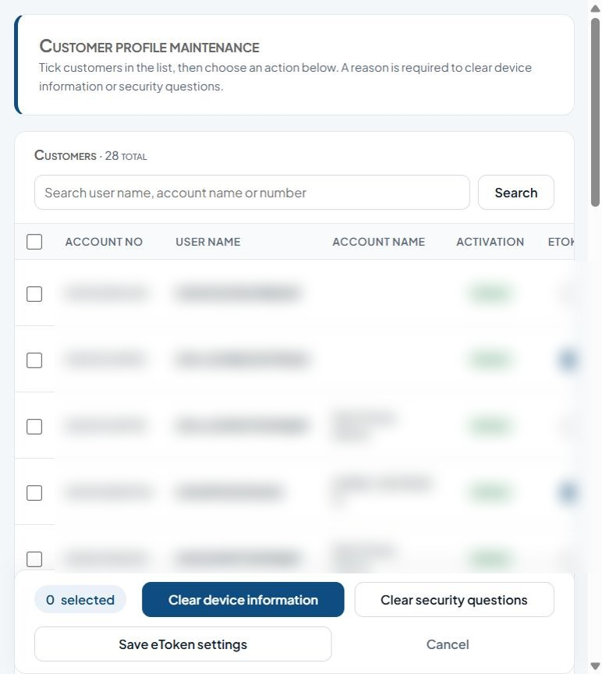
Figure 10: Customer profile maintenance

Fields
Field | Type | Description
Search user name, account name or number | Text | Text to search for.
Select (per customer) | Tick box | Tick to include the row(s) in the next action.
eToken / Mobile / iPortal / USSD (per customer) | Tick box | Tick to enable.
Reason (to deactivate or clear questions) | Multi-line text | Explanation for the action; required when rejecting, disapproving, deactivating or clearing settings.
List columns: Account no, User name, Account name, Activation, Etoken, Registration phone, Registration address, Mobile, Iportal, Ussd, Reason.

Buttons and actions
Button | What it does
Search | Run the search.
Clear device information | Unbind the ticked customers' registered devices (reason required).
Clear security questions | Make the ticked customers set new security questions (reason required).
Save eToken settings | Save the eToken and channel tick boxes for the listed customers.
Cancel | Discard and clear the selection.

How to use this screen
- Type a user name, account name or account number and click Search.
- Tick the customer(s) to work on.
- Enter a Reason in the row. A reason is required to clear device information or security questions.
- Click Clear device information to unbind the customer's device, or Clear security questions to make them set new ones.
- Tick or untick eToken, Mobile, iPortal and USSD for each customer and click Save eToken settings to save channel settings.
- Click Cancel to discard.

4.6 User Profile
Menu path: Menu > Administration > User Profile
Purpose: Creates and maintains back-office user accounts: permissions, data-posting limits, approval limits and role memberships.
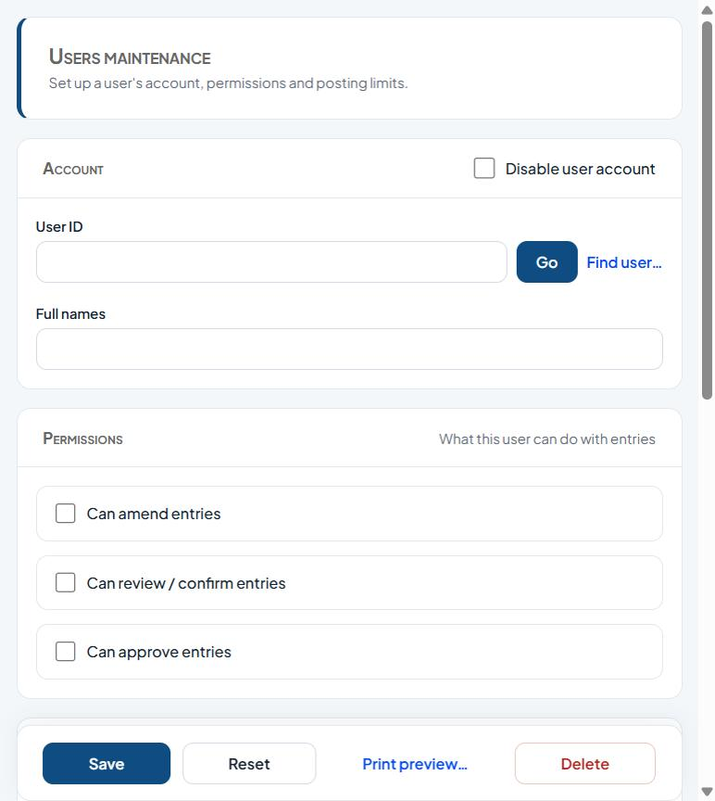
Figure 11: Users maintenance

Fields
Field | Type | Description
Disable user account | Tick box | Tick to block the account from signing in.
User ID | Text | The user's login ID. Click Go to load an existing user.
Full names | Text | The person's full name.
Can amend entries | Tick box | Permission granted to the user.
Can review / confirm entries | Tick box | Permission granted to the user.
Can approve entries | Tick box | Permission granted to the user.
Data posting limits - Cash receipts / Cash payments / Non-cash payments (minimum, maximum, ceiling) | Text | Amount limits per transaction category.
Posting approval limits - Cash receipts / Cash payments / Non-cash payments (minimum, maximum) | Text | Amount limits per transaction category.

Buttons and actions
Button | What it does
Go | Load the record for the ID entered.
Find user… | Search for a user.
Save | Save the changes.
Reset | Clear the form, or apply the chosen reset to the ticked users.
Print preview… | Preview a printable copy.
Delete | Delete the record (cannot be undone).

How to use this screen
- Enter the User ID and click Go, or click Find user… to search.
- Enter or check the Full names. Tick Disable user account to block the user.
- Under Permissions, tick what the user may do: amend, review/confirm, or approve entries.
- Under Data posting limits, enter the minimum, maximum and ceiling amounts for cash receipts, cash payments and non-cash payments.
- Under Posting approval limits, enter the minimum and maximum approval amounts.
- Under Memberships, assign the user's role(s).
- Click Save. Use Reset to clear, Delete to remove the user, or Print preview… to print.

4.7 Profile Activation
Menu path: Menu > Administration > Profile Activation
Purpose: Activates or deactivates customer profiles and sets the channels (eToken, Mobile, iPortal, USSD) each customer can use.
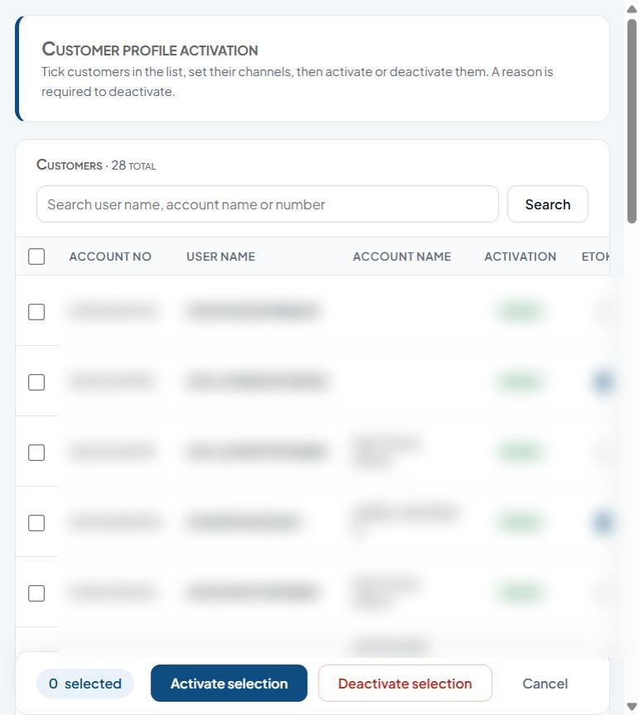
Figure 12: Customer profile activation

Fields
Field | Type | Description
Search user name, account name or number | Text | Text to search for.
Select (per customer) | Tick box | Tick to include the row(s) in the next action.
Active / eToken / Mobile / iPortal / USSD (per customer) | Tick box | Tick to enable.
Reason (required to deactivate) | Multi-line text | Explanation for the action; required when rejecting, disapproving, deactivating or clearing settings.
List columns: Account no, User name, Account name, Activation, Etoken, Registration phone, Registration address, Mobile, Iportal, Ussd, Reason.

Buttons and actions
Button | What it does
Search | Run the search.
Activate selection | Activate the ticked items.
Deactivate selection | Deactivate the ticked customers (reason required).
Cancel | Discard and clear the selection.

How to use this screen
- Search by user name, account name or number.
- Tick the customer(s) and set their channel tick boxes.
- Click Activate selection to activate them.
- To deactivate, enter a Reason on each row (required) and click Deactivate selection.
- Click Cancel to discard.

4.8 Online Policy
Menu path: Menu > Administration > Online Policy
Purpose: Bank-wide (general) online policies, such as the maximum withdrawal per week, non-working hours per day, and NIP local and inter-bank transfer limits.
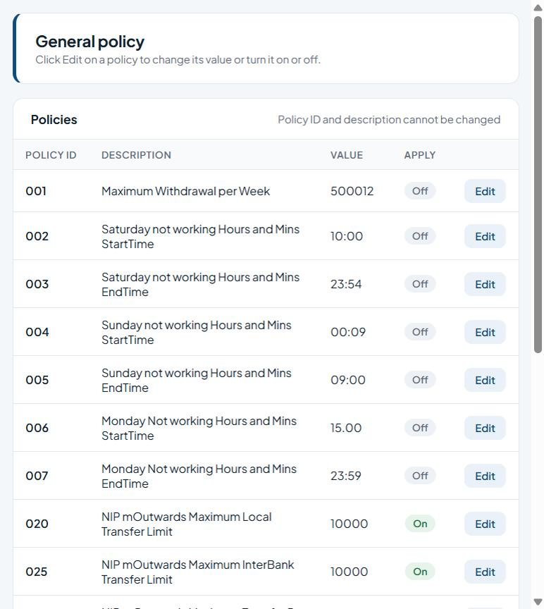
Figure 13: General policy
List columns: Policy id, Description, Value, Apply.

Buttons and actions
Button | What it does
Edit | Edit the row.

How to use this screen
- Find the policy in the Policies list (Policy ID, Description, Value, Apply).
- Click Edit on its row.
- Change the Value and/or switch Apply on or off. Policy ID and description cannot be changed.
- Save the change.
Note: Policy ID and description cannot be changed; click Edit to change a policy's value or turn it on/off (e.g. weekly withdrawal limit, non-working hours, NIP transfer limits).

4.9 Customer Account Policy
Menu path: Menu > Administration > Customer Account Policy
Purpose: Requests a customer-specific policy (for example a higher transfer limit) for an account. Requests go for approval under Approval > Approve Account Policy.
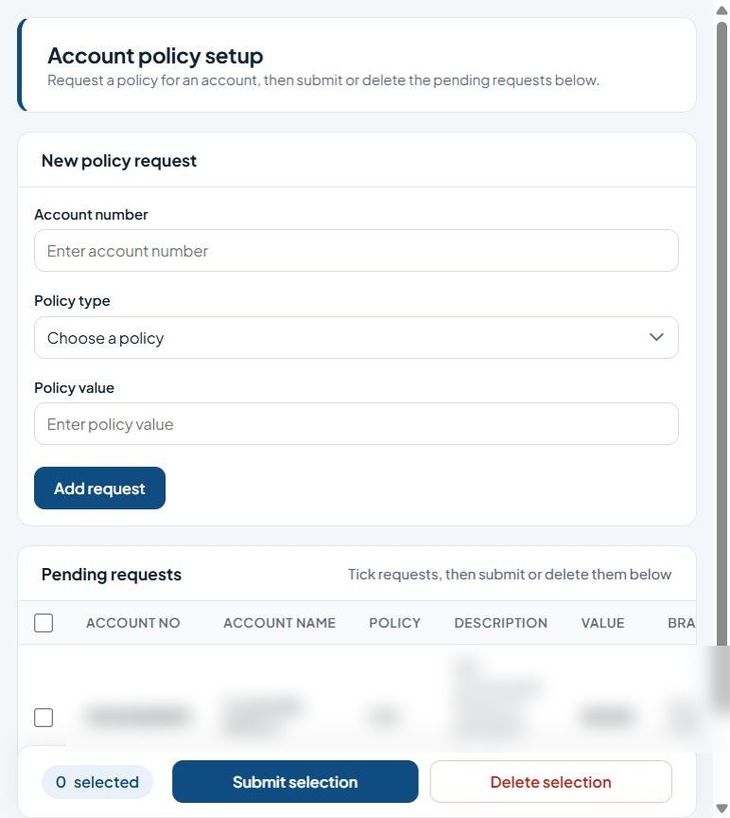
Figure 14: Account policy setup

Fields
Field | Type | Description
Account number | Text | The customer account number (validated against the core banking system).
Policy type | Drop-down list | The policy to apply.
Policy value | Text | The value for the policy (e.g. limit amount).
Select (per request) | Tick box | Tick to include the row(s) in the next action.
List columns: Account no, Account name, Policy, Description, Value, Branch, Requested.

Buttons and actions
Button | What it does
Add request | Add the request to the pending list.
Submit selection | Send the ticked items for approval.
Delete selection | Remove the ticked items.

How to use this screen
- Enter the Account number.
- Choose the Policy type and enter the Policy value.
- Click Add request. It appears under Pending requests.
- Tick the requests to send and click Submit selection to send them for approval, or Delete selection to remove them.

4.10 Roles & Permissions
Menu path: Menu > Administration > Roles & Permissions
Purpose: Creates and maintains user roles and the screens/actions each role is allowed to use.
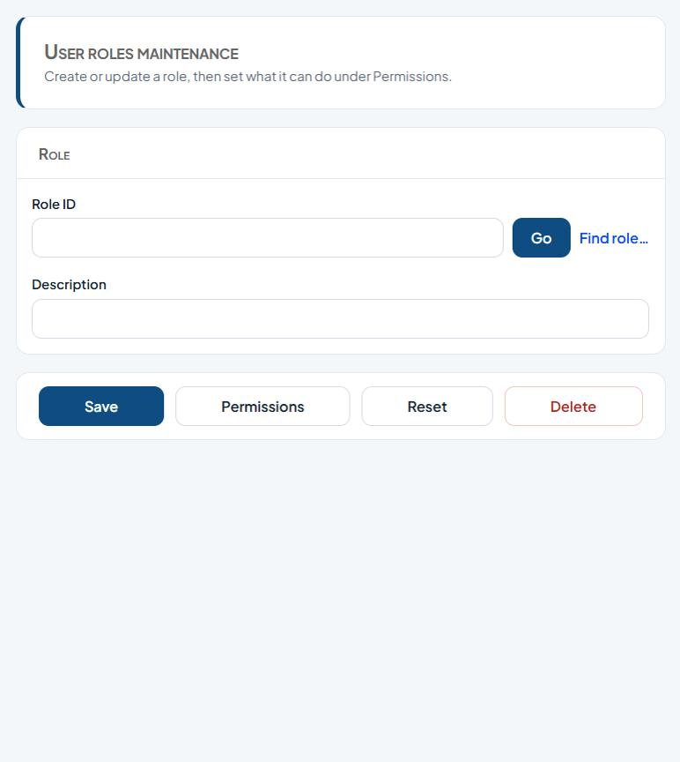
Figure 15: User roles maintenance

Fields
Field | Type | Description
Role ID | Text | Enter the role ID.
Description | Text | Free-text description.

Buttons and actions
Button | What it does
Go | Load the record for the ID entered.
Find role… | Search for a role.
Save | Save the changes.
Permissions | Set what the role can access.
Reset | Clear the form, or apply the chosen reset to the ticked users.
Delete | Delete the record (cannot be undone).

How to use this screen
- Enter a Role ID and click Go, or use Find role… to search.
- Enter the Description.
- Click Save.
- Click Permissions to choose the menu items and actions the role can access, then save.
- Use Delete to remove a role or Reset to clear the form.

4.11 Reset User Profile
Menu path: Menu > Administration > Reset User Profile
Purpose: Resets locked or disabled back-office users and clears logon problems.
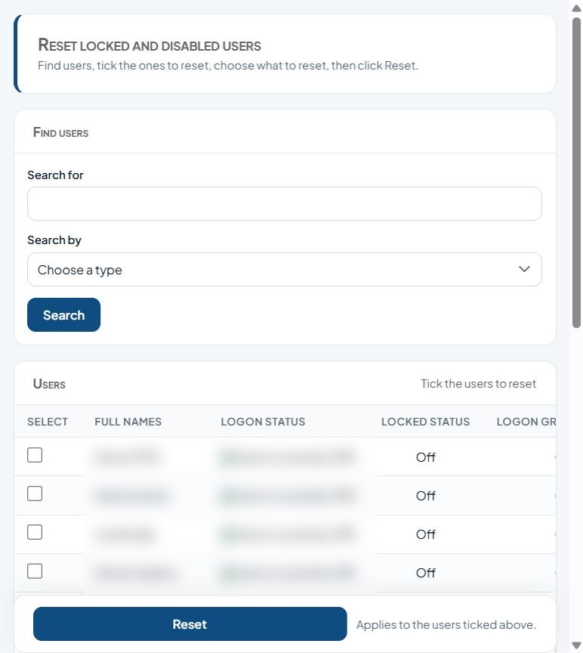
Figure 16: Reset locked and disabled users

Fields
Field | Type | Description
Search for | Text | Text to search for.
Search by | Drop-down list | Text to search for.
Select (per user) | Tick box | Tick to include the row(s) in the next action.
Reset locked users only | Tick box | Tick to enable.
Clear user from logon log | Tick box | Tick to enable.
Reset locked and disabled users | Tick box | Tick to enable.
Reset all | Tick box | Tick to enable.
Reset user's password only | Tick box | Tick to enable.
List columns: Select, Full names, Logon status, Locked status, Logon group.

Buttons and actions
Button | What it does
Search | Run the search.
Reset | Clear the form, or apply the chosen reset to the ticked users.

How to use this screen
- Enter a search value in Search for and choose Search by, then click Search.
- Tick the user(s) in the Users list.
- Under What to reset, choose one option: reset locked users only; clear user from logon log; reset locked and disabled users; reset all; or reset the user's password only.
- Click Reset. The action applies to all ticked users.

4.12 Setup Application Security Questions
Menu path: Menu > Administration > Setup Application Security Questions
Purpose: Maintains the list of security questions customers choose from when they set up their profile.
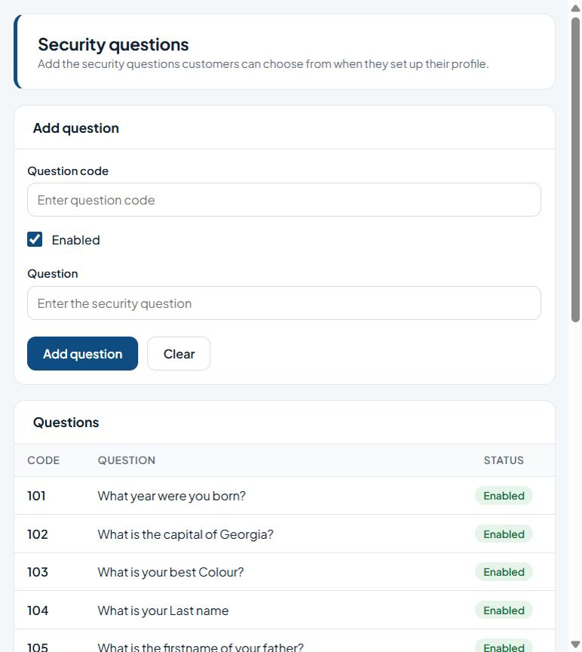
Figure 17: Security questions

Fields
Field | Type | Description
Question code | Text | Unique code/identifier.
Enabled | Tick box | Tick to enable.
Question | Text | Enter the question.
List columns: Code, Question, Status.

Buttons and actions
Button | What it does
Add question | Save the new security question.
Clear | Clear the form without saving.

How to use this screen
- Enter a Question code.
- Type the Question.
- Leave Enabled ticked so customers can choose it.
- Click Add question. It appears in the Questions list with its status.

4.13 Setup Biller
Menu path: Menu > Administration > Setup Biller
Purpose: Sets up billers (for example airtime, data, utilities) within a biller category for bill payments.
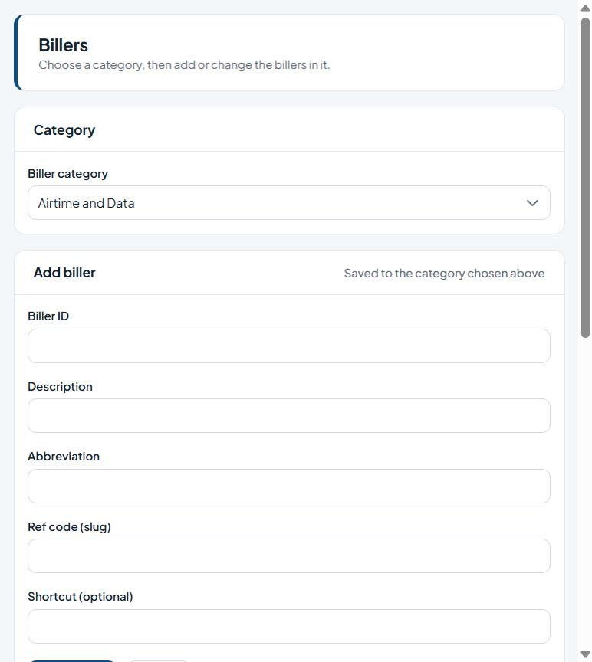
Figure 18: Billers

Fields
Field | Type | Description
Biller category | Drop-down list | Choose a value from the list.
Biller ID | Text | Enter the biller ID.
Description | Text | Free-text description.
Abbreviation | Text | Enter the abbreviation.
Ref code (slug) | Text | Enter the ref code (slug).
Shortcut (optional) | Text | Enter the shortcut (optional).
List columns: Biller id, Description, Abbreviation, Ref code, Category, Shortcut.

Buttons and actions
Button | What it does
Add biller | Save the new biller.
Clear | Clear the form without saving.

How to use this screen
- Choose the Biller category.
- Enter Biller ID, Description, Abbreviation, Ref code (slug) and, optionally, a Shortcut.
- Click Add biller. The biller is saved to the chosen category and appears under Billers in this category.
- Click Clear to empty the form.

4.14 Setup Biller Product
Menu path: Menu > Administration > Setup Biller Product
Purpose: Maintains the products (packages and price plans) offered by each biller.
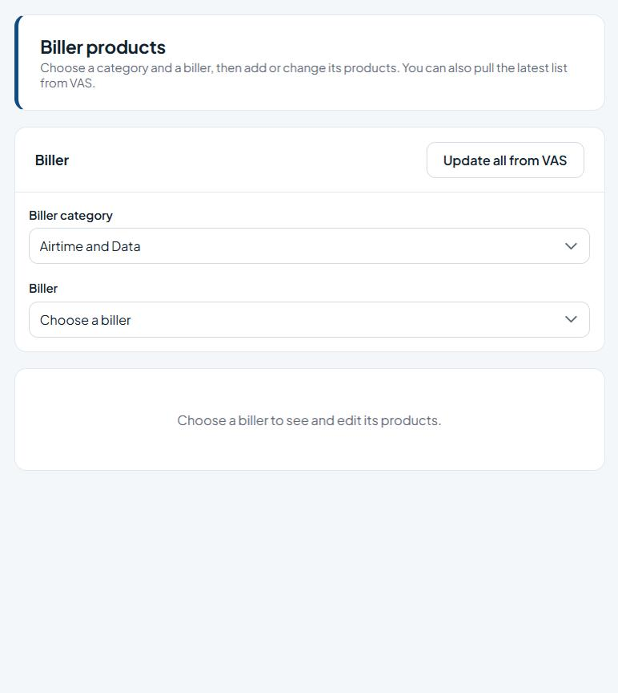
Figure 19: Biller products

Fields
Field | Type | Description
Biller category | Drop-down list | Choose a value from the list.
Biller | Drop-down list | Choose a value from the list.

Buttons and actions
Button | What it does
Update all from VAS | Download the latest products for all billers from the VAS provider.

How to use this screen
- Choose the Biller category, then the Biller.
- The biller's products are listed. Add or edit them as needed.
- Click Update all from VAS to pull the latest product list from the VAS provider.
Note: Choose a category and a biller to see and edit its products; Update all from VAS pulls the latest product list.

4.15 Setup Corporate Organization
Menu path: Menu > Administration > Setup Corporate Organization
Purpose: Sets up corporate organisations (corporate internet-banking customers) and their main account.
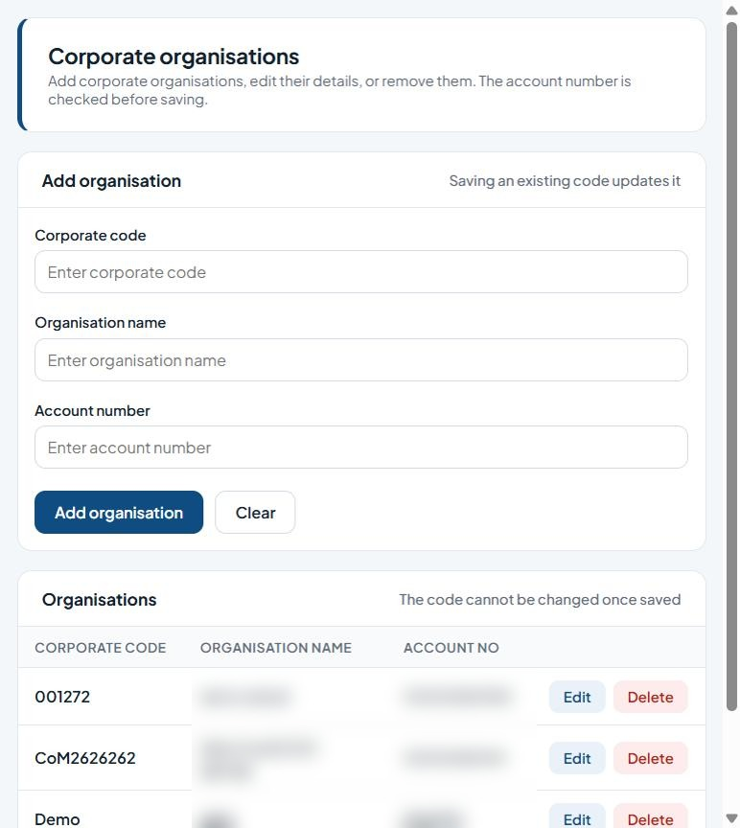
Figure 20: Corporate organisations

Fields
Field | Type | Description
Corporate code | Text | Unique code/identifier.
Organisation name | Text | Name to record.
Account number | Text | The customer account number (validated against the core banking system).
List columns: Corporate code, Organisation name, Account no.

Buttons and actions
Button | What it does
Add organisation | Save the organisation (updates it if the code exists).
Clear | Clear the form without saving.
Edit | Edit the row.
Delete | Delete the record (cannot be undone).

How to use this screen
- Enter the Corporate code, Organisation name and Account number.
- Click Add organisation. The account number is checked before saving.
- Saving an existing code updates that organisation. The code cannot be changed once saved.
- Use Edit or Delete on a row in the Organisations list.
Note: The account number is checked before saving. Saving an existing code updates it; the code cannot be changed once saved.

4.16 Setup Corporate User Profile
Menu path: Menu > Administration > Setup Corporate User Profile
Purpose: Creates and maintains users for corporate organisations, with their posting and approval rights.
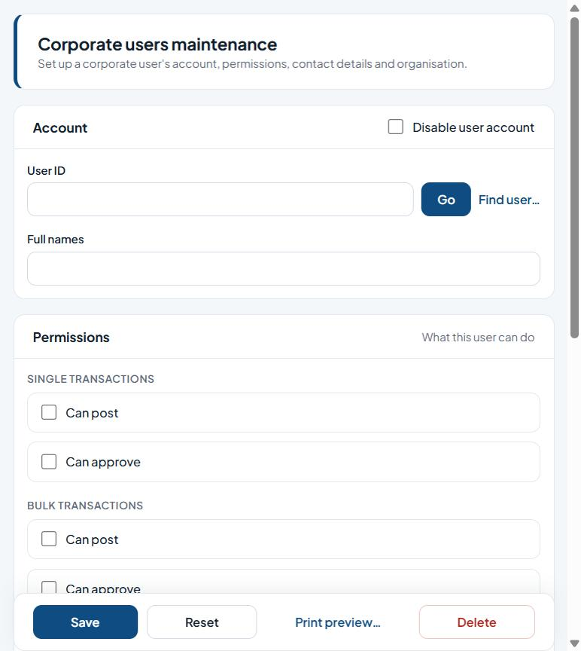
Figure 21: Corporate users maintenance

Fields
Field | Type | Description
Disable user account | Tick box | Tick to block the account from signing in.
User ID | Text | The user's login ID. Click Go to load an existing user.
Full names | Text | The person's full name.
Single transactions - Can post / Can approve | Tick box | Tick to enable.
Bulk transactions - Can post / Can approve | Tick box | Tick to enable.
Can view balance | Tick box | Permission granted to the user.
Is approving officer | Tick box | Permission granted to the user.
Can view status | Tick box | Permission granted to the user.
Contact phone number | Phone number | Contact phone number.
Contact email | E-mail address | Contact e-mail address.
Organisation name | Drop-down list | Name to record.

Buttons and actions
Button | What it does
Go | Load the record for the ID entered.
Find user… | Search for a user.
Save | Save the changes.
Reset | Clear the form, or apply the chosen reset to the ticked users.
Print preview… | Preview a printable copy.
Delete | Delete the record (cannot be undone).

How to use this screen
- Enter the User ID and click Go (or Find user…). Enter the Full names.
- Under Permissions, tick Can post / Can approve for single and bulk transactions, plus Can view balance, Is approving officer and Can view status as needed.
- Enter the Contact phone number and email and choose the Organisation name.
- Assign memberships and click Save.

4.17 Setup eTeller Profile
Menu path: Menu > Administration > Setup eTeller Profile
Purpose: Creates and maintains eTeller users: their teller account, permissions and posting/approval limits.
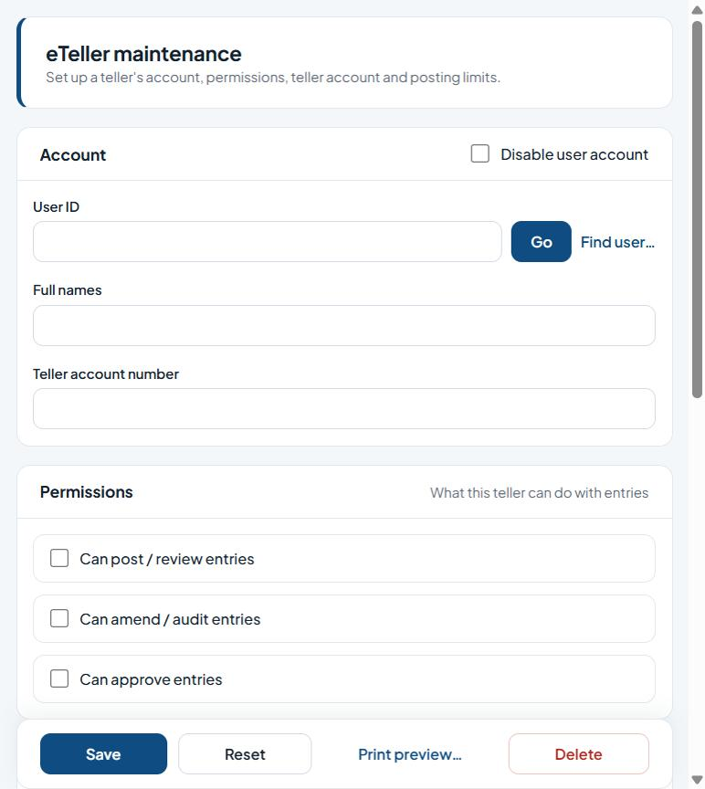
Figure 22: eTeller maintenance

Fields
Field | Type | Description
Disable user account | Tick box | Tick to block the account from signing in.
User ID | Text | The user's login ID. Click Go to load an existing user.
Full names | Text | The person's full name.
Teller account number | Text | Enter the teller account number.
Can post / review entries | Tick box | Permission granted to the user.
Can amend / audit entries | Tick box | Permission granted to the user.
Can approve entries | Tick box | Permission granted to the user.
Data posting limits - Cash receipts / Cash payments / Non-cash payments (minimum, maximum, ceiling) | Text | Amount limits per transaction category.
Posting approval limits - Cash receipts / Cash payments / Non-cash payments (minimum, maximum) | Text | Amount limits per transaction category.

Buttons and actions
Button | What it does
Go | Load the record for the ID entered.
Find user… | Search for a user.
Save | Save the changes.
Reset | Clear the form, or apply the chosen reset to the ticked users.
Print preview… | Preview a printable copy.
Delete | Delete the record (cannot be undone).

How to use this screen
- Enter the User ID and click Go (or Find user…). Enter the Full names and Teller account number.
- Tick permissions: post/review, amend/audit, approve entries.
- Enter the data posting limits and posting approval limits.
- Assign memberships and click Save.

5. Reports
All reports use the same report viewer: choose a Start Date and End Date, optionally add filter conditions, click go, then page through, zoom or export the results.

5.1 Card Reports
Menu path: Menu > Reports > Card Reports
Purpose: Lists card requests (account, card display name, PAN, display-name length, address) for a date range.
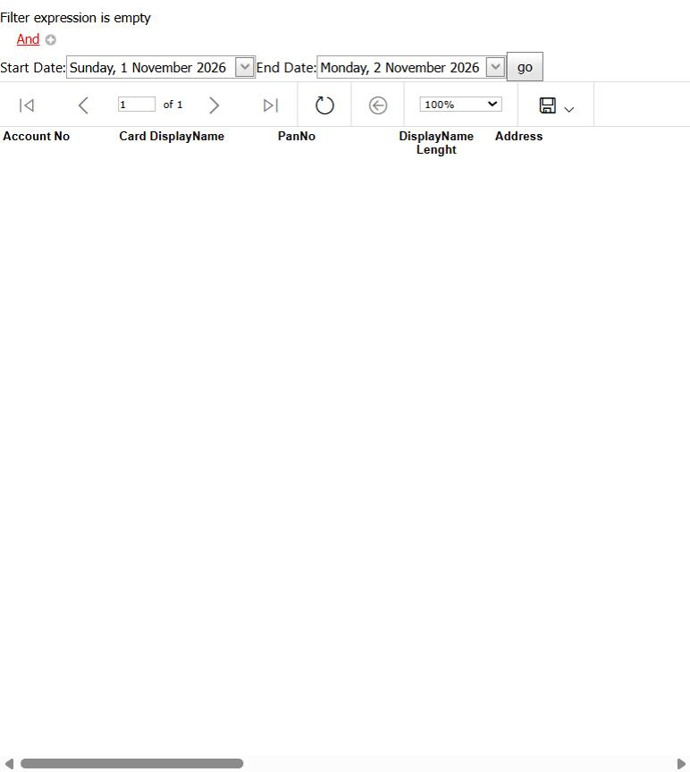
Figure 23: Card Request Report

Fields
Field | Type | Description
Filter expression (And / +) | Filter builder | Optional conditions to narrow the report (click And / + to add a condition).
Start Date | Date picker | Start (or issue) date.
End Date | Date picker | End (or expiry) date.
List columns: Account no, Card displayname, Panno, Displayname lenght, Address.

Buttons and actions
Button | What it does
go | Load the record / run the report.
First / Previous / Page / Next / Last | Move between report pages.
Refresh | Reload the list.
Back | Go back.
Zoom | Change the report zoom.
Export / Save | Export the report (e.g. PDF, Excel).

How to use this screen
- Choose the Start Date and End Date.
- Optionally build a filter: click And / (+) to add a condition.
- Click go to run the report.
- Use the toolbar to page through results, refresh, zoom, or export/save (for example to PDF or Excel).

5.2 eChannels Reports / eChannels By Branch Reports
Menu path: Menu > Reports > eChannels Reports
Purpose: Lists e-channel requests (tracking number, display name, account, address), including the branch breakdown.
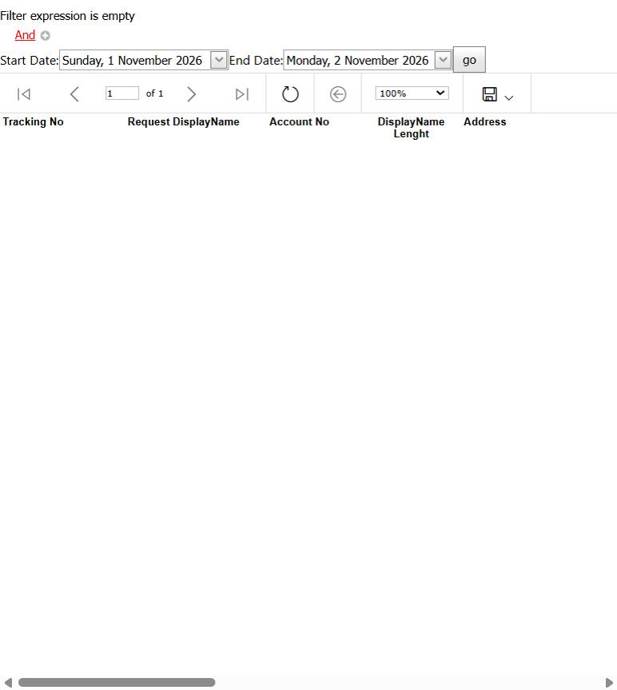
Figure 24: eChannels Request Report

Fields
Field | Type | Description
Filter expression (And / +) | Filter builder | Optional conditions to narrow the report (click And / + to add a condition).
Start Date | Date picker | Start (or issue) date.
End Date | Date picker | End (or expiry) date.
List columns: Tracking no, Request displayname, Account no, Displayname lenght, Address.

Buttons and actions
Button | What it does
go | Load the record / run the report.
First / Previous / Page / Next / Last | Move between report pages.
Refresh | Reload the list.
Back | Go back.
Zoom | Change the report zoom.
Export / Save | Export the report (e.g. PDF, Excel).

How to use this screen
- Choose the Start Date and End Date.
- Optionally add filter conditions.
- Click go, then page through, zoom or export the results.

5.3 Customer AuditLog Reports
Menu path: Menu > Reports > Customer AuditLog Reports
Purpose: Audit trail of customer (application) activity: audit details, serial number, user ID, audit type and remarks.
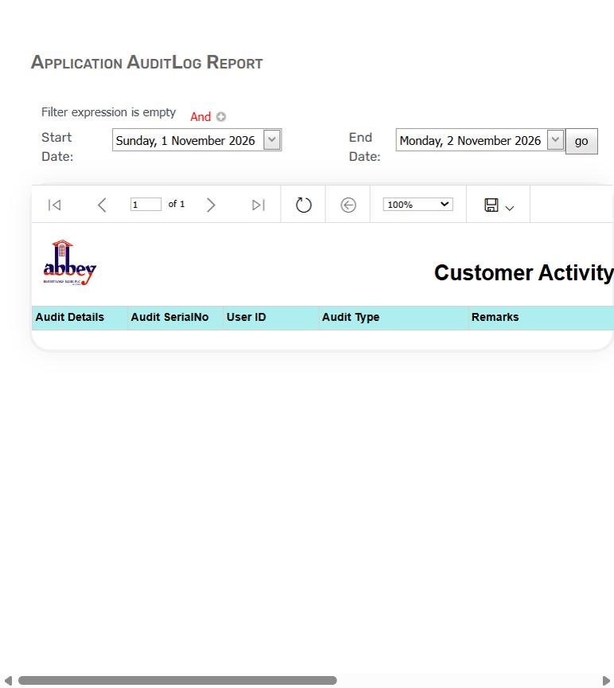
Figure 25: Application AuditLog Report

Fields
Field | Type | Description
Filter expression (And / +) | Filter builder | Optional conditions to narrow the report (click And / + to add a condition).
Start Date | Date picker | Start (or issue) date.
End Date | Date picker | End (or expiry) date.
List columns: Audit details, Audit serialno, User id, Audit type, Remarks.

Buttons and actions
Button | What it does
go | Load the record / run the report.
Page navigation | Move between report pages.
Refresh | Reload the list.
Zoom | Change the report zoom.
Export / Save | Export the report (e.g. PDF, Excel).

How to use this screen
- Choose the Start Date and End Date and optional filters.
- Click go.
- Export the report using the save button if needed.

5.4 Unprofiled User AuditLog Reports
Menu path: Menu > Reports > Unprofiled User AuditLog Reports
Purpose: Audit trail of activity by users who are not yet profiled (unregistered or incomplete users).
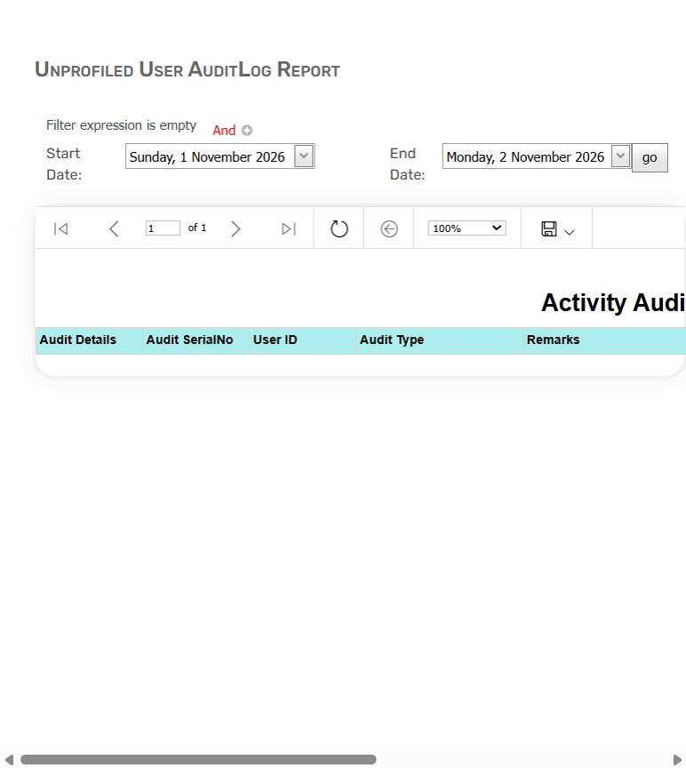
Figure 26: Unprofiled User AuditLog Report

Fields
Field | Type | Description
Filter expression (And / +) | Filter builder | Optional conditions to narrow the report (click And / + to add a condition).
Start Date | Date picker | Start (or issue) date.
End Date | Date picker | End (or expiry) date.
List columns: Audit details, Audit serialno, User id, Audit type, Remarks.

Buttons and actions
Button | What it does
go | Load the record / run the report.
Page navigation | Move between report pages.
Refresh | Reload the list.
Zoom | Change the report zoom.
Export / Save | Export the report (e.g. PDF, Excel).

How to use this screen
- Choose the date range and optional filters.
- Click go, then review or export.

5.5 User AuditLog Reports
Menu path: Menu > Reports > User AuditLog Reports
Purpose: Audit trail of back-office (backend) user activity.
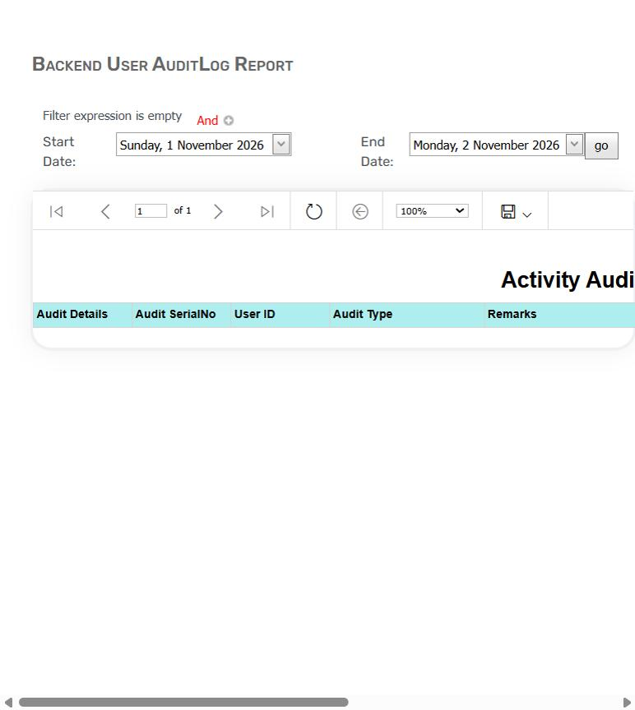
Figure 27: Backend User AuditLog Report

Fields
Field | Type | Description
Filter expression (And / +) | Filter builder | Optional conditions to narrow the report (click And / + to add a condition).
Start Date | Date picker | Start (or issue) date.
End Date | Date picker | End (or expiry) date.
List columns: Audit details, Audit serialno, User id, Audit type, Remarks.

Buttons and actions
Button | What it does
go | Load the record / run the report.
Page navigation | Move between report pages.
Refresh | Reload the list.
Zoom | Change the report zoom.
Export / Save | Export the report (e.g. PDF, Excel).

How to use this screen
- Choose the date range and optional filters.
- Click go, then review or export.

5.6 Customer Transaction Reports
Menu path: Menu > Reports > Customer Transaction Reports
Purpose: Customer transaction history (NIP log): transaction date, account, branch, posting date, narration and amount.
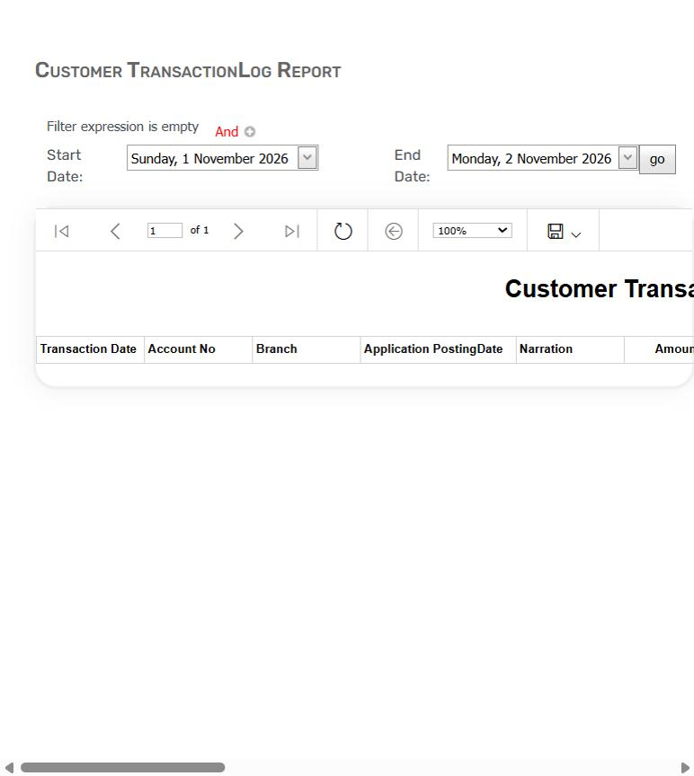
Figure 28: Customer TransactionLog Report

Fields
Field | Type | Description
Filter expression (And / +) | Filter builder | Optional conditions to narrow the report (click And / + to add a condition).
Start Date | Date picker | Start (or issue) date.
End Date | Date picker | End (or expiry) date.
List columns: Transaction date, Account no, Branch, Application postingdate, Narration, Amount.

Buttons and actions
Button | What it does
go | Load the record / run the report.
Page navigation | Move between report pages.
Refresh | Reload the list.
Zoom | Change the report zoom.
Export / Save | Export the report (e.g. PDF, Excel).

How to use this screen
- Choose the date range and optional filters (for example account number).
- Click go, then review or export.

6. Approval
Checker screens. Each shows items waiting for your approval. Tick items, then approve or disapprove them; a reason is always required to disapprove.

6.1 Approve Bulk Payments
Menu path: Menu > Approval > Approve Bulk Payments
Purpose: Approves or rejects bulk payment batches uploaded through Bulk FundsTransfer.
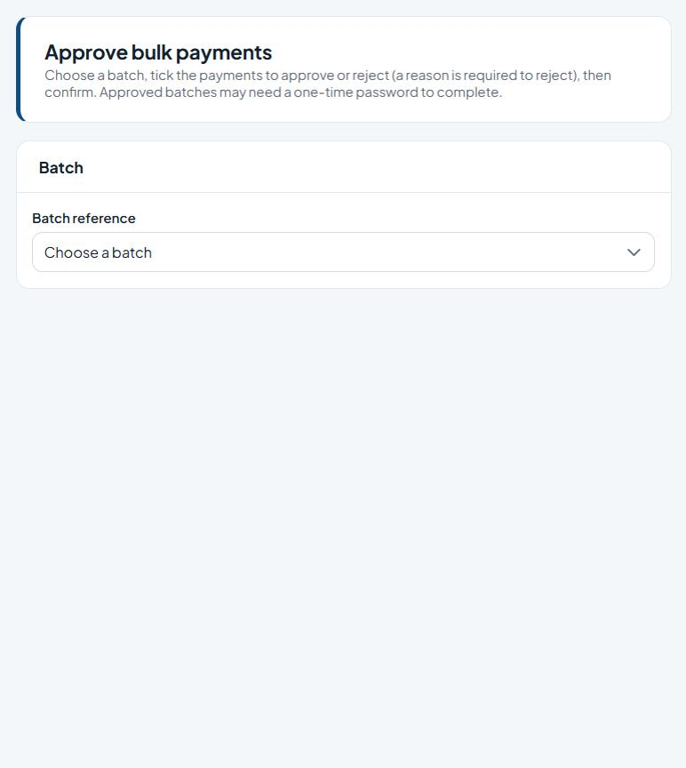
Figure 29: Approve bulk payments

Fields
Field | Type | Description
Batch reference | Drop-down list | The batch to work on.
Select (per payment) | Tick box | Tick to include the row(s) in the next action.
Reason (required to reject) | Text | Explanation for the action; required when rejecting, disapproving, deactivating or clearing settings.

Buttons and actions
Button | What it does
Approve | Approve the ticked payments.
Reject | Reject the ticked payments (reason required).
Confirm | Complete the approval or rejection (an OTP may be requested).

How to use this screen
- Choose the Batch reference.
- Review the payments in the batch and tick the ones to approve or reject.
- To reject, enter a reason (required).
- Confirm. Approved batches may ask for a one-time password (OTP) to complete.
Note: Choose a batch, tick the payments to approve or reject (a reason is required to reject), then confirm. Approved batches may need a one-time password (OTP) to complete.

6.2 Approve eChannels Request
Menu path: Menu > Approval > Approve eChannels Request
Purpose: Approves or disapproves card and e-channel requests raised for your branch (from eBranch Management > eChannels Requistion).
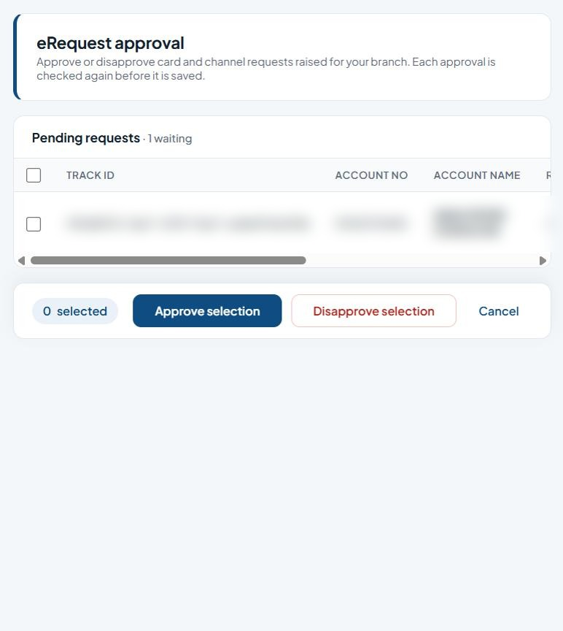
Figure 30: eRequest approval

Fields
Field | Type | Description
Select all / Select (per request) | Tick box | Tick to include the row(s) in the next action.
Reason | Multi-line text | Explanation for the action; required when rejecting, disapproving, deactivating or clearing settings.
List columns: Track id, Account no, Account name, Request, Request date, Branch, Reason.

Buttons and actions
Button | What it does
Approve selection | Approve all ticked items.
Disapprove selection | Reject all ticked items (reason required).
Cancel | Discard and clear the selection.

How to use this screen
- Review the Pending requests list.
- Tick the request(s).
- Click Approve selection, or enter a reason and click Disapprove selection.
- Each approval is checked again before it is saved.
Note: Approve or disapprove card and channel requests raised for your branch. Each approval is checked again before it is saved.

6.3 Approve Account Policy
Menu path: Menu > Approval > Approve Account Policy
Purpose: Approves or disapproves customer account policy changes requested under Administration > Customer Account Policy.
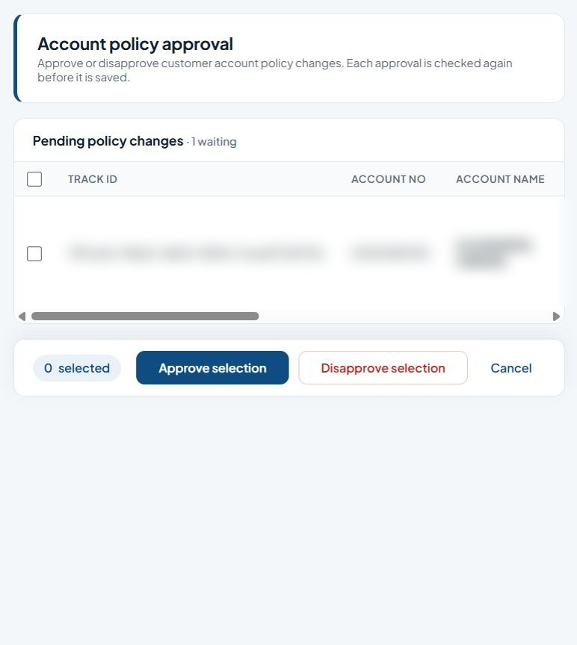
Figure 31: Account policy approval

Fields
Field | Type | Description
Select all / Select (per request) | Tick box | Tick to include the row(s) in the next action.
Reason | Multi-line text | Explanation for the action; required when rejecting, disapproving, deactivating or clearing settings.
List columns: Track id, Account no, Account name, Policy type, Request, Policy value, Request date, Branch, Reason.

Buttons and actions
Button | What it does
Approve selection | Approve all ticked items.
Disapprove selection | Reject all ticked items (reason required).
Cancel | Discard and clear the selection.

How to use this screen
- Review the pending policy changes (policy type, value, branch).
- Tick the change(s).
- Click Approve selection, or enter a reason and click Disapprove selection.

6.4 Approve User KYC Information
Menu path: Menu > Approval > Approve User KYC Information
Purpose: Reviews and approves KYC documents uploaded by customers.
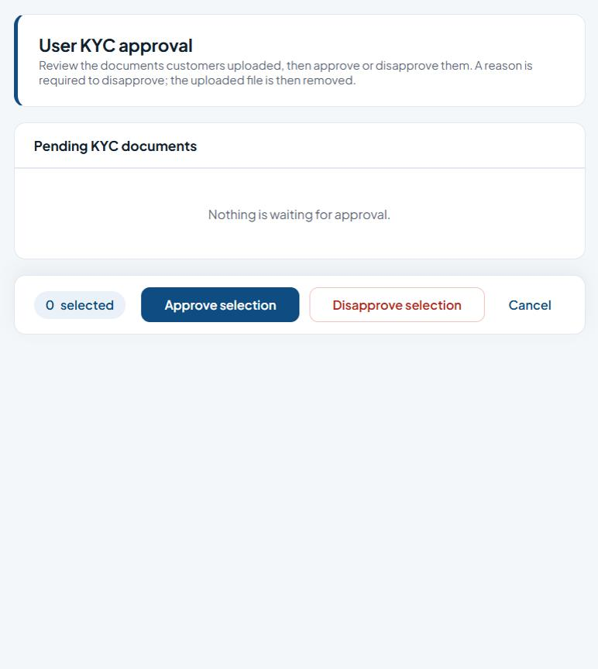
Figure 32: User KYC approval

Fields
Field | Type | Description
Select (per document) | Tick box | Tick to include the row(s) in the next action.
Reason (required to disapprove) | Text | Explanation for the action; required when rejecting, disapproving, deactivating or clearing settings.

Buttons and actions
Button | What it does
Approve selection | Approve all ticked items.
Disapprove selection | Reject all ticked items (reason required).
Cancel | Discard and clear the selection.

How to use this screen
- Open each pending document and check it.
- Tick the document(s).
- Click Approve selection, or enter a reason and click Disapprove selection. Disapproving removes the uploaded file.
Note: Review documents customers uploaded. A reason is required to disapprove; the uploaded file is then removed.

6.5 Approve QRCode Information (QR merchants)
Menu path: Menu > Approval > Approve QRCode Information
Purpose: Approves merchants for NIBSS NQR (QR code) payments.
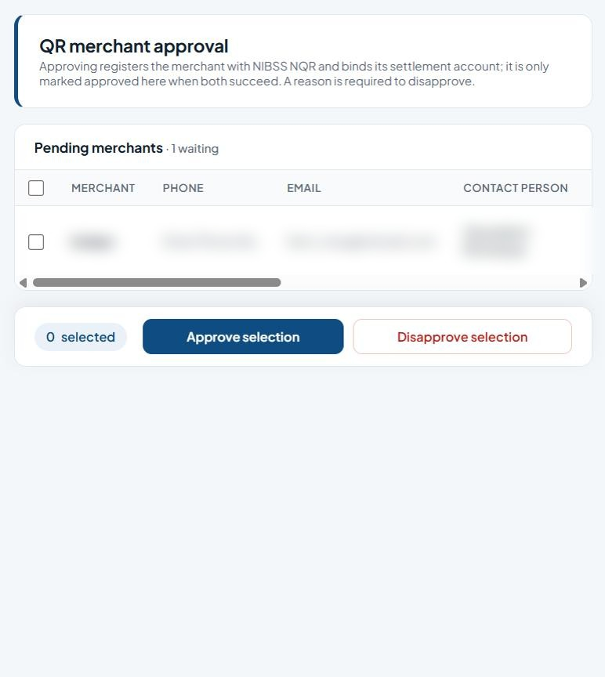
Figure 33: QR merchant approval

Fields
Field | Type | Description
Select all / Select (per merchant) | Tick box | Tick to include the row(s) in the next action.
Reason | Multi-line text | Explanation for the action; required when rejecting, disapproving, deactivating or clearing settings.
List columns: Merchant, Phone, Email, Contact person, Tin, Account no, Account name, Address, Posted by, Reason.

Buttons and actions
Button | What it does
Approve selection | Approve all ticked items.
Disapprove selection | Reject all ticked items (reason required).

How to use this screen
- Review the pending merchants (contact details, TIN, settlement account).
- Tick the merchant(s) and click Approve selection. Approval registers the merchant with NIBSS NQR and binds the settlement account; it is only marked approved when both succeed.
- To reject, enter a reason and click Disapprove selection.
Note: Approving registers the merchant with NIBSS NQR and binds its settlement account; it is only marked approved when both succeed. A reason is required to disapprove.

6.6 Approve Card Request
Menu path: Menu > Approval > Approve Card Request
Purpose: Approves or disapproves card requests.
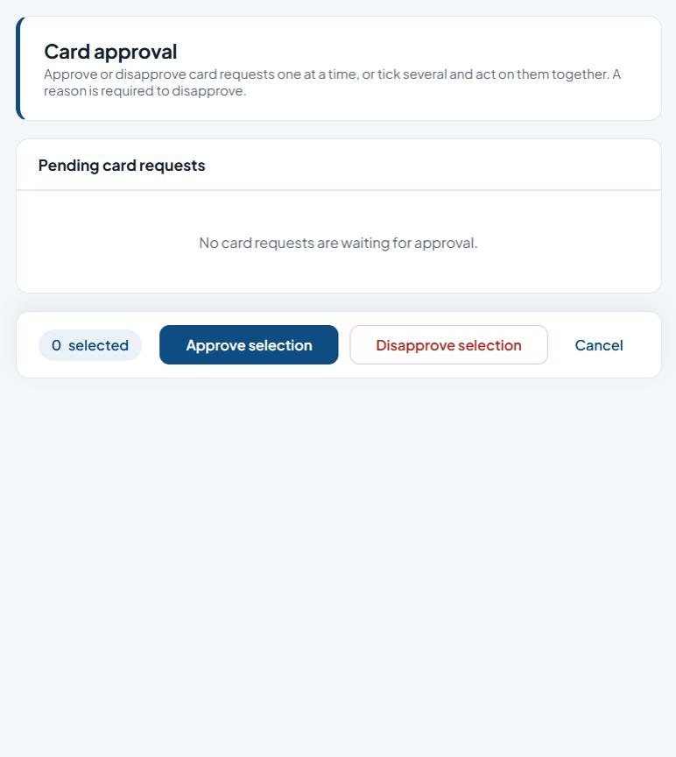
Figure 34: Card approval

Fields
Field | Type | Description
Select (per request) | Tick box | Tick to include the row(s) in the next action.
Reason (required to disapprove) | Text | Explanation for the action; required when rejecting, disapproving, deactivating or clearing settings.

Buttons and actions
Button | What it does
Approve selection | Approve all ticked items.
Disapprove selection | Reject all ticked items (reason required).
Cancel | Discard and clear the selection.

How to use this screen
- Review the Pending card requests.
- Approve or disapprove them one at a time, or tick several and act on them together.
- A reason is required to disapprove.

6.7 Approve NDD e-Mandate
Menu path: Menu > Approval > Approve NDD e-Mandate
Purpose: Approves NIBSS Direct Debit (NDD) e-mandates created under Direct Debit > Create eMandate. In the menu this appears as the second 'Approve QRCode Information' item.
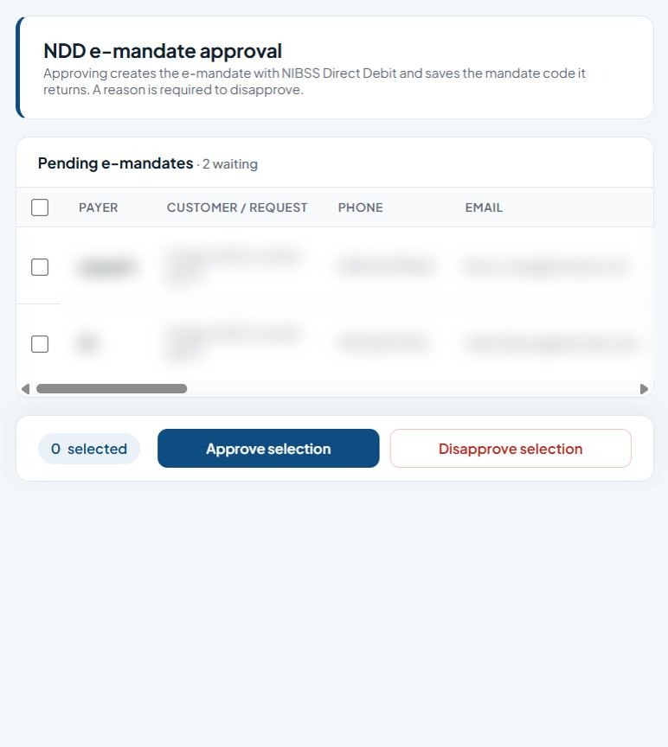
Figure 35: NDD e-mandate approval

Fields
Field | Type | Description
Select all / Select (per mandate) | Tick box | Tick to include the row(s) in the next action.
Reason | Multi-line text | Explanation for the action; required when rejecting, disapproving, deactivating or clearing settings.
List columns: Payer, Customer / request, Phone, Email, Amount, Frequency, Narration, Start, End, Payer account, Payer account name, Biller account, Biller account name, Address, Bank, Fixed, Posted by, Reason.

Buttons and actions
Button | What it does
Approve selection | Approve all ticked items.
Disapprove selection | Reject all ticked items (reason required).

How to use this screen
- Review the pending e-mandates (payer, amount, frequency, start/end, accounts).
- Tick the mandate(s) and click Approve selection. Approval creates the mandate with NIBSS Direct Debit and saves the returned mandate code.
- To reject, enter a reason and click Disapprove selection.
Note: Approving creates the e-mandate with NIBSS Direct Debit and saves the mandate code it returns. A reason is required to disapprove.

7. Card Management
The card life cycle: request, approval, extraction/production, confirmation, allocation to accounts and de-allocation, including AfriGOPAY cards and mobile/USSD requests.

7.1 Generate Cards Request
Menu path: Menu > Card Management > Generate Cards Request
Purpose: Requests new cards for customer accounts. Every account submitted together shares one new batch reference, which then goes for approval and extraction.
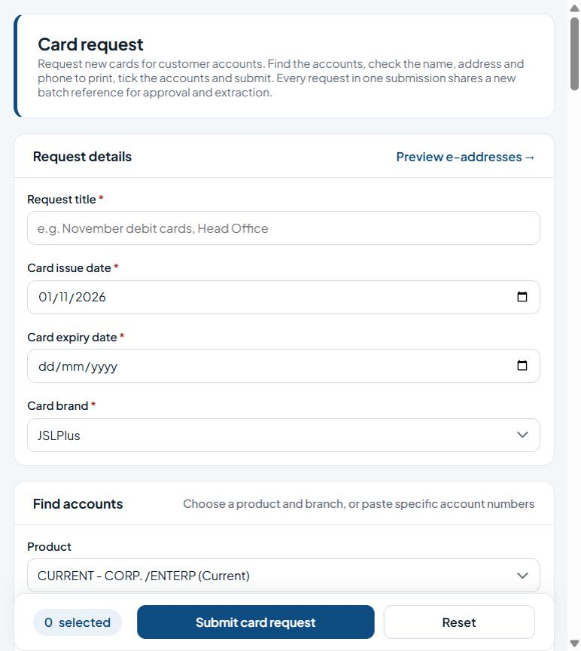
Figure 36: Card request

Fields
Field | Type | Description
Request title * | Text | Required. A short name for the request batch.
Card issue date * | Date picker | Required. Start (or issue) date.
Card expiry date * | Date picker | Required. End (or expiry) date.
Card brand * | Drop-down list | Required. The card scheme/brand to produce.
Product | Drop-down list | Account product to select customers by.
Branch | Drop-down list | The bank branch.
Specific accounts (optional) | Multi-line text | Enter the specific accounts (optional).
Include every page (all listed accounts) | Tick box | Tick to enable.
List columns: Account no, Card display name, Product, Date of birth, Address, City, Phone, Transaction status, Account status.

Buttons and actions
Button | What it does
Load accounts | List the accounts for the chosen product and branch (or the pasted accounts).
Submit card request | Submit the ticked accounts as one new card request batch.
Reset | Clear the form, or apply the chosen reset to the ticked users.

How to use this screen
- Enter the Request title and the Card issue date and Card expiry date (expiry must be after issue), and choose the Card brand.
- Under Find accounts choose the Product and Branch, or paste account numbers into Specific accounts, and click Load accounts.
- In the list, check (and correct if needed) each customer's card display name, address, city and phone.
- Tick the accounts to include, or tick Include every page to take every listed account.
- Click Submit card request. The new batch reference is shown; the batch appears under Approval > Approve Card Request.
- Reset clears the page.

7.2 Cards Extraction
Menu path: Menu > Card Management > Cards Extraction
Purpose: Lists approved card batches waiting for extraction. Extracting writes the card-production files for a batch into its own folder under the extraction path and moves the batch on.
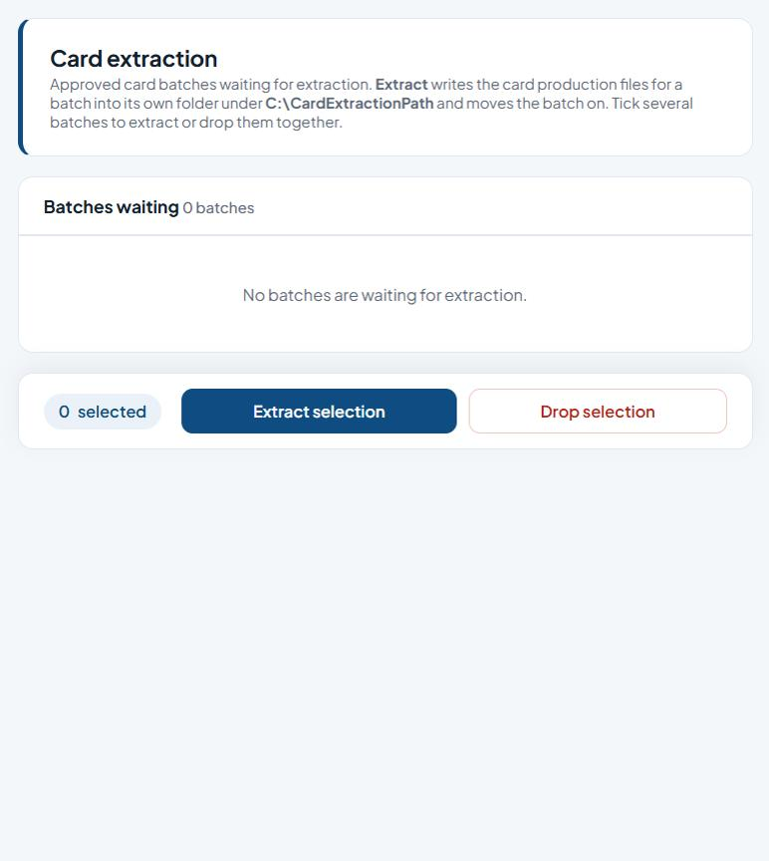
Figure 37: Card extraction
List columns: Request title, Batch ref, Issue date, Expiry date, Generated by.

Buttons and actions
Button | What it does
Extract selection | Write the card production files for the ticked batches.
Extract | Extract that batch.
Drop selection | Remove the ticked items (you are asked to confirm).

How to use this screen
- Find the batch in Batches waiting (request title, batch ref, issue and expiry dates, generated by).
- Click Extract on a row, or tick several batches and click Extract selection.
- Click Drop selection to take ticked batches out of the queue (you are asked to confirm).
- Collect the files from Card Management > Card Extraction Download.

7.3 Cards Extraction (AfroGOPAY)
Menu path: Menu > Card Management > Cards Extraction
Purpose: Generates AfriGOPAY cards for approved batches.
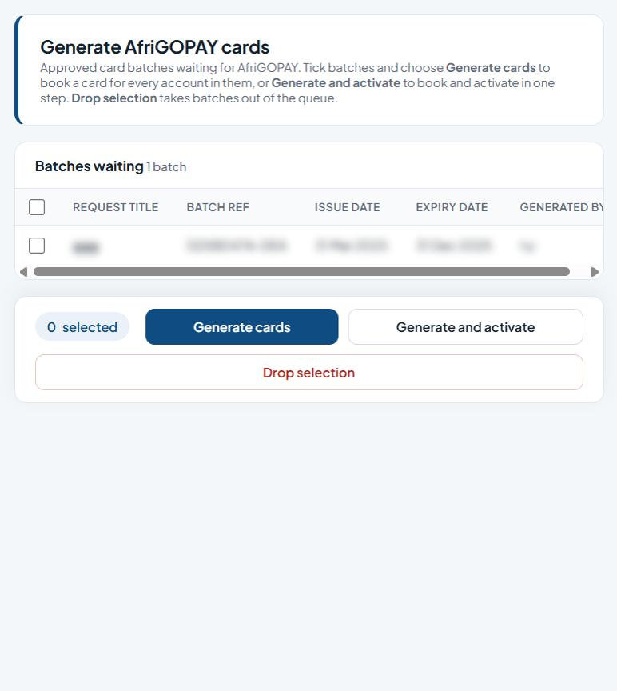
Figure 38: Generate AfriGOPAY cards
List columns: Request title, Batch ref, Issue date, Expiry date, Generated by.

Buttons and actions
Button | What it does
Generate cards | Book a card for every account in the ticked batches.
Generate and activate | Book and activate the cards in one step.
Drop selection | Remove the ticked items (you are asked to confirm).

How to use this screen
- Tick the batch(es) in Batches waiting.
- Click Generate cards to book a card for every account in them, or Generate and activate to book and activate in one step.
- Click Drop selection to remove ticked batches from the queue.
- Generated (not yet activated) cards are activated under Cards Activation (AfroGOPAY).

7.4 Cards Activation (AfroGOPAY)
Menu path: Menu > Card Management > Cards Activation
Purpose: Activates AfriGOPAY cards that have been generated but not yet activated.
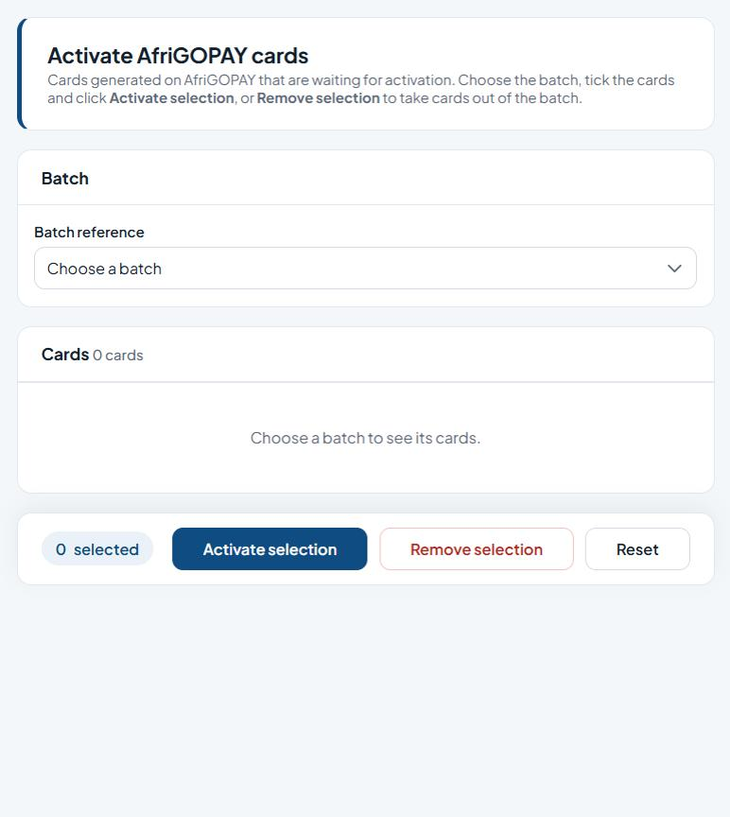
Figure 39: Activate AfriGOPAY cards

Fields
Field | Type | Description
Batch reference | Drop-down list | The batch to work on.
List columns: Account no, Card display name, Product, Pan, Issued, Expires, Issue count, Address.

Buttons and actions
Button | What it does
Activate selection | Activate the ticked items.
Remove selection | Take the ticked cards out of the batch.
Reset | Clear the form, or apply the chosen reset to the ticked users.

How to use this screen
- Choose the Batch reference.
- Tick the cards to activate (the header box ticks the whole page).
- Click Activate selection, or Remove selection to take cards out of the batch.
- Reset clears the page.

7.5 Card RequestMobile
Menu path: Menu > Card Management > Card RequestMobile
Purpose: Card requests for customers onboarded on the mobile channel. It works exactly like Generate Cards Request, with the card PAN shown in the list.
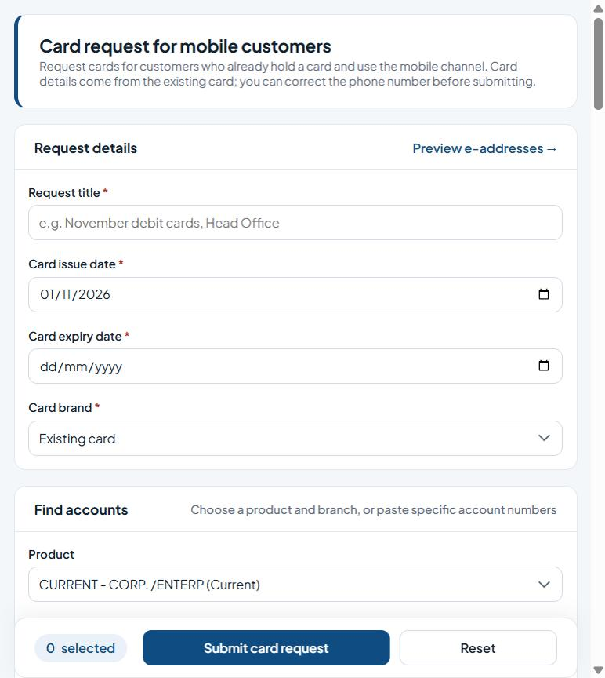
Figure 40: Card request for mobile customers

Fields
Field | Type | Description
Request title * | Text | Required. A short name for the request batch.
Card issue date * | Date picker | Required. Start (or issue) date.
Card expiry date * | Date picker | Required. End (or expiry) date.
Card brand * | Drop-down list | Required. The card scheme/brand to produce.
Product | Drop-down list | Account product to select customers by.
Branch | Drop-down list | The bank branch.
Specific accounts (optional) | Multi-line text | Enter the specific accounts (optional).
Include every page (all listed accounts) | Tick box | Tick to enable.
List columns: Account no, Card (pan), Card display name, Product, Address, City, Phone, Transaction status, Account status.

Buttons and actions
Button | What it does
Load accounts | List the accounts for the chosen product and branch (or the pasted accounts).
Submit card request | Submit the ticked accounts as one new card request batch.
Reset | Clear the form, or apply the chosen reset to the ticked users.

How to use this screen
- Enter the Request title, issue and expiry dates and Card brand.
- Choose Product and Branch (or paste specific accounts) and click Load accounts.
- Check the customers' details, tick the accounts (or Include every page) and click Submit card request.

7.6 Card Extraction Download
Menu path: Menu > Card Management > Card Extraction Download
Purpose: A read-only file browser for the card extraction files. It opens at the card extraction folder (C:\CardExtractionPath unless set otherwise in the site settings) and cannot go outside it. Each download is recorded in the audit log.
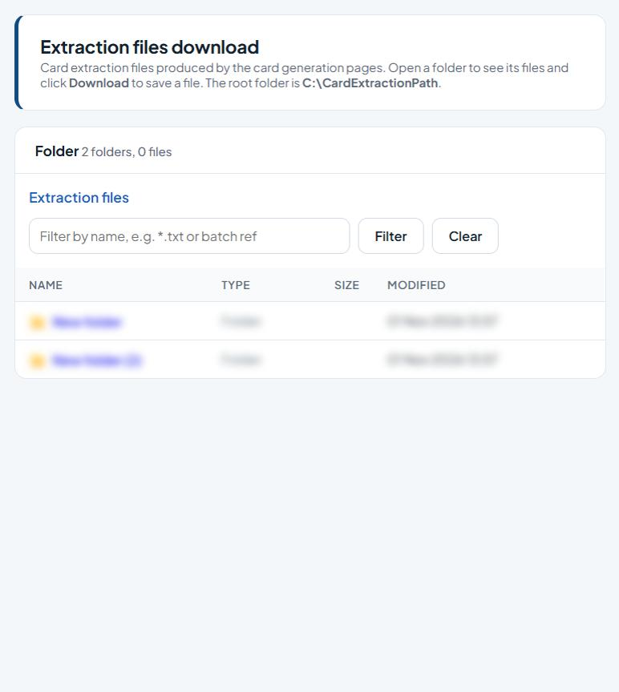
Figure 41: Extraction files download

Fields
Field | Type | Description
Filter by name (e.g. *.txt or batch ref) | Text | The batch to work on.
List columns: Name, Type, Size, Modified.

Buttons and actions
Button | What it does
Filter | Show only names that match the filter.
Clear | Clear the form without saving.
Download | Save the file to your computer.

How to use this screen
- Click a folder name to open it; use the folder path at the top to go back up.
- Type part of a name (or a pattern such as *.txt) and click Filter; Clear shows everything again.
- Click Download on a file to save it to your computer.

7.7 Card USSD
Menu path: Menu > Card Management > Card USSD
Purpose: Card requests for customers onboarded on USSD. It works exactly like Generate Cards Request, with the card PAN shown in the list.
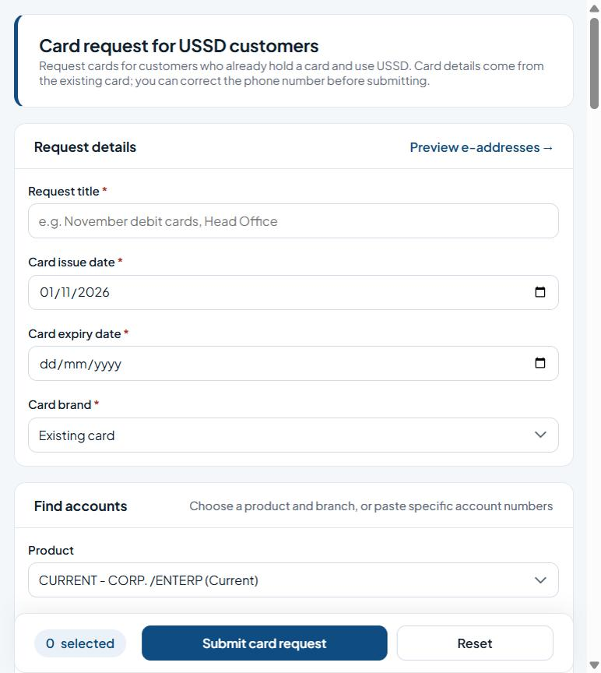
Figure 42: Card request for USSD customers

Fields
Field | Type | Description
Request title * | Text | Required. A short name for the request batch.
Card issue date * | Date picker | Required. Start (or issue) date.
Card expiry date * | Date picker | Required. End (or expiry) date.
Card brand * | Drop-down list | Required. The card scheme/brand to produce.
Product | Drop-down list | Account product to select customers by.
Branch | Drop-down list | The bank branch.
Specific accounts (optional) | Multi-line text | Enter the specific accounts (optional).
Include every page (all listed accounts) | Tick box | Tick to enable.
List columns: Account no, Card (pan), Card display name, Product, Address, City, Phone, Transaction status, Account status.

Buttons and actions
Button | What it does
Load accounts | List the accounts for the chosen product and branch (or the pasted accounts).
Submit card request | Submit the ticked accounts as one new card request batch.
Reset | Clear the form, or apply the chosen reset to the ticked users.

How to use this screen
- Enter the Request title, issue and expiry dates and Card brand.
- Choose Product and Branch (or paste specific accounts) and click Load accounts.
- Check the customers' details, tick the accounts (or Include every page) and click Submit card request.

7.8 eRequest Booking
Menu path: Menu > Card Management > eRequest Booking
Purpose: Books card and e-channel requests sent in from the remote channels for your branch into a new card request batch, or drops them.
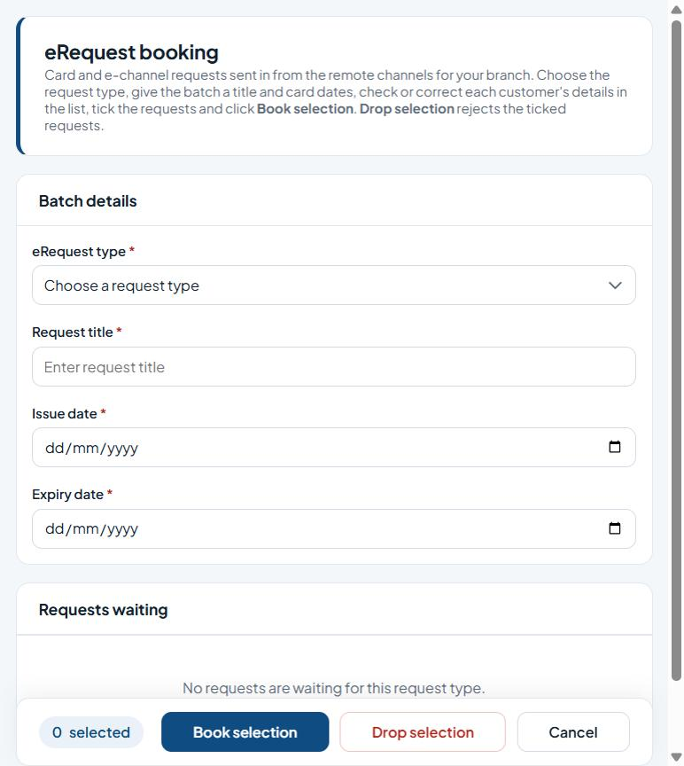
Figure 43: eRequest booking

Fields
Field | Type | Description
eRequest type * | Drop-down list | Required. Choose the type from the list.
Request title * | Text | Required. A short name for the request batch.
Issue date * | Date picker | Required. Start (or issue) date.
Expiry date * | Date picker | Required. End (or expiry) date.
List columns: Branch, Track id, Account no, Display name, Product, Date of birth, Address, City, Phone no, Transaction status, Account status.

Buttons and actions
Button | What it does
Book selection | Book the ticked requests into a new batch.
Drop selection | Remove the ticked items (you are asked to confirm).
Cancel | Discard and clear the selection.

How to use this screen
- Choose the eRequest type. The waiting requests are listed, grouped by branch.
- Enter the Request title and the Issue date and Expiry date (expiry must be after issue).
- Check each customer's display name, address, city, phone and date of birth and correct them in the list if needed.
- Tick the requests and click Book selection. They are booked into a new batch (the reference is shown) and marked booked.
- To reject requests, tick them and click Drop selection. Cancel reloads the page.

7.9 Cards Confirmation / Cards Maintenance
Menu path: Menu > Card Management > Cards Confirmation
Purpose: Confirms the cards produced for a batch (also opened from the Cards Maintenance menu item).
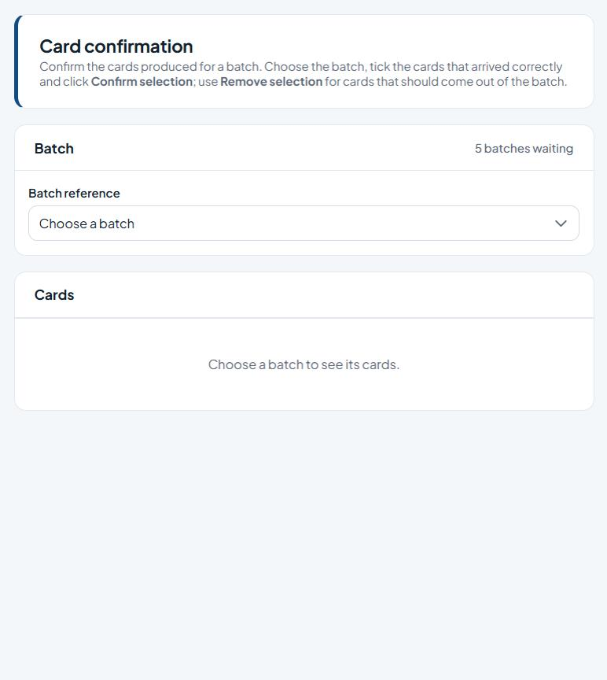
Figure 44: Card confirmation

Fields
Field | Type | Description
Batch reference | Drop-down list | The batch to work on.
List columns: Account no, Card display name, Product, Pan, Issued, Expires, Issue count, Address.

Buttons and actions
Button | What it does
Confirm selection | Confirm (or link) the ticked cards.
Remove selection | Take the ticked cards out of the batch.
Cancel | Discard and clear the selection.

How to use this screen
- Choose the Batch reference.
- Tick the cards that arrived correctly and click Confirm selection.
- Tick cards that should come out of the batch and click Remove selection.
- Cancel clears the selection.

7.10 Cards Allocation
Menu path: Menu > Card Management > Cards Allocation
Purpose: Links the cards allocated to you to customer accounts.
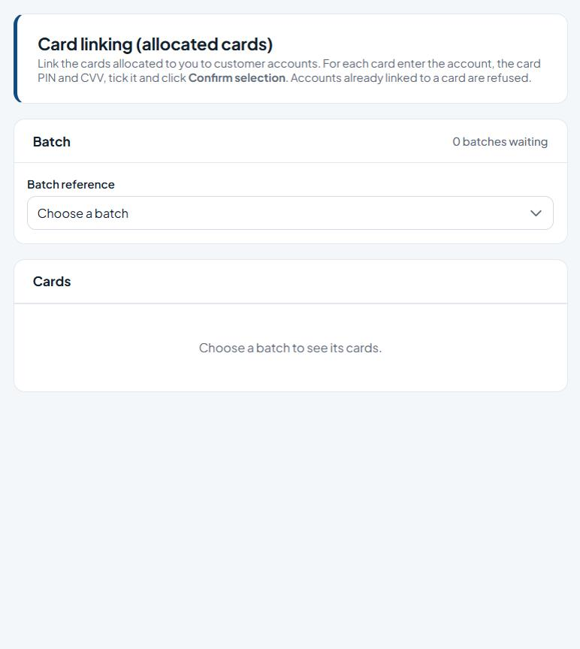
Figure 45: Card linking (allocated cards)

Fields
Field | Type | Description
Batch reference | Drop-down list | The batch to work on.
List columns: Account no, Card display name, Product, Pan, Card pin, Cvv, Issued, Expires, Link account.

Buttons and actions
Button | What it does
Confirm selection | Confirm (or link) the ticked cards.
Cancel | Discard and clear the selection.

How to use this screen
- Choose the Batch reference.
- For each card, enter the Link account, Card PIN and CVV.
- Tick the cards and click Confirm selection. Accounts already linked to a card are refused and listed in the message.

7.11 Cards DeAllocation
Menu path: Menu > Card Management > Cards DeAllocation
Purpose: Takes allocated cards back from branch officers; the cards return to the pool for allocation again.
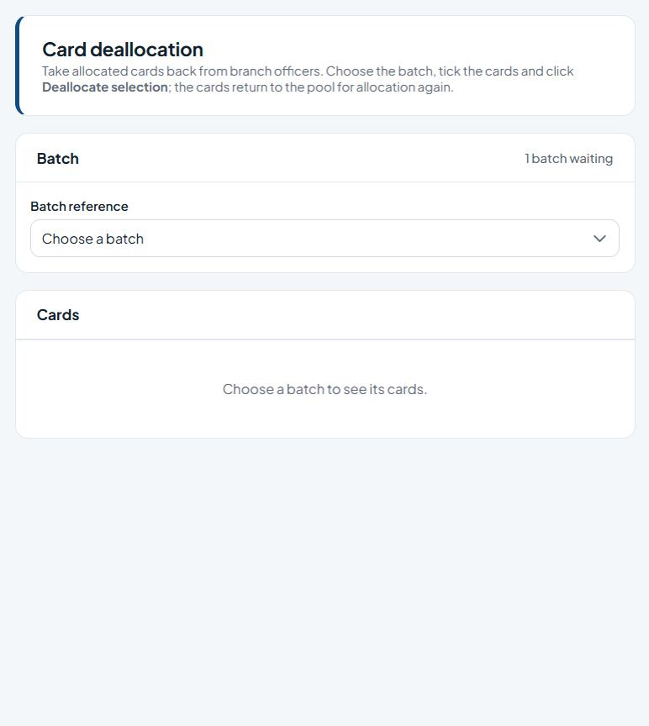
Figure 46: Card deallocation

Fields
Field | Type | Description
Batch reference | Drop-down list | The batch to work on.
List columns: Account no, Card display name, Product, Pan, Issued, Expires, Officer.

Buttons and actions
Button | What it does
Deallocate selection | Return the ticked cards to the pool.
Cancel | Discard and clear the selection.

How to use this screen
- Choose the Batch reference. The Officer column shows who holds each card.
- Tick the cards and click Deallocate selection.

8. Broadcast
Bulk e-mail and SMS notifications to customers, statement e-mails (immediate or scheduled), and the upload of terminal (POS) settlement files.

8.1 Bulk Email
Menu path: Menu > Broadcast > Bulk Email
Purpose: Sends a bulk e-mail to customers chosen by product and branch, or by a pasted list of accounts. Placeholders in the message are filled in for each account.
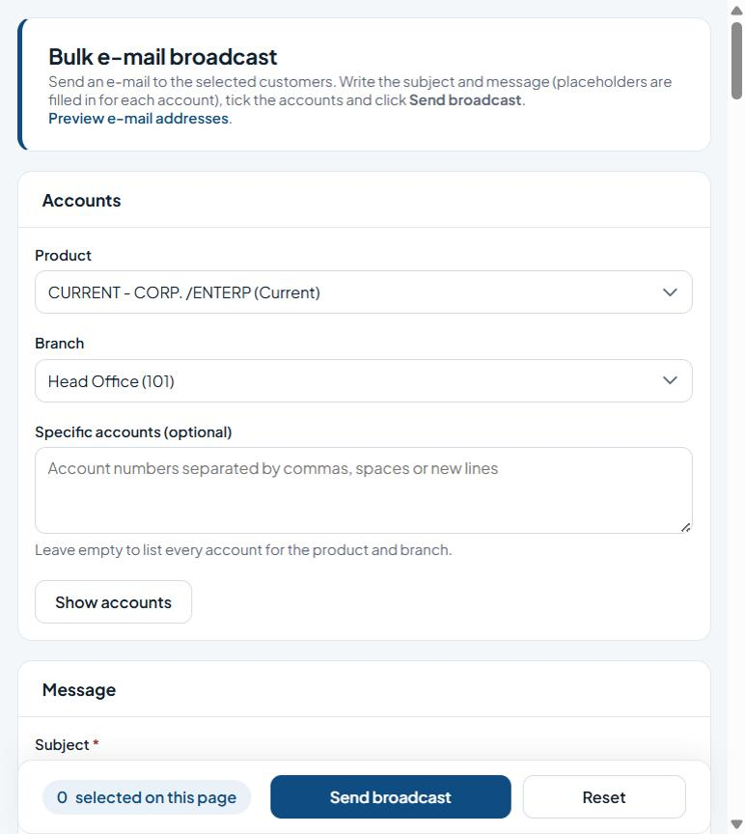
Figure 47: Bulk e-mail broadcast

Fields
Field | Type | Description
Product | Drop-down list | Account product to select customers by.
Branch | Drop-down list | The bank branch.
Specific accounts (optional) | Multi-line text | Enter the specific accounts (optional).
Subject * | Text | Required. Enter the subject.
Plain message / HTML message | Option buttons | Choose plain-text or HTML formatting.
Message * | Multi-line text | Required. Enter the message.
Send to every listed account (all pages) | Tick box | Tick to enable.
List columns: Account no, Account name, Product, Date of birth, Address, City, Book bal, Cleared bal, Transaction status, Account status.

Buttons and actions
Button | What it does
Show accounts | List the accounts for the chosen product and branch (or the pasted accounts).
Send broadcast | Send the message to the ticked (or all listed) accounts.
Reset | Clear the form, or apply the chosen reset to the ticked users.

How to use this screen
- Under Accounts choose Product and Branch (or paste Specific accounts) and click Show accounts.
- Enter the Subject, choose Plain message or HTML message and write the Message.
- Tick the recipients, or tick Send to every listed account (all pages).
- Click Send broadcast. The result shows how many were sent and lists any that failed (for example, no valid e-mail address).
- Reset clears the page.

8.2 Bulk SMS
Menu path: Menu > Broadcast > Bulk SMS
Purpose: Sends a bulk SMS to the selected customers, optionally charging the SMS fee to their accounts.
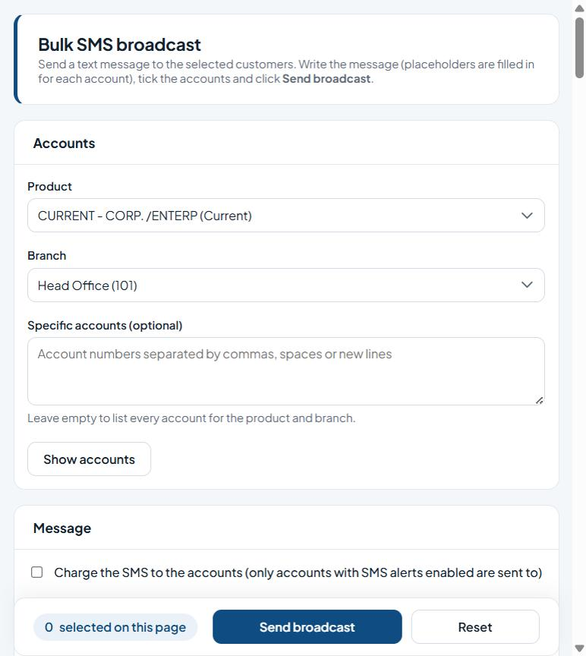
Figure 48: Bulk SMS broadcast

Fields
Field | Type | Description
Product | Drop-down list | Account product to select customers by.
Branch | Drop-down list | The bank branch.
Specific accounts (optional) | Multi-line text | Enter the specific accounts (optional).
Charge the SMS to the accounts | Tick box | Tick to enable.
Message * | Multi-line text | Required. Enter the message.
Send to every listed account (all pages) | Tick box | Tick to enable.
List columns: Account no, Account name, Product, Date of birth, Address, City, Book bal, Cleared bal, Transaction status, Account status.

Buttons and actions
Button | What it does
Show accounts | List the accounts for the chosen product and branch (or the pasted accounts).
Send broadcast | Send the message to the ticked (or all listed) accounts.
Reset | Clear the form, or apply the chosen reset to the ticked users.

How to use this screen
- Choose Product and Branch (or paste Specific accounts) and click Show accounts.
- Tick Charge the SMS to the accounts if customers should pay for the message (only accounts with SMS alerts switched on are then sent to).
- Write the Message.
- Tick the recipients (or Send to every listed account) and click Send broadcast. The counter at the bottom shows how many are ticked on the page.

8.3 eTransactions Upload
Menu path: Menu > Broadcast > eTransactions Upload
Purpose: Uploads a tab-separated POS settlement file (terminal transactions) and posts it for approval.
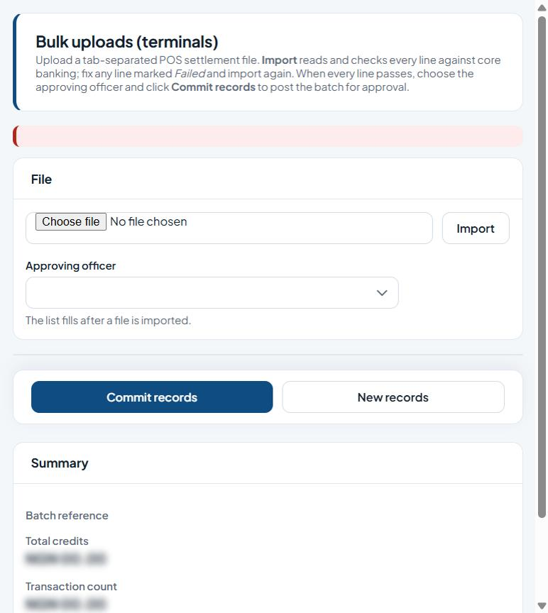
Figure 49: Bulk uploads (terminals)

Fields
Field | Type | Description
Settlement file | File picker | Enter the settlement file.
Approving officer | Drop-down list | The officer who will approve the upload.

Buttons and actions
Button | What it does
Import | Read and check the chosen file.
Commit records | Post the imported batch for approval.
New records | Clear the screen for a new upload.

How to use this screen
- Click Choose file and pick the settlement file, then click Import.
- Every line is checked against core banking. The Summary shows the batch reference, total credits, transaction count and failed count. Fix any line marked Failed in the file and import again.
- When every line passes, choose the Approving officer (the list fills after an import).
- Click Commit records to post the batch for approval, or New records to start again.

8.4 E-statements
Menu path: Not on the menu: open eOperations/eStatement.aspx (or add it to a role)
Purpose: E-mails each selected customer a password-protected PDF statement for the chosen period.
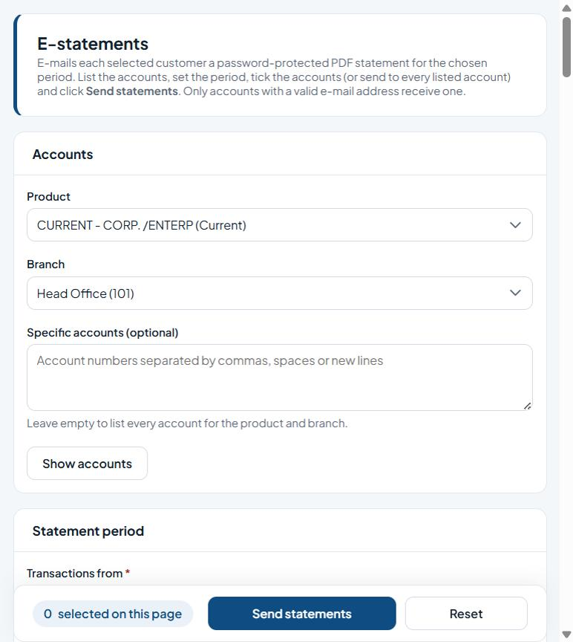
Figure 50: E-statements

Fields
Field | Type | Description
Product | Drop-down list | Account product to select customers by.
Branch | Drop-down list | The bank branch.
Specific accounts (optional) | Multi-line text | Enter the specific accounts (optional).
Transactions from * | Date picker | Required. Enter the transactions from.
Transactions to * | Date picker | Required. Enter the transactions to.
Statement type | Drop-down list | Choose the type from the list.
Send to every listed account (all pages) | Tick box | Tick to enable.
List columns: Account no, Account name, Product, Date of birth, Address, City, Book bal, Cleared bal, Transaction status, Account status.

Buttons and actions
Button | What it does
Show accounts | List the accounts for the chosen product and branch (or the pasted accounts).
Send statements | E-mail statements to the ticked (or all listed) accounts.
Reset | Clear the form, or apply the chosen reset to the ticked users.

How to use this screen
- Choose Product and Branch (or paste Specific accounts) and click Show accounts.
- Under Statement period set Transactions from and Transactions to, or choose a Statement type (for example Monthly) to fill the dates.
- Tick the accounts, or tick Send to every listed account.
- Click Send statements. Only accounts with a valid e-mail address receive one; the result lists any that were skipped.

8.5 Account statements by e-mail
Menu path: Not on the menu: open eOperations/FrmBulkEmails.aspx (or add it to a role)
Purpose: Same as E-statements: e-mails password-protected PDF statements to the selected accounts.
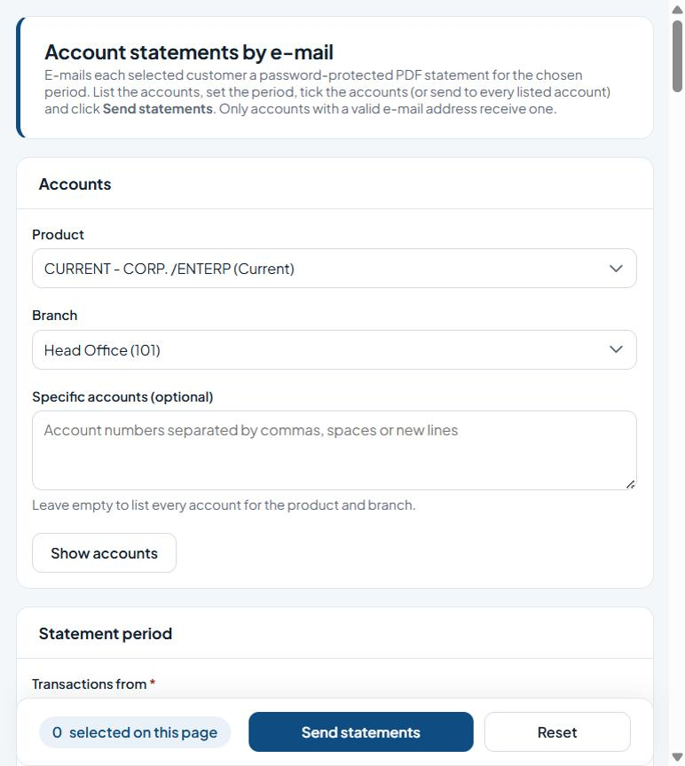
Figure 51: Account statements by e-mail

Fields
Field | Type | Description
Product | Drop-down list | Account product to select customers by.
Branch | Drop-down list | The bank branch.
Specific accounts (optional) | Multi-line text | Enter the specific accounts (optional).
Transactions from * | Date picker | Required. Enter the transactions from.
Transactions to * | Date picker | Required. Enter the transactions to.
Statement type | Drop-down list | Choose the type from the list.
Send to every listed account (all pages) | Tick box | Tick to enable.
List columns: Account no, Account name, Product, Date of birth, Address, City, Book bal, Cleared bal, Transaction status, Account status.

Buttons and actions
Button | What it does
Show accounts | List the accounts for the chosen product and branch (or the pasted accounts).
Send statements | E-mail statements to the ticked (or all listed) accounts.
Reset | Clear the form, or apply the chosen reset to the ticked users.

How to use this screen
- List the accounts with Show accounts.
- Set the period (or a Statement type).
- Tick the accounts (or all listed) and click Send statements.

8.6 Account statement notifications
Menu path: Not on the menu: open eOperations/FrmNstatements.aspx (or add it to a role)
Purpose: Statement notifications: e-mails password-protected PDF statements to the selected accounts.
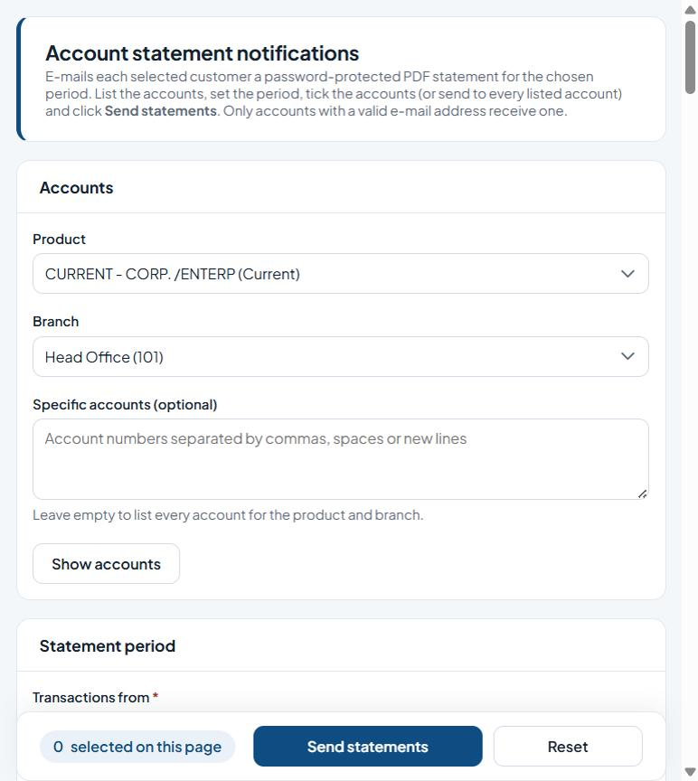
Figure 52: Account statement notifications

Fields
Field | Type | Description
Product | Drop-down list | Account product to select customers by.
Branch | Drop-down list | The bank branch.
Specific accounts (optional) | Multi-line text | Enter the specific accounts (optional).
Transactions from * | Date picker | Required. Enter the transactions from.
Transactions to * | Date picker | Required. Enter the transactions to.
Statement type | Drop-down list | Choose the type from the list.
Send to every listed account (all pages) | Tick box | Tick to enable.
List columns: Account no, Account name, Product, Date of birth, Address, City, Book bal, Cleared bal, Transaction status, Account status.

Buttons and actions
Button | What it does
Show accounts | List the accounts for the chosen product and branch (or the pasted accounts).
Send statements | E-mail statements to the ticked (or all listed) accounts.
Reset | Clear the form, or apply the chosen reset to the ticked users.

How to use this screen
- List the accounts with Show accounts.
- Set the period (or a Statement type).
- Tick the accounts (or all listed) and click Send statements.

8.7 Statement e-mail scheduler
Menu path: Not on the menu: open eOperations/FrmShedBulkEmail.aspx (or add it to a role)
Purpose: Schedules statement e-mails to be sent later by the scheduler, once or for every period.
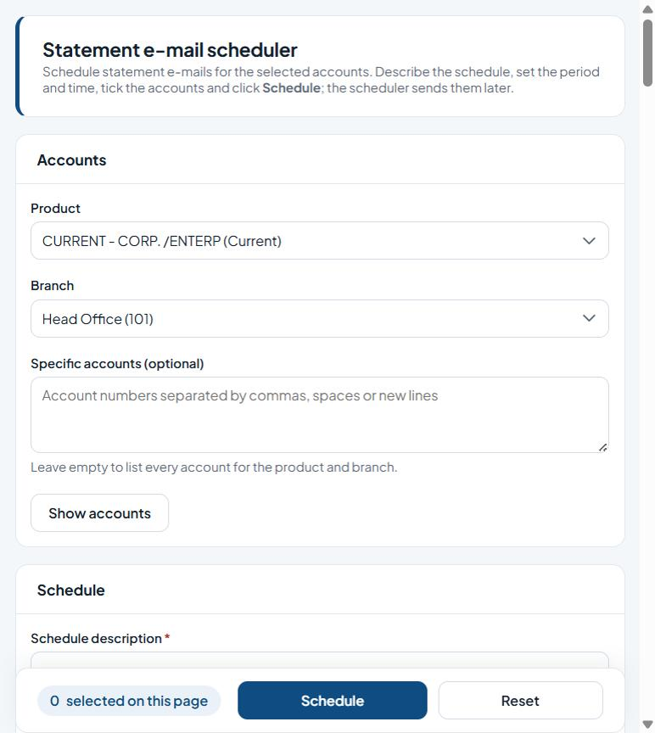
Figure 53: Statement e-mail scheduler

Fields
Field | Type | Description
Product | Drop-down list | Account product to select customers by.
Branch | Drop-down list | The bank branch.
Specific accounts (optional) | Multi-line text | Enter the specific accounts (optional).
Schedule description * | Text | Required. Free-text description.
Transactions from * | Date picker | Required. Enter the transactions from.
Transactions to * | Date picker | Required. Enter the transactions to.
Statement type | Drop-down list | Choose the type from the list.
Send at | Time picker | Enter the send at.
Recurrent (repeat for every period) | Tick box | Tick to enable.
Schedule every listed account (all pages) | Tick box | Tick to enable.
List columns: Account no, Account name, Product, Date of birth, Address, City, Book bal, Cleared bal, Transaction status, Account status.

Buttons and actions
Button | What it does
Show accounts | List the accounts for the chosen product and branch (or the pasted accounts).
Schedule | Save the schedule for the ticked (or all listed) accounts.
Reset | Clear the form, or apply the chosen reset to the ticked users.

How to use this screen
- List the accounts with Show accounts.
- Under Schedule enter a Schedule description, the period (or Statement type) and the Send at time.
- Tick Recurrent to repeat the schedule for every period.
- Tick the accounts (or Schedule every listed account) and click Schedule.

9. eBranch Management
Branch-level requests for customers' cards and e-channels.

9.1 eChannels Requistion
Menu path: Menu > eBranch Management > eChannels Requistion
Purpose: Branch staff raise card and e-channel requests for customers and submit them for approval.
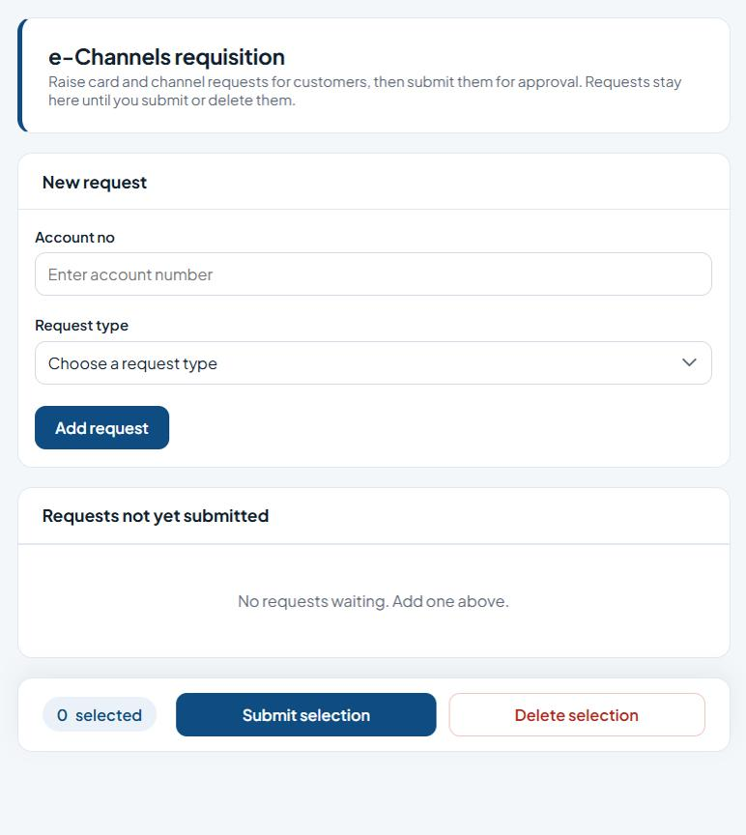
Figure 54: e-Channels requisition

Fields
Field | Type | Description
Account no | Text | The customer account number (validated against the core banking system).
Request type | Drop-down list | Choose the type from the list.
Select (per request) | Tick box | Tick to include the row(s) in the next action.

Buttons and actions
Button | What it does
Add request | Add the request to the pending list.
Submit selection | Send the ticked items for approval.
Delete selection | Remove the ticked items.

How to use this screen
- Enter the customer's Account no and choose the Request type.
- Click Add request. It appears under Requests not yet submitted.
- Tick the requests and click Submit selection to send them to Approval > Approve eChannels Request, or Delete selection to remove them.
Note: Raise card and channel requests for customers, then submit them for approval. Requests stay here until you submit or delete them.

10. eChannels Management
Activation of new customer e-channel subscriptions.

10.1 eChannels Activation
Menu path: Menu > eChannels Management > eChannels Activation
Purpose: Activates new e-subscriptions (customer self-registrations) waiting for activation.
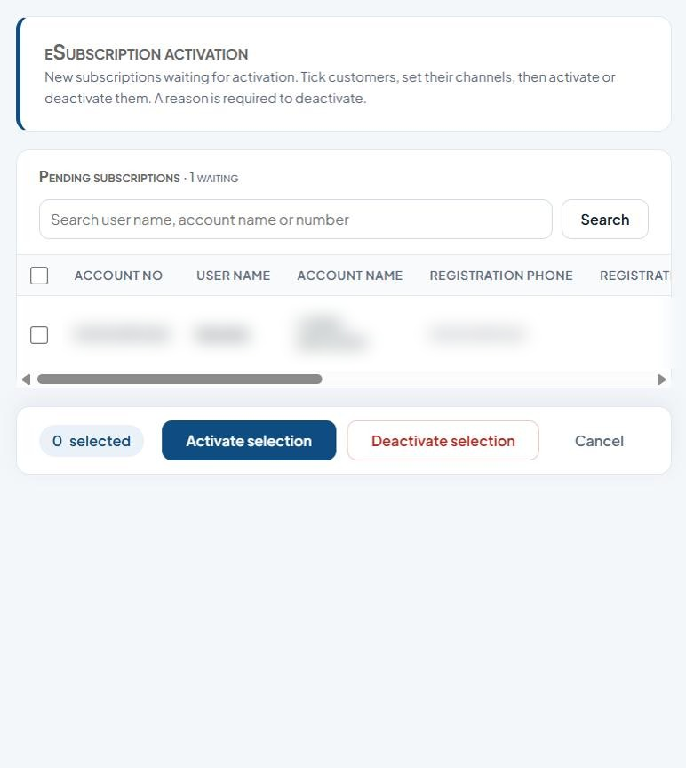
Figure 55: eSubscription activation

Fields
Field | Type | Description
Search user name, account name or number | Text | Text to search for.
Select all / Select (per customer) | Tick box | Tick to include the row(s) in the next action.
Mobile / iPortal (per customer) | Tick box | Tick to enable.
Reason (needed to deactivate) | Multi-line text | Explanation for the action; required when rejecting, disapproving, deactivating or clearing settings.
List columns: Account no, User name, Account name, Registration phone, Registration address, Date of birth, Gender, Mobile, Iportal, Reason.

Buttons and actions
Button | What it does
Search | Run the search.
Activate selection | Activate the ticked items.
Deactivate selection | Deactivate the ticked customers (reason required).
Cancel | Discard and clear the selection.

How to use this screen
- Search by user name, account name or number.
- Tick the customer(s) and set their channels (Mobile, iPortal).
- Click Activate selection, or enter a reason and click Deactivate selection.

11. Revenue Collection
Lagos State revenue collection by tellers.

11.1 Pay Lagos State Bills
Menu path: Menu > Revenue Collection > Pay Lagos State Bills
Purpose: Lets tellers pay Lagos State bills that have already been assessed (billed), through the Lagos State revenue collection service.
Note: The page could not be opened in the test environment: the Lagos State revenue service it connects to (98.71.64.150) did not respond. It requires a live connection to the revenue collection service. A screenshot and field list will be added once the service is reachable.

11.2 Generate Lagos State Bills
Menu path: Menu > Revenue Collection > Generate Lagos State Bills
Purpose: Lets tellers generate a Lagos State bill (unbilled payment) for a taxpayer and collect it.
Note: The page could not be opened in the test environment: the Lagos State revenue service it connects to (98.71.64.150) did not respond. It requires a live connection to the revenue collection service. A screenshot and field list will be added once the service is reachable.

12. Direct Debit
NIBSS Direct Debit (NDD): billers, biller products, customer e-mandates and mandate status.

12.1 Create Biller Product (NDD)
Menu path: Menu > Direct Debit > Create Biller Product
Purpose: Sets up a customer biller together with its product title for NIBSS Direct Debit. New records go for approval.
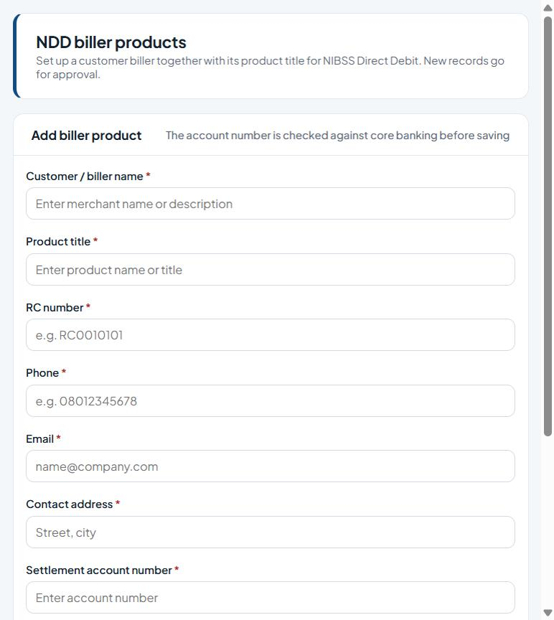
Figure 56: NDD biller products

Fields
Field | Type | Description
Customer / biller name * | Text | Required. Enter the customer / biller name.
Product title * | Text | Required. Enter the product title.
RC number * | Text | Required. Enter the RC number.
Phone * | Phone number | Required. Contact phone number.
Email * | E-mail address | Required. Contact e-mail address.
Contact address * | Text | Required. Enter the contact address.
Settlement account number * | Text | Required. Enter the settlement account number.
List columns: Customer / biller, Product, Rc number, Phone, Email, Address, Account no, Account name, Biller id, Status.

Buttons and actions
Button | What it does
Add biller product | Save the new biller product (the account is checked first).
Clear | Clear the form without saving.

How to use this screen
- Enter the Customer / biller name, Product title, RC number, Phone, Email, Contact address and Settlement account number.
- Click Add biller product. The account number is checked against core banking before saving.
- The record appears in the Biller products list with its biller ID and status.

12.2 Create Biller (NDD) / Create Product (NDD)
Menu path: Menu > Direct Debit > Create Biller
Purpose: Sets up the merchants (billers) that collect payments through NIBSS Direct Debit. New billers go for approval; once approved, use Products to create the biller's NIBSS products.
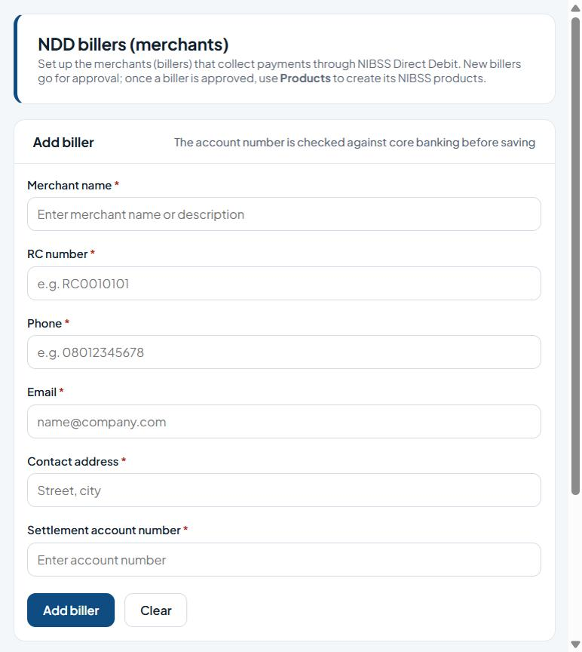
Figure 57: NDD billers (merchants)

Fields
Field | Type | Description
Merchant name * | Text | Required. Enter the merchant name.
RC number * | Text | Required. Enter the RC number.
Phone * | Phone number | Required. Contact phone number.
Email * | E-mail address | Required. Contact e-mail address.
Contact address * | Text | Required. Enter the contact address.
Settlement account number * | Text | Required. Enter the settlement account number.
List columns: Merchant, Rc number, Phone, Email, Address, Account no, Account name, Biller id, Status.

Buttons and actions
Button | What it does
Add biller | Save the new biller.
Clear | Clear the form without saving.
Products | Open the products of an approved biller.

How to use this screen
- Under Add biller enter the Merchant name, RC number, Phone, Email, Contact address and Settlement account number (all required).
- Click Add biller. The account number is checked against core banking before saving; the biller appears in the Billers list with its status.
- When a biller is approved, click Products on its row to set up its products.
- Clear empties the form.

12.3 eMandate Status Query (NDD)
Menu path: Menu > Direct Debit > eMandate Status Query
Purpose: Lists approved e-mandates, checks their status with NIBSS and sends mandates the bank has approved for recovery. It can also run automatically on a schedule.
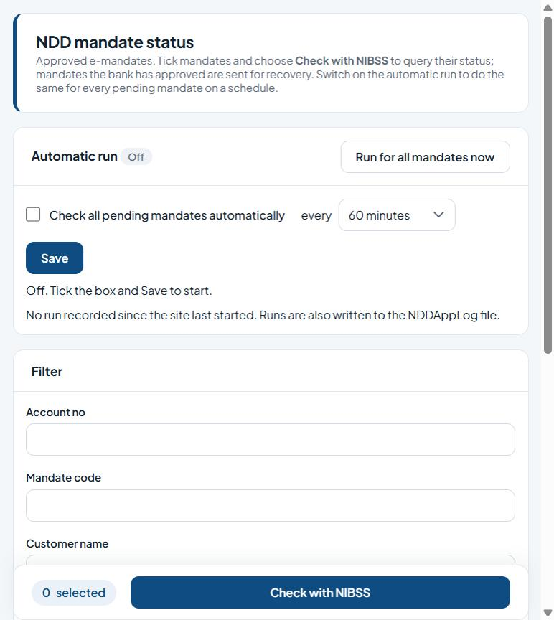
Figure 58: NDD mandate status

Fields
Field | Type | Description
Check all pending mandates automatically | Tick box | Tick to include the row(s) in the next action.
Every (minutes) | Drop-down list | Choose a value from the list.
Account no | Text | The customer account number (validated against the core banking system).
Mandate code | Text | Unique code/identifier.
Customer name | Text | Enter the customer name.
Date from | Date picker | Start (or issue) date.
Date to | Date picker | End (or expiry) date.
Narration contains | Text | Free-text description.
List columns: Mandate code, Account no, Customer name, Amount, Narration, Created, Sent, Next due, Status.

Buttons and actions
Button | What it does
Run for all mandates now | Check every pending mandate with NIBSS immediately.
Save | Save the changes.
Apply filter | Show only mandates matching the filter.
Clear | Clear the form without saving.
Check with NIBSS | Query the status of the ticked mandates with NIBSS.

How to use this screen
- Use the Filter (account no, mandate code, customer name, dates, narration) and click Apply filter.
- Tick mandates and click Check with NIBSS to query them now.
- To automate, tick Check all pending mandates automatically, choose how often (every …), and click Save. The status badge shows On or Off.
- Run for all mandates now checks every pending mandate at once. Each run is written to the NDDAppLog file.

12.4 Create eMandate (NDD)
Menu path: Menu > Direct Debit > Create eMandate
Purpose: Captures a customer's direct-debit mandate: who pays, from which bank account, how much and for how long. New and edited mandates go to Approval > NDD e-mandate approval; approved mandates cannot be changed or deleted.
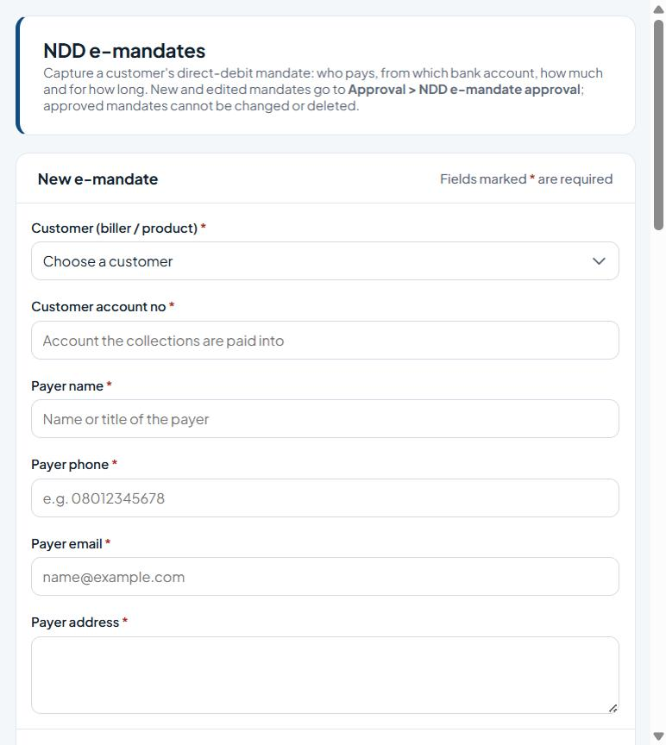
Figure 59: NDD e-mandates

Fields
Field | Type | Description
Customer (biller / product) * | Drop-down list | Required. Choose a value from the list.
Customer account no * | Text | Required. The customer account number (validated against the core banking system).
Payer name * | Text | Required. Enter the payer name.
Payer phone * | Phone number | Required. Contact phone number.
Payer email * | E-mail address | Required. Contact e-mail address.
Payer address * | Multi-line text | Required. Enter the payer address.
Bank * | Drop-down list | Required. Choose a value from the list.
Payer account no * | Text | Required. Enter the payer account no.
Amount (NGN) * | Number | Required. Amount in Naira (NGN).
Frequency (months) * | Number | Required. Enter the frequency (months).
Fixed amount mandate | Tick box | Amount in Naira (NGN).
Start date * | Date picker | Required. Start (or issue) date.
End date | Read-only | End (or expiry) date.
Narration * | Multi-line text | Required. Free-text description.
List columns: Payer, Payer account, Payer account name, Bank, Customer account, Amount, Months, Start, End, Fixed, Narration, Status.

Buttons and actions
Button | What it does
Save mandate | Save the e-mandate and send it for approval.
Clear | Clear the form without saving.
Edit | Edit the row.
Delete | Delete the record (cannot be undone).

How to use this screen
- Choose the Customer (biller / product) and enter the Customer account no that collections are paid into.
- Enter the Payer name, phone, e-mail and address.
- Under Payer's bank account choose the Bank and enter the Payer account no.
- Under Amount and period enter the Amount (NGN), Frequency (months) and Start date; the End date is worked out for you. Tick Fixed amount mandate if the amount never changes.
- Enter the Narration and click Save mandate.
- Use Edit or Delete in the E-mandates list for mandates that are not yet approved.

12.5 Bulk Status Query Push (NDD)
Menu path: Menu > Direct Debit > Bulk Status Query Push
Purpose: Checks every approved e-mandate that is waiting (status 3) with NIBSS in one run. Mandates NIBSS reports as Bank Approved are sent for recovery straight away.
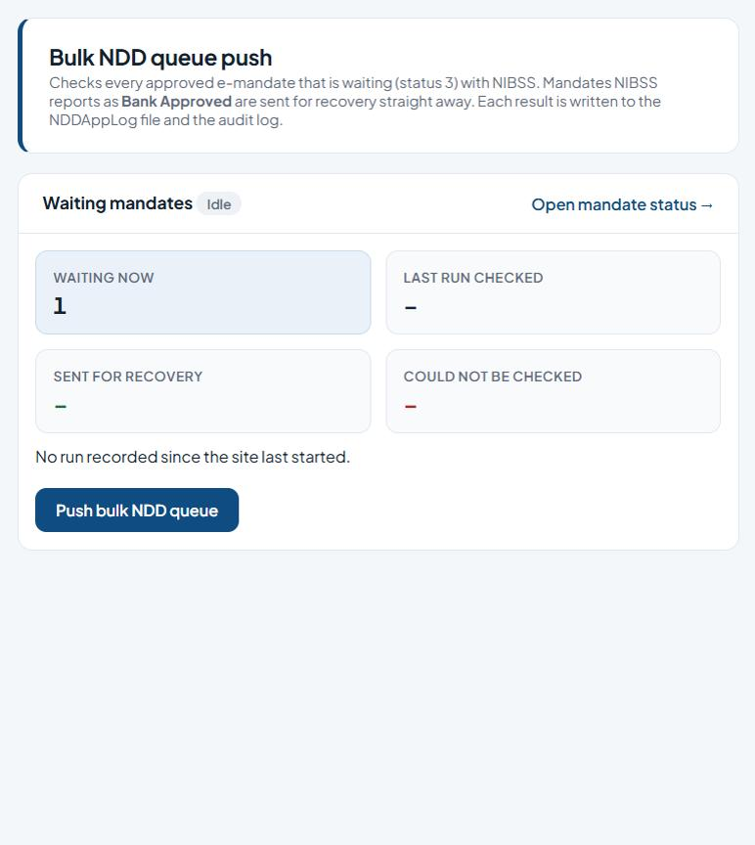
Figure 60: Bulk NDD queue push

Buttons and actions
Button | What it does
Push bulk NDD queue | Check every waiting mandate with NIBSS now.
Open mandate status | Open the NDD mandate status screen.

How to use this screen
- Check Waiting now for the number of mandates in the queue.
- Click Push bulk NDD queue.
- When the run finishes, the cards show how many were checked, sent for recovery and could not be checked. Each result is written to the NDDAppLog file and the audit log.
- Click Open mandate status to see individual mandates.

13. eOperations
Funds transfers, bulk transfers, external journal uploads and transaction reconciliation.

13.1 Transaction Reconciliation
Menu path: Menu > eOperations > Transaction Reconciliation
Purpose: Reconciles transaction batches: select transactions until the reconciliation difference is zero, then post.
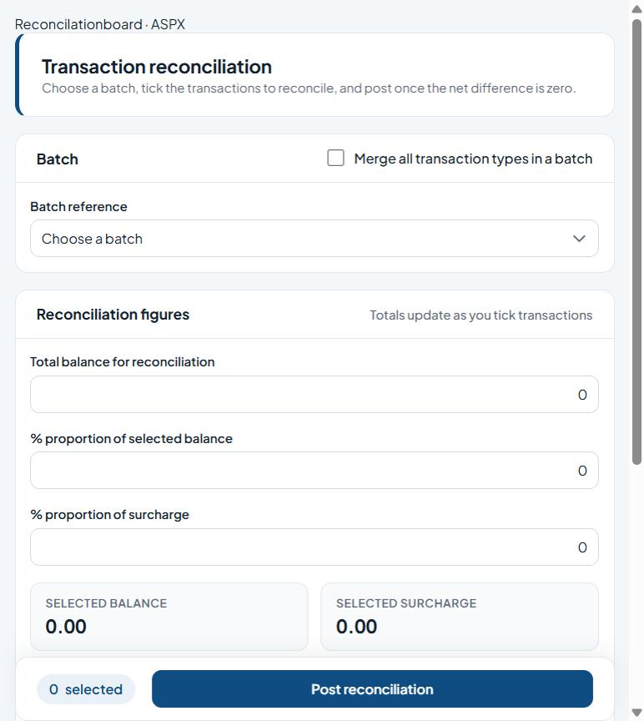
Figure 61: Transaction reconciliation

Fields
Field | Type | Description
Merge all transaction types in a batch | Tick box | Choose the type from the list.
Batch reference | Drop-down list | The batch to work on.
Total balance for reconciliation | Number | Enter the total balance for reconciliation.
% proportion of selected balance | Number | Enter the % proportion of selected balance.
% proportion of surcharge | Number | Enter the % proportion of surcharge.
Selected balance / Selected surcharge / Fee-only surcharge / Difference | Read-only | Tick to include the row(s) in the next action.
Select (per transaction) | Tick box | Tick to include the row(s) in the next action.

Buttons and actions
Button | What it does
Post reconciliation | Post the reconciliation (only when the difference is zero).

How to use this screen
- Choose the Batch reference. Tick Merge all transaction types in a batch if required.
- Enter the Total balance for reconciliation and the % proportions of balance and surcharge.
- Tick transactions in the list. Selected balance, selected surcharge, fee-only surcharge and difference update as you tick.
- When the difference is zero, click Post reconciliation.
Note: Choose a batch, tick the transactions to reconcile; totals update as you tick. Post once the net difference is zero.

13.2 Single FundsTransfer
Menu path: Menu > eOperations > Single FundsTransfer
Purpose: Makes a single funds transfer to another bank through NAPS.
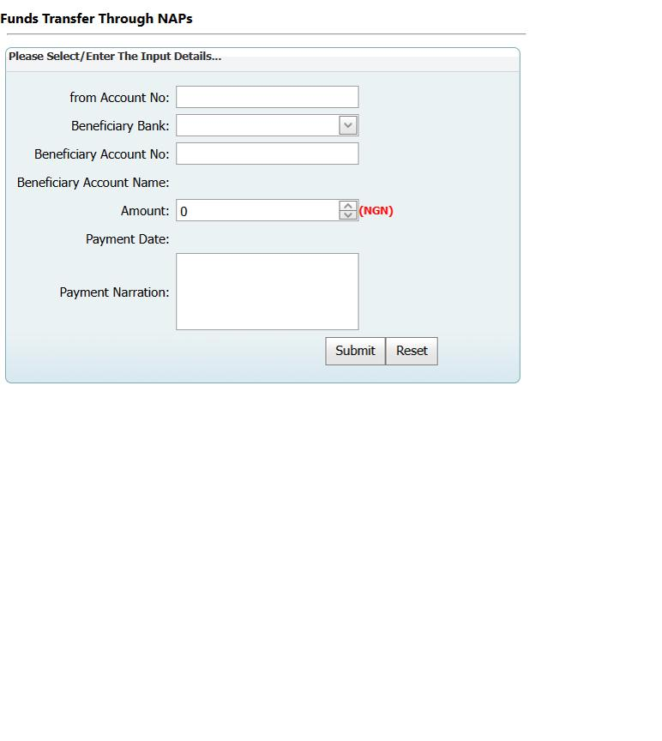
Figure 62: Funds Transfer Through NAPs

Fields
Field | Type | Description
From Account No | Text | The customer account number (validated against the core banking system).
Beneficiary Bank | Drop-down list | Choose a value from the list.
Beneficiary Account No | Text | Enter the beneficiary Account No.
Beneficiary Account Name | Read-only | Filled in automatically.
Amount (NGN) | Number | Amount in Naira (NGN).
Payment Date | Read-only | Filled in automatically.
Payment Narration | Multi-line text | Free-text description.

Buttons and actions
Button | What it does
Submit | Submit the form.
Reset | Clear the form, or apply the chosen reset to the ticked users.

How to use this screen
- Enter the From Account No.
- Choose the Beneficiary Bank and enter the Beneficiary Account No. The account name is looked up and shown.
- Enter the Amount (NGN) and the Payment Narration.
- Click Submit. Reset clears the form.

13.3 Bulk FundsTransfer
Menu path: Menu > eOperations > Bulk FundsTransfer
Purpose: Uploads a bulk funds-transfer file as a batch for approval.
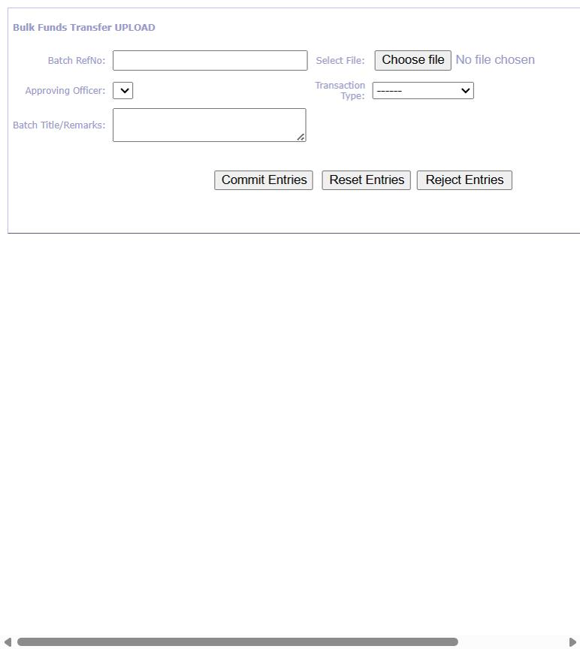
Figure 63: Bulk Funds Transfer Upload

Fields
Field | Type | Description
Batch RefNo | Text | The batch to work on.
Select File | File picker | Tick to include the row(s) in the next action.
Approving Officer | Drop-down list | The officer who will approve the upload.
Transaction Type | Drop-down list | Choose the type from the list.
Batch Title/Remarks | Multi-line text | Free-text description.

Buttons and actions
Button | What it does
Import Entries | Read the chosen bulk file.
Commit Entries | Submit the batch for approval.
Reset Entries | Clear the imported entries.
Reject Entries | Discard the imported batch.

How to use this screen
- Enter the Batch RefNo and Batch Title/Remarks.
- Choose the Transaction Type and the Approving Officer.
- Click Choose file and select the bulk file, then import it.
- Review the entries and click Commit Entries. Use Reset Entries to start again or Reject Entries to discard.
- The batch is approved under Approval > Approve Bulk Payments.
Note: Committed batches are approved under Approval > Approve Bulk Payments.

13.4 External journal entries upload
Menu path: Not on the menu: open eOperations/TransImportsExt.aspx (or add it to a role)
Purpose: Uploads external journal entries as a batch for approval.
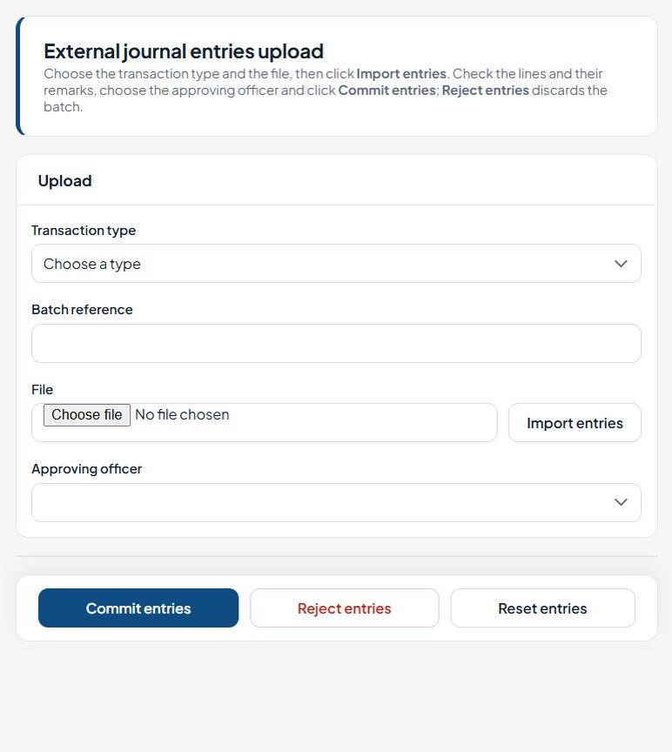
Figure 64: External journal entries upload

Fields
Field | Type | Description
Transaction type | Drop-down list | Choose the type from the list.
Batch reference | Text | The batch to work on.
File | File picker | Enter the file.
Approving officer | Drop-down list | The officer who will approve the upload.

Buttons and actions
Button | What it does
Import entries | Read the chosen file.
Commit entries | Submit the batch for approval.
Reject entries | Discard the imported batch.
Reset entries | Clear the imported entries.

How to use this screen
- Choose the Transaction type and enter the Batch reference.
- Choose the File and click Import entries. Check the imported lines and their remarks.
- Choose the Approving officer and click Commit entries.
- Reject entries discards the imported batch; Reset entries clears the page.

13.5 Reconciliation Maint.
Menu path: Menu > eOperations > Reconciliation Maint.
Purpose: Removes (drops) transactions from a reconciliation batch.
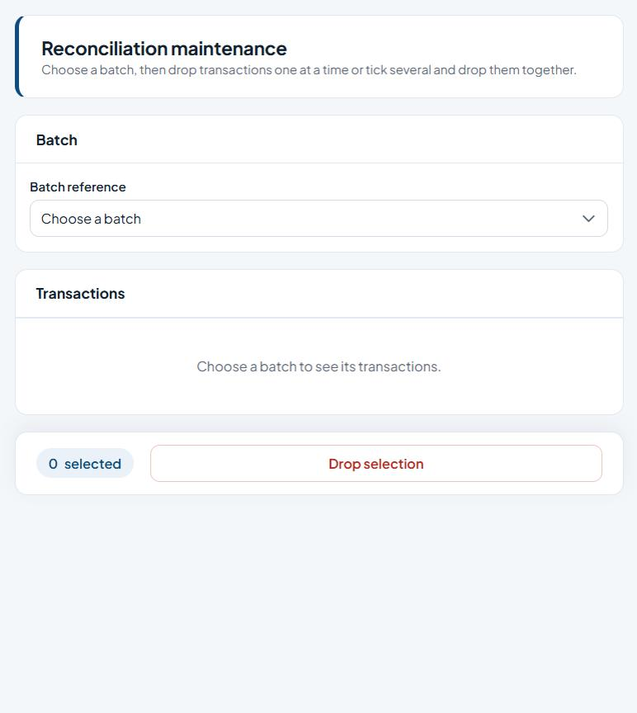
Figure 65: Reconciliation maintenance

Fields
Field | Type | Description
Batch reference | Drop-down list | The batch to work on.
Select (per transaction) | Tick box | Tick to include the row(s) in the next action.

Buttons and actions
Button | What it does
Drop | Remove that transaction from the batch.
Drop selection | Remove the ticked items (you are asked to confirm).

How to use this screen
- Choose the Batch reference to list its transactions.
- Drop transactions one at a time, or tick several and click Drop selection.
Note: Choose a batch, then drop transactions one at a time or tick several and drop them together.

Appendix A. Common controls

A.1 Data grids
- Tick the box at the start of a row to select it; the box in the header row ticks every row on the page.
- Where shown, tick the "every page" / "all listed accounts" option to include rows on all pages, not just the one on screen.
- The bar at the bottom of the screen shows how many rows are ticked and holds the main buttons.
- Use the page numbers under the list to move between pages.
- Actions that change or remove data ask you to confirm first. The result appears as a green or red message at the top; rows that failed are listed with the reason.
- Some older screens still use the previous grid, where you can drag a column header to group rows and click Create Filter to filter.

A.2 Report viewer toolbar
Control | Use
First / Previous / Next / Last and page box | Move between report pages.
Refresh | Re-run the report.
Back | Return to the parent report (drill-through).
Zoom (100%) | Change the report size.
Save (disk) menu | Export the report, e.g. to PDF, Excel or Word.

A.3 Signing out and security
- Always click Log out when you finish, especially on shared computers.
- Never share your user ID or password. If your account is locked, ask an administrator to use Administration > Reset User Profile.
- You only see the menu items allowed by your role (Administration > Roles & Permissions).

Appendix B. Menu index
Every menu item, the screen it opens and its page address (relative to the site root).
Module | Menu item | Page
Manage Account | Home (Subscribe to products / payment details) | /Processing/HomeDefault.aspx
Administration | Setup Fees | /eOperations/ebankRatesSetup.aspx
Administration | Terminal Registration | /eOperations/TerminalRegForm.aspx
Administration | Setup Transaction Profile | /eOperations/FTTransTypeSetup.aspx
Administration | USSD Onboarding | /Processing/FrmUsersOnboard.aspx
Administration | Profile Maintenance | /Administration/eUserProfileMgt.aspx
Administration | User Profile | /Processing/Frm_Users.aspx
Administration | Profile Activation | /Administration/ActivateProfile.aspx
Administration | Online Policy | /Administration/FrmATMPolicyConsole.aspx
Administration | Customer Account Policy | /Processing/FrmAccountAppPolicy.aspx
Administration | Roles & Permissions | /Processing/Frm_Roles.aspx
Administration | Reset User Profile | /Processing/Frm_UserReset.aspx
Administration | Setup Application Security Questions | /Processing/FrmSecQuestion.aspx
Administration | Setup Biller | /Administration/BillerSetup.aspx
Administration | Setup Biller Product | /Administration/BillerProducts.aspx
Administration | Setup Corporate Organization | /Processing/FrmCorpOrgs.aspx
Administration | Setup Corporate User Profile | /Processing/FrmCorpAppUser.aspx
Administration | Setup eTeller Profile | /Processing/FrmTellerInfo.aspx
Reports | Card Reports | /Reports/RsCardRequestPar.aspx
Reports | eChannels Reports / eChannels By Branch Reports | /Reports/eRemoteRequestBranch.aspx
Reports | Customer AuditLog Reports | /Reports/Rs_Auditlog.aspx
Reports | Unprofiled User AuditLog Reports | /Reports/Rs_AuditLogUnprofile.aspx
Reports | User AuditLog Reports | /Reports/Rs_AuditlogUser.aspx
Reports | Customer Transaction Reports | /Reports/Rs_NIPHistLog.aspx
Approval | Approve Bulk Payments | /Approvals/ApproveBulkTransfers.aspx
Approval | Approve eChannels Request | /Approvals/AppreRequest.aspx
Approval | Approve Account Policy | /Approvals/ApprAccountPolicy.aspx
Approval | Approve User KYC Information | /Approvals/AppreUserKYC.aspx
Approval | Approve QRCode Information (QR merchants) | /Approvals/ApprQRCodeMerchants.aspx
Approval | Approve Card Request | /Approvals/ApproveCards.aspx
Approval | Approve NDD e-Mandate (second 'Approve QRCode Information' menu item) | /Approvals/ApprNDDeMandate.aspx
Card Management | Generate Cards Request | /Request/CardRequestForm.aspx
Card Management | Cards Extraction | /Request/CardExtraction.aspx
Card Management | Cards Extraction (AfroGOPAY) | /Request/CardExtractionAfroGOPAY.aspx
Card Management | Cards Activation (AfroGOPAY) | /Request/CardAfroPayConfirm.aspx
Card Management | Card RequestMobile | /Request/CardRequestMobile.aspx
Card Management | Card Extraction Download | /Request/CardExtractionDownload.aspx
Card Management | Card USSD | /Request/CardRequestUSSD.aspx
Card Management | eRequest Booking | /Request/eChannelsRequest.aspx
Card Management | Cards Confirmation / Cards Maintenance | /Request/CardConfirmation.aspx
Card Management | Cards Allocation | /Request/CardLinkAllo.aspx
Card Management | Cards DeAllocation | /Request/CardLinkDeAllo.aspx
Broadcast | Bulk Email | /eOperations/FrmBulkEmail.aspx
Broadcast | Bulk SMS | /eOperations/FrmBulkSMS.aspx
Broadcast | eTransactions Upload | /eOperations/BulkFTLocal.aspx
Broadcast | E-statements (not on menu) | /eOperations/eStatement.aspx
Broadcast | Account statements by e-mail (not on menu) | /eOperations/FrmBulkEmails.aspx
Broadcast | Account statement notifications (not on menu) | /eOperations/FrmNstatements.aspx
Broadcast | Statement e-mail scheduler (not on menu) | /eOperations/FrmShedBulkEmail.aspx
eBranch Management | eChannels Requistion | /Remote/CardRequisition.aspx
eChannels Management | eChannels Activation | /Administration/ActivateRequest.aspx
Revenue Collection | Pay Lagos State Bills | /AlphaBeta/TellerBilled.aspx
Revenue Collection | Generate Lagos State Bills | /AlphaBeta/TellerUnBilled.aspx
Direct Debit | Create Biller Product (NDD) | /NDD/NDDBillerProduct.aspx
Direct Debit | Create Biller (NDD) / Create Product (NDD) | /NDD/NDDBiller.aspx
Direct Debit | eMandate Status Query (NDD) | /NDD/NDDQueryservice.aspx
Direct Debit | Create eMandate (NDD) | /NDD/NDDeMandate.aspx
Direct Debit | Bulk Status Query Push (NDD) | /NDD/NDDBulkServicePush.aspx
eOperations | Transaction Reconciliation | /eOperations/ReconcilationBoard.aspx
eOperations | Single FundsTransfer | /eOperations/FTSingleAcct.aspx
eOperations | Bulk FundsTransfer | /eOperations/FTBulkAcct.aspx
eOperations | External journal entries upload (not on menu) | /eOperations/TransImportsExt.aspx
eOperations | Reconciliation Maint. | /eOperations/ReconMaintenance.aspx

Appendix C. About this edition
- Version 2.0 (November 2026) replaces version 1.0. It covers the new theme, the redesigned sign-in and home pages, and the rebuilt Card Management, Broadcast, Direct Debit and eOperations upload screens (see section 1.6).
- The screenshots were taken from the application running locally on branch ebizWorkingBr (http://localhost:8080), signed in as a user with full menu access.
- Customer names, account numbers, phone numbers and e-mail addresses are blurred in the screenshots for privacy.
- Revenue Collection (Pay / Generate Lagos State Bills) could not be opened because the external revenue service was unreachable from the test machine; those sections describe the purpose only.
- Screens were viewed only: no records were saved, submitted or approved while this manual was prepared. Button descriptions are based on the on-screen labels and instructions.
- Some menu labels point to the same screen (eChannels Reports and eChannels By Branch Reports; Cards Confirmation and Cards Maintenance; Create Biller and Create Product (NDD)). The second "Approve QRCode Information" item opens the NDD e-mandate approval screen.

