

Exploring the effective management of internal stakeholders leading to IT project success

MBA Project Management

Femi Sodiq Odeniyi

Word Count: 21528

Student number: 10032981

2015

# Table of Contents

Acknowledgements………………………………………………………………………4

List of Tables and Figures………………………………………………………………..5

Abstract…………………………………………………………………………………...6

Chapter 1- Introduction………………………………………………………………………7

1.1 Background………………………………………………………………………7

1.2 Research objectives, Research questions, Research Limitations……………….10

1.3 Research Ethics…………………………………………………………………12

Chapter 2 - Literature Review………………………………………………………………..13

2.1 Introducing Stakeholder Management………………………………………….13

2.2 Literature Introduction………………………………………………………….15

2.3 Project Stakeholder and Relationships………………………………………….15

2.4 Stakeholder Influence and Power……………………………………………….17

2.5 Tools for visualizing stakeholders and their influence………………………….19

2.6 Building trust in project relationships……………………………………….….21

2.7 Communication in IT projects………………………………………………….22

2.8 Leadership……………………………………………………………………....24

2.9 Change Management…………………………………………………………....25

2.9.1 The concept of change…………………………………………………...26

2.9.2 Types of changes……………………………………………………….26

2.9.3 The causes of change…………………………………………….……..26

2.9.4 Impact of change……………………………….…………………….…27

2.10 Stakeholder Management (Tools and Techniques)…………………………...27

2.11 Stakeholder Analysis……………………………………………………….....28

2.12 Stakeholder Cycle………………………………………….………………....29

Chapter 3 - Methodology………………………………………………………………….....31

3.1 Introduction……………………………………………………………………..31

3.2 Research Philosophy……………………………………………………………31

3.3 Research Approach……………………………………………………………...32

3.4 Research Strategy……………………………………………………………….32

3.5 Research Choice……………………………………………...…………………33

3.6 Time Horizon…………………………………………………………...………34

3.7 Data Collection………………………………………………………………....34

3.8 Data Analysis Procedures……………………………………………………....36

3.9 Population and Sample…………………………………………………………37

3.10 Limitations of the research………………………………………..……………38

3.11 Conclusion…………………………………………………………………..….39 Chapter 4 - Data Results and Findings……………………………………………………….40

4.1 Introduction……………………………………………………………………...40

4.2 Descriptive Statistics (Survey) ………………………………………………….40

4.3 Descriptive Analysis (Semi-Structured Interview) ……………………………..49

Chapter 5 - Discussion & Conclusion………………………………………………………..55

5.1 Introduction……………………………………………………………………...55

5.2 Theories of stakeholder management and analysis……………………………...56

5.3 Project stakeholders and their relationships…………………………………….57

5.4 Influence and power of stakeholders……………………………………………58

5.5 Does the effective management of internal stakeholders have an impact on the

final delivery of an IT project? …………………………………………………59

5.6 Recommendations for Future Research………………………………………...60

Chapter 6 - Self Reflection on own learning and skills development………………………..61

6.1 Introduction……………………………………………………………………...61

6.2 Academic………………………………………………………………………...63

6.3 Personal………………………………………………………………………….64

6.4 Conclusion……………………………………………………………………….64

Chapter 7 – References……………………………………………………………………….65

Appendices…………………………………………………………………………………...70

Appendix A - Qualitative Process…………………………………………………………70

Appendix B - The Quantitative Process…………………………………………………...70 Appendix C – Stakeholder Prototype……………………………………………………...71 Appendix D - Deductive Method………………………………………………………….71

Appendix E - Inductive Method…………………………………………………………...72

Appendix F – Research Onion…………………………………………………………….72

Appendix G - Project Plan………………………………………………………………...73

Appendix H - Survey………………………………………………………………………74

Appendix I - Interview with Noah Baderibigbe…………………………………………...76 Appendix J - Interview with Gbolahan Abeleje……………………………………….......79

# Acknowledgement

First of all, I would like to thank my mentor Patrick Mongey for the initial direction he gave me on my dissertation. I would also like to extend a big gratitude to my parents for the financial support and encouragement I got from them when I felt alone and down, without them I would not be where I am right now. I would also like to thank my classmates that have become like friends to me during this year, would like to thank them for being the best classmates and friends I could ever have because they were always there. Lastly, I would like to thank Dublin Business School for the exceptional knowledge of this course that they have impacted in us.

This dissertation is dedicated to my family and friends.

## List of Tables and Figures

Figure 1: “Stakeholder Model”

Figure 2: “Qualitative Process”

Figure 3: “The Quantitative” Process”

Figure 4: “Stakeholder Prototype”

Figure 5: “Deductive Method”

Figure 6: “Inductive Method”

Figure 7: “Research Choice”

Figure 8.1: “Gender of the respondents”

Figure 8.2: “Age of respondents”

Figure 8.3: “Education level of respondents” (Chart)

Figure 8.4: “Level of Income (Chart)”

Figure 8.5: “Have you ever worked on an Information Technology (IT) project?” (Chart)

Figure 8.6: “What was your role?” (Chart)

Figure 8.7: “What type of stakeholders were involved in the IT project?” (Chart)

Figure 8.8: “They as the Stakeholders, did they take an active role during the project?” (Chart)

Figure 8.9:“How influential were they?” (Chart)

Figure 8.10: “Rate the success of this project?” (Chart)

Figure 8.11: “If successful, do you think stakeholder involvement had a positive impact on the success of the project?” (Chart)

Figure 8.12: “If unsuccessful, do you think stakeholder involvement would have mitigated the failure or lead to the success of the project?” (Chart)

Figure 8.13: **“**How would you rate your role in managing stakeholders during the project?**”** (Chart)

Figure 9: “Honey and Mumford's learning cycle”

Figure 10: “Research Onion”

Figure 11: “Project Plan”

Figure 12: “Survey Table”

Figure 13: “Interview with Noah Baderibigbe”

Figure 14: “Interview with Gbolahan Abeleje”

# ABSTRACT

A recent study in 2013 shows that 50% of IT projects fail and this projects are mostly undertaken by government institutions which leads to financial loss. In addition, it’s important to note that the Nigerian government has started investing a lot on IT projects. This research will investigate if effective internal stakeholder management on an IT project can lead to project success.

The academic part of this research is divided into three parts and they are literature review, methodology and primary research. During the literature review, it was identified that stakeholders are becoming more interested in projects being undertaken unlike 10yrs ago. They have become one of the main important assets in a project a project manager has to identify and keep a close relationship with because of the influence they possess on a project. During a project, there are usually two different types of stakeholders and they can be internal or external. Research shows that lots of authors have examined and explored the impact of external stakeholders on a project but little has been done on the impact of the internal stakeholders on a project. With the growing failure of IT projects and it receiving lots of attention from internal stakeholders, hence reason why the researcher has decided to explore their impact on projects either positively or negatively. The primary research includes data that was collected from survey respondents and two IT experts in Nigeria. The results of this research shows that even though internal stakeholders does not have great impact on the final delivery of the project, they help in the day to day decision making on a project for project managers. The results also shows that before this can happen, a project manager needs to create a strong relationship with the internal stakeholders so as to prevent unwanted circumstances and manage stakeholder’s expectation effectively.

## 1. Introduction

### 1.1 Background

The presence of computer and information technologies in today's organizations has expanded dramatically. Some estimates indicate that, since the 1980's, about 50 percent of all new capital investment in organisations has been in information technology. Several issues have been modifying the way business is done and managed. Now organizations tend to cooperate and create links among them due to several reasons (Ponnappa, G. 2014). Information Technologies play a crucial role in this change, not only reducing distances but also supporting operations and interchanges among organizations (Kleis, L., Chwelos, P., Ramirez, R. and Cockburn, I. 2012). There is sufficient evidence to strongly suggest that most future growth and successes of organizations will result from successful development of projects that generate new and exclusive infrastructure facilities, unique public domain services to citizens and sustainable policies, which will create a conducive environment for appropriate investments; and new products, services, or procedures. According to Project Management Journal (2013), these sort of projects will also be a principal way of creating organizational change, implementing change and growth strategies will usually also be entrusted to project managers. However, they argue, project success is often as much the results of the organizational environment as of the knowledge and skills of the project manager. Information Technology projects naturally affect or even engage a great diversity of different individuals and organizations. In addition to that, their interests and worldviews differ and even change significantly throughout different phases within a project (Moura and Teixeira, 2010). A wide range of differing interests meet, entailing a need to be handled by professional means. However, this is not addressed as a problem, rather it is examined as a given social phenomena of resistance to change. It is underpinned by the causality since Information Technology entails change, it is very likely that humans resist (Davenport, T.

2013).

Current assessments of various IT projects in Nigeria are recorded as a failure. The majority of projects depict the following dimensions

* Inefficient projects - projects failing to meet budget and schedule expectations (Project Management Journal., 2013).
* Unsustainable potential—projects unable to open new markets or new product lines or help to develop new technology (private sector) and projects unable to contribute toward improving the standard of living or provide better infrastructure or help to create a conducive environment for foreign direct investment (Project Management Journal., 2013).
* Weak impacts on stakeholders (Project Management Journal., 2013).
* Unsuccessful business/or unsuccessful development strategy—projects do not achieve significant commercial success or development programs/projects unable to achieve developmental goals (Project Management Journal., 2013).

All these symptoms will need to be looked into if IT projects in Nigeria is going to remain as a means by which organizations etc. achieve their objectives in Nigeria. Despite the heightened need for competent project managers in Nigeria, traditional project management still elope the project landscape. Traditional project management is often conducted through intuition and experience. In a majority of cases, individuals are appointed as project managers because they have qualifications in the same field as the project’s core business. These traditional fixing had resulted in some serious deficiencies and failures. Failures are mostly related to lack of understand of the underlying issues relating to project management. Authors have strongly supported the idea of separating different expertise from the management of project. There's a strong indication that for a project to succeed, the starting point will be employing project management competence (Project Management Journal., 2013).

The concept of the stakeholder was first introduced to project management theory in 1984 when Freeman defined a stakeholder as “any group or individual who can affect or is affected by the achievement of the organization's objectives (Greiman, V. 2013). Cleland later defined stakeholders as having an “interest in” the project, and introduced stakeholder identification, classification, and analysis as important stakeholder management processes who have power, legitimacy, and urgency. But it also comprises those who are only urgent in their interest and thus may not have direct economic impact on a project outcome (Harrison, J. S., Bosse, D. A. and Phillips, R. A, 2010). PMI then later defined stakeholder as an individual, group, or organization who may affect, be affected by, or perceive itself to be affected by a decision, activity, or outcome of a project (PMI 2013, 562). Stakeholders are recognized worldwide as an important participant in development projects. They attract a high level of public attention and interest because of the substantial impact they can have on social and environmental reform. Partners and stakeholders are often defined similarly. Thus, corporate social responsibility is a pivotal aspect that organizations need to face to, especially when the environment wherein they act is sensitive to ethical questions. From a commercial and managerial perspective, stakeholder management can facilitate successful project execution in terms of time, costs, and quality. Active stakeholder management has been found to prevent time delays and increased costs that may occur (Harrison, J. S., Bosse, D. A. and Phillips, R. A, 2010).

The stakeholder management concept acknowledges areas such as risks, uncertainties, ethics, communication, and sustainability. Proactive stakeholder management contributes and synergizes with proactive risk management as it anticipates and foresees possible social risks and relationship risks. All relationships are created, shaped, and nurtured with communication (Ponnappa, G. 2014). Hence, in order to understand the characteristics of relationships, the topic of communication has been included in this research. It has also been chosen to investigate decision-making in regards to stakeholder management strategies. And challenging the question of how the management of internal stakeholders can lead to IT project success. Communication has been identified for a prudent execution of stakeholder management, so the topic communication will also be taken into account.

### 1.2 Research objectives

The aim of the research is to identify the existing relationship that exist in the efficient management of internal stakeholder relationships in a project and how this leads to the successful delivery of a project.

The research objectives are the following:

* Explore theories of stakeholder management and analysis of theories provided by various authors.
* Identification of stakeholders involved in a project and their relationships.
* Influence and power of stakeholders on IT projects.
* Exploring tools & techniques used to manage stakeholder relationships**.**

### 1.2 Research questions

The research aims to identify the impact of management on internal stakeholders during a project, and how much of an impact it makes? The proposed research question was developed from our research objective and it’s:

• Does the effective management of internal stakeholders have an impact on the final delivery of an IT project?

The aim of this question is to identify if the management of internal stakeholder relationships on an IT project in Nigeria has a direct correlation with the successful delivery of IT projects.

### 1.2 Research limitations

In order to access primary data some practical effort will be required. For example it will be necessary to get in touch with project managers in IT projects in Nigeria and try to explain the potential importance of the research to the company and how it could improve the organizational management within their company. However, there are specific limitations associated with the access to these companies since I won't be there personally in Nigeria. Being an external researcher there is a lack of status recognition of the researcher among these companies which might result in disinterest towards the research and ultimately unwillingness to participate in the interviews. Also, there are few IT projects undertaken in Nigeria since it is just a developing country. But I hope to get access to the few that are available through friends, colleagues and relatives that are currently working in this organizations. According to Qu, S. and Dumay, J. (2011), Interviews provide a useful way for researchers to learn about the world of others although real understand may sometimes be elusive. Even when the interview and the interviewee seem to be conversing the same language, theirs word may mean something differently culturally and we also have time restraint and time required for data collection, these are part of several limitations involved with qualitative research which is why the research has decided to add a quantitative research to his project so as to get a better understanding and clear result.

### 1.3 Research Ethics

This is said to be the standards of behaviour that guide conducts in relation to the rights of those who become the subject of your research or involved in it (Cerinus, M. 2001).

The literature on research ethics shows an ethical framework required for four main reasons and they are (Cerinus, M. 2001).

* Portraying the respect to be afforded to and the intended protection of the human participants within research process.

* To provide a basis for ethical decision-making throughout the research process

* To make explicit the basis on which the relationship of trust between researcher and society in general and the relationship between researcher and researcher participants in particular is established.

* To develop a way of helping but not importantly resolving ethical problems encountered

As this is going to be both a qualitative and quantitative research, data collected from the interviews and questionnaires will be stocked for academic purposes and names of respondents will be undisclosed in order to obey the confidentiality clause. The research is being conducted through quantitative and qualitative approach. The author has decided this Master thesis will contain online questionnaires and interviews and of course with no harm to the career prospects of the participants and confidentiality will be maintained. Due to the nature of questionnaire (closed questionnaire) and interviews, professional stance will be maintained all through the process. The sample population that was chosen will be entirely dependent on the researcher and due to the limited time frame the survey will be limited to 100-200 respondents for the questionnaire and 2 interviews from experts. Due to the fact that most respondents require anonymity and professionalism, maintaining confidentiality and anonymity will be the primary objective of the research. All data received will be erased after the successful completion of the Master’s degree.

## 2. Literature Review

### 2.1) Introducing Stakeholder Management

The current application of stakeholder management theory originates from the Stanford Research Institute, which in 1963 used the term to expand the belief that shareholders were the only group that management needed to be concerned with. The term stakeholder then became better known in the business world following the publication of Strategic Management (von Meding, J., McAllister, K., Oyedele, L. and Kelly, K. 2013). A

Stakeholder Approach was written by Freeman in 1984. Subsequently the concept developed an even greater importance with increasing public interest, ethical concerns and media focus on the conduct of businesses (von Meding, J., McAllister, K., Oyedele, L. and Kelly, K.

2013). The stakeholder theory authors have argued that relationships with an organization’s entire network of stakeholders are essential for its long-term survival. While the focus of the research is on the contribution of relationship management to project success for the life of the project, it is important to understand that relationships do not begin and end with the initiation and closure of a project, but are continuing aspects of the life of a professional project manager. It may be necessary to consider what a stakeholder’s stake actually is when trying to define what his or her needs or requirements are or how he or she could impact the project (Fassin, Y. 2012).

A stake could be an interest, a right, or ownership. An interest is a circumstance in which a person or group will be affected by a decision. It has interest in that decision. Most project stakeholders will have an interest, many will have a right. People with a disability or citizens with a right to privacy and some will have Ownership (Fassin, Y. 2012).

To ensure effective stakeholder management, we must have a better understanding of stakeholder behaviour (Beringer, C., Jonas, D., Kock, A. and er, 2013). In general and in project management specifically, a limited number of scholars have explicitly addressed aspects of stakeholder behaviour to date. Some authors like Mitchell 1997 added their research with their categorization of stakeholder salience. Some further researchers have added relevant aspects to the general research on stakeholder behaviour. They proposed that, in addition to interest-based action, the identity of a stakeholder can vary the intensity of a stakeholder action. Scholars in stakeholder research have developed various conceptualizations and definitions of stakeholders. However, the pioneer definition of (Freeman 1984), who refer to a stakeholder as 'any group or individual who can affect or is affected by the achievement of the organization's objectives', is still widely used and is the basis for many other definitions (Fassin, Y. 2012).

Most stakeholder scholars have adopted a largely corporate perspective on stakeholder theory although few articles have complemented the dominant view with the perspective of individual stakeholders and networks of stakeholders. Freeman cited in (Fassin, Y., 2012), introduced the concept of stakeholder influence and power to the debate and proposed a model of stakeholder influence strategies. The stakeholder literature offers many classifications of stakeholders using various criteria. Most classical categorisations, based on priority, refer to primary versus secondary stakeholders or normative vs derivative stakeholders. Primary stakeholders are those who enjoy a direct and contractually determined relationship with the company, whereas secondary stakeholders are actors at the boundaries of the firm who may be affected on by its actions but lack any contractual connection. Normative stakeholders are those stakeholders to whom the organisation has a moral obligation like an obligation of stakeholder fairness. Derivative stakeholders are those groups or individuals who can either harm or benefit the organisation, but to who the organisation has no direct moral obligation as stakeholders. These final categories can affect a corporation but have no legitimate relationship with it (Mainardes, E., Alves, H. and Raposo, M. 2012).

Researchers have examined the vagueness in scope and other ambiguities of stakeholder theory. One can detect two basic views, depending on whether one adopts a narrow or a broad definition of a stakeholder. There are two distinguished views on the definition of stakeholder and one of them is the claimant definition being any individual or group that maintains a stake in an organisation, a claim, a right or an interest and the influencer definition are those who can affect or can be affected by the firm. The classical claimant definition has been expanded to an influencer definition and, as a consequence, the list of stakeholders has been extended using pragmatic arguments from a strategic perspective. These two opposing visions of the stakeholder concept reflect different issues and have their foundations in the differences between managerial and legal interpretations (Fassin, Y., 2012, Gnan, L., Hinna, A., Monteduro, F. and Scarozza, D. 2013).

## 2.2) Literature Introduction

The primary source of the initial research focuses around stakeholder management, how internal stakeholder relationships can be managed in IT projects ((Mainardes, E., Alves, H. and Raposo, M. 2011). Research has been contributed to the stakeholder relationship management to project success for the life of the project, it is important to understand that relationships do not begin and end with the initiation and closure of a project, but are continuing aspects of the life of a professional project manager. As this is a relatively emerging area with very little defined theory, this literature review draws from many sources in order to get the best possible overview of the topic.

## 2.3) Project Stakeholder and Relationships

It’s extremely important to involve the stakeholders in all phases of the project as their involvement in the project significantly increases the chances of success by building in a selfcorrecting feedback loop which is already known and the next question will be how they can be managed effectively. According to Alladi, A. and Vadari, S. (2011), project team is one of the most important internal stakeholders in a project because they emphasizes the need for stakeholder engagement to attain long term goals and objectives (Alladi, A. and Vadari, S. 2011). Throughout the industry, projects are under enormous pressure to complete complex and uncertain task in the shortest amount of time without sacrificing the cost and quality criteria or leaving the customers and users dissatisfied. But what makes the team's performance a success or failure? There must be some factors within the project structure that either contribute to or inhibit the team process? One such factor is emotions (Berg, M. and Karlsen, J. 2014). It's vital for a project manager to build good relations with the stakeholders who are identified as being most crucial for the project. Researchers in industrial marketing has indicated that developing relationship with a firms business clients plays an important role in the future success of the firm. Therefore, it is not surprising that many firms contribute large amounts of resources and investments to maintaining existing and developing new relationships. In a project context, stakeholder management takes on a slight different character. These type of relationships can be termed 'interimistic relational exchanges' in that they concentrate on a project with a finite life for a short time period. Interimistic relationships exhibit different attributes from those of more enduring relationships. Previous research has pointed to the temporary nature of project transactions, forcing managers to continuously reshape the positioning of the project in a relationship framework. Moreover, the often complex and uncertain type of transaction that projects represent adds to the challenges of establishing well-functioning coordination and cooperation routines in IT projects (Karlsen, J. 2008). Therefore, for example we can say software projects represent an important empirical context for the formation of relationships between stakeholders (Bourne, L. and Walker, D. 2008).

The number of stakeholders involved or interested in the project can dramatically increase the complexity and uncertainty of the situation. Each stakeholder usually has different interest and priorities that can place them in a conflict or disagreements with the project. Researchers have written extensively on the need to focus on external stakeholders but will argue extensively that it is wrong to ignore the internal stakeholders or attempt to impose a rigid stakeholder relationship on them because they can also make or break a project. It's important to develop an understanding that will generate appreciation and trust that will lead to a constructive working relationships (Karlsen, J. 2008).

There are various methods and processes being followed by professionals to identify the internal and external stakeholders for an IT project. And if a software project is taken as an example, this project specific documents mentioned below needs to be mentioned to arrive at identifying key stakeholders (Alladi, A. and Vadari, S. 2011).

* Project Charter
* Requirements received from customers
* Project initiation meetings
* Talking to the customers. Formal and informal methods
* Email History
* Surveys, questionnaires to the customers
* Going over the previous deliverables which are relevant to the current project, if available.

The inclusive nature of the stakeholder engagement helps to build confidence, trust and relationship between the project teams and their key stakeholders which will result in a winwin situation for both the organisation and stakeholders. Need for stakeholder engagement in an IT project includes (Alladi, A. and Vadari, S. 2011)

* To get the buy in from all the stakeholders on a given problem/issue
* The requirements from the customer are ambiguous
* Not able to identify each and every stakeholders involved during the project development in advance
* Not realizing the impact and influence a stakeholder could make on the project or service deliverable
* Not able to for see the risks ahead of time
* No clarity about the deliverables/end products/ services
* Conflicting expectations among stakeholders (Alladi, A. and Vadari, S. 2011).

## 2.4) Stakeholder Influence and Power

Stakeholders and the influence that they can exert upon project management teams are variable and poorly understood. Effective project managers require keen analytical and intuitive skills to identify stakeholders and work with them to understand their expectations and influence upon project success. For example, it is easy to see how a major stakeholder such as the paying client or customer can make or break project success through positive supportive or negative reactionary behaviour. It is less easy to visualize the way in which this level of behaviour can influence operational management of delivering projects. At the less visible end of the stakeholder continuum are hidden stakeholders with little apparent influence, but strong connections that turn innocuous power into a real threat or strong support (von Meding, J., McAllister, K., Oyedele, L. and Kelly, K. 2013).

According to Fassin Y (2012), organizations change constantly which means a project's stakeholder set will change as stakeholders change roles within the organization, move into different roles or leave the organization to take up roles in other organization. For whatever reason, the ability of individual stakeholders to influence the project may increase or decrease. Individual primary stakeholders may have a certain amount of influence within the firm. When grouped together, their influence may increase, especially if they have active representatives, such as unions for employees, or consumers associations and shareholders representatives. Stake watchers and pressure groups, and stake seekers especially grassroots activist groups, seek to have a voice and to participate in the public debate. Their objective is to have things changed in line with the cause they advocate like human rights, etc. Strategy starts with a resource dependence analysis of a situation. In fact, stakeholder engagement starts from the analysis of the relative influence and power of the firm and the stakeholder. Authors influence analysis of various categories concludes that real genuine stakeholders are dependent on the corporation and vice versa and that the corporation is dependent on its employees and on its customers to realise its project scope and objectives (Fassin, Y. 2012).

Successful completion of project deliverables, however, is critically dependent upon relationship management skills, amongst these the need to achieve project objectives that fully address stakeholder expectations throughout the project lifecycle. In this case, one major task that needs to be undertaken in developing a projects strategic aims is to identify stakeholders in order to develop a project brief that best addresses their often conflicting range of needs and wishes. Traditionally, development of tools, techniques and frameworks to identify stakeholders and view, the identification of stakeholders is more concerned with heir instrumentality agency capacity, or being vectors of influence (Bourne and Walker, 2005). This view implies a need for negotiation and expected reactions ranging from standoff to mutual adjustment depending on such intermediate variables such as trust and commitment, motivational forces. What becomes clear, whatever philosophy one holds regarding stakeholder theory, is that "legitimate and valid" stakeholders need to be identified and their power and influence mapped so that their potential impact on projects can be better understood. Appropriate strategies can then be formulated and enacted to maximise a stakeholder's positive influence and minimise any negative influence. This become a key risk-management issue for project managers. Failure to appreciate this has led to countless project failures (Bourne and Walker, 2005).

Figure 1 illustrates a stakeholder model that helps us visualise where stakeholders that possesses power and influence may emerge from. Apart from stakeholder groups identifiable by their more obvious connection with projects there are clear and major groups that are invisible but whose cooperation and support is vital for project success (Pajunen, K. 2006).

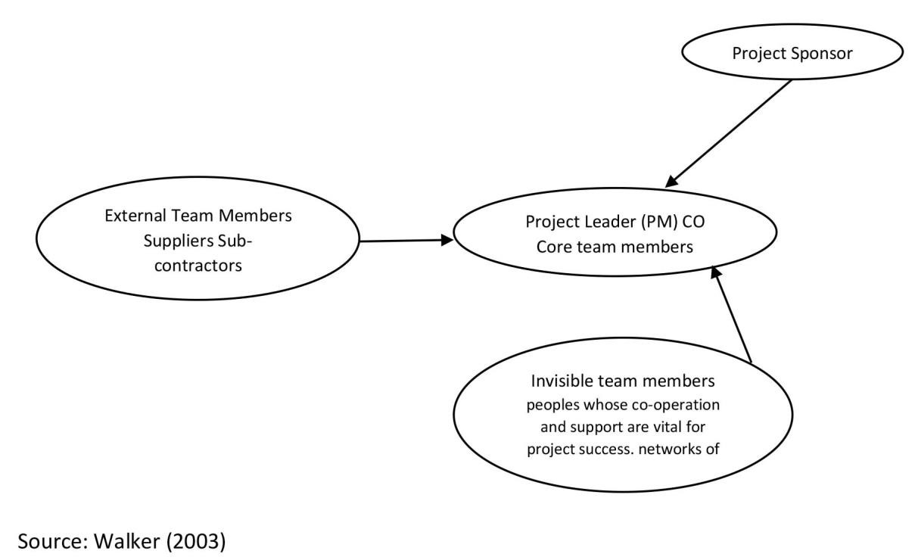

## 2.5) Tools for visualising stakeholders and their influence

Most recently authors addressed some of the limits earlier models but distinguishing stakeholders into four configurations depending on whether the material interest or the set of ideas of a firm and stakeholders is necessary or contingent in terms of its contractual form. However, neither the identification of a stakeholder group having compatible interests and a contractual relationship with the firm, nor of some other group with a different configuration, provides much information on the stakeholder's actual or potential level of influence regarding organizational survival (Bourne and Walker, 2005).

*Power versus interest grids*

This provides one means by which a stakeholder interest intensity map can be developed.

It can also be segmented and can be applied to a sub-set of stakeholders (PMBOK 2013). These grids array on a two by two

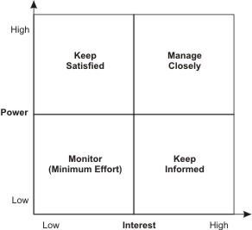

Fig. 2 Source (PMBOK 2013)

matrix where the dimensions are the stakeholder's interest (in a political sense as opposed to simple inquisitiveness). And the stakeholders power to affect the organization's or issue's future. Power vs interest grids typically help determine which players' interests and power bases must be taken into account in order to address the problem or issue at hand. They also help highlight coalitions to be encouraged or discouraged, what behaviour should be fostered and whose 'buy in' should be sought or who should be 'co-opted'. Finally, they provide some information on how to convince stakeholders to change their views. Interestingly, the knowledge gained from the use of such a grid can be used to help advance the interests of the relatively powerless (Pajunen, K. 2006).

## 2.6) Building trust in project relationships

Trust means that one believes in, and is willing to depend on, another party and a willingness to be vulnerable. Since trust exist in an uncertain and risky environment, one who prepares to take risk should have acknowledged the uncertainties and trust in this respect is the acceptance of risk. Yet, even levels of commitment amongst project participants and risks or rewards not shared fairly between parties are still regarded as the potential obstacle in implementing partnering or relational contracting. This suggests that the problematic area is with the implementation where the soft issues are less easy to measure objectively. Since trust and control is a managing concept encompassing social psychology usually in the form of formal and informal structures, managing projects therefore requires interchangeable acts of trust and control. This constitutes managing differences among people and bears risk itself (Zaitsev, A. 2011).

Trust is an important factor in business-to-business relationships but it’s portrayed as a complex entity that is difficult to measure. The concept of trust is not new but in the focus of research in project management it is new. Opposite of trust is distrust and they can exist simultaneously in a project. For building trust faster managers should highlight the reputation and professional qualifications of their team. Kick off meetings and other milestone meetings are important for trust building. Celebrations are also important trust-builders (Zaitsev, A. 2011). According to Zaitsev, there are two trust related issues in project management which are the use of formal and informal structures, and the management of risk and uncertainty. Good relationships do not just happen, they are the result of sharing a combination of individual attributes such as honesty, integrity, respect, commitment, trust, confidence and openness and as such, the intangibles in a relationship as expressed in personal dimension can be referred to employee commitment and company's reputation in creating an environment for working together and being prepared for problems. To get people work in harmony in a complex project working environment is not an easy task, and managing differences is a further challenge. As managing differences can improve project performance and is the key to success in a relationship which means relationship issues have to be considered (Zaitsev, A. 2011). Even though it has received great deal of attention, there are so many different views of trust that it tends to confuse more than it clarifies (Karlsen, J., Graee, K. and Massaoud, M. 2008). Trust has been expanded to a range of theories and concepts applied in different fields according to their natures and characteristics. Owing to the complexity of many projects especially IT projects, the theories and concepts of trust are often different from setting to setting. According to Karlsen, J., Graee, K. and Massaoud, M. (2008), there is no universal accepted definition of trust even though it is acknowledged there are several definitions of it and one that is widely agreed with is (Rosseau et all 1998, p. 395), cited in that trust "a psychological state comprising the intention to accept the vulnerability based upon positive expectations of the intentions or behaviour of another".

Recently, one of the management challenges is to win the trust of stakeholders. Many have often spoken about having trust but stakeholders nowadays have become cynical which means more needs to be done to convince them. Trust is a powerful asset and can create loyalty that gives an organization the benefit of the doubt in situations where they want to be understood and believed. The trust, the information manager has to the stakeholders is affected by how the stakeholders treat them and vice versa. If one is distrustful, it will go back the other way round also (Karlsen, J., Graee, K. and Massaoud, M. 2008). IT projects are exposed to more uncertainty than any other simple project. Problems arising from a high degree of uncertainty can only be resolved by a multi-task work group and in a flexible manner because it requires sharing knowledge and collaboration in teamwork. A good working relationships hep to eliminate uncertainty because members are willing to express their views and opinions before any real crisis occurs. To create an environment of trust, five important activities that involved people and assure a common understanding of ideas, actions and results have been stressed. These activities are sharing thoughts and feelings, assuming commitments that one can fulfil, admitting errors, requesting and accepting feedback, recognising and testing suppositions. Good working relationships, coupled with adequate knowledge and capability, is essential to the successful delivery of an IT project (de Carvalho, M. 2013).

## 2.7) Communication in IT projects

Early communication theory described communication within and by the firm in terms of a simple linear model, wherein the firm’s stakeholders constitute “receivers” or “audiences” for particular messages (Crane, A. and Livesey, S. 2003). Lewis wrote that "communication is the fundamental to organising', noting that "organising entails the exchange of symbolic representations of ideas, events, emotions and information in order to overcome problems related to uncertainty, identity, and interdependence", issues that were previously argued to

be endemic to contemporary IT projects and project management practice (Lewis, L. 2006). Within an IT project context, communication is the integrative element that supports organization and the seamless interplay between the five processes argued to constitute project management. Communication is widely regarded as the key to successful implementation of organisational change. Ensuring adequate communication in all IT projects thus seems imperative. Support for the argument that communication is central to successful organizing and managing is further evidenced by the fact that problems of poor communication rate is the causes of IT project problems and failures (McKay, J., Marshall, P. and Grainger, N. 2014). According to McKay, J., Marshall, P. and Grainger, N., the project manager who recognizes the importance of communication in their work practices, it would not be unreasonable for them to turn to PMBOK for guidance on deep appreciation and understanding of communication processes, as well as skills in the practical art of communication. However while this may offer sound guidance on how to plan communications through the life of a project, it says very little at all about the challenges of successfully communicating in a project context, nor on how a project manager can learn to effectively communicate to range of stakeholders in a project.

It is crucial to establish good communication channels with involved stakeholders, both internal and external by setting clear communication goals, keeping an active involvement, and being persistent. Project communication has been of interest to a number of scholars and the bodies of knowledge to establish guidelines for communication in projects. The project manager suggests that it is through communication that we learn, for instance, how people reach and this is also the foundation for trust or distrust. Project communications planning serves to reduce misunderstandings, which are common in projects that ultimately lead to significant waste. We have different backgrounds and bring different sets of values and expectations to the table, giving us diverse ways of seeing things and unique communication needs and techniques. The saying, “it’s not what you look at, it’s what you see” describes the gap in communication, since we often do not understand each other and quite often do not express ourselves in the way we intend. Our beliefs and assumptions, that our communications are understood as intended, are simply not realistic and do not always match reality Thus, good communication has the ability to contribute to building a trust environment, and supplies stakeholders with information about the strategic issues of the project (Karlsen, J., Graee, K. and Massaoud, M. 2008).

Effective communication is central to building relationships through understanding and managing the expectations of stakeholders especially those stakeholders who have been identified as key or important in IT project. According to Project Management Body of Knowledge (PMBOK® Guide), Project Managers put more of their effort in communicating with team members and other project stakeholders as much as 80-90%. Good communication is considered critical to project success and has a hand in everything that takes place in the project, across all knowledge areas and throughout the project lifecycle. It is not complicated or difficult to understand what constitutes effective communication, but most project managers have at least a few misconceptions about communication, including some or all of the following (Schibi, O. 2013).

* Communication is not given much attention like it should be given.
* Communication in IT projects is taken for granted, thinking that being able to utilize few tools like (e.g., email, texting) will make information flow in a sufficient, timely, uninterrupted and efficient fashion.
* PMs are convinced that we are effective communicators and that should be enough to get everyone around us to become good communicators.
* PM’s fail to realize that although communication is easy to manage but it requires time, effort, and focus to achieve success (Schibi, O. 2013).

The realm of mistakes that can be made related to communication is boundless. It would be impossible to outline and describe every type of communication issue or gaffe a project team might encounter while executing an IT project. It's rare for a stakeholder group to have the same level or type of engagement with a project as does the project team. Because of this a project manager might assume a little bit too much or too little of others (Cervone, F. 2014).

## 2.8) Leadership

In the early project literature, the notion of project leadership mainly departed from a taskoriented perspective. Leadership was often seen as a 'soft' or 'human' phenomenon that was needed to make the project team deliver according to plan. The basis of project management is the need for the rational handling of temporary tasks that could not be handled through permanent organisational arrangements. Thus, project leadership can be seen mainly as a task-oriented phenomenon where relations could be set aside for the efficient execution of the project plan (Lindgren, M. and Packendorff, J. 2009). While leadership has long been recognized as a success factor at the organizational level, it was not until recently that this concept was adopted in the realm of project management. Despite the advancement in leadership theory, successful project management was regarded as the application of tools and techniques regardless of a project manager's leadership style. And also, research shows that both the project managers procedures and the project managers leadership competence should be taken into account when assigning a project manager to a project and the latter was later researched on with the upcoming popularity of the emotional intelligence school of leadership and in this case the ability of self-management and management of others became the focus. It was built on four dimensions which are self-awareness, self-management, social awareness and relationship management (Muller, R. and Turner, J. 2010). This schools most prominent representation as cited in Goleman (1995) by Muller, R. and Turner, J. (2010) shows that emotional capabilities are more important for leadership than intellectual capabilities. Therefore, leadership success is linked to the leader’s ability to increase resonance within those being led which is reading the emotions of the followers accurately, becoming attuned to these feelings and then move them into a positive emotional direction. Building on this, as cited Goleman (2002) by Muller, R. and Turner, J. (2010) identified six leadership styles and they are visionary, coaching, affiliate, democratic, pacesetting, and commanding.

The visionary style creates resonance through sharing of a common goal which creates a forward movement. Coaching creates resonance by interlinking individual’s wants to the goals of the organization. The afflictive styles creates resonance through harmony, achieved by interlinking people. The democratic style allows for resonance by valuing people's input and participation. Then the last two styles which are the pacesetting and commanding are authoritative in a way and are only suggested in case of emergency. They only work in the short term and can create a threat for the long-relationships between follower and leader (Muller, R. and Turner, J. 2010).

Even though vision is known as being necessary for leadership success, in cases of projects, vision may be better communicated by the sponsor or owner of the project. All too visionary project managers may have difficulties finishing their projects within the triple constraints of time, cost and quality. Cited in Turner, J., Muller, R. and Dulewicz, V. (2009) Boyatzis (1982) and Crawford and Turner (2007) suggest that project success and the project managers competencies are closely connected and project manager competence is in itself a factor in the successful delivery of projects. However, Crawford and Turner note that whereas leadership appears consistently in the highest ranking category amongst project manager competency factors, it’s not recognized in the highest ranking category for project success factors.

## 2.9) Change Management

In the process of IT project implementation, project managers have to face a series of challenges. A most frequent and troublesome problem is changes. Project change and in most cases cannot be avoided which will lead to increased costs, declining quality of the software, delays of the development process, or even complete failure of the project. In 2004, the Standish Group International company of Massachusetts, USA announced such investigation results upon completed software projects, 18% of the projects completely failed, 23% were counted as successful and the remaining 53% were questioned. The questioned ones were those projects that exceeded time or cost more money to complete. Therefore, how to understand and handle the change correctly is the important issue that the project manager or developer must think about in order to avoid the accidental failure caused by changes (Hu, E.

and Liu, Y. 2008).

## 2.9.1) The concept of change

The project life cycle is now divided into three according to the modern methodology and they are initiating, implementing and closing. Even if early stage of a project shows a consensus, losing control increase is still very possible and common. According to Hu, E. and Liu, Y. (2008), scope increase can also be called "change" which should be considered through the entire lifecycle of a project because its inevitable in IT projects. Therefore, change needs to be monitored throughout a project, a change management process needs to be established (Hu, E. and Liu, Y. (2008).

## 2.9.2) Types of changes

Under IT projects mainly software projects, there are two types of changes and they are (Hu, E. and Liu, Y. 2008)

**Functional Changes**: These occurs when some functions are added or delete in a project.

Depending on the impact of the change which will determine if it will be approved or not.

**Bug fixing**: These occurs when repairing defects in the earlier stage of a project if it occurs at the later stage of a project, then a change control process might have to be carried out.

It's important that project managers fully realize the impact of change, carefully analyse the reasons and take relevant measurements according to the actual situation. According to Hu, E. and Liu, Y. (2008), good change management can not only avoid the failure of the project, but also to improve the quality of projects and ensure the successful completion of the project.

## 2.9.3) The causes of change

A certain process needs to be followed when change occurs in a project and the main causes of change can either be internal or external. For example change maybe the cause of various factors and events like

* Wrong understand of the initial scope due to neglecting the definition of the initial scope.
* Government Regulations.
* Change in organizational structure of a firm.
* The management team of the user hopes to achieve morre functions than they originally requested or consented.
* Reduce in budget or not enough to complete the project (Hu, E. and Liu, Y. 2008).

## 2.9.4) Impact of change

Change can come in different ways. It can either increase the budget, the number of prople needed to complete the project and affect the developing progress of the project. Deviation that change causes is collected, reorganized, analyzed and evaluated. If the change passes the evaluation change, which means it will affect the overall delivery of the project (Hu, E. and Liu, Y. 2008).

## 2.10) Stakeholder Management (Tools and Techniques)

Consequently, our literature review points out two main implications and necessities. The first implication is to consider developing a relevant framework to identify the key stakeholders and maintain good relationships throughout the project. The second implication is that this framework should integrate stakeholder relationships' dynamic and emergent nature and, thus, project management stakeholders' time perspective. In the face of these implications, we propose to develop a relevant conceptual approach based on a theory often used in the understanding of stakeholder analysis and engagement in the field of project management (Missonier, S. and Loufrani-Fedida, S. 2014). The purpose of stakeholder management tools is to support decision-making, to share knowledge, to reduce the level of subjectivity and to remain transparent for ‘project-outsiders’. Beyond this stage, there are number of tools proposed in literatures to help define stakeholders, categorise, engage and manage them and they are

* The stakeholder analysis
* The stakeholder circle
* The organisational zoo
* Stakeholder management matrix
* The power/interest matrix
* Stakeholder mapping
* Stakeholder risk assessment
* Stakeholder-Commitment Matrix
* Vested Interest Index
* Stakeholder Ethical Responsibility Matrix and others (Walley, P. 2013, Bourne, L.

2010).

## 2.11) Stakeholder Analysis

Approaches to stakeholder analysis have become increasingly popular with a broad range of organizations in many different fields. It can be a very important tool that can be used to understand stakeholder’s behaviour intentions, interrelations and interest and for assessing the influence and resources they bring to bear on decision-making or implementation processes. It aims to evaluate and understand stakeholders from the perspective of an organization, or to determine their relevance to a project and also to understand the diverse range of potentially conflicting stakeholders interest (Missonier, S. and Loufrani-Fedida, S.

2014).

The typology and methods of stakeholder which can be categorized as

* Identifying stakeholders
* Differentiation and categorizing stakeholders
* Investigating relationships between stakeholders (Walley, P. 2013).

**Identifying stakeholders:** According to Walley P. (2013), identifying stakeholders is an iterative process during which additional stakeholders are added as the analysis continues and to do this expert opinion, focus groups, semi structured interviews, snow ball sampling can be used.

**Differentiation and Categorizing Stakeholders**: There two methods used in differentiating and categorizing stakeholders and they are known as top-down analytical categorization using interest-influence matrices and radical trans-activeness and bottom-up reconstructive methods using stakeholder-led stakeholder categorization and Q methodology (Gnan, L., Hinna, A., Monteduro, F. and Scarozza, D. 2013).

**Investigating relationships between stakeholders**: In this category, there are 3 principal methods which can be used to investigate or analyse stakeholder relationships and they are

* Actor linkage matrices
* Social Network
* Knowledge mapping analyses (Walley, P. 2013).

Our literature review reveals that prior studies have not addressed the emergent nature of relationships. In particular, prior studies on stakeholder analysis from the Social Network Theory anchored in a relational perspective have actually shown developments by studying the “resultant” effects of stakeholder relationships. Nevertheless, the “emergent” effects have been understudied. The studies overlook the importance of the emergent nature of stakeholder networks, i.e. the co-evolution of the stakeholder identity and the project over time (Missonier, S. and Loufrani-Fedida, S. 2014).

## 2.12) Stakeholder Cycle

The Stakeholder management methodology and visualisation tool, The Stakeholder Circle, was developed to assist in assessing the relative influence of a project's stakeholders, understanding their expectations and defining appropriate engagement procedure to influence the key stakeholders expectations and perceptions to the benefit of the project (Bourne, L. and Walker, D. 2008). According to Bourne (2005) cited in Bourne, L. and Walker, D. 2008, Key elements of the stakeholder circle are concentric circle lines that indicate distance of stakeholders from the project or project delivery entity, the size of the block, its relative area, indicates the scale and scope of influence and the radical depth that can indicate the degree of impact (Prototype of Stakeholder shown in Fig.4).

The Stakeholder Circle Methodology consists of five parts and they are

* Identify
* Prioritise
* Visualise
* Engage and
* Monitor (Bourne, L. and Walker, D. 2008).

The outcomes from this process is a series of recommendations for action plans that lead to risk mitigation plans, stakeholder engagement plans and while this may appear to generate reactionary strategies to potential negative outcomes it can also trigger proactive strategies as well as being used to accentuate positive traits and trends in stakeholder relationship and influence (Bourne, L. and Walker, D. 2008). According to Bourne, L. and Walker, D. (2008), the new approaches to project relationship in the form of theory in the Stakeholder Circle methodology and visualisation tool should benefit the profession through improving the chances of project success.

## 3. Methodology

### 3.1 Methodology Introduction

According to Creswell, J. W. (2012) research can be defined as a search for knowledge and understanding and an activity undertaken with the aim of establishing something, a fact, a theory, a principle or an application from conceptualizing a problem to analysis, interpretation and report writing.

Covered in this chapter are topics related to the research method implemented by researchers in (figure 2), (figure 3) and (figure 4). Also included is the research plan are ethics, limitations, and time allocation

## 3.2) Research Philosophy

It is difficult to come to a conclusion on the one and only philosophy used in the research, because there are many similarities, of course and difference, between them. Basically, the researcher will make use of both Interpretivism andPositivism since the researcher will be using both the Qualitative and Quantitative research methods. Positivism adopts a clear quantitative approach to investigating phenomena, as opposed to post-positivist approaches which aim to describe and explore in-depth phenomena from a qualitative perspective. This research philosophies were chosen because it has to do with the explanation and expatiation of the circumstances regarding Stakeholder Management, internal relationships and decisions made by project managers affecting the behaviour of stakeholders which is a vast area of interest.

Moving on to the interpretivism philosophy, as explained by Saunders and Lewis (2012,

p.106) it “relates to the study of social phenomena in their natural environment.” In other words, interpretivism is a study of people and their own points of view towards a specific issue or problem; hence it is crucial that the view is understood by the researcher. Moreover,

Saunders et al. (2012, p. 137) introduces two ‘intellectual traditions’ of this philosophy: phenomenology and symbolic interactionism. As author explains they both are closely linked with the people view of the social surroundings or the world around them and influence of interaction with other people.

This mix of philosophies not only provides the researcher with the link with his research questions, but strengthens and helps with the process of data collection. While mixing these philosophies the researcher can remain objective and use strategies that can be deemed relevant for the research; hence qualitative method is going to be used throughout this research, as established before that is supported by the philosophies chosen.

## 3.3) Research Approach

On the research onion, after the first stage of defining the research philosophy, it's the moment for the researcher to identify the specific tools in order to find an answer for the research question. In this case, it's important to choose from the available two approaches or use both (Saunders, Lewis & Thornhill, 2009). The researcher has decided to use both inductive and deductive approach in the analysis of data.

**Deductive**: The researcher firstly studies existing theories and concepts related to his/her field before proceeding into testing hypothesis associated with the theories (Blackstone, 2012). The end result of this type of research are summaries of observations/findings or hypothesis. Shown in **Fig. 5**

**Inductive**: The researcher begins by collecting data that is relevant to his or her topic of interest. Once a substantial amount of data have been collected, the researcher will then take a breath from data collection, stepping back to get a bird’s eye view of her data. At this stage, the researcher looks for patterns in the data, working to develop a theory that could explain those patterns (Blackstone, 2012). Shown in **Fig. 6**

While inductive and deductive approaches to research seem quite different, they can actually be rather complementary. The deductive approach is used to gain an understanding of underlying reasons, opinions, and motivations. It provides insights into the problem or helps to develop ideas or hypothesis for potential quantitative research which can be used to validate our results from our inductive research.

## 3.4) Research Strategy

According to Saunders, M., Lewis, P. & Thornhill, A (2009), this is the third layer of the research onion which gives a diversity of strategies like: survey, case study, experiment, archival research, grounded theory, ethnography, and action research. Most of these strategies offer a better use while conducting a deductive approach while others will fit with inductive.

A **survey** will be done and used as a base for the analysis. Surveys allows the researcher immerse themselves into the respondent group and in this case a number of quantitative data collection approaches are used (Cohen, L., Manion, L., & Morrison, K. 2013). The purpose of the grounded theory method is to produce a theory that explains the internal relationship of stakeholders and with the help of interviews, the researcher will be able to answer the why, what and how.

**Interviews**: This qualitative study tries to explore reasons for how relationships are carried out with internal stakeholders. So it's preferable to use interviews since it is an ambiguous subject. The intention is to execute the interviews according to something similar to the “five whys” developed by Sakichi Toyoda, in order to find the root of their underpinning values and beliefs.

## 3.5) Research Choice

The research choice can be said to be the method used for the technique of collation and analysis of data. Figure 7

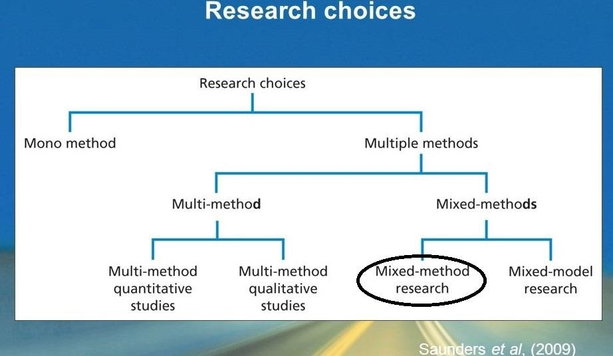

**Mixed Method Research**

For this research, the author decided to use the mixed research method which means the author chose to use two different types of technique for the collection and analysis of data from both primary and secondary research. In a more elaborate context, the researcher used the mixed research method which contains both the qualitative and quantitative method. A qualitative study aims to gather an in-depth understanding predominantly through the use of interview that generates or use non-numerical data which is the other way around for quantitative study because this involves numerical data which the research has to define himself (Saunders et al 2009).

The researcher chose to use both methods because he thinks it’s the best way to answer and validate questions on the subject.

## 3.6) Time Horizon

The research is dominantly a cross-sectional study which refers to the “*study of a particular phenomenon at a particular time*” according to Saunders et al (2009). The crosssectional research design offers the possibility of obtaining descriptive information that helps to build theories about research while designing longitudinal research offers the opportunity to study the development and change over time. Regarding the time restraints giving by the college, the time horizon for this study will be cross sectional as the time giving for my research does not give space to a longitudinal study.

## 3.7) Data Collection

The quantitative aspect of the analysis will deal with survey. This instrument was taken to better explain and understand the phenomena by collecting numerical data. Therefore, as quantitative research is essentially about collecting numerical data to explain a particular phenomenon, particular questions seem immediately suited to being answered using a questionnaire. A key ethical question is quantitative research is whether the data, results and conclusions can be trusted which is the reason why the author has also decided to use the qualitative approach (Saunders et al. 2012, p. 365). The qualitative approach involves a semi- structured interview as earlier stated. Using qualitative investigations subjective interpretations of 'relevance limits' and the action orientations of actors may be discovered in the empirical material about which the investigator had no prior theoretically based assumptions, and which therefore cannot be taken into account in constructing the datacollection instruments. Qualitative investigations, therefore often yield this type of information, which could not easily have been obtained using a quantitative research design (Saunders et al. 2012, p. 371). This instrument was also taken to better evaluate the participants attitudes, views and opinions towards the issues raised in this thesis. One of the most important factor in while choosing interviews is stated by Manson (2009, p. 63) where the author states it is suggested that "PM's knowledge, views, understandings, interpretations, experiences, and interactions are meaningful properties of the social reality which your research questions are designed to explore.” Hence, throughout the process of qualitative interview the views, understandings, opinions, and the impact of effective management of internal stakeholders will be explored and evaluated (Saunders et al. 2012, p. 378).

It is important to establish that there are other data collecting instruments that are related to qualitative approach such as case studies, focus groups and others. Kvale and Brinkmann (2009, p. 150) explains that nowadays focus groups are a really popular tool used while doing consumer research. However, the researcher believes that a semi structured interview will be more relevant to this research, due to some advantages that it brings. Regarding focus groups, Ghauri and Gronhaug (2005, p. 142) are soon to state that one of the biggest disadvantage is that the results and answers of the focus group respondents can be influenced by one another, hence making the data collected to be less important and relevant to the research. Moreover, the authors continue by stating that semi-structured interviews will often help to obtain information that can be more personal, attitudinal or about “value-laden” maters. Thus, if one of the main reasons of this research to establish how effective internal stakeholder relationships in IT projects can be managed, semi-structured interviews are more likely to establish solid base for this research where the quantitative approach will just give an idealistic conclusion. Ghauri and Gronhaug (2005, p. 132) also explains that although semistructured interviews have similar qualities to an unstructured interviews, they differ because the sample size, respondents and most importantly questions has to be determined before starting the interview process. In other words, although the semi-structured interviews provide enough space for a small discussion, because it is situated only between the interviewer and interviewee there is no other people to factor the respondent’s answers. Other important factor that justifies the use of semi-structured interviews is directly linked with managing stakeholders in projects. Ghauri and Gronhaug (2005, 132) elaborates, while the semi-structured interview gives you the chance to find out the attitudes and the views of the respondent.

Furthermore, unlike surveys, interviews provide the ability to, as Saunders et al. (2012, p.

378) puts it, ‘probe’ answers. In other words the researcher has the ability to go deeper into the participant’s answers and ask him to elaborate, explain or build on it. Semi-structured interview has the ability to carry out some probing through the course of it. (Silverman 2006, p. 110) The probing process in itself is important in this case, due to the fact that the participants will be exposed to several different questions regarding how effective internal stakeholders in an IT project can be managed. Moreover, the probing process as describe by Maykut and Morehouse (1994, p. 95) can be detailed oriented, when the interviewer asks additional questions to the answer, elaborative when the interviewer asks the respondent to answer the question in more detail and clarification, when the interviewer actually participates by explaining the questions or the topics in more depth so the respondent will understand it fully. Throughout this research it is important to pinpoint that the clarification probing is relevant, hence the questions will be based upon stakeholders in general and specifically about internal stakeholders in IT projects that can be difficult to understand for the respondent.

The researcher believes that asking general questions about IT projects and relevant factors that determine the success of a project and other important factors may show different patterns appearing even before the stakeholders will be mentioned. Some practical issues arise while collecting the data. While the ethical issues were evaluated above, it is crucial to add that one of the most important issues that rise is the interpretation of the results. Thus researcher should be deemed objective and not in any case try to interpret or twist the results to get the necessary answer (Silverman 2006, p. 135).

## 3.8) Data Analysis Procedures

The author made use of a questionnaire to collate data from the vast majority that has once been involved in an IT project. The generated data of the survey, categorical data will be used, which values cannot be measured numerically but can be classified into categories. Descriptive data count the number of occurrences in each category of a variable to identify, which category has the most cases and allocation of the cases. For valuable analyses the software tool survey monkey was used, visualizing the research findings in form of diagrams and tables to identify interdependences and compare proportions, trends and conjunctions. During the analyses process, it will be focused on the data distribution, specific values and highest or lowest values. During the interview which has been done via the internet (Skype), the author used a recorder and he listened to transcribe the relevant points that the experts highlighted. The researcher used probing to start a small discussion and added or subtracted questions where he deemed are necessary to gain more data. The collected data is then separated by the representing objectives and is provided below. After this a comparison was made between both data from the questionnaire and interview to compare the similarities, and then to emphasize the differences in the data collected.

## 3.10) Population and Sample

### Mixed Research Sampling Technique "Simple Random Sampling and Snow Ball Sampling"

As the author described in the previous section, he decided to refer to the use of questionnaire to involve the mass population of whoever has once partaken in an IT project before and that was why he used "Simple Random Sampling" which allows results to be generalized to the larger population and statistical analysis performed (The International Society for Quality in Health Care, 2003). The author also made use of "Snow Ball Sampling" in regards to the interview aspect of the sampling where the author interviewed two experts that have directly worked on two or more IT projects and are experts in this sector. According to The International Society for Quality in Health Care (2003) Snow Ball Sampling is used when it is difficult to identify members of the population. It is important to use the right method of sampling and to be aware of the limitations and statistical implications of each so as to be able to analyse our findings and come to a valid conclusion.

Due to the nature of the project and the population involved, the author decided to seek out a quantitative sample through the internet. To find the sample, he began to publish announcements on both the professional social network (LinkedIn) and on a solely page for project managers on “Facebook” explaining and asking respondents to take part in his survey. Through this publication and thanks to his professional network, respondents were able to take part in this survey. And to extend his knowledge, the author then got through to some contacts in Nigeria who has once worked in an IT company and they were able to link him to two different experts who have worked in one of the biggest IT companies in Nigeria.

The names of the people interviewed and their link to IT projects are listed below, they are indeed an interesting, valid and credible sample in relation to the dissertation topic

#### Noah BADERIBEGBE

A current employer at Dataflex, currently doing his Phd at the University of Lagos in Nigeria. He has worked as a project manager in the IT sector for 10yrs which means he has a vast understanding of IT projects and also currently work as a software project advisor to the Lagos State government.

#### Gbolahan ABELEJE

A former employee of ECONET Nigeria before their close up and had 5yrs experience prior to working with Ericsson and has been working with them for the past 6yrs. Mr Gbolahan currently works as the 3D operation project manager and is responsible for project analysis, implementation, control and delivery for projects relating to 3G operations across the telecom Airtel network in Ericsson.

## 3.11) Limitations of the research

There are lots of limitations in this research. First thing is that even though there are lots of academic literature on this dissertation topic, there is little academic literature on this subject in Nigeria. Thus, the author has relied on international research studies. However, information provided by these sources are reliable and can be transmitted in this context. The author has made a point of honour to name the sources that are known to be credible and reliable. Also, the limitation of time was considered being that Masters dissertation does not provide enough time to go deep in research which is why instruments like questionnaires and semi-structured interviews were chosen to better collect the data in the frame of time given.

The most disturbing limitation is regarding the samples. Although lots of companies and organizations have started taking up IT projects, still it took quite an amount of time to be able to find and get through to people who has a deep knowledge about IT projects and lots of experiences in them.

Also I think would be that there's just only one researcher. Designing a questionnaire and interview questions then getting it out there took lots of time which could be linked with time limitation but the author also never expected that the data collection and analysing part would also take quite a lot of time.

The conclusions of this research are developed by the author through the interpretation of the data he collected. This interpretation is affected by the experience and knowledge of the author gathered by the author before and after research while stepping back to expose the reality of it.

## 3.12) Conclusion

To collaborate quantitative and qualitative data to prove the hypotheses of this research, a quantitative, qualitative self-conducting, paper-based questionnaire and interview question is proposed. The questionnaire will contain 14 questions while the interview was semi structured due to information that may arise during interview.

# CHAPTER 4: DATA RESULTS AND FINDINGS

## 4.1) Introduction

The author have introduced earlier on how the research process was conducted which consist of research philosophies, research approaches, research strategies, research choices, time horizons, sample collection and data collection method. First the quantitative data will be analysed in this chapter and the qualitative analysis will come next. The quantitative data will be analysed from a questionnaire made up of 14 questions and in total 213 responses were received for this research and 2 interviews were also conducted which took 10 minutes for the respondents to answer. In general, this question wants to investigate the role of effective management of internal stakeholders in relation to IT project success in a project.

## 4.2) Descriptive Statistics (Survey)

The total number of respondents who sent in the questionnaire was 213. As figure 7.1 shows, the total number of male who participated in the survey comes to a total of 42.86% while the total number of females are 57.14% respectively. 3 respondents skipped the question.

*Figure 8.1: Gender of the respondents*

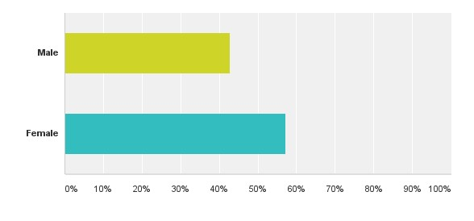

*Figure 8.2: Age of respondents*

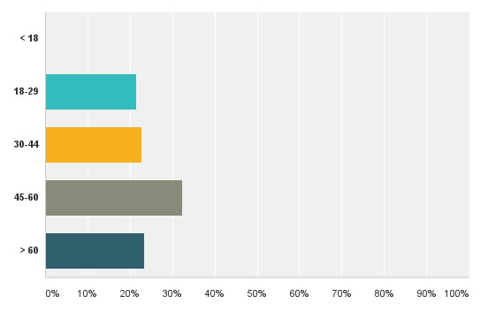

Most respondents who took part in the survey belonged to the age group of 45-60 taking 32.38% while the second age group was from 60yrs and over taking 23.33%. 30-34 age group took a percentage of 22.86% while 18-29 had the least percentage of respondents with only 21.43%.

*Fig. 8.3: Education level of respondents*

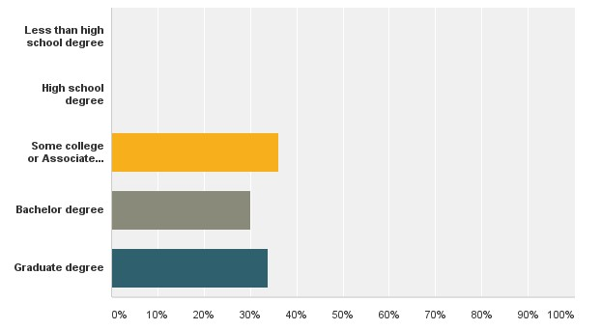

From the response received, 36.19% which is the most out of all of the respondent sampled attended some college or have an associate degree. 33.81% of the respondents has a Graduate Degree and 30.00% of the respondents which is the least percentage out of all has a Bachelor’s degree has shown in Fig. 7.3 below. From this result, it shows that most of the respondents are well educated or have done one or more professional course. Three respondents skipped the question.

*Figure 8.4 Level of Income*

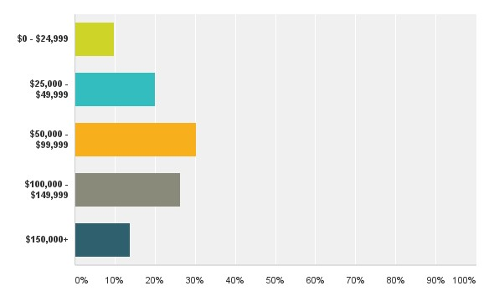

Even though this will not add or deduct from the researchers hypothesis. The bar below represents the level of income among the respondents where 30.29% of the respondents make between $50,000 - $99,999 annually while 29.26% out of them makes between $100,000 - $149,999. There are 20.00% earning between $25,000 - $49,999 while 13.71% are earning more than $150,000. The least among the earners have a percentage of 9.71% earning between $0 - $24,999. 10 respondents skipped this question.

*Figure 8.5 Have you ever worked on an Information Technology (IT) project?*

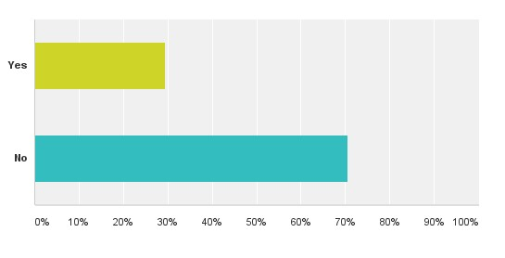

This question was directed to respondents on the first page of the questionnaire to be able to confirm the validity of their answer. 70.65% of the respondents clicked no which means they were automatically disqualified from answering the questionnaire and 29.35% click yes which were those that was able to continue answering the questionnaire.

*Figure 8.6 What was your role?*

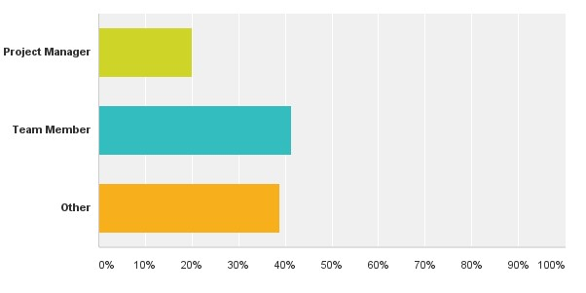

This question was asked to rather determine what part they played in the project so as the researcher to better understand and validate his research. And out of the 80 respondents that were eligible to answer the researcher’s questionnaire, 20% of them has once been a project manager or currently a project manager of an IT project while 41.25% of them has been a team member of an IT project or currently one and the others chose none out of both.

*Figure 8.7 What type of stakeholders were involved in the IT project?*

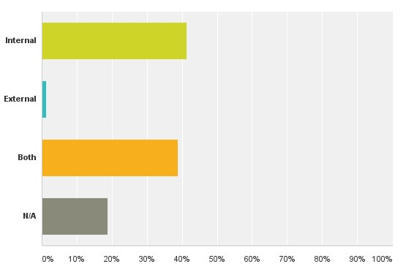

41.25% of the respondents which is the most answered that they had internal stakeholders involved in their project while 38.75% answered they had both in their project. 1.25% of the respondents had external stakeholders in their project and 18.75% click no answer.

*Figure 8.8 They as the Stakeholders, did they take an active role during the project*?

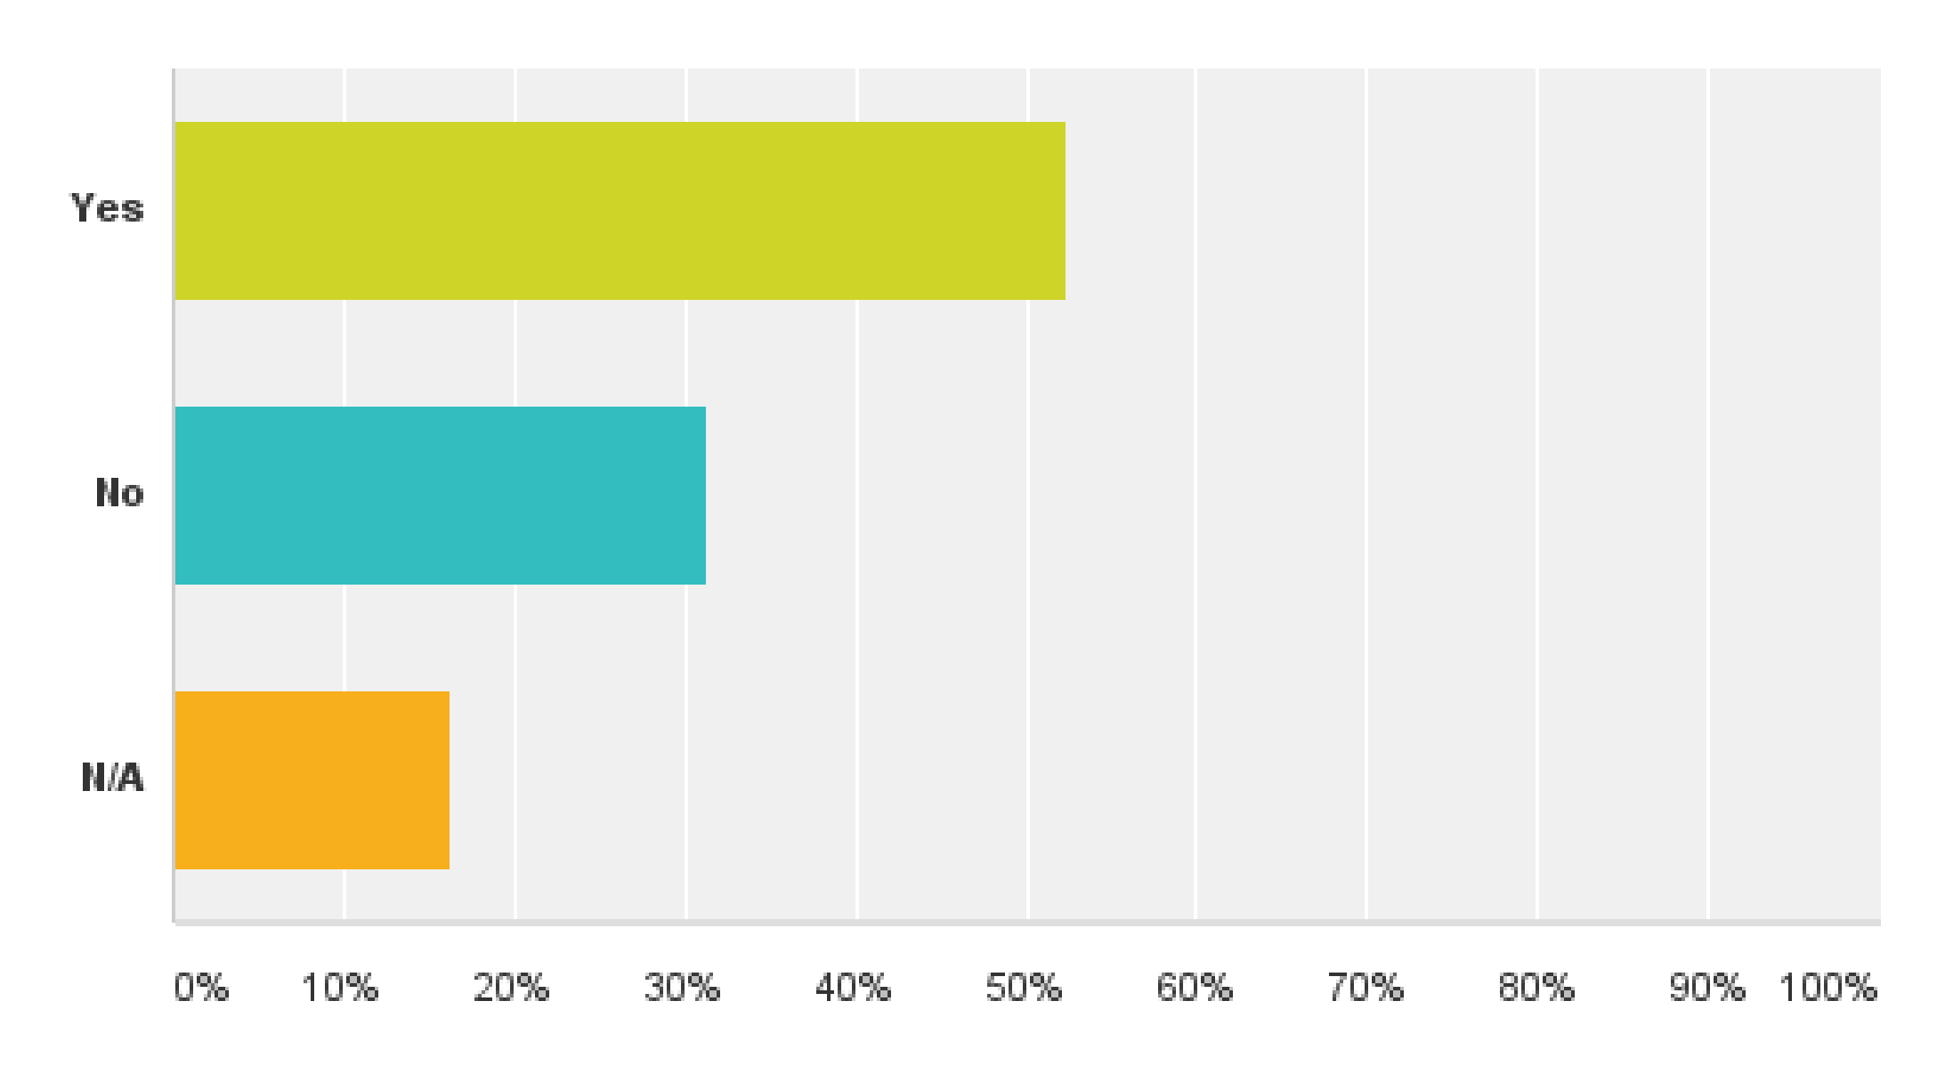This question is to help the researcher determine how much involvement the stakeholders had during the project and from the answers, seems most stakeholders always want to know or kept informed of the progress of a project during each phase because 52.50% which is more than average of the respondents answered yes while 31.25% answered No and the remaining

16.25% answered N/A.

*Figure 8.9 How influential were they?*

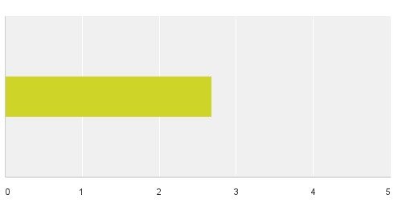

During the project from 0 to 5, average of 2.68 answered how influential these stakeholders were. 3 respondents skipped the question.

*8.10 Rate the success of this project?*

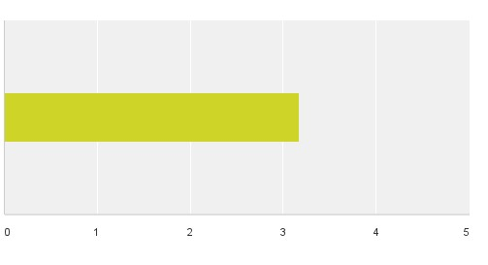

On a scale of 0-5, the researcher asked the respondent to rate the success of the project they were referring to which came to an average of 3.17. 21.25% of the respondents chose 1, 7.50% chose 2, while 25% chose 3 and 4 and 21.25% chose 5. And no one skipped the question.

*8.11 If successful, Do you think stakeholder involvement had a positive impact on the success of the project?*



According to the response, 51.25% of the respondents answered yes which means majority of the people think stakeholder involvement had an impact on the overall delivery of the project while 32.50% answered no which means they don’t think it makes a difference while we have no answer of 16.25%.

*8.12 If unsuccessful, Do you think stakeholder involvement would have mitigated the failure or lead to the success of the project?*

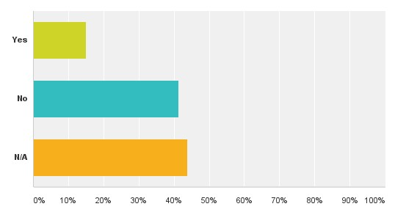

According to Asay (2008), after a survey it was discovered that 62% of IT projects fail which made us put this second question out to the respondents. 15% of the people answered yes to the question meaning if there had been more stakeholder engagement and involvement in the project, there might have been changes to the overall delivery of the project while 41.25% of the people answer no which means it didn’t matter if the stakeholder were deeply involved in the project, it would have failed after all and 43.75% answered N/A.

*Figure 8.13 How would you rate your role in managing stakeholders during the project?*

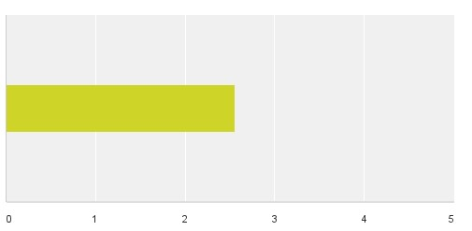

This part shows that project manager should really focus more also on the management of stakeholders during project. From the scale of 0-5, approximately 35.06% of the professionals answered 1 while 7.79% answered 2, 32.47% clicked on 3 while 15.58% clicked on 4 and the second to the least clicked on 5 which is 9.09% which gave the researcher an average of 2.56 overall. The hypothesis that stakeholder relationship management during projects is very low can then be confirmed.

## 4.3) Descriptive Analysis (Interviews)

As earlier stated in the research methodology, a qualitative analysis was also conducted for the research with two experts directly related or currently working in the IT sector in Nigeria. The interviews were clearly recorded with a recorder during the interview and have been clearly transcribed in writing (see appendix 1 and 2).

*Interview samples includes*

Noah Baderibigbe – IT project expert with more than 10yrs experience

Gbolahan Abeleje – 3D operation project manager in Ericsson with more than 11yrs experience in IT projects.

The results of this interview are specifically aimed at helping the author validate his survey response and respond to its research objectives and question which is:

• Does the effective management of internal stakeholders have an impact on the final delivery of an IT project?

The author had a customized question for each expert but was willing to ask more if something new comes up during the interview that needs shedding light on.

This section is organized according to the questions asked and answers given by the experts. Therefore, the purpose of this section is to compare and extract differences to be able to compare and develop a deeper analysis with our research.

**Information gathered during the interview**

This interview enlightens the researcher more about his proposed research which will enable him to be able to validate his research.

Question: *From your introduction, it shows clearly you worked on different projects during your time in Ericsson?*

This was actually the second question directed to the interviewees after they introduced themselves and even though the author knows this people are experts in this area, he just needed to confirm his research about having been a project manager on two or more IT projects in the past.

Both interviews of course have both worked on IT projects before.

Noah Baderibigbe answered : Of course, I have in vast area stretching between various departments at Ericson.

While Gbolahan Abeleje answered that Yes he has worked on different IT projects during the time he has been working for Ericsson and even mention the fact that just because their customers always want to improve their network enables them to take on projects very often.

Question: *Were this IT related projects? And on most of this project what was your role?*

This question was asked to determine to the nature of the projects the experts must have worked on because IT companies undergo different types of projects and definitely not all of them are IT related.

Mr Noah Baderigbe answered stating the enormous amount of projects he has worked on with Dataflex together with other telecommunication industry in Nigeria and he also stated his roles during this projects ranging from supplies, documentation to the last bit which is reporting.

Gbolahan Abeleje referred me back to the fact that Ericsson is a telecommunication and IT company, so meaning most of the projects they work on are IT related while stating that some of them are active or passive. He also stated that during the past few years he has held different roles on different project at Ericsson but mostly he has always been a project engineer and project manager on projects.

Question: *Let's take a look at one particular project which you took the role as a project manager. Were Stakeholders involved in this project? And if so, what sort of stakeholders were involved?*

In different projects, there are different kinds of stakeholders and this question was directed at the interviewees to be able to determine what sort of stakeholders they have encountered in a specific project they can pinpoint on

According to Noah Baderibigbe, Dataflex prides itself with their wireless networks and currently he’s on a project with one of the most biggest telecommunication company in

Nigeria called MTN and the main purpose of the project is managing MTN’s network infrastructure in some of the most populous cities in Nigeria and he also stated that yes on this projects, there are definitely stakeholders and most of them are internal. Even though

Noah Baderibigbe didn’t specify if they were internal or external to the company, the author then directed a question to him by what he meant with private and public stakeholders for clarification.

According to Gbolahan Abeleje, he emphasized on the fact that Ericsson runs a service contract with its customers, so there are definitely stakeholders involved in their projects and majority of the projects they embark on are backed by stakeholders and they can be both internal and external.

Question: *Did they as the Stakeholders take an active role during the project?*

As earlier stated in the literature review, project success frequently requires a higher level of involvement by project stakeholders i.e. technical experts should be actively involved with modeling, senior management also needs to publicly and private support your project, operations and support staff must actively work with your project team towards making your production environment ready to accept the system. Therefore, that's why this question was directed to the interviewees to see if during this project stakeholders took an active role.

According to Noah Baderibigbe, MTN which was one of the stakeholders during the project took an active role so as for them to be able to understand what and how MTN wants things to be done.

While Gbolahan Baderibigbe stated that like every other projects the stakeholders took an active role because they were important to the project and the implementation of it which is why they kept a close relationship with their stakeholders.

Question: *Which of these stakeholders were more influential during each phase of the project?*

Like earlier stated in the literature review, stakeholders and the influence they can exert upon projects and projects and teams can be pooly understood sometimes. This specific question was directed to the experts to be able to understand more which of the stakeholders can have a bigger impact on the success of a project, those the project managers need to focus more on to be able to determine if they are on track

As Noah Baderibigbe stated, it depends on the stage of a project that will determine which stakeholder to focus more on during different phase of a project while Gbolahan Badribigbe emphasized on a specific project that he was working on that the external stakeholders were more of importance in this because they were the one they are going to roll on the process for when it’s done, so they need feedback from them often.

Question: *What do you think of the influence of the internal stakeholders in the project? and do you think they affected the project either positively or negatively during each phase of the process?*

The author intends to know and confirm his research about what role the internal stakeholders play on a project by this question and what is their influence like on a project, if it’s helps in the rolling out of the process positively or negatively

Noah Baderibigbe shared his knowledge about the success of internal stakeholders partaking in the phase of a project while Gbolahan Abeleje also confirmed this by saying internal stakeholders do have a role or two to play on a project even though they can be subversive sometimes.

Question: *Can you rate the success of this project from 1 - 5, where 1 comes as failed and 5 come as very successful?*

The rate in which IT projects fail is alarming and even though there has been lots of steps taken to minimise IT projects failure, we still have so many government IT projects that fail which is why we decided to ask specifically how would the experts rate the success of one or two projects they have worked on or currently working on

Noah Baderibigbe confirms that the project is going fine and from 1 to 5, he would give the project a 3. While Gbolahan Abeleje rated the project he worked on recently successful and from 1-5 rated it a 4 being that they delivered on time, according to specification and within budget even though they faced problems during implementation.

Question: *How was the management of stakeholders throughout the whole process? were they taken into consideration?*

The researcher hopes to know with this question if the project manager has taken his time to not only manage his team to achieve his main goal but has also made sure all the stakeholders has been on the project has been identified and making sure the relationship between the project team and the stakeholders are clear enough for them to understand each other. According to research, most IT project managers has failed in this sector because they are always mostly rolling up a software etc without considering if they are actually doing exactly what the stakeholders want.

Noah Baderibigbe confirmed the fact that even though they were considered at every phase of the project, they were never part of the integral process on how their job were carried out. Gbolahan Abeleje also confirmed that yes stakeholders are always involved in the process of a project but also emphasized that not only were they part of the project, they also involved them in the decision making process which made the management process easy. And he also said putting stakeholders into consideration makes their work easier.

Question: *According to reports, IT projects has the biggest failure, Do you think if the internal stakeholders are more involved in each phase and process of IT projects this can have an impact on the final quality and success of the project?*

Noah Baderibigbe stressed that if a middle ground is found between the project team and the stakeholders, there can be a good platform to launch from giving the project a boost for success which confirms that involving stakeholders more in the process of IT projects can be of assistance to the project teams and the project itself.

Gbolahan Abeleje stressed its grey area as per this question but also added that every failed

IT projects has its reasons for failure which shouldn’t be generalised. Internal stakeholders are important and always have a role to play in project delivery, this I can say due to the number of projects I’ve been involved and the role stakeholders have played. So yes internal stakeholders are important for the success, quality and delivery of a project. So relating to your question, if internal stakeholders have played little or no role in those failed IT projects, I can say that has probably been the cause of so many failed IT projects like you mentioned he said.

Question: *If you were an internal stakeholder in a project, what would expect from a project manager in regards to relationship management among the stakeholders?*

This question posed a new dimension into the researcher’s theory and the author just wants to take the experts back one moment and see through the eyes of the stakeholders what they would want done in regards to the management of stakeholders in a project.

While Noah Baderibigbe thinks this is a tricky question because he has never actually been a stakeholder ever but says there is no one answer to it, I would like to know what kind of information about the project that the manager intends to share in respect to the agreement pre or during the project. I would also be interested in the quality of staffing and materials used. But again there must be a pre-arranged method for collaboration already established because on the field things can quickly go sour.

And according to the expert Gbolahan Abeleje, If I was an internal stakeholder, in terms of relationship management I would require a project manager to manage closely and effectively communicate with me during a project, continually updating and making me aware of situation during the project. If I may mention, the success of any project also depends on communication, therefore i would expect a project manager to organise meeting that would enable us deliberate on how to make the project successful.

Question: *Is there anything else you would like to add sir?*

This was just a general question which the author asked to see if there is any other thing that he wasn’t able to cover that the experts would like to add

While expert Gbolahan Abeleje said No, he dosen’t have anything to do. Mr Noah Baderibigbe added that on the handling of project stakeholders, it all depends on how the project manager on the project handles the management of stakeholders which would determine their input which might in a way help in the lay down of the project.

# CHAPTER 5: DISCUSSION & CONCLUSION

## 5.1) Introduction

The purpose of this research was to explore the impact of management on internal stakeholder relationship on an IT project. For this research to be highlighted as successful, completed and relevant with our research objectives, the researcher separated his work into two main groups which are secondary and primary. It was during the secondary research that the author was able to come up with research questions and objectives that was linked up with his analysis. Throughout the literature review the author was able to understand the definition of stakeholders and their importance while trying to reach the target audience. Furthermore, the author analysed their influence and power on projects and also identified some stakeholder management tools which are mostly used nowadays. During the research, the author discovered that even though there has been studies about the impact of stakeholders on projects but most of this research has mostly been focused on external stakeholders and there has been less or limited research when it comes to the impact effective internal stakeholder relationship has on a project and how this can lead to IT project success and that was how the main research question was developed.

To answer the research objective the author will need to correlate the results of the secondary research of the literature review with his qualitative (interviews) and quantitative (survey) data of the primary research.

The plan of this chapter goes below

* Theories of stakeholder management and analysis of theories provided by various authors.
* Analysis of project stakeholders and their relationships.
* Influence and power of stakeholders on IT projects.

And the author will end his research by answering the main question which is

* Does the effective management of internal stakeholders have an impact on the final delivery of an IT project?

## 5.2) Theories of stakeholder management and analysis

Stakeholder theory has it origin rooted in the field of strategy. It's managerial and constitutes of attitudes, practices, structures that creates a stakeholder management. The stakeholder theory is therefore presented as a theory of ethics. Stakeholder management was said to originate from Stanford Research Institute which was used in the 1960's and believed to involve only shareholders. It was then later discovered that stakeholders does not only involve shareholders because are not the only ones who shares to lose on a project but other constituents that are involved in the delivery of the project which is why the author would stick with the definition of stake as a person of interest, right or ownership on a project and take a stakeholder is any group or individual who can affect or is affected by the achievement of the organizations objectives (Fassin, Y. 2012). Project stakeholder management is created to assist the effective project management for encouraging stakeholder activities that might affect a project and also to assist the project team in taking advantage of opportunities therein to collaborate stakeholder support of project goals.

There has been too much focus on the hard elements involved in projects and it's been more helpful to know that authors have dedicated their studies on the soft skills research of stakeholders, the vagueness in scope and other ambiguities of stakeholder theory. It's also important to call the awareness of project managers to the fact that attitudes of stakeholders towards a project can either make or break it.

**5.3) Project stakeholders and their relationships.**

First of all, in any project it's necessary to build an outstanding confidence, trust and relationship between project teams, shareholders and key stakeholders. Project success and failure can be directly attributed to its stakeholder’s perceptions of value and nature of relationship during the project. The importance of this relationship on an IT project can either be

To be able to convince stakeholders on issues that involves their decision

To eliminate bias between stakeholders about the progress of the project

To monitor unseen circumstances

Trust is being seen as a very important tool in projects because it helps produce relationship, necessary for everyday interaction and its fundamental for exchange. Furthermore, it shows that trust can even be recognized as a tool for increasing the performance of a project. In every project, each stakeholders usually has their own interest especially the internal stakeholders and this can dramatically increase the complexity of managing the project. It's important to generate an atmosphere of trust and understanding in a project which can create a productive working relationships.

*Other importance of creating trust in a projects are:*

* A reasonable amount of trust between the project and stakeholder will result in a closer relationship.
* Access to joint database by the stakeholders and project manager will result in a closer relationship between the project manager and the stakeholders.
* Tremendous level of uncertainty and the project manager's need for curbing the situation will result in a closer relationship between the project and stakeholder.
* Goal agreement can be achieved by forming a partnering relationship between the project and the stakeholder.

When building a relationship, time is also a defining factor because both the situations of the past and present can affect what can be created now. When a project manager has been able to develop a relationship, then the problem is how to adopt and cope with the relationship while has channelling them to success. Trust is something that must be earned on a project. Both parties in a project which are the project manager and stakeholders should work on building trust between each other on a project because this is what creates and builds a trustful relationship. It is also important that after a relationship is created between the project manager and stakeholder, they should be followed because changes in assumption may force changes in the relationship during project.

## 5.4) Influence and power of stakeholders

Stakeholders have the ability to influence decision making on a project. Stakeholders act an important role in determining project goals and strategies that organisations adopt. Communication is a very important tool that can be used to create a substantial relationship with close stakeholders and also with those that are hostile to the success of the project. In projects, there can be substuitive stakeholders, these type of stakeholders can slow or affect the success of a project negatively by causing trouble for the project manager and the only way to deal with this type of stakeholders is only if the project manager can set out a foundation of understanding the stakeholders influence and their impact on a project then only can he/she engage influence stakeholders in a proactive communication and failure can be averted early if there is going be any from them and it is also ruled that having the quality of a good leader can help in developing this relationship and as well as use of wider range of interpersonal skills because this will enable the project manager work more proactively in certain and uncertain events, it would also give the project manager the ability to take lead on every situation thereof. And of course, if there is going to be a long term relationship between both the project managers and influential stakeholders, there needs to be a great amount of effort between both of them.

A project manager must also be able to identify problems early in the course of the project, the warning signs of possible disruption of the project especially with internal stakeholders. Only a project manager who has developed some kind of relationship with his/her current stakeholders will be able to identify these potential signs of disruption, conflict or anything that might have negative impact on the project and diffuse them or mitigate the risk before it becomes a disaster or leads to the cancellation of the project.

**5.5) Does the effective management of internal stakeholders have an impact on the final delivery of an IT project?**

This is the main research question which is the main focus of this research because stakeholder management has been one of the soft skills area that has been highlighted as very necessary for project management to advance.

In the context of this research, the author examines if the effective management of internal stakeholder relationship have an impact on the final delivery of a project either positively or negatively. The questionnaire respondents confirms that the main way stakeholders are classified as are internal and external which also affirms the interview stage theory. Internal and External stakeholders are used as a prime characteristics in identifying stakeholders which always relate to an individual project.

As technology advance more experience becomes needed, the profile of stakeholders has become increasingly important in Nigeria and which is why it's important to consider their involvement on a project. From the data collected, it shows that stakeholders in IT projects in Nigeria are becoming more involved in every day decision of a project. 50% out of the questionnaire respondents answered that internal stakeholders are starting to take an active role in the involvement of projects which was confirmed during the interview with the experts. The experts confirmed that stakeholder’s behaviour during projects has changed and that they always have to seek their advice on every decision making that involves the project and continual report on the progress of the project has to always go through review by the internal stakeholders.

Research shows that internal stakeholders has some influence on a project. Results from primary research shows they don't really pose a great threat to affect the project negatively that might lead to failure of the project since all the stakeholders want is to see the roll out of the project successfully. However, the fact that internal stakeholders does not really pose a great threat to the final delivery of an IT project does not mean they can't influence the project positively or negatively and give advice in the right decision. Managing stakeholders, keeping them involved and supportive can be made easier by stakeholder analysis, a method of determining their levels of interest and influence over the effort. Once that information is available, then appropriate approach for each individual and group can be determined. A strong relationship can be kept with the internal stakeholders through communication and understanding so as to create trust, avoid conflict or any other unseen circumstances and in return this will assist the project manager in every day to day decision, managing of internal stakeholder expectation and create an alignment of value for the project.

# 5.6) RECOMMENDATIONS FOR FUTURE RESEARCH

With the growing popularity of stakeholder management, more problems are discovered. The author believes that this research could be organized in other different ways on the same subject. As this research only focus on IT projects, for future research it is possible to conduct a study that will involve other large projects that organizations are involved in, for example "construction projects" and then find out if there is a direct correlation between the effective management of internal stakeholders and their successful delivery.

The research could be taken in another dimension that will involve the study of subversive stakeholders on IT projects, their impact and how they can be managed in a project or a study of stakeholder behaviour on IT projects can be researched.

Finally, a more interesting study to embark on will be the perception of stakeholders about each other meaning how stakeholders view stakeholders on a project. The aim of this research will be to explore which stakeholders are viewed as key influencers on a project and which the others think ought to be the key stakeholders.

# 6) SELF-REFLECTION ON OWN LEARNING AND SKILLS DEVELOPMENT

## 6.1) Introduction

This dissertation enables the author tap into his practical knowledge and academic that can be used for further studies either in his personal or professional life. According to Kolb (2014), learning is said to be a particular form of learning from life experience which is often contrasted with lecture and classroom. This part of the dissertation will describe my initial knowledge before I started the dissertation and where I am currently and the knowledge I have gained, the approach taken during research and the challenges that, how I started putting the research into words, construction of survey and interview and how this newly acquired knowledge will be beneficial to me in the future.

Kolb in the early 1980's developed a four stage learning cycle which was later adapted and associated to a classification of four different types of learners and they are activist, reflector, pragmatist and theorist (Honey and Mumford, 2000). See Figure 9 below

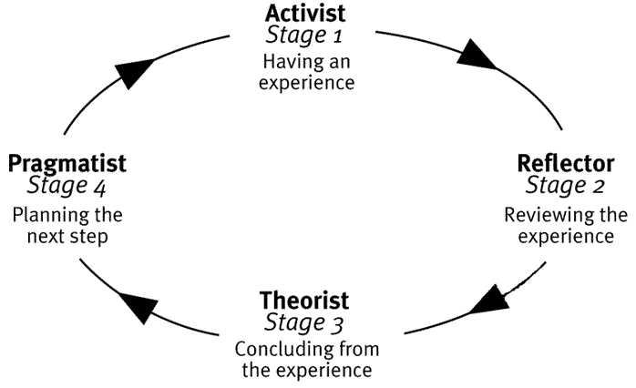

*Activist* can be defined or characterized as someone who prefers to act which is doing things and accumulating concrete experience. They try anything once. They also tend to thrive on the challenge of new experiences and constantly involve themselves with other people.

*Reflectors* are characterized as the people that are likely to stand back and review experiences from all sorts of different perspectives. They are cautious and thoughtful people who like to consider all possible angles and implications before making a move (Honey and Mumford, 2000).

*Theorist* are referred to as the people that look at things as "if it is logical, then it's good" They tend to integrate observations into complex but logical sound theories. They focus more on understanding (Honey and Mumford, 2000).

While the *Pragmatist* search out for new ideas directly related to their immediate circumstances and take the first opportunity to experiment with its applications. They respond to problems and opportunities as a challenge and are likely to get on with things with clear purpose (Honey and Mumford, 2000).

The Honey and Mumford's learning cycle was applied to this dissertation. The experience was associated to the choice of the research topic and experiencing the research itself. In regards to this research, the author has a more reflective and pragmatist approach style of learning. This is useful for the researcher to be able to put himself in the situation and make quick decisions since the research is only for a specific amount of time. As for myself, the MBA in project manager program was something I decided to do for me, it was definitely a difficult period of personal and academic growth. Being an unexperienced candidate, it was a time that proved more stressful that I thought because most of my group mates were more at an advantage than I was since some of them are more matured and have been working. Because of the fast pace of the course, I was up long nights at first but got better in the later run. The MBA program has helped me develop some new skills through different academic activities that includes assignments, group work, presentations, exams and finally the dissertation. The skills developed in me can be divided into two which are academic and personal skills.

## 6.2) Academic

The researcher gained a much vital knowledge in this aspect which will be of use to him in his professional career specifically in project management. From this MBA, the author has been able to gain more knowledge about project management, more specifically the steps and processes involved in executing and implementing a project. The researcher also gained an in-depth view on how projects work, why projects fail, the risk involved, how they can be mitigated and also the people involved in a project. A better understanding of how communication is an important aspect of project management was gained and different communication channels that can be used in a project to assist free flow of messages from the sender to the receiver and vice versa. The author was also able to get some knowledge on tools and techniques used in project management through practice and some of them are WBS, Stakeholder Cycle, Gantt Charts and many others.

During the literature review, the researcher gained more perspective on stakeholder management in a whole, the amount of influence they have on a project and advantages and disadvantages of involving them in a project. Research by various authors shows that lots of studies has been done on stakeholder management and the impact of external stakeholders on a project but less has been done in regards to internal stakeholders which grabbed the researchers attention immediately and this was how the researcher came up with a primary research for his dissertation. With the help of extensive literature review the researcher was able to broaden his knowledge on stakeholder management and through this came up with research objectives and question.

Even though the researcher has never been involved in a research like this before which involves creating a questionnaire and interview questions, he was still able to gain lots of experience in this aspect, he got a better understanding on how to create a survey, Even though during studies we were thought how to use SPSS to analyse our quantitative, the author thought its best to make use of survey monkey which is the best and most practical choice he could have made because there was time constraints for this project and he had an interview question write up also. Even though it was difficult at first, the researcher put it on himself to write up some different questions for his interviewees and this was where being a reflector came in, I took some days off writing after sending this questions to some friends that have done an MBA before, they gave me their advice and it was after this I reconstructed a much more better questions for my survey respondents. After doing this, it was much easier for me to come up with interview questions because I already got some experience while creating the questionnaire and knew the questions I wanted to ask. After the collection of data, the researcher also gained more knowledge on how the collected data can be transcribed into figures and text based information. I have always been the short of words type of person but this dissertation has definitely increased my writing skills and obtaining more experience for any future research.

## 6.3) Personal

During the MBA and dissertation period, the researcher has been able to build up his communication skills, how to interact with people from different sphere of the world, it was difficult at the beginning but later improved. Time management skills is also one that I developed during this MBA from planning to go to lectures by 9am to planning for long term goals like writing the dissertation, graduating staring a job, getting married and on and on. And due to the fact that the author had to study with a diverse range of students from all over the world, the researcher learnt to tolerate others and how to work best in a team. Thanks to the MBA because it has contributed a whole lot in improving the researcher's academic and behavioural skills.

## 6.4) Conclusion

For this chapter, the researcher summarised the skills he obtained during his MBA program in project management. The hard skills of project management and soft skills such as communication, time management and team player will definitely be useful to the researcher in future both in his personal and professional life.

## References

Asay, M. (2008). 62 percent of IT projects fail. Why? - CNET. [online] CNET. Available at: http://www.cnet.com/news/62-percent-of-it-projects-fail-why/ [Accessed 17 Nov. 2014].

Berg, M. and Karlsen, J. (2014). How project managers can encourage and develop positive emotions in project teams. International Journal of Managing Projects in Business, 7(3), pp.449--472.

Beringer, C., Jonas, D., Kock, A. and er, (2013). Behavior of internal stakeholders in project portfolio management and its impact on success. International Journal of Project Management, 31(6), pp.830--846.

Blackstone, A., 2012. Principles of Sociological Inquiry: Qualitative and Quantitative Methods. [online] Available at:

<http://catalog.flatworldknowledge.com/bookhub/reader/3585?e=blackstone_1.0-ch02_s03> [Accessed 24 April. 2014]

Bryman, A. (2012). Social Research Methods - 4th Ed. Oxford: OXFORD UNIVERSITY PRESS.

Bourne, L. and Walker, D. (2008). Project relationship management and the Stakeholder

Circle™. International Journal of Managing Projects in Business, 1(1), pp.125--130.

Bourne, L. (2010). BEYOND REPORTING THE COMMUNICATION STRATEGY.

Bourne, L. and Walker, D. (2005). Visualising and mapping stakeholder influence.

Management Decision, 43(5), pp.649--660.

Cerinus, M. (2001). The ethics of research. Nurse Researcher, 8(3), pp.72--89.

Cervone, F. (2014). Effective communication for project success. OCLC Systems \& Services, 30(2), pp.3--3.

Crane, A. and Livesey, S. (2003). Are you talking to me? Stakeholder communication and the risks and rewards of dialogue. Stakeholder Communication and the Risks and Rewards of Dialogue.

Cohen, L., Manion, L., & Morrison, K. (2013). Research methods in education. Routledge.

Creswell, J. W. (2012). Qualitative inquiry and research design: Choosing among five approaches. Sage.

Davenport, T. (2013). Process innovation. Boston, Mass.: Harvard Business School Press.

de Carvalho, M. (2013). An investigation of the role of communication in IT projects.

International Journal of Operations & Production Management, 34(1), pp.36--64.

DeMarco, T. and Lister, T. (2013). Waltzing with bears:Managing risk on software projects Addison-Wesley

Fassin, Y. (2012). Stakeholder management, reciprocity and stakeholder responsibility.

Journal of business ethics, 109(1), pp.83--96.

Greiman, V. (2013). Megaproject management.

Gnan, L., Hinna, A., Monteduro, F. and Scarozza, D. (2013). Corporate governance and management practices: stakeholder involvement, quality and sustainability tools adoption. Journal of Management \& Governance, 17(4), pp.907--937

Harrison, J. S., Bosse, D. A. and Phillips, R. A. (2010), Managing for stakeholders, stakeholder utility functions, and competitive advantage. Strat. Mgmt. J., 31: 58–74. doi: 10.1002/smj.801

Honey, P. and Mumford, A. (2000). The learning styles helper's guide. Maidenhead: Peter Honey Learning.

Hu, E. and Liu, Y. (2008). It project change management. 1, pp.417--420.

Karlsen, J., Graee, K. and Massaoud, M. (2008). Building trust in project-stakeholder relationships. Baltic Journal of Management, 3(1), pp.7--22.

Kleis, L., Chwelos, P., Ramirez, R. and Cockburn, I. (2012). Information technology and intangible output: The impact of IT investment on innovation productivity. Information Systems Research, 23(1), pp.42--59.

Kolb, D. (2014). Experiential Learning: Experience as the Source of Learning and Development,. 2nd ed. Hemel Hempstead: Pearson FT Press.

Karlsen, J. (2008). Forming relationships with stakeholders in engineering projects. European Journal of Industrial Engineering, 2(1), pp.35--49.

Lau, E. and Rowlinson, S. (2011). The implications of trust in relationships in managing construction projects. International Journal of Managing Projects in Business, 4(4), pp.633-659.

Lewis, L. (2006). Employee perspectives on implementation communication as predictors of perceptions of success and resistance. Western Journal of Communication, 70(1), pp.23--46.

Learning styles and mentoring. (1997). Management Development Review, 10(4), pp.139140.

Lindgren, M. and Packendorff, J. (2009). Project leadership revisited: Towards distributed leadership perspectives in project research. International Journal of Project Organisation and Management, 1(3), pp.285--308.

Mainardes, E., Alves, H. and Raposo, M. (2012). A model for stakeholder classification and stakeholder relationships. Management Decision, 50(10), pp.1861--1879

Mainardes, E., Alves, H. and Raposo, M. (2011). Stakeholder theory: Issues to resolve.

Management Decision, 49(2), pp.226--252.

Missonier, S. and Loufrani-Fedida, S. (2014). Stakeholder analysis and engagement in projects: From stakeholder relational perspective to stakeholder relational ontology.

International Journal of Project Management.

Moura, H. M. & TEIXEIRA, J. C. (2010). Managing Stakeholder Conflicts, Construction

Stakeholder Management. Chichester: Backwell Publishing Ltd. pp. 286-316

Muller, R. and Turner, J. (2010). Attitudes and leadership competences for project success.

Baltic Journal of Management, 5(3), pp.307--329.

McKay, J., Marshall, P. and Grainger, N. (2014). Rethinking Communication in IT Project Management. pp.4315--4324.

Pajunen, K. (2006). Stakeholder Influences in Organizational Survival*. Journal of Management Studies, 43(6), pp.1261--1288.

Ponnappa, G. (2014). Project Stakeholder Management. Project Management Journal, 45(2), pp.3--3.

PMBOK. (2013). 5th ed. Newtown Square, Pa: PMI.

Project Management Journal., (2013). Managing Projects in Africa. Hoboken: Wiley.

Qu, S. and Dumay, J. (2011). The qualitative research interview. Qualitative Research in Accounting & Management, 8(3), pp.238--264.

Shah, N. & Harris, P. T. (2010). Using Change Management to Support Stakeholder Management, Construction Stakeholder Management. Chichester: Backwell Publishing Ltd. pp. 338-349 von Meding, J., McAllister, K., Oyedele, L. and Kelly, K. (2013). A framework for stakeholder management and corporate culture. Built Environment Project and Asset Management, 3(1), pp.24--41.

Saunders, M., Lewis, P. and Thornhill, A. (2003). Research methods for business students.

Harlow, England: Prentice Hall.

Schibi, O. (n.d.). Managing stakeholder expectations for project success.

The International Society for Quality in Health Care. (2003). International Journal for Quality in Health Care, 15(4), pp.365-365.

Turner, J., M"uller, R. and Dulewicz, V. (2009). Comparing the leadership styles of functional and project managers. International Journal of Managing Projects in Business, 2(2), pp.198--216.

Walley, P. (2013). Stakeholder Management: the socio dynamic approach. International Journal of Managing Business in Projects, 6(3), pp.485-501.

Saunders, M., Lewis, P., & Thornhill, A. 2012, Reasearch Methods for Business Students, 6th edn. Harlow: Pearson Education Limited

Kvale, S. and Brinkmann, S. (2009) Interviews: Learning the Craft of Qualitative Research Interviewing 2nd edn., California: Sage Publications Inc.

Silverman, D. 2006, Interpreting Qualitative Data, 3rd edn. London: SAGE Publication

Ghauri, P. and Gronhaug, K. (2005) Research Methods Business Studies: A Practical Guide 3rd edn., Harlow: Pearson Education Limited

Zaitsev, A. (2011). Distributed IT-projects, Trust and Communication practices. pp.42--47.

**APPENDICES:**

**Appendix A**: **Qualitative Process**

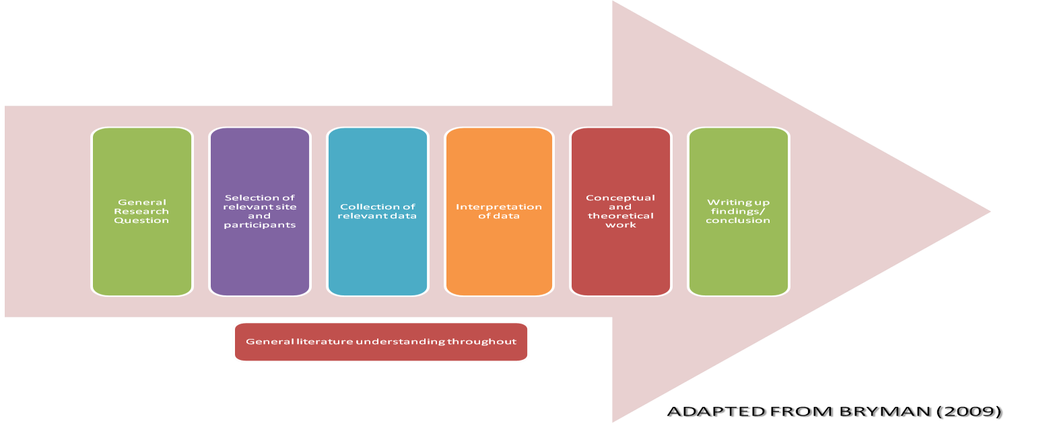

**Figure 2**

**Appendix B: The Quantitative Process**

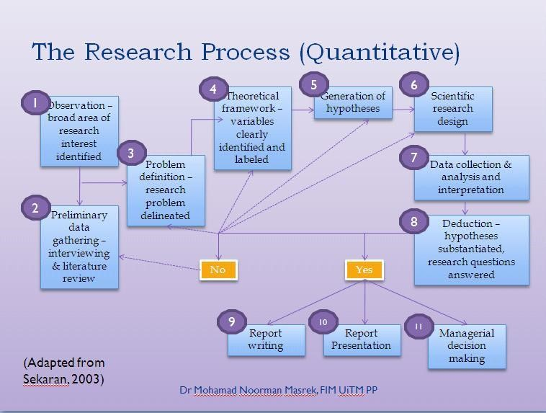

**Figure 3**

**Appendix C: Stakeholder Prototype**

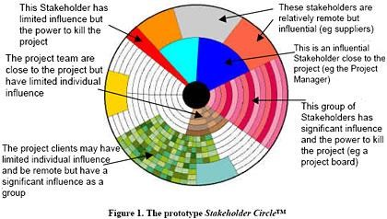

**Figure 4**

**Appendix D: Deductive Method**

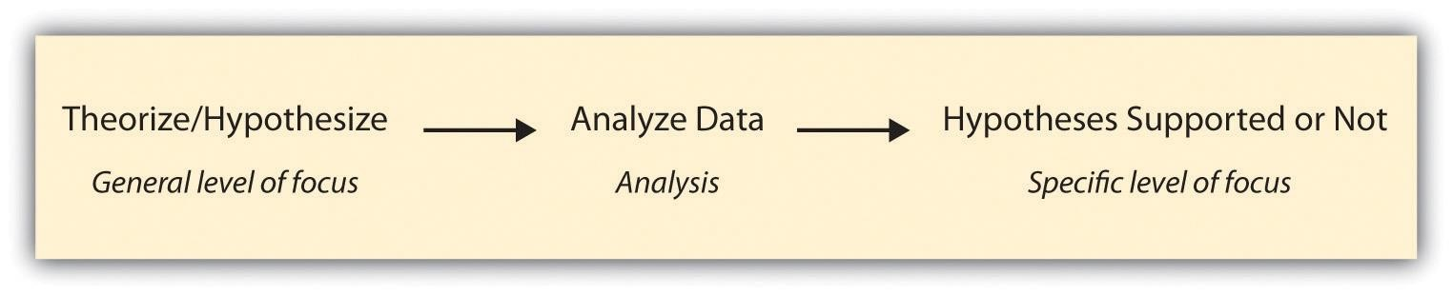

**Figure 5**

**Appendix E: Inductive Method**

**Figure 6**

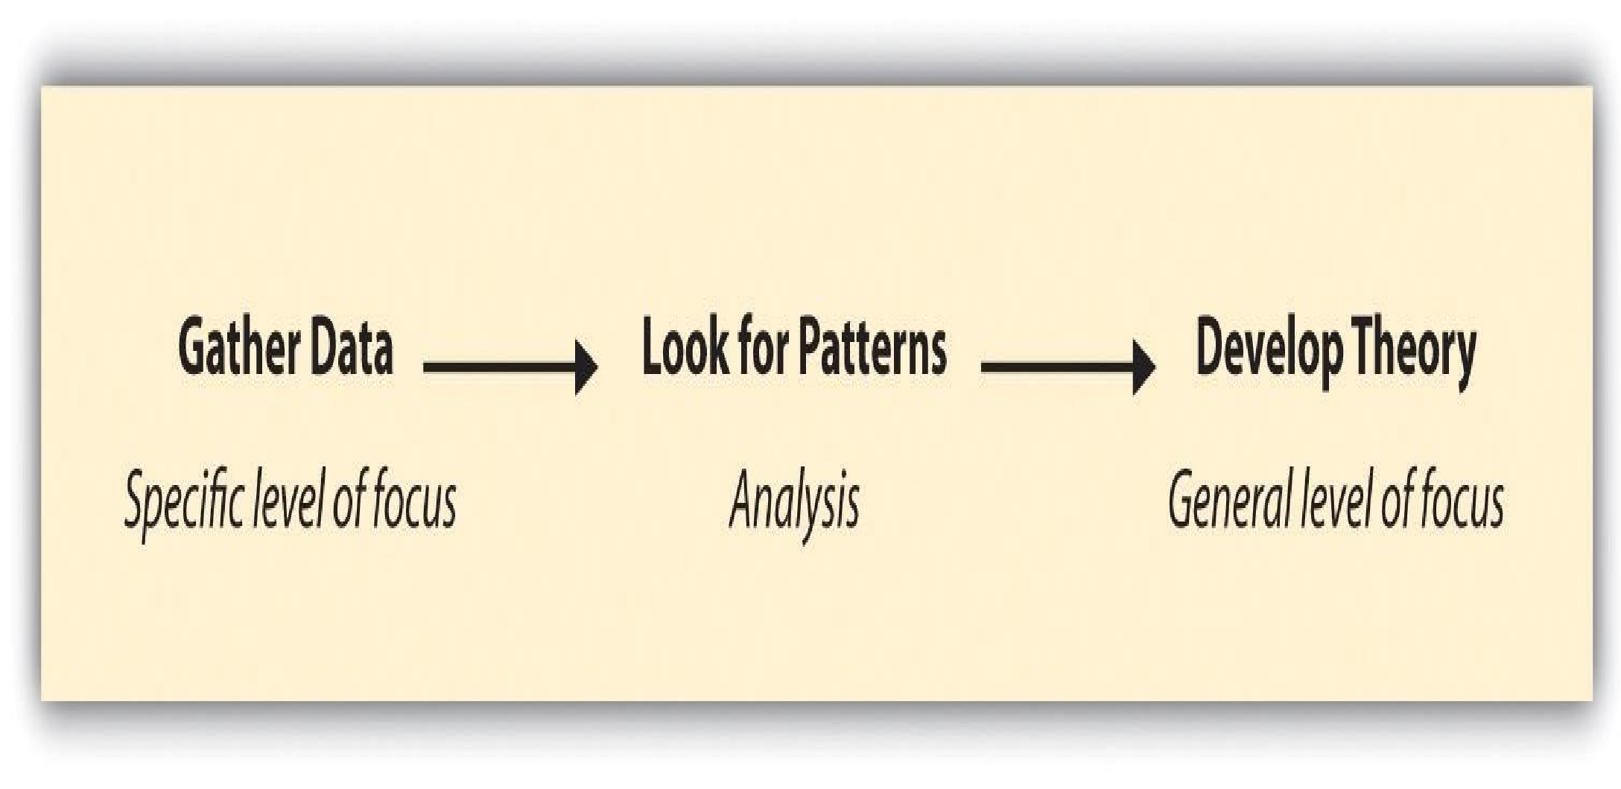

**Appendix F: The Research**

**Onion**

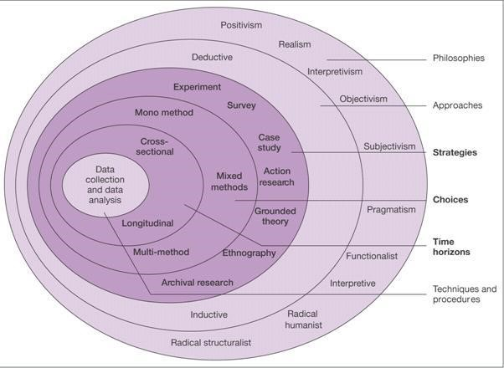

**Figure 10**

**Appendix G**

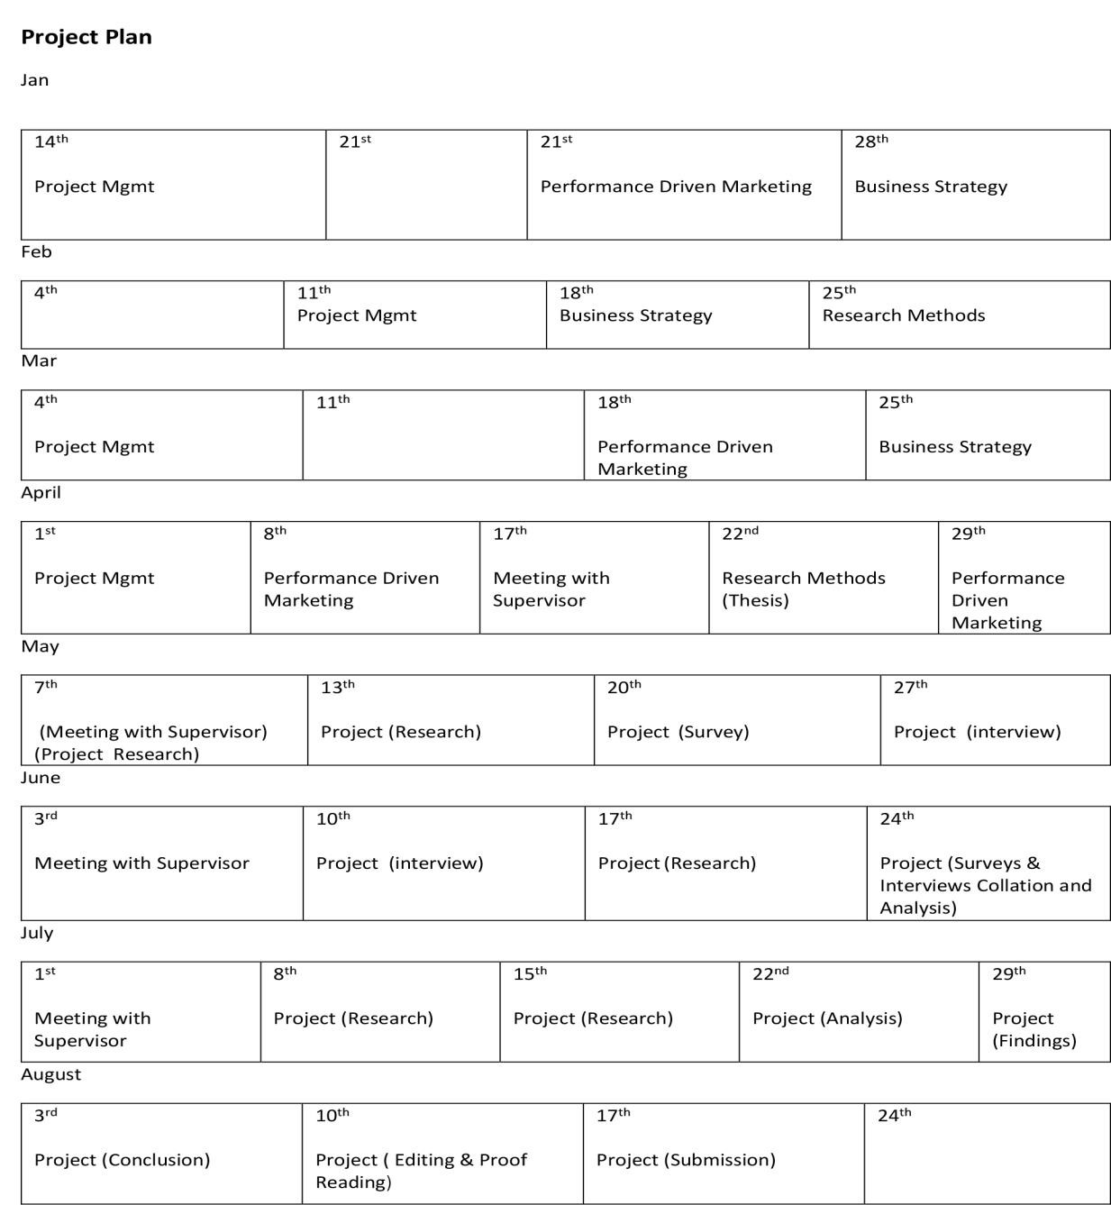

**Fig. 11**

**Appendix H: Figure 12 Survey**

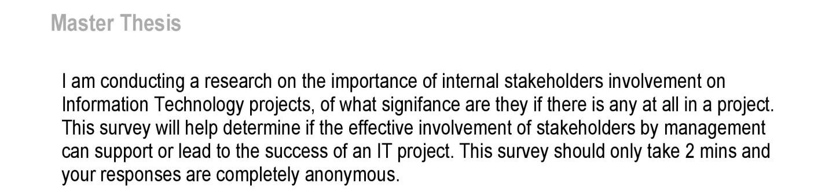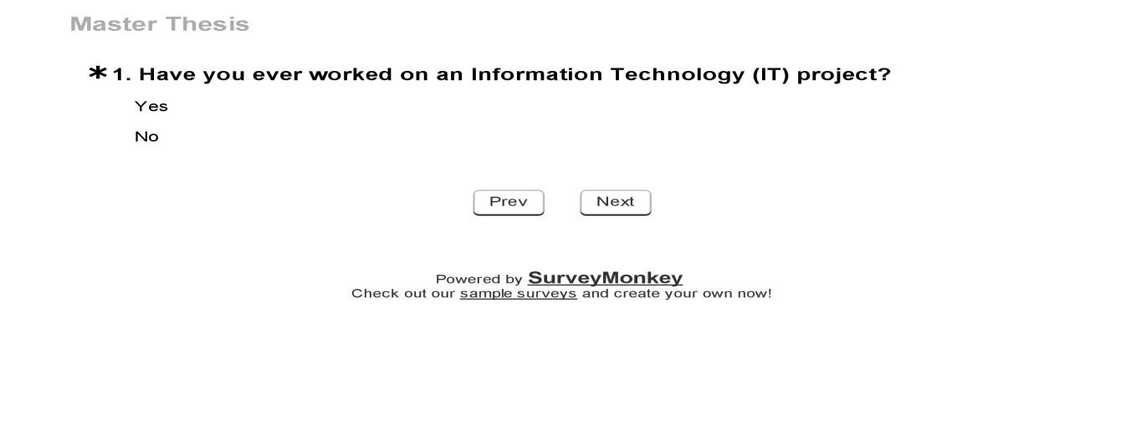

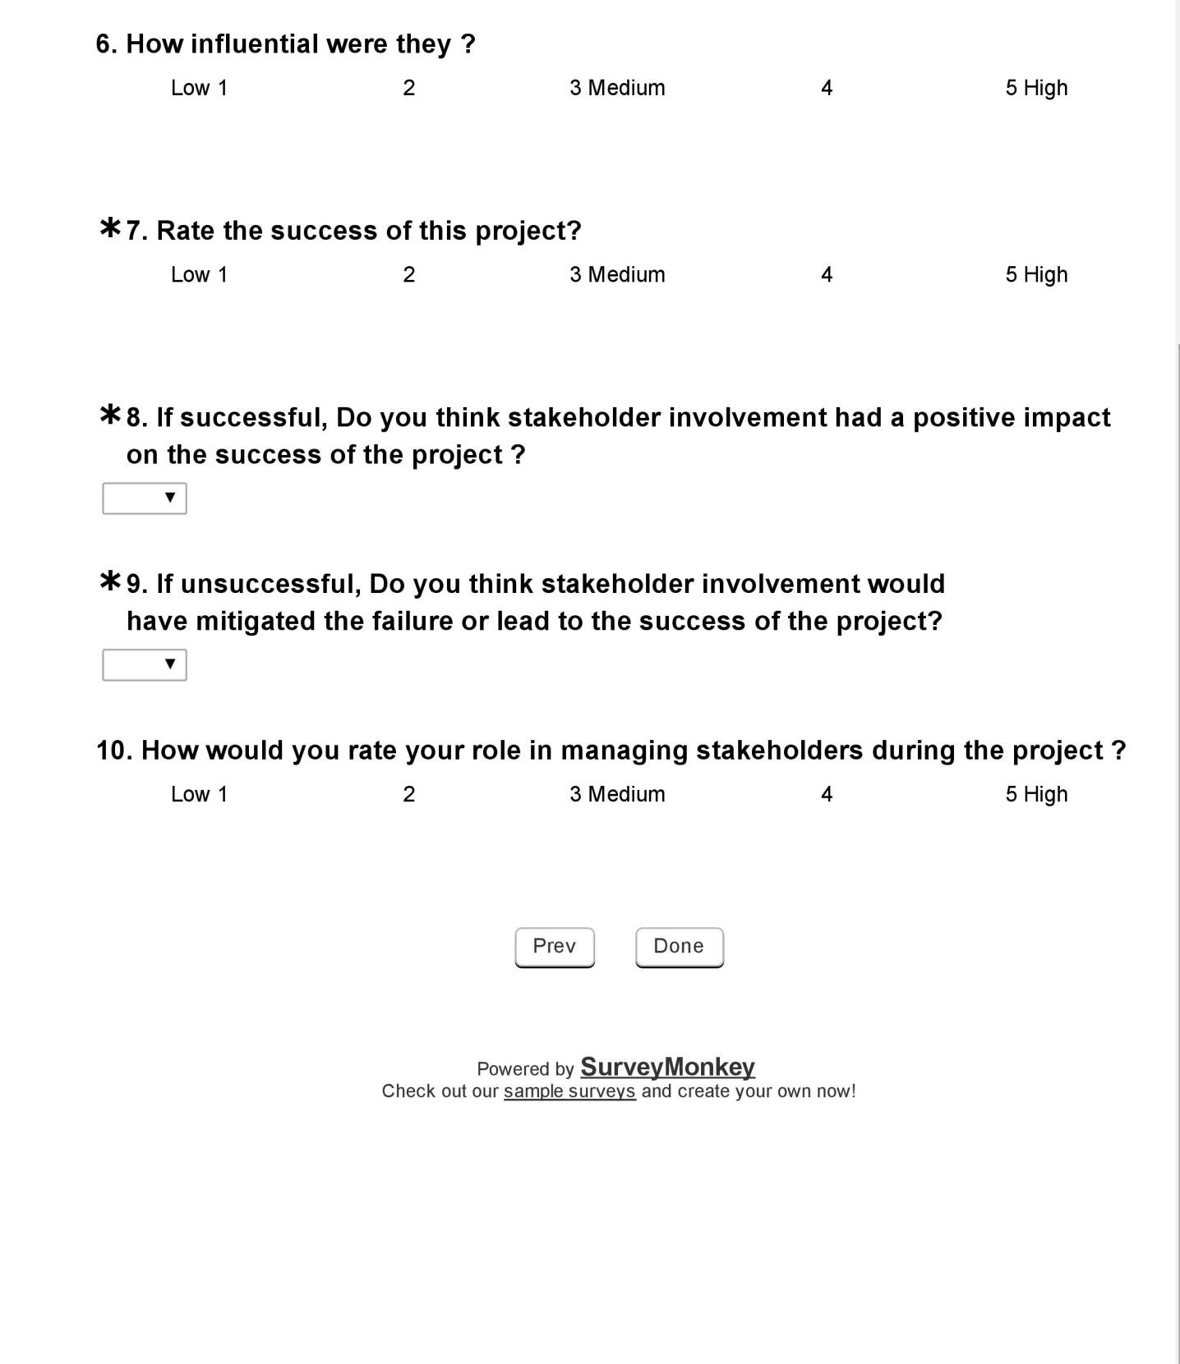

## Appendix I: Figure 13 Interview with Noah Baderibigbe

**Can you briefly introduce yourself sir?**

My name is Noah Baderibidge. A project consultant. I was with Dataflex for 9yrs prior to that, I have worked at other companies but at the moment I am currently doing my Phd, working per time with Dataflex and also as a project advisor to the Lagos State government, as you’re aware the Lagos state government are heads over hills to get certain infrastructures that will aid communications working as soon as possible and that’s where I come in.

**From your introduction, it shows clearly you worked on different projects during your time in Dataflex?**

Of course, I have in vast area stretching between various departments at Dataflex

**Were this IT related projects? And on most of this project what was your role?**

Yes, especially in the telecom sector in Nigeria, there are numerous projects we worked on together with Telecom companies like MTN and the others in Nigeria. And my role there varies from the below:

* Dealing with things relating to supply on logistics, materials and sourcing of required functions in rollout
* Project documentation
* Ensure the proper Dataflex’s standard and quality are upheld
* Reflection of progress and time recording/tracking
* Ensuring the timely delivery of results and/or meetings customer’s expectation
* Strategic preparation, planning and organizing of activities
* Reporting activities and progress above while following specific procedures

**Let's take a look at one particular project which you took the role as a project manager. Were Stakeholders involved in this project? And if so, what sort of stakeholders were involved?**

Dataflex prides itself with their Wireless networks for a lot of infrastructure including Mobile networks, the most interesting one I have done is still on going, and it’s a deal with MTN Nigeria, we are tasked to take care of MTN’s Network infrastructure in the Top states in Nigeria which includes, Lagos, Port-Harcourt, Abuja, Enugu and Asaba and that’s the bulk of

MTN’s operation in the country.

Well in the aspect of stake holders yes, MTN has liaison officers, also the Nigerian Communication Commission NCC has set of monitoring our operations to ensure the

Nigerian government’s interest is represented, so I’ll say private and public stake holders, if I get your question well.

**Do you mean Internal and External stakeholders by private and public stakeholders if I get you right?**

Yes

**Did they as the Stakeholders take an active role during the project?**

The Private Stake holders, I mean MTN company who awarded us the contract, is taking an active role as we at Dataflex try to understand how they were doing their job for smooth transition and also, there is a mutual understanding in how they participate. On another angle, the NCC guys whom I might say is the public stake holder’s representative are taking a passive role

**Which of these stakeholders were more influential during each phase of the project?**

Well it depends at all stages the MTN guys have stayed in touch, as they also have their own social responsibility, and like I said before, it’s their business, and we needed to understand how they were operating right on ground, we already know but keeping an open communication channel open between us and them makes the work seamless. The NCC guys, had a pretty interesting role, because if you read the news, they give certain fines to telecom companies in Nigeria for not living up to their expectations, so they are always watching, let’s call them the big daddy.

**What do you think of the influence of the internal stakeholders in the project? and do you think they affected the project either positively or negatively during each phase of the process?**

At the initial stage it was ok to have them always around, it allowed us to know their fault and understand the bigger picture they saw before contracting us, this enabled and is still enabling us take all issues pertaining the maintenance of the infrastructure well, going into more details would have been given you more understanding however, the NDA will not let me talk more. Maintenance is usually very ambiguous, and given the power issue in the country, the traditional methods we employ at Dataflex may be adjusted in some cases and this is positive as the input from the stakeholders has enabled us see comfort in that.

**Can you rate the success of this project from 1 - 5, where 1 comes as failed and 5 comes as very successful?**

As the project is still on-going, however what I can say is so-far so-good and I’ll give 3 on the overall success so far.

**How was the management of stakeholders throughout the whole process? were they taken into consideration?**

Yes they were considered at every point but not as an integral part of how we carry out our job, we pay them their respect passively while we carry out our job and there are certain knowledge I am allowed to share with them and same applies going up the chain of command.

**According to reports, IT projects has the biggest failure, Do you think if the internal stakeholders are more involved in each phase and process of IT projects this can have an impact on the final quality and success of the project?**

Yes I strongly believe that, however its up for debate and depends wholly on the scope of the project, I can tell you how to do the job I delegated you to do, and can decide not to tell you and watch you do it, but given an instance where we find a middle ground outlining the point of inputs, guidance, standards monitoring and request for reports well ahead of time, we can have a good platform to launch from giving the project a boost for success

**If you were an internal stakeholder in a project, What would expect from a project manager in regards to relationship management among the stakeholders??**

This is a tricky question because I have never actually been one, and again there is no one answer to it, nevertheless, I would like to know what kind of information about the project that the manager intends to share in respect to the agreement pre or during the project. I would also be interested in the quality of staffing and materials used. But again there must be a pre-arranged method for collaboration already established because on the field things can quickly go sour

**Is there anything else you would like to add sir?**

Well, nothing much really, I just hope I have been able to answer your questions as best as I can. I would also like to add that on the handling of project stakeholders, it all depends on how the project manager on the project handles the management of stakeholders which would determine their input which might in a way help in the lay down of the project.

## Appendix J: Figure 14 Interview with Gbolahan Abeleje

**Can you briefly introduce yourself sir?**

I am the 3G operations Customer Project manager responsible for project analysis, implementation, control and delivery for projects relating to 3G operations across the telecom Airtel network in Ericsson, I report to a few people in the organisation such as the KAM (Key account manager i.e. head of the project), Regional technical Managers and Our customers project directors.

I have been in this role for the past 6 years now and can tell you it been a good experience. Continually this role avails me the opportunity to learn more and more about project management because when carrying projects you can only be faced with similar project risks and problem; they are never the same and would require different approach.

**From your introduction, it shows clearly you worked on different projects during your time in Ericsson?**

Yes i have been involved with several projects while working for Ericsson. Our customers are always trying to improve their network, therefore we are always involved in project constantly. If i can mention, we run a managed service contract with our customer, this means, we are in charge of the network, so all the customer does is to tell us what they want to implement on the network and we are responsible for carrying it out from initiation to delivery.

**Were this IT related projects? And on most of this project what was your role?**

Ericsson is a telecoms and IT company, so definitely majority of the projects carried out are IT related. They are projects relating to the IT network and 3G operations of the telecoms network. Some of these projects are active projects while some are passive. But definitely for the question you’ve asked, IT related projects are active. Examples of these projects in the past include implementation and expansion of core network nodes, upgrade and downgrade of nodes etc. Nodes are equipments which the network is built on. Over the past years, i have held a few different roles during different project. At the beginning when i started with Ericsson, i worked as a project engineer and over the years with experience and successful delivery of projects with my team i rose to be a project manager. So i can tell you that roles i have held include being a project engineer and project manager.

**Let's take a look at one particular project which you took the role as a project manager. Were Stakeholders involved in this project? And if so, what sort of stakeholders were involved?**

Like I mentioned earlier Ericsson runs a managed service contract with its customers, so definitely stakeholders are always involved. Majority of the projects carried out by Ericsson are usually supported by stakeholders. Let me break down to you. Ericsson Nigeria reports to the global Ericsson, hence Ericsson global is a stakeholder in Ericsson Nigeria. Ericsson Nigeria has it customers which they carry out managed service contracts, these customers are definitely stakeholders also in whatever project we carry out for them. Also within Ericsson Nigeria we have different project offices, each project office has to balance its accounts and deliver to the Ericsson Nigeria as a whole.

So we can easily describe our different stakeholders as both internal and external stakeholders.

A particular project I would reference for you which i was the PM was the 3G network deployment. This Project involved rolling out 3G network service across the state and ultimately across the country. For this project, like I explained earlier during my breakdown of stakeholders that we interact with, all stakeholders both internal and external were involved as it was a major project worth millions of dollars.

**Did they as the Stakeholders take an active role during the project?**

Oh yes, they did and like every other project they always do. The stakeholders were very important during the project because we had some discussion which we couldn’t take on our own ill we relayed to the stakeholders and had to wait for their view and go ahead. Asides decision making, we always had to report to them and continually update them about progress of the projects at each stage gate for review, this was very important to avoid a reverse input and according to project management principles, it is important to report to stakeholders.

**Which of these stakeholders were more influential during each phase of the project?**

For this particular project that i make reference to, the external stakeholders here in referred to as customers were more influential throughout the duration of these project. Reason being, firstly the project was to be delivered to them. Secondly they set out the requirement for this project and are expecting a desired output, so at every stage gate which we report to review, they always had input which they make changes, add or subtract to the project being carried out. There influence for this particular project was well felt in terms of decision making, even though Ericsson was in charge of the project as a whole, we were confined to the rules and expectation of the stakeholders who was an external. So i can conclude for you that the customer who is actually an external stakeholder was more influential during this particular project.

**What do you think of the influence of the internal stakeholders in the project? and do you think they affected the project either positively or negatively during each phase of the process?**

Looking at the influence of the internal stakeholders here in referred to as the project office and Ericsson Nigeria, i would say their influence also affected the project. They had a role to play in terms of delivering this particular within budget and stipulated time. Also they were responsible for providing the necessary resources, tools and manpower needed for the completion of the project. The internal stakeholders were there to guide during this project and also consult with the external stakeholders when critical decisions were to be made. Even though each project has its ups and downs and some decision taken by the internal stakeholders weren’t favourable still i wouldn’t regard their influence has negative. So answering your question, i would say the internal stakeholders influenced the project positively

**Can you rate the success of this project from 1 - 5, where 1 comes as failed and 5 come as very successful?**

I would rate this particular project as 4 being successful reason being, we delivered according to specification and within budget, not therefore implying we didn’t have issues or face problems but that despite the problems, we took calculated risks which in turn favoured us during the implementation of the project.

**How was the management of stakeholders throughout the whole process? were they taken into consideration?**

The management of the stakeholders was straight and simple. There were rules & regulation and binding contracts on what the project entails, this gave a very good guide in terms of communications and reporting during the project. Project guidelines made the management of stakeholders easy. We knew the level of decisions which we could take on our own, so also decisions which were above our jurisdiction we knew when to involve the stakeholders making the management process easy.

So definitely they stakeholders were always in consideration. Let me throw you and example/question, an investor has invested in you for a project, along the line you experience a problem which could jeopardise the project and would affect the investor, knowing this, would you take any critical decision without informing the investor?

So always we are always putting the stakeholders into consideration.

**According to reports, IT projects has the biggest failure, Do you think if the internal stakeholders are more involved in each phase and process of IT projects this can have an impact on the final quality and success of the project?**

This is a grey area for me, as it this question sound general and is disputable in terms of IT projects being the biggest failure. My perception is that every failed IT project has its reason for failure which shouldn’t be generalised. Before a project fails so many things must have gone wrong.

Internal stakeholders are important and always have a role to play in project delivery, this i can say due to the number of projects I’ve been involved and the role stakeholders have played. So yes internal stakeholders are important for the success, quality and delivery of a project.

So relating to your question, if internal stakeholders have played little or no role in those failed IT projects, I can say that has probably been the cause of so many failed IT projects like you mentioned.

**If you were an internal stakeholder in a project, what would expect from a project manager in regards to relationship management among the stakeholders??**

If i was an internal stakeholder, in terms of relationship management i would require a project manager to manage closely and effectively communicate with me during a project, continually updating and making me aware of situation during the project. If i may mention, the success of any project also depends on communication, therefore i would expect a project manager to organise meeting that would enable us deliberate on how to make the project successful.

**Is there anything else you would like to add sir?**

No, that’s all and wish you best of luck.