# Unit : Course Overview

About the Course

Fast Track to the Sir Speedy Content Management teaches you how to add, update, and delete content in the new Sir Speedy website, depicted in Figure 1.

Underpinning the new SirSpeedy.com website is the Ektron CMS400 Web Content Management Server Version 9.0, from Ektron ([http://www.ektron.com](http://www.ektron.com/)) which provides a number of core services such as browser-based editing, content reuse, taxonomy, approval workflow, document management, notifications, and content syndication.

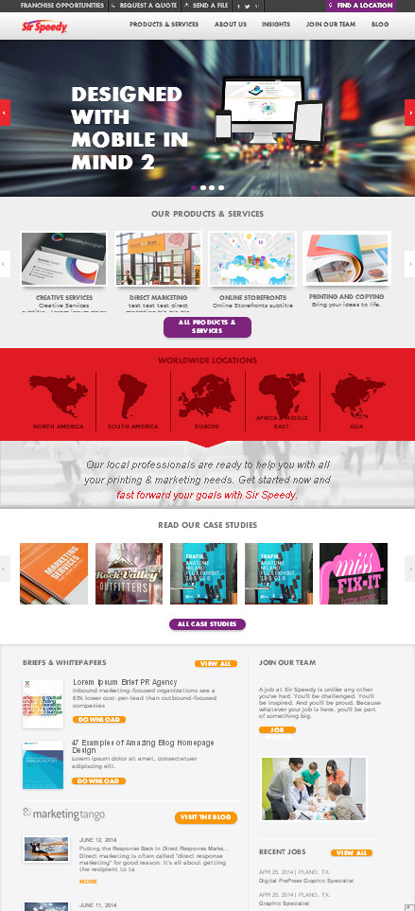

Figure : The new Ektron-based Sir Speedy site

## About this Guide

This Training Guide serves as a one-day Fast Track to the Sir Speedy Content Management instructor-led courseware. Designed to reinforce key topics related to managing an Ektron-driven web site, these walkthroughs provide step-by-step instructions for accomplishing common development tasks. This course is designed for individuals who have no prior experience with web development, yet have a casual familiarity with web browsing and using Microsoft Windows™ style applications.

Reviewing the Course Objectives

After completing this course, you should be able to:

* Understand how the Ektron WCM system will affect your job.
* Understand the “Content Contributor” role and its related permissions.
* Log into Ektron, and navigate the ***CMS400*** Workarea.
* Create a new content page on your website.
* Add and edit different types of content.
* Submit content into an approval process.
* Create a form for submitting user data to an editor.
* Locate and edit pages that have been referred back for changes or corrections.
* Approve content for publication.

Reviewing the Course Prerequisites

The knowledge prerequisites for this course are:

1. Prior experience using a web browser
2. Prior experience using WYSIWYG content editors, such as Microsoft Word
3. A casual understanding of how to locate files on your local machine and local network.

Reviewing Software Requirements

You will need a broadband connection to the internet. In addition, the following software is REQUIRED to be installed on each student workstation:

* One of the following web browsers
* Microsoft Internet Explorer 10+
* Mozilla Firefox 3.6+ *(disable Popup blocker in Tools > Options > Content or allow popups for author.sirspeedy.com)*
* Google Chrome

## Reviewing the Course Format

This course is divided into three units, each of which presents new information and contains demonstrations, walkthroughs, and labs. At the end of each unit, you will find a summary and a short review to test your knowledge of the unit’s content.

The following icons are used throughout the guide:



**Concepts** introduce new information.



**Demonstrations** illustrate new concepts.

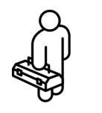

**Best Practices** provide you with helpful insights and information.

Outlining the Course Content

* **Unit 1: Introducing the Course**
  + About the course
  + Reviewing the Course Objectives
  + Understanding Content Management Systems
* **Unit 2: Logging In, Creating Content and Editing Content**
  + Accessing the Ektron Workarea
  + Creating a New Page
  + Working with the Ektron Rich Text Editor
  + Working with Images
  + Creating Hyperlinks
  + Working with Files and Documents
  + Page Expiration and Notification
  + Reviewing Content State and Version History
  + Moving and Copying Content
* **Unit 3: Approval Workflow and Smart Forms**
  + Approval Process
  + Bar Bulletin
  + Bar Journal
  + Calendar Events
  + Ethics Opinions
  + Info Packets
  + News Articles
  + Photo Gallery
  + Section Chair Widgets
  + Solo Conference Page
  + Videos

Understanding Ektron Web Content Management

The term Ektron serves as the Web Content Management System that manages and serves up the pages that are viewable to the public. It enables you to focus on adding and maintaining your web content without having to understand the technical underpinnings of web pages such as the Hypertext Markup Language, Cascading Style Sheets, and Javascript.

Ektron also enforces business rules that restrict the sections of your site and areas of web pages that you may edit while handling most formatting tasks automatically. One of its primary goals is to keep you focused on updating your content and messaging instead of getting bogged with its presentation. Its content approval workflow system ensures that your pages are reviewed prior to becoming publicly accessible. You can even schedule your content to become available on a future date.

You will author content in your site by using your web browser. No other software is required. With a minimal software configuration and an interface requiring very little training, you should be able to add content directly to your site instead of passing that responsibility off to a third party (typically a design or IT department).

To sum up, an Ektron Content Contributor adds content to their site, submits it for approval, when it's approved it goes live. No coding or advanced technical knowledge is required.

### Ektron within Sir Speedy

For this implementation, local and national administrators use a separate interface to choose the content to display for their centers. They do not have access to the Ektron Workarea. Only Super Administrators whom have content editing rights to the Ektron workarea are able to perform core Ektron tasks such as creating content blocks, uploading images, organizing site folders, and creating centers and profiles.

### Understanding your Web Site Organization

Ektron divides your site's content into the following hierarchy:

* **Folders** that represent subdirectories on your web server
* **Templates** that control how content looks on a browser
* **Content Blocks** that represent editable regions on a page and can consist of text, images, links, multimedia assets, and more

#### Organizing Content into Folders

Folders are subdirectories in which you place your content and are used to segment information into more granular “buckets.” You can search for content based on the folder in which it has been placed.

The location of your content influences a number of factors, including the following:

* Easier to find for editors who must manage a page
* The page's breadcrumb links (if applicable)
* The navigation links that appear in the left-column of the page

As indicated by Figure 2, folders may be nested.

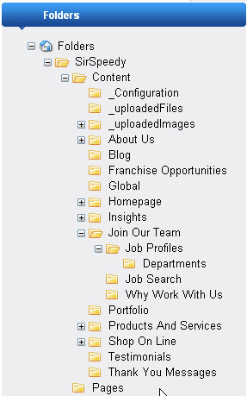

Figure : Folder hierarchy tree for Sir Speedy site

*Some folders may not be accessible to you, depending on your level of access.*

#### Working with Content

Content blocks contain data that is visible to your readers. Content blocks include a Title and Description. Additional properties can be added to blocks of content for tags, taxonomy terms, and other display elements. These fields are used by the public search engines, such as Google, to index your site. Pages are hidden from the public until they are released by you for publication. You can also configure security restrictions that require a user to be logged-in (members only) in order to view a page.

**Terminology:** Throughout the course, the use of the word “page” may be interspersed with “content”. Most users are familiar with web pages, and those pages containing text, images, navigation, links, and multimedia assets. Although it is fair to compare the creation of a content element to that of a web page, the Ektron WCM system constructs a web page dynamically from a predefined template and the data from one or more content blocks. This means that the Ektron system allows you to build pieces of a page. In some cases, content blocks are just data being displayed in an area of a page that don't necessarily have a visible page in which to view them individually.

Your implementation of Ektron relies heavily on the location of the page or content block to determine what template to use, which security restrictions to apply, which content blocks are available in the Administrative interface, and which navigation to display on the page. This method sets the default values for content editors to simplify the page creation process.

#### Editing Content Blocks

Content blocks are containers for data. Content blocks come in different types based on the type of content a block holds. A content block might hold text, or an image, or a combination of both. A block might also be a form, a blog posting, a calendar event, or a video.

In order to help ensure consistency between what is visible on a page, only specific areas of a page are editable to a content editor. Depending on the page's template, editable fields will be highlighted, or various options for content will be presented.

Each content block type has a custom form associated with it, as depicted in Figure 4. Some may include a WYSIWYG editor whereas others might simply contain a set of simple text input fields. Changes to content blocks do not become publicly accessible until they are submitted for publication and approved. After approval, those changes can be “rolled back” by using Ektron's Version History feature.

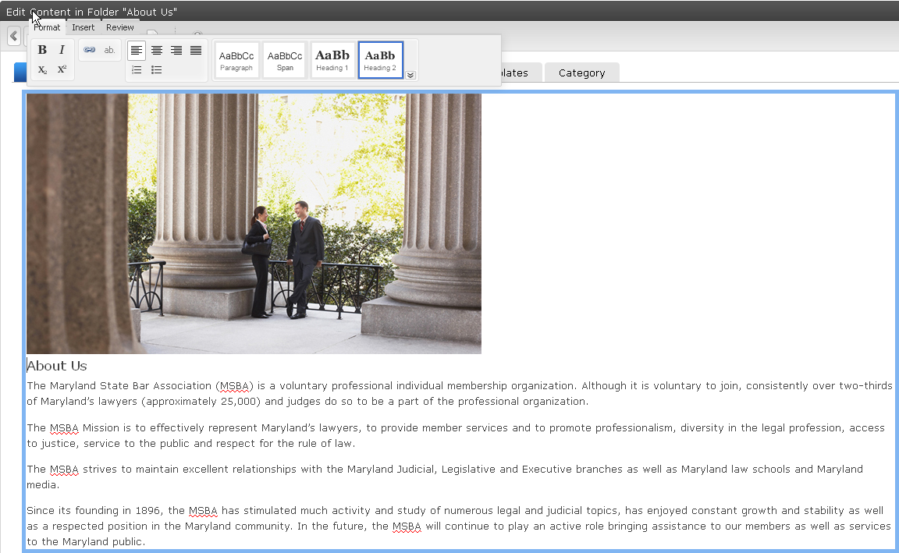Figure 4: Sample of content block with Text Field and Rich Text Editor

##### Ektron Check-Out/Check-In System

The Ektron system uses a check-out/check-in system similar a brick-and-mortar library. This system permits a single user to check-out (or lock) a particular piece of content so that it cannot be edited by any other user until the user that checked it out is finished. Content editors can view checked-out content but will not be able to edit content blocks that are checked-out by another editor.

*Note: Administrators can “check-in” content that other users may have inadvertently kept checked out.*

Consult **Unit 2: Introducing the Workarea** for more information about content statuses.