**Answers**

1. **From your analysis of the categorical variables from the dataset, what could you infer about their effect on the dependent variable?**

Bike Rentals are more:

* On Saturday, Wednesday and Thursday
* During the Fall season and in summer
* In the year 2019 compared to 2018
* In clear weather
* During the month of September

PFB visualization of categorical variables.

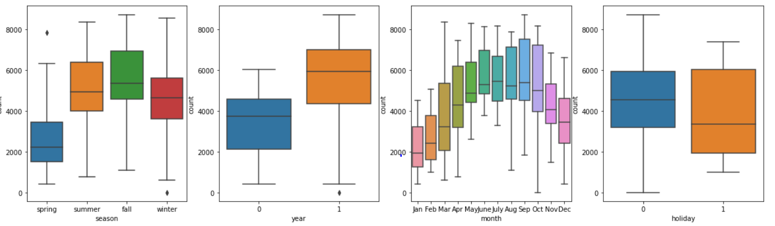

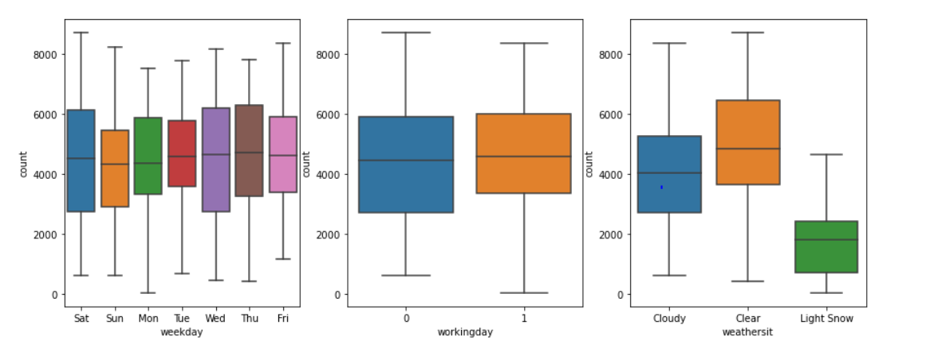

1. **Why is it important to use drop_first=True during dummy variable creation?**

drop_first=True is important to use, as it helps in reducing the extra column created during dummy variable creation. It reduces the correlations created among dummy variables.

1. **Looking at the pair-plot among the numerical variables, which one has the highest correlation with the target variable**

The variable temp (temperature) had the highest correlation.

PFB the pair-plot of temp and atemp variables

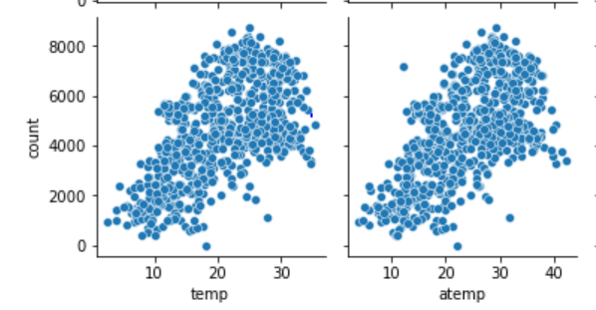

1. **How did you validate the assumptions of Linear Regression after building the model on the training set?**

There is a linear relationship between X and Y.

X and Y should display some sort of a linear relationship, otherwise there is no use of fitting a linear model between them. PFB the snip from analysis.

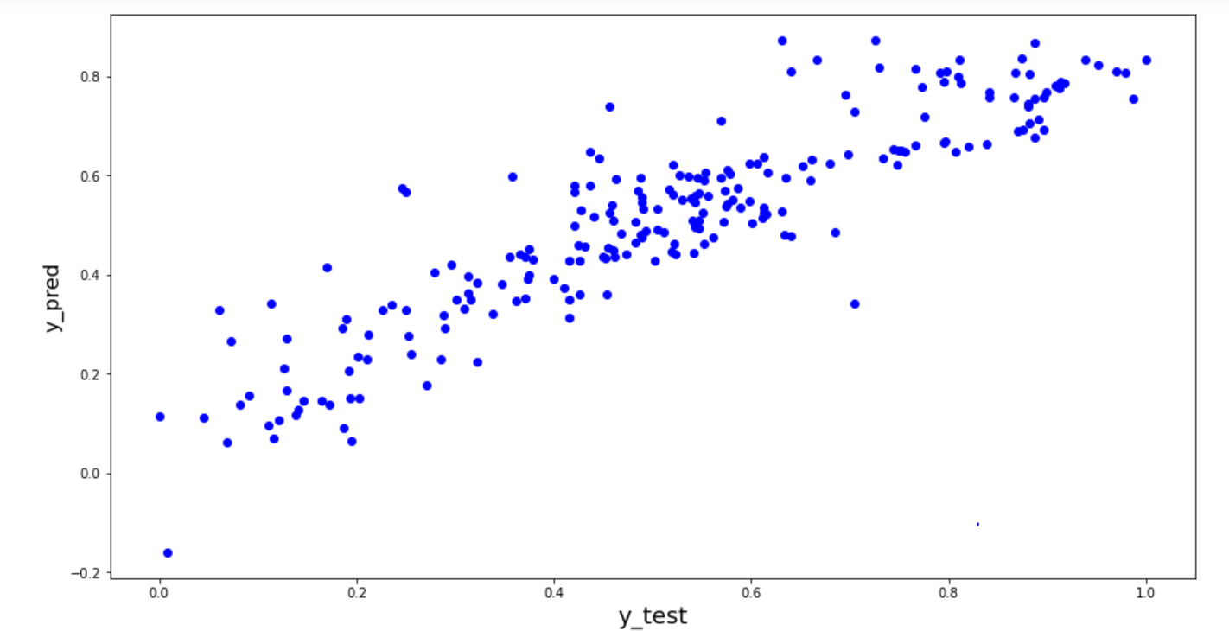

Error terms are normally distributed with mean zero. PFM the snip fromanalysis

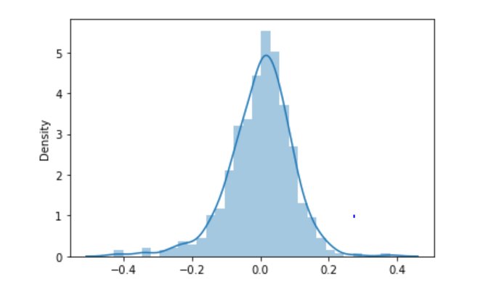

Error terms are independent of each other. Checking assumption of homoscedasticity and autocorrelation.

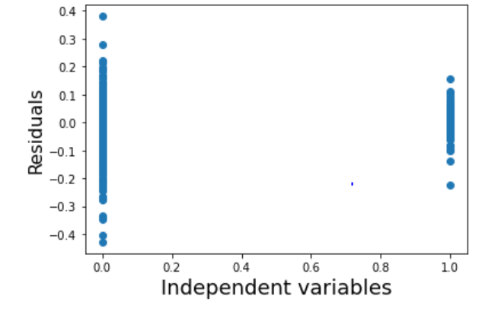

1. **Based on the final model, which are the top 3 features contributing significantly towards explaining the demand of the shared bikes?**

As per our final Model, there are top 3 predictor variables that influences the bike booking are:

temp - A coefficient value of ‘0.4583’. Indicates that a unit increase in temp variable increases the bike hire numbers by 0.4583 units. Therefore, as temperature increases the bike booking increases.

Light Snow, Light Rain + Thunderstorm + Scattered clouds, Light Rain + Scattered clouds – A coefficient value of ‘-0.2863’. Therefore, in snowy climate the bike booking decreases

Year - A coefficient value of ‘0.2349’ indicated that a unit increase in yr variable increases. The bike hire numbers by 0.2349 units. Therefore, in year 2019 the bike booking increased.

1. **Explain the linear regression algorithm in detail.**

**Linear Regression** is a machine learning algorithm based on **supervised learning**. It performs a **regression task**. Regression models a target prediction value based on independent variables. It is mostly used for finding out the relationship between variables and forecasting.

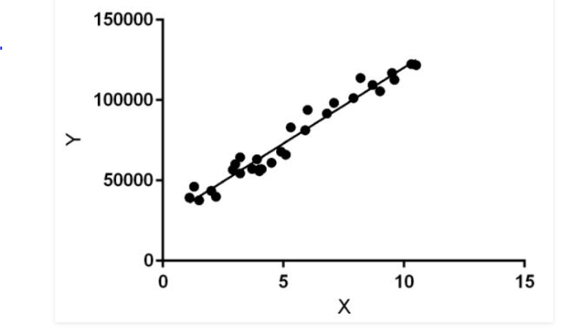

Linear regression performs the task to predict a dependent variable value (y) based on a given independent variable (x). So, this regression technique finds out a linear relationship between x (input) and y(output). Hence, the name is Linear Regression.  
In the figure above, X (input) is the work experience and Y (output) is the salary of a person. The regression line is the best fit line for our model.

Either a simple or multiple [regression](https://www.britannica.com/topic/regression-statistics) model is initially posed as a [hypothesis](https://www.merriam-webster.com/dictionary/hypothesis) concerning the relationship among the dependent and independent variables. For simple linear regression, the least squares estimates of the model parameters β0 and β1 are denoted b0 and b1. Using these estimates, an estimated regression equation is constructed: ŷ = b0 + b1x

1. **Explain the Anscombe’s quartet in detail**

Anscombe’s Quartet can be defined as a group of four data sets which are nearly identical in simple descriptive statistics, but there are some peculiarities in the dataset that fools the regression model if built. They have very different distributions and appear differently when plotted on scatter plots.

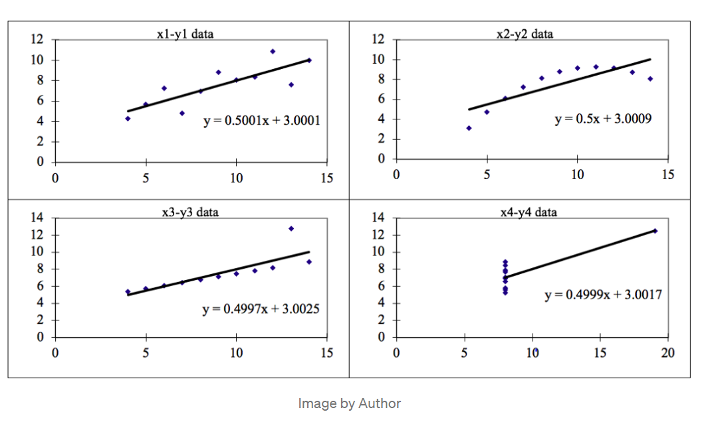

There are four data set plots which have nearly same statistical observations, which provides same statistical information that involves variance, and mean of all x,y points in all four datasets.This tells us about the importance of visualising the data before applying various algorithms out there to build models out of them which suggests that the data features must be plotted in order to see the distribution of the samples that can help you identify the various anomalies present in the data like outliers, diversity of the data, linear separability of the data, etc

The four datasets can be described as

Dataset 1: this fits the linear regression model pretty well.

Dataset 2: this could not fit linear regression model on the data quite well as the data is non-linear.

Dataset 3: shows the outliers involved in the dataset which cannot be handled by linear regression model.

Dataset 4: shows the outliers involved in the dataset which cannot be handled by linear regression model.

1. **What is Pearson’s R**

Pearson's r is a numerical summary of the strength of the linear association between the variables. If the variables tend to go up and down together, the correlation coefficient will be positive. If the variables tend to go up and down in opposition with low values of one variable associated with high values of the other, the correlation coefficient will be negative. "Tends to" means the association holds "on average".

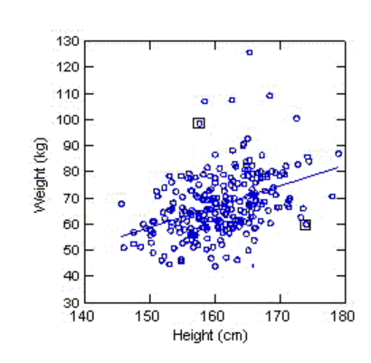

The correlation coefficient is positive and height and weight tend to go up and down together. Yet, it is easy to find pairs of people where the taller individual weighs less, as the points in the two boxes illustrates.

The Pearson's correlation coefficient varies between -1 and +1 where:

r = 1 means the data is perfectly linear with a positive slope ( i.e., both variables tend to change in the same direction)

r = -1 means the data is perfectly linear with a negative slope ( i.e., both variables tend to change in different directions)

r = 0 means there is no linear association

r > 0 < 5 means there is a weak association

r > 5 < 8 means there is a moderate association

r > 8 means there is a strong association

The figure below shows some data sets and their correlation coefficients. The first data set has an r=0.996, the second has an r = -0.999 and the third has an r= -0.233

1. **What is scaling? Why is scaling performed? What is the difference between normalized scaling and standardized scaling**

Scaling is a step of data Pre-Processing which is applied to independent variables to normalize the data within a particular range. It also helps in speeding up the calculations in an algorithm.

Most of the times, collected data set contains features highly varying in magnitudes, units and range. If scaling is not done then algorithm only takes magnitude in account and not units hence incorrect modelling. To solve this issue, we have to do scaling to bring all the variables to the same level of magnitude.

It is important to note that scaling just affects the coefficients and none of the other parameters like t-statistic, F-statistic, p-values, R-squared, etc.

1. Normalization/Min-Max Scaling:

It brings all of the data in the range of 0 and 1. MinMaxScaler helps to implement normalization in python.

1. Standardization Scaling:

Standardization replaces the values by their Z scores. It brings all of the data into a standard normal distribution which has mean (μ) zero and standard deviation one (σ).

1. **You might have observed that sometimes the value of VIF is infinite. Why does this happen?**

The variance inflation factor (VIF) quantifies the extent of correlation between one predictor and the other predictors in a model. It is used for diagnosing collinearity/multicollinearity. Higher values signify that it is difficult to impossible to assess accurately the contribution of predictors to a model.

VIF = 1/1-R^2

If there is perfect correlation, then VIF = infinity. A large value of VIF indicates that there is a correlation between the variables. If the VIF is 4, this means that the variance of the model coefficient is inflated by a factor of 4 due to the presence of multicollinearity. This would mean that that standard error of this coefficient is inflated by a factor of 2 . The standard error of the coefficient determines the confidence interval of the model coefficients. If the standard error is large, then the confidence intervals may be large, and the model coefficient may come out to be non-significant due to the presence of multicollinearity.

1. **What is a Q-Q plot? Explain the use and importance of a Q-Q plot in linear regression.**

Q Q Plots (Quantile-Quantile plots) are plots of two quantiles against each other. A quantile is a fraction where certain values fall below that quantile. For example, the median is a quantile where 50% of the data fall below that point and 50% lie above it. The purpose of Q Q plots is to find out if two sets of data come from the same distribution. A 45-degree angle is plotted on the Q Q plot; if the two data sets come from a common distribution, the points will fall on that reference line.

The quantile-quantile (q-q) plot is a graphical technique for determining if two data sets come from populations with a common distribution. A q-q plot is a plot of the quantiles of the first data set against the quantiles of the second data set.

The slope tells us whether the steps in our data are too big or too small. For example, if we have N observations, then each step traverses 1/ (N-1) of the data. Therefore, we are seeing how the step sizes (a.k.a. quantiles) compare between our data and the normal distribution.

A steeply sloping section of the QQ plot means that in this part of our data, the observations are more spread out than we would expect them to be if they were normally distributed.