1: Introduction to reinforcement learning
WHAT IS AI?
AI: allowing machines to find solutions to problems themselves requires learning autonomously how to make decisions (3 key terms in AI)
Intelligence: a definition of intelligence is "to be able to learn to make decisions to achieve goals"
WHAT IS REINFORCEMENT LEARNING
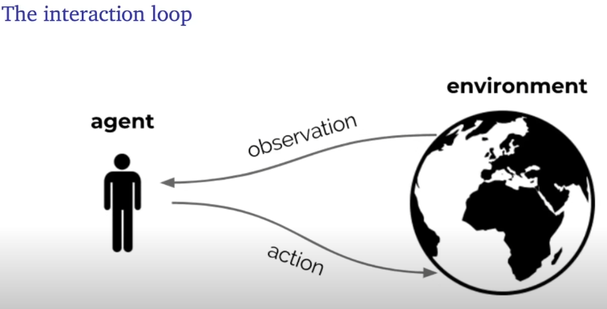
GOAL: optimise sum of rewards through repeated interaction
Reinforcement learning is based on the reward hypothesis: any goal can be formalized as the outcome of maximising a cumulative reward
If the goal is to learn via interaction, it's a reinforcement learning problem, irrespective of which solution (what reward when) you use
There are distinct reasons to learn:
- to find solutions
- to adapt online: deal with unforeseen circumstances (learn efficiently during operation, not just generalisation)
RL can provide algo's for both
Reinforcement Learning is the science and framework of learning to make decisions from interaction requires to think abt time and (long-term) consequences of actions, through actively gathering experience and predicting the future and dealing with uncertainty

FORMALISIGN THE RL PROBLEM
at each step t, the agent :
- receives opbservation O_{t} (and reward R_{t})
- executes action A_{t}
The environment:
- receives action A_{t}
- emits observation O_{t+1} (and reward R_{t+1})
reward Rt is a scalar feedback sdignal (remember reward hypothesis)
- indicates how well agent is doing at step t –-> defines the goal
- agents job is to maximise cumulative rward:
  - Gt == Rt+1 + Rt+2 + Rt+3…
  - Gt = return ; future rewards summed together (can't change the past anymore!)
- The expected return from a state s, is the value: v(s) = E [G_{t} | St = s]
  - Value depends on the action the agent takes
  - Goal is to maximize value
- Rewards and values define utility of states and action (no supervised feedback)
- Value and return can be defined recursively:
- 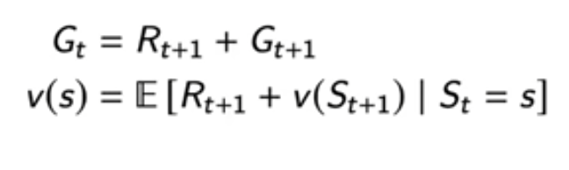
GOAL: select actions to maximise value;
Actions may have long term consequences reward may be delayed, or it may be better to sacrifice immediate reward to gain more longterm reward
Policy: a mapping from states to actions
We can also condition the value on acitons rather than states: the expected return on being in that state, and then taking that action
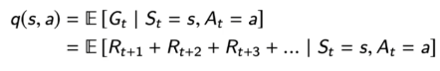
CORE CONCEPTS
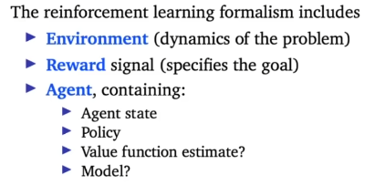

INSIDE THE AGENT: THE AGENT STATE
The agent state S_{t} is essentially everything the agent takes with it from one timestamp to the next
The environment state is the environment's itnernal state. It is usually invisible to the agent, and even if visible, contains lots of irrevant info.
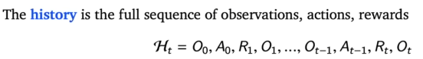
History is used to construct the agent state St
Ful observability: suppose the agent sees the full environment state, i.e. observation = environment state St = Ot = environment state
MDP's : markov decision processes
A decision process is Markov(-ian) if
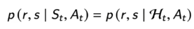 (the probablity of a reward and a state occuring at the next timestamp, T+1, given a state St we're in and an action At we'll take, doesn't change if we add a history) state containds all te need to know; adding more history doesn't help, doesn’t mean it contains everything! Could be that observations are rather useless once state is known, history may be thrown away, so typically the agent state St is some compression of Ht
Partial observability: observations are not Markovian; like a poker playing agent, it only observes public cards and not the hands dealt to opponents using observation as state would not be Markovian (not always bad idea, but it can be a bad idea) partially observable markov decision process POMDP
!environment state can still be markov, but agent doesn't know it. Might still be able to construct a markov agent state

Agent state
Agents actions depend on state
State is a function of the history: 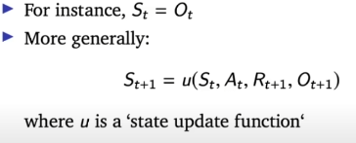

INSIDE THE AGENT: POLICY
Policty definies agents behaviour; map from agent state to action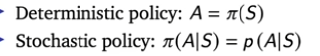
INSIDE THE AGENT: VALUE ESTIMATES
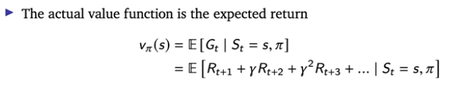
! definition of value, later we'll learn how to apprroximate it
(reward based on state and policy, which determines the aciton!)
Introduced a discount factor : helps determine goal in addition to reward function (trades off importance of immediate vs longterm rewards)
- Disc factor small (or zero): only care about near-term future!
Value function can be used to evaluate desirablility of states, and can be used to select between acitons
INSIDE THE AGENT/ MODELS
Model predicts what the env will do next

L2
EXPLORATION VS EXPLOITATION
Learning agents need to trade off 2 thigns:
- Exploitation: maximise performance based on current knowledge
- Exploration: increase knowledge
Best long-term strategy may involve short-term sacrifces
FORMALISING THE PROBLEM
Multi-armed bandit: set of distributions where there is a reward distr per action
Goal: get highest average reward
Maximise cumulative reward == minimise total regret

ALGORITHMS
Greedy, ε-greedy and UCB use action value estimates : Q_{t}(a) ≈ q(a)
(big q : approximation, small q = real)

ALGORITHMS: GREEDY
Take action with highest estimated value
Notation: pi is the policy, which is the probablility of selecting that action, which is an indicator again (either the action is the one with highest value or it isnt)
Can get stuck on a suboptimal action forever doesn't explore enough, only exploits knowledge it has without considering uncertainty

ALGORITHMS: ε-greedy (epsilon)
Adds some noise to keepon exploring

ALGORITHMS: POLICY GRADIENTS

THEORY: WHAT IS POSSIBLE?

OPTIMISM IN THE FACE OF UNCERTAINTY
When we're uncertain about the value of an action, we'll be optimistic about its value, and pick it more often, to becomee more certain
Flatter curve = more uncertainty

ALGORITHMS: UCB
Upper confidence bound : determince upper confidence for each action value, such that the actual value will be smaller than or equal to the estimate of the value + the upper confidene bound

THEORY: THE OPTIMALITY OF UCB

BAYESIAN APPROACHES
We keep track of a distribtuion over the expected value for each action
‼ not modelling the distribution of the rewards, instead quantify uncertainty about what the expected reward (aka value) of action a
Theta = the parameters of the distribution
! prob should be interpreted as a belief that q(a) = x, doesn't affect the actual number
We use these beliefs to guide the exploration
xA = [nr of times the reward was 0] + 1 for action At
note: x + y = nr of times the action was selected + 2 (since they both start at 1)
examples: remember that e map the mean!n hence why the probablity of the mean being 0 drops to nothing when we only have one result of 1 as the dataset
ALGORITHMS: THOMPSON SAMPLING

PLANNING TO EXPLORE

