**Host-only Network for Virtual Box**

NB: Turn off the operating systems before configuration .can do it with command (sudo shutdown -P now)

In order to create (or verify the existence of) a Host-Only network :

1.click on **Global Tools** in the top-right corner of the VirtualBox window.

2.Click on the Networks tab or host Network Manager depends on what is there in your machine

3.You can see one more entrees there. if not we can also create IPV4 Address/Mask to IP 192.168.56.1/24 as shown below:

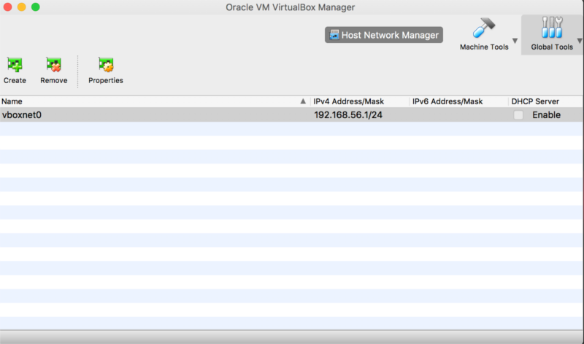

4.check the enable box of DHCP server so that the IP addresses will be automatically generated while creating the guest instances

Cloning the Virtual machine which our host or the base Ubuntu to create instances:

To clone a VirtualBox virtual machine, you need to perform the following steps:

1. In the **VirtualBox Manager** console, select and right-click the virtual machine that you want to clone and then select **Clone**.

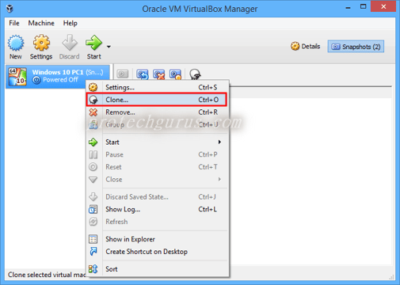

In the **Clone Virtual Machine** window, specify the name of clone virtual machine. Select the Generate new Mac addresses

Click **Next** to proceed.

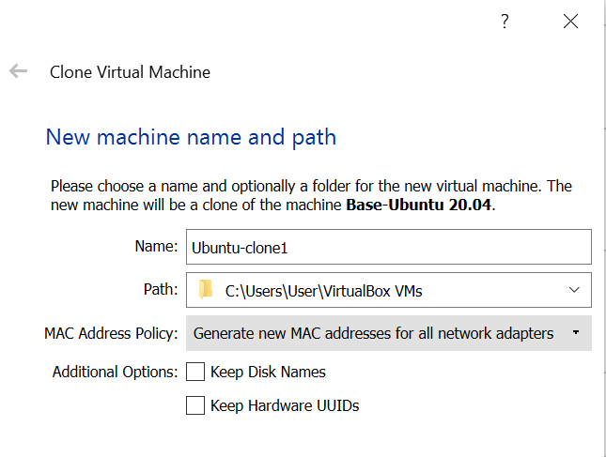

Select the **Full clone**

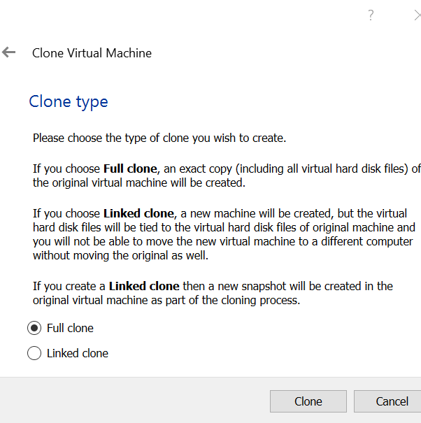

Finally, click the **Clone** button to create the Clone VM. A new clone VM will be created in the **VirtualBox Manager**console., a **Full clone VM** may take several minutes depending on the size of virtual hard disk images

Once you created a clone of a virtual machine, you can use the cloned virtual machine as a separate virtual machine in VirtualBox.

You can create as one more clone as per your memory limit. Incase of memory error try to allocate 1 GB each to the clones. This you can do by selecting the Clone and then go to settings->system->

Add host-only network to your VirtualBox guest:

Each VirtualBox guest need to be configured to use the Host-only network of VirtualBox.

For this click on Machine Tools

Select your machine and click on Settings.

Click on the Network tab.

**Adapter 1** is set to **NAT.**

Click to **Adapter 2**

Select "Attached to:" **"Host-only Adapter".**

Name: select the vboxnet0 or whatever it is called on your system.

Press OK.

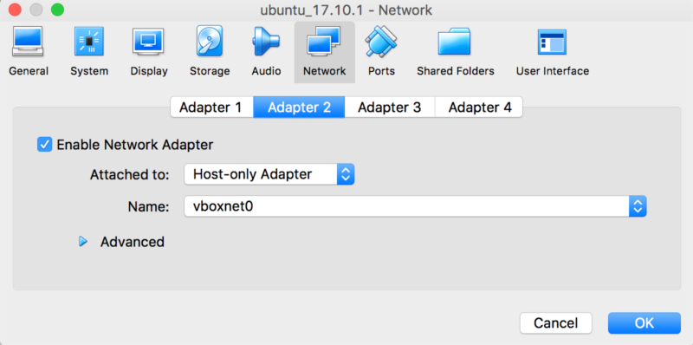

Now creating the clones and configurations done. Now we can start the guest machine or clones and start running

Communication between the Host and the guests or clients:

1.start the two guests for eg: ubuntu-1 and ubuntu-2

2.Access the terminal of both.

2.Check whether the internet connection is there by pinging both the machines using the command

**ping google.com**

3.if you can receive the bytes then internet connection is established successfully in both machines.

4.Now we can check the IP address of both the machines using the command **ifconfig -a**

5. Note the IP address of both the machines and try to ping each other using the command:

Eg: ping 192.168.56.103 from ubuntu1, where IP address of my ubuntu-2 is 192.168.56.102

ping 192.168.56.102 from ubuntu-2, where IP address of my ubuntu-1 is 192.168.56.102

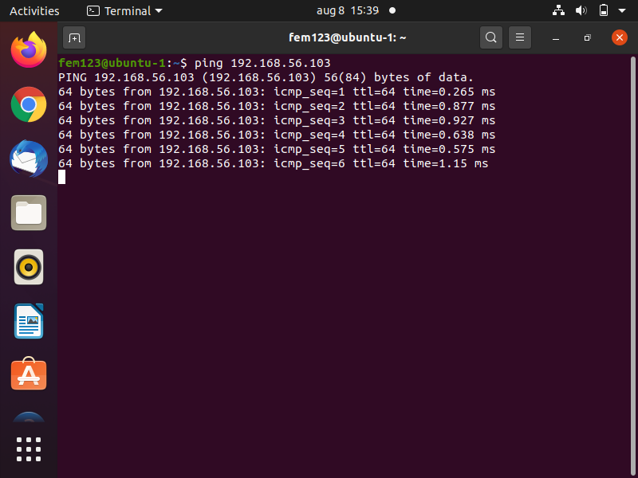

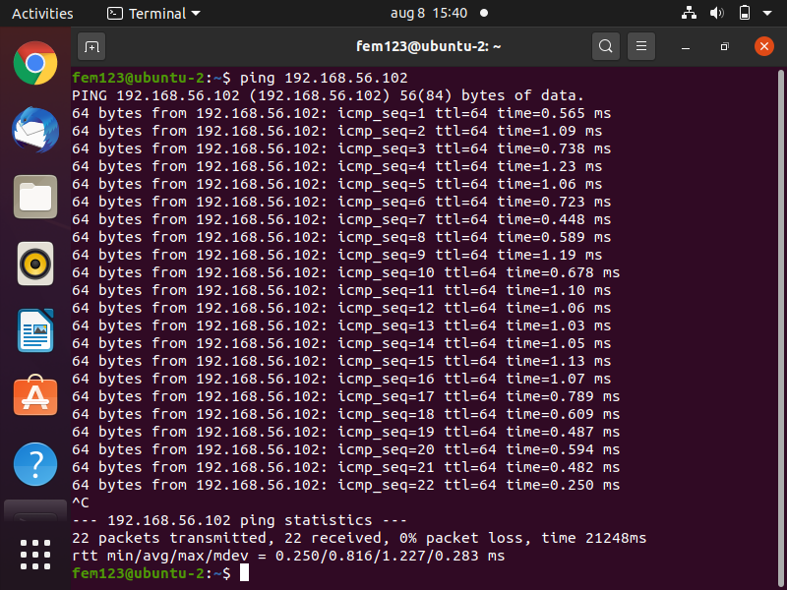

6. Now we can try ssh from both machines so that we can access on machine and its contents from other machine.As shown below:

Accessing ubuntu2 from ubuntu1using the command **ssh yoursername@ipaddress. For example ssh fem123@192.168.56.103**

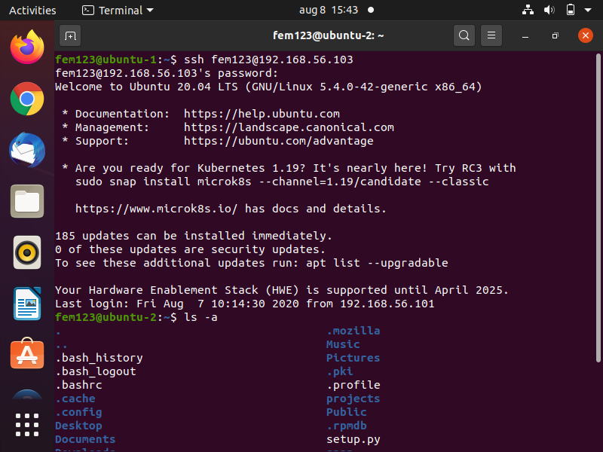

Accessing ubuntu1 from ubuntu 2

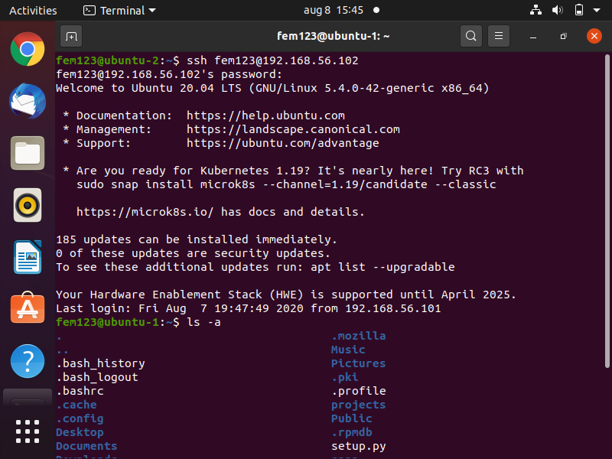

Type exit to close the ssh access

NB: In case ssh command is giving error ,you need to install the ssh using the following commands:

**sudo apt-get update**

**sudo apt-get install openssh-server**

**sudo service ssh restart**

Then try the ssh command again.

Now let’s try to access the guest machines from host or base machine via ssh:

1.Access the terminal of host and try to ping the guests.

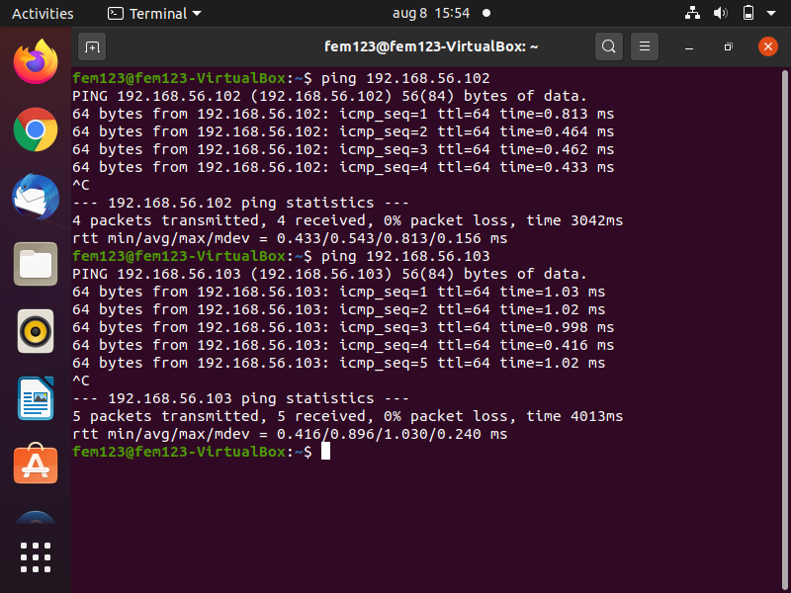

1. We can try accessing each machine via ssh command

Accessing ubuntu1 from host machine

1. 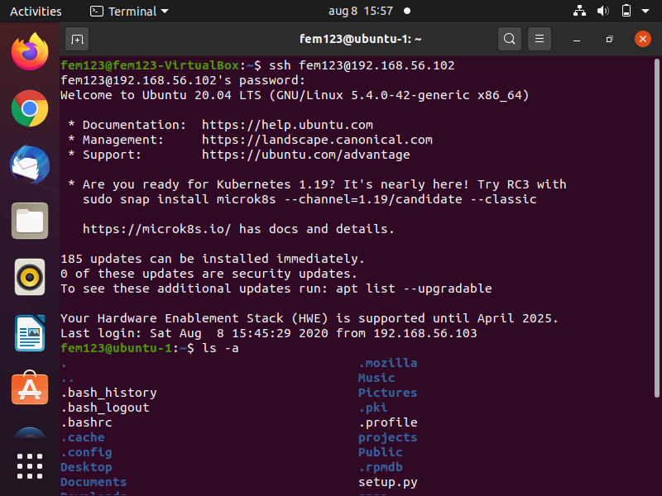

Accessing ubuntu 2 from host machine:

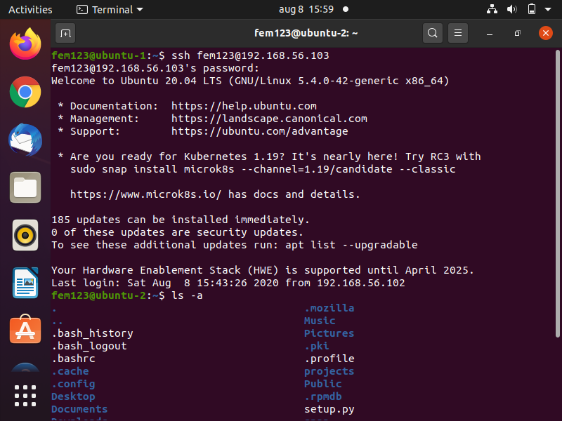

In the same way you can access the host machine from any of the guest machine: for eg: below I am accessing host from ubuntu1

