# **CHAPTER 2: TENSORFLOW INSTALLATION**

## **Theory**

In this chapter, we show how to install and configure the environment, and use the Tensorflow on various operating systems such as Windows and Ubuntu which are widely used as the machine learning framework, and how to create a simple code using Tensorflow.

## **Basic concepts**

* Operation

The nodes on the graph are called operations (abbreviation op). An operation can receive one or more tensors. Operations can perform calculations and return results in one or more tensors.

* Tensor

Internally, all data is represented by tensors. Tensors are a kind of multidimensional array, in which only tensors are passed between operations in the graph. (Similar to Caffe's Blob.)

* Session

A session object is required to run the graph. A session is an encapsulation of the execution environment of an operation.

* Variable

Variables are used to store and update parameters when the graph is run. It acts as a buffer to store the tensor in memory.

## **Tensorflow**

Tensorflow made by Google is quite famous among the packages for deep learning.

But Tensorflow is not the only alternative. The packages for deep learning are as follows.

Famous among them are Facebook's Torch-based Torchnet, Google's Tensorflow, their ancestors Theano, and Berkeley's Caffe.

Among them, Google's Tensorflow is made easy to write in Python environment.

|  |  |  |  |  |
| --- | --- | --- | --- | --- |
| Software | Creator | Software license | Open Source | Platform |
| Caffe | Berkeley Vision and Learning Center,  Community contributors | BSD 2- Clause License | Yes | Ubuntu, OS X, AWS, unofficial Android port, Windows supported by Microsoft Research, unofficial Windows port |
| CNTK | Microsoft | Free | Yes | Windows, Linux |
| Deeplearning4j | Various;  Originally Adam Gibson | Apache 2.0 | Yes | Linux, OSX, Windows, Android, CyanogenMod |
| MXNet | Distributed (Deep) Machine Learning Community | Apache 2.0 | Yes | Ubuntu, OS X, Windows AWS, Android, iOS, Javascript |
| Neural Designer | Artelnics | Proprietary | No | Windows, OS X, Linux |
| OpenNN | Artelnics | GNU LGPL | Yes | Cross platform |
| SINGA | Apache Incubator | Apache 2.0 | Yes | Linux |
| SystemML | IBM Research,  Databricks,  Netflix | Apache 2.0 | Yes | Linux, Max OS, Windows |
| Tensorflow | Google Brain team | Apache 2.0 | Yes | Linux, Mac OS X, Windows |
| Theano | University Montreal | BSD license | Yes | Cross-platform |
| Torch | Ronan Collobert,  Koray,  Kavukcuoglu,  Clement Farabet | BSD license | Yes | Linux, Android, Mac OS X, iOS |

Tensorflow is one of the mostly used framework and open source library for machine learning and deep learning developed by Google. Data flow graph (DFG) mode is used in Tensorflow.

Data flow graphs represent mathematical calculations and flow of data as directed graphs using nodes and edges.

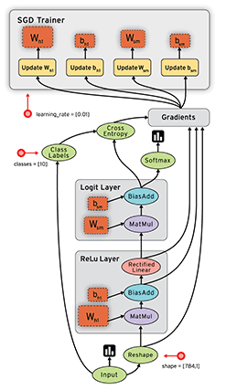

Nodes perform operations such as mathematical computation, data input / output, and data read / save. And the edge represents the input / output relationship of data between nodes.

The edge carries a dynamically sized multidimensional data array (= tensor) and Tensorflow was named from there.

Tensor is a concept that has been used in various fields such as science and engineering. In mathematics, it is known as a notation for expressing arbitrary geometry in a coordinate-independent manner, but it is used in slightly different meanings for each field. In this case, you will understand the multidimensional array in which the training data is stored.

We can write operation codes using Python, a high-level programming language. Most other languages ​​are supported, but most are Python related. Despite the fact that it was not so long ago, Tensorflow has been used in various fields.

Both the regular and GPU-accelerated versions are available. The generic version can run on any computer, and the GPU-accelerated version works much faster because it uses GPGPU to perform large-scale operations quickly.

However, since it uses NVIDIA's GPGPU language, CUDA, it can’t be used without an NVIDIA graphics card. There is also a version that Google uses internally for its services, which runs on Google's own AI acceleration hardware, the Tensor Processing Unit (TPU). It is 15 to 30 times faster than Intel Xeon or NVIDIA Tesla.

The tensor flow has the following characteristics.

* Rich expressiveness through data flow graph
* Works in CPU / GPU mode without code modification
* Available from idea test to service level
* Processes the differential calculation automatically when calculation structure and objective functions are defined
* Support Python / C++, and various languages via SWIG

Let's take a quick look at the basic concepts.

import tensorflow as tf

# Initialize variable to 0

state = tf.Variable(0, name="counter")

# Create an operation to add 1 to state

one = tf.constant(1)

new_value = tf.add(state, one)

update = tf.assign(state, new_value)

# The graph must first initialize the variable. Create an init operation through the function below

init_op = tf.initialize_all_variables()

# Launch graphs and execute operations

with tf.Session() as sess:

# Execute initialization operation

sess.run(init_op)

# Output the initial value of state

print(sess.run(state))

# Perform an operation to update state and output state

for _ in range(3):

sess.run(update)

print(sess.run(state))

The results are displayed such as below.

0

1

2

3

## **AIM**

The aim of the following lab exercise is to install Tensorflow on various operating systems and run, test it

Following steps are required.

Task 1: Installing Tensorflow on Windows

Task 2: Installing Tensorflow on Ubuntu

We need following packages to perform the lab exercise:

* Python
* Tensorflow
* Anaconda
* Cuda
* cuDNN

## **LAB EXERCISE 2: INSTALLING TENSORFLOW**

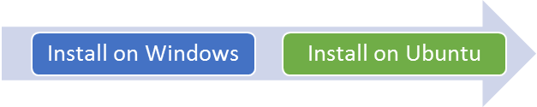

1. **Installing Tensorflow on Windows**
2. **Installing Tensorflow on Ubuntu**

## **Task 1: Installing Tensorflow on Windows**

The process of installing the Tensorflow consists of the following four steps.

* Install Anaconda
* Install Tensorflow
* Install Jupyter Notebook (optional)
* Test Tensorflow

**Install Anaconda:**

To install Tensorflow, Python must be installed by default.

However, rather than just installing Tensorflow in Python, installing Anaconda, a distribution package that includes both Python's machine learning library, sklearn (scikit-learn), and Jupyter Notebook is an easy way to work for machine learning.

And more importantly, Anaconda also includes Python.

This means that if you install Anaconda then Python will be installed automatically. (It is unconditionally installed.)

The current latest version of Anaconda is 4.4.0, and Tensorflow is 1.3.0.

Anaconda for Windows could be downloaded from Anaconda site and could install it at once.

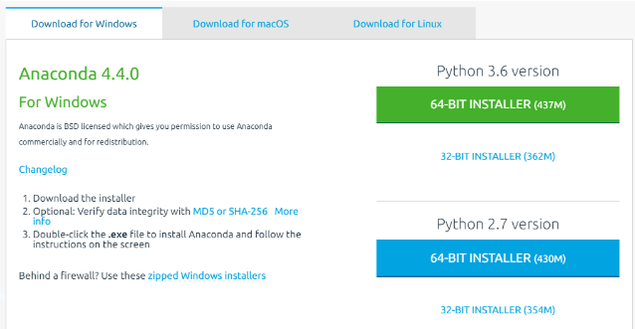

Download Anaconda 4.2 and install it.

The installation screens below are screens installed on Windows 10 64bit.

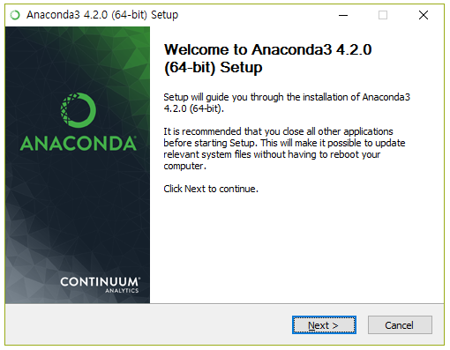

Anaconda 4.2 is installed by default in c: \ Program files \ Anaconda3.

Anaconda 4.3 is installed by default at c: \ PrgramData \ Anaconda3.

Installing anaconda takes a while. It seems like it took about 10 minutes.

After the installation is complete, you can confirm that Anaconda is installed in the Windows Start menu. I have installed only one Anaconda, but I can see that IPython, Jupyter Notebook, Spyder and so on are installed.

And you can confirm Python 3.5.2 is installed in Anaconda, too.

To run Python, first run Anaconda Prompt. When you run it, a command window displays.

If you check the version of Python installed, you can see that Python 3.5.2 is installed.

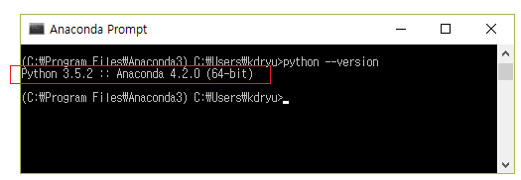

**Install Tensorflow:**

The packages or libraries are installed through the pip package in the Python, similar to Linux.

Once the Anaconda has been installed, you need to install the Tensorflow package. Anaconda provides a virtual execution environment for Python library management and so on.

So before installing the Tensorflow, first upgrade the pip package to the latest, create Anaconda's virtual development environment, and install Tensorflow there.

To install Tensorflow, first run Anaconda Prompt in administrator mode and enter the following command:

python -m pip install --upgrade pip

conda create -n tensorflow python=3.5

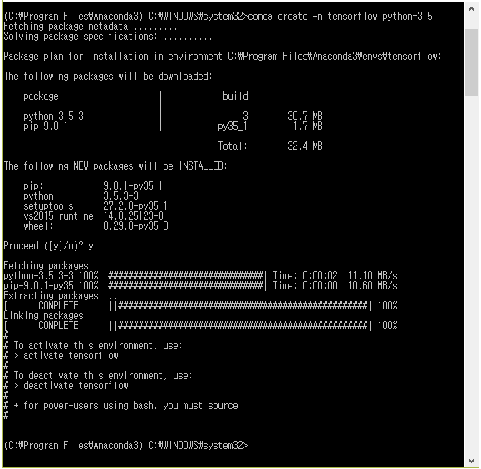

And then enter into environment.

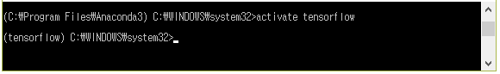

When run, the name of the virtual environment (tensorflow) is prepended to the prompt.

From now on, all packages installed in the (tensorflow) environment are managed separately under C:\Program Files\Anaconda3\envs\tensorflow.

Then install Tensorflow.

pip install tensorflow

Because Tensorflow is a Python package, you can install it with the pip install command.

If you use the source code of Tensorflow directly, you can also download it through github and compile it.

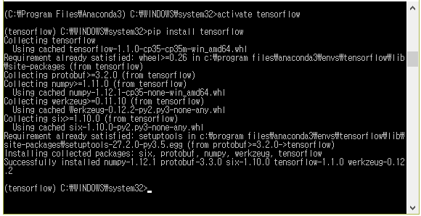

After that you can check if tensorflow is installed properly by using python command as below.

import tensorflow as tf

If there isn’t any errors, we can know Tensorflow has installed successfully.

**Install Jupyter Notebook:**

Jupyter Notebook is a development environment for developing Python. This is used in Python development because it allows you to write and execute source code directly from a web browser without using a separate editor, so it provides a development environment that is easier to work with and share with github.

When you install Anaconda, Jupyter Notebook is installed by default. So when you type Jupyter Notebook at the anaconda prompt, the Jupyter notebook runs in your browser.

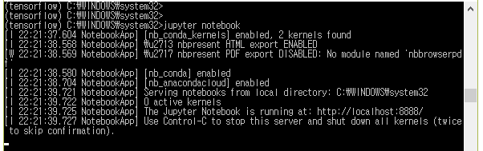

If you type the above command in the command window, Jupyter notebook will run in your browser as below.

Jupyter Notebook will run in the folder where Anaconda Prompt is executed because it runs in the directory where the command window is executed.

Pressing the New button at the top right opens an editor where you can enter Python code.

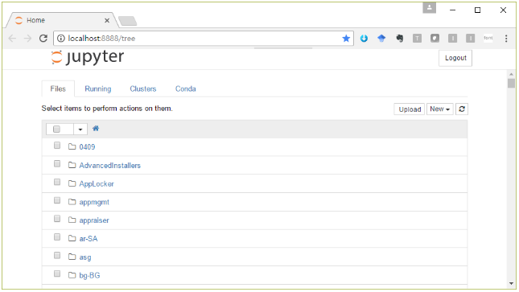

And you can use PyCharm instead of Jupyter Notebook.

Task1 is complete.

## **Task 2: Install Tensorflow on Ubuntu**

If you have GPU card, you can install Cuda and cuDNN for improve the performance.

**Update Graphic card driver:**

Go to System Settings> Software & Updates> Addition Drivers tab in Ubuntu 16 and select the NVIDIA binary driver to update it automatically. Once the update is complete, please reboot once.

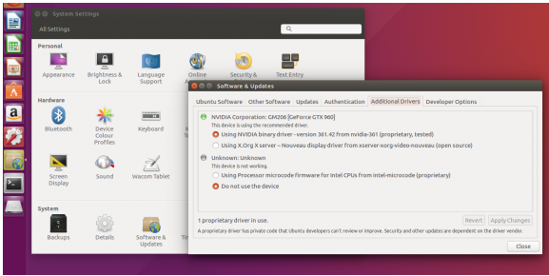

**Install Cuda Toolkit:**

We can install cuda-toolkit using apt-get command,

$ sudo apt-get install nvidia-cuda-toolkit

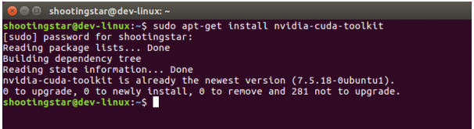

**Install cuDNN:**

Download the cuDNN v4 or latest Library for Linux version from https://developer.nvidia.com/rdp/cudnn-download.

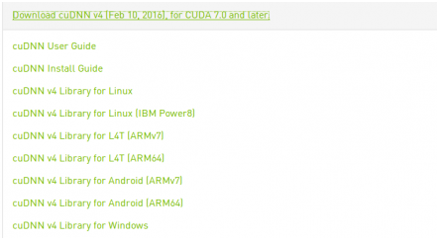

Unzip the downloaded file and you will see the cuda folder. Go to the cuda folder.

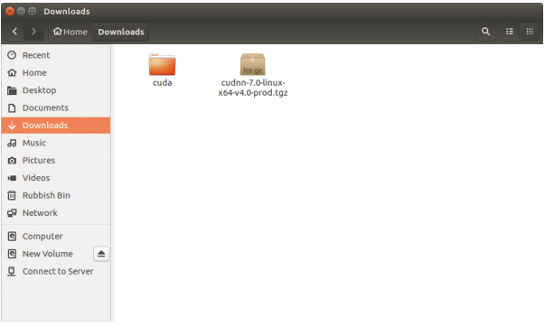

You can see the include folder and the lib64 folder in the cuda folder.

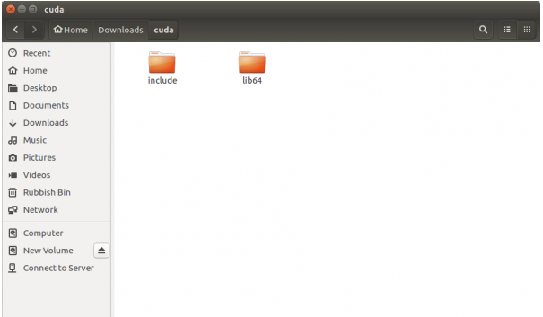

Copy the cuda folder under /usr/local such as /usr/local/cuda.

When copying is complete, run the bottom line to set permissions.

$ sudo chmod a+r /usr/local/cuda/include/cudnn.h /usr/ local/cuda/lib64/libcudnn*

**Install Virtualenv and Tensorflow:**

If you prefer Python 2, you can change python3 to python in the command below.

$ sudo apt-get install python3-pip python3-dev python-virtualenv

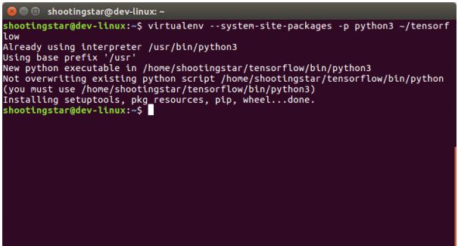

If the above command is executed successfully, tensorflow folder will be created.

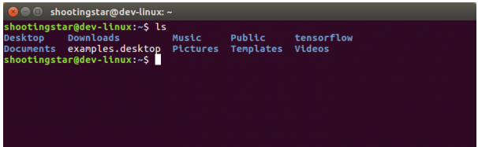

Then activate the virtualenv.

$ source ~/tensorflow/bin/activate

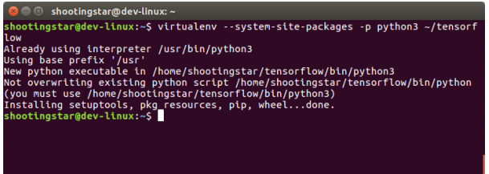

Then check the version of Python you are using.

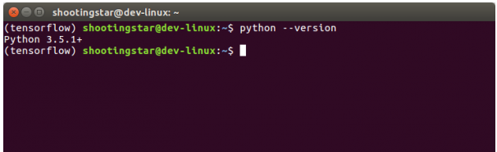

Find the URL of the appropriate tensorflow binary version for Python version from the list below.

# Ubuntu/Linux 64-bit, CPU only, Python 2.7

(tensorflow)$ export TF_BINARY_URL=https://storage.googleapis.com/tensorflow/linux/cpu/tensorflow-0.9.0-cp27-none- linux_x86_64.whl

# Ubuntu/Linux 64-bit, GPU enabled, Python 2.7

# Requires CUDA toolkit 7.5 and CuDNN v4. For other versions, see "Install from sources" below.

(tensorflow)$ export TF_BINARY_URL=https://storage.googleapis.com/tensorflow/linux/gpu/tensorflow-0.9.0-cp27-none- linux_x86_64.whl

# Mac OS X, CPU only, Python 2.7:

(tensorflow)$ export TF_BINARY_URL=https://storage.googleapis.com/tensorflow/mac/tensorflow-0.9.0-py2-none-any.whl

# Ubuntu/Linux 64-bit, CPU only, Python 3.4

(tensorflow)$ export TF_BINARY_URL=https://storage.googleapis.com/tensorflow/linux/cpu/tensorflow-0.9.0-cp34-cp34m -linux_x86_64.whl

# Ubuntu/Linux 64-bit, GPU enabled, Python 3.4

# Requires CUDA toolkit 7.5 and CuDNN v4. For other versions, see "Install from sources" below.

(tensorflow)$ export TF_BINARY_URL=https://storage.googleapis.com/tensorflow/linux/gpu/tensorflow-0.9.0-cp34-cp34m -linux_x86_64.whl

# Ubuntu/Linux 64-bit, CPU only, Python 3.5

(tensorflow)$ export TF_BINARY_URL=https://storage.googleapis.com/tensorflow/linux/cpu/tensorflow-0.9.0-cp35-cp35m -linux_x86_64.whl

# Ubuntu/Linux 64-bit, GPU enabled, Python 3.5

# Requires CUDA toolkit 7.5 and CuDNN v4. For other versions, see "Install from sources" below.

(tensorflow)$ export TF_BINARY_URL=https://storage.googleapis.com/tensorflow/linux/gpu/tensorflow-0.9.0-cp35-cp35m -linux_x86_64.whl

# Mac OS X, CPU only, Python 3.4 or 3.5:

(tensorflow)$ export TF_BINARY_URL=https://storage.googleapis.com/tensorflow/mac/tensorflow-0.9.0-py3-none-any.whl

Then execute export.

(tensorflow)$ export TF_BINARY_URL=https://storage.googleapis.com/tensorflow/linux/gpu/tensorflow-0.9.0-cp35-cp35m -linux_x86_64.whl

Of course you could select higher version Tensorflow and install it same method.

Install the Tensorflow using the following command.

(tensorflow)$ pip3 install --upgrade $TF_BINARY_URL

**Test:**

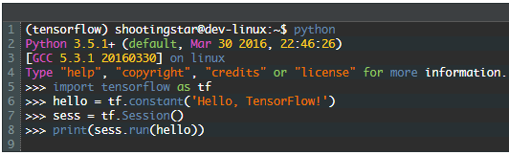

You can see results similar to the following.

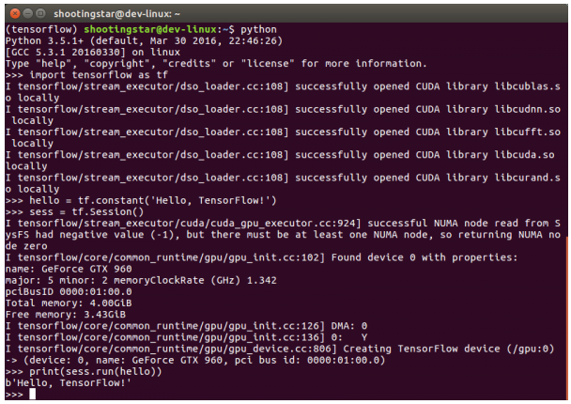

You can install Jupyter or PyCharm for edit Python code on Ubuntu similar with Windows.

And on Mac OS we could install Tensorflow similar with Ubuntu, too.

Task2 is complete.

## **LAB CHALLENGE**

**Challenge**

In this task what is more important is select the version of packages such as Python, Tensorflow, and Anaconda and so on.

See below URLs for a more detailed description.

* https://www.tensorflow.org/install/
* https://www.tensorflow.org/versions/r0.12/get_started/os_setup

## **SUMMARY**

Tensorflow is one of the mostly used framework and open source library for machine learning and deep learning developed by Google.

Tensorflow package is available for download along with github open source code or Tensorflow website.

## **REFERENCES**

* https://en.wikipedia.org/wiki/TensorFlow
* https://www.tensorflow.org/install/

## **INDEX**

Theory 1

Basic concepts 1

Tensorflow 1

AIM 6

LAB EXERCISE 2: INSTALLING TENSORFLOW 7

Task 1: Installing Tensorflow on Windows 8

Task 2: Install Tensorflow on Ubuntu 13

LAB CHALLENGE 20

SUMMARY 21

REFERENCES 22