

Student Guide

40567A

Microsoft Excel associate 2019

Module 1: Introduction

Contents

Contents 2

Module overview 4

Description 4

Scenario 5

Cornerstone 5

Lesson 1: Getting to know Excel 6

Overview 6

Warm-up 6

Topic 1: Create and open workbooks 7

Create a new workbook 7

Open an existing workbook 8

Create a new workbook by using an existing workbook 9

Activity: Guess and tell 9

Try-it: Create and open workbooks 9

Try-it 1 10

Try-it 2 10

Topic 2: Explore the Excel interface 11

Explore the ribbon and manage views 13

Activity: Guess and tell 14

Try-it: Explore the Excel interface 15

Try-it 15

Resources 15

Wrap-up 16

Lesson 2: Introducing the Excel fundamentals 17

Overview 17

Warm-up 17

Topic 1: Enter and edit data 18

Enter data 18

Complete a data entry 18

Edit cell contents 19

Cancel a cell entry 19

Clear cell contents 19

Activity: Pose a challenge 20

Try-it: Enter and edit data 20

Try-it 1 20

Try-it 2 21

Topic 2: Save workbooks 21

Save a new workbook 22

Save an existing workbook 22

Save an existing workbook as another name or to a new location 22

Save a workbook in a different format 23

Save a workbook as a PDF 23

Convert a workbook to a newer version 24

Activity: Discuss and learn 24

Try-it: Save workbooks 25

Try-it: 1 25

Try-it: 2 26

Try-it: 3 26

Wrap-up 27

Lesson 3: Navigating and filling cells 28

Overview 28

Warm-up 28

Topic 1: Navigate to named cells, ranges, or workbook elements 29

Navigate to a named cell, range, or table 30

Display workbook elements 30

Activity: Tell a story 31

Try-it: Navigate to named cells, ranges, or workbook elements 32

Try-it 1 32

Try-it 2 33

Try-it 3 33

Topic 2: Search for data 34

Find data in a workbook 34

Replace data in a workbook 35

Activity: Show and tell 36

Try-it: Search for data 36

Try-it 1 37

Try-it 2 37

Topic 3: Use the AutoFill feature 38

AutoFill using a pointer device 38

AutoFill using the Fill command 39

AutoFill a series of numbers with a pointing device 39

Activity: Guess and tell 40

Try-it: AutoFill 40

Try-it: 1 40

Resources 40

Instructions 40

Try-it: 2 41

Try-it: 3 41

Wrap-up 42

Glossary 44

Cornerstone 45

Overview 45

Objectives 45

Duration 45

Instructions 45

Tasks 46

Thumbnail image 48

# Module overview

## Description

Welcome to the first module of the Excel Associate course, in which you’ll will get the chance to get know Excel 2019. Excel 2019 is a robust software program included in the Microsoft Office suite. It is used to create spreadsheets, where data is arranged in rows and columns; imagine Excel as a big table of data. Excel is extremely versatile and powerful, and it can be used for answering questions about data through analysis and visualization. It almost does your work for you!

This module will set you up for your future use of Excel, whether that’s at home, in class, or at work. At the end of each module, you’ll complete a Cornerstone project that will help embed the skills that you’ve learned and during each lesson. You’ll also participate in activities and try-its to practice and learn new skills. As you go through the lessons, you’ll find helpful links to websites that will provide further learning and maybe even a little homework! You will also find handy notes and tips. Good luck and enjoy the course!

|  |  |  |
| --- | --- | --- |
| Lesson | Learning objective | Exam objective(s) |
| Getting to know Excel | Create and open workbooks; become familiar with the Excel interface. | Not mapped |
| Introducing the Excel fundamentals | Enter and edit data; save workbooks in alternate formats | 1.5.2 |
| Navigating and filling cells | Navigate to named cells, named ranges and other workbook objects; search for data and use Autofill to fill cell contents. | 1.2.2  1.2.1  2.1.2 |
| Helping a fellow intern with Microsoft Excel | Open/create/save workbooks; enter/edit data including AutoFill cell contents; search for data; and navigate to named cells, named cell ranges, and other workbook objects. | .5.2  1.2.1  1.2.2  2.1.2 |

Table 1: Objectives by lesson

## Scenario

You’ve been working as an intern within the finance team of a farming operation. The finance team is currently working on converting as much paperwork as they can to digital. You’ve been working with a sales analysist for the past year. Several inexperienced interns will be starting soon, and they have no prior Excel experience. You’ve been tasked with teaching the interns Excel basics that will allow them to assist you with inputting the sales and personnel data. You’ve used Excel only a few times and you know that you don’t have enough knowledge to teach the interns everything they’ll need to know to be able to do their jobs. To get prepared, you’re going back to the basics to make sure you have the skills you’ll need to train the interns.

## Cornerstone

One of the interns has been working on two workbooks containing data that summarize the annual produce for various fruit and vegetables. The data needs to be ready for a meeting with your boss within the next hour. You’ll need to examine the files before the meeting to ensure the data is correct and that nothing is missing from data.

You’ll need to use AutoFill to enter data, locate named cells, find and replace data, and save the workbooks in alternate formats.

If your aim is to become an Excel expert, then completing the lessons and Cornerstone in this module and future modules will help you reach your goal sooner than you think. If you don’t want to be an Excel expert, just great at Excel, then these lessons and Cornerstone will help.

# Lesson 1: Getting to know Excel

## Overview

This lesson is intended to introduce you to Microsoft Excel 2019. You’ll learn how to open, create, and save workbooks, including saving to alternate formats. You’ll also learn how to enter and edit data within a worksheet. Finally, you’ll learn how to navigate to named ranges, tables, and cells, and how to use AutoFill.

## Warm-up

This is the first lesson in Excel, but you might have some past experience with spreadsheets. Be ready to share your experience with the class. Where have you observed spreadsheets being used? Have you ever used Excel?

Use these questions to find out what you already know about this lesson’s topics:

1. When you are in the Excel application, what shortcut key can you use to open an existing workbook?

Select the correct option.

1. Ctrl+Alt+O
2. Ctrl+O
3. Shift+O
4. Ctrl+Shift+O
5. Which area of the Excel application has the following three commands: Save, Undo, and Redo?

Select the correct option.

1. Status Toolbar
2. Mini Toolbar
3. Quick Access Toolbar
4. Formula Bar
5. How can you access the Backstage view?

Select the correct option.

1. Windows key
2. Select File
3. Select Home
4. Ctrl+B
5. To create a new workbook:

Select all that apply.

1. Go to File > New
2. Select Ctrl+N on your keyboard
3. Select Ctrl+O on your keyboard
4. Go to File > Open

## Topic 1: Create and open workbooks

One of the quickest ways to do anything in Excel, or any other Office application, is to use keyboard shortcuts. For example, to create a new workbook you can use Ctrl+N and to open an existing workbook you can use Ctrl+O.

There are hundreds of keyboard shortcuts available and they really do help save time. Do not underestimate the value of the shortcut! Many keyboard shortcuts are common across Office apps and are used throughout the Microsoft Office Suite. Basic keyboard shortcuts remove the need for the new user to navigate through numerous commands on the ribbon. Learn keyboard shortcuts, and you’ll take the guesswork out trying to find out how to do things like Print, whether it’s a Word document, an Excel document, or just about any other document you encounter today.

Here are some of the ways to create and open workbooks:

### Create a new workbook

1. Either select Ctrl+N or select New on the Quick Access Toolbar if it has been added, or File > New.
2. Select the type of workbook to create. It can either be a new blank workbook, the most common way to start, or any pre-built template, which are great and can save a lot of time with content and design.

### Open an existing workbook

1. Start by selecting Ctrl+O, or via File > Open.
2. Depending upon where the workbook is stored, you might be able to either:
   * Simply double-click (or select the space bar and Enter) on the file if it is listed in the Open screen.

Or

* + Select the workbook listed under Workbooks (the file will open immediately).

Or

* + Select Folder (or other online location) to locate the folder in which the file is stored, select the folder to open it, and then select the file to open.



Figure 1. File Open screen – Workbooks and Folders

Or

* + Select This PC, then select the folder on the recent list, or select the Navigate up one level arrow to move up a level within the file structure and continue to locate the file.

Or

* + Select Browse to go to the Open dialog box (Ctrl+F12 will go here also). Locate the file to open and double-click to open it, or select it once and then select Open.
  + Extra tip: Consider using Windows E to open the File Explorer to quickly locate the file you would like to open. When you find the file you want, double-click on it or select the spacebar and enter. If it’s an Excel file, it will open in Excel, otherwise it will open in the application it belongs to.

|  |  |
| --- | --- |
|  | Video  To view a video on creating workbooks, go to: [Create a new workbook](https://aka.ms/Create_a_new_workbook) |

### Create a new workbook by using an existing workbook

Using Ctrl+O or File > Open, after the workbook has been located, you can right-click or access the context menu and then select Open a Copy.

### Activity: Guess and tell

The teacher will open Excel and create a new workbook and open an existing workbook. Be prepared to answer questions about opening files and other commands in Backstage view.

#### Resources required

You will need the following resources for this activity:

* Excel 2019
* L1_T1_act_calendar.xlsx

#### Activity instructions

The following are the steps that you must perform during this activity:

1. Open Excel and create a new workbook.
2. Follow along with the teacher.
3. Answer/ask questions.

|  |  |
| --- | --- |
|  | Did you know?  There are 1,048,576 rows and 16,384 columns in a standard Excel workbook? That’s a whopping 17,179,869,184 cells! |

### Try-it: Create and open workbooks

 This is a leveled try-it to create a new workbook in Excel 2019 in preparation for Topic 2, and to open a copy of an existing workbook.

### Try-it 1

In this try-it, you’ll create a new workbook by using the Backstage view and/or a shortcut key.

#### Resources

You’ll need the following resources for this activity:

* None required

#### Instructions

The following are the general tasks that you must perform during this try-it:

1. Close any open files without saving them.
2. Create a new workbook by using a shortcut key.
3. Create another workbook by using any design template.
4. Close all open files, leaving one open to help with the next topic.

### Try-it 2

In this try-it, you’ll create a new workbook using a shortcut key and you’ll use an existing workbook to open a copy of it.

#### Resources

You’ll need the following resources for this activity:

* Any existing workbook

#### Instructions

The following are the general tasks that you must perform during this try-it:

1. Close any open files without saving them.
2. Create a new workbook by using a shortcut key.
3. Use the Open window to open a copy of any existing workbook listed.
4. Close all open files, leaving one open to help with the next topic.

## Topic 2: Explore the Excel interface

Before you dive into learning how to set up a workbook, let’s get you comfortable with the application interface and terminology.

When you open Excel for the first time, you’re prompted with a menu to create a new file or open an existing file.

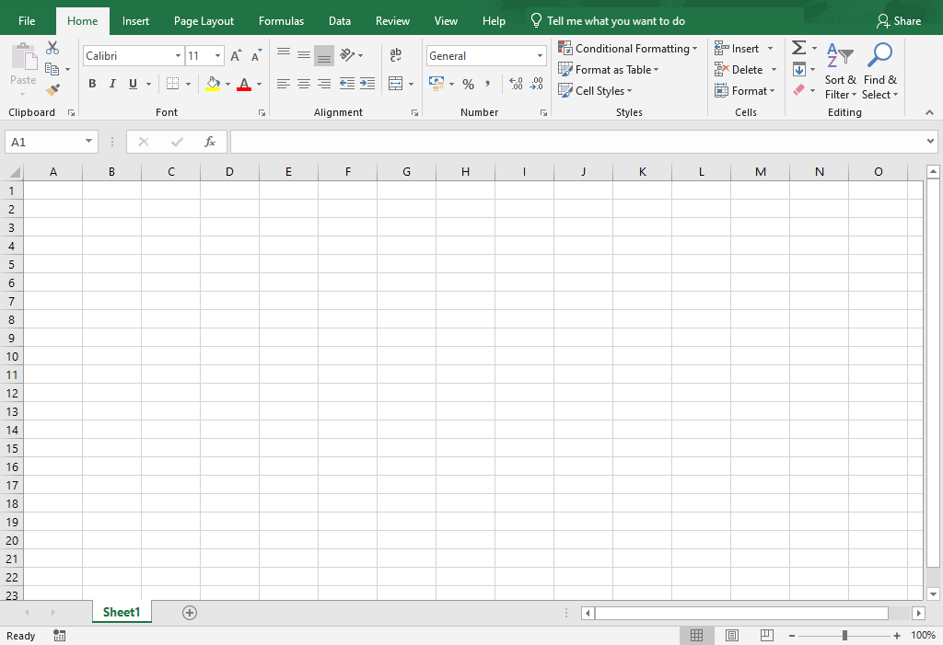

Figure 2. Excel interface

At the top of the application, there’s a bar known as the ribbon, which holds several tabs; these are usually File, Insert, Page Layout, Formula, Data, Review, View, and Help. Your ribbon might have different tabs. Each tab contains commands assembled together in logical groups.

The first ribbon tab is File. When the File tab is selected, it does not display a ribbon. Instead, it displays a panel on the left side of the application and includes commands such as: Information, New, Open, Save, Print, Share, Export, Options, and more. This panel area is referred to as the Backstage view.

* Think of the Backstage view as opening the curtain to access what’s going on behind the workbook.
* When you have a workbook open and select the File menu, the workbook Info tab will be displayed by default.
* At any time, select the back arrow in Backstage view to return to the workbook sheet, or select the Esc key on your keyboard.

When a workbook, even a blank workbook, is opened in Excel, other elements in the application interface will be activated, with the workbook area taking up most of the application area.

Directly above the ribbon, in the upper-right corner of the application (in the Title bar) are the commands Minimize, Restore, and Close to manage the size of the screen.

Next to that, you’ll find Ribbon Display Options. From here, there are three options that you can select to hide or collapse the ribbon as necessary. For example, if you have a large set of data and need more space to view it, you can temporarily collapse the ribbon and then bring it back into view when needed.

* Auto-hide Ribbon – Hide the ribbon. Select the top of the application to show it. As soon as this option is selected, the entire ribbon is collapsed. To display the ribbon for a quick view or to access the commands simply select More, the ellipsis (…) at the top right of the window, or select the ALT key. To fully restore and show the ribbon and commands again, select the third option.
* Show Tabs – Show ribbon tabs only. Select a tab to show the commands. This will collapse the commands chunk below the tab name, but all the commands are still accessible from the tab name.
* Show Tabs and Commands – Show ribbon tabs and commands all at the same time. This is the default view, where the entire ribbon is expanded, displaying all the tabs and their associated commands.

Screenshot of the Ribbon Display Options


Figure 3. Ribbon display options

Note: If you double-click on any tab label twice, the ribbon will automatically hide. Double-click again to show the full tabs and commands.

In the upper-left corner above the ribbon is the Quick Access Toolbar. The Quick Access Toolbar can be displayed above or below the ribbon and can be customized to your needs. You’ll learn more about this later in the course. By default, the Quick Access Toolbar will display the AutoSave, Save, Undo, Redo and a drop-down menu.

Search (also known as Tell Me) is in the center of the Title bar. You can search for commands, get insights from an internet search, or get Excel help from here. Search/Tell Me is also available in other Office 2019 and Office 365 applications and is in the same position for each application.

The Name box and the Formula Bar are directly underneath the ribbon. You’ll learn more about these during the course.

At the bottom of the worksheet, you’ll find the Sheet tabs contained within the current workbook. The default sheet names are Sheet1, Sheet2, and so forth. Next to that there is the New sheet button (a little +) to add extra sheets as necessary.

Over to the right of the screen there is a Vertical scrollbar and there is a Horizontal scrollbar along the bottom to help you scroll through the worksheet. Finally, underneath the horizontal scroll bar, you’ll find Display Settings, with three screen views: Normal, Page Layout, and Page Break Preview. You’ll also find the Zoom slider bar, which lets you increase or decrease the size of the worksheet that is displayed on the screen.

### Explore the ribbon and manage views

If you’re new to Excel 2019, take a few minutes to read each tab description below, then go check each tab ribbon in the application. As you observe the groups and tools in a ribbon, go back and review the ribbon tab name. There is a correlation here; the name of the tab is a hint to the tools it holds. Insert contains many tools to insert something into a worksheet, like an image, table, chart, to name a few.

* File (Backstage View) – Access and manage application and workbook settings.
* Home – The popular tools and commands used most, like the Clipboard tools, font formatting, cell alignment, and number formatting.
* Insert – Add objects and elements into your worksheet, such as Pictures, Icons, Charts and SmartArt.
* Draw – Make notes with a digital pen, convert ink to a shape, and convert ink to math. (If your device is not touch screen enabled, you might need to add this tab to the ribbon.)
* Page Layout – Modify the workbook themes, page setup, and sheet options.
* Formulas – Create functions, define names, audit formulas, and set calculation options.
* Data – Get data from other sources, create queries, sort, filter, and use other data tools.
* Review – Perform proofing, track changes, protection, and accessibility functions for the worksheet.
* View – Manage and modify workbook views, zoom in and out, arrange workbook windows, and create macros.
* Help – Access Excel help, contact Microsoft support, give feedback about Excel, and access learning.

|  |  |
| --- | --- |
|  | Did you know?  You can change your pointer device into a rainbow or galaxy pen and draw on screen. You’ll find it on the Draw tab. (You might need to add the Draw tab to the ribbon first). |

### Activity: Guess and tell

A guess and tell activity requires you to pay close attention to the demonstration so that you can respond to the teacher’s question or prompt.

#### Resources required

You will need the following resources for this activity:

* Any open workbook or new blank workbook

#### Activity instructions

The following are the steps that you must perform during this activity:

1. Observe as the teacher demonstrates the different Excel interface elements.
2. Follow along with the steps and note where the teacher has navigated, so that you have a solid understanding of each interface element. Pay close attention to each command the teacher mentions and note the group and tab on which it resides.
3. The teacher might ask you to guess the purpose of a command. You might be able to identify commands not specifically called out in this activity.
4. Feel free to share your knowledge with your classmates or ask questions while the teacher is demonstrating to get further clarification. For example:
5. What is the purpose of the Quick Access Toolbar?
6. What actions can I perform in the Backstage view?
7. Which tab should I go to if I want to insert a formula in my spreadsheet?

### Try-it: Explore the Excel interface

 Open a blank workbook and use it to find key components of the Excel interface.

### Try-it

Explore the Excel interface on your device to locate the key elements. When you find the elements, consider their individual purpose.

### Resources

You’ll need the following resources for this activity:

* L1_T2_try_interface_starter.docx.

#### Instructions

1. Open a blank workbook in Excel.
2. Open L1_T2_try_interface_starter.docx and refer to the first column.
3. Identify the commands that you need to locate in the interface.
4. Fill in the table.
5. If you need help, ask your teacher to pair you with a partner.

## Wrap-up

Turn to a nearby student partner. Ask each other to describe something they learned in class today that they’ll be able to use the next time they use Excel. Be prepared to share with the class.

Then, use these questions to be sure you’ve learned these concepts from the lesson.

1. Where will you find the formula bar?

Select the correct option.

1. File > Open
2. File > Options
3. Directly below the ribbon
4. On the Quick Access Toolbar
5. If you double-click a ribbon tab twice, what happens to the ribbon?

Select the correct option.

1. It disappears.
2. It will show tabs only.
3. It will auto hide.
4. It will move to the bottom of the screen.
5. If you have the ribbon on the Auto-hide setting, there will be an   
   Select here to enter text. next to the Ribbon Display Options.

Fill in the blank space.

1. When you access File > Open, you can switch between workbooks and   
   Select here to enter text..

Fill in the blank space.

# Lesson 2: Introducing the Excel fundamentals

## Overview

In this lesson, you’ll learn how to enter and edit data in a workbook and then save workbooks in alternate formats.

## Warm-up

Participate in a discussion with your classmates. Why do you think Excel is a powerful tool in the world of business? For what tasks do you think businesses use Excel?

Use these questions to find out what you already know about this lesson’s topics:

1. When you are in the Excel application, what method can you use to save an existing workbook with a different name?

Select all that apply.

1. F11
2. File > Save
3. F12
4. File > Save As
5. If you save an Excel workbook as a 97-2003 version, what will the file extension be?

Select the correct option.

1. .xlsx
2. .xlxs
3. .xlt
4. .xls

1. By default, when you select Enter to complete a cell entry, where will the active cell be?

Select the correct option.

1. In the row below
2. In the row above
3. In the next cell to the left
4. In the next cell to the right
5. When you enter data into a cell, where else on-screen will what you have entered display?

Select the correct option.

1. The cell below
2. The cell above
3. The ribbon
4. The formula bar

## Topic 1: Enter and edit data

To enter data into an open worksheet, you can simply select a cell, enter text or numbers, and select enter on the keyboard to complete the entry. You’ll probably want to alter the width of the columns and height of the rows at some point. That functionality will be covered in the next module.

### Enter data

1. Open the existing workbook or create a new one.
2. Select the cell in which you’d like to enter data and begin entering text or numbers.

### Complete a data entry

1. Select Enter, which will move you to the row below.
2. Use the Tab key to move to the adjacent cell to the right of the current cell.
3. Use the Shift Tab keys to move to the adjacent cell to the left of the current cell.
4. Use any directional arrow key to move one cell in any direction.
5. Select the Enter button (tick) next to the formula bar to stay in the same cell (or select Ctrl+Enter).
6. Select any other cell. (This is not best practice, but it is a commonly used method.)

### Edit cell contents

* Select the cell that you wish to edit, make your alterations directly within the cell or via the formula bar, and use any method to complete the edit.

Or

* Double-click into the cell to edit in an exact position within the cell or formula bar, and use any method to complete the edit.

Or

* Select F2, make your alterations, and use any method to complete the entry.

### Cancel a cell entry

1. Select Esc on your keyboard before completing the entry, or
2. Select the Cancel button (X) next to the formula bar before completing the entry.

### Clear cell contents

* Access the context menu or right-click on a cell to clear, and select Clear Contents.

Or

* Select Delete on your keyboard.

Note: If you select Delete from the context menu, Excel will want to shift data into the deleted cell(s)!

You can use the Undo or Redo commands or (Ctrl+Z or Ctrl+Y) to undo or redo any actions.

|  |  |  |
| --- | --- | --- |
|  | | Did you know?  You can undo/redo up to 100 actions, even after a file has been saved. Although undoing 100 actions could lose a lot of work, and maybe just making an edit would be better! |
|  | Additional information  For more information on the Undo or Redo command, go to: [Undo, redo, or repeat an action](https://aka.ms/Undo_redo_or_repeat_an_action) | |

### Activity: Pose a challenge

The teacher will open Excel, create a new workbook, and enter some data. You’ll be asked to suggest ways to complete the data entry.

#### Resources required

You’ll need the following resources for this activity:

* New blank workbook

#### Activity instructions

Follow the teacher’s demonstration. Be prepared to ask and answer questions.

1. Open a new blank workbook.
2. Follow the teacher’s instructions.
3. Participate in the activity as directed.
4. Offer suggestions on how to complete the task when asked by the teacher.

### Try-it: Enter and edit data

 Now that you can access the tools and options of Excel, it’s time to put all of that knowledge to work. In this try-it, you’ll enter and edit data in an existing workbook. Entering that data gets into an Excel workbook is an essential skill. You want the interns at Munson’s Pickles and Preserves Farm to be Excel “power users” and to understand that there are many ways to accomplish this task.

### Try-it 1

Entering data into a workbook.

#### Resources

You’ll need the following resources for this activity:

* Open L2_T1_try1_visitors_starter.xlsx in this lesson’s Learning Activity Resources.

#### Instructions

The following are the general tasks that you must perform during this try-it:

1. Open L2_T1_try1_visitor_starters.xlsx.
2. Enter 161 into cell B3.
3. Enter 248 into the cell below (C3).
4. Note the new values in cells H3 and H4. (The teacher will decide how you should note the values because that depends on the resources available.)
5. Save the workbook as the same name plus your initials. For example, L2_T1_try1_visitor_starters_DM.xlsx.

### Try-it 2

Edit data and clear the contents of cells.

#### Resources

You’ll need the following resources for this activity:

* Open L2_T1_try2_visitors_starter.xlsx in this lesson’s Learning Activity Resources.

#### Instructions

1. Open L2_T1_try2_visitors_starter.xlsx.
2. Use a keyboard shortcut to edit the contents of cell A6 to contain Group/Family instead of Group.
3. Clear the contents of cell B20.
4. Save the workbook as the same name plus your initials. For example, L2_T1_try2_visitor_starters_DM.xlsx.

## Topic 2: Save workbooks

If you make changes to a new workbook or an existing workbook, and you want to keep the changes, you’ll need to save the workbook. Before saving, consider whether you would like the workbook saved in an online location, which is useful for collaboration purposes, or whether you would like it saved locally.

Saving a file follows a similar process as opening a file. Depending upon where you wish to store the workbook or what format you want to use, the process will differ slightly.

### Save a new workbook

1. Go to File and select Save.
2. Check the location/folder to store the workbook in.
3. Enter an appropriate name, and select Save.

Or

1. Select Ctrl+S.
2. Give the workbook an appropriate name.
3. Check the location to store it in, and select Save. (If you select More Save Options, you will go to Backstage, Save As and can continue from there).

### Save an existing workbook

* From File, select Save, or Ctrl+S.

Or

* Select the Save command on the Quick Access Toolbar.

### Save an existing workbook as another name or to a new location

1. From File, select Save As, or select F12.
2. Check the location/folder to save the workbook in.
3. If you are changing the name, enter the new name and select Save.

|  |  |
| --- | --- |
|  | Did you know?  A workbook can have up to 218 characters in the filename. But note that the file path (the names of folders in which it is stored) is part of the name and is included in the 218 characters. |

### Save a workbook in a different format

1. Start by going to File and select Save As, or F12.
2. Check the location/folder to save the workbook in.
3. Enter a suitable name for the workbook, and select the drop-down in the Save as type box.
4. Select the type of file you would like to save the workbook as, for example, PDF, Template, or Excel 97-2003 workbook.
5. When you use Save As to save a file, depending upon what you wish to do, you can either:
   * Enter a name in the filename box, and select Save (this will be in the last location you were using).

Or

* + Select This PC, then select the folder on the recent list or select the Navigate up one level arrow to move up a level within the file structure, locate the folder to store in, then give the workbook a new name if necessary, and select Save.

Or

* + Select Browse to go to the Save As dialog box (F12 will go there directly). Locate the folder to save in, double-click to open it or to select the folder, and then select Enter, give the workbook a new name if necessary, and select Save.

Or

* + Select the OneDrive/SharePoint/Online location and continue to locate the folder to store in, give the workbook a new name if necessary, and select Save.

### Save a workbook as a PDF

1. From File, select Export, and then Create PDF/XPS.
2. Check the location to store it in and edit the filename if necessary.
3. Select Publish to have the active worksheets exported to PDF.

Or

* Select Options to alter the page range and what to publish, for example, to ignore any print areas or remove document properties, select OK, and then select Publish.

|  |  |
| --- | --- |
|  | Did you know?  If an Excel workbook is stored in a cloud-based location, such as Microsoft SharePoint, and you (or someone else for that matter!) makes a real mess of your workbook, you can restore it to an unspoiled version. How cool is that? For more information about restoring to a previous version of a file, go to: [Restore a previous version of a file without unwanted changes](https://aka.ms/restore-a-previous-version-of-a-file-without-unwanted-changes) |

### Convert a workbook to a newer version

When a workbook has been saved as an Excel 97-2003 version, some of the commands on the ribbon are disabled (grayed out) and cannot be used. For example, you can’t use any of the cool new charts, sparklines (which are a type of mini chart), or slicers and timelines in Pivot Tables. These fantastic topics are covered in later modules or in the Excel Expert course.

It’s important to note, however, that sometimes it’s necessary to save a workbook as an older version for individuals who are using an older version of Excel.

* From File, select Convert.
* A pop-up message will appear checking if you wish to proceed with the upgrade.
* Select Yes to continue.

|  |  |
| --- | --- |
|  | Additional information  For more information about saving workbooks in alternate formats, go to: [Save a workbook in another file format](https://aka.ms/Save-a-workbook-in-another-file-format) |

### Activity: Discuss and learn

The teacher will open an Excel workbook in the 97-2003 format and a newer version to discuss the differences between .xls and .xlsx workbooks.

#### Resources required

You’ll need the following resources for this activity:

* Open L2_T2_act_membership_summary.xlsx in this lesson’s Learning Activity Resources.
* Open L2_T2_act_membership_summary.xls in this lesson’s Learning Activity Resources.

#### Activity instructions

Follow the teacher’s demonstration. Be prepared to ask and answer questions.

1. Open L2_T2_act_membership_summary.xls and L2_T2_act_membership_summary.xlsx.
2. Compare both versions and observe any differences.
3. Answer/ask questions.
4. Close both workbooks.

### Try-it: Save workbooks

 In this try-it, you’ll save a workbook in various formats. Try-It 1 will cover saving a workbook with a different name. At Munson’s Pickles and Preserves Farm, the preferred naming style is to use underscores instead of spaces or dashes within the filename. Try-It 2 will cover converting older files into a newer version, and Try-It 3 will cover exporting a file to PDF, which is Munson’s preferred file type for sending workbooks as an email.

### Try-it: 1

Save an existing workbook with a different name.

#### Resources

You’ll need the following resources for this activity:

* Open L2_T2_try1_Jan_June_starter.xlsx in this lesson’s Learning Activity Resources.

#### Instructions

The following are the general tasks that you need to perform during this try-it:

1. Open L2_T2_try1_Jan_June_starter.xlsx.
2. Save as Jan_June_Summary_plus your initials.xlsx in the lesson’s Learning Activity Resources folder.

### Try-it: 2

Convert an older version workbook into a new version file.

#### Resources

You’ll need the following resources for this activity:

* Open L2_T2_try2_sales_starter.xls in this lesson’s Learning Activity Resources.

#### Instructions

The following are the general tasks that you need to perform during this try-it:

1. Open L2_T2_try2_sales_starter.xls.
2. Convert to a newer version of Excel.
3. Then save the file using the same name plus your initials.

### Try-it: 3

Export an existing workbook to PDF so that it cannot be easily edited. When worksheets are emailed outside of Munson’s, it is preferred that they are sent as a PDF.

#### Resources

You’ll need the following resources for this activity:

* Open L2_T2_try3_Jan-June_starter.xlsx in this lesson’s Learning Activity Resources.

#### Instructions

The following are the general tasks that you need to perform during this try-it:

1. Open L2_T2_try3_Jan-June_starter.xlsx in this lesson’s Learning Activity Resources.
2. Export to PDF with the name Jan_June_Summary plus your initials.
3. Ensure that any print areas are ignored and that all document properties are not included before publishing to PDF.

|  |  |
| --- | --- |
|  | Additional information  For more information about saving workbooks in alternate formats, go to: [Save a workbook as a template](https://aka.ms/save-a-workbook-as-a-template) |

## Wrap-up

Now that you have learned how to enter data and save workbooks in alternate formats, ask your neighbor if they can think of any way that they might be able to use Excel at home or at school. Use these questions to check your understanding of what you learned in this lesson:

1. Select the Select here to enter text. next to the formula bar to complete a data entry into a cell and remain in the same cell.

Fill in the blank space.

1. Which format can a workbook be saved in?

Select all that apply.

1. .xlsx
2. .xlxs
3. .xls
4. .xlsm
5. Which statement is true?

Select all that apply.

1. There is no difference between using Convert or using Save As to upgrade a workbook to the latest version of Excel.
2. Converting a file replaces the old-version file with a new-version file, leaving one copy.
3. When a file is converted, you’ll be able to use the full functionality of Excel.
4. A file saved in an older version of Excel cannot be opened in Excel 2019.
5. The Select here to enter text. key moves one cell position to the right of the currently selected cell.

Fill in the blank space.

# Lesson 3: Navigating and filling cells

## Overview

In this lesson, you’ll learn how to navigate to named cells, ranges, and other workbook objects, and how to search for data and use AutoFill to fill cell contents automatically. Sometimes, you inherit a workbook containing special formatting, formulas, named ranges, cells, or tables, all of which might not be obvious. Being able to familiarize yourself with everything that a workbook contains will help save time in future and help you understand the data better.

## Warm-up

Continue the discussion that you had with your classmates during the last lesson: What career do you think you might choose in your future? How do you imagine Excel might be used in your work?

Now use these questions to find out what you already know about this lesson’s topics:

1. The box directly under the ribbon, on the left side of the screen, is known as the Select here to enter text. box.

Fill in the blank space.

1. What is the keyboard shortcut key to go to elements of a workbook?

Select all that apply.

1. Ctrl+E
2. Ctrl+F
3. Ctrl+G
4. F5

1. If cell A1 contained the number 1 and you used AutoFill to fill the cells automatically down to A20, what number would be in cell A20?

Select the correct option.

1. 20
2. 10
3. 2
4. 1
5. If cell A1 contained January and you used AutoFill to fill the cells automatically across to L1, the contents of L1 would be Select here to enter text..

Fill in the blank space.

1. The Find command is located on the Find & Select here to enter text. button on the Home tab.

Fill in the blank space.

1. What is the keyboard shortcut key to search for data in a workbook?

Select the correct option.

1. Ctrl+E
2. Ctrl+F
3. Ctrl+G
4. F5

## Topic 1: Navigate to named cells, ranges, or workbook elements

Did you know that a workbook can contain hidden information? Not everything on display is obvious.

Every cell in Excel has a unique reference, that is, A1, B1, C1, and others. However, you can apply a name of your own choice to cells, ranges of data, and tables. All this will be covered in more detail later in the course. In this lesson, you’ll learn how to quickly go to named cells, ranges, or tables by using the Name Box and the Go To command. The Go To command can also highlight workbook elements, such as formulas and conditional formatting. Again, this will be covered in more detail later in the course.

### Navigate to a named cell, range, or table

Enter any cell reference into the Name Box and select Enter, and you’ll navigate there. However, if a workbook contains a named item, you can use the Name Box to jump there also.

1. Select the drop-down button on the Name Box. (The Name Box is directly beneath the ribbon, on the left side of the screen.)
2. Select the name of the item you wish to jump to from the list.

Or

1. From the Find & Select command on the Home tab, select Go To (Ctrl+G or F5) to open the Go To dialog box.
2. Select the item you wish to jump to and select OK.

### Display workbook elements

* Select Find & Select on the Home tab, and then select Go To Special.

Or

1. Select Ctrl+G or F5 and select Special.
2. Select the item to display, and select OK.

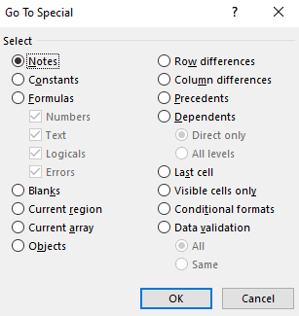

Figure 4. Go To Special dialog box

|  |  |  |
| --- | --- | --- |
|  | Additional information  To review the article on navigating to named ranges, go to: [Find named ranges](https://aka.ms/Find-named-ranges)  To review the article on finding cells that meet specific conditions, go to: [Find and select cells that meet specific conditions](https://aka.ms/Find_and_select_cells_that_meet_specific_conditions) | |
|  | | Did you know?  You can use the Name Box to jump to any cell within a workbook. Enter your initials, your age, and your shoe size into the box and select Enter, that is, DML168 and that’s where you’ll jump! What about the initials of your favorite pop music group and the year you first discovered their music? Or your favorite film and the year it was produced? |

### Activity: Tell a story

The teacher will open L3_T1_act_summary.xlsx and ask how to find named cells or cells that have special formatting applied, such as conditional formatting, or any cells that contain formulas. Don’t worry about what conditional formatting is, because that will be covered in more detail later in the course. If you take the expert course, you’ll learn more there.

|  |  |
| --- | --- |
|  | Additional information  If you decide that you can’t wait to find out more about conditional formatting, check out this link: [Use conditional formatting to highlight information](https://aka.ms/Apply-conditional-formatting-in-Excel)  If you would like to discover more about named ranges, go to: [Create a named range from selected cells in a worksheet](https://aka.ms/create-a-named-range-from-selected-cells-in-a-worksheet)  Formulas are coming soon in this course, but if you want to check out formulas in advance, go to: [Overview of formulas in Excel](https://aka.ms/Overview-of-formulas-in-Excel) |

#### Resources required

You’ll need the following resources for this activity:

* Open L3_T1_act_summary.xlsx in this lesson’s Learning Activity Resources.

#### Activity instructions

The following are the steps that you need to perform during this activity:

1. Open L3_T1_act_summary.xlsx and follow along with the teacher.
2. Offer suggestions on how to find any conditional formatting contained within the worksheet.

### Try-it: Navigate to named cells, ranges, or workbook elements

 You have inherited a workbook containing named ranges and want to familiarize yourself with the workbook components. Try-It 1 will cover navigating to a named cell. Try-It 2 will navigate to a table, and Try-It 3 will highlight cells on screen that contain formulas.

### Try-it 1

Locate a named cell.

#### Resources

You’ll need the following resources for this activity:

* Open L3_T1_try1_summary_starter.xlsx in this lesson’s Learning Activity Resources.

#### Instructions

The following are the general tasks that you must perform during this try-it:

1. Open L3_T1_try1_summary_starter.xlsx.
2. Locate the cell named Total_New_Members.
3. Compare the value with your elbow partner(s). It can be tricky to find the selected cell, so make sure that everyone is finding the selected cell.

### Try-it 2

Locate a named table.

#### Resources

You’ll need the following resources for this activity:

* Open L3_T1_try2_summary_starter.xlsx in this lesson’s Learning Activity Resources.

#### Instructions

The following are the general tasks that you need to perform during this try-it:

1. Open L3_T1_try2_summary_starter.xlsx.
2. Locate the table named Jan_June.
3. Do you recognize what just occurred? If not, ask your elbow partner(s) to check if they know.

### Try-it 3

Highlight cells containing a formula.

#### Resources

You’ll need the following resources for this activity:

* Open L3_T1_try3_summary_starter.xlsx in this lesson’s Learning Activity Resources.

#### Instructions

The following are the general tasks that you must perform during this try-it:

1. Open L3_T1_try3_summary_starter.xlsx.
2. Go to the Membership Summary sheet.
3. Use a shortcut key or command to highlight any cells containing a formula.
4. Make a list of any column or row containing formulas.
5. Check with your elbow partner(s) to check if you have noted the correct columns and rows.

## Topic 2: Search for data

Imagine a huge list of data where you had to find data quickly and easily. Well, guess what? Excel has a command that does exactly that! You can even find data and replace it with different data, and you can find formatting and replace it with different formatting. If it wasn’t for these fantastic tools, you would have to do it manually. This way, you’ll have more time for doing fun stuff!

### Find data in a workbook

1. From the Home tab Editing group, select Find & Select.
2. Select Find (or Ctrl+F).
3. Enter whatever you need to find in the Find what box.
4. Select Options to expand the dialog box and set further search criteria. For example, you can search for uppercase text only or match entire cell contents.
5. Select Find Next to jump to the first entry that has been found.
6. Select Find Next again to work through any entries that match your search criteria one by one.

Alternatively, select Find All to have all the entries that match your search criteria in a list. You can then use the list to jump to any specific entry that you need to find.

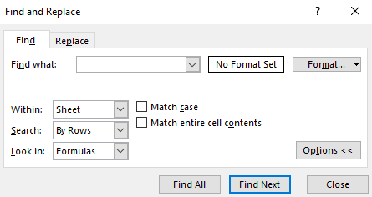

Figure 5. Find dialog box

If you have expanded the dialog box to set more options:

1. Select the drop-down arrow next to Within to search the current sheet or the entire workbook.
2. Select the drop-down arrow next to Search to search by row or column.
3. From the drop-down next to Look in, you can look in formulas, values, notes, or comments.
4. Check Match case to find items that match the case you have entered in the Find what box.
5. Check Match entire cell contents to ignore cells that have partial match (for example, if you searched for apple, it would ignore apples.
6. Select Format to search for specific types of formatting. This will open the Format Cells dialog box. Set the formatting to search for in the dialog box and select OK.

### Replace data in a workbook

1. From the Home tab Editing group, select Find & Select.
2. Select Replace (or Ctrl+H).
3. Or select Find and switch to the Replace tab.
4. Enter whatever you need to find in the Find what box.
5. Enter whatever you need to replace it with in the Replace with box.
6. Select Options to expand the dialog box and add further criteria as described previously.
7. Select Replace and repeat as necessary to replace all entries that match your criteria one by one, or select Replace All to replace all entries in one action.

If you have used the Find or Replace to for formatting, select the drop-down arrow against Format to clear the set formatting if necessary.

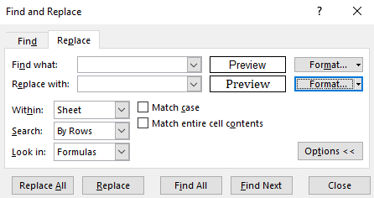

Figure 6. Replace dialog box

|  |  |
| --- | --- |
|  | Additional information  For more information about finding and replacing data, go to: [Find or replace text and numbers on a worksheet](https://aka.ms/find-or-replace-text-and-numbers-on-a-worksheet) |

### Activity: Show and tell

Is it possible to replace blank cells with 0?

#### Resources required

You’ll need the following resources for this activity:

* Open L3_T2_act_summary.xlsx in this lesson’s Learning Activity Resources.

#### Activity instructions

The following are the steps that you must perform during this activity:

1. Open L3_T2_act_summary.xlsx and observe the empty cells contained in the table on the Membership Summary sheet.
2. Follow the teacher’s demonstration. Be prepared to ask and answer questions.

### Try-it: Search for data

In this try-it, you’ll use the Find and Replace tool to find data and replace it with different data. Try-It 1 will replace text and Try-It 2 will replace formatting.

### Try-it 1

Find text within a workbook and replace with different text.

#### Resources

You’ll need the following resources for this activity:

* Open L3_T2_try1_summary_starter.xlsx in this lesson’s Learning Activity Resources.

#### Instructions

The following are the general tasks that you must perform during this try-it:

1. Open L3_T2_try1_summary_starter.xlsx.
2. Replace every entry of the word Junior with Child in the entire workbook.
3. Save the workbook as the same name plus your initials.

### Try-it 2

Find specific formatting within a workbook and replace with different formatting.

#### Resources

You’ll need the following resources for this activity:

* Open L3_T2_try2_summary_starter.xlsx in this lesson’s Learning Activity Resources.

#### Instructions

The following are the general tasks that you need to perform during this try-it:

1. Open L3_T2_try2_summary_starter.xlsx.
2. Replace every cell with Arial font to Cambria, size 11 in the entire workbook.
3. Save the workbook as the same name plus your initials.

## Topic 3: Use the AutoFill feature

AutoFill allows you to copy entries from the active cell to adjacent cells sequentially or by repeating the entry. For example, you might wish to enter the months of the year in your worksheet. You can enter any month and then use AutoFill to complete the rest.

### AutoFill using a pointer device

1. Select the cell(s) to be sequentially copied.
2. Position the pointer at the bottom right corner of the cell(s). The pointer will change to a small black cross.
3. Select and drag over the cells required.
4. Release the pointer to complete the action.
5. An AutoFill Options button is displayed in the corner of the filled data.
6. Select a tag to change the fill to another option; for example, you might wish to copy the data rather than fill a data series.

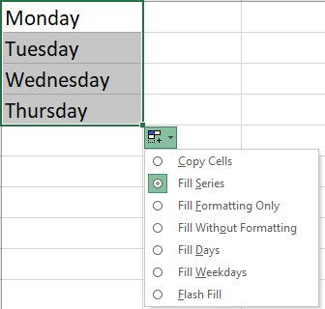

Figure 7. AutoFill Options

|  |  |
| --- | --- |
|  | Did you know?  Years ago, there were no fill options when you filled data in Excel. You had to select more than one cell to make a sequence, or you had to use the Ctrl key while filling. Why not experiment with dates or numbers? |

### AutoFill using the Fill command

1. Select the range that you want to fill, including the cell to copy from.
2. From the Home tab, select Fill from the Editing group.
3. Select a direction to fill from the submenu, and the range will contain the same entry as that of the active cell.

Or

1. Select Series… to fill the range with a sequential pattern of numbers, that is, from 1 to 5.
2. Select Justify for all the filled data to fit across the width of the cells selected.
3. Select Flash Fill when you want Excel to help you extract data from cells.

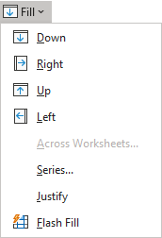

Figure 8. Fill Options from the Home tab

### AutoFill a series of numbers with a pointing device

Select the first two values or the number of cells required for Excel to recognize the sequence, and then drag them together to the adjacent cells.

Excel recognizes the sequence and completes the cells in the sequence you have set, such as 2, 4, 6, 8…., or 1 April, 8 April, 15 April.

|  |  |
| --- | --- |
|  | Additional information  For more information about filling cells automatically, go to: [Automatically number rows](https://aka.ms/automatically-number-rows) |

### Activity: Guess and tell

Teacher will demonstrate using AutoFill and then ask you to guess what will be filled automatically, using various data examples.

#### Resources required

You’ll need the following resources for this activity:

* New blank workbook for experimenting with different AutoFill options.

#### Activity instructions

The following are the steps that you must perform during this activity:

1. Open a new blank workbook or create a new sheet in any open workbook.
2. Suggest answers to the teacher’s questions.

### Try-it: AutoFill

 This try-it will give you a chance to practice using AutoFill to automatically fill cells so that you are equipped with different techiques that you can show to the other interns and use to enter sequential data into worksheets in the future.

### Try-it: 1

Use AutoFill to enter months.

### Resources

You’ll need the following resources for this activity:

* Open a new workbook.

### Instructions

The following are the general tasks that you must perform during this try-it:

1. Open a new blank workbook.
2. Enter Jan in cell A1 and Mon in B2.
3. Fill both cells down to row 20.
4. If the contents of A20 is not Aug and the contents of B20 is not Sat, try it again.
5. Save the file as Fill_Months_Days plus your initials in the Learning Resource folder.

### Try-it: 2

Use AutoFill to enter sequential numbers.

#### Resources

You’ll need the following resources for this activity:

* Open a new blank workbook.

#### Instructions

The following are the general tasks that you need to perform during this try-it:

1. Open a new blank workbook.
2. Enter 5 into A1 and 10 into A2.
3. Fill the cells down to A20 so that they automatically are incremented by 5.
4. Enter 7 into B1 and 14 into B2.
5. Fill the cells down to B20 so that they automatically are incremented by 7.
6. The contents of A20 should be 100 and the contents of B20 should be 140. If not, try again.
7. Save the file as Fill_Numbers plus your initials in the Learning Resource folder.

### Try-it: 3

Use AutoFill to enter sequential dates.

#### Resources

You’ll need the following resources for this activity:

* Open a blank workbook.

#### Instructions

The following are the general tasks that you must perform during this try-it:

1. Open a new blank workbook.
2. Enter the current date in cell A1.
3. Enter the date in 7 days’ time in B1.
4. Fill the dates across to J1 so that they automatically are incremented by 7 days.
5. Enter the current date into cell A2.
6. Enter the date in thirty days’ time in B2.
7. Fill across to J2 so that each cell increments by one month.
8. Save the file as Fill_Dates plus your initials in the Learning Resource folder.

#### Additional information

You can create your own custom list that you can use with AutoFill. For further information, go to: [Create or delete a custom list for sorting and filling data](https://aka.ms/Create-or-delete-a-custom-list-for-sorting-and-filling-data)

Flash Fill is an option within AutoFill options that has not been covered in this module. For further information on Flash Fill, go to [Using Flash Fill in Excel](https://aka.ms/Use_AutoFill_and_Flash_Fill)

## Wrap-up

Turn to a neighbor and share the favorite thing that you learned about AutoFill or anything else covered in the module. Be prepared to share with the class. Then use these questions to check what you learned in this lesson:

1. When a cell or range has a defined name, what is that known as?

Select all that apply.

1. Range
2. Named range
3. Named cell
4. Defined cell
5. Which of the following shortcuts can you use to highlight cells containing formulas?

Select all that apply.

1. F5
2. F6
3. F4
4. Ctrl+G
5. If you used AutoFill to fill Quarter 1 into cell A1 down to A5, what would the contents of A5 contain?

Select the correct option.

1. Quarter 5
2. Quarter 3
3. Quarter 4
4. Quarter 1
5. If you used AutoFill to fill Jan from cell A1 across to L1, which of the following AutoFill options will be available to select?

Select all that apply.

1. Copy cells
2. Fill formatting only
3. Fill without formatting
4. Fill months
5. You can use the Replace feature to find specific formatting and replace with different formatting. True or false?
6. True
7. False
8. Which is the correct shortcut to access the Replace feature?

Select the correct option.

1. Ctrl+G
2. Ctrl+H
3. Ctrl+R
4. Ctrl+I

Note: If you have any concerns about any topics covered in this module, ask your teacher for assistance.

# Glossary

|  |  |
| --- | --- |
| Backstage | Accessed via File tab. Here you can save, save as, print, open, check file info, export to PDF, and other tasks. |
| Template | A master file that can be used to create new files. |
| AutoFill | A tool that allows you to automatically fill cell contents based on the starting content. |
| Named Range | A cell or range with a defined name applied. This topic will be covered in detail in a later module. |
| Go To | A tool that helps you navigate to specific cells, ranges, elements, or cells with special attributes such as formulas and conditional formatting. |
| Conditional Formatting | Special formatting applied to cells to display various criteria. This topic will be covered in detail in a later module. |

# Cornerstone

## Overview

In this Cornerstone, you’ll edit two workbooks, which will include finding data, filling cells automatically with AutoFill, navigating to workbook elements and saving in alternate formats. Using these tools will not only save you time in the future but also help prepare you for the next module in this course.

## Objectives

|  |  |
| --- | --- |
| Cornerstone objectives | MOS Exam objective(s) |
| Use AutoFill to automatically fill data into cells | 2.1.2: Fill cells by using Auto Fill |
| Save workbooks in alternate formats | 1.5.2: Save workbooks in alternative file formats |
| Search for data | 1.2.1 Search for data within a workbook |
| Navigate to named cells, ranges, or workbook elements | 1.2.2 Navigate to named cells, ranges, or workbook elements |

Table 2: Cornerstone objectives

### Duration

50 minutes

### Instructions

1. Complete the tasks for each file.
2. When saving your file, add your name to the end of the filename, for example: Cornerstone_Mod1_Dwayne_Espino. Follow your teacher’s directions for where to save your files.
3. Refer to the thumbnail image provided to observe how your project should generally appear.
4. When you’re done with the Cornerstone, assess your completion and enter the points you think you earned within the task lists below. You can request help from your teacher if required.

### Tasks

You will work with two files in this Cornerstone. The following are the tasks you must perform within each file.

#### File 1: Cornerstone_Starter.xlsx

#### Task: AutoFill (2 points)

1. Enter Qtr1 in cell B1 on the Produce sheet. (1 point)
2. Use AutoFill to fill all four quarters of the year to cell E1. (1 point) (Exam objective 2.1.2)

Points scored: Select here to enter text./2

#### Task: Edit cell contents (1 point)

* Edit the contents of cell E7 to the value of 6694 (1 point)

Points scored: Select here to enter text./1

#### Task: Locate named cell (2 points)

1. Locate the named cell Total. (1 point) (Exam objective 1.2.2)
2. Enter the contents of the named cell into cell A2 of the Summary sheet. (1 point)

Points scored: Select here to enter text./2

#### Task: Find and Replace (2 points)

* Find every cell with an Arial font and replace with the Cambria font in the entire workbook. (2 points) (Exam objective 1.2.1)

Points scored: Select here to enter text./2

#### Task: Save as PDF (2 points)

* Export the entire workbook as a PDF with the name Cornerstone_Mod1_Plus your name in this lesson’s Learning Activity Resources folder. (2 points) (Exam objective 1.2.1)

Points scored: Select here to enter text./2

FILE 1 TOTAL POINTS: Select here to enter text./9

#### File 2: Cornerstone2_starter.xls

#### Task: Find and replace (2 points)

* Replace every entry of corn with sweetcorn in the entire workbook. (2 points) (Exam objective 1.2.1)

Points scored: Select here to enter text./2

#### Task: Navigate (4 points)

1. Navigate to the range named W_S_Total.(1 point) (Exam objective 1.2.2)
2. Enter the number it contains into cell J1 on the All Year sheet. (1 point)
3. Navigate to the range named S_A_Total.(1 point) (Exam objective 1.2.2)
4. Enter the number it contains into cell J2 on the All Year sheet. (1 point)

Points scored: Select here to enter text./4

#### Task: Edit cell contents (1 point)

* Edit the text in cell E80 on the Winter-Spring sheet to Winter-Spring Total. (1 point)

Points scored: Select here to enter text./1

#### Task: Convert file (2 point)

* Convert the file to the newest version of Excel and then save the file as Cornerstone2_Mod1_plus your name. (2 points) (Exam objective 1.2.1)

Points scored: Select here to enter text./2

FILE 2 TOTAL POINTS: Select here to enter text./9

## Thumbnail image

Your finished project should appear similar to this image.

Solution 1:

The Summary sheet contains 159,863 centered in cell A2.

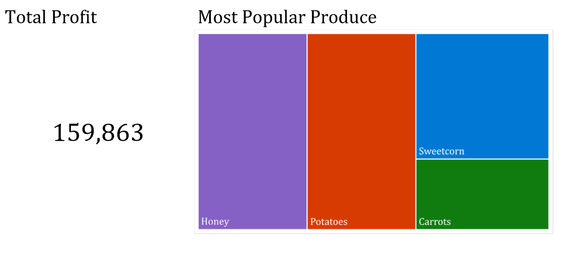

The Produce sheet contains the text Qtr1 in cell B1, Qtr2 in cell C2, Qtr3 in cell D2, and Qtr4 in cell E2.

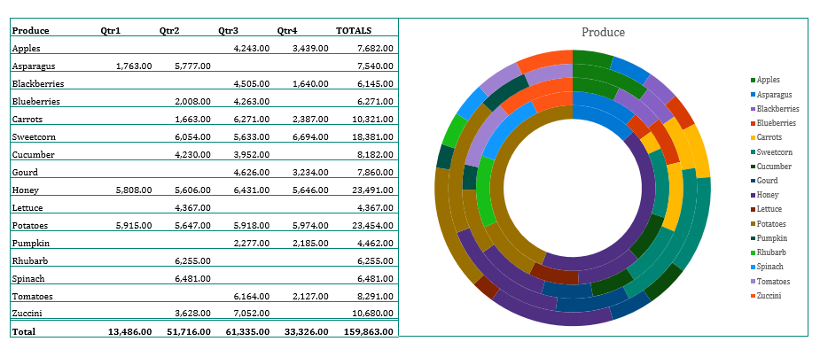

Solution 2:

(This workbook contains a lot of data that will not reproduce well as a screen shot.)