

Student Guide

40567A

Microsoft Excel associate 2019

Module 2: Managing worksheets and workbooks

Contents

Contents 2

Module overview 4

Description 4

Scenario 5

Cornerstone 5

Lesson 1: Structuring a worksheet 6

Overview 6

Warm-up 6

Topic 1: Set up columns, rows, and cells 7

Insert a row into a worksheet 7

Delete a row 7

Insert a column 8

Delete a column 8

Delete multiple columns or rows 9

Adjust a row height or column width 9

Insert a cell 10

Delete a cell 10

Activity: Student teach back 10

Try-it: Columns, rows, and cells 11

Topic 2: Set up worksheets 12

Insert an extra worksheet 12

Delete a worksheet 13

Rename a worksheet 13

Move a worksheet within the same workbook 14

Copy a worksheet within the same workbook 14

Move a worksheet to a different workbook 15

Copy a worksheet to a different workbook 16

Activity: Discuss and learn 16

Try-it: Worksheets 17

Try-it 1 17

Try-it 2 17

Wrap-up 18

Lesson 2: Editing a worksheet 20

Overview 20

Warm-up 20

Topic 1: Cut, copy, paste, and move data 21

Cut data 21

Copy data 22

Further ways to copy data 23

Paste copied or cut data 23

Move data 24

Activity: Group/team 24

Try-it: Cut, copy, paste, and move 25

Try-it 1 25

Try-it 2 26

Topic 2: Use Paste Special 27

Paste Special 27

Activity: Pose a question 28

Try-it: Paste Special 29

Try-it: 1 29

Try-it: 2 30

Try-it: 3 30

Wrap-up 31

Lesson 3: Customizing views and toolbars 32

Overview 32

Warm-up 32

Topic 1: Freeze panes and workbook views 33

Change the screen zoom 33

Change screen display 34

Freeze worksheet titles 34

Unfreeze worksheet titles 35

Move between workbook windows 35

View all the workbooks you want to interact with 35

[View two workbooks side by   
side 36](#_Toc28691479)

Split your screen into panes 36

Clear worksheet panes 37

Navigation keyboard shortcuts 37

Activity: Research 38

Try-it: Freeze panes and workbook views 39

Topic 2: Use the Quick Access Toolbar 39

Use the ribbon to customize the Quick Access Toolbar 40

Customize using the Quick Access Toolbar 40

Activity: Show and tell 42

Try-it: Quick Access Toolbar 42

Try-it: 1 42

Try-it: 2 43

Try-it: 3 44

Wrap-up 45

Glossary 46

Cornerstone 47

Overview 47

Objectives 47

Duration 47

Instructions 48

[File 1: Cornerstone_beehive_data  
_starter.xlsx 48](#_Toc28691500)

[File 2: Cornerstone_honeybee_colonies  
_starter.csv 49](#_Toc28691501)

# Module overview

## Description

Now that you’ve been introduced to Microsoft Excel in Module 1, this module will expand your knowledge in many areas of the app, which will help you as you progress though the course. In this module you’ll learn how to manage worksheets, columns, and rows. No matter what type of data you’re working in Excel, you need to know how to manage worksheet columns, rows, and cells so that data is more easily understood. You’ll also learn how to cut, copy, paste, and move data, including how to use Paste Special. Finally, you’ll learn how to customize your screen appearance and how to customize the Quick Access Toolbar.

Each lesson will include activities and try-its that will help you understand why, when, where, and how you might use these skills. At the end of the module you’ll complete a cornerstone. Most of the objectives listed in the following table will be included in the cornerstone, with the addition of a few objectives covered in Module 1. It’s always good to be reminded of what you already know. That way you’re less likely to forget these fantastic skills in future!

|  |  |  |
| --- | --- | --- |
| Lesson | Learning objective | Exam objective(s) |
| Structure a worksheet | Adjust columns and rows in a worksheet  Insert, delete, rename, move, or copy worksheets | 2.1.3  2.1.4  1.3.2 |
| Edit a worksheet | Cut, copy, paste, and move data  Paste data by using special paste options | 2.1.1 |
| Customize views and toolbars | Freeze worksheet panes, and change worksheet and window views  Customize the Quick Access Toolbar | 1.4.2  1.4.3  1.4.4  1.4.1 |
| Cornerstone  Inherited beekeeping workbook | Insert columns and rows  Insert and delete cells  Adjust columns and rows  Cut, copy, paste and move data  Customize views  Save in alternate formats | 2.1.3  2.1.4  1.3.2  2.1.1  1.4.3  1.5.2 |

Table 1: Objectives by lesson

## Scenario

Munson’s Pickles and Preserves Farm has several honeybee apiaries that they lend to area farms for crop pollination. They have been tracking the movement of the hives in workbooks.

You’ve inherited beekeeping workbooks from a colleague that track the locations, dates, and other associated information about the hives. They are a mess! The workbook, its worksheets, their columns, rows, and cells are inconsistent in size and format. It’s your job to tidy these up for easier viewing and structure consistency. In a brief perusal of the document you’ve noted that:

* Columns and rows need to be resized.
* Information needs to be copied and moved from one area to another while keeping the associated formatting.
* Panes need to be frozen for easier viewing across many rows and columns.
* Data needs to be repositioned.

## Cornerstone

You’ve inherited two workbooks tracking beehive data and they are in much need of restructuring; columns and rows are inconsistent, and headings are missing. You need to fix them! The heading row on each worksheet needs to be frozen at the top for easier viewing. This cornerstone will help build these key skills when you’re working in Excel.

# Lesson 1: Structuring a worksheet

## Overview

This lesson is about the various ways in which you can adjust worksheets, columns, rows, and cells. The topics in this lesson include inserting, deleting, and resizing columns and rows. It also includes inserting, deleting, copying, moving, and renaming worksheets. This lesson will also cover cutting, moving, copying, and pasting data, and customizing the Quick Access Toolbar and your application display.

The skills covered in this lesson are key to your future productivity in Excel. You might even be surprised by how many ways there are to use copy and paste!

## Warm-up

Ask your neighbor if they have any questions about the topics covered in Module 1. Help them if you can, then use these questions to find out what you already know about this lesson’s topics:

1. Which of these methods can you use to insert a new row in a worksheet?

Select all that apply.

1. Right-click or access the context menu for a row number, select Insert
2. Right-click or access the context menu for a column header, select Insert
3. Right-click or access the context menu for a cell, select Insert Entire Row
4. Home, Cells group, Insert > Insert Sheet Rows
5. Which of these methods can you use to set the width of a column in a worksheet?

Select the correct option.

1. Double-click between a column divider to make it autofit
2. Select the divider between 2 rows and drag up or down
3. Right-click or access the context menu for a column header and select Row Height
4. Select Format in the Cells group, and then select Row Height
5. When you select all the columns in your worksheet and double-click on a column divider, that is known as Select here to enter text..

Fill in the blank space.

1. To delete a column in a worksheet, you can select the column header and use which of the following shortcut keys?

Select the correct option.

1. Ctrl+Plus sign (+)
2. Ctrl+Slash (/)
3. Ctrl+Hyphen (-)
4. Ctrl+Asterisk (*)

## Topic 1: Set up columns, rows, and cells

As the content of a worksheet develops and your knowledge of Excel expands, at some time you’ll probably need to insert or delete columns, rows, and cells. You might also need to adjust the column width or row height. This will help with the readability of your data. As usual there are many ways to adjust a workbook. Here are some of the ways you can complete the following actions.

### Insert a row into a worksheet

To insert a row into a worksheet, you can either:

* Right-click or access the context menu on top of the row header and choose Insert.
* Select the row header, and then select the Ctrl+ Plus sign (+) keys.
* Select the row header. Then on the ribbon, on the Home tab, select the Insert Cells button drop-down list, and then select Insert Sheet Rows

Note: The number of rows you select will determine the number of rows that will be inserted.

### Delete a row

To delete a row, you can either:

* Right-click the top of the row header or access its context menu, and then select Delete.
* Select the row header, and then select the Ctrl + Hyphen (-) keys.
* Select the row header. Then on the ribbon, on the Home tab, select the Delete Cells button, and then select Delete Sheet Rows.
* Right-click or access the context menu on a cell and choose Delete from the menu, then select Entire Row.

Note: the number of rows you select will determine the number of rows that will be deleted.

### Insert a column

To insert a column, you can either:

* Right-click on top of the column header or access its context menu, and then from the menu, select Insert.
* Select the column header, and then select Ctrl + Plus sign (+).
* Select the column header. Then on the ribbon, on the Home tab, select the Insert Cells button, and then select Insert Column Rows.

Note: the number of columns you select will determine the number of columns that will be inserted.

### Delete a column

To delete a column, you can either:

* Right-click on top of the column header or access its context menu, and then select Delete.
* Select the column header, and then select the Ctrl + Hyphen (-).
* Select the column header. Then on the ribbon, on the Home tab, select the Delete Cells button, and then select Delete Sheet Columns.
* Right-click on a cell or access its context menu, select Delete, and then select Entire Column.

Note: the number of columns you select will determine the number of columns that will be deleted.

### Delete multiple columns or rows

To delete multiple columns or rows, you can choose from either of the following two tasks:

1. Select the first column or row you would like to delete.
2. Hold the Ctrl key, and then the select any column or row you would like to delete. (This allows you to select nonconsecutive columns or rows.)
3. Use any of the previous deletion methods to delete them.

Or

1. Select the first column or row you want to delete.
2. Hold the Shift key, and the select the last column or row you would like to delete. (This allows you to delete a block of columns or rows.)
3. Use any of the previous deletion methods to delete them.

Note: you cannot delete columns and rows simultaneously. You can only delete multiple columns, or multiple rows at one time.

### Adjust a row height or column width

To adjust a row height or column width, you can either:

* Select the rows or columns to be adjusted. Then move your pointing device between any of the selected rows or columns. When you’re pointing device changes shape, select the divider and drag to the size you would like. As you drag your pointing device, the points (pixels) increase or decrease.
* Select the rows or columns to be adjusted. Then move your mouse between any of the selected rows or columns. When your mouse changes shape, double-click. The rows or columns will be the exact size they need to be to fit the data. This is known as AutoFit.
* Right-click or access the context menu on the selected rows or columns, and then select Row Height or Column Height. Set the exact size you would like and select OK.
* Select the rows or columns you would like to adjust, and then on the ribbon, on the Home tab, from the Format button, select the options you would like to use.

|  |  |
| --- | --- |
|  | Did you know?  When you stretch a row to make it wider, the maximum height of the row is 409.5 points (456 pixels)! The default setting is 15 points (20 pixels). |

### Insert a cell

To insert a cell, you can either:

1. Right-click on the cell where you would like to insert a cell, or access its context menu.
2. Select Insert, and then select to Shift cells right or Shift cells down.

### Delete a cell

To delete a cell, you can either:

1. Right-click on the cell where you would like to delete a cell, or access its context menu.
2. Select Delete, and then select to Shift cells right or Shift cells down.

Note: Be careful when inserting or deleting cells that you don’t mess up the rest of your data. It might be better to select Clear Contents or use the Delete key on your keyboard to delete cells, and to insert an entire row or column when you want to insert a cell.

|  |  |
| --- | --- |
|  | Video  To review the video on inserting and deleting cells, columns and rows into a worksheet, go to: [Insert or delete rows, and columns](https://aka.ms/Insert-or-delete-rows-and-columns) |

### Activity: Student teach back

Your teacher will open an Excel workbook and ask for your help to fix the data. They need you to arrange and display the data, so it’s more easily read and understood. Students will take turns at the teacher’s computer to make changes using suggestions from fellow students.

#### Resources required

You will need the following resource for this activity:

* Open L1_T1_act_volunteer_sheet.xlsx in this lesson’s Learning Activity Resources.

#### Activity instructions

You need to perform the following task during this activity:

* Volunteer to take control at the teacher’s computer and/or offer suggestions to fellow students on how to improve the readability of the data shown.

### Try-it: Columns, rows, and cells

You’ll have 20 seconds to try to fix a problem with a workbook. When the time is up, you’ll move to the next computer and continue from where your neighbor left it. When the full time is up, you’ll return to your own computer to review what has happened to your workbook.

#### Resources

You will need the following resource for this activity:

* Open L1_T1_try_volunteers_starter.xlsx in this lesson’s Learning Activity Resources.

#### Activity instructions

Participate in the activity by following these instructions:

1. Open L1_T1_try_volunteers_starter.xlsx.
2. Examine the worksheet: are the column and row widths okay? Is data out of line? Is there anything missing?
3. Within 20 seconds, make any alteration you feel is appropriate and improves the readability in the way the data is displayed.
4. When instructed, move to your neighbor’s computer, and make further alterations to their worksheet.
5. Continue moving along to other computers as instructed, and make any further alterations that you think might be needed to improve the readability of the data.
6. When the time is up, return to your own computer to review what has changed with your workbook. Are the column and row widths okay? Is data out of line? Is there anything missing?
7. Save the workbook with the original file name and your initials.

## Topic 2: Set up worksheets

Every new workbook has one worksheet by default, named Sheet1. As your workbook develops you might need to add additional worksheets. If so, having worksheets named Sheet1, Sheet2, Sheet3, and so forth is not very helpful for future reference. For example, how can you know what data is on a worksheet named Sheet1?

There’s also every probability that you’ll need to move worksheets around or copy them. Imagine your confusion when Sheet1 is moved and is now located at the end of the workbook instead of in the first location.

For these reasons, you’ll want to keep your workbook organized. You’ll want to rename worksheets to something meaningful, so at a glance you’ll know what data is in them. If your workbook contains unnecessary worksheets, such as blank worksheets or duplicated worksheets, it’s a good idea to delete them. The following information will help you take control of worksheets in your workbooks.

|  |  |
| --- | --- |
|  | Did you know?  You can start Excel with an accessible template to better support your users’ accessibility needs. For further information, refer to: [Start with an accessible Excel template](https://aka.ms/Video-Start-with-an-accessible-Excel-template) |

### Insert an extra worksheet

To insert an extra worksheet, use one of the following three methods:

* Select the New Sheet button (the plus (+) next to the worksheet tabs at the bottom of the screen). This will insert a new worksheet to the right of the active worksheet.
* Right-click or access the context menu on any existing worksheet tab, and then select Insert. Select the type of worksheet to insert from the selections available, and then select Insert. This will insert a worksheet to the left side the active worksheet.
* On the ribbon, on the Home tab, select the Insert Cells button drop-down menu, and then select Insert Sheet.

### Delete a worksheet

To delete a worksheet, use one of the following two methods:

* Right-click the top of the worksheet tab or access its context menu, and then select Delete.
* On the ribbon, on the Home tab, select Delete Cells, and then select Delete Sheet.

Note: You can select more than one worksheet at a time by holding either the Shift key or Ctrl key. The Shift key will allow you to select a range of worksheets, while the Ctrl key will allow you to select nonconsecutive worksheets.

Another Note: Take extra care when deleting worksheets—you cannot undo this action! If you accidentally delete a worksheet, while you could close the workbook without saving it, you could lose lots of work in the process.

### Rename a worksheet

When you rename a worksheet, you need to consider some naming conventions. For more information on renaming worksheets, check out the Additional Information section. To rename a worksheet, use one of the following three methods:

* Double-click the current worksheet name, and when the existing name is selected, enter a new name. Then select anywhere off the tab to save the changes.
* Right-click the worksheet name or access its context menu, and then select Rename. Enter a new name, and then select anywhere off the tab to save the changes.
* On the ribbon, on the Home tab, select Format, and then select Rename Sheet. Enter a new name, and then select anywhere off the tab to save the changes.

|  |  |
| --- | --- |
|  | Did you know?  You cannot use these characters * / \ ? : [ ] within a worksheet name because these characters are used for coding and unpredictable things might happen behind the scenes. (Don’t panic, you don’t need to know about coding in this module!) For the Excel veteran, in Excel 2019, you can add spaces in the worksheet name! |

### Move a worksheet within the same workbook

To move a worksheet within the same workbook, you can use one of the following methods:

1. Right-click or access the context menu on top of the worksheet tab, and then select Move or Copy. In the Move or Copy dialog box, select which worksheet you would like to move the worksheet before or select move to end, and then select OK.

Or

1. Select Format from the Home tab and then select Move or Copy Sheet. In the Move or Copy dialog box, select which worksheet you would like to move the worksheet before or select move to end, and then select OK.

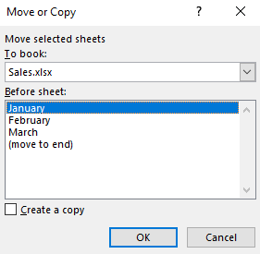

Figure 1: Move or Copy dialog box

1. Select on the worksheet tab to move, hold the mouse, drag the worksheet to the new position, and release the mouse.

### Copy a worksheet within the same workbook

To move a worksheet within the same workbook, you can use one of the following methods:

1. Select Format from the Home tab, and then select Move or Copy Sheet.

Or

1. Right-click the top of the worksheet tab name or access its context menu, and then select Move or Copy. In the Move or Copy dialog box, select the Create a copy check box. In the Before sheet list, select which worksheet you would like the new worksheet inserted before, or select move to end, and then select OK.

Or

1. Select the worksheet tab to copy, hold the mouse and Ctrl key, drag the worksheet to the new position, and release the mouse.

### Move a worksheet to a different workbook

If you need to move a worksheet to another workbook, you don’t need to use copy and paste. Excel has a command that will move the worksheet for you. For this to work though, you must have both workbooks open.

To move a worksheet to a different workbook:

1. For the worksheet you want to move, right-click the worksheet tab name or access its context menu. (Alternatively, you can select Format on the ribbon, on the Home tab.)
2. Select Move or Copy.
3. In the Move or Copy dialog box, select the To book drop-down icon, and then select the workbook to move the worksheet to. (If you are creating a new workbook with the worksheet, select new book).

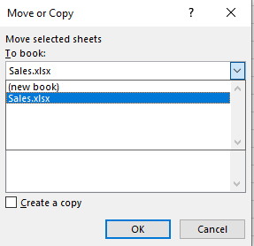

Figure 2: Move or Copy dialog box, drop-down arrow

1. In the Before copy pane, select which worksheet you want to move the worksheet before or select move to end. Then select OK.

Screenshot of Move or Copy dialog box, Before sheet list


Figure 3: Move or Copy dialog box, Before sheet list

### Copy a worksheet to a different workbook

Imagine you’ve created a worksheet in a workbook that contains data that can be used in other workbooks. Rather than having to insert a new worksheet into the other workbook and then copying and pasting the original worksheet into the workbook, you can use the Copy worksheet command. However, just like moving a worksheet between workbooks, you must have both workbooks open for this to work.

To copy a worksheet to a different workbook:

1. Right-click on the name of the worksheet tab that you want to copy, or access its context menu. (Alternatively, you can select Format on the ribbon, on the Home tab.)
2. Select Move or Copy.
3. Select the Create a copy check box.
4. Select the To book drop-down arrow, and choose which workbook to copy it to. (If you are creating a new workbook with the worksheet, select new book).
5. In the Before copy pane, select which worksheet you want to insert the worksheet before, or select move to end. Then select OK.

|  |  |
| --- | --- |
|  | Additional information  To review the article on renaming worksheets, go to: [Rename a worksheet](https://aka.ms/Rename-a-worksheet) |
|  | To review the video on moving or copying a worksheet, go to: [Move or copy worksheets or worksheet data](https://aka.ms/Move-or-copy-worksheets-or-worksheet-data) |

### Activity: Discuss and learn

Your teacher will open a discussion regarding naming conventions (giving worksheets a suitable name) when renaming worksheets.

#### Resources required

You will need the following resource for this activity:

* Open L1_T2_act_produce.xlsx in this lesson’s Learning Activity Resources.

#### Activity instructions

You will need to perform the following steps during this activity:

1. Open L1_T2_act_produce.xlsx.
2. Examine the data on the three worksheets, and consider suitable names for the worksheets. Is there anything obvious about the seasons or the months on each worksheet?
3. Engage in the discussion, by asking and answering questions.

### Try-it: Worksheets

 In this leveled try-it activity, you’ll rename worksheets to better reflect what each worksheet contains, you’ll copy a worksheet into a new workbook, and rename the worksheet.

### Try-it 1

In this try-it, you’ll rename worksheets.

#### Resources

You will need the following resource for this activity:

* Open L1_T2_try1_volunteer_hours_starter.xlsx in this lesson’s Learning Activity Resources.

#### Activity instructions

Participate in the activity by following these instructions:

1. Open L1_T2_try1_volunteer_hours_starter.xlsx.
2. Examine the contents of each worksheet, and rename them to make it clear whether it’s for a 28, 30, or 31-day month. For example, you could use the name 30-day month.
3. Save the workbook with the original file name plus your initials.

### Try-it 2

In this try-it, you’ll copy a worksheet to a new workbook.

#### Resources

You will need the following resource for this activity:

* Open L1_T2_try2_volunteer_hours_starter.xlsx in this lesson’s Learning Activity Resources.

#### Activity instructions

Participate in the activity by following these instructions:

1. Open L1_T2_try2_volunteer_hours_starter.xlsx, and copy Sheet 1 to a new workbook.
2. Rename the worksheet 30-day month.
3. Save the new workbook as Apr_Jun_Sept_Nov_plus your initials to this lesson’s Learning Activity Resources folder.

## Wrap-up

Use these questions to check what you learned in this lesson:

1. Which is the correct shortcut to copy a worksheet to another worksheet in the same workbook?

Select the correct option.

1. Select the sheet to copy, then use Ctrl, drag and drop
2. Select the sheet to copy, then use drag and drop
3. Select the sheet to copy, then use Shift, drag and drop
4. Select the sheet to copy, then use Alt, drag and drop
5. Which of the following processes can you use to rename a worksheet?

Select all that apply.

1. Right-click in any blank cell and select Rename Sheet.
2. Right-click on the sheet tab and select Rename.
3. Select Format in the Cells group and select Edit Sheet Name.
4. Select Format in the Cells group and select Rename Sheet.
5. Which of these methods can you use to set the width of a row in a worksheet?

Select all that apply.

1. Select Format in the Cells group and select AutoFit Row Height.
2. Right-click on a row header and select Column Height.
3. Double-click between a column divider to make it AutoFit.
4. Right-click on a row header and select Row Height.
5. To insert a row into a worksheet, you can select the row header and use which of the following shortcuts?

Select the correct option.

1. Ctrl+Plus sign (+)
2. Ctrl+Hyphen (-)
3. Ctrl+Asterisk (*)
4. Ctrl+Slash (/)

# Lesson 2: Editing a worksheet

## Overview

In this lesson you’ll learn how to cut, copy, paste, and move data in an Excel workbook, including using the Paste Special feature. Paste Special is so unique that it gets a topic all its own. You’ll learn a bit about it in Topic 1, and then explore it in more detail in Topic 2.

## Warm-up

In the previous lesson, you learned how to move or copy worksheets. In this lesson you’ll learn how to move or copy data, including using Paste Special options. Use these questions to find out what you already know about this lesson’s topics:

1. Ctrl+C is the keyboard shortcut to Select here to enter text. data?

Fill in the blank space.

1. What is the keyboard shortcut to cut data from a cell?

Select the correct option.

1. Ctrl+C
2. Ctrl+D
3. Ctrl+X
4. Ctrl+Z
5. To paste copied data from horizontal to vertical, which option would you use from Paste Special?

Select the correct option.

1. Values
2. Formulas
3. Transpose
4. Formatting only
5. The keyboard shortcut to access the Paste Special dialog box is:

Select the correct options.

1. Ctrl+Alt+A
2. Ctrl+V
3. Ctrl+Alt+V
4. Ctrl+Shift+P

## Topic 1: Cut, copy, paste, and move data

Why would you repeatedly add data into a worksheet that you have created before when you could simply copy and paste it or move it instead? This topic will cover the many ways in which you can use cut, copy, paste, and move data in Excel. You might already know many techniques; however, you might even be surprised how many ways there are!

### Cut data

If you want to move data from one position to another, you can cut the data and paste it into the new position instead of having to re-enter data in the new position. You can also simply move the data using your pointer device (described later in this topic).

To cut data:

1. Select the cell(s) to cut, then either select Ctrl+X, or right-click or access the context menu, and then select Cut.
2. On the ribbon, on the Home tab, in the Clipboard group, select the Cut button.

Note: Nothing will happen, except for a dotted line rotating around the selected cell or cells. However, the cut data has been added to the Clipboard. You need to paste the cut data somewhere else if you want to re-use it.

|  |  |
| --- | --- |
|  | Did you know?  If you right-click on selected cells or access their context menu and select Delete, Excel will assume you want to cut the cells and will offer you the option to move data from the neighboring cells up, left, down, or right, depending on where you started the action.  If you right-click on selected cells or access their context menu and choose Clear Contents, the data contained will be deleted (in the same way as using the delete key on a keyboard) and the data in other cells will not be moved. |

### Copy data

Copying data in Excel is similar to copying data in Microsoft Word. To copy data, you can use one of the following two methods:

* Select the cells(s) to copy, then either select Ctrl+C, or right-click the cells or access their context menu, and select Copy.
* Select the cells(s) to copy, then on the ribbon, on the Home tab, in the Clipboard group, select the Copy button.

Any data you copy in Excel will be added to the Clipboard, which you can access via the Clipboard launcher icon in the corner of the Clipboard group. If you don’t paste the copied data before performing a different action though, it will disappear from the clipboard and you’ll need to copy it again.

|  |  |
| --- | --- |
|  | Did you know?  If you open the Clipboard, up to 24 copied items can be listed and pasted at any time while working in Excel. It even will list anything you copy from other applications, such as from Word or Microsoft PowerPoint. |

### Further ways to copy data

There are even more ways you can copy data:

* Select Ctrl + D to duplicate the cell(s) above selected cell(s), for example, if cell B1 contained the text Honeybees, and if you selected cell B2 and then selected Ctrl+D, cell B2 would then also contain the text Honeybees.
* Select Ctrl + R to repeat the cell(s) to the left of selected cell(s). For example, if cell D3 contained the number 3000, and if you selected cell E3 and then selected Ctrl+R, cell E3 would then also contain the number 3000.
* Select cells to copy, then select Ctrl, and drag.
  + Use Format Painter to copy formatting or special attributes (but not content) from selected cells to other cells. The format of a cell refers to attributes such as font style, size, color, and borders. (We will be covering Format Painter in more detail later in the lesson.)
* Use AutoFill, and select Copy from the AutoFill options tag.

### Paste copied or cut data

There are several methods you can use to paste your copied or cut data. After selecting the cell where you want to paste the data:

* Select Ctrl+V.
* Right-click or access the context menu, select Paste, then select the paste option you need.
* Select the Paste button in the Clipboard group.
* Select the Paste button drop-down, and select a different paste option.
* Select Enter on keyboard.
* Select Ctrl+Alt+V to open the Paste Special dialog box and use any of its options.
* Select the item to paste from the Office Clipboard, if it’s open.
* If you’ve copied a whole row, right-click or access the context menu and select Insert Copied Row. (You use the same process for columns by selecting Insert Copied Column.)
* Right-click or access the context menu, select Insert Copied Cells, then choose to shift cells one of the directions suggested.

### Move data

To move data, select the cells you want to move, and then use one of the following two methods:

* Select Ctrl+X, select the cells you want to move the data to, and then use any method to paste the data.
* Move to the border of the selected cells, then select and drag it to the new position in which you want it. Don’t use the bottom, right corner of the selected cells though, as this will fill the data to the new position rather than move it.

|  |  |
| --- | --- |
|  | Video  To review the video on Copy and Paste, go to: [Move or copy cells and cell contents](https://aka.ms/Move-or-copy-cells-and-cell-contents) |
|  | Additional information  For further information on how to cut, copy, move, or paste data, go to: [Excel help center](https://aka.ms/Excel-help-center), and use the search box to search. You can use this site to research anything you want to know about Excel or any other Microsoft application. |

### Activity: Group/team

Students will collaborate to research and learn about various ways in which you can cut, copy, paste, and move data.

#### Resources required

You will need the following resources for this activity:

* Open a workbook or use paper to record your team’s answers.
* After completing your research, open L2_T1_act_cut_copy_paste_move_reference.docx in this lesson’s Learning Activity Resources to compare results.

#### Activity instructions

You will need to perform the following steps during this group/team activity:

1. Work with a partner or two as instructed by your teacher. Discuss and decide upon a process to research and record the information you learn about each editing strategy (Cut, Copy, Paste, and Move).
2. Open any workbook or use any design template to create a new workbook to use for research purposes.
3. Create four categories either on paper, in a Word document, or in an Excel workbook to record what you learn about Cut, Copy, Paste, and Move.
4. Use the Ask me or other resources to identify methods to accomplish each task. Add the details about what you learned, under the appropriate category.
5. If you’re having difficulty finding methods of using Cut, Copy, Paste, and Move, ask the teacher for help.
6. When finished, compare your results with other teams.

### Try-it: Cut, copy, paste, and move

As you have learned, there are many ways to cut, copy, paste, and move data. In the following try-it you’ll have a chance to practice some of these methods.

### Try-it 1

In this try-it, you’ll copy information from a Word document into Excel.

#### Resources

You will need the following resources for this activity:

* Open L2_T1_try1_ingredients_starter.docx in this lesson’s Learning Activity Resources.
* Open L2_T1_try1_event_volunteers_starter.xlsx in this lesson’s Learning Activity Resources.

#### Activity instructions

Participate in the activity by following these instructions:

The following are the general tasks that you need to perform during this try-it:

1. Open L2_T1_try1_event_volunteers_starter.xlsx and L2_T1_try1_ingredients_starter.doc.
2. Copy the illustration of a garlic bulb from L2_T1_try1_ingredients_starter.docx into the Master List worksheet in L2_T1_try1_event_volunteers_starter.xlsx.
3. Move the illustration anywhere in the heading area so that no text is obscured.
4. When you’ve completed the tasks, save and close the workbook with the original file name plus your initials.
5. Close the Word document.

### Try-it 2

In this try-it, you’ll copy and paste data from one worksheet to another.

#### Resources

You will need the following resource for this activity:

* Open L2_T1_try2_event_volunteers_starter.xlsx in this lesson’s Learning Activity Resources.

#### Activity instructions

Participate in the activity by following these instructions:

1. Open L2_T1_try2_event_volunteers_starter.xlsx.
2. Copy column C from the Master list worksheet and insert it between column B and C on the Event Volunteers worksheet.
3. Use any method to move the data that has moved out of line so that it’s in the correct place.
4. Copy row 2 from the Master list worksheet and insert it between rows 1 and 2 on the Event Volunteers worksheet.
5. Once you’ve completed the tasks, close and save the workbook with the original file name plus your initials.

## Topic 2: Use Paste Special

The Paste Special feature allows you to paste copied items in various ways, including format only, value only, or as a link. In technical terms you could say that Paste Special allows you to paste the *attributes* of a cell rather than the contents of a cell. Most office applications offer Paste Special options. However, Excel’s options are probably some of the most impressive!

### Paste Special

To access the Paste Special options:

1. Copy the data you want to paste, and then paste the data to the new location using one of the methods you’ve learned.
2. Once you’ve pasted the data, a (Ctrl) button will display. Selecting the button opens a list of options, as indicated in the following screenshot.

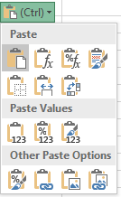

Figure 4: Paste Special options

From here you can choose from many different paste options. For example, you can choose to paste formatting only, paste a link to the copied data, or keep the source column widths.

Alternatively, you can access the Paste Special dialog box by copying the data you want to paste, and then selecting from one of the following methods:

* On the ribbon, in the Clipboard group, select the Paste command drop-down arrow and choose one of the options.
* Right-click the data or access its context menu, then drag it on top of itself to paste as values.
* Right-click the data or access its context menu and select Paste Special.
* Select Ctrl+Alt+V to open the Paste Special dialog box, as in the following figure.

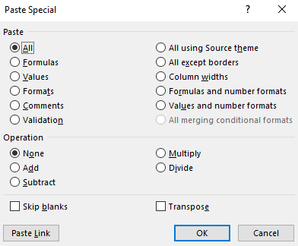

Figure 5: Paste Special dialog box

The Paste Special dialog box provides the most paste options of all the methods. For example, you can choose to paste calculations when you paste on top of existing numerical data.

|  |  |
| --- | --- |
|  | Additional information  For more information on using Paste Special, go to: [Paste options](https://aka.ms/Copy-cell-data-and-paste-attributes-only) |

### Activity: Pose a question

During this activity, your teacher will pose questions about Paste Special.

#### Resources required

You will need the following resource for this activity:

* Open L2_T2_act_common_bees.xlsx in this lesson’s Learning Activity Resources.

#### Activity instructions

1. Open L2_T2_act_common_bees.xlsx and follow along as the teacher demonstrates Paste Special.
2. Ask any questions you might have, and answer any questions you know the answer to.
3. Close the workbook without saving it.

### Try-it: Paste Special

 In this series of leveled try-it activities, you’ll use the headings from an existing workbook to make a list in a new workbook. You’ll also paste data as values, and paste data using the Paste Special dialog box.

### Try-it: 1

In this try-it, you’ll cut and paste data from horizontal to vertical.

#### Resources

You will need the following resource for this activity:

* Open L2_T2_try1_volunteer_shift_form_starter.xlsx in this lesson’s Learning Activity Resources.

#### Activity instructions

Participate in the activity by following these instructions:

1. Open L2_T2_try1_volunteer_shift_form_starter.xlsx and create a new workbook.
2. Copy the range A5 to G5 from L2_T2_try1_volunteer_shift_form_starter.xlsx into the new workbook, so the data is pasted from horizontal to a vertical list beginning at cell A1.
3. Set the column width for column A to 20, and the row heights for rows 1-9 to 33.
4. Save the new workbook as Time_Slot_plus your initials in the lesson’s Learning Activity Resources folder for use later.

### Try-it: 2

In this try-it, you’ll paste data as values.

#### Resources

You will need the following resource for this activity:

* Open L2_T2_try2_volunteer_shift_form_starter.xlsx in this lesson’s Learning Activity Resources.

#### Activity instructions

Participate in the activity by following these instructions:

1. Open L2_T2_try2_volunteer_shift_form_starter.xlsx and create a new workbook.
2. Copy the range name Station_Time_Slots into a new workbook so the data is pasted as values in cell A1.
3. Set the column widths for all the columns containing data to 18, and save the workbook as Shift_form_plus your initials in the lesson’s Learning Activity Resources folder.

### Try-it: 3

In this try-it, you’ll paste data using the Paste Special dialog box.

#### Resources

You will need the following resource for this activity:

* Open L2_T2_try3_volunteer_shift_form_starter.xlsx in this lesson’s Learning Activity Resources folder.

#### Activity instructions

Participate in the activity by following these instructions:

1. Open L2_T2_try3_volunteer_shift_form_starter.xlsx.
2. Copy the range name Station_Time_Slots and use a keyboard shortcut to paste it into a new workbook starting in cell A1.
3. Use another keyboard shortcut to access the Paste Special dialog box and set column widths.
4. Save the new workbook as Volunteer_form_plus your initials in the lesson’s Learning Activity Resources folder.

## Wrap-up

Play a rock, paper, scissors hand game with a nearby student. When one person loses a round, they must describe one of the Paste Special options. The winner of that round must think of a situation when that option would be useful. Continue playing until the three Paste Special options have been discussed.

Alternatively, take turns to describe what you know about Paste Special, or what option is usually available in the paste options.

Then use the following questions to check what you learned in this lesson:

1. When you’ve copied data, which of the following is a correct method to paste it somewhere else?

Select all that apply.

1. Select where you want to paste the data, and then select enter on your keyboard.
2. Right-click or access the context menu for where you want to paste the data, and select Paste.
3. Select where to paste, and then select Ctrl+V.
4. Right-click or access the context menu for where you want to paste the data, and then select Paste here.
5. The option that allows you to copy data that is vertical and paste it horizontal is known as Select here to enter text..

Fill in the blank space.

1. Which statement is true?

Select all that apply.

1. When you’ve right-clicked or accessed the context menu on a cell where you want to paste data, Paste Special is not available on the context menu.
2. When you’ve right-clicked or accessed the context menu on a cell where you want to paste data, you can select Paste Special on the context menu.
3. When you’ve copied data, you can access Paste Special using Ctrl+Alt+V.
4. The Paste Special button can be found on the Paste drop-down arrow on the Home tab.
5. When you cut data from a cell, Excel adds it to the Select here to enter text..

Fill in the blank space.

# Lesson 3: Customizing views and toolbars

## Overview

In this lesson you’ll learn about different ways to arrange the Excel screen display, and to customize the Quick Access Toolbar to suit your needs. You’ll also learn several ways to quickly navigate around a workbook. All of these skills will make you a more efficient Excel user and prepare you for more advanced assignments in the lessons to come.

## Warm-up

In Lesson 2 you learned about several ways to cut, copy, paste, and move data. Ask your neighbor to recall any keyboard shortcuts they can remember, then use these questions to find out what you already know about this lesson’s topics:

1. The Quick Access Toolbar has which commands by default?

Select all that apply.

1. AutoSave
2. Save As
3. Undo
4. Redo
5. You can customize the Quick Access Toolbar via which method?

Select all that apply.

1. Right-click or access the context menu of a button on the ribbon and add it.
2. Right-click or access the context menu on the ribbon and select Customize Quick Access Toolbar.
3. On the File tab, select Options, and then select the Quick Access Toolbar.
4. Right-click or access the context menu on top of a button on the Quick Access Toolbar and remove it.
5. You can find Freeze panes on the Select here to enter text. tab.

Fill in the blank space.

1. Which of the following commands does not belong to the Windows group on the View tab?

Select the correct option.

1. Hide
2. Split
3. Zoom
4. Arrange All

## Topic 1: Freeze panes and workbook views

When you’re faced with a worksheet containing a vast amount of data, you might find it helpful to customize how your worksheet displays on your screen. In this topic you’ll learn how to do that using Freeze Panes, Split Screen, Arrange All, and the Zoom. Most of the commands that help with this are on the View tab, or next to the zoom bar in the bottom, right corner of the Excel interface.

### Change the screen zoom

You can change the magnification of your screen using one of two methods:

* In the bottom, right corner of your screen, either select and drag the slide bar, or select the zoom out (-) or zoom in (+) icons to increase or decrease magnification in blocks of 10 percent.

Screenshot of Zoom slider bar

Figure 6: Zoom slider bar

Or

1. On the View tab on the ribbon, select an option from the Zoom group.

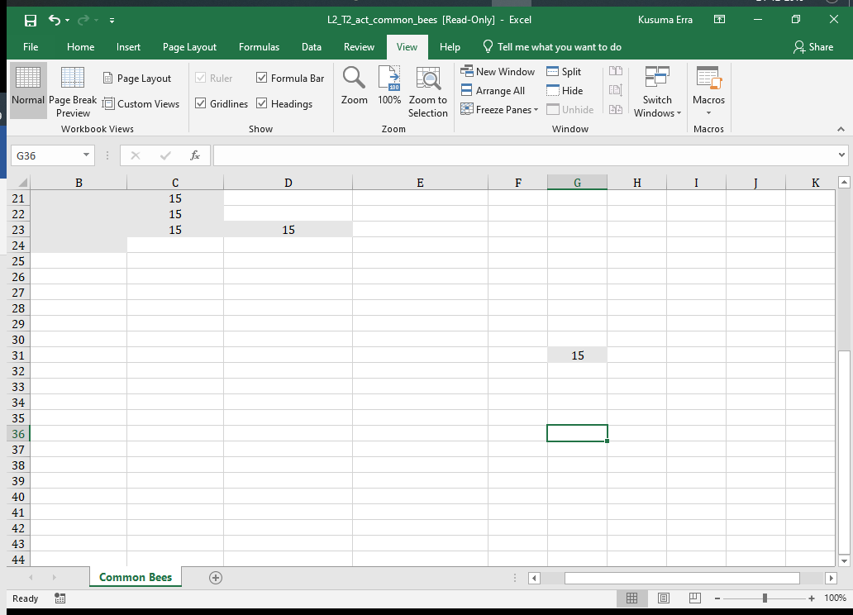

Figure 7: Commands in the Zoom group

1. When you’ve zoomed a screen in or out, you can use Ctrl+Z to undo the change.
2. Select 100% to return the zoom to the normal screen size.

### Change screen display

Sometimes you might find it useful to change your screen display from the default view. There are several views to choose from. To change your view, use one of the following two methods:

* On the View tab, in the Window group, select either Page Break Preview or Page Layout.

Or

* Next to the zoom slider, select from one of three view option icons: Normal, Page Layout, or Page Break Preview.

Screenshot of screen view next to Zoom slider bar

Figure 8: Screen view next to Zoom slider bar

|  |  |
| --- | --- |
|  | Additional information  To review the article on Page Break View, go to: [Insert, move, or delete page breaks in a worksheet](https://aka.ms/Insert-move-or-delete-page-breaks-in-a-worksheet) |

### Freeze worksheet titles

When you’re working with a large amount of data and you move further down the data, you can lose the headings, making is harder to understand the data. For example, if you have multiple columns how can you know what type of data you’re working with when you don’t know what the column header says? Similarly, when you move over to the right side of the data, you can lose the labels on the left.

Excel has a feature that can help with this. Freeze Panes does just that—it freezes panes. When you apply Freeze Panes to your data, as you move down or across the worksheet the headings are frozen above or to the left of the freeze line.

To insert a freeze line:

1. Select the cell where you want the freeze to be applied. For example, if you want row 1 to be frozen in place when you scroll down, and columns A and B to be frozen in place when you move across to the right, your cursor should be in cell C2.
2. On the View tab, in the Window group, select Freeze Panes.
3. Select from Freeze Panes to freeze around the current position of your cursor, Freeze Top Row, or Freeze First Column.

### Unfreeze worksheet titles

When you are ready to unfreeze your worksheet, you follow almost the same steps:

1. On the View tab, in the Window group, select Freeze Panes.
2. Choose Unfreeze Panes.

|  |  |
| --- | --- |
|  | Video  To review the video on freezing panes, go to: [Freeze panes to lock rows and columns](https://aka.ms/Freeze-panes-to-lock-rows-and-columns) |

### Move between workbook windows

If you have more than one workbook open at a time and you’re switching back and forth from workbook to workbook, you might find it useful to use the Switch Windows command.

To move between workbooks, you can use either of the following methods:

* On the View tab, in the Window group, select Switch Windows, and then select the workbook name you want to switch to or select Ctrl F6.

Or

* Select the workbook name on the taskbar, and then select Alt+Tab.

### View all the workbooks you want to interact with

To simultaneously view all the workbooks you want to interact with:

1. On the View tab, in the Window group, select Arrange All.
2. In the Arrange Windows dialog box, select either Tiled, Horizontal, Vertical, or Cascade, and then select OK.

Note: Just as you can view multiple workbooks simultaneously, you can also view multiple worksheets from the same workbook simultaneously. To do this:

1. In the Window group, select New Window in every worksheet that you want to view.
2. Then, from any of the worksheets you’ve just selected, select Arrange All.

### View two workbooks side by side

To view two workbooks side by side:

1. Open the two workbooks you want to view.
2. On the View tab, in the Window group, select View Side by Side.
3. If you don’t want the screens to be synchronized when you scroll, de-select Synchronous Scrolling.

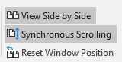

Figure 9: Synchronous Scrolling command

### Split your screen into panes

When you’re working in a really large worksheet, using the split command can be quite helpful, especially if you need to interact with the top, bottom, left, or right side of the screen at the same time. You can split your screen into four panes, so the bottom of the worksheet can be displayed on screen at the same time as the top, and the left side of the worksheet can be displayed at the same time as the right side.

To split your screen into panes:

1. Select the cell where the split is to be located.
2. On the View tab, in the Window group, select Split.
3. Select any pane to activate it, or select the F6 key to activate each pane in sequence.

|  |  |
| --- | --- |
|  | Additional information  To review the article on Split panes, go to: [Split panes to lock rows or columns in separate worksheet areas](https://aka.ms/Split-panes-to-lock-rows-or-columns-in-separate-worksheet-areas) |

### Clear worksheet panes

To clear the worksheet panes, use one of the following methods:

* Double-click on the split lines individually. (If you have four split screens, you can switch to half screens first this way.)
* Select and drag the split lines away to the edge of the worksheet.
* On the View tab, in the Window group, select Split.

### Navigation keyboard shortcuts

As you’ve learned, there are various ways to navigate around a workbook. In Module 1, you used named ranges that already existed in a workbook to navigate, and you also learned about the Go To command. However, Excel also offers simple navigational keyboard shortcuts that you can use, as listed in the following table.

|  |  |
| --- | --- |
| To move: | Select: |
| One cell to the right | ➔ (right arrow key) |
| One cell to the left | ⬅ (left arrow key) |
| One cell up | ⬆ (up arrow key) |
| One cell down | ⬇ (down arrow key) |
| To the right edge of the current area* | Ctrl+➔(right arrow key) |
| To the left-hand edge of the current area* | Ctrl+⬅ (left arrow key) |
| To the top edge of the current area* | Ctrl+⬆ (up arrow key) |
| To the bottom edge of the current area* | Ctrl+⬇ (down arrow key) |
| To the first cell in the row | Home |
| To the end of the row | End |
| To the beginning of the worksheet* | Ctrl+Home |
| To the lowest data entry point on right hand side* | Ctrl+End |
| One screen up | Page Up |
| One screen down | Page Down |
| One screen to the right | Alt+Page Down |
| One screen to the left | Alt+Page Up |
| One cell to the right within a selection | Tab |
| To move: | Select: |
| One cell to the left within a selection | Shift+Tab |
| One cell up within a selection | Shift+Enter |
| One cell down within a selection | Enter |

Table 2: Navigation keyboard shortcuts

* Adding the Shift key to any of the keyboard shortcuts marked with an asterisk will select all the data in that direction, or at least to the first cell or the last cell in that worksheet.

As you work through the lessons and modules in this course try to practice these navigational shortcuts to help you remember them in the future. They will save you time and make working on your data much easier!

|  |  |
| --- | --- |
|  | Additional information  To review the article on Excel shortcut keys, go to: [Keyboard Shortcuts in Excel](https://aka.ms/Keyboard_shortcuts_in_Excel) |

### Activity: Research

When you need help with Excel, it’s important to know how to find it. In this activity you’ll be using the help tools to research changing screen and window views, including arranging windows and splitting worksheet panes.

The teacher will open two workbooks and ask you to gather as much information as possible in 10 minutes about changing the screen view and navigating around workbooks. Consider how to complete the following tasks in your research:

1. Change the screen display to make the data easier to work with, including freezing panes.
2. Display more than one workbook on screen at the same time.
3. Display more than one worksheet from the same workbook on screen at the same time.
4. Split the screen into two or four panes.

#### Resources required

You will need the following resources for this activity:

* Open L3_T1_act_this_year.xlsx in this lesson’s Learning Activity Resources.
* Open L3_T1_act_last_year.xlsx in this lesson’s Learning Activity Resources.

#### Activity instructions

You will need to perform the following steps during this activity:

1. Open both L3_T1_act_this_year.xlsx and L3_T1_act_last_year.xlsx.
2. Use any method available to you to research changing the screen and window views.

### Try-it: Freeze panes and workbook views

In this try-it you’ll help your partner by teaching them at least two different methods to either change the screen or window view, or freeze worksheet titles.

#### Resources

You will need the following resources for this activity:

* Open L3_T1_try_this_year_starter.xlsx in this lesson’s Learning Activity Resources.
* Open L3_T1_try_last_year_starter.xlsx in this lesson’s Learning Activity Resources.

#### Activity instructions

Prepare two or three things you can teach your partner about how to change the screen and window view, and/or how to freeze worksheet titles.

## Topic 2: Use the Quick Access Toolbar

As the name implies, the Quick Access Toolbar is a place for you to quickly access the tools you use most often. Think of this as the expressway for getting your work done.

In this topic you’ll learn how to customize the toolbar so that you can add your favorite or most used tools and commands. This skill will help make your work with Excel much easier. If you have a computer at home, you might decide to customize its toolbar as well!

The Quick Access Toolbar is available in all Office 2019 applications, and comes preset with the default AutoSave, Save, Undo, and Redo commands included. The default location in each Office application—including Excel—is in the upper-left corner of the application, just above the ribbon. You can also move it beneath the ribbon, which will provide more space for more commands and tools to be added!

### Use the ribbon to customize the Quick Access Toolbar

To begin adding commands and features to your Quick Access Toolbar:

1. Navigate to the command you want to add.
2. Right-click or access the context menu for the command, and then select Add to Quick Access Toolbar.

The command shortcut will now display to the right of the default command shortcuts.

### Customize using the Quick Access Toolbar

You can also customize your Quick Access Toolbar from the toolbar itself:

1. Select the Customize Quick Access Toolbar button at the end of the Quick Access Toolbar. Here, the most popular commands are listed on the menu. Commands already pinned to the toolbar have a checkmark next them.

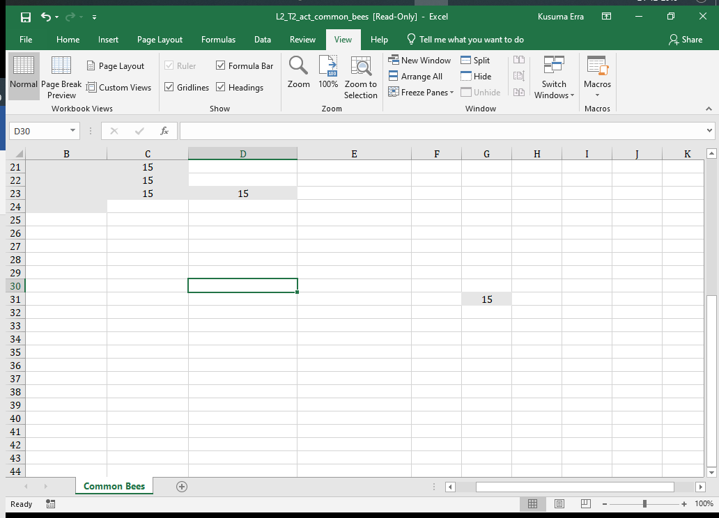

Figure 10: Quick Access Toolbar

1. Select a command to pin it to the toolbar.
2. If the command you need is not listed, at the bottom of the menu select More Commands. This takes you to Excel Options, Quick Access Toolbar customization area.
3. The column on the left displays a list of commands to choose from. However, if the command need does not display:
4. Select the drop-down menu in the Choose commands from field, and then select from one of the options.

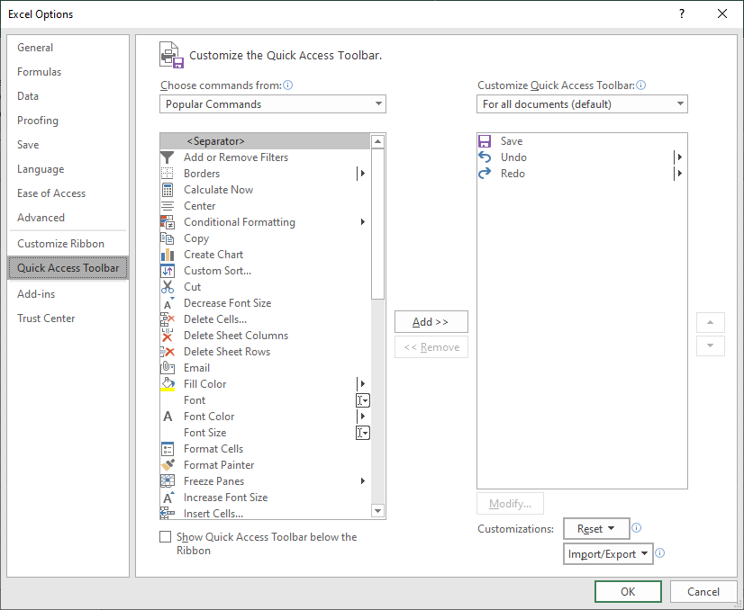

Figure 11: Excel Options - Quick Access Toolbar

1. Select a command, and then select the Add >> button. The command will now display in the Customize Quick Access Toolbar column.
2. To re-arrange the order of the commands on the toolbar from left to right, select a command in the Customize Quick Access Toolbar column, then select the Move up or Move down arrows to position the command. The command at the top will be in the farthest left position of the Quick Access Toolbar continuing one position to the right for each command listed.
3. After you’ve completed your modifications, select OK.

Just as commands on a ribbon are organized in groups, the commands listed in the Quick Access Toolbar can be organized into groups by adding separators. To do that, access the Customize Quick Access Toolbar dialog box (as described above), select <Separator> from the list of commands and then Add >>.

|  |  |
| --- | --- |
|  | Video  To review the video on customizing the Quick Access Toolbar, go to: [Video: Customize the Quick Access Toolbar](https://aka.ms/Customize-the-Quick-Access-Toolbar-Video) |
|  | Additional information  For more information about customizing the Quick Access Toolbar, go to: [Customize the Quick Access Toolbar](https://aka.ms/Customize-the-Quick-Access-Toolbar) |

### Activity: Show and tell

Your teacher will now demonstrate adding buttons to Quick Access Toolbar directly from the ribbon, and from a command’s drop-down arrow. They also will demonstrate how to reposition the Quick Access Toolbar above or below the ribbon.

#### Resources required

You will need the following resource for this activity:

* Open L3_T2_act_common_bees.xlsx in this lesson’s Learning Activity Resources.

#### Activity instructions

You will need to perform the following steps during this activity:

* Open L3_T2_act_common_bees.xlsx and follow the teacher’s instructions.

### Try-it: Quick Access Toolbar

 In this series of leveled try-it activities, you’ll add commands to the Quick Access Toolbar using the Customize Quick Access Toolbar button. You’ll then add commands from More Commands, and move commands to different postions on the Quick Access Toolbar. You’ll learn more advanced Quick Access Toolbar options, such as adding separators to group commands.

### Try-it: 1

In this try-it, you’ll customize the Quick Access Toolbar using the Quick Access Toolbar button.

#### Resources

You will need the following resource for this activity:

* Open L3_T2_try1_common_bees_starter.xlsx or use any other open workbook in this lesson’s Learning Activity Resources.

#### Activity instructions

Participate in the activity by following these instructions:

1. Add the New command to the Quick Access Toolbar using customize Quick Access Toolbar button.
2. Go to More Commands, and add any other command from the Commands not in the Ribbon list.

### Try-it: 2

In this try-it, you’ll customize the Quick Access Toolbar using right-click or accessing the context menu, and via Excel options.

#### Resources

You will need the following resource for this activity:

* Open L3_T2_try2_common_bees_starter.xlsx or use any other open workbook in this lesson’s Learning Activity Resources.

#### Activity instructions

Participate in the activity by following these instructions:

1. Add the Sort button to the Quick Access Toolbar by accessing the Sort context menu (with a right-click).
2. Use the Quick Access Toolbar context menu (right-click) to open Excel options and customize the Quick Access Toolbar.
3. In the Excel options window, from the Choose commands from drop-down menu, select Commands not in the Ribbon, and add at least three extra commands to the Quick Access Toolbar.
4. Move any of the newly added commands up or down the list as necessary to make it easier to find the command later.

### Try-it: 3

In this try-it, you’ll customize the Quick Access Toolbar via Backstage, including adding separators.

#### Resources

You will need the following resource for this activity:

* Open L3_T2_try3_common_bees_starter.xlsx or use any other open workbook this lesson’s Learning Activity Resources.

#### Activity instructions

Participate in the activity by following these instructions:

1. Customize the Quick Access Toolbar via Backstage, adding commands from Commands not in the Ribbon.
2. Add two separators and reorder commands into groups.
3. Right-click or access the context menu to add Spelling, and then Check Accessibility to the Quick Access Toolbar.
4. Via Backstage, add at least three further commands of your choice from Commands not in the Ribbon.
5. Access More Commands again, and add a separator to the Quick Access Toolbar.
6. Add further separators if necessary, and reposition the commands into logical groups.

|  |  |
| --- | --- |
|  | Did you know?  The abbreviation for the Quick Access Toolbar, QAT, is pronounced “cat” in many countries/regions. |

## Wrap-up

In this lesson you learned how to customize the Quick Access Toolbar. Work with your neighbor to find out how to reset your Quick Access Toolbar back to the default settings. When you find out how, reset your Quick Access Toolbar. Help anyone else in the class that has not been able to find out how to do it.

Then use these questions to check what you learned in this lesson:

1. Which of the following statements are true?

Select the correct option.

1. The Quick Access Toolbar can be moved to beneath the ribbon.
2. The Quick Access Toolbar cannot be reset to default settings.
3. The Quick Access Toolbar cannot be moved beneath the ribbon.
4. The Quick Access Toolbar cannot be hidden from view.
5. Instead of removing all the commands you added to the Quick Access Toolbar, you can use the Select here to enter text. tool to set it back to only the default commands.

Fill in the blank space.

1. In the bottom, left corner of the Excel interface, which of the following screen views are not available?

Select the correct option.

1. Print preview
2. Page break preview
3. Page layout
4. Normal
5. To display more than one workbook on the screen at the same time, you would use the Select here to enter text. command.

Fill in the blank space.

# Glossary

|  |  |
| --- | --- |
| Paste Special | A feature that allows you to paste special attributes of a cell, rather than just the contents of a cell. |
| Office Clipboard | The place where copied data is stored for future pasting purposes. It can hold up to 24 copied items from any Microsoft application. |
| Quick Access Toolbar | The Quick Access Toolbar displays above the ribbon by default. It contains the AutoSave, Save, Undo, and Redo commands by default, it can be customized to suit your needs. |
| Quick Access Toolbar button | This is the drop-down arrow on the Quick Access Toolbar that displays the additional commands you can add to it. |
| Freeze panes | A feature that freezes worksheet titles on screen, meaning if you move down or across to the right, the titles will remain on the screen. |
| Arrange all | A feature that allows to you display more than one workbook or worksheet on screen at the same time. |
| Split | A feature that splits your screen into halves or quarters to help you move around large spreadsheets. |

# Cornerstone

## Overview

In this cornerstone, you’ll edit two documents that Fernando, the beekeeper at Munson’s, uses. The documents track the health of beehives across the United States and the population statistics in honeybee colonies. The data has been edited by interns with less Excel experience than you. You need to make the data more presentable and easier to understand when it’s sent as a PDF. One of the documents is a .xlsx file and the other a .csv file. The data contains inconsistent columns and rows, headings are missing, and the data is a little messy.

## Objectives

The following table outlines the Cornerstone objectives and their corresponding MOS exam objectives.

|  |  |
| --- | --- |
| Insert columns and rows | 2.1.3: Insert and delete multiple columns and rows |
| Insert and delete cells | 2.1.4: Insert and delete cells |
| Adjust columns and rows | 1.3.2: Adjust row height and column width |
| Cut, copy, paste, and move data | 2.1.1: Paste data by using special paste options |
| Customize views | 1.4.3: Freeze worksheet rows and columns  1.4.4: Change window views |
| Save in alternate formats | 1.5.2: Save in alternate formats |

Table 3: Cornerstone objectives

### Duration

50 minutes

## Instructions

Complete the tasks for each file:

1. When saving your file, add your name to the end of the original filename, for example, Beehive_Data_Dwayne_Espino.xlsx. Follow your teacher’s directions for where to save your files.
2. When you’ve finished the cornerstone, assess your completed work, and enter the points you think you earned within the following tasks. Ask the teacher for help as needed.

### File 1: Cornerstone_beehive_data_starter.xlsx

#### Task: Delete columns and rows (2 points)

1. Open Cornerstone_beehive_data_starter.xlsx file and examine all four worksheets in the workbook.
2. Remove any unnecessary rows or columns on any worksheet. (2 points) (Exam objective 2.1.4)

Points scored: Select here to enter text./2

#### Task: Paste Special (4 points)

1. Copy the headings from row 1 on the Jan-Mar 19 worksheet. (1 point)
2. Paste the headings into all the other worksheets, and include the column widths. (3 points) (Exam objective 2.1.1)

Points scored: Select here to enter text./4

#### Task: Freeze Panes (2 points)

1. Freeze the heading row at the top of each worksheet. (2 points) (Exam objective 1.4.3)
2. Save the workbook to include your name in the file name.

Points scored: Select here to enter text./2

FILE 1 TOTAL POINTS: Select here to enter text./8

### File 2: Cornerstone_honeybee_colonies_starter.csv

#### Task: Save the file as .xlsx (1 point)

* Open Cornerstone_honeybee_colonies_starter.csv, and save the file as a .xlsx file named Colonies_plus your name. (1 point) (Exam objective 1.5.2)

Points scored: Select here to enter text./1

#### Task: Insert rows (2 points)

1. Insert two rows at the beginning of the worksheet. (1 point) (Exam objective 2.1.3)
2. Enter the text, April to June Statistics in cell A1. (1 point)

Points scored: Select here to enter text./2

#### Task: Zoom (1 point)

* Enlarge or zoom the workbook to 120% to make the data appear larger on the screen. (Exam objective 1.5.2)

Points scored: Select here to enter text./1

#### Task: Rename a worksheet (1 point)

* Rename the worksheet to Colonies_Apr_to_June.

Points scored: Select here to enter text./1

#### Task: Column widths (2 points)

* Set column A to a width of 20 (145 pixels) and set columns from B to H to AutoFit. (1 point) (Exam objective: 1.3.2)

Points scored: Select here to enter text./2

#### Task: Move data (2 points)

* Move the data in column K to three rows beneath the table, into column A (there should be three empty rows between the table and the additional information). (1 point) (Exam objective 2.1.3)

Points scored: Select here to enter text./2

#### Task: Delete cells (1 point)

1. Find the text Virginia and observe that the data is out of line.
2. Fix the data so that the numbers are in the correct position. (1 point) (Exam objective 2.1.4)
3. Save the workbook.

Points scored: Select here to enter text./1

FILE 2 TOTAL POINTS: Select here to enter text./10