

Student Guide

40567A

Microsoft Excel associate 2019

Module 4: Managing tables and range data

# Contents

Contents 2

Module overview 4

Description 4

Scenario 5

Cornerstone 6

Lesson 1: Understanding tables and ranges 7

Overview 7

Warm-up 7

Topic 1: Format data as a table and change the table style 8

Create a table without a style applied 9

Create a table with a style applied at the same time 10

Activity: Tell a story 13

Try-it: Format data as a table and change the table style 14

Try-it 14

Try-it 2 15

Topic 2: Convert a table to a range 15

Activity: Pose a challenge 16

Activity instructions 16

Try-it: Convert a table to a range 16

Wrap-up 17

Lesson 2: Configuring table format options 19

Overview 19

Warm-up 19

[Topic 1: Configure table style   
options 20](#_Toc36983407)

Activity: Discuss and learn 21

Activity instructions 22

[Try-it: Configure table style   
options 22](#_Toc36983410)

Topic 2: Insert and manage rows, columns, and the total number of rows 23

Use the Resize command 23

Enter data 24

Paste data 24

Insert data 25

To insert a column 26

Delete rows or columns in a table 27

Total Row 27

Activity: Discuss and learn 28

[Try-it: Insert and manage rows, columns, and total number of   
rows 29](#_Toc36983420)

Wrap-up 30

Lesson 3: Naming tables and ranges 31

Overview 31

Warm-up 31

Topic 1: Name a table 32

Activity: Pose a challenge 33

Activity instructions 34

Try-it: Name a table 34

Topic 2: Define a named range 35

Edit and delete named ranges 37

Activity: Discuss and learn 38

Try-it: Define a named range 39

Try-it 1 39

Wrap-up 40

Lesson 4: Sorting and filtering 42

Overview 42

Warm-up 42

Topic 1: Sort and filter records 43

Sort a cell range column in ascending or descending order 44

Change the Sort Options Orientation for a data set 44

Sort a table column in ascending or descending order 44

Filter a cell range column 45

Filter a table column 47

Clear a filter from a column 47

Clear all filters in a worksheet 48

Remove all filters in a worksheet 49

Activity: Show and tell 49

Try-it: Sort and filter records 50

Topic 2: Perform a custom sort 50

Sort text 51

Sort numbers 52

Sort dates and times 53

Sort by more than one column 55

[Sort by cell color, font color, or   
icon 56](#_Toc36983454)

Activity: Pose a challenge 57

Activity instructions 57

Try-it: Perform a custom sort 58

Wrap-up 58

Cornerstone 60

Overview 60

Objectives 60

Duration 61

Instructions 61

Tasks 61

[File 1: Cornerstone_Munsons_apparel_  
starter.xlsx 62](#_Toc36983465)

File 2: Cornerstone_Munsons_bee_product_inventory_ starter.xlsx 63

Glossary 64



# Module overview

## Description

Whether your data range is small or gigantic, analyzing data can be a manual and time-consuming process. Knowing how to turn data and a data range into a table makes the process much more efficient; it provides you with options to sort, filter, and perform calculations faster.

In this module, you will turn a data range into a table. You will add a style to the table, change the color of the table borders, add a banded row background color effect, emphasize first or last rows, and include a total row. Along the way, as questions come up about the table data, you will apply a filter or sort to group data in a way that best answers your questions. Some workbooks are large and contain many tables across many worksheets. In this case, you will give a table a name for ease of navigation. In other cases, a table is no longer needed, and you will need to turn it back into a data range.

This module builds on what was covered in the previous one as you applied formatting and structure to cells, columns, rows, and worksheets. Now you will correlate your understanding to similar formatting and structure of tables.

The lessons and learning objectives that will help you acquire these skills are outlined below. Once you are comfortable with these skills, you will get a chance to apply them in a task-based Cornerstone project.

|  |  |  |
| --- | --- | --- |
| Lesson | Learning objective | Exam objective(s) |
| Understanding tables and ranges | * Convert a data range to a table and apply a style | * 3.1.1 * 3.1.2 |
| Configuring table format options | * Manage rows and columns of a table | * 3.2.2 |
| Naming tables and ranges | * Name a table and define a named range | * 2.3.1 * 2.3.2 |

|  |  |  |
| --- | --- | --- |
| Lesson | Learning objective | Exam objective(s) |
| Sorting and filtering | * Sort and filter data range and table records | * 3.2.2 * 3.3.1 * 3.3.2 |
| Cornerstone: Organizing farm merchandise data | * Format data as a table, work with table style options, create a named table, and filter and sort data | * 3.1.1 * 3.1.2 * 3.1.3 * 3.2.1 * 3.2.2 * 3.2.3 * 3.3.1 * 3.3.2 |

Table 1: Objectives by lesson

## Scenario

Munson’s Pickles and Preserves Farm distributes their harvested crops to many local and regional outlets, including grocery stores, restaurants, farmers markets, and their own onsite farm stand.

Distribution data is captured in workbooks, but workbooks are not set up for filtering and sorting the harvest yield, distribution routes, wholesale pricing, retail pricing, and more.

You have been asked to sort out the disorderly data. Your first task is to create the tables that capture information such as harvest yield, distribution locations, wholesale prices, etc. The tables allow you to quickly filter, sort, and find specific information. Because time is precious, and production on the farm doesn’t stand still, you need to get this done quickly.

## Cornerstone

At the end of this module, the cornerstone will help you recall how to manage tables and data.

It’s a task-based project to help you practice the following skills:

* Convert a range of data to a table
* Convert a table to a range
* Modify table settings and options
* Modify a table or range
* Apply sorting to data
* Apply filtering to data

# Lesson 1: Understanding tables and ranges

## Overview

After this lesson, you’ll be proficient in creating and formatting a table created in Excel. You’ll be able to format a range as a table, change a table style, and convert a table to a range.

## Warm-up

In the previous lesson, you learned how to apply worksheet styles to cells and remove formatting from worksheet cells.

In this lesson, you will learn how similar formatting can be applied to a range of cells by formatting these as a table. With the help of the Format as Table and Table commands, you will learn two different processes to accomplish this. The Format as Table command creates a table and applies a style at the same time. However, the Table command creates a table only. A style can be applied later if the user chooses.

You will also learn how to convert a table back to a range.

Get ready for discussions and step-by-step demonstrations, along with opportunities to put to practice what you learn along the way. But first, check how well you know the prerequisite concepts needed to follow this lesson.

Use these questions to find out what you already know about this lesson’s topics:

1. What keyboard shortcut can you use to insert a table?

Select the correct option.

1. Ctrl+T
2. Ctrl+Shift+=
3. Ctrl+Shift+L
4. Ctrl+Shift+-
5. A Select here to enter text. provides the capability to select the arrow in the column header to narrow the data.
6. What option is a unique combination of borders and shading to change the appearance of the table?

Select the correct option.

1. Themes
2. Effects
3. Styles
4. Colors
5. A table can be converted to which of the following?

Select the correct option.

1. Chart
2. PivotTable
3. Data range
4. SmartArt

## Topic 1: Format data as a table and change the table style

 Imagine you have been given an Excel workbook full of popular video game data that has been collected over the past few years. You want to use the data to find answers to some questions you have about your favorite games. Trying to answer these questions by organizing the data can be a time-consuming and manual process. Converting the data into a table gives it structure to help you quickly manage and analyze it.

There are several ways to insert a table.

### Create a table without a style applied

1. Select a cell within your worksheet data range.
2. Select the Insert tab, go to the Tables group, and then select Table.

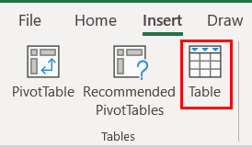

Figure 1: Table command

1. The Create Table dialog box displays. The Where is the data for your table? field displays the range. If changes are needed to the range, select the range of cells in the worksheet or modify the range in the dialog box field.

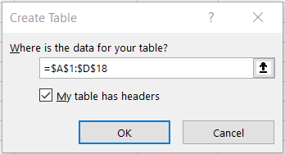

Figure 2: Create Table dialog box

1. Indicate if the table has headers by selecting the My table has headers check box.

Note: By default, a table has a header row. Every table column has filtering enabled in the header row so that you can filter or sort your table data quickly.

1. Select OK.

|  |  |
| --- | --- |
|  | Did you know?  You can insert a table by using the keyboard shortcut Ctrl+T. |

### Create a table with a style applied at the same time

1. Select the cell or the data range.
2. On the Home tab, go to the Styles group, and then select Format as Table.

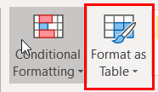

Figure 3: Format as Table command

1. The Styles gallery appears with three categories of styles to choose from: light, medium, and dark.

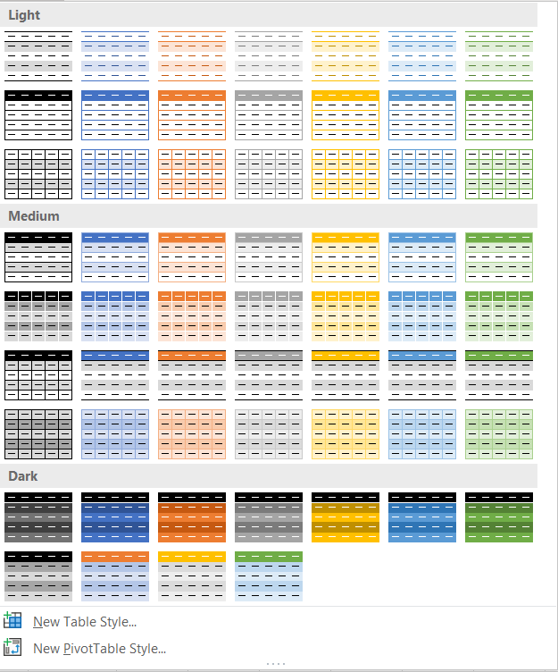  
Figure 4: Format as Table Style Gallery

1. Place the cursor over a style and observe the live preview of this table style applied to the data range.
2. Select a style that is appropriate for the worksheet and overall workbook style. Some companies have specific branding to go with a logo.
3. In the Format as Table dialog box, set the cell range.
4. Indicate whether the table has headers by selecting the My Table has headers check box.
5. Select OK.

|  |  |
| --- | --- |
|  | Video  To review the video on creating a formatting table, go to: [Create a table](https://aka.ms/Video_Create_and_format_tables) |

When a cell in a table is selected, by design, the Table Tools Design contextual ribbon displays. The application indicates a table has been selected, and it presents all the Table commands in one ribbon. This makes it convenient for you to customize table styles, table options, and other formatting quickly.

For now, let’s focus on the Table Styles group.

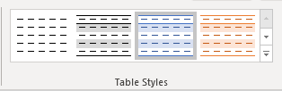

Figure 5: Table Styles group

If the table created doesn’t already have a style applied or you need to change the current style that has been applied, you can select a new style from the Table Styles group; for example, you know your boss dislikes purple and you want to select another color. To change the style:

* Select Row 1 of n button to view the gallery styles row-by-row or select the More button to display the entire gallery at once. Note that the value of n might vary based on the number of rows in your table.
* Select a style to update the table.

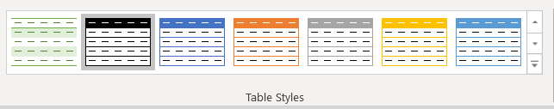

Figure 6: Table Styles gallery

Note when you select a cell outside of the table area, the Design ribbon disappears.

|  |  |
| --- | --- |
|  | Did you know?  Data tables are part of a suite of What-If Analysis commands. Go to: [Calculate multiple results by using a data table](https://aka.ms/calculate-multiple-results-by-using-a-data-table) for more information. |

### Activity: Tell a story

Get ready for a story shared by your teacher about the challenges of organizing data. This activity includes a group discussion and teacher-led demonstration of converting a data range into a table and applying a style. In this activity, your teacher will tell a story to highlight how turning a data range into a table can help with data analysis. You’ll participate in a group discussion on how the process of creating a table with the Table command differs from the Format as Table command.

#### Resources required

You will need the following resources for this activity:

* Open L1_T1_act_crop_distribution_starter.xlsx in this lesson’s Learning Activity Resources.

#### Activity instructions

Participate in the activity by following these instructions:

1. Observe the workbook the teacher has opened.
2. Ask clarifying questions.
3. Answer questions asked by the teacher.
4. Participate in the group discussion.

### Try-it: Format data as a table and change the table style

 Crop harvesting at Munson’s is a fast-paced process. Munson’s does an excellent job of capturing information about when the crop was picked, by what team, and where the crop goes from there through distribution. You need quick ways to get answers to questions such as what fruit was shipped to our community-supported agriculture shareholders last month? For this and other sorting and filtering capabilities, you need to convert the data range into a table and then apply a style.

In this leveled try-it, you will discover how converting a data range into a table helps you organize data quicker and allows for different formats to be applied.

### Try-it

#### Resources

You will need the following resources for this try-it:

* Open the L1_T1_try1_crop_distribution_starter.xlsx file in this lesson’s Learning Activity Resources.
* Select the CSA worksheet.

#### Instructions

The following are the general tasks that you need to perform during this try-it:

1. Navigate to the CSA worksheet.
2. Convert the data range into a table.
3. Select any cell in the data range.
4. Format the data range as a table.
5. Select a style from the Style gallery categories (Light, Medium, or Dark).
6. Don’t forget to save your work!

If you are confident your solution file is complete for this exercise and have time to attempt the next try-it, leave the solution file open. It should be the same as the Try-it 2 starter file.

### Try-it 2

#### Resources

You will need the following resources for this try-it:

* Open the L1_T1_try2_crop_distribution_starter.xlsx file in this lesson’s Learning Activity Resources.

#### Instructions

The following are the general tasks that you need to perform during this try-it:

1. Navigate to the Processing worksheet.
2. Convert the data range, cells A1 to F21, into a table.
3. Select any cell in the data range.
4. Insert a table.
5. Apply a style from the Styles gallery categories (Light, Medium, or Dark).
6. Don’t forget to save your work!

## Topic 2: Convert a table to a range

Sometimes a table is no longer needed to represent groups of data in a meaningful way. While working on a group project, you might have inherited an Excel table that your team member has created. You like the style formatting that was applied to the table but just need a range that can still be sorted and filtered. You can convert a table back to a range of data while retaining the table style without the table functionality.

To convert a table to a range of data:

1. Select any cell in the table, go to the Table Tools Design ribbon, and then select Tools group.
2. Select Convert to Range. Alternatively, right-click or access the context menu, and then from the context menu, select Table > Convert to Range.

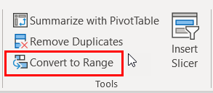

Figure 7: Convert to Range command

Note table features are no longer available. The row headers no longer include the sort and filter arrows.

### Activity: Pose a challenge

The teacher poses a challenge to you: find a way to take the table created in the last topic activity and convert it back to a range. You’ll participate in a group discussion to examine the options for converting a table back to a range. You’ll then follow the teacher in a teacher-led demonstration.

#### Resources required

You will need the following resources for this activity:

* Open the L1_T2_act_crop_distribution_starter.xlsx file.

### Activity instructions

1. Go to the Crop_Sourcing worksheet.
2. Work with a fellow student to figure out how to convert the Crop Sourcing table back to a data range.
3. Here are some clues to get help with this challenge:
   * Observe the available table ribbon commands.
   * Enter keywords, such as convert range, in the Tell me what you want to do field.
   * Use the F1 key to get help or go to the File tab and select Help (question mark icon).
   * Ask the teacher or other students questions for additional help.

### Try-it: Convert a table to a range

 While working on your group project, you discover that you no longer need the table format for the data, but you want to keep the style of the table. You need to convert the table back to a range.

In this stand-alone try-it, you will apply your learning and see for yourself how you can convert a table back to a range.

#### Resources

You will need the following resources for this try-it:

* Open the L1_T2_try_crop_distribution_starter.xlsx file in this lesson’s Learning Activity Resources.

#### Instructions

The following are the general tasks that you need to perform during this try-it:

1. Go to the Processing worksheet.
2. Convert the table to a range.
3. Don’t forget to save your work!

## Wrap-up

In the previous lesson, you learned how to apply styles to worksheet cells and remove formatting from worksheet cells. This lesson relates how similar formatting can be applied to a range of cells by formatting these as a table. With the help of the Format as Table and Table commands, you learned about two different processes to accomplish this. The Format as Table command creates a table and applies a style at the same time. The Table command creates a table only, and a style can be applied later.

You also learned that when a table is no longer needed, it can be converted back to a range with the help of the Convert to Range command within the Table Tools Design ribbon.

All the tools you learned in this lesson can help you quickly create a table and go back to a range as needed.

Use these questions to check what you learned in this lesson:

1. Which command creates a table and simultaneously applies a table style?

Select the correct option.

1. Insert Table
2. Data Table
3. Format as Table
4. From Table/Range
5. Which ribbon tab contextually appears when a cell in a table is selected?

Select the correct option.

1. Format
2. Analyze
3. Design
4. View
5. Which of the following options are table style categories?

Select all that apply.

1. Light
2. Standard
3. Dark
4. Custom
5. A Select here to enter text. row is automatically included by default when a table is inserted.

# Lesson 2: Configuring table format options

## Overview

In this lesson, you will configure table options, including inserting a header row, table rows, table columns, and a table total row, adding a banded row effect, and removing rows and columns.

## Warm-up

In the previous lesson, you learned how to create a table from a range and how to convert a table back to a range. This was a great start to working with ranges and tables.

In this lesson, you will learn how to configure table format options and insert and manage rows, columns, and a total row.

Get ready for discussions and step-by-step demonstrations, along with opportunities to put to practice what you learn along the way. But first, check how well you know the prerequisite concepts needed to follow this lesson.

Use these questions to find out what you already know about this lesson’s topics:

1. What are the steps you need to take to turn the Filter button on or off?

Select all that apply.

1. Go to the Design tab, Table Styles Options group, and then select/clear the Filter button.
2. Go to the Home tab, Editing group, Sort & Filter, and then select Filter.
3. Go to the Data tab, Sort & Filter group, and then select Filter.
4. With a table cell selected, right-click or access the context menu, select Filter, and then select either Clear Filter from, or Reapply.
5. Which table row calculates numeric data by using functions?

Select the correct option.

1. Header row
2. Total row
3. Banded row
4. Footer row
5. Select here to enter text. are even rows that are formatted differently than odd rows.
6. The command Select here to enter text. provides a way to select additional rows and columns to include in an existing table.

## Topic 1: Configure table style options

 In the previous lesson, you learned how to quickly create a table with a predefined table style.

Sometimes a predefined style isn’t enough. Imagine you have a table that tracks all the school fundraisers, including the name of the fundraiser, which school club ran it, fundraiser date, and how much money each one made. You need to emphasize the money column. With the Style Options group of commands, you can adjust options for table elements. Selecting the Last Column box in the Table Styles Options group of the Table Tools Design ribbon makes the money column (last column) bold. Other table elements such as Header and Total Rows, First Column, Banded Rows and Columns, as well as Auto Filtering can be enabled or disabled as well.

To choose table style options to format the table elements:

1. Select any cell in the table.
2. Go to the Table Tools Design ribbon, Table Style Options group, then select or clear any of the options (option descriptions are below the figure).

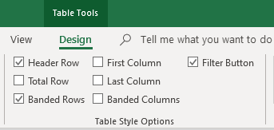

Figure 8: Table Style Options

* + Header Row—Apply or remove formatting from the first row in the table.
  + Total Row—Quickly add SUBTOTAL functions such as SUM, AVERAGE, COUNT, MIN/MAX to your table from a drop-down selection. SUBTOTAL functions allow you to include or ignore hidden rows in calculations.
  + First Column—Apply or remove formatting from the first column in the table.
  + Last Column—Apply or remove formatting from the last column in the table.
  + Banded Rows—Display odd and even rows with alternating shading for ease of reading.
  + Banded Columns—Display odd and even columns with alternating shading for ease of reading.
  + Filter Button—Toggle AutoFilter on and off.

### Activity: Discuss and learn

This is a teacher-led demonstration that reflects on prior learning of creating a table and the contextual ribbon that appears to help customize the table design options and settings. You’ll participate in a group discussion about enabling and disabling Table Style Options and how each option works.

#### Resources required

You will need the following resources for this activity:

* Open L2_T1_act_crop_distribution_starter.xlsx

### Activity instructions

Participate in the activity by following these instructions:

1. You and your teacher will open the same L2_T1_act_crop_distribution_starter.xlsx starter file and examine the table formatting in the Crop_Sourcing worksheet.
2. Your teacher will also demonstrate how to make Table Style Option changes and lead a group discussion.

### Try-it: Configure table style options

In this stand-alone try-it, you will apply your learning and see for yourself how you can apply style options to an existing table.

#### Resources

You will need the following resources for this try-it:

* Open L2_T1_try_crop_distribution_starter.xlsx in this lesson’s Learning Activity Resources.

#### Instructions

The following are the general tasks that you need to perform during this try-it:

1. Go to the Processing worksheet.
2. Select any cell within the table.
3. Enable the table header row.
4. Observe the filters in the header row.
5. Emphasize the first column of the table.
6. Observe the formatting change for the first column.
7. Emphasize the last column of the table.
8. Observe the formatting change for the last column.
9. Save your work.

## Topic 2: Insert and manage rows, columns, and the total number of rows

 After you create an Excel table, you can add or remove rows and columns by using different methods, which include:

* Using the Resize command
* Entering text or numbers in a cell just below the last row or to the right of the last column
* Pasting data into a cell
* Inserting rows or columns between existing rows or columns

### Use the Resize command

1. Select any cell within a table in an Excel worksheet.
2. Go to the Table Tools Design ribbon, the Properties group, and then select Resize Table.

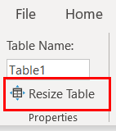

Figure 9: Resize Table command

1. Select the range you want to include, starting with the upper left-most cell.
2. In the following example, the original table includes the range, A1:G4.

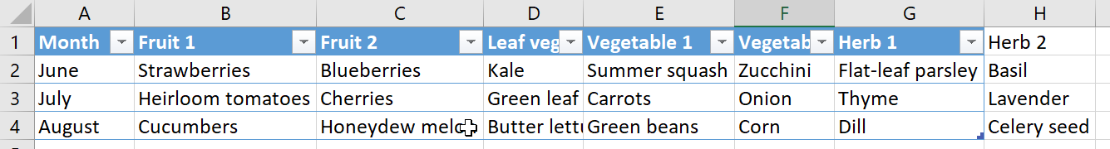

Figure 10: Original table

* + After resizing to add additional columns and rows, the table includes the range, A1:H4.

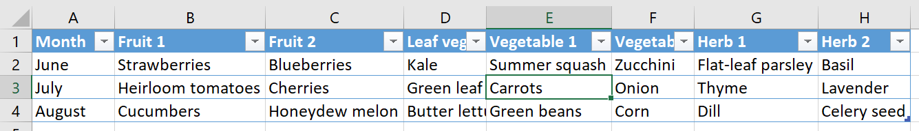

Figure 11: Updated table

### Enter data

* To add a row to a table, start entering data in a cell below the last table row. The table expands to include the new row.
* To add a column to the right of the table, start entering text or numbers in a cell to the right of the last column.

### Paste data

* To add a row, paste the data in the left-most cell below the last table row.
* To add a column, paste the data to the right of the table’s right-most column.
* If the data pasted has as many or fewer columns than the table, the table expands to include all the cells in the range pasted.
* If the data pasted has more columns than the table, the extra columns are not included as part of the table. You will need to use the Resize command to expand the table to include the data.

### Insert data

To insert a row:

1. Pick any cell that is not part of the header row and right-click or access the context menu.
2. Select Insert, and then select Table Rows Above.

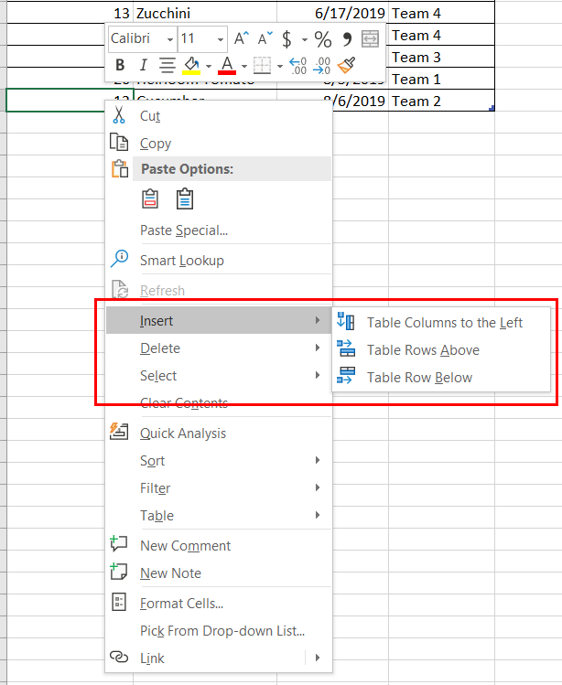

Figure 12: Context menu—Insert Table Row command

Note: If the selection is in the last row, Table Rows Above or Table Rows Below can be selected.

### To insert a column

1. Pick any cell in the table and right-click or access the context menu.
2. Select Insert, and then select Table Columns to the Left.

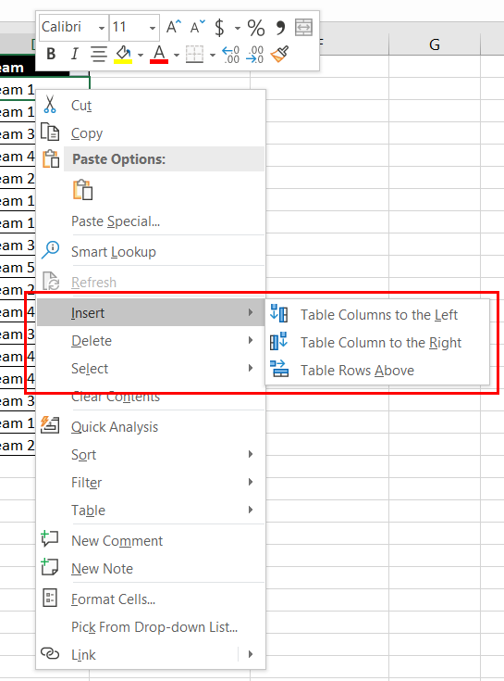

Figure 13: Insert a column

### Delete rows or columns in a table

Table rows and columns can be deleted from the Home ribbon or the right-click context menu.

#### From the Home ribbon

1. Select the table rows or table columns.
2. Go to the Home ribbon, Cells group, and select the arrow next to the Delete command. Then, select Delete Table Rows or Delete Table Columns.

#### Right-click context menu

1. Select the table rows or table columns.
2. Right-click or access the context menu, and then select Table Columns or Table Rows.

### Total Row

A Total Row can be displayed at the end of the table. By default, it uses the SUBTOTAL function to display a total of the numeric data in a column. Instead of manually inserting a formula or function to calculate ticket sales for a school play or sports game, by checking the Total Row box in the Style Options group, Excel quickly calculates the total for you. In the last topic, you applied style options to a table such as a header row, banded rows and columns, and a filter button. Another command called Total Row is also a command that is part of the Table Style Options.

|  |  |
| --- | --- |
|  | Video  To review the video on how to total numeric data in a table, go to: [Add a total row to a table](https://aka.ms/Video_Total_the_data_in_and_Excel_table) |

To enable a total row at the end of a table:

1. Select a cell within the table.
2. Go to the Design Table Tools ribbon, the Table Style Options group, and select the Total Row box.
3. The Total Row is inserted at the bottom of the table.
4. The default Total Row setting uses the SUBTOTAL function for SUM. This is a Structured Reference formula and is exclusive to Excel tables. You can also apply a different function to the total value by selecting the More Functions option or by writing your own.

|  |  |  |
| --- | --- | --- |
|  | Additional information  To expand your learning, discover how to use structured references in tables by going to: [Using structured references with Excel tables](https://aka.ms/using-structured-references-with-excel-tables) | |
|  | | Did you know?  There is a keyboard shortcut for the Total Row command.  Use the Ctrl+Shift+T keyboard shortcut to add a total row at the bottom of a table. |

### Activity: Discuss and learn

This is a teacher-led group discussion and demonstration building on learning from a previous topic about how to insert and delete columns and rows in a data range. Students will be able to compare what they previously learned about working with data ranges with the process of inserting and deleting columns, rows, and a total row in a table.

#### Resources required

You will need the following resources for this activity:

* Open L2_T2_act_crop_distribution_starter.xlsx in this lesson’s Learning Activity Resources.

#### Activity instructions

Participate in the activity by following these instructions.

Your teacher will project a workbook that contains a data range and a table and will ask for your help with adding and removing columns and rows.

1. Examine the workbook data range and table.
2. When asked by the teacher, suggest how to add columns, rows, and a total row.
3. When asked by the teacher, suggest how to remove columns and rows.

### Try-it: Insert and manage rows, columns, and total number of rows

A Munson’s colleague has updated the Processing worksheet to include row totals for each crop item. You need to insert a column for notes and include a total row to display the average total.

#### Resources

You will need the following resources for this try-it:

* Open L2_T2_try_crop_distribution_starter.xlsx in this lesson’s Learning Activity Resources.

#### Instructions

The following are the general tasks that you need to perform during this try-it:

1. Go to the Processing worksheet.
2. Select cell E2.
3. Insert a table column to the left.
4. Observe the table. The new column has been inserted.
5. In cell E1, replace the text, Column1, with Notes.
6. Add a total row to the table.
7. Observe the table. A total row has been added in Column H.
8. Change the table total to display an average total.
9. Now you have a total row with the average displayed for all numeric values in the Total column displayed.
10. Don’t forget to save your work!

## Wrap-up

In the previous lesson, you learned how to create a table from a range and how to convert a table back to a range. This was a great start to working with ranges and tables.

In this lesson, you learned how to configure table format options and insert and manage rows, columns, and a total row.

All the tools you learned in this lesson can help you quickly apply formatting to a variety of table layouts.

Use these questions to check what you learned in this lesson:

1. What keyboard shortcut can you use to turn on or turn off a Total Row at the end of the table?

Select the correct option.

1. Ctrl+F
2. Ctrl+Shift+T
3. Ctrl+Shift+F
4. Ctrl+T
5. On which tab can you find the Insert Sheet Columns and Insert Sheet Rows commands?

Select the correct option.

1. Page Layout
2. Insert
3. Home
4. View
5. The Select here to enter text. check box displays special formatting for the first column of the table.
6. Select here to enter text. are even columns formatted differently than odd columns.

# Lesson 3: Naming tables and ranges

## Overview

In this lesson, you will give ranges and tables unique names, making it easier for navigation and referencing within a workbook.

## Warm-up

In the previous lesson, you learned how to configure table format options.

In this lesson, you will learn how to change the default name assigned to a table to something more meaningful to the data included. You will also learn how to name a range of cells.

Use these questions to find out what you already know about this lesson’s topics:

1. A range can be named in the Name Box.

Select the correct option.

1. True
2. False
3. Which of the following options cannot be part of a range name?

Select the correct option.

1. Space
2. Number
3. Period
4. Underscore
5. What is the default name for a new table?

Select the correct option.

1. Table_1
2. Table 1
3. Table.1
4. Table1
5. A table name can have up to Select here to enter text. characters.

## Topic 1: Name a table

 You may recall from earlier lessons that each time you create a new workbook, Excel assigns a default name to the workbook according to this naming convention: Book1, Book2, Book3, and so on.

When a new worksheet is added to a workbook, Excel assigns a default name to the worksheet according to this naming convention: Sheet1, Sheet2, Sheet3, and so on.

A newly added table is no different. Each time you create a table, Excel assigns a default name to the table according to this naming convention: Table1, Table2, Table3, and so on.

Let’s say you have a workbook that tracks how much money you make with a part-time job. Sheet1 or Table1 doesn’t help you understand which month’s pay it is. Naming it January or January_Pay can make a big difference!

As the previous example illustrated, to make it easier for reference purposes, you can change a table name to something more meaningful as it applies to the table data.

Before you rename a table, here are the rules you must follow:

* Use valid characters. Always begin a name with a letter; an underscore character (_); or a backslash (\). Use letters, numbers, periods, and underscore characters for the rest of the name.

Exceptions: You can’t use “C”, “c”, “R”, or “r” for the name, because they’re already designated as a shortcut for selecting the column or row for the active cell when you enter them in the Name or Go To box.

* Don’t use cell references. Names can’t be the same as a cell reference, such as Z$100 or R1C1.
* Don’t use a space to separate words. Spaces cannot be used in the name. Consider how you can write the name using no spaces. You might also use an underscore character (_) or a period (.) as word separators; for example, DeptSales, Sales_Tax, or First.Quarter.
* Use a maximum of 255 characters. A table name can only have up to 255 characters.
* Use unique table names. Duplicate names aren’t allowed. Excel doesn’t distinguish between uppercase and lowercase characters in names, so if you enter “Sales” but already have another name called “SALES” in the same workbook, you’ll be prompted to choose a unique name.

To rename a table:

1. Select a cell within the table.
2. Go to the Table Design > Design ribbon, Properties group, Table Name field.
3. Enter a new name.

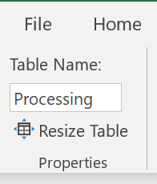

Figure 14: Table Name field

|  |  |
| --- | --- |
|  | Did you know?  Table names appear in the Name Box.  Select the Name Box arrow in the Name Box field (next to the Formula Bar) to see a list of all named tables in the workbook. Select any table from the list, and Excel will take you directly to that table, even if it’s on another worksheet. |

### Activity: Pose a challenge

The teacher will pose a challenge to you to brainstorm/predict strategies for solving the table name challenge. You’ll pair up with another student and try to solve the challenge.

Your teacher will then lead a demonstration of how to name a table by using the Table Name field and will lead a group discussion.

#### Resources required

You will need the following resources for this activity:

* Open L3_T1_act_crop_distribution_starter.xlsx in this lesson’s Learning Activity Resources.

### Activity instructions

The teacher will lead a discussion about naming tables. Participate in the activity by following these instructions:

1. Listen to the instructions given by the teacher.
2. Apply critical thinking to find possible solutions to the challenge.
3. Share your solutions with the class.

### Try-it: Name a table

 The Crop_Distribution workbook will be shared with many colleagues at Munson’s once it's finalized. You realize the table you have been working with has the default name, Table3. You need to rename the table to something that more closely represents the data it contains. This will surely help everyone find and work with the table much quicker!

#### Resources

You will need the following resources for this try-it:

* Open L3_T1_try_crop_distribution_starter.xlsx in this lesson’s Learning Activity Resources.

#### Instructions

The following are the general tasks that you need to perform during this try-it:

1. Go to the Processing worksheet table.
2. Select a cell within the table.
3. Replace the current name, Table2, with ProcessedOrders.
4. Observe the named tables including the updated table name you just changed, ProcessedOrders.
5. Don’t forget to save your work!

## Topic 2: Define a named range

In the previous topic, you named a table. You can also name a range of cells. Naming a range can be useful for quickly navigating to the range from the Name Box or Go To command. It can also help simplify the process of referencing cells in a formula.

* There are a several ways to name a range of cells. Before you try naming a range, here are the naming rules you must follow:
  + Use valid characters. Always begin a name with a letter; an underscore character (_); or a backslash (\). Use letters, numbers, periods, and underscore characters for the rest of the name.

Exceptions: You can’t use “C”, “c”, “R”, or “r” for the name, because they’re already designated as a shortcut for selecting the column or row for the active cell when you enter them in the Name or Go To box.

* + Don’t use cell references. Names can’t be the same as a cell reference, such as Z$100 or R1C1.
  + Don’t use a space to separate words. Spaces cannot be used in the name. Consider how you can write the name using no spaces. You might also use an underscore character (_) or a period (.) as word separators; for example, DeptSales, Sales_Tax or First. Quarter.
  + Use a maximum of 255 characters. A range name can only have up to 255 characters.
  + Use unique range names. Duplicate names aren’t allowed. Excel doesn’t distinguish between uppercase and lowercase characters in names, so if you enter “Sales” but already have another name called “SALES” in the same workbook, you’ll be prompted to choose a unique name.
* There are several different commands you can use to name a range. Let’s start with the Name Box.

Name a range with the Name Box:

1. Select the range you want to name.
2. Select the Name Box.
3. Type or input a name and press Enter.

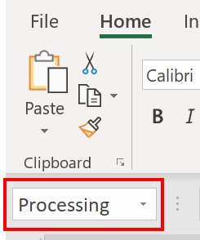

Figure 15: Name Box field

* Next, let’s work with the Create from Selection command.

Name a range with the Create from Selection command:

1. Select the range you want to name, including the row or column labels.
2. Select the Formulas ribbon, Defined Names, and then select Create from Selection.
3. In the Create Names from Selection dialog box, select the check boxes depending on the location of your row/column header.
4. If you have only a header row at the top of the table, just select Top row.
5. If you have a top row and left column header, select Top row and Left column options, and so on.
6. Select OK.
7. Names are automatically selected and applied based on the column or row labels.

* The Define Name command is another way to give a range a name.

Name a range with Define Name:

1. Select the range you want to name.
2. Go to the Formulas tab, Defined Names group, and select Define Name. Alternatively, right-click or access the context menu, and select Define Name.
3. In the New Name dialog box, Name field, enter a name.
4. The Scope field is set to Workbook by default. This means the named range is accessible from a worksheet of the workbook. If it only needs to be accessible from a specific worksheet, select the arrow, and from the drop-down list select the name of the worksheet.
5. Add an optional comment about this range in the Comment field.
6. The Refer to field displays the worksheet and range specified. If the range needs to be updated, select this field.
7. Enter text or numbers in the field or select new cells to update.
8. If the New Name dialog box is in the way of the range, select the arrow within this field to collapse the dialog box.
9. Select the arrow again to expand the dialog box.
10. Select OK.

* The Name Manager command is one other method to create a named range.

Define a range name with the Name Manager:

1. Select the range you want to name.
2. Go to the Formulas tab, Defined Names group, and select Name Manager.
3. In the New Name dialog box, in the Name field, type or input a name.
4. The Scope field is set to Workbook by default. This means the named range is accessible from a worksheet of the workbook. If it only needs to be accessible from a specific worksheet, select the arrow, and from the drop-down list select the name of the worksheet.
5. Add an optional comment about this range in the Comment field.
6. The Refer to field displays the worksheet and range specified. If the range needs to be updated, select this field. Enter the cell references in the field or select new cells to update. If the New Name dialog box is in the way of the range, select the arrow within this field to collapse the dialog box. Then select the arrow again to expand the dialog box.
7. Select OK.

### Edit and delete named ranges

* Named ranges cannot be managed through the Name Box area. If a named range needs to be updated or deleted, use the Name Manager command.

To edit a named range:

1. Go to the Formulas tab, select the Defined Names group, and select Name Manager.
2. In the Name Manager dialog box, select the named range from the list.
3. Select the Edit button.
4. Make the necessary changes to the Name, Scope, Comment, and Refers To fields.
5. Select OK.
6. Select Close.

* Here’s how to delete a named range:

1. Go to the Formulas tab, select the Defined Names group, and select Name Manager.
2. In the Name Manager dialog box, select the named range from the list.
3. Select the Delete button.
4. A question displays asking if you are sure you want to delete the named range. Select OK.
5. Select OK again.
6. Select Close.

|  |  |
| --- | --- |
|  | Additional information  For more information on inserting a named range in a formula, go to: [Insert a named range into a formula in Excel](https://aka.ms/insert-a-named-range-into-a-formula-in-excel) |
|  | Video   * Use the Video quick part if you are inserting videos. * Use the following boilerplate text to introduce a link/video:   To review the video on defining and using names in formulas, go to: [Define and use names in formulas](https://aka.ms/Define_and_use_names_in_formulas) |

### Activity: Discuss and learn

This is a teacher-led demonstration and group discussion to help you build on the previous learning about naming a table and how naming cell ranges has a similar process and naming convention.

#### Resources required

You will need the following resources for this activity:

* Open L3_T2_act_crop_distribution_starter.xlsx in this lesson’s Learning Activity Resources.

#### Activity instructions

Your teacher will demonstrate how to name a table with the Table Name field and name a range of cells with the Name Box field, Create from Selection command, Define Name command, and Name Manager command. You will also observe how to edit and delete named ranges with the Name Manager command.

Participate in the activity by following these instructions:

1. Open the Crop_Distribution workbook.
2. Get familiar with the workbook contents, worksheets, and named areas: tables, cells, and cell ranges.
3. Observe the demonstration and discussion of renaming a table led by the teacher.
4. Participate in the group discussion.

## Try-it: Define a named range

 You have a table that has been converted to a range. You want to make it easier for everyone working with this data range in the future by naming the range. You need to apply a descriptive name to the range.

### Try-it 1

In this stand-alone try-it, you will apply a name to a range of cells.

#### Resources

You will need the following resources for this try-it:

* Open L3_T2_try_crop_distribution_starter.xlsx in this lesson’s Learning Activity Resources.

#### Instructions

The following are the general tasks that you need to perform during this try-it:

1. Go to the Processing worksheet.
2. Select the cell range A2:G21.
3. Name the range: ProcessedOrders.
4. Go to another worksheet within the Crop_Distribution workbook.
5. Observe the named ranges and named tables.
6. Select ProcessedOrders from the list.
7. Observe the area it takes you to and that is selected.
8. Don’t forget to save your work!

## Wrap-up

In the previous lesson, you learned how to configure table format options and insert and manage rows, columns, and a total row.

In this lesson, you learned how to update the name of a table to something more meaningful for the data it represents. You also learned how to give a range of cells a meaningful name. Giving tables and ranges of cells names can help workbook readers quickly navigate to the associated data. Named ranges can also be used in formulas.

Use these questions to check what you learned in this lesson:

1. Which of the following fields create a named range?

Select all that apply.

1. Name Box
2. Create from Selection
3. Define Name
4. Name Manager
5. You can name a range with a right-click or using the context menu.

Select the correct option.

1. True
2. False
3. The Select here to enter text. command is where a named range can be created, edited, and deleted.
4. You can access a table from which of the following areas?

Select all that apply.

1. Find
2. Name Box
3. Go To
4. Selection Pane

# Lesson 4: Sorting and filtering

## Overview

In this lesson you will sort and filter records in a data range and table.

## Warm-up

In the previous lesson, you learned how to update a table name and name a range of cells. In this lesson, you will learn how to sort and filter data in cell ranges and tables.

Use these questions to find out what you already know about this lesson’s topics:

1. Which command displays data in an alphabetized or numerical order?

Select the correct option.

1. Filter
2. Sort
3. Replace
4. Arrange All
5. Which command provides a way to sort with multiple levels?

Select the correct option.

1. Custom Sort
2. Sort A to Z
3. Sort Z to A
4. Sort Smallest to Largest
5. Sort Largest to Smallest
6. A filter based on cell color can be applied to a column.

Select the correct option.

1. True
2. False
3. A Select here to enter text. is created to sort by any other characteristic that doesn’t sort well alphabetically.

## Topic 1: Sort and filter records

You’re a farmer, and you sell honey at the local farmers market. Well, you didn’t sell the honey in the past, but your enterprising daughter did before she went off to college. Now that you are doing it, you’ve been trying to organize everything. After entering all the sales receipts into an Excel spreadsheet, you see that there is no organization to the sales. You’d like to sort the receipts in a variety of ways. First, you’d like to sort these by honey categories—wildflower, orange blossom, and clover—to understand which varieties are the favorites among the local community. Next, you’d like to filter transactions with multiple sales in chronological order to determine changes to the upcoming sales promotions that you have to approve.

What do you do? Sort and filter.

Depending on the data arrangement orientation, you can sort columns or rows to display text such as names or companies in alphabetical order or numbers from largest to smallest.

There may be times that sorting isn’t enough; there’s just too much data in the worksheet to figure out the answers to the questions you have about the data. For this or similar situations, filtering can help. You can choose which data to temporarily hide for a column or multiple columns.

Sorting options depend on the contents of the column or row selected. If it contains a text string, the sorting options will be A to Z (ascending order) or Z to A (descending order). If it contains a numeric string, the sorting options will be smallest to largest number or largest to smallest number.

While cell range and table columns and rows have the same sort and filter capabilities (also called AutoFilter) and the process is similar, it’s worth going over the steps for each.

### Sort a cell range column in ascending or descending order

1. Select a cell in the column you want to sort.
2. Right-click or access from the context menu, select Sort, and then:
3. To sort an alpha text string, select Sort A to Z or Sort Z to A. You may also go to the Home ribbon, Editing group, select Sort & Filter, and select Sort A to Z or Sort Z to A.
4. To sort a numeric string, select Sort Smallest to Largest or Sort Largest to Smallest. You may also go to the Home ribbon, Editing group, select Sort & Filter and Sort Smallest to Largest or Sort Largest to Smallest.

Note: When a column is sorted, the related information in the other columns moves as well.

### Change the Sort Options Orientation for a data set

Most data sets are arranged in a column layout with labels defining the information in each column. For this reason, the default setting for sorting orientation is to sort top to bottom. If the data set you are working with is a row labeled layout, you will need to change the Sort Options Orientation.

1. Go to the Home ribbon, Editing group.
2. Select Sort & Filter, and then select Custom Sort.
3. In the Sort Options dialog box Orientation section, select the Sort left to right option.
4. Select OK.

### Sort a table column in ascending or descending order

1. Locate the Filter command next to the column label you want to sort. If the Filter command is not present, go to the Table Tools Design ribbon, Table Style Options group, and check the Filter Button box.
2. Select the Filter command. From the context menu, if sorting text, select Sort A to Z or Sort Z to A. If sorting numbers, select Sort Smallest to Largest or Sort Largest to Smallest.

|  |  |  |
| --- | --- | --- |
|  | | Did you know?   * If fill colors have been applied to cells, sort by color can also be selected.   When a table column is sorted, the related information in the other columns moves as well. If fill colors have been applied to cells, the sort by color option can be selected. |
|  | Additional information  For more information about sorting and filtering data by color, go to: [Guidelines and examples for sorting and filtering data by color](https://aka.ms/Guidelines-and-examples-for-sorting-and-filtering-data-by-color) | |

### Filter a cell range column

1. Select a cell within the range.
2. Locate the column you want to sort. If the Filter option is not available in the column header row, go to the Table Tools Design ribbon, the Table Style Options group, and then select the Filter box.
3. Select the column Filter command.
4. Select Text Filters or Number Filters, and then select a comparison like Between.

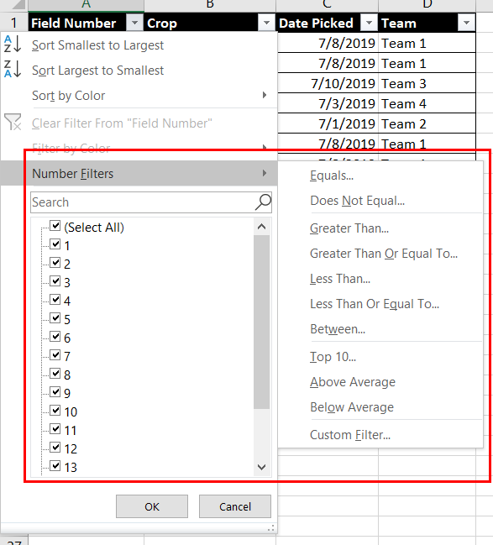

Figure 16: Table Number Filters context menu

1. Enter the filter criteria and select OK.

|  |  |
| --- | --- |
|  | Video  To review the video on sorting and filtering records, go to: [Sorting and filtering data](https://aka.ms/Video_sorting_and_filtering_data) |

### Filter a table column

When you put your data in a table, filter controls are automatically added to the table headers.

1. Select the column Filter option from the column you want to filter. If someone working in the table has previously turned the filter off, go to the Table Tools Design ribbon, the Table Style Options group, and select the Filter box.
2. Clear (Select All) and select the boxes you want to show.
3. Select OK.
4. The column Filter command icon changes, indicating that not all data is displayed in this column. Select this icon to change or clear the filter.

|  |  |
| --- | --- |
|  | Video  To review the video on filtering data go to: [Filter data in a range or table](https://aka.ms/Video_filter_data_in_a_range_or_table) |

### Clear a filter from a column

Select the Filter button next to the column header, and then select Clear Filter from the context menu<column name>.

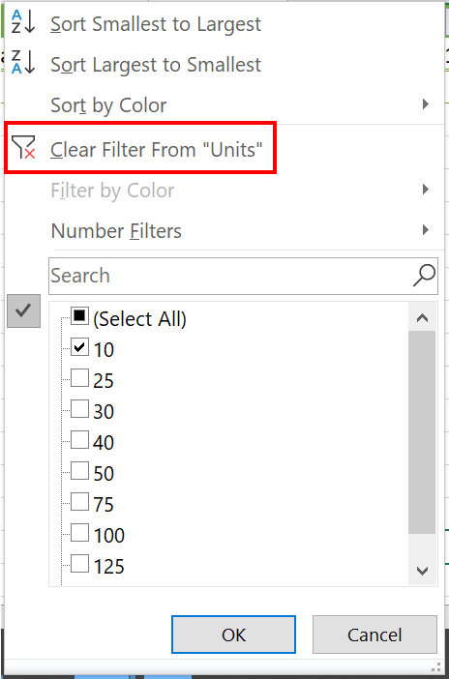

Figure 17: Clear Filter command

### Clear all filters in a worksheet

Navigate to the Data tab and then select Clear.

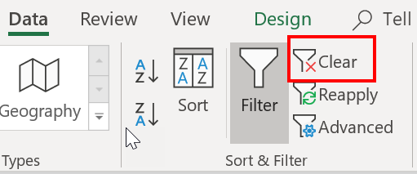

Figure 18: Clear command

### Remove all filters in a worksheet

If you want to completely remove filters, go to the Data tab, and then select the Filter button, or use the keyboard shortcut Alt+D+F+F.

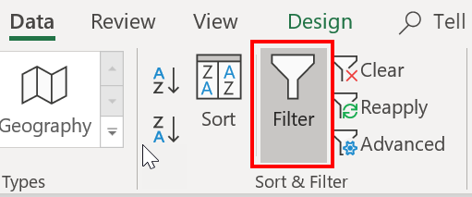

Figure 19: Filter command

### Activity: Show and tell

Your teacher will lead a quick demonstration of how to sort and filter a data range and a table. This will help you understand the similarities for the sort and filter processes as well as how the outcomes differ slightly.

You will then write a letter to an absent friend explaining why someone might use sort and filter and also the steps to use sort and filter.

#### Resources required

You will need the following resources for this activity:

* Open L4_T1_act_crop_distribution_starter.xlsx in this lesson’s Learning Activity Resources.

#### Activity instructions

This is a teacher-led demonstration and discussion of how to sort and filter a data range and table.

Participate in the activity by following these instructions:

1. Observe the demonstration.
2. Participate in the class discussion.
3. Write your letter explaining why someone might use sort and filter.

### Try-it: Sort and filter records

 Your boss at Munson’s has asked about orders placed by Liberty’s Delightful Sinful Bakery & Café. You need to filter the Processing_Range worksheet to only display orders from this buyer.

In this stand-alone try-it, you will work with a partner to sort and filter data in a table.

#### Resources

You will need the following resources for this try-it:

* Open L4_T1_try_crop_distribution_starter.xlsx in this lesson’s Learning Activity Resources.

#### Instructions

The following are the general tasks that you need to perform during this try-it:

1. Go to the Processing worksheet.
2. Sort the Crop column in A to Z order.
3. Filter the Buyer column to display Liberty’s Delightful Sinful Bakery & Café only.
4. Don’t forget to save your work so that it is filtered when your boss opens it!

## Topic 2: Perform a custom sort

|  |  |
| --- | --- |
|  | Video  To review the video on sorting a table, go to: [Sort data in a range or table](https://aka.ms/Video_sort_data_in_a_range_or_table) |

Sorting data is an integral part of data analysis. Imagine you are tracking a list of birthday party invite responses. You can arrange a list of names in alphabetical order, compile a list of guests each invitee is bringing, and sort these numbers from the highest to the lowest. You can even order rows by colors or icons assigned to special guests. Sorting data helps you quickly visualize and understand your data better, organize and find the data that you want, and make more effective decisions.

Text can be sorted alphabetically in ascending or descending order (A to Z or Z to A); numbers can also be sorted in ascending or descending order (smallest to largest or largest to smallest); and dates and times can be sorted in ascending or descending order (oldest to newest and newest to oldest) in one or more columns.

### Sort text

1. Select a cell in the column you want to sort.
2. On the Data tab, in the Sort & Filter group, do one of the following:
   * To quick sort in ascending order, select (Sort A to Z). To quick sort in descending order, select (Sort Z to A).

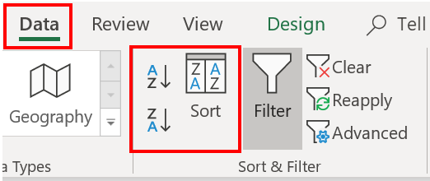

Figure 20: Sort commands

* If a table filter has been enabled, you can also select the Filter command for a column and then select a quick sort in ascending Sort A to Z; descending Sort Z to A; or select sort by Color Custom Sort.

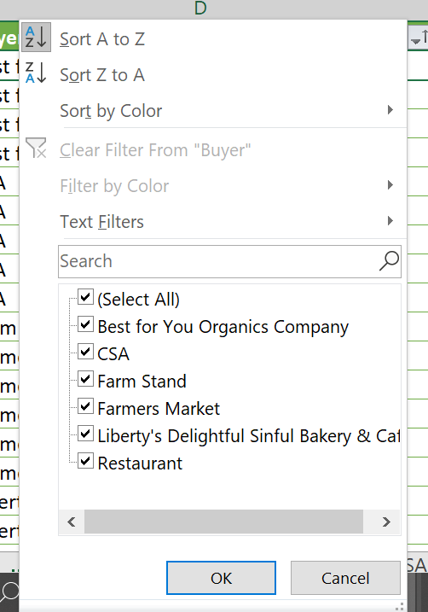

Figure 21: Filter context menu Sort commands

|  |  |
| --- | --- |
|  | Did you know?  If there is a mix of data stored as text and numbers in a column, you can access the Format Cells dialog box with the keyboard shortcut, Ctrl+1. Then you can select the Number tab, General Category, and select Number or Text. |

### Sort numbers

1. Select a cell in the column you want to sort.
2. On the Data tab, in the Sort & Filter group, do one of the following:
   * To sort from low to high, select Sort Smallest to Largest.
   * To sort from high to low, select Sort Largest to Smallest.



Figure 22: Sort commands

If a table filter has been enabled, you can also select the Filter command for a column and then select a quick sort. To sort from low to high, select (Sort Smallest to Largest); from high to low (Sort Largest to Smallest); or Sort by Color (Custom Sort).

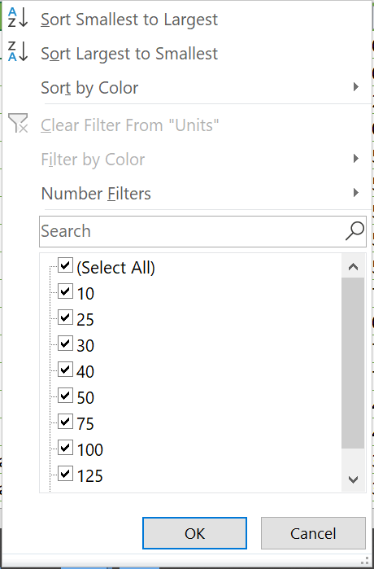

Figure 23: Filter context menu Number Sort commands

### Sort dates and times

1. Select a cell in the column you want to sort.
2. On the Data tab, in the Sort & Filter group, do one of the following:
   * To sort from an earlier to a later date or time, select Sort Oldest to Newest.
   * To sort from a later to an earlier date or time, select Sort Newest to Oldest.



Figure 24: Sort commands

If a table filter has been enabled, you can also select the Filter command for a column and then select a quick sort. To sort from an earlier to a later date or time, select (Sort Smallest to Largest); from a later to an earlier date or time, select (Sort Largest to Smallest); or Sort by Color (Custom Sort).

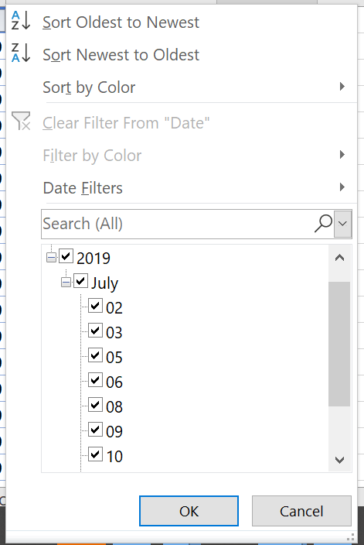

Figure 25: Filter context menu Sort commands

|  |  |
| --- | --- |
|  | Did you know?   * Extra leading spaces from imported data can affect sorting. The TRIM function can remove all leading spaces.   To review an article on how to use the TRIM function, go to: [TRIM Function](https://aka.ms/TRIM-function) |

### Sort by more than one column

You may want to sort by more than one column or row when you have data that you want to group by the same value in one column or row, and then sort another column or row within that group of equal values. For example, if you have a School club column and a Student column, you can first sort by School club (to group all the students in the same school club together) and then sort by name (to put the names in alphabetical order within each school club). You can sort by up to 64 columns. For best results, the range of cells that you sort should have column headings.

1. Select any cell in the table.
2. On the Data tab, in the Sort & Filter group, click Sort.
3. In the Sort dialog box, under Column, in the Sort by box, select the first column that you want to sort.
4. Under Sort On, select the type of sort. Do one of the following:
   * To sort by text, number, or date and time, select Values.
   * To sort by format, select Cell Color, Font Color, or Cell Icon.
5. Under Order, select how you want to sort. Do one of the following:
   * For text values, select A to Z or Z to A.
   * For number values, select Smallest to Largest or Largest to Smallest.
   * For date or time values, select Oldest to Newest or Newest to Oldest.
6. To sort based on a custom list, select Custom List.
7. To add another column to sort by, click Add Level, and then repeat steps 3–5. To copy a column to sort by, select the entry, and then click Copy Level.
8. To delete a column to sort by, select the entry, and then click Delete Level.

Note: You must keep at least one entry in the list.

1. To change the order in which the columns are sorted, select an entry, and then click the Up or Down arrow next to the Options button to change the order.

Entries higher in the list are sorted before entries lower in the list.

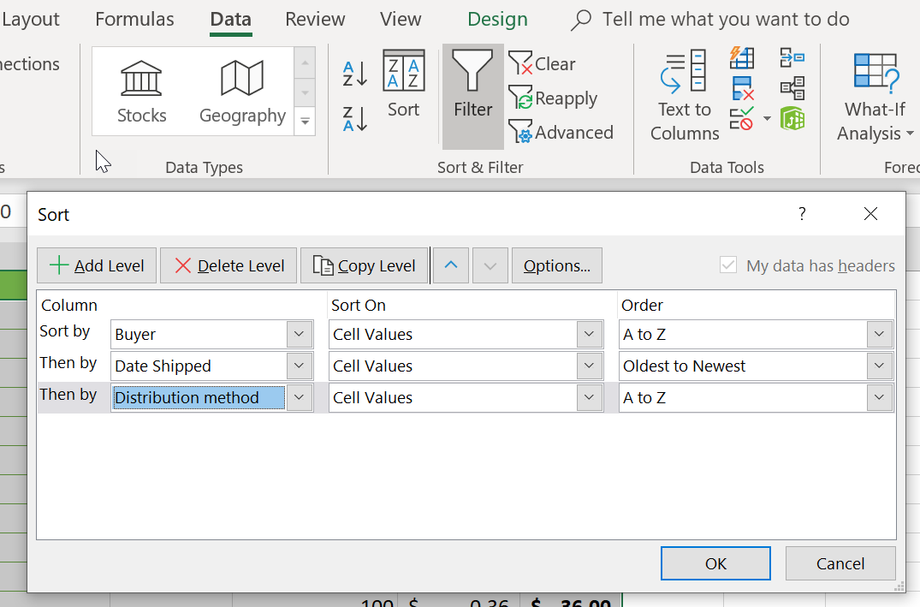

Figure 26: Custom Sort—Multiple levels

### Sort by cell color, font color, or icon

If you have manually or conditionally formatted a range of cells or a table column by cell color or font color, you can also sort by these colors. You can also sort by an icon set that you created with conditional formatting.

1. Select a cell in the column you want to sort.
2. On the Data tab, in the Sort & Filter group, click Sort.
3. In the Sort dialog box, under Column, in the Sort by box, select the column that you want to sort.
4. Under Sort On, select Cell Color, Font Color, or Cell Icon.
5. Under Order, click the arrow next to the button and then, depending on the type of format, select a cell color, font color, or cell icon.
6. Next, select how you want to sort. Do one of the following:
7. To move the cell color, font color, or icon to the top or to the left, select On Top for a column sort, and On Left for a row sort.
8. To move the cell color, font color, or icon to the bottom or to the right, select On Bottom for a column sort, and On Right for a row sort.

Note: There is no default cell color, font color, or icon sort order. You must define the order that you want for each sort operation.

1. To specify the next cell color, font color, or icon to sort by, click Add Level, and then repeat steps three through five.
2. Make sure that you select the same column in the Then by box and that you make the same selection under Order.
3. Keep repeating for each additional cell color, font color, or icon that you want included in the sort.

### Activity: Pose a challenge

The teacher poses a challenge to your class: brainstorm/predict strategies for solving the challenge of sorting multiple columns. You will read an Office support article to help solve it and work in groups to solve the challenge. You will race against other student groups. The winning group of students will demonstrate to the class how to complete the task. If other groups find different ways to complete the same task, those student groups will also demonstrate their process.

Your teacher will then quickly review how to sort multiple columns using the Custom Sort command.

#### Resources required

You will need the following resources for this activity:

* Open the Office support article link and read the instructions to help solve the challenge. Also open the L4_T2_act_crop_distribution_starter.xlsx starter file and follow the Activity instructions.
  + [Sort data using a custom list](https://aka.ms/Sort-data-using-a-custom-list).

### Activity instructions

Participate in the activity by following these instructions:

1. Go to the Crop_Sourcing_Range worksheet.
2. Join the group assigned by your teacher.
3. Read the Sort data using a custom list support article and discuss with your team members.
4. Observe the table in the Crop_Sourcing_Table worksheet.
5. Sort the multiple columns in this order: Date Picked, and then Crop.
6. Observe the teacher-led demonstration.

### Try-it: Perform a custom sort

 In this stand-alone try-it, you will sort multiple columns of a table. You need to know which crops are being purchased the most by each buyer (in alphabetical order). You need to apply a multiple column sort to determine this.

#### Resources

You will need the following resources for this try-it:

* Open L4_T2_try_crop_distribution_starter.xlsx in this lesson’s Learning Activity Resources.

#### Instructions

The following are the general tasks that you need to perform during this try-it:

1. Go to the Processing worksheet.
2. Sort the Units column from largest to smallest.
3. Sort the Buyer column in A to Z order.
4. What answer did you find? Which buyer has purchased the most units of a produce item?
5. Don’t forget to save your work!

## Wrap-up

In the previous lesson, you learned how to update the name of a table to something more meaningful for the data it represents. You also learned how to give a range of cells a meaningful name.

In this lesson, you learned how to arrange the contents of a data set and table with the help of the sort and filter commands. When the arrangement involves several columns of data, you learned how sorting multiple columns can quickly update the column contents order to accomplish this.

Use these questions to check what you learned in this lesson:

1. Which ribbon command clears the filter and the sort state for the current range of data?

Select all that apply.

1. Home ribbon, Editing group, Clear Formats
2. Data ribbon, Sort & Filter, Clear
3. Home ribbon, Editing group, Sort & Filter, Clear
4. Data ribbon, Sort & Filter, Reapply
5. Which of the following options are choices in the Sort Options dialog box?

Select all that apply.

1. Case sensitive
2. Delete level
3. Orientation
4. Copy level
5. The filter choice Select here to enter text. displays only empty cells.
6. Each Select here to enter text. determines the order a custom sort displays the data.

# Cornerstone

## Overview

In this Cornerstone, you will analyze the farm market apparel and bee products workbooks by creating tables; applying settings, sorting, and filtering a table; and converting a table to a range.

## Objectives

The following table outlines the Cornerstone objectives and their corresponding Microsoft Office Specialist (MOS) exam objectives.

|  |  |
| --- | --- |
| Convert a worksheet data range to a table | * 3.1.1: Create Excel tables from cell ranges |
| Apply a pre-formatted style to a table | * 3.1.2 Apply table styles |
| Apply sorting to a table column | * 3.3.2: Sort data by multiple columns |
| Apply filtering to table columns | * 3.3.1: Filter records |
| Modify a table by inserting a new column | * 3.2.1: Add or remove table rows and columns |
| Apply emphasis to a table column | * 3.2.1: Add or remove table rows and columns |
| Setup a filter for a table | * 3.2.2: Configure table style options |
| Modify a table to include a total row | * 3.2.3: Insert and configure total rows |
| Configure a table total row | * 3.2.3: Insert and configure total rows |
| Modify a table's style options by removing a banded row effect | * 3.2.2: Configure table style options |
| Convert a table to a range | * 3.1.3: Convert tables to cell ranges |
| Apply a name to a range | * 2.3.1: Define a named range |

Table 2: Cornerstone objectives

## Duration

25 minutes

## Instructions

1. Complete the tasks below for each file.
2. When saving your file, add your name to the end of the filename; for example, Munsons_ApparelDwayne_Espino. Follow your teacher’s directions for where to save your files.
3. When you’re done with the Cornerstone, assess your completion and enter the points you think you earned within the task lists below. You can use the help of your teacher if you need it.

## Tasks

You will work with two files in this Cornerstone. The following are the tasks you need to do within each file.

### File 1: Cornerstone_Munsons_apparel_starter.xlsx

#### Task: Convert a range to a table and add a style. (2 points)

1. Go to the Logo Merchandise worksheet. Convert the data range to a table with headers. (1 point) (Exam objective 3.1.1)
2. Apply Blue, Table Style Light 9 to the table. (1 point) (Exam objective 3.1.2)

Points scored: Select here to enter text./2

#### Task: Sort, filter, and adjust a table (5 points)

1. Within the Logo Merchandise worksheet, sort the Category column in ascending order. (1 point) (Exam objective 3.3.2)
2. Filter the table to show short-sleeve black shirts only with a quantity of 10 or less. (2 points) (Exam objective 3.3.1)
3. Insert a new column to the right of the Quantity column. Title it Order Quantity. (1 point) (Exam objective 3.2.1)
4. Even though values have not been entered in the Order Quantity column yet, add emphasis to the last column. (1 point) (Exam objective 3.2.2)

Points scored: Select here to enter text./5

#### Task: Apply table options and update a table name (5 points)

1. Go to the Apparel Sales worksheet. Add a filter to the table. (1 point) (Exam objective 3.2.3)
2. Add a total row. (1 point) (Exam objective 3.2.3)
3. Update the total to display an average of the sales total. (1 point) (Exam objective 3.2.3)
4. Remove the banded row effect. (1 point) (Exam objective 3.2.2)
5. Name the table Apparel_Sales. (1 point) (Exam objective 2.3.2)

Points scored: Select here to enter text./5

FILE 1 TOTAL POINTS: Select here to enter text./10

### File 2: Cornerstone_Munsons_bee_product_inventory_ starter.xlsx

#### Task: Convert a table to a range and give the range a name(2points)

1. Go to the Cosmetics Inventory worksheet. Convert the table to a range. (1 point) (Exam objective 3.1.3)
2. Select the cell range A2:E15 and name the range Bee_cosmetics. (1 point) (Exam objective 2.3.1)

Points scored: Select here to enter text./2

FILE 2 TOTAL POINTS: Select here to enter text./2

# Glossary

Add key terms and their definitions used in the module.

|  |  |
| --- | --- |
| Table | A group of cells that have been formatted in a column or row tabular format. |
| Range of cells | A group of consecutive or nonconsecutive cells in a worksheet that have been selected. Also known as a cell range. |
| Sort | A command that sorts the contents of a range or table. Data values can be sorted by one or more columns. Only the matching results are returned. |
| Filter | A command that filters a range or table based on selected criteria. Only matching criteria results are displayed. |
| Style | A combination of preformatted attributes that can be applied to a range of cells or a table. |
|  |  |

Table 3: Glossary terms and definitions