

Student Guide

40567A

Microsoft Excel associate 2019

Module 5: Using formulas and functions

Contents

Contents 2

Module overview 4

Description 4

Scenario 5

Cornerstone 5

Lesson 1: Performing basic calculations 6

Overview 6

Warm-up 6

Topic 1: Understand basic formulas 7

Order of operations 9

Use parentheses to modify the order of operations 10

Activity: Show and tell 10

Use cell references in formulas 11

Try-it: Understand basic formulas 12

Try-it 1 12

Try-it 2 13

Try-it 3 13

Topic 2: Display formulas 14

Activity: Show and tell 15

Try-it: Display formulas 16

Wrap-up 16

Lesson 2: Using references in formulas 18

Overview 18

Warm-up 18

Topic 1: Understand relative and absolute references 19

Use relative cell references in a formula 19

Use absolute cell references in a formula 20

Use mixed cell references in a formula 21

Activity: Tell a story 22

Try-it: Understand relative and absolute references 22

Topic 2: Use named ranges and worksheet references in formulas 23

Use worksheet references in a formula 26

Activity: Quiz Me! 26

Try-it: Use named ranges and worksheet references in formulas 27

Try-it 1 27

Try-it 2 28

Wrap-up 28

Lesson 3: Introducing functions 30

Overview 30

Warm-up 30

Topic 1: Use functions in calculations 31

Use the Function Library to insert functions 32

Use the SUM function 34

Use the AVERAGE function 35

Activity: Show me how 35

[Try-it: Use functions in   
calculations 36](#_Toc28777034)

Try-it 1 36

Try-it 2 37

Topic 2: Use MAX and MIN functions in formulas 37

Overview of the MAX function 37

Overview of the MIN function 38

Activity: Show me how 38

Try-it: Use MAX and MIN functions in formulas 39

Try-it 1 39

Try-it 2 39

Wrap-up 40

Lesson 4: Using count functions 41

Overview 41

Warm-up 41

Topic 1: Use COUNT and COUNTA functions to analyze data 42

The COUNT Function 42

The COUNTA Function 42

Activity: Discuss and learn 43

Try-it: Use COUNT and COUNTA functions to analyze data 44

Try-it 1 44

Try-it 2 44

Topic 2: Use the COUNTBLANK function 45

The COUNTBLANK function 45

Activity: Pose a challenge 46

Try-it: Use the COUNTBLANK function 46

Wrap-up 47

Lesson 5: Using logical functions 49

Overview 49

Warm-up 49

Topic 1: Understand IF statements 50

Use logical operators 50

Activity: Discuss and learn 51

Try-it: Understand IF statements 51

Topic 2: Use the IF function 52

IF function syntax 52

Considerations when using the IF function 53

Activity: Show and tell 53

Try-it: Use the IF function 54

Try-it 1 54

Try-it 2 55

Wrap-up 55

Glossary 57

Cornerstone 58

Overview 58

Objectives 58

Duration 59

Instructions 59

Tasks 59

File 1: Cornerstone_attendance_ticketsales_starter.xlsx 59

# Module overview

## Description

One of the primary strengths of Microsoft Excel is its ability to perform both basic and complex calculations. This is likely the main reason why you choose to use Excel when working with numerical data. Similar to a calculator, you can use an Excel worksheet to add, subtract, multiply, and divide numbers by using simple formulas or by integrating them into complex functions.

In this module, you will learn how to use Excel to perform calculations on data using formulas and functions. The module begins with a discussion on basic concepts of formulas and calculations and ends with an introduction to more complex concepts related to using functions. You will also learn how relative and absolute references and named ranges can help you in devising a formula or function within your worksheet.

The following table provides an outline of the specific lessons and learning objectives that are covered in this module.

|  |  |  |
| --- | --- | --- |
| Lesson | Learning objective | Exam objective(s) |
| Performing basic calculations | Create formulas to perform basic calculations, understand calculation operators and order of precedence, and display formulas | 1.4.6 |
| Using references in formulas | Use relative, absolute, and mixed references; define named ranges and worksheet references in formulas | 4.1.1  4.1.2 |
| Introducing functions | Use basic functions in formulas such as SUM, AVERAGE, MAX, and MIN | 4.2.1 |
| Using count functions | Use count functions in formulas such as COUNT, COUNTA, and COUNTBLANK | 4.2.2 |
| Using logical functions | Use logical functions in formulas such as the IF function | 4.2.3 |
| Lesson | Learning objective | Exam objective(s) |
| Cornerstone: Calculating and summarizing event attendance and ticket sales | Use Excel to complete a report that summarizes the attendance and ticket sales data to help the management team assess the success of an event | 1.4.6  4.1.1  4.1.2  4.2.1  4.2.2  4.2.3 |

Table 1: Exam objectives by lesson

## Scenario

Munson’s Pickles and Preserves Farm’s weeklong Fall Festival event has ended. To prepare for a post-event review meeting, you have been asked to summarize the number of visitors and determine the sales revenue for the farm event. You have a workbook containing a worksheet with data logged during the event.

## Cornerstone

Munson’s Pickles and Preserves Farm hosts many public events throughout the year. Typically, admission tickets are sold with different pricing for junior, youth, adult, senior, family, and group attendees. After each event, the management team holds a meeting to review how successful the event was and what can be improved for future events. To help prepare for the post-event review meeting, you need to complete a report that summarizes the attendance and ticket sales data to help the management team assess the success of the event. You have a workbook that includes a worksheet with the data logged during the Munson’s event.

# Lesson 1: Performing basic calculations

## Overview

In Excel, knowing how to create a basic formula to perform a calculation is the foundation for many more complex tasks. Simply knowing how to add, subtract, multiply, or divide numbers in Excel allows you to perform many of the calculations routinely used in worksheets.

In this lesson, you will learn how to create basic formulas to perform calculations in an Excel worksheet. You will also observe how the mathematical order of operations is used to calculate a specific result. Finally, you will learn how formulas are displayed in an Excel worksheet.

## Warm-up

Use these questions to find out what you already know about this lesson’s topics:

1. A formula is used in an Excel workbook to Select here to enter text..

Fill in the blank space.

1. What is the answer to the following calculation: (4+6)*2-10/2 ?

Select the correct option.

1. 5
2. 3
3. 15
4. -30
5. Which of the following operators is used to start a formula in Excel?

Select the correct option.

1. *
2. /
3. =
4. $
5. Which of following operators is used to multiply in Excel?

Select the correct option.

1. *
2. /
3. ^
4. X
5. PEMDAS is the acronym for Select here to enter text..

Fill in the blank space

## Topic 1: Understand basic formulas

To perform calculations in Excel, you enter a formula into the worksheet. A formula is a mathematical equation that performs calculations on values in a worksheet. Formulas often perform calculations related to addition, subtraction, multiplication, and division but can also contain more advanced features such as Excel Functions.

A formula contains one or more of the following:

* Cell reference—The coordinate of a specific cell. For example, A1 refers to the cell located in the A column and the first row.
* Range of cell references—A specification used to indicate a set of adjacent cells. For example, cells A1 to A5 can be referred to as A1:A5 when specifying the range.
* Operator—A symbol used in mathematical operations to specify the calculations to be performed.
* Constant—A number or text value that is entered directly into a formula.
* Function—A pre-built command in Excel that performs mathematical operations such as automatically adding up a range of cells or looking up values to be used in calculations.

|  |  |
| --- | --- |
|  | Did you know?  You begin a formula with an equal (=) sign at the start of the calculation. This is used so that Excel can distinguish the formula from regular data in the worksheet. |

When you enter a formula in an Excel worksheet, the result of the calculation is displayed in the cell. You can view the underlying formula by selecting the cell and then referring to the formula bar.

As shown in Figure 1, the active cell is A1, which has the value of 22. The formula bar displays the formula that was entered to result in this calculation.

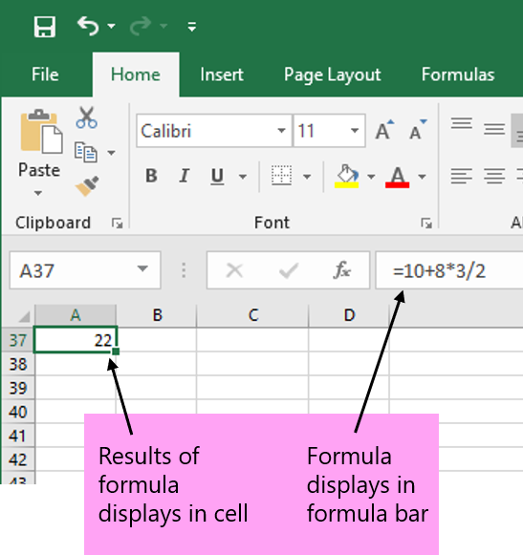

Figure 1: Viewing a formula

Excel uses arithmetic operators when performing calculations in formulas. Refer to Table 2, which describes the more common arithmetic operators used for formulas in Excel.

|  |  |  |  |
| --- | --- | --- | --- |
| Arithmetic operator | Name | Calculation | Example |
| + | Plus sign | Addition | 10+5 |
| - | Minus sign | Subtraction | 10-5 |
| * | Asterisk | Multiplication | 10*5 |
| / | Forward slash | Division | 10/5 |
| % | Percent sign | Percent | 50% |
| ^ | Caret | Exponentiation | 10^2 |

Table 2: Arithmetic operators

### Order of operations

You will often use more than one operator in a formula. To ensure that your formula results in the correct calculation, you need to understand how the calculation takes place.

Excel follows standard mathematical rules called the order of operations when calculating a formula. Table 3 describes the order of operations.

|  |  |
| --- | --- |
| Arithmetic operator | Description |
| - | Negative number |
| % | Percent |
| ^ | Exponentiation |
| * and / | Multiplication and division in order left to right |
| + and - | Addition and subtraction in order left to right |

Table 3: Order of operations

Excel performs operations in the order shown from top to bottom in Table 3. For example, consider the formula 3+6 * 2.

Following the order of operations, multiplication takes place first: 6 * 2. The result of 12 is then added to 3 with the final calculation of 15.

### Use parentheses to modify the order of operations

You can override the standard order of operations by using parentheses in a formula. Excel always performs calculations inside parentheses first before continuing with the rest of the order of operations.

For example, if the above formula is changed to contain parentheses, the result is much different: (3+6) * 2.

With the parentheses taking precedence, the first calculation results in 9. Then the standard order resumes to multiply by 2. The final result is now 18.

|  |  |
| --- | --- |
|  | Did you know?  You can remember the order of operations by using the acronym: PEMDAS (parentheses, exponents, multiplication, division, addition, subtraction). |

### Activity: Show and tell

In this activity, your teacher will demonstrate how to create calculations with formulas. Your teacher will also show you how the order of operations will affect the result of a calculation.

#### Resources required

You will need the following resources for this activity:

None.

#### Activity instructions

Pay close attention as your teacher demonstrates the following tasks:

1. Entering a simple formula into a cell.
2. Using arithmetic operators in formulas.
3. Changing the order of operations in formulas.
4. Using cell references in formulas.

### Use cell references in formulas

Although you can use constant numbers in formulas, more often you will want to use cell references instead. A cell reference identifies the coordinate of a specific cell. For example, A1 refers to column A and row 1. The power behind using a cell reference is that you can change the data in a cell and immediately observe the results of any formula that references the cell.

For example, in Figure 2, the number 10 is entered in cell A1 and the number 8 is entered in cell B1. The formula in cell C1 is configured to add the two numbers together. Notice that C1 does not contain the constant values (10 and 8) but rather the cell references of A1 and B1. If you decide to change the values in cells A1 and B1, the formula in C1 automatically calculates to the new result.

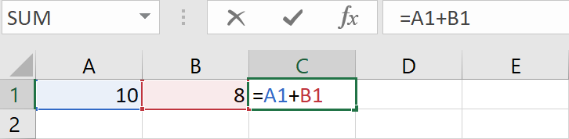

Figure 2: Using cell references for calculating a formula

|  |  |  |
| --- | --- | --- |
|  | | Did you know?  You can either type the formula or you can use the mouse and select the cells to be included in the formula. After you type the = sign, simply use the mouse and select the cells you want to include in the calculation before and after the operator. |
|  | Additional information  For more information on types of operators and order of operations, go to: [Calculation operators and precedence](https://aka.ms/calculation-operators-and-precedence) | |

### Try-it: Understand basic formulas

 In this leveled try-it activity, you will open a blank document and create a simple formula. You will then open an existing document and devise a more complex formula with multiple operators and sets of parentheses.

### Try-it 1

In this try-it, you will open a blank document and create a simple formula.

#### Resources

You will need the following resources for this try-it:

* Open a blank worksheet in Excel.

#### Instructions

The following are the general tasks that you need to perform during this try-it:

1. In the blank worksheet, enter numbers as shown in the following table:

|  |  |  |  |
| --- | --- | --- | --- |
|  | A | B | C |
| 1 | 10 | 8 |  |
| 2 | 15 | 6 |  |
| 3 | 25 | 10 |  |
| 4 | 22 | 2 |  |

1. In cell C1, create a formula that adds cells A1 and B1. Use constant numbers for this formula.
2. In cell C2, create a formula that subtracts cells A2 and B2. Use cell references for this formula.
3. In cell C3, create a formula that multiplies cells A3 and B3. Use cell references for this formula.
4. In cell C4, create a formula that divides cells A4 and B4. Use cell references for this formula.
5. In cell A1, change the number to 20.
6. In cell A2, change the number to 10.
7. In cell A3, change the number to 10.
8. In cell A4, change the number to 40.
9. Which results automatically changed? Why?
10. Save and close the file.

### Try-it 2

In this try-it, you will open an existing document and devise a more complex formula with two operators and parentheses.

#### Resources

You will need the following resources for this try-it:

* Open L1_T1_try2_formula_two_operators_starter.xlsx in this lesson’s Learning Activity Resources.

#### Instructions

The following are the general tasks that you need to perform during this try-it:

1. In cell D2, create a formula that adds cells A2 and B2 and then subtracts cell C2.
2. In cell D3, create a formula that adds cells A3 and B3 and then multiplies cell C3.
3. In cell D4, create a formula that subtracts cells A4 and B4 and then divides cell C4.
4. Use parentheses to modify the formula in cell D3 so that the result is 750.
5. Use parentheses to modify the formula in cell D4 so that the result is 25.5.
6. Save and close the file.

### Try-it 3

In this try-it, you will open an existing document and devise a more complex formula with four operators and parentheses.

#### Resources

You will need the following resources for this try-it:

* Open L1_T1_try3_formula_parentheses_starter.xlsx in this lesson’s Learning Activity Resources.

#### Instructions

The following are the general tasks that you need to perform during this try-it:

1. Under Exercise 1, next to No Parentheses, select cell B2.
2. In the formula bar, take note of the formula. What is the order of precedence used to calculate 76.5?
3. In cell B3, use one set of parentheses to modify the formula so that the result is 37.
4. In cell B4, use two sets of parentheses to modify the formula so that the result is 52.
5. Under Exercise 2, next to No Parentheses, select cell B7.
6. In the formula bar, take note of the formula. What is the order of precedence used to calculate 64?
7. In cell B8, use one set of parentheses to modify the formula so that the result is 264.
8. In cell B9, use two sets of parentheses to modify the formula so that the result is 524.
9. Save and close the file.

## Topic 2: Display formulas

 As discussed previously, when you enter a formula into an Excel worksheet, only the result of the calculation is displayed within the cell. The underlying formula is only visible, by default, in the formula bar when the cell containing the formula is active.

Excel provides several options for displaying and editing formulas. These options include:

* Viewing and editing the cell in the formula bar.
* Double-clicking the cell to view and edit the formula.
* Using the Show Formulas command to display all formulas in the worksheet.

Figure 3 illustrates a worksheet with the Show Formulas command enabled. Notice that in Column D, the Total for each row displays the formulas. The results of the calculation are not shown in the worksheet while the Show Formulas command is enabled.

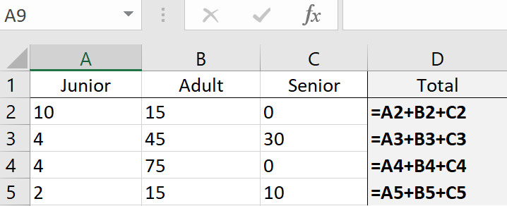

Figure 3: Show Formulas option enabled

To enable the Show Formulas command, select the Formulas tab, and then in the Formula Auditing group, select Show Formulas.

|  |  |
| --- | --- |
|  | Did you know?  When you double-click a cell to edit the formula, if you do not press Enter, you can cancel all edits by pressing the Esc key on the keyboard. If you do press Enter, you can use the Undo command to revert to the previous entry in the cell. |

### Activity: Show and tell

In this activity, your teacher will demonstrate various ways to display and edit formulas.

#### Resources required

You will need the following resources for this activity:

None.

#### Activity instructions

Pay close attention as your teacher demonstrates the following tasks:

1. Using the formula bar.
2. Displaying and editing a formula within a cell.
3. Using the Show Formulas command.

### Try-it: Display formulas

 In this try-it activity, you will open an existing document and use several methods to display formulas in an Excel worksheet.

#### Resources

You will need the following resources for this try-it:

* Open L1_T2_try_display_formulas_starter.xlsx in this lesson’s Learning Activity Resources.

#### Instructions

The following are the general tasks that you need to perform during this try-it:

1. Select cell D2 and notice the formula displayed in the formula bar.
2. Select cell D3 and press F2 on the keyboard. Notice the formula displayed in the cell.
3. Press Esc to cancel the cell display mode.
4. From the ribbon, enable the Show Formulas command.
5. Save and close the file.

## Wrap-up

Use these questions to check what you learned in this lesson:

1. The formula =6*2/3 produces the same result as =6*(2/3).

Select the correct option.

1. True
2. False
3. Which of the following symbols can you use to override the order of operations?

Select the correct option.

1. “ “
2. @
3. ( )
4. *

1. The +, -, *, and / are all examples of Select here to enter text..

Fill in the blank space.

1. To display formulas in the worksheet, you can select the Select here to enter text. command in the ribbon.

Fill in the blank space.

1. Which following operator is used to divide in Excel?

Select the correct option.

1. *
2. /
3. ^
4. @

# Lesson 2: Using references in formulas

## Overview

As you learned in Lesson 1, a cell reference identifies the coordinates of a cell based upon the column letter and row number. To provide more flexibility in your worksheet, you typically use cell references instead of hard coding constant values when creating a formula in Excel.

In this lesson, you will learn the types of cell references that can be used when devising a formula in an Excel worksheet. You will also learn how named ranges and references are used in formulas to refer to cell references within or across worksheets.

## Warm-up

Use these questions to find out what you already know about this lesson’s topics:

1. If you do not want a cell reference to change when you copy or move it, you need to make a(n) Select here to enter text. cell reference in a formula.

Fill in the blank space.

1. Which of the following is the best example of a mixed cell reference?

Select the correct option.

1. A2
2. $A$2
3. A2:B5
4. A$2

1. Which of the following symbols specifies an absolute reference?

Select the correct option.

1. %
2. &
3. $
4. @
5. Which of the following is a valid named range?

Select the correct option.

1. A7
2. Sales_Data
3. Sales Data
4. Sales\Data

## Topic 1: Understand relative and absolute references

 The benefit of using a cell reference is that when you copy the formula to a new location, the cell reference automatically updates. However, there may be times that you need the formula to always refer to a specific cell, regardless of where the formula is copied to in the worksheet. To ensure that your formulas calculate as intended, it is important to understand the concepts of relative, absolute, and mixed cell references.

### Use relative cell references in a formula

As you copy a formula from one location to another in a worksheet, you will notice that, by default, the formula reference changes based upon where you copy the formula to. What actually is copied is related to the “pattern” of the formula as opposed to the specific references in the formula. This is called a relative cell reference.

For example, as shown in Figure 4, the first table has cell E1 selected. The formula within the cell is =B1+C1+D1. When this formula is copied to cells E2 and E3, notice that the cell reference changes based upon where the formula is copied to. Cell E2 shows a formula of =B2+C2+D2, and cell E3 shows a formula of =B3+C3+D3.

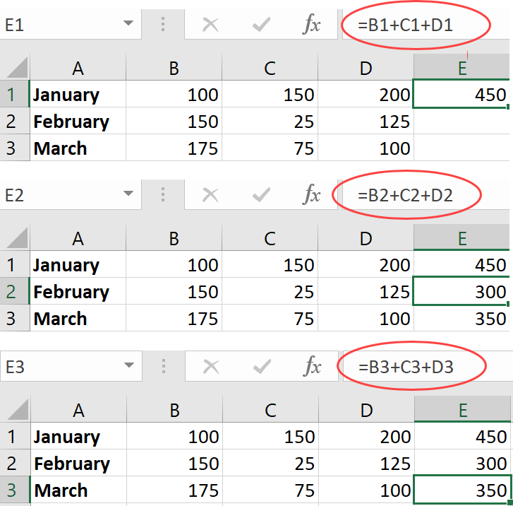

Figure 4: Relative cell references

|  |  |
| --- | --- |
|  | Did you know?  You can use the standard Copy and Paste feature to copy formulas to another location in the worksheet; if the cells are adjacent to the original cell, you can use the Auto Fill handle to copy the formula. |

### Use absolute cell references in a formula

You may have circumstances where you do not want a cell reference to change when it is moved or copied. An absolute cell reference refers to a formula that contains a specific cell or range of cells that do not change regardless of where the formula is copied or moved to.

To specify an absolute cell reference in a formula, use the dollar sign ($) before the column and the row of the cell you want to reference.

For example, as shown in Figure 5, the first table has cell F2 selected. The formula within the cell is =$B$6*E2. This formula multiplies the Bonus in cell B6 with the Total in cell E2 to calculate the Bonus amount in cell F2.

When the formula in cell F2 is copied to cells F3 and F4, notice that the cell reference to B6 does not change because the absolute reference indicator ($) has been applied to the column and row. Also note that the original reference to cell E2 continues to change relative to where the formula is copied to because it does not contain an absolute reference indicator.

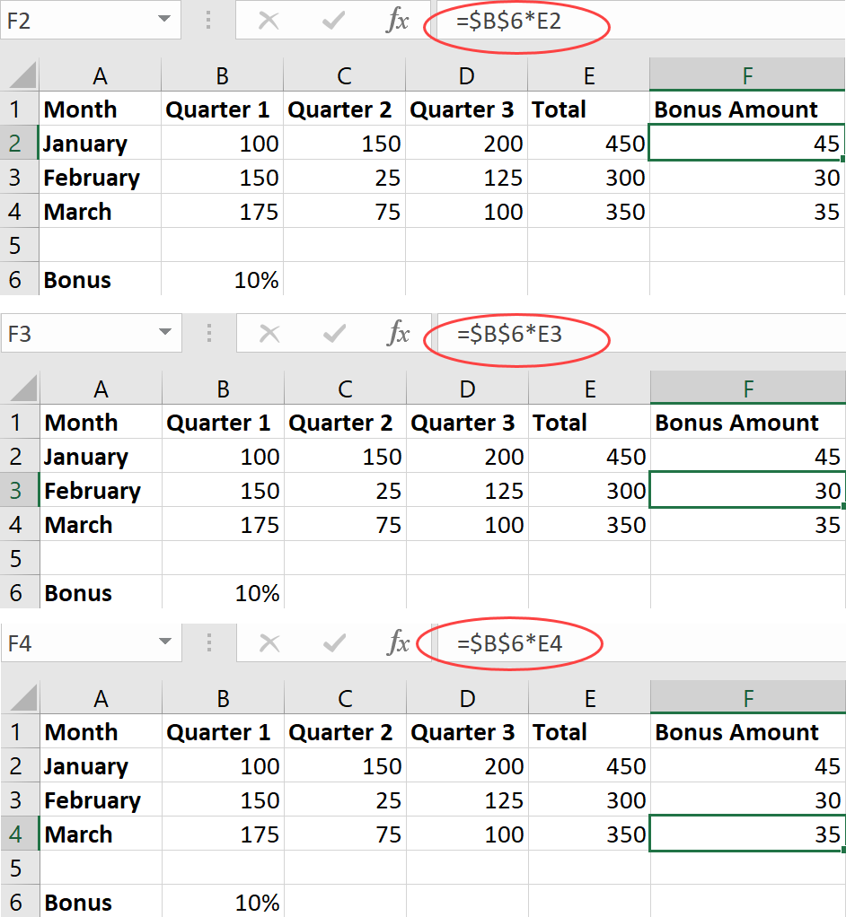

Figure 5: Absolute cell references

### Use mixed cell references in a formula

There may be scenarios when you need to copy a formula, but the formula must only change the row reference and keep the column reference the same. In this case, you would configure only the column reference with the absolute reference indicator ($).

This type of cell referencing combines both relative and absolute elements and is called a mixed cell reference.

For example, a formula is copied with the mixed cell reference of B$6. In this case, the row reference stays constant wherever the formula is copied. The column reference changes relative to where the formula is copied to.

|  |  |  |
| --- | --- | --- |
|  | Did you know?  As you create a formula using cell references, you can toggle between relative, absolute, and mixed references by pressing F4 on the keyboard. This will cycle through the various reference types and add or remove the dollar sign ($) in the formula. | |
|  | | Additional information  For more information on using relative, absolute, and mixed references, go to: [Switch between relative, absolute, and mixed references](https://aka.ms/Switch-between-relative-absolute-and-mixed-references) |

### Activity: Tell a story

In this activity, your teacher will describe and demonstrate a scenario to help you understand how relative and absolute references are used in formulas.

#### Resources required

You will need the following resources for this activity:

None.

#### Activity instructions

Your teacher will open a document that contains Munson’s Pickles and Preserves Farm sales data for shareholder memberships. Munson’s plans to donate a percentage of sales to a local food bank. Pay close attention as your teacher demonstrates the following tasks:

1. How relative cell references work in a formula.
2. How absolute cell references work in a formula.

### Try-it: Understand relative and absolute references

 For this exercise, you will open an existing Excel workbook and configure formulas to use relative and absolute cell references.

#### Resources

You will need the following resources for this try-it:

* Open L2_T1_try_donation_amount_starter.xlsx in this lesson’s Learning Activity Resources.

#### Instructions

The following are the general tasks that you need to perform during this try-it:

1. In the Donation Amount column, in cell F3, create a formula that calculates 10% of the total sales in January. Be sure to use relative cell references for the formula.
2. Copy the formula from cell F3 to cells F4 to F8.
3. Take note of the calculations. Are the calculations correct, and do they refer to the correct cell references?
4. Edit the formula in cell F3 to use absolute cell references where needed.
5. Copy the formula from cell F3 to cells F4 to F8.
6. Take note of the calculations. Are the calculations now correct, and do they refer to the correct cell references?

## Topic 2: Use named ranges and worksheet references in formulas

 Module 4: Managing tables and ranges introduced you to the concept of defining a named range. As you might recall, a named range can either be a single cell or a group of cells with a designated name.

Using a named range in a worksheet provides several benefits. For larger worksheets, a named range can be used as a type of bookmark, which enables you to quickly navigate to the location that has been named. For formulas, a named range enables you to assign meaningful names to cells or groups of cells, which can be used in place of the column and row references. The named range can also be assigned a scope to be used within a specific worksheet or even be referred to from multiple worksheets within the entire workbook.

For example, as shown in Figure 6, cell B6 has been defined with the name Bonus. This named cell is used in the formula for F2. In the formula bar, notice that =Bonus*E2 displays. Using the name Bonus is much easier to remember than referring to cell B6 when you reference this location in formulas.

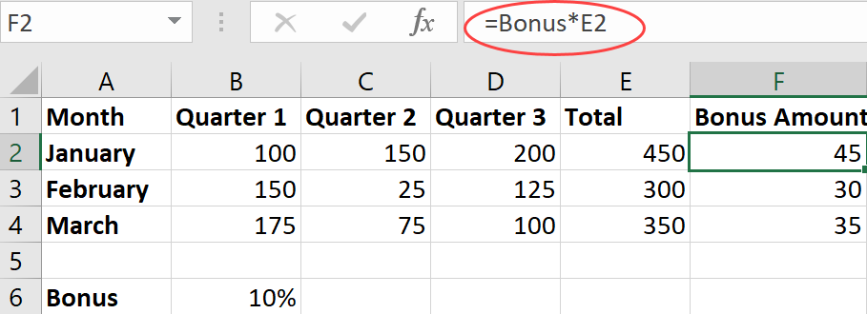

Figure 6: Using a named range in a formula

|  |  |
| --- | --- |
|  | Did you know?  When you use a named range in a formula, it is treated as an absolute reference. |

After you have defined named ranges in your workbook, you can reference the stored names as you input a formula in a worksheet. To reference a named range, begin the formula with an equal (=) sign. At this point, you can simply enter the name of the reference to be added to the formula.

As shown in Figure 7, as you input the name, IntelliSense automatically suggests stored names based upon the characters you input. You can select the suggested name and then continue entering the formula.

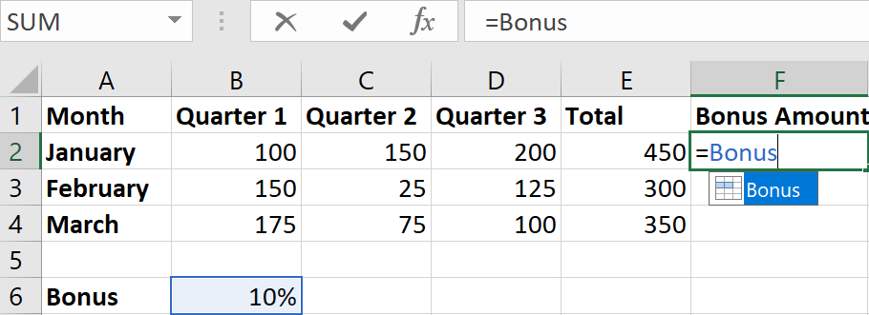

Figure 7: Inserting a named range

Another method used to add a named range to a formula is to select the Use in Formula option found in the Defined Names group of the ribbon. As shown in Figure 8, this option displays all the named ranges defined in the workbook. This is quite handy if you do not remember the name of a specific range that needs to be referenced in a formula.

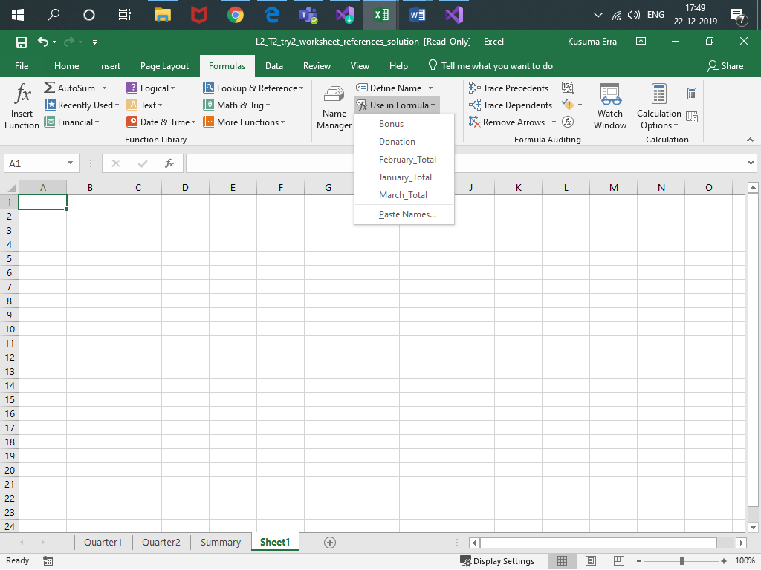

Figure 8: Use in Formula button showing named ranges

|  |  |
| --- | --- |
|  | Did you know?  The Paste Names option in the Use in Formula command is used to create a list of names and cell references stored in the workbook. This information can be used as a guide to show reviewers each of the defined named ranges and their associated cell ranges. |

|  |  |
| --- | --- |
|  | Additional information  For additional information on defining and using names in formulas, go to: [Define and use names in formulas](https://aka.ms/Define-and-use-names-in-formulas) |

### Use worksheet references in a formula

A worksheet reference refers to a cell, range of cells, or named range located in another worksheet. You might use worksheet references whenever you need to create formulas that reference data throughout multiple worksheets. For example, one worksheet may display a summary of data based upon information located in other worksheets within the workbook.

The format of a formula that references a cell in another worksheet is as follows:

* SheetName!CellAddress
* SheetName! refers to the name of the sheet that contains the data.
* CellAddress refers to the column and row reference that contains the data.

|  |  |
| --- | --- |
|  | Did you know?  You can also reference data in another workbook by including the name of the workbook in square brackets ([ ]); for example, [WorkbookName]SheetName!CellAddress. |

### Activity: Quiz Me!

In this activity, you will participate in a teacher-led discussion and demonstration on how to define and use named ranges in formulas.

#### Resources required

You will need the following resources for this activity:

None

#### Activity instructions

Your teacher will open a sample workbook and quiz you and fellow students on the following tasks:

1. Create named ranges.
2. Use named ranges in formulas.
3. Reference data in another worksheet.

### Try-it: Use named ranges and worksheet references in formulas

 In each of these exercises, you will open a sample document and practice defining and using named ranges in formulas.

### Try-it 1

In this try-it, you will open a sample document and define and use a named range in a formula.

#### Resources

You will need the following resources for this try-it:

* Open L2_T2_try1_named_ranges_starter.xlsx in this lesson’s Learning Activity Resources.

#### Instructions

The following are the general tasks that you need to perform during this try-it:

1. For cell B10, define a name called Donation.
2. In the Donation amount column, in cell F3, create a formula that multiples the Total by the Donation Amount. Be sure to use the defined name and cell reference.
3. In the Donation Amount column, copy the formula in cell F3 to calculate the donation amount for the rest of the months (cells F4 to F8).
4. Save and close the file.

### Try-it 2

In this try-it, you will open a sample document and create a formula with worksheet references.

#### Resources

You will need the following resources for this try-it:

* Open L2_T2_try2_worksheet_references_starter.xlsx in this lesson’s Learning Activity Resources.

#### Instructions

The following are the general tasks that you need to perform during this try-it:

1. Select the Quarter2 sheet.
2. In cell F3, configure a formula that will multiply the Donation named range by the January Total on the Quarter2 sheet.
3. On the Quarter2 sheet, in the Donation Amount column, copy the formula in cell F3 to calculate the Donation Amount for the rest of the months (cells F4 to F8).
4. On the Summary sheet, in cell B3, configure a formula that adds the Donation Amount for January from the Quarter1 and Quarter2 sheets.
5. On the Summary sheet, in the Donation Amount column, copy the formula in cell B3 to calculate the Donation Amount for the rest of the months (cells B4 to B8).
6. On the Quarter1 sheet, change the Donation percentage rate and observe the changes to the amounts in the workbook.

## Wrap-up

Use these questions to check what you learned in this lesson:

1. Which keyboard shortcut can you use to toggle relative, absolute, and mixed references?

Select the correct option.

1. F1
2. F4
3. F6
4. F8

1. Review the following formula: =$C$2*A7. This formula uses which of the following reference types?

Select the correct option.

1. Absolute
2. Relative
3. Mixed
4. Worksheet
5. Review the following formula: =Sales!C10+A7. This formula uses which of the following reference types?

Select the correct option.

1. Absolute
2. Relative
3. Named
4. Worksheet
5. Describe two methods you can use to create a named range.

Select here to enter text.

Select here to enter text.

1. Describe the benefits of using a named range.

Select here to enter text.

Fill in the blank space.

# Lesson 3: Introducing functions

## Overview

Excel’s built-in functions provide a relatively simple and efficient way to perform complex tasks within your worksheet. A function is a predefined formula used for specific purposes and calculations. There are over 470 functions in Excel, covering numerous categories, including mathematical calculations, lookup operations, logical evaluations, and calculating dates and times.

In this lesson, you will learn the concept of functions and how they are used in an Excel worksheet. You will also review several of the more common functions such as SUM, AVERAGE, MAX, and MIN to identify how these functions can help you with your formula and worksheet calculations.

## Warm-up

Your teacher will introduce the topics to be covered in this lesson. Be prepared to discuss and answer the following questions during the classroom discussion:

1. Which function is used to add specified values?

Select the correct option.

1. AVERAGE
2. SUM
3. COUNT
4. MAX
5. Like a standard formula, a function begins with an equal sign (=). True or false?

Select the correct option.

1. True
2. False

1. You want to add a range of cells and then divide by the number of cell entries. Which function can help you with this task?

Select the correct option.

1. AVERAGE
2. COUNT
3. IF
4. MAX
5. The Select here to enter text. command helps you search and select a function to be used in a worksheet.

Fill in the blank space.

## Topic 1: Use functions in calculations

 To effectively use a function in your worksheet, you need to understand how it is structured and which components are required or optional. A function is structured with the following elements:

* Function name: All functions begin with the standard equal (=) sign followed by the name of the function and an opening and closing parentheses.
* Arguments: Most functions use arguments within the brackets, which often refer to cell references or ranges to include in the calculation. For functions that do contain multiple arguments, at least one argument is required; additional arguments are optional, with each separated by a comma.

To insert a function into a worksheet, start by entering the equal (=) sign followed by the name of the function. As you enter the function name, Excel uses IntelliSense to provide a list of all the functions related to the letters you type. When the intended function is displayed, use the Tab key to have Excel automatically finish the function name and start the opening parentheses for you. Figure 9 shows an example of the structure for the SUM function. Take note of the function name, required argument, and optional arguments.

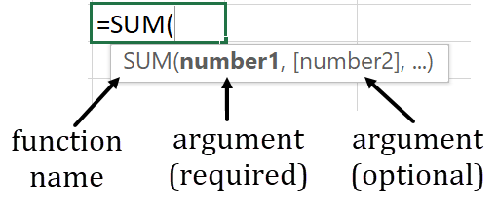

Figure 9: SUM function structure

|  |  |
| --- | --- |
|  | Did you know?  Not all functions contain arguments. For example, to insert a formula that returns today’s date, you can simply use the =TODAY() function. Notice that this function still follows the correct structure but does not contain or require any arguments within the brackets. |

### Use the Function Library to insert functions

The Formulas tab in Excel contains the Function Library, where you will find all the functions listed by category, such as Financial, Logical, Date &Time, Math & Trig, and so on.

Figure 10 shows the Function Library and its categories.

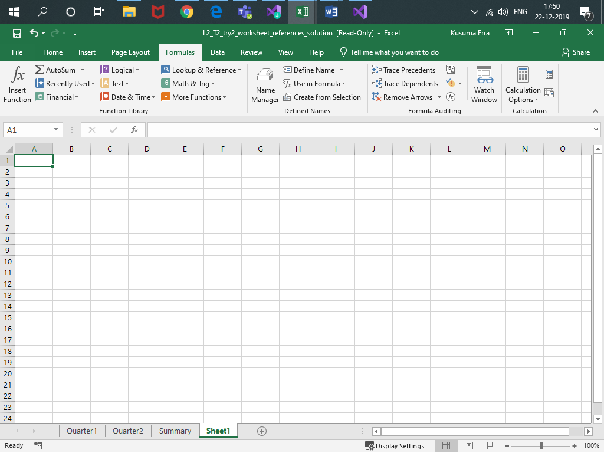

Figure 10: Function Library

You can use the Function Library to browse for a specific function to insert into your worksheet. After you select a function to be used, the function wizard launches to assist in adding additional arguments and finalizing the build of your formula.

If you need assistance in finding a function to perform a specific task, use the Insert Function command found in the Function Library or to the left of the formula bar.

As shown in Figure 11, Insert Function helps you search for a function by name, description, or category. You then select the function name to launch the function wizard, which is used to help build your formula.

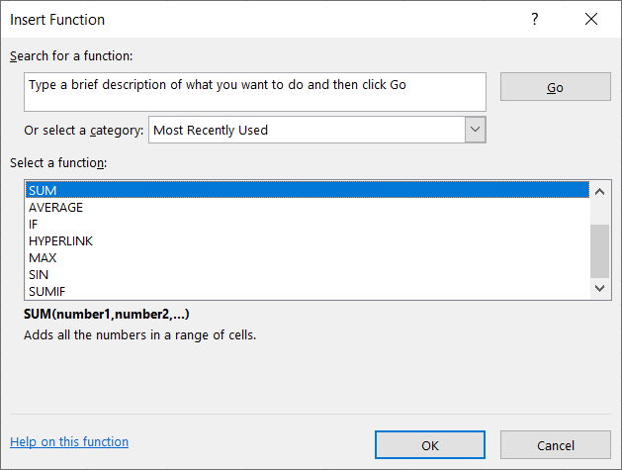

Figure 11: Insert Function dialog box

|  |  |
| --- | --- |
|  | Did you know?  Another method to open the Insert Function dialog box is to use the Shift F3 shortcut key combination on the keyboard. |

If you select a function that requires additional arguments, the function wizard displays the Function Arguments dialog box. As shown in Figure 12, the Function Arguments dialog box provides helpful guidance to build the formula, including sections to add additional arguments as needed. The dialog box also displays expected results and descriptions on how the function is structured.

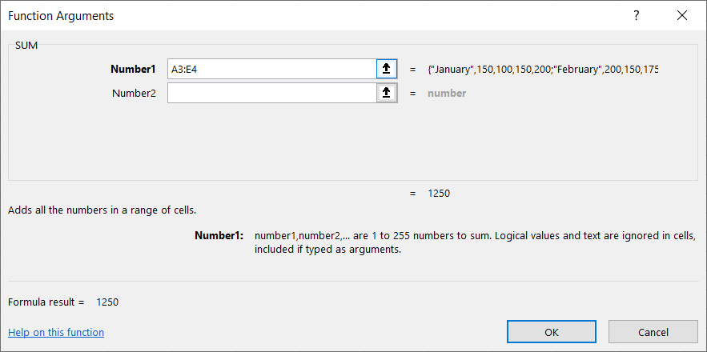

Figure 12: Function arguments for the SUM function

### Use the SUM function

One of the more common types of calculations used in a worksheet is adding numbers together to result in a sum total. You can easily use the plus (+) sign to add a range of numbers. However, for large ranges of numbers, the formula could become quite unmanageable.

As shown in Figure 13, the formula in cell F2 manually adds the cells from A2 to E2. Using this type of formula is prone to input error because each cell must be manually entered into the calculation.

The formula in cell F3 contains the SUM function, which totals the range of cells from A3 to E3, as indicated by A3:E3.

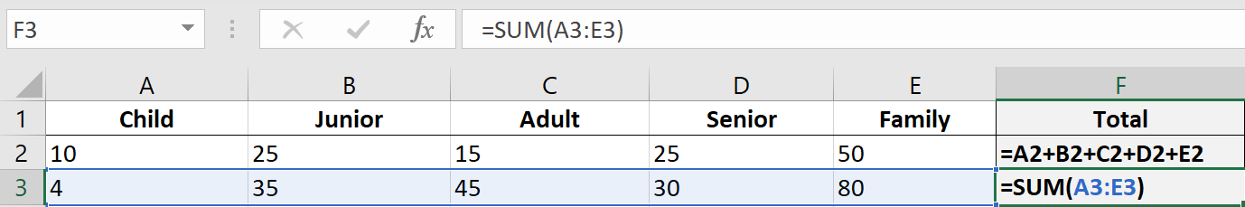

Figure 13: Comparing manual addition to the SUM function

|  |  |
| --- | --- |
|  | Did you know?  You can use the Alt = keyboard shortcut to enter the SUM function into a cell. This will start the formula and will then require you to specify the cells to be calculated. |

### Use the AVERAGE function

Some worksheet calculations may require you to add a range of cells and then divide by the number of cell entries. The result displays the average of the values entered in the cells. Similar to the SUM function, you can manually input the calculation. However, using the AVERAGE function is easier because it performs the calculation automatically.

To calculate the average for a range of cells, start with the equal (=) sign followed by the word AVERAGE and then an opening parentheses. You can then input or select the range of cells to average.

Figure 14 shows the AVERAGE function as it is manually typed into a cell. As with all functions, you can also use the Insert Function command or the Function Library to insert the formula as needed.

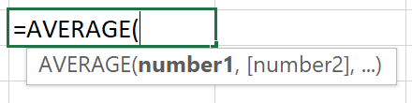

Figure 14: AVERAGE Function

|  |  |
| --- | --- |
|  | Additional information  For more information on functions, go to: [Formulas and functions](https://aka.ms/Formulas-and-functions) |

### Activity: Show me how

This is a teacher-led demonstration showing how to integrate the SUM and AVERAGE functions into formulas within an Excel worksheet.

#### Resources required

You will need the following resources for this activity:

None

#### Activity instructions

Pay close attention as your teacher demonstrates the following tasks. You will have a chance to test out your new knowledge on your own after the teacher-led demonstration:

1. Manually enter formulas to calculate the sum and average of specified cells.
2. Use the SUM function to simplify adding values for specified cells.
3. Use the AVERAGE function to simplify calculating averages.

### Try-it: Use functions in calculations

 In each of these exercises, you will open a sample document and then practice using the SUM and AVERAGE functions.

### Try-it 1

In this try-it, you will open a sample document and practice using SUM function.

#### Resources

You will need the following resources for this try-it:

* Open L3_T1_try1_sum_function_starter.xlsx in this lesson’s Learning Activity Resources.

#### Instructions

The following are the general tasks that you need to perform during this try-it:

1. In cell F2, input the column header Total.
2. In cell A9, input the column header Total.
3. In cell F3, use the Function Library to enter a function that sums B3 to E3.
4. Copy the formula from cell F3 to cell F4 through to cell F8.
5. In cell B9, use the Insert Function wizard to enter a function that sums B3 to B8.
6. Copy the formula from cell B9 to cell C9 through to cell F9.
7. Select cells B9 to F9 and format a Top and Double Bottom Border for the range of cells.
8. Save and close the file.

### Try-it 2

In this try-it, you will open a sample document and practice using AVERAGE function.

#### Resources

You will need the following resources for this try-it:

* Open L3_T1_try2_average_function_starter.xlsx in this lesson’s Learning Activity Resources.

#### Instructions

The following are the general tasks that you need to perform during this try-it:

1. In cell G3, use the Insert Function wizard to enter a function that averages cells B3 to E3.
2. Copy the formula from cell G3 to cell G4 through to cell G9.
3. Save and close the file.

## Topic 2: Use MAX and MIN functions in formulas

 As mentioned previously, all functions in the Function Library are grouped into several categories. Located in the Statistical category are two functions that are useful when analyzing financial data: the MAX function and the MIN function.

### Overview of the MAX function

The MAX function returns the largest value in a specified range of cells in the worksheet. This function is useful if, for example, you need to determine the highest expense or revenue amount in a financial worksheet.

As shown in Figure 15, the MAX function consists of the name followed by an opening parentheses. The first argument is required and can be either a number, named range, or cell reference. All subsequent arguments are optional. The final part of the function is the closed parentheses.

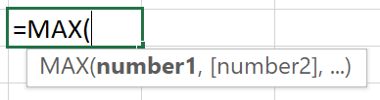

Figure 15: MAX function

The MAX function evaluates numerical values but ignores empty cells, text values, and the logical values of TRUE and FALSE.

### Overview of the MIN function

The MIN function returns the smallest value in a specified range of cells in the worksheet. This function is used for any scenario where you need to find the minimum values in a range of data; it is often used in financial analysis.

As shown in Figure 16, the MIN function consists of the name followed by an opening parentheses. The first argument is required and can be either a number, named range, or cell reference. All subsequent arguments are optional. The final part of the function is the closed parentheses.

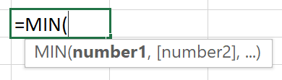

Figure 16: MIN function

The MIN function evaluates numerical values but ignores empty cells, text values, or logical values contained within the specified range.

|  |  |
| --- | --- |
|  | Did you know?  The Function library contains a button called AutoSum. The AutoSum will, by default, calculate the total from the adjacent cell through to the first non-numeric cell. The drop-down arrow on the button also provides an option to change this command to perform AVERAGE, MAX, MIN, and COUNT. |

### Activity: Show me how

This is a teacher-led demonstration about how to use the MAX and MIN functions in an Excel worksheet.

#### Resources required

You will need the following resources for this activity:

None.

#### Activity instructions

Participate in the activity by assisting your teacher in performing the following tasks:

1. Insert the MAX function to find the largest value.
2. Insert the MIN function to find the smallest value.

### Try-it: Use MAX and MIN functions in formulas

 In each of these exercises, you will open a sample document and practice using the MAX and MIN functions.

### Try-it 1

In this try-it, you will open a sample document and practice using MAX function.

#### Resources

You will need the following resources for this try-it:

* Open L3_T2_try1_max_monthly_usage_starter.xlsx in this lesson’s Learning Activity Resources.

#### Instructions

The following are the general tasks that you need to perform during this try-it:

1. In cell A16, input the row header Max Usage.
2. In cell B16, use the Function Library to enter a function that finds the maximum value for energy usage in 2012.
3. Copy the formula from cell B16 to cell C16 through to cell I16.
4. Select cells A16 to I16 and format a Top and Double Bottom Border for the range of cells. Format the range to be bold.
5. Save and close the file.

### Try-it 2

In this try-it, you will open a sample document and practice using MIN function.

#### Resources

You will need the following resources for this try-it:

* Open L3_T2_try2_min_monthly_usage_starter.xlsx in this lesson’s Learning Activity Resources.

#### Instructions

The following are the general tasks that you need to perform during this try-it:

1. In cell A17, input the row header Min Usage.
2. In cell B17, use the Function Library to enter a function that finds the minimum value for energy usage in 2012.
3. Copy the formula from cell B17 to cell C17 through to cell I17.
4. Select cells A16 to I16 and format a Top and Double Bottom Border for the range of cells. Format the range to be bold.
5. Save and close the file.

## Wrap-up

Use these questions to check what you learned in this lesson:

1. Which of the following are not evaluated in the MAX or MIN functions?

Select all that apply.

1. Cells with number values
2. Ranges with number values
3. Empty cells
4. Text values in the specified range
5. You need to determine the largest value in a range of numbers. Which function should you use?

Select the correct option.

1. MIN
2. SUM
3. COUNT
4. MAX
5. A(n) Select here to enter text. is a predefined formula used for specific purposes and calculations.

Fill in the blank space.

# Lesson 4: Using count functions

## Overview

As you analyze statistical data in a worksheet, there may be times when you need to determine how many cells contain numeric or text values. Or you may simply want to know how many cells are empty within a large worksheet.

Excel provides the COUNT, COUNTA, and COUNTBLANK functions, which can each assist with these types of analysis. In this lesson, you learn the use and structure of the Count functions in Excel.

## Warm-up

Use these questions to find out what you already know about this lesson’s topics:

1. The COUNTBLANK function counts the number of Select here to enter text. _ cells in a range.

Fill in the blank space.

1. The COUNT functions are in which of the Function Library categories?

Select the correct option.

1. Financial
2. Date & Time
3. Math & Trig
4. Statistical
5. The COUNT function counts the following value types:

Select all that apply.

1. Numeric constants
2. Numeric cell ranges
3. Text values
4. Empty cells
5. Numeric cell references
6. The Select here to enter text. function counts all the nonblank entries in a range.

Fill in the blank space.

## Topic 1: Use COUNT and COUNTA functions to analyze data

 The COUNT and COUNTA functions are found in the Statistical category of the Formula Library. Both functions are used to analyze specified data ranges to determine how many cells contain values.

### The COUNT Function

The COUNT function is used to indicate how many cells contain a numeric value. Numeric values can include constants, cell references, and ranges. The types of numbers that are counted include negative numbers, percentages, dates, time, and fractions.

Empty cells, text values, and the logical values TRUE and FALSE are ignored and are not counted.

Figure 17 shows the structure of the COUNT function. Similar to all other functions, it begins with an equal (=) sign followed by the name and opening parentheses. The value1 argument is required and typically refers to a range of cells. All other arguments are optional.

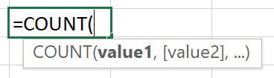

Figure 17: COUNT function

|  |  |
| --- | --- |
|  | Video  To review the video on how to use the COUNT function, go to: [COUNT function](https://aka.ms/COUNT-function) |

### The COUNTA Function

The COUNTA function counts the number of cells that are not empty in a specified range. Values that are counted include numbers, text, logical values, error values, and empty text strings.

The COUNTA function does not count cells that are completely empty.

Figure 18 shows the structure of the COUNTA function. The function begins with an equal (=) sign followed by the name and opening parentheses. The value1 argument is required and typically refers to a range of cells. All other arguments are optional.

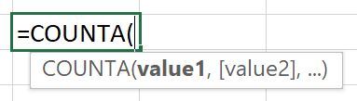

Figure 18: COUNTA function

|  |  |
| --- | --- |
|  | Additional information  For more information on using the COUNTA function, go to: [COUNTA function](https://aka.ms/counta-function) |

### Activity: Discuss and learn

This is a teacher-led discussion and demonstration about how to use the COUNT and COUNTA functions in an Excel worksheet.

#### Resources required

You will need the following resources for this activity:

None.

#### Activity instructions

Pay close attention as your teacher demonstrates the following tasks. You will have a chance to test out your new knowledge on your own after the teacher-led demonstration:

1. Use the COUNT function to determine how many Produce Box types have had sales to shareholders.
2. Use the COUNTA function to determine how many Produce Box types have been allocated to shareholders.

### Try-it: Use COUNT and COUNTA functions to analyze data

 In each of these exercises, you will open a sample document and practice using the COUNT and COUNTA functions.

### Try-it 1

In this try-it, you will open a sample document and practice using COUNT function.

#### Resources

You will need the following resources for this try-it:

* Open L4_T1_try1_count_producebox_starter.xlsx in this lesson’s Learning Activity Resources.

#### Instructions

The following are the general tasks that you need to perform during this try-it:

1. On the Sales tab, in cell E10, use the Function Library to enter a function that counts how many Produce Box types have been sold to shareholders.
2. In cell B5, enter 150. Does the count change?
3. In cell E7, enter the text Yes. Does the count change?
4. Save and close the file.

### Try-it 2

In this try-it, you will open a sample document and practice using COUNTA function.

#### Resources

You will need the following resources for this try-it:

* Open L4_T1_try2_counta_producebox_starter.xlsx in this lesson’s Learning Activity Resources.

#### Instructions

The following are the general tasks that you need to perform during this try-it:

1. On the Allocation tab, in cell G9, use the Function Library to enter a function that counts how many Produce Box types have been allocated to shareholders.
2. In cells D5 and H4 enter Yes. Does the count change?
3. In cells B5 and G6 enter 100. Does the count change?
4. How does the COUNTA function differ from the COUNT function used in the previous exercise?
5. Save and close the file.

## Topic 2: Use the COUNTBLANK function

The COUNT and COUNTA functions are quite beneficial in counting the number of cells that have a supported value entered. However, both these functions do not count the number of cells that, when evaluated, return a blank value. There may be circumstances, especially in financial analysis worksheets, where you might need to determine how many cells return a blank value when evaluated.

### The COUNTBLANK function

The COUNTBLANK function counts the number of empty or blank cells in a specified range. Any cells that include numbers, text, logical values, and error values are not counted.

Consider the following when you use the COUNTBLANK function:

* Cells that contain zero (0) are not considered blank and will not be counted because zero is a number.
* If a cell contains a formula that returns an empty text string (“ “), Excel will consider the cell blank and will count that cell.

Figure 19 shows the structure of the COUNTBLANK function. The function begins with an equal (=) sign followed by the name and opening parentheses. The range argument is required and refers to a range of cells to be evaluated.

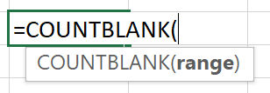

Figure 19: COUNTBLANK function

|  |  |
| --- | --- |
|  | Additional information  For more information on the COUNTBLANK function, go to: [COUNTBLANK function](https://aka.ms/countblank-function) |

### Activity: Pose a challenge

This is a teacher-led discussion and demonstration about how to use the COUNTBLANK function in an Excel worksheet.

#### Resources required

You will need the following resources for this activity:

None.

#### Activity instructions

Pay close attention as your teacher demonstrates the following tasks. You will have a chance to test out your new knowledge on your own after the teacher-led demonstration:

* On the Membership Summary tab, determine how many entries are missing in the New Membership section of the table.

### Try-it: Use the COUNTBLANK function

 In this try-it activity, you will use the COUNTBLANK function to determine empty cells in a worksheet.

#### Resources

You will need the following resources for this try-it:

* Open L4_T2_try_summary_starter.xlsx in this lesson’s Learning Activity Resources.

#### Instructions

The following are the general tasks that you need to perform during this try-it:

1. On the Membership Summary tab, in cell F35, use the Function Library to enter a function that will determine how many entries are missing in the New Membership section of the table.
2. In cell F37, use the Function Library to enter a function that will determine how many entries are missing in the Renewed Membership section of the table.
3. Review the results and ensure that the results match the number of missing entries in the table.
4. Save and close the file.

## Wrap-up

Use these questions to check what you learned in this lesson:

1. The COUNT function will not count negative numbers when evaluating a range of values. True or false?

Select the correct option.

1. True
2. False
3. A cell that contains zero (0) is evaluated as a blank cell. True or false?

Select the correct option.

1. True
2. False
3. The COUNTBLANK function counts the following value types:

Select all that apply.

1. Numeric constants
2. Numeric cell ranges
3. Empty text strings
4. Empty cells
5. Errors
6. The Select here to enter text. function counts all the numeric values in a specified range.

Fill in the blank space.

# Lesson 5: Using logical functions

## Overview

One of the more powerful aspects of Excel is its ability to perform a logical comparison between values in a worksheet and produce a result. In many cases, the result is further evaluated, and specific actions are performed to provide additional insight into the analysis. Excel includes a variety of logical functions, including Boolean functions, conditional functions, and constant value functions.

In this lesson, you are introduced to the IF function, which is one of the most popular conditional logical functions in Excel.

## Warm-up

Use these questions to find out what you already know about this lesson’s topics:

1. You are constructing an IF statement that evaluates whether cell C9 is greater than 150. Which logical operator would you use?

Select the correct option.

1. =
2. <
3. >
4. <>
5. How many arguments does a typical IF statement use to evaluate conditions?

Select the correct option.

1. 1
2. 3
3. 2
4. 4

1. Describe what happens with the following IF statement; =IF(A10>100, “Great!”, “Not good”)

Select to enter text.

Fill in the blank space.

## Topic 1: Understand IF statements

 To fully understand how the IF function works in Excel, it is important to recognize the main elements of a typical IF statement.

An IF statement:

* Evaluates a specified condition.
* Returns one result if the evaluated condition is true.
* Returns another result if the evaluated condition is false.

For example, consider the following statement:

* If sales are greater than $2,000, calculate a 10 percent bonus; otherwise, calculate a 5 percent bonus.

This statement contains a condition (if sales are greater than $2,000) and then describes what to do if the condition is true (calculate a 10 percent bonus) and what to do if the condition is false (calculate a 5 percent bonus).

Consider this second example:

* If your test score is greater than 65 percent, you pass; otherwise, you must retake the test.

This statement contains the condition, “score is greater than 65 percent”. If the condition is true, you pass; if the condition is false, you must retake the test.

### Use logical operators

As you create an IF statement, you will often use logical operators to specify the conditions to be evaluated. Table 4 describes some of the common logical operators used when specifying conditions for IF statements.

|  |  |  |
| --- | --- | --- |
| Logical operator | Description | Example |
| > | Greater than | A1 > B1 |
| < | Less than | A1 < B1 |
| Logical operator | Description | Example |
| = | Equal to | A1 = B1 |
| <> | Not equal to | A1 <> B1 |
| >= | Greater than or equal to | A1 >= B1 |
| <= | Less than or equal to | A1 <= B1 |

Table 4: Logical operators used for conditions

### Activity: Discuss and learn

In this activity, the teacher will display several IF statements for you to analyze.

#### Resources required

You will need the following resources for this activity:

None.

#### Activity instructions

Follow along as the teacher presents several IF statements. As you analyze each statement, discuss:

* What is the condition being evaluated?
* What happens if the result is true?
* What happens if the result is false?

### Try-it: Understand IF statements

 This try-it activity has you identify examples of using IF statements in Excel.

#### Resources

You will need the following resources for this try-it:

None.

#### Instructions

The following are the general tasks that you need to perform during this try-it:

1. Pair up with a fellow student and discuss: What are three situations where an IF statement would be useful in an Excel worksheet?
2. Share your ideas with the class.

## Topic 2: Use the IF function

IF statements are integrated into an Excel worksheet by using the IF function. The IF function follows the same principle as an IF statement where a condition is evaluated and then returns a specific result based upon a TRUE or FALSE evaluation.

IF functions are quite useful in an Excel worksheet such as in the following situations:

* You need to test if a condition is true or false when evaluated against data in a worksheet.
* You need to output specific text based upon the evaluation of a condition.
* You need to perform additional calculations on data based upon the evaluation of a condition.

### IF function syntax

As shown in Figure 20, the IF function begins with an equal (=) sign followed by the name and opening parentheses. The function contains three arguments described as follows:

* logical_test (required)—A value or expression that specifies the condition you want to test.
* value_if_true (optional)—The value you want returned if the result of the logical_test is TRUE. This can contain numbers, text, and additional formulas or functions to be evaluated.
* value_if_false (optional)—The value you want returned if the result of the logical_test is FALSE. This can contain numbers, text, and additional formulas or functions to be evaluated.

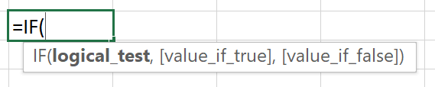

Figure 20: IF function

### Considerations when using the IF function

As shown in the syntax, the IF function only requires the logical_test argument in the formula. Both the value_if_true and the value_if_false arguments are optional. It is important to understand the impact to your formula if you omit the TRUE or FALSE arguments.

When constructing an IF function, consider the following:

* If you omit the value_if_true argument, the IF function will return 0 when the condition is met. For example, consider the following statement:  
  =IF(A1>100, “No”)  
  If A1 is greater than 100, then 0 will automatically display since the second argument is omitted. If A1 is not greater than 100, the text “No” will display.
* If you omit the value_if_false argument, when the condition is false, the IF function will return the logical value of FALSE. If you place a comma after the value_if_true argument, the evaluation will return a 0. For example, consider the following statement:   
  =IF(A1>100, “Yes”)  
  The value_if_false argument is omitted. This results in the logical value of FALSE being displayed. If you place a comma after the word “Yes”, the evaluation will return a 0.

|  |  |  |
| --- | --- | --- |
|  | | Did you know?  If you do not want the IF statement to display any value when the condition is evaluated, enter double quotes (““) in the argument that you want to have blank. For example: =IF(A1>100, “Yes”, ““) results in an empty string when the formula is evaluated as FALSE. |
|  | Video  To review the video and additional information on how to use the IF function, go to: [IF function](https://aka.ms/IF-function) | |

### Activity: Show and tell

In this activity, your teacher will demonstrate and explain how to use the IF function in an Excel worksheet.

#### Resources required

You will need the following resources for this activity:

None.

#### Activity instructions

Pay close attention as your teacher demonstrates and explains the following tasks:

1. Determine the structure of an IF statement.
2. Construct an IF function to perform an evaluation of data.

### Try-it: Use the IF function

 In this try-it activity, you will open a sample document and create and troubleshoot IF functions.

### Try-it 1

In this try-it, you will open a sample document and create an IF function.

#### Resources

You will need the following resources for this try-it:

* Open L5_T2_try1_matching_if_statement_starter.xlsx in this lesson’s Learning Activity Resources.

#### Instructions

The following are the general tasks that you need to perform during this try-it:

1. In the Company Match column, in cell G3, create a formula that evaluates the following:
   * If the donation amount is over $150, display the word “Match.”
   * If the donation amount is not over $150, display the word “No Match.”
2. Copy the formula created in cell G3 to cells G4 through to G8.
3. Bonus step: Apply a conditional formatting rule to the Company Match column that highlights all entries that say Match with a Light Red Fill with Dark Red Text.
4. In cell H2, enter the column heading Match Amount.
5. In the Match Amount column, in cell H3, create a formula that evaluates the following:
   * If the Company Match entry says Match, then multiply the donation amount by 2 to get the match amount.
   * If the Company Match entry says No Match, then display 0 in the Match amount column.
6. Copy the formula created in cell H3 to cells H4 through to H8.
7. Save and close the file.

### Try-it 2

In this try-it, you will open a sample document and edit an IF function.

#### Resources

You will need the following resources for this try-it:

* Open L5_T2_try2_edit_if_statement_starter.xlsx in this lesson’s Learning Activity Resources.

#### Instructions

The following are the general tasks that you need to perform during this try-it:

1. In the Company Match column, in cell G3, edit the If statement as follows:
   * If the donation amount is equal to or over $150, then multiply the donation amount by 2 to get the company match amount.
   * If the donation amount is not over $150, then display a blank cell.
2. Copy the formula created in cell G3 to cells G4 through to G8.
3. Save and close the file.

## Wrap-up

Use these questions to check what you learned in this lesson:

1. An IF function can contain additional calculations as arguments. True or false?

Select the correct option.

1. True
2. False
3. Describe what happens with the following IF statement; =IF(C20>=25,C20*5,) Select to enter text.

Fill in the blank space.

1. Consider the following formula: =IF(C20>=25,C20*5,). What happens to a false result if you remove the last comma in the If statement?

Select the correct answer.

1. 0 is displayed.
2. FALSE is displayed.
3. Error is displayed.
4. C20*5 is displayed.

# Glossary

|  |  |
| --- | --- |
| Formula | A mathematical equation that performs calculations on values in a worksheet. |
| Value | A representation in Excel that can be a number, cell address, date, text, or range of cells. |
| Constant | A number or text value that is entered directly into a cell. |
| Operator | An indicator used to specify the type of calculation to take place, such as add (+); subtract (-); multiply (*); or divide (/). |
| Function | A pre-built command in Excel that performs mathematical operations such as automatically adding up a range of cells or looking up values to be used in calculations. |
| Order of operations | A standard mathematical process used to determine which operator to calculate first when evaluating a formula. |
| Cell reference | Identifies a cell’s location within a worksheet. |
| Relative cell reference | A cell or range reference in a formula that changes based upon the relation to the cell containing the formula. |
| Absolute cell reference | A cell reference in a formula that refers to a specific cell or range regardless of where the formula is located in the worksheet. |
| Mixed cell reference | A cell or range in a formula that uses both a relative and absolute reference. |
| Named range | A single cell or group of cells in an Excel worksheet with a designated name. |
| Function | A predefined formula that is used for a specific purpose and performs special calculations in an Excel worksheet. |

Table 5: Glossary terms and definitions

# Cornerstone

## Overview

To help prepare for the post-event review meeting, you need to complete a report that calculates and summarizes the attendance and ticket sales data to help the management team assess the success of the event. You also need to determine a donation amount and a bonus amount based upon total sales. In this cornerstone, you will use formulas and functions to analyze and calculate the sales data results.

## Objectives

The following table outlines the Cornerstone objectives and their corresponding Microsoft Office Specialist (MOS) exam objectives.

|  |  |
| --- | --- |
| Configure, reference, and display named ranges in formulas. | 1.4.6: Display formulas  4.1.2: Reference named ranges and named tables in formulas |
| Configure absolute references in formulas. | 4.1.1: Insert relative, absolute, and mixed references |
| Calculate formulas using SUM, AVERAGE, MAX, and MIN functions | 4.2.1: Perform calculations by using the AVERAGE(), MAX(), MIN(), and SUM() functions |
| Count values using COUNT and COUNTBLANK functions | 4.2.2: Count cells by using the COUNT(), COUNTA(), and COUNTBLANK() functions |
| Perform conditional operations using the IF function | 4.2.3: Perform conditional operations by using the IF() function |

Table 6: Cornerstone objectives

## Duration

50 minutes

## Instructions

1. Complete the tasks below for each file.
2. When saving your file, add your name to the end of the filename; for example, “Cornerstone_attendance_ticketsales_Dwayne_Espino.” Follow your teacher’s directions for where to save your files.
3. When you’re done with the Cornerstone, assess your completion and enter the points you think you earned within the task lists below. You can use the help of your teacher if you need it.

## Tasks

You will work with one file in this Cornerstone. The following are the tasks you need to do within the file.

### File 1: Cornerstone_attendance_ticketsales_starter.xlsx

#### Task: Configure, reference, and display named ranges in formulas (10 points)

1. Open Cornerstone_attendance_ticketsales_starter.xlslx. On the BlueberryFestival worksheet, configure a named range called Attendance that includes values B5 to B10. (2 points) (Exam objective 4.1.2)
2. Configure a named range called Cost_per_Ticket that includes values C5 to C10. (2 points) (Exam objective 4.1.2)
3. In cell D5, calculate the total sales for each membership category. Be sure to create a formula that references the named ranges. (2 points) (Exam objective 4.1.2)
4. Copy the formula from cell D5 to cells D6 through D10. (2 points)
5. Turn on the Show Formulas command. Call your teacher to verify this step and then turn off the Show Formulas command. (2 points) (Exam objective 1.4.6)

Points scored: Select to enter text. /10

#### Task: Calculate formulas using SUM, AVERAGE, MAX, and MIN functions (12 points)

1. On the BlueBerryFestival sheet, in cell A12, enter the label Total Ticket Sales: and then apply the bold format to the label. (1 point)
2. In cell D12, use the SUM function to add the numbers in the Total column. (2 points) (Exam objective 4.2.1)
3. In cell A13, enter the label Average Attendance: and then apply the bold format to the label. (1 point)
4. In cell D13, use the AVERAGE function to average the numbers in the Attendance column. Format the cell to have no decimal places if necessary. (2 points) (Exam objective 4.2.1)
5. In cell A14, enter the label Maximum Attendance: and then apply the bold format to the label. (1 point)
6. In cell D14, use the MAX function to return the maximum attendance number. (2 points) (Exam objective 4.2.1)
7. In cell A15, enter the label Minimum Attendance: and then apply the bold format to the label. (1 point)
8. In cell D15, use the MIN function to return the minimum attendance number. (2 points) (Exam objective 4.2.1)

Points scored: Select to enter text. /12

#### Task: Configure absolute references in formulas (8 points)

1. On the BlueBerryFestival sheet, in cell A19, enter the label Donation Percentage: and then apply the bold format to the label. (1 point)
2. In cell E4, enter the label Donation Amount and then apply the bold format to the label. Expand the column as needed to fit the title. (1 point)
3. Format cell B19 with the Percent format and then enter 10% into the cell. (1 point)
4. In cell E5, use a formula to determine the Donation Amount based upon the Donation Percentage and Total Sales/Membership amounts. Be sure to configure absolute references as needed. (3 points) (Exam objective 4.1.1)
5. Copy the formula from cell E5 to E6 through to E10. (2 points)

Points scored: Select to enter text. /8

#### Task: Perform conditional operations using the IF function (6 points)

1. On the BlueBerryFestival sheet, in cell F4, enter the label Bonus and then apply the bold format to the label. (1 point)
2. In cell F5, use a formula to evaluate the following: (3 points) (Exam objective 4.2.3)

If the Donation Amount is greater than 100, calculate a 10 percent bonus on the Donation amount; otherwise, leave a blank cell.

1. Copy the formula from cell F5 to F6 through to F10. (2 points)

Points scored: Select to enter text. /6

#### Task: Count values using COUNT and COUNTBLANK functions (9 points)

1. On the BlueBerryFestival sheet, in cell A16, enter the label Number of Bonus Entries: and then apply the bold format to the label. (1 point)
2. On the BlueBerryFestival sheet, in cell A17, enter the label Number of No Bonus Entries: and then apply the bold format to the label. (1 point)
3. In cell C16, use a formula to count the number of cells under the Bonus heading that contains a value. (2 points) (Exam objective 4.2.2)
4. In cell C17, use a formula to count the number of empty cells under the Bonus heading. (2 points) (Exam objective 4.2.2)
5. Format all numbers that represent dollar amount to the Currency format. (3 points)

Points scored: Select to enter text. /9

FILE 1 TOTAL POINTS: Select to enter text. /45