

Student Guide

40567A  
Microsoft Excel associate 2019

Module 6: Getting and transforming data

Contents

Contents 2

Module overview 5

Description 5

Scenario 6

Cornerstone 6

Lesson 1: Importing data 7

Overview 7

Warm-up 7

Scenario 8

Topic 1: Get data from other sources 8

Get & transform data 8

Activity: Pose a challenge 9

Try-it: Get data from other sources 9

Topic 2: Import data from .txt files 10

[Using Notepad to review a .txt   
file 10](#_Toc29043495)

Getting data from .txt files 10

Activity: Show and tell 11

Try-it: Import data from .txt files 11

Topic 3: Import data from .csv files 12

[Using Notepad to review a .csv   
file 12](#_Toc29043500)

Getting data from .csv files 12

Activity: Show and tell 12

Try-it: Import data from .csv files 13

Wrap-up 14

Lesson 2: Manipulating text 15

Overview 15

Warm-up 15

Topic 1: Convert text to columns 16

Splitting text into columns 16

Activity: Discuss and Learn 17

Try-It: Convert text to columns 18

Topic 2: Extract text by using the LEFT, RIGHT, MID, and LEN functions 19

LEFT function 19

RIGHT function 20

LEN function 21

MID function 21

Character counting 22

Activity: Show and tell 23

Try-it: Extract text by using the LEFT, RIGHT, MID, and LEN functions 24

Try-it 1 24

Try-it 2 25

Try-it 3 25

Try-it 4 26

Wrap-up questions 26

Lesson 3: Converting text 28

Overview 28

Warm-up questions 28

Topic 1: Convert text by using the PROPER function 29

Converting Text: PROPER 29

[Copying a formula to multiple   
cells 29](#_Toc29043530)

Using Paste Special 30

Activity: Tell a story 31

Try-it: Convert text by using the PROPER function 31

Try-it 1 32

Try-it 2 32

Try-it 3 32

Topic 2: Convert text by using the UPPER and LOWER functions 33

Converting Text: UPPER 33

Converting Text: LOWER 34

Activity: Show and tell 34

Try-it: Convert text by using the UPPER and LOWER functions 35

Try-it 1 35

Try-it 2 35

Try-it 3 36

Wrap-up 36

Lesson 4: Combining text 38

Overview 38

Warm-up 38

Topic 1: Combine text by using the CONCAT function 39

Combining text: CONCAT 39

Adding space or a word between data when using the CONCAT function 40

Combining text using absolute cell references 40

Activity: Discuss and learn 41

Try-it: Combine text by using the CONCAT function 42

Try-it 2 43

Try-it 3 43

Topic 2: Combine text by using the TEXTJOIN function 44

Combining text: TEXTJOIN 44

Combining text: CONCAT and TEXTJOIN 44

Activity: Pose a challenge 45

Try-it: Combine text by using the TEXTJOIN function 46

Try-it 1 46

Try-it 2 47

Wrap-up 47

Lesson 5: Inserting hyperlinks 49

Overview 49

Warm-up 49

Topic 1: Insert hyperlinks to navigate inside a workbook 50

Creating a hyperlink to place within the document 51

[Creating a hyperlink to a cell   
range 52](#_Toc29043570)

Activity: Tell a story 53

Try-it: Insert hyperlinks to navigate inside a workbook 55

Try-it 1 55

Try-it 2 55

Try-it 3 56

Topic 2: Insert hyperlinks to navigate outside a workbook 57

[Creating a hyperlink to another   
file 57](#_Toc29043577)

Creating a hyperlink to a website 58

Activity: Discuss and learn 59

Try-it: Insert hyperlinks to navigate outside a workbook 60

Try-it 1 60

Try-it 2 61

Try-it 3 61

Topic 3: Remove hyperlinks 62

Removing a hyperlink: Edit Hyperlink dialog box 62

Removing a hyperlink: context menu 62

Removing hyperlinks from multiple cells 63

Try-it: Remove hyperlinks 63

Try-it 1 63

Try-it 2 64

Try-it 3 64

Wrap-up 65

Glossary 66

Cornerstone 67

Overview 67

Objectives 67

Duration 67

Instructions 68

Tasks 68

File 1: Blank new Excel file 68

# Module overview

## Description

At times you might want to work with large quantities of data within a spreadsheet. This can become difficult and cause errors when entering data manually into the spreadsheet. Microsoft Excel 2019 allows you to use other sources to import the needed data, thus reducing the potential for errors.

The following table outlines the lessons in this module and their corresponding learning objectives.

|  |  |  |
| --- | --- | --- |
| Lesson | Learning objective | Exam objective(s) |
| Importing data | Import data from text files (.txt and .csv) | 1.1.1  1.1.2 |
| Manipulating text | Use Text-to-Columns and the LEFT, RIGHT, MID, and LEN functions | 4.3.1 |
| Converting text | Use the PROPER, UPPER, and LOWER functions | 4.3.2 |
| Combining text | Use the CONCAT and TEXTJOIN functions | 4.3.2 |
| Inserting hyperlinks | Insert hyperlinks for navigation within and outside the workbook, and remove hyperlinks | 1.2.3 |
| Importing data into a workbook | Import data from text files; manipulate, convert, and combine text using Text-to-Columns and Text functions; insert hyperlinks for navigation | 1.1.1  1.1.2  1.2.3  4.3.1  4.3.2 |

Table 1: Objectives by lesson

## Scenario

The best months to sow, plant, and harvest crops are at a set time each year. As a Research & Development intern, you have been asked to check common problems with crop growth.

You have separate .csv and .txt files containing useful crop information. You need to import the data from these files into an Excel workbook. You also need to fix issues with the data formatting—some data has some text in upper case and lower case and unnecessary spaces. Other related data needs to be accessible from the workbook by inserting a hyperlink.

## Cornerstone

At times, you may use crop growth data from other sources to help plan the crop growth for Munson’s. This data might come in a .txt or .csv format, such as from government websites, which you are required to import into your workbook without retyping it. After importing the data, you may find capitalization errors in the data or you might want to separate or combine data from what you have been provided. You perform these tasks by using the built-in functions in Excel.

# Lesson 1: Importing data

## Overview

In this lesson, you’ll explore what is meant by data, and how you can bring large data sets into an Excel file. You’ll learn how to use the Get & Transform option to bring in data from .txt and .csv files.

## Warm-up

Use these questions to find out what you already know about this lesson’s topics:

1. Which of the following options best describes a .txt file?

Select the correct option.

1. A special spreadsheet file containing dates
2. A file used to store numbers
3. A file used to hold data without formatting
4. A file used to hold music files
5. What is a delimiter?

Select the correct option.

1. A way to combine data
2. A way to organize data
3. Something used to limit the use of data
4. A process to collect data
5. What is unique about a .csv file?

Select the correct option.

1. It contains only numeric data
2. The file uses a space to separate data
3. It uses a comma as a delimiter
4. It is a file type restricted to the use of a word processing program
5. List three ways you can separate data within a data file.

Select to enter text.

## Scenario

Munson’s Pickles and Preserves currently has a customer list containing customer names, addresses, and phone numbers in a document file. They need all the information within that file placed into an Excel workbook. You have been given the task to place the customer information into the Excel workbook. How would you attempt this task?

Come up with your own ideas on how to complete this task. Be prepared to discuss your ideas with a partner and then with the rest of the class.

## Topic 1: Get data from other sources

Data is a group of letters, symbols, and numbers that a computer can perform operations upon to create useful information. The data can be manipulated in different ways to create useful information. Data can be obtained from many different sources. Each time you enter your name and other information into a website to purchase an item or add your name to a mailing list, you are entering data that the computer will later use to perform a task for users of the data. You can store data in different types of files. Excel will allow you to use those files to enter the data into your Excel worksheet.

### Get & transform data

Excel allows you to get data from sources other than other Excel files, and enter the data yourself. To import data from other sources:

1. Select the Data tab.
2. On the Get & Transform Data tab, select to get data from the source of your choice.

|  |  |
| --- | --- |
|  | Additional information  For more information on importing data from external data sources, go to: [Import data from external data sources (Power Query)](https://aka.ms/Import-data-from-external-data-sources-Power-Query) |

### Activity: Pose a challenge

Excel’s Data tab allows you to get data from several different sources. In this activity, you’ll explore the functions within the Data tab.

#### Resources

You will not need any resources for this activity.

#### Activity instructions

Participate in the activity by following these instructions:

1. Open a blank Excel worksheet.
2. You have been given a word processor file with the names, addresses, and phone numbers of customers, and are asked to enter this data into an Excel spreadsheet.
3. You’re very limited on time. How do you get the data from the word processor file into the Excel spreadsheet correctly and quickly?

### Try-it: Get data from other sources

 In this standalone try-it, you will explore the options that are available within the Data tab.

#### Resources

You will not need any resources for this activity.

#### Instructions

The following steps are the general tasks that you need to perform during this try-it:

1. Open a blank Excel worksheet.
2. On the Home ribbon, select the Data tab.
3. Study the Get & Transform Data group.
4. Be prepared to discuss the following questions with the class:
   * What different data formats can you use with Excel?
   * What do you think is meant by .csv?
   * What resources do you think exist on the web that might be used for data?

## Topic 2: Import data from .txt files

Sometimes, you’ll have to work with data within a word-processor file. You can convert these files into a .txt file. A .txt file is a file format that contains no formatting; it has only text, numbers, and symbols. You can identify a .txt file by its extension .txt.

### Using Notepad to review a .txt file

To use Notepad to review a .txt file:

1. Locate a .txt file.
2. Right-click or access the context menu for the file, select Open With, and then select Notepad.

### Getting data from .txt files

To retrieve the data from .txt files:

1. Open a blank Excel workbook.
2. On the Home ribbon, select the Data tab.
3. In the Get & Transform Data group, select From Text/CSV.
4. In the Import Data dialog box, find the .txt file, and then select Import.
5. A second dialog box will open displaying the data you will be bringing into Excel. This dialog box allows you to preview the data prior to bringing it into Excel.
6. In the Delimiter drop-down menu, select the type of delimiter that will work for this file, and then select Load. A delimiter determines how the data is separated into columns. In this file, the delimiter is a tab.
7. The data from the .txt file will be loaded into the Excel file.

|  |  |
| --- | --- |
|  | Additional information  For more information on importing or exporting text (.txt or .csv) files, go to: [Import or export text (.txt or .csv) files](https://aka.ms/Import-or-export-text-txt-or-csv-files) |

### Activity: Show and tell

Opening .txt files using Notepad will enable you to preview what the file contains prior to using the Get & Transform Data tool within Excel.

#### Resources required

You will need the following resource for this activity:

* Open the L1_T2_act_customer_list.txt file in this lesson’s Learning Activity Resources folder.

#### Activity instructions

Participate in the activity by following these instructions:

1. Using the L1_T2_act_customer_list.txt file, right-click or access the context menu for the file, select Open With, and then select Notepad.
2. Study the data within the file and answer the following questions:
   * What data is included in the file?
   * What categories are used to organize the data?
   * How is the data separated? What is used between the categories?

### Try-it: Import data from .txt files

 In this standalone try-it, you will import data from a .txt file into a blank Excel worksheet.

#### Resources

You will need the following resource for this try-it:

* Locate the L1_T2_try_customer_list_starter.txt file in this lesson’s Learning Activity Resources folder.

#### Instructions

During this try-it, you will perform the following tasks:

1. In a blank Excel workbook, get the data from the L1_T2_try_customer_list_starter.txt and import it into the blank workbook using Tab as the delimiter.
2. Save your work.

## Topic 3: Import data from .csv files

Sometimes, you will find data within a .csv file. .csv stands for Comma Separated Values. The process for importing .csv data into Excel is very similar to the process for importing .txt data. However, a .csv file is set up in a slightly different way.

### Using Notepad to review a .csv file

To use Notepad to review a .csv file:

1. Locate a .csv file.
2. Right-click the file or open it from the context menu, select Open With, and then select Notepad.

### Getting data from .csv files

To get data from a .csv file:

1. Using a blank Excel workbook, on the Home ribbon, select the Data tab.
2. In the Get & Transform Data group, select From Text/CSV.
3. In the Import Data dialog box, find the .csv file, and then select Import.

A second dialog box will open displaying the data you will be bringing into Excel. This dialog box allows you to preview the data prior to bringing it into Excel.

1. In the Delimiter drop-down menu, select Comma. A .csv file separates the data into columns using a comma. Then, select the Load button.

The data from the .csv file will be loaded into the Excel file.

|  |  |
| --- | --- |
|  | Additional information  For more information on importing or exporting text (.txt or .csv) files, go to: [Import or export text (.txt or .csv) files](https://aka.ms/Import-or-export-text-txt-or-csv-files) |

### Activity: Show and tell

You can open a .csv file using the Notepad app the same way you can open a .txt file. Opening .csv files using Notepad will allow you to preview what the file contains prior to using the Get & Transform Data group within Excel.

#### Resources required

You will need the following resource for this activity:

* Locate L1_T3_act_customer_purchases.csv file in this lesson’s Learning Activity Resources folder.

#### Activity instructions

Participate in the activity by following these instructions:

1. Using the L1_T3_act_customer_purchases.csv file, right-click the file or open the context menu, select Open With, and then select Notepad.
2. Study the data within the file and answer the following questions:
3. What data does this file contain?
4. What categories are used to organize the data?
5. Can you locate the commas that separate the categories?

### Try-it: Import data from .csv files

 In this standalone try-it, you will import data from a .txt file into a blank Excel worksheet.

#### Resources

You will need the following resource for this try-it:

* Locate the L1_T3_try_customer_purchases_starter.csv file in this lesson’s Learning Activity Resources folder.

#### Instructions

You will perform the following general tasks during this try-it:

1. In a blank Excel workbook, import the data from the L1_T3_try_customer_purchases_starter.csv file and use Comma as the delimiter.
2. Save your work.

## Wrap-up

Use these questions to check what you learned in this lesson:

1. What does a delimiter do?

Select the correct option.

1. It provides a way to give color and style to a workbook.
2. It tells Excel how to organize data into columns.
3. It tells Excel where to place a title for a workbook.
4. It gives information about the data being imported.
5. What delimiter does a CSV file use?

Select the correct option.

1. Tab
2. Spacebar
3. Hash tag
4. Comma
5. What is data?

Select all that apply.

1. It’s a group of letters, numbers, and symbols that a computer can perform an operation on.
2. It’s the same thing as information.
3. It’s information that is used to track daily sales.
4. It’s a graphical representation.
5. Select here to enter text. is the option users use in Excel to bring in data from sources such as TXT and CSV files.
6. Give a detailed example of when you might need to bring outside data into Excel to create a worksheet.

Select here to enter text.

# Lesson 2: Manipulating text

## Overview

When using data files, sometimes the data isn’t divided up into useful components. At times, two or more pieces of data will be included within the same category, when the user will want it to be in separate categories. Excel allows you to manipulate the data so that you can separate one category of data into two or more columns.

## Warm-up

Use these questions to find out what you already know about this lesson’s topics:

1. Which of the following options would be the best way to separate data?

Select the correct option.

1. One category: Name + address + zip code + phone number
2. Two categories: Name + address & zip code + phone number
3. Three categories: Name & address & zip code + phone number
4. Four categories: Name & address & zip code & phone number
5. Which of the following options would be the best way to categorize someone’s name?

Select the correct option.

1. Just one category with first and last name.
2. Just one category with the last name first and first name last.
3. Two categories with the first and last name in one category and the phone number in the second category.
4. Two categories with the first name in one category and the last name in a second category.
5. Which of the following answers explains how to use the MID function?

Select the correct option.

1. MID allows users to find the midpoint of a line.
2. The MID function allows the user to specify a starting point and how many characters to extract from that point.
3. The MID function takes the data to the left and the right of a category starting from the middle of the data.
4. MID finds the middle column of a group of columns within a workbook.
5. To separate the area code from a phone number, use the Select here to enter text. function.
6. Explain how separating the area code from a phone number might be useful.

Select here to enter text.

## Topic 1: Convert text to columns

 Munson’s Pickle and Preserves now has their Customer List and Customer Purchases data in an Excel file. They would like to increase their marketing efforts assigning two marketing associates to make calls to follow up with their customers. As many of their customers are within the state of Kansas, it makes sense to assign one marketing associate to the state of Kansas, and the second to all the other states. To complete this task, Munson’s needs to separate all the phone numbers within their Customer List into area codes and phone numbers.

### Splitting text into columns

You can separate data from one column into multiple columns. To separate the data, you use a delimiter. A delimiter is a method for separating text.

To split text into columns:

1. On the Home ribbon, select the Data tab, and locate the Data Tools group.
2. Select the column containing the data you want to separate.
3. Select the Text to Columns option.
4. In the Convert Text to Columns Wizard - Step 1 of 3, make sure the Delimited radio button has been selected.

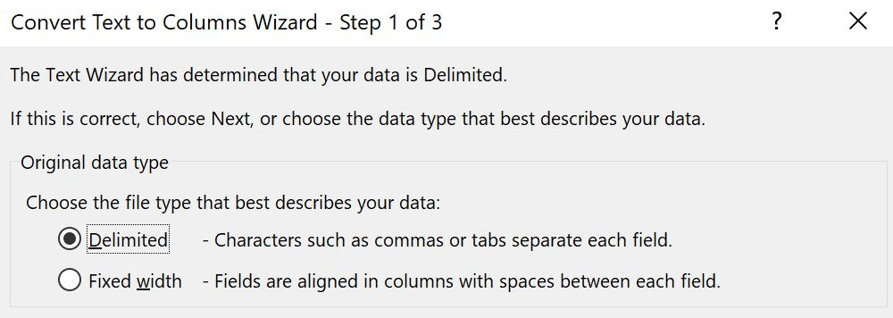

Figure 1: Convert Text to Columns Wizard - Step 1 of 3 dialog box

1. Select the Next button.
2. In the Convert Text to Columns Wizard - Step 2 of 3, select the type of delimiter to use to separate the data. The Other choice allows you to enter a dash as a delimiter.

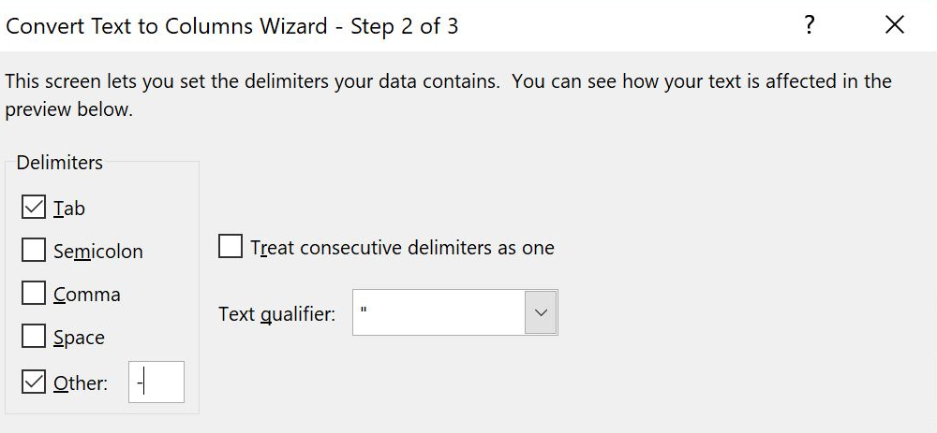

Figure 2: Convert Text to Columns Wizard - Step 2 of 3 dialog box

1. Select Finish.

Your .csv file will now be entered into your Excel file.

### Activity: Discuss and learn

Munson’s has sent an email asking for data in one column of a workbook to be split into two columns. What type of data do you think could be in the column that needs to be split into two columns?

#### Resources required

You will need the following resource for this activity:

* Locate L2_T1_act_customer_names_starter.xlsx file in this lesson’s Learning Activity Resources folder.

#### Activity instructions

Participate in the activity by completing these steps:

1. On the Data tab locate the Data Tools group.
2. Select column A (the column with the customer names in it).
3. Select the Text to Columns option.
4. In the Convert Text to Columns Wizard - Step 1 of 3, make sure the Delimited radio button has been selected.
5. Select Next.
6. In the Convert Text to Columns Wizard - Step 2 of 3, select the Space option.
7. Select Finish.

Your result should place the customer’s first name in the A column and the customer’s last name in the B column.

### Try-it: Convert text to columns

One way to divide up the phone numbers into area codes and phone numbers is to use Text to Columns. Text to Columns uses a delimiter to determine how to separate the text into separate columns. A delimiter could be any character that is used between the separate parts.

#### Resources required

You will need the following resource for this try-it:

* Open the L2_T1_try_customer_list_starter.xlsx file found in this lesson’s Learning Activity Resources folder.

#### Instructions

You will need to perform the following general tasks during this try-it:

1. Select column H (the column with the phone numbers in it).
2. Use the Text to Columns option to separate the phone number into columns using the dash as the delimiter.
3. Save your work.

## Topic 2: Extract text by using the LEFT, RIGHT, MID, and LEN functions

Using the Text to Columns feature doesn’t really fix Munson’s problem. When using the Text to Columns function, the area code is separated out, but the seven-digit phone number is separated into two parts because of the second dash. Munson’s would like the area code by itself and the rest of the phone number left intact. There are several ways of accomplishing this task. All the solutions deal with the idea of extracting parts of a string.

A string is a collection of characters upon which no mathematical calculations are to be performed. For example, a phone number or zip code is a collection of specialized characters called numbers; however, these numbers are not going to be used in a mathematical way—they are a string.

Strings can contain groupings of specialized characters called text. The information you are reading now is text. The letters are grouped together to form words, the words are grouped together to form sentences, and so forth.

### LEFT function

The LEFT function allows you to select a specific number of characters starting from the left side of the data.

To use the LEFT function in a formula:

1. Select the cell where you want your resulting data to be placed.
2. In the formula bar, enter =LE
3. The wizard will offer suggestions to complete your function. Make sure LEFT is highlighted, and then select the Tab button.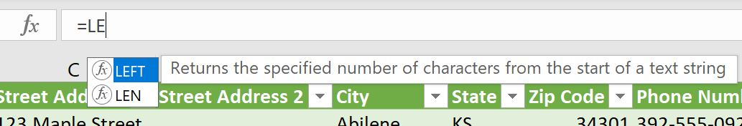

Figure 3: Wizard suggesting function names

The wizard leads you through completing your function by displaying the required data to complete the function. For example, =LEFT(text, [num_chars]). This function takes the left number of characters you specify from the text you enter.

### RIGHT function

The RIGHT function allows you to select a specific number of characters starting from the right side of the data.

To use the RIGHT function in a formula:

1. Select the cell where you want your resulting data to be placed.
2. In the formula bar, enter =RI.
3. The wizard will offer suggestions to complete your function. Make sure RIGHT is highlighted, and then select the Tab key.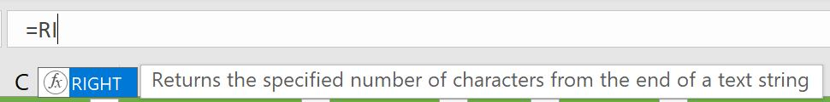

Figure 4: Wizard making function suggestions

1. The wizard will lead you through completing your function. It will display the data necessary to complete the function. For example, =RIGHT(text, [num_chars]). This is very similar to the LEFT function. This function takes the right number of characters you specify from the text you enter.

### LEN function

The LEN function counts the number of characters within a text string.

To use the LEN function in a formula:

1. Select the cell where you want your resulting data to be placed.

Variations of the LEFT and RIGHT functions make it possible to select various selections of text from data. For example, if you want to remove the area code from a phone number, you could do that combining the RIGHT function with the LEN function. The LEN function determines the length of the data and then manipulates the data according to your specifications.

1. In the formula bar, enter =RI.
2. The wizard will offer suggestions to complete your function. Make sure RIGHT is highlighted, and then select the Tab button.

Figure 5: Wizard making function suggestions

1. You want to remove the area code from each phone number. Enter the cell reference where the phone number is held. For example, if the phone number is stored in column B2 use B2 for the text reference in both the RIGHT and LEN functions. You will also need to subtract four characters from the length of the data. Your function should read like this: =RIGHT(B2,(LEN(B2)-4)).
2. You can combine the LEFT function with the LEN function in a similar manner.

### MID function

The MID function allows you to remove text from data starting at any point you designate within a text string. You can also designate the number of characters to extract from the data.

To use the MID function in a formula:

1. Select the cell where you want your resulting data to be placed.

An additional way to extract data from a column is to use the MID function. The MID function allows you to start from the left of the data and move in a specified number of characters and then extract so many characters.

1. In the formula bar, enter =MID.
2. The wizard will offer suggestions to complete your function. Make sure MID is highlighted, and then select the Tab button.

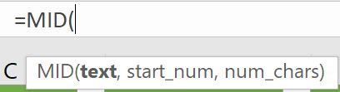

Figure 6: Wizard help tip

The MID function has three criteria that must be chosen to complete the extraction. First is the text, second is the start_num and third is the num_chars. The text and num_chars are the same criteria as used previously, but start_num allows the user to select how many characters from the left start of the data to begin extracting characters.

For this example, if a phone number is listed in B2, enter:

* + The B2 (the phone number and area code column) as the text area.
  + The number 5 for the start_num (this will allow the function to start after the dash following the area code).
  + The number 3 for the num_chars (this will extract only the phone number prefix). Your function should read like this: =MID(B2,5,3).

You can use the LEFT, RIGHT, MID, and LEN functions in various formats to extract data from a row, and then place the extracted data into a new location.

### Character counting

You begin counting with the number 1. But a computer begins with 0. This is important to remember when counting characters and determining character positions.

Using this information, answer the following questions using the sentence that follows:

Today is Thursday.

1. In what position is the first d?
2. Begin counting each letter starting with 0.
3. The first d is in the 2 position. (T is 0, o is 1, and d is 2.)
4. In what position is the first s?
5. Begin counting each letter starting with 0.
6. The first s is in position 7. (T is 0, o is 1, d is 2, a is 3, y is 4, space is 5, i is 6, and s is 7.)
7. Spaces are always counted.
8. In what position is the second s? The second s is in the 13 position.

|  |  |
| --- | --- |
|  | Additional information  For more information on the LEFT function, go to: [LEFT, LEFTB functions](https://aka.ms/LEFT-LEFTB-functions) |
|  | Additional information  For more information on the RIGHT function, go to: [RIGHT, RIGHTB functions](https://aka.ms/RIGHT-RIGHTB-functions) |
|  | Additional information  For more information on the LEN function, go to: [LEN, LENB functions](https://aka.ms/LEN-LENB-functions) |
|  | Additional information  For more information on the MID function, go to: [MID, MIDB functions](https://aka.ms/MID-MIDB-functions) |

### Activity: Show and tell

There might be times when you’ll need to separate data in a cell. This can happen when text in a column of data includes combined values. Selecting one of the functions will allow you to extract a portion of the data into a new cell.

#### Resources required

You will need the following resource for this activity:

* Locate L2_T2_act_zip_codes_starter.xlsx file in this lesson’s Learning Activity Resources folder.

#### Activity instructions

Participate in the activity by following these instructions:

1. In D1, enter LEFT. In E1, enter RIGHT. In F1, enter LEN. In G1, enter MID.
2. In D2, use the LEFT function to extract the five-digit zip code. Enter the function =LEFT(C2,5).
3. Use the Fill Handle to copy the formula for the remaining zip codes.
4. In E2, use the RIGHT function to extract the last four digits of the nine-digit zip code. Enter the function =RIGHT(C2,4).
5. Use the Fill Handle to copy the formula for the remaining zip codes.
6. In F2, use the LEFT and LEN functions to extract five-digit zip code and the dash following the five digits. Enter the function =LEFT(C2,LEN(C2)-4).
7. Use the Fill Handle to copy the formula for the remaining zip codes.
8. In G2, use the MID function to extract the two digits on each side of the dash. Your result should be similar to XX-XX where the X’s are numbers. Enter the function =MID(C2,4,5).
9. Use the Fill Handle to copy the formula for the remaining zip codes.

### Try-it: Extract text by using the LEFT, RIGHT, MID, and LEN functions

 In this leveled try-it activity, you will use the LEFT, RIGHT, MID, and LEN functions to extract data from an Excel worksheet.

### Try-it 1

In this try-it, you’ll use the LEFT function to extract the area codes from phone numbers.

#### Resources

You will need the following resource for this try-it:

* Open your Customer_List.xlsx file created in Lesson 1 or use the L2_T2_try1_customer_list_area_code_left_starter.xlsx in this lesson’s Learning Activity Resources folder.

#### Instructions

You will complete the following general tasks during this try-it:

1. In cell I1, enter Area Code.
2. In cell J1, enter Phone Number.
3. Use the LEFT function to extract the Area Code into I2.
4. Use the Fill Handle to copy the formula for the rest of the phone numbers.
5. Save your work.

### Try-it 2

In this try-it, you’ll use the RIGHT function to extract data to the right of a specified character.

#### Resources

You will need the following resource for this try-it:

* Open L2_T2_try2_customer_list_area_code_right_starter.xlsx in this lesson’s Learning Activity Resources folder.

#### Instructions

You will complete the following general tasks during this try-it:

1. In cell J2, use the RIGHT function to extract the phone number without the area code.
2. Use the Fill Handle to copy the formula for the rest of the phone numbers.
3. Save your work.

### Try-it 3

In this try-it, you’ll use the LEN function along with other functions to extract a specified number of characters from data.

#### Resources

You will need the following resource for this try-it:

* Open your Customer_List_Area_Code_RIGHT.xlsx file created in the Lesson 2 Try-it 2, or use the L2_T2_try3_customer_list_area_code_len_starter.xlsx in this lesson’s Learning Activity Resources folder.

#### Instructions

You will complete the following general tasks during this try-it:

1. Select cell K1, and then enter Four Digit.
2. Select cell K2.
3. Combine the RIGHT and LEN functions to extract the phone number prefixes.
4. Use the Fill Handle to copy the formula for the rest of the phone numbers.
5. Save your work.

### Try-it 4

In this try-it, you’ll use the MID function to extract a specified number of characters from data.

#### Resources

You will need the following resource for this try-it:

* Open L2_T2_try4_customer_list_area_code_mid_starter.xlsx in this lesson’s Learning Activity Resources folder.

#### Instructions

You will complete the following general tasks during this try-it:

1. Place the cursor in cell L1, and then enter Middle.
2. Select cell L2.
3. Use the MID function to extract the phone prefix.
4. Use the Fill Handle to copy the formula for the rest of the phone numbers.
5. Save your work.

## Wrap-up

1. The data in H2 is I like strawberries. What would the result be for the function =LEFT(H2,4)?

Select the correct option.

1. I lik
2. I like
3. I li
4. I like s
5. The data in J2 is the zip code 43892-3424. What would the result be for the function =MID(J2,7,4)?

Select all that apply

1. -342
2. -34
3. 3424
4. 424
5. There are Select here to enter text. characters in this zip code 45392-2342?
6. If the data in I2 is 345-555-3425, which of the following would result in the data 555 being extracted?

Select all that apply

1. =LEFT(I2,3)
2. =RIGHT(I2,8)
3. =MID(I2,5,3)
4. =LEFT(I2,LEN(I2)-5)
5. Indicate the correct order for entering the LEFT function in the formula bar.

Indicate the correct sequence by adding numbers 1 to 4 next to the following items.

1. Number of characters Select here to enter text.
2. LEFT Select here to enter text.
3. = Select here to enter text.
4. Cell reference Select here to enter text.

# Lesson 3: Converting text

## Overview

When importing data into Excel from outside sources, the data might not always be formatted correctly. Sometimes data will have all the text capitalized., which might not be the most useful way to understand it. Excel provides functions to change that data.

## Warm-up

1. Which of the following functions would correct the capitalization errors in MAIN STREET?

Select the correct option.

1. PROPER
2. UPPER
3. LOWER
4. TITLE
5. Which of the following is an example of the function LOWER?

Select all that apply

1. SUNSHINE
2. Rain
3. snow
4. wIND
5. How would you convert text within a spreadsheet from all lowercase to every first letter of every word capitalized?

Select all that apply

1. Reenter the information.
2. Use a function.
3. You can’t change it.
4. Use a text color tool.
5. What would the formula be to convert the text in A2:A10 to all lower-case?

Select here to enter text.

1. How would you replace the formulas in B2:B10 with the values from A2:A10?

Select here to enter text.

## Topic 1: Convert text by using the PROPER function

Munson’s just received a new customer list. When they opened the list, they found that the customers names, street addresses, and the state abbreviations are all lowercase. This is not the proper format for mailing out mail to their customers, and the file needs to be fixed. The customer list is rather large and reentering the names isn’t a feasible option.

### Converting Text: PROPER

The PROPER function capitalizes the first letter of each word within the selected cell.

To convert text using PROPER:

1. Select the cell where you want your resulting data to be placed.
2. Enter =PROPER( .
3. Enter the cell reference for the data you want to convert the first letter of each word to a capital letter.
4. End the formula with an ending parenthesis ). Your formula should be similar to =PROPER(A3).
5. Select Enter.

### Copying a formula to multiple cells

Use one of the following techniques to copy a formula to multiple cells:

* Right-click a cell or open the context menu, and select Copy. Then select the range of cells you want to copy the formula to, right-click or access the context menu, and then select Paste.
* Select the cell housing the formula, and from the Home tab, select Copy.
* Select the area you want to copy the formula to, and then from the Home tab, select Paste.
* Use the Fill Handle found in cell of the formula, and drag the Fill Handle down to H27.

### Using Paste Special

When using the PROPER function, the newly created data refers to the data found in the original location. Because the data in the original location isn’t that useful, it would be helpful to delete this data. However, if it’s deleted, the newly created data will contain an error message. To solve this problem, Excel provides a Paste Value option previously discussed in Module 2, Lesson 2: “Edit a worksheet.”

To use Paste Special:

1. After you have applied the PROPER function to the data and copied to the correct cells, keep the range of newly created cells selected.
2. Select Copy, and then select the Paste Special button.



Figure 7: Paste Special button

1. Within the Paste dialog box, select Paste Values, and then select Values. This will replace the formula that was created with the value from the referenced cell.

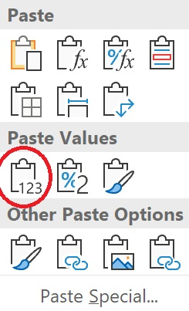

Figure 8: Paste Values

1. Adjust the column as needed to fit the data.

|  |  |
| --- | --- |
|  | Additional information  For more information on the PROPER function, go to: [PROPER function](https://aka.ms/PROPER-function) |
|  | Additional information  For more information on Paste Special, go to: [Paste options](https://aka.ms/paste-special-when-copying-from-excel) |

### Activity: Tell a story

You have just been given a .txt file and have been asked to import the data into an Excel workbook. When you finish importing the data into the workbook, you notice that all the text was entered with the CapsLock key on so all the letters are capitalized. Fortunately, Excel has functions to convert the case of text.

#### Resources required

You will need the following resource for this activity:

* Locate L3_T1_act_customer_names_starter.xlsx file in this lesson’s Learning Activity Resources folder.

#### Activity instructions

Participate in the activity by following these instructions:

1. In B2, enter =PROPER(A2), and then select Enter.

The data in A2 (tina bright) will be converted to Tina Bright.

1. Copy the formula from B2 to B3:B27.
2. Select the range B2:B27.
3. On the Home tab, in the Clipboard group, select Copy.
4. Select the Paste Special option.
5. In the dialog box, locate the Paste Values section.
6. Select the Paste Values, Values option. This will remove the formula reference and replace it with the converted text.

### Try-it: Convert text by using the PROPER function

 In this leveled try-it activity, you will use the PROPER function to convert text.

### Try-it 1

#### Resources

You will need the following resource for this try-it:

* Open L3_T1_try1_customer_list_starter.xlsx in this lesson’s Learning Activity Resources folder.

#### Instructions

You will perform the following general tasks during this try-it:

1. In H1, enter Names.
2. Use the PROPER function to convert the names within column H.
3. Save your work.

### Try-it 2

#### Resources

You will need the following resource for this try-it:

* Open L3_T1_try2_customer_list_starter.xlsx in this lesson’s Learning Activity Resources folder.

#### Instructions

You will perform the following general tasks during this try-it:

1. Converting a single cell wasn’t that helpful when all the names needed converted, so copy the formula from H2 to the range H3:H27.
2. Save your work.

### Try-it 3

#### Resources

You will need the following resource for this try-it:

* Open the L3_T1_try3_customer_list_starter.xlsx file in this lesson’s Learning Activity Resources folder.

#### Instructions

Review the formula that was previously entered in cells H2:H27 and note, these cells all refer to the data found in column A. Because the data in column A isn’t that useful, it would be nice to delete this column. However, if you delete column A, the cells in column H will contain an error message.

You will perform the following general tasks during this try-it:

1. In H1, enter Names.
2. In H2, convert the text from A2 using the PROPER function.
3. Copy this formula to H2:H27.
4. Use Paste Special to remove the PROPER function and replace it with the converted text.
5. Reuse these steps to convert the address from column B to column I, and the cities from column C to column J respectively using PROPER case. Don’t forget to use the Paste Values option.
6. Save your work.

## Topic 2: Convert text by using the UPPER and LOWER functions

 In the previous topic, PROPER case converted text so that the first letter of every word was capitalized. This isn’t always something you need though. At times, text needs to be converted to all uppercase or all lowercase. Both functions are similar in their use. This topic will focus on converting text to uppercase.

### Converting Text: UPPER

The UPPER function is similar in use to the PROPER function. However, the UPPER function converts text to all uppercase.

To convert text to all uppercase:

1. Select the cell where you want your converted text to be placed.
2. Enter =UPPER(.
3. Enter the cell reference for the data you want to convert, ending with a closing parenthesis ). Your resulting function should be similar to =UPPER(A2).

### Converting Text: LOWER

The LOWER function is similar in use to the PROPER and UPPER functions. However, the LOWER function converts text to all lowercase.

To convert text to all lowercase:

1. Select the cell where you want your converted text to be placed.
2. Enter =LOWER(.
3. Enter the cell reference for the data you want to convert, ending with a closing parenthesis ). Your resulting function should be similar to =LOWER(A2).

|  |  |
| --- | --- |
|  | Additional information  For more information on the UPPER function, go to: [UPPER function](https://aka.ms/UPPER-function) |
|  | Additional information  For more information on the LOWER function, go to: [LOWER function](https://aka.ms/LOWER-function). |

### Activity: Show and tell

You import another .txt file into Excel and this one has a mix of uppercase and lowercase data. In some cases, you have to change data from lowercase to uppercase and in other cases, you have to change data from uppercase to lowercase. You will use the Excel functions to convert the case of text.

#### Resources required

You will need the following resource for this activity:

* Locate L3_T2_act_customer_names_starter.xlsx file in this lesson’s Learning Activity Resources folder.

#### Activity instructions

Participate in the activity by following these instructions:

1. In C2, enter =UPPER(A2), and then select Enter.

All the letters in A2 will now be uppercase in C2.

1. In E2, enter =LOWER(A2), and then select Enter.

All the letters in A2 will now be lowercase in E2.

### Try-it: Convert text by using the UPPER and LOWER functions

 In this leveled try-it activity, you will use the UPPER function to convert text.

### Try-it 1

#### Resources

You will need the following resource for this try-it:

* Open L3_T2_try1_customer_list_starter.xlsx in this lesson’s Learning Activity Resources folder.

#### Instructions

You will complete the following general tasks during this try-it:

1. Place the cursor in cell K1, and then enter State.
2. Use the UPPER function in cell K2 to convert the two-digit state code to all uppercase letters.
3. Save your work.

### Try-it 2

#### Resources

You will need the following resource for this try-it:

* Open L3_T2_try2_customer_list_starter.xlsx in this lesson’s Learning Activity Resources folder.

#### Instructions

You will complete the following general tasks during this try-it:

1. Place the cursor in cell K3.
2. Use the UPPER function in cell K3 to convert the two-digit state code to all uppercase letters.
3. Use the Fill Handle to copy this formula from K3:K27.
4. Save your work.

### Try-it 3

#### Resources

You will need the following resource for this try-it:

* Open the L3_T2_try3_customer_list_starter.xlsx in this lesson’s Learning Activity Resources folder.

#### Instructions

You will complete the following general tasks during this try-it:

1. In K1, enter State.
2. Use the UPPER function in cell K2 to convert the two-digit state code to all uppercase letters.
3. Use the Fill Handle to copy this formula from K2:K27.
4. Apply Paste Special, Values to the cell range to remove the function and replace it with the correct text.
5. Save your work.

## Wrap-up

1. Which of the following options would be an example of the result after using the UPPER function?

Select the correct option.

1. guy rabin
2. GUY RABIN
3. gUY rABIN
4. Guy Rabin
5. Which function functions would be best to apply to a cell containing a title of a book where the first letter of every word should be capitalized?

Select all that apply.

1. UPPER
2. LOWER
3. TITLE
4. PROPER
5. By using Select here to enter text. the reference cells can be deleted because the formulas have converted to values.

# Lesson 4: Combining text

## Overview

Sometimes you might find that data from one area would be better served when combined with another area. For example, a data resource might have an individual’s first name in one column and the last name in another column. It might be best to combine the two data fields together. In the Customer Purchases file, the customer names were split into two separate columns. Excel provides a function that allows you to combine these two pieces of information into one.

## Warm-up

1. Which of the following situations would make most sense for combining them into one category?

Select the correct option.

1. Birth date and year
2. Last name and car model
3. Favorite color and shoe size
4. Year in college and weight
5. How would you combine text from different columns within a workbook?

Select the correct option.

1. Reenter the information into a new column.
2. Use the CONCAT option
3. Use the COMBINE option
4. Use a plus sign (+) between the two cell references (for example, A2+B2)
5. A list of items exists within the cells in column A. The items need to be placed in cell B2 with commas between each item as a list. Which of the following is the correct procedure to complete this task?

Select the correct option.

1. Use =TEXTJOIN(", ",true,A1:A13).
2. Reenter the items in B2 by using commas between each item.
3. Use =COMMAS(A1:A13).
4. Use =CONCAT(A1:A13, ", ",B2).
5. Which of the following functions allow you to combine items using a comma (,), a semicolon (;), or a space( )?

Select the correct option

1. CONCAT
2. COMBIN
3. ADD
4. TEXTJOIN

## Topic 1: Combine text by using the CONCAT function

### Combining text: CONCAT

The CONCAT function enables you to take data from two different cells and combine them into one cell.

To combine text from two different cells into one cell:

1. Select the cell where you want your converted text to be placed.
2. Enter =CONCAT(.
3. Next, enter the two cells housing the data you want to combine, separated by a comma. For example, =CONCAT(A2,B2) would combine the data in cell A2 with the data in B2.
4. Adjust the cell to fit the text.

|  |  |
| --- | --- |
|  | Did you know?  CONCAT is a more powerful replacement for CONCATENATE, which will still work for existing workbooks and has backwards compatibility. |

### Adding space or a word between data when using the CONCAT function

When using the CONCAT function, space is not automatically added between the combined data.

To add space or a word between data:

* Use the double quotation marks followed by a space and ending with a double quotation mark.

For example, =CONCAT(A2," ",B2) would combine the data from cell A2 followed by a space, and then the data from B2.

In a similar manner, you can add a word between data combined using the CONCAT function. For example, =CONCAT(A2," and ",B2) would combine the data from cell A2 followed by a space, the word and, and then the data from B2.

### Combining text using absolute cell references

There might be times when you will need to combine the data located in one cell with multiple other cells. You can do this by using absolute cell references.

When you use a cell reference, you have been entering the cell as a column and row reference such as A2. This is called a relative cell reference. A relative cell reference changes when it’s copied to another location. If you use a formula or function using a relative cell reference and copy it to succeeding rows, the row value of the reference will change. The same is true for the column reference.

An absolute reference puts a dollar sign ($) before the column, row, or both depending on which reference you want to remain the same.

As an example, if you want to CONCAT the data in cell A2 with A1 in cell B2:

1. Enter =CONCAT(A2," ",A1) in B2. The result would be the data from A2 followed by a space, and then the data from A1.
2. Copy this function to B3. This would result in the function =CONCAT(A3," ",A2) because both A2 and A1 in the original function are relative references.
3. Revise B2 to =CONCAT(A2," ",$A$1). This will ensure that the reference will always be to A1, no matter where the function was copied.

|  |  |
| --- | --- |
|  | Additional information  For more information on the CONCAT function, go to: [CONCAT function](https://aka.ms/CONCAT-function) |
|  | Additional information  For more information on relative, absolute, and mixed references, go to: [Switch between relative, absolute, and mixed references](https://aka.ms/Switch-between-relative-absolute-and-mixed-references) |

### Activity: Discuss and learn

Why might you need to combine text? How might text from different cells need to be combined?

Munson’s Marketing Department is planning a new marketing campaign and wants to focus it around the premium line of preserves. A worksheet already exists with a listing of the preserves. Instead of recreating the list, you have been asked to combine the data within the worksheet to create the names of each preserve to be used in the marketing campaign.

#### Resources required

You will need the following resource for this activity:

* Locate L4_T1_act_product_list_starter.xlsx file in this lesson’s Learning Activity Resources folder.

#### Activity instructions

Participate in the activity by following these instructions:

1. In cell E4, enter =CONCAT(A2, This will access the text Munson’s Own Premium.
2. Enter " ", to place a space after the text, and after the next section of text.
3. Enter A4, to access the text Strawberry.
4. Enter " ", to place a space after the text, and after the next section of text.
5. Enter A3) to access the text Preserves.

The final function should read =CONCAT(A2," ",A4," ",A3). The resulting text should be Munson’s Own Premium Strawberry Preserves.

Copying this function from E4 to E5:E8 will result in a jumbled result of words.

You want the text Munson’s Own Premium and Preserves to always be used and for the name of the preserve to change as the function is copied. To achieve this, you need to make these pieces of text to be absolute references:

1. Edit the function adding the absolute references to the respective cells.
2. Your resulting function should be =CONCAT($A$2," ",A4," ",$A$3).
3. Use this function to copy to the cell range A5:A8.

### Try-it: Combine text by using the CONCAT function

In this leveled try-it activity, you will use the CONCAT function to combine text.

#### Try-it 1

#### Resources

You will need the following resource for this try-it:

* Open L4_T1_try1_customer_purchases_starter.xlsx in this lesson’s Learning Activity Resources folder.

#### Instructions

1. Place the cursor in cell G1, and enter the word Names.
2. In G2, use the CONCAT function to combine the first and last name of the customer.
3. Copy the formula from G2:G27.
4. Adjust the column to fit the text.
5. Save your work.

### Try-it 2

#### Resources

You will need the following resource for this try-it:

* Open L4_T1_try2_customer_purchases_starter.xlsx file in this lesson’s Learning Activity Resources folder.

#### Instructions

You will need to perform the following general tasks during this try-it:

1. In cell H2, create a CONCAT formula to combine the price of the item purchased with the name of the item purchased. Be sure there is a space between the price of the item purchased and the item purchased name.
2. Copy this formula to H3:H27.
3. Adjust column H to fit the data.
4. Save your work.

### Try-it 3

#### Resources

You will need the following resource for this try-it:

* Open L4_T1_try3_customer_purchases_starter.xlsx file in this lesson’s Learning Activity Resources folder.

#### Instructions

1. In cell A29, enter 2019. This is the year when all the purchases on this workbook were made.
2. In cell I2, enter a function using CONCAT to combine the data in column B with the data in A29.
3. Copy the formula from I2:I27.
4. Adjust column I to fit the data.
5. Save your work.

## Topic 2: Combine text by using the TEXTJOIN function

### Combining text: TEXTJOIN

TEXTJOIN is a function you can use for simple combinations of data with a delimiter.

To combine text using TEXTJOIN:

1. Select the cell where you want your converted text to be placed.
2. Enter =TEXTJOIN(.
3. TEXTJOIN requires several pieces of information to perform the function. The first piece of information is the delimiter. Place the delimiter between the data that is being combined. The delimiter being used must be entered into the function using double quotations marks on either side of the delimiter. The delimiter could be a space between the double quotation marks, which would create a space between the data.
4. The next piece of information to put into the equation is whether you want empty cells ignored. This piece of information is set to either true (yes, you want empty cells ignored) or false (you don’t want empty spaced ignored).
5. The final piece of information you need to put in the equation is the cell locations of the text to be combined.

For example: If you wanted to combine the text in cell A2 with B2 and to place a dash between the pieces of text ignoring any empty cells, your resulting function would be =TEXTJOIN("-",true,A2,B2).

### Combining text: CONCAT and TEXTJOIN

You can also combine the CONCAT and TEXTJOIN functions to create more complex combinations of text.

|  |  |
| --- | --- |
|  | Additional information  For more information on the TEXTJOIN function, go to: [TEXTJOIN function](https://aka.ms/TEXTJOIN-function) |

### Activity: Pose a challenge

What if you had repetitive text (such as a list of items) to combine with text in another cell? What could you do to accomplish this task?

You could use CONCAT to combine the text while you could use TEXTJOIN to combine the repetitive text.

Munson’s needs to create item numbers for their preserves to use in their upcoming catalog. The item number is created by using the location of the item, aisle location, and identifier number. This data is separated by a dash. You have been asked to create these item numbers.

#### Resources required

You will need the following resource for this activity:

* Open the L4_T2_act_product_list_starter.xlsx file in this lesson’s Learning Activity Resources folder.

#### Activity instructions

Participate in the activity by following these instructions:

1. In H4, enter =TEXTJOIN(. The data for the item number is located in cells A4, B4, and C4. Munson’s wants this data separated by a dash.
2. In your TEXTJOIN function, enter "-" as the delimiter followed by a comma.
3. Enter true to ignore any empty cells followed by a comma.
4. Enter A4,B4,C4 to combine the data from those cells followed by a closing a parenthesis ).
5. Your resulting function should be =TEXTJOIN("-",true,A4,B4,C4).
6. Copy this formula to H4:H8.
7. In A10, Munson’s would like the sentence Munson’s Own Premium preserves include strawberry, cherry, apple, mixed berry, and plum. to display.
8. In A10, enter =CONCAT(A2," ",D3 followed by a comma. This will combine Munson’s Own Premium and Preserves with a space between the text.
9. Next, we need to add in the word include. Enter " include " followed by a comma, making sure you place a space before and after the word include. This will place a space between the words being combined.
10. Next, to create the list of preserves, you will need to use the TEXTJOIN function. Enter TEXTJOIN(.
11. Enter ", " making sure to place a space after the comma followed by another comma. This will be used as a delimiter between the words in the list.
12. Enter true followed by a comma, to ignore empty cells.
13. Enter D4:D8 to place the types of preserves in the list.
14. End the function with double parenthesis )).
15. Your final function should be =CONCAT(A2, " ",D3," include ",TEXTJOIN(", ",TRUE,D4:D8))
16. Select Enter.
17. The text in cell A10 should now be Munson’s Own Premium Preserves include strawberry, cherry, apple, mixed berry, plum.

### Try-it: Combine text by using the TEXTJOIN function

 In this leveled try-it activity, you will use the TEXTJOIN function to combine text.

### Try-it 1

#### Resources required

You will need the following resource for this activity:

* Open L4_T2_try1_customer_list_starter.xlsx in this lesson’s Learning Activity Resources folder.

#### Activity instructions

Participate in the activity by following these instructions:

1. In I1, enter Full Address.
2. Use the TEXTJOIN function in I2 to connect the Name, Address, Address2, City, State, and Zip Code to form a full address for each customer separated by commas.
3. Copy this formula down to I27 using the Fill Handle.
4. Adjust the column to fit the text.
5. Save your work.

### Try-it 2

#### Resources

You will need the following resource for this try-it:

* Open the L4_T2_try2_current_items_starter.xlsx file in this lesson’s Learning Activity Resources folder.

#### Instructions

The range of cells A3:C13 contains the listing of item currently on hand at Munson’s Pickles and Preserves. You need to combine this information with the partially completed sentence in A17 for both the Pickles and Preserves categories.

You will complete the following general tasks during this try-it:

1. In cell A19, combine the CONCAT and TEXTJOIN functions to create the following statement Pickle items we currently have on hand include: Sweet Pickles, Dill Pickles, Kosher Pickles.
2. Use the previous steps to create a similar statement for the Preserves category.
3. Save your work.

## Wrap-up

1. Cell A2 contains the first name, and B2 contains the last name. Which of the following is the correct formula to combine both the first and last name?

Select the correct option.

1. =CONCAT(A2," ",B2)
2. =TEXTJOIN(A2:B2,false," ")
3. =COMBIN(A2," ",B2)
4. =A2 + " " + B2
5. Cell A1 contains the area code for a phone number. Cell B1 contains the seven-digit phone number with a dash separating the third and fourth numbers. What would be the result of the formula =TEXTJOIN(A1:B1,true," ")?

Select the correct option.

1. 555-345-0162
2. 555 345 0162
3. 555-345 0162
4. 555 345-0162
5. Which of the following can you use as a delimiter within a TEXTJOIN function?

Select the correct option.

1. A space
2. A comma (,)
3. A dash (-)
4. All the above.
5. A school secretary has an Excel file containing parents’ and guardians’ names and the names of the students who live with them. This information needs to be combined so that a list can be created connecting the students with the parents or guardians they live with in the same household. Remembering that there might be more than one guardian in the household and might be more than one student living in the same household, which function would be best to use in this situation?

Select the correct option.

1. CONCAT, using a delimiter of a space.
2. TEXTJOIN, using true and a comma with a space as a delimiter.
3. TEXTCOMB, using a comma delimiter.
4. TEXTJOIN, using false and a comma as a delimiter.
5. To combine text from one cell with another cell, use the Select here to enter text.function.

# Lesson 5: Inserting hyperlinks

## Overview

Munson’s Pickles and Preserves now has a customer list and a list of current items for sale to the public. The marketing department has decided to target customers who commonly purchase specific products. Production of each product happens at different times of the year, so it would be helpful to the marketing department to know which customers to target when a fresh batch of sweet pickles have been produced. This would provide the name and address of those customers to target their efforts during that time of year.

## Warm-up

1. You can use a hyperlink to connect which of the following?

Select all that apply.

1. A cell
2. A range of cells
3. A named range of cells
4. A website
5. Customer email addresses have been added to a file. The email addresses automatically become active links. How can you remove these active links without removing the email address?

Select the correct option.

1. Clear the cells.
2. Right-click or access the context menu and select remove hyperlink.
3. When entering the email address, enter a space after the email address.
4. Use the Link option on the Insert menu.
5. When creating a hyperlink within a cell, what is the best method for creating the hyperlink?

Select the correct option.

1. Select descriptive text for the link, and in the Insert tab, in the Links group, select Link to create it.
2. Copy and paste the link into the cell.
3. Use the LINK feature and allow Excel to create the text.
4. Always connect the cell with a website.
5. Which is the proper way to insert a hyperlink within a cell?

Select the correct option.

1. =HYPERLINK(www.website.com,true,open)
2. Select text within a cell, then on the Insert tab, in the Links group, select Link.
3. Copy and paste a hyperlink into the cell.
4. Enter the link directly into the cell.
5. Using a hyperlink within a workbook makes Select here to enter text. to a place within the workbook or outside the workbook easier.

## Topic 1: Insert hyperlinks to navigate inside a workbook

 Munson’s marketing department is well versed in marketing techniques. However, the marketing staff is not familiar with using Excel. The information they need to properly market to customers is located within an Excel workbook. Navigation needs to be provided within the workbook to help the marketing department obtain the information they need.

### Creating a hyperlink to place within the document

To create a hyperlink to place within the document:

1. Select the cell where you want to locate the hyperlink or the text you want to embed the hyperlink into.
2. Access the Insert tab.
3. Select the insert Link button.

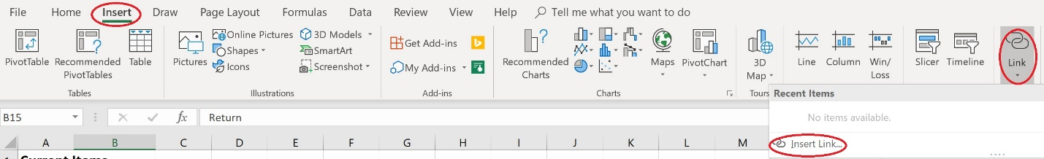

Figure 9: Screenshot of the Insert tab with the Link arrow circled

1. When the Insert hyperlink dialog box displays, within the Link to: area make sure the Place in this document option is selected.
2. Within the Insert Hyperlink dialog box, enter the text to display if no text was used in the selected cell. Verify the cell reference in the Type the cell reference area. If you want to link to a specific cell, you could also reference the cell by entering the cell information here.
3. Next, select the place within the document to where you want to the hyperlink to take the user, and then select OK.

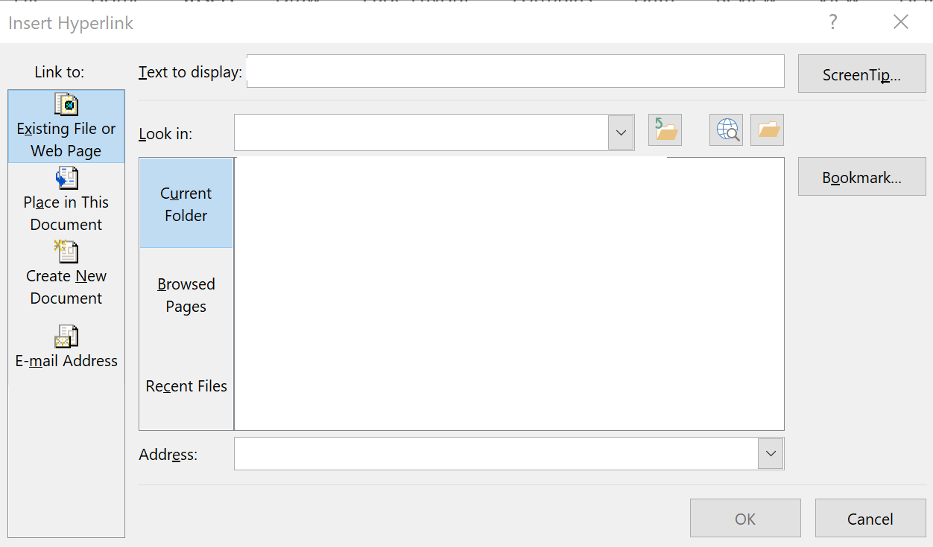

Figure 10: Insert Hyperlink dialog box

### Creating a hyperlink to a cell range

The marketing department would like to select on a customer’s recently purchased item and then be taken to the current related items and pricing.

1. Select the cell where the hyperlink should be located.
2. From the Insert tab, select Insert Link.
3. In the Insert Link dialog box, a list of defined names will display. In this example the defined name areas are Pickle_Cust, Pickles, Pres_Cust, and Preserves. Make sure in the Link to: area that Place in this document is selected.
4. Select the defined named area you want to link, and then select OK. In this example, you are using Pickles.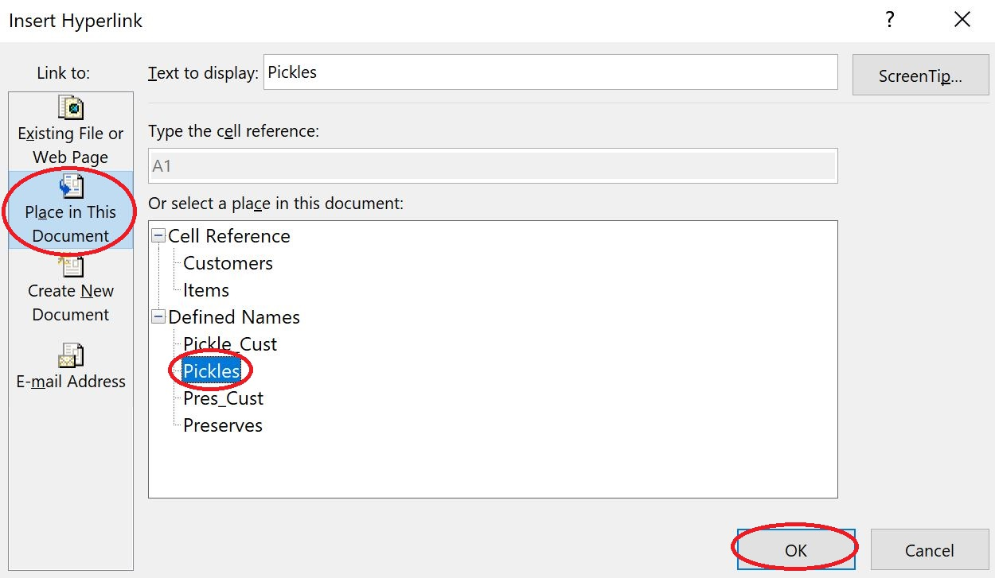

Figure 11: Insert Hyperlink dialog box

|  |  |
| --- | --- |
|  | Additional information  For more information on working with hyperlinks in Excel, go to: [Work with hyperlinks in Excel](https://aka.ms/Work-with-hyperlinks-in-Excel) |

### Activity: Tell a story

Munson’s has hired you to create Excel files for them. However, the rest of the staff isn’t as proficient working with Excel as you are. Munson’s has asked you to create hyperlinks within a workbook to guide users of the file to different areas.

#### Resources required

You will need the following resource for this activity:

* Locate L5_T1_act_data_starter.xlsx file in this lesson’s Learning Activity Resources folder.

#### Activity instructions

Participate in the activity by following these instructions:

1. Verify that you are on the Home Page tab of the workbook ribbon.
2. B7 contains the text Customer List. This text needs to be linked to the Customer List tab. Select B7, and then select the Insert ribbon.
3. In the Links group, select the Link option.
4. In the Insert Hyperlink dialog box, verify that the Text to display is Customer List.
5. In the Link to: group, select Place in this Document.
6. In the Or select a place in this document: area, under Cell Reference, select Customer List. This will link the words Customer List to the Customer List workbook tab.
7. Select the OK button.
8. Press Enter.
9. Select the hyperlink to test it. Verify it takes you to the Customer List tab.
10. While on the Customer List tab, review text in cell A29. When selected, you will need to make this text return the user to Home Page.
11. Select A29, and then on the ribbon, select the Insert tab.
12. In the Links group, select the Link option.
13. In the Insert Hyperlink dialog box, verify that the Text to display is Return to Home Page.
14. In the Link to: group, select Place in this Document.
15. In the Or select a place in this document: area, under Cell Reference, select Home Page. This will link the Customer List tab back to the Home Page workbook tab.
16. Select the OK button.
17. Press Enter.
18. Select the hyperlink to test it.
19. Use the same process to link the text in cells B9, B11, and B13 to their respective workbook tabs, and link the Return to Home Page text in each cell back to the Home Page tab.

### Try-it: Insert hyperlinks to navigate inside a workbook

 You will create links within a workbook to make navigation from one area to another easier.

### Try-it 1

#### Resources

You will need the following resource for this try-it:

* Open L5_T1_try1_customer_list_starter.xlsx in this lesson’s Learning Activity Resources folder.

#### Instructions

You will need to perform the following general tasks during this try-it:

1. Open the Items worksheet.
2. Verify that cell B15 has the word Return in it. This needs to be a hyperlink back to the Customer tab so that the marketing department can move back and forth between the two worksheets without using the tabs.
3. Create this hyperlink.
4. Save your work.

### Try-it 2

#### Resources

You will need the following resource for this try-it:

* Open L5_T1_try2_customer_list_starter.xlsx in this lesson’s Learning Activity Resources folder.

#### Instructions

You will need to perform the following general tasks during this try-it:

1. Access the Items worksheet.
2. Select cells B4:C6.
3. Review the Name box to verify that cells B4:C6 are named Pickles.

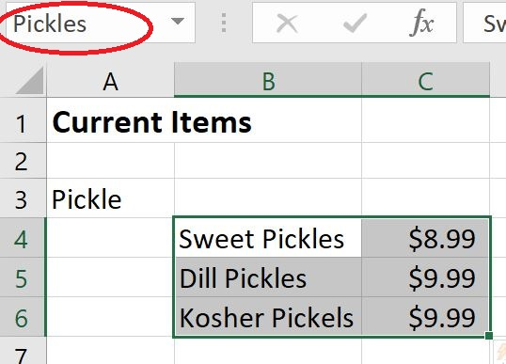

Figure 12: Named region of Pickles

1. Access the Customers tab.
2. The marketing department would like to select on a customer’s recently purchased item and then be taken to the current related items and pricing. Yeen Zhuang is the first person in the list to have purchased pickles. Create this hyperlink.
3. Use the Return link to return to the Customers tab.
4. Use steps 4 through 6 to create a link for Tina Bright. The name of the range for preserves in the Items tab is Preserves.
5. Save your work.

### Try-it 3

#### Resources

You will need the following resource for this try-it:

* Open L5_T1_try3_customer_list_starter.xlsx in this lesson’s Learning Activity Resources folder.

#### Instructions

You will need to perform the following general tasks during this try-it:

1. Access the Items tab.
2. Select A3 (the word Pickle).
3. On the Insert tab, select the Insert Link button.
4. Create a hyperlink from the word Pickle to the Pickle_Cust Defined Name area.
5. Select the link to test it. It should take you to the Customer List tab and highlight Pickle purchases.
6. Complete a similar procedure to link the word Preserve in the Items worksheet to the cells in the named region Pres_Cust.
7. Save your work.

## Topic 2: Insert hyperlinks to navigate outside a workbook

 Munson’s would like to provide its customers with definitions of pickle types, and include some pickle recipes. The marketing department has also asked for email addresses for each customer to be added so that they can use these emails to send marketing materials.

### Creating a hyperlink to another file

To create a hyperlink to another file:

1. Select the cell where you want to the link to be located.
2. From the Insert tab, select the Insert Link button.
3. In the Insert Hyperlink dialog box, make sure the Existing File or Web Page is highlighted in the Link to: area. In the Look in: area, make sure Current Folder is highlighted, and then browse to the document you want to link. You can use the tools to the Browse for File option to help locate the file.



Figure 13: Insert Hyperlink dialog box

1. In the Text to display area, enter a description of the file to which you are linking, and then select OK.
2. Select the link to test it.

### Creating a hyperlink to a website

Creating a hyperlink to a website is like linking to a file. To create a hyperlink to a website:

1. Select the cell where you want to locate the link to a website.
2. Access the Insert ribbon, and then select the Insert Link button.
3. In the Insert Hyperlink dialog box, make sure Existing File or Web page is highlighted. In the Address area, enter http://munsonspicklesandpreservesfarm.com.
4. In the Text to display area, enter a description of the website to which you are linking, and then select OK.
5. Select the link to test it.

|  |  |
| --- | --- |
|  | Additional information  For more information on working with hyperlinks in Excel, go to: [Work with hyperlinks in Excel](https://aka.ms/Work-with-hyperlinks-in-Excel) |

### Activity: Discuss and learn

How do you think hyperlinks to external sources might be used within a workbook? What external sources do you think would be linked within a workbook?

Munson’s would like for you to add their recent Quarterly Report to the Home Page tab of the Data file. They have asked that a link to the Microsoft Support website also be added for those who need more information about using Excel. They also have a third request, which is to add your email address so that users can email you with questions about the file.

#### Resources required

You will need the following resources for this activity:

* Locate L5_T2_act_data_starter.xlsx file in this lesson’s Learning Activity Resources folder.
* Locate the L5_T2_act_quarterly_report.docx file in this lesson’s Learning Activity Resources folder.

#### Activity instructions

Participate in the activity by following these instructions:

1. Verify that you are on the Home Page tab of the workbook.
2. Select cell A15 (Quarterly Report), and then access the Insert tab.
3. In the Links area, select Link.
4. In the Insert Hyperlink dialog box, in the Link to: area, select Existing File or Web Page.
5. Use the Browse for File option to locate the Quartery_report.docx file.
6. Select the Quarterly_report.docx file, and then select OK.
7. Press Enter and select the hyperlink to test it.
8. Select cell A17 (Microsoft Support), and then access the Insert ribbon.
9. In the Links area, select the Link option.
10. In the Insert Hyperlink dialog box, in the Link to: area, select Existing File or Web Page.
11. In the Address: area, enter http://support.microsoft.com, and then select OK.
12. Press Enter and select the hyperlink to test it.
13. Select cell A19, and then access the Insert ribbon.
14. In the Links area, select the Link option.
15. In the Insert Hyperlink dialog box, in the Link to: area, select E-mail address.
16. Verify that the Text to display: area has Email technical support at Munson’s.
17. In the E-mail address: area, enter john@contoso.com, and then select OK.

Note: You cannot test this email link because it’s a fictious email address.

### Try-it: Insert hyperlinks to navigate outside a workbook

You can also create hyperlinks to places outside of a workbook. Places outside a workbook could include a website or an email. The marketing department would like to include links to the company’s information about pickle types, recipes, and the company’s website to the customer list.

### Try-it 1

#### Resources

You will need the following resources for this try-it:

* Open L5_T2_try1_customer_list_starter.xlsx in this lesson’s Learning Activity Resources folder.
* Locate L5_T2_try1_pickle_types.docx in this lesson’s Learning Activity Resources.
* Locate L5_T2_try1_pickle_recipes.docx in this lesson’s Learning Activity Resources.

#### Instructions

You will need to complete the following general tasks during this try-it:

1. In cell A30, enter the text Suggested Resources.
2. In cell A31, enter the text Pickle Types.
3. In cell A32, enter the text Pickle Recipes.
4. In cell A33, enter the text Munson’s Website.
5. Select cell A31 (Pickle Types), and create a link to L5_T2_try1_pickle_types.docx.
6. Select the link to test it. It should take you to a document describing the types of pickles sold by Munson’s.
7. Use a similar procedure to link A32 (Pickle Recipes) to the L5_T2_try1_pickle Recipes.docx document, which is located in the Learning Activity Resources folder for this lesson.
8. Save your work.

### Try-it 2

#### Resources

You will need the following resource for this try-it:

* Open L5_T2_try2_customer_list_starter.xlsx in this lesson’s Learning Activity Resources folder.

#### Instructions

You will need to complete the following general tasks during this try-it:

1. Select A33, the text Munson’s Website.
2. Create a hyperlink to the Munson’s website using the URL http://munsonspicklesandpreservesfarm.com and then select OK. Select the link to test it. The link will take you to a Microsoft webpage.
3. Save your work.

### Try-it 3

#### Resources

You will need the following resource for this try-it:

* Open L5_T2_try3_customer_list_starter.xlsx in this lesson’s Learning Activity Resources folder.

#### Instructions

You will need to complete the following general tasks during this try-it:

1. In cell I1, enter Email Address.
2. In cell I2, create an email address for Tina Bright by using her first name and @contoso.com (tina@contoso.com).
3. Continue this procedure for all of the customers within the Customer List file.
4. As you continue entering email addresses, Excel will find the pattern you are creating using the email addresses and will autofill the remaining emails for you. To accept the Autofill suggestions, select the Tab button.
5. Save your work.

## Topic 3: Remove hyperlinks

 For various reasons, you might need to remove hyperlinks. As you enter an email address or website address into a cell, it automatically becomes a hyperlink. This can make it difficult to access the cell to edit it, or select it because the hyperlink is activated. Therefore, you might need to remove a hyperlink from an Excel workbook.

### Removing a hyperlink: Edit Hyperlink dialog box

To remove a hyperlink from an Excel workbook:

1. In the Insert ribbon, select the Link symbol.

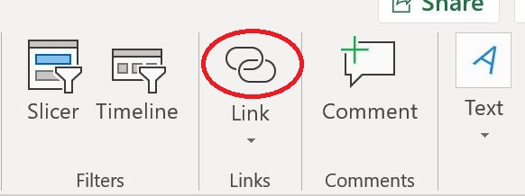

Figure 14: Link symbol

1. Select the Remove Link button. The hyperlink will be removed.

### Removing a hyperlink: context menu

To remove a hyperlink using the context menu:

1. Right-click or open the context menu for the hyperlink.
2. In the context menu, select Remove Hyperlink.

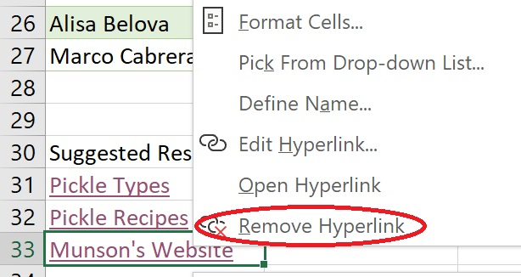

Figure 15: Context menu with Remove Hyperlink highlighted

### Removing hyperlinks from multiple cells

To remove hyperlinks from multiple cells:

1. Select the range of cells where you want to remove the hyperlinks.
2. Use the Edit Hyperlink dialog box to remove the hyperlinks.

|  |  |
| --- | --- |
|  | Additional information  For more information on removing hyperlinks in Excel, go to: [Remove or turn off hyperlinks](https://aka.ms/Remove-or-turn-off-hyperlinks) |

### Try-it: Remove hyperlinks

In this series of try-its, you will explore different processes to remove hyperlinks.

### Try-it 1

Cell H2 has a hyperlink that isn’t as useful as it might be. Munson’s management has requested that it be removed. It’s possible to remove the hyperlink using a similar process that you use to insert it.

#### Resources

You will need the following resource for this try-it:

* Open L5_T3_try1_customer_list_starter.xlsx in this lesson’s Learning Activity Resources folder.

#### Instructions

You will need to perform the following general tasks during this try-it:

1. Select G2 and use the arrow keys to move to H2.
2. Use the Edit Hyperlink dialog box to remove the hyperlink.
3. Use this same process to remove the link in H3.
4. Save your work.

### Try-it 2

Munson’s has found its website URL is too long for many customers, so the company is in the process of changing it. While this is in process, management has asked for the hyperlink to the website within the Customer List file to be removed. Use the arrow keys (or an alternate method) to move the cursor to A33.

#### Resources

You will need the following resource for this try-it:

* Open L5_T3_try2_customer_list_starter.xlsx in this lesson’s Learning Activity Resources folder.

#### Instructions

You will need to perform the following general tasks during this try-it:

1. Use the context menu to remove the hyperlink.
2. Save your work.

### Try-it 3

Sometimes you’ll want to remove hyperlinks from multiple cells. Feedback from Munson’s customers has been negative when receiving emails. Management has requested that you remove the email hyperlinks, but would like to keep the emails for possible future use.

#### Resources

You will need the following resource for this try-it:

* Open L5_T3_try3_customer_list_starter.xlsx in this lesson’s Learning Activity Resources folder.

#### Instructions

You will need to perform the following general tasks during this try-it:

1. Use the Edit Hyperlink dialog box to remove all the email hyperlinks.
2. Save your work.

## Wrap-up

1. When creating a link to a document within a workbook, which area of the Insert Hyperlink dialog box would you use?

Select the correct option.

1. Create a new file
2. Email address
3. Place in this document
4. Existing file or webpage
5. You can edit or remove a hyperlink using which action?

Select the correct option.

1. Selecting the hyperlinked cell and selecting delete.
2. Selecting the hyperlinked cell and selecting Tab.
3. Selecting the hyperlinked cell and using the Link command found on the Insert tab.
4. Selecting the hyperlinked cell and using the Edit ribbon.
5. Which of the following statements about hyperlinks is false?

Select the correct option.

1. When removing multiple hyperlinks, they must be removed one at a time.
2. You can remove a hyperlink by right-clicking on it or accessing the context menu, and then selecting Remove hyperlink.
3. You can link hyperlinks to several areas including an internal cell, an external document, an email address, or a website.
4. A hyperlink to a named group of cells can be created.
5. Select here to enter text. provide navigation throughout a workbook or to external resources.

# Glossary

|  |  |
| --- | --- |
| CONCAT | An Excel function that allows for data from multiple cells to be combined. |
| .csv | A file containing data that is separated by commas. |
| Delimiter | A character used to separate individual pieces of data. |
| Hyperlink | A feature that takes the user to another location either within the document, external file, or website. |
| LOWER | An Excel function that converts every letter to lowercase. |
| PROPER | An Excel function that allows the first letter of every word to be capitalized. |
| String | A collection of characters upon which no mathematical calculations are to be performed (for example, letters, zip codes, or telephone numbers). |
| Text | A collection of letters that have meaning. |
| TEXTJOIN | An Excel function that combines data from multiple cells into a list separated by a delimiter. |
| .txt | A file that contains data that is commonly separated by tabs. |
| UPPER | An Excel function that converts every letter to uppercase. |

Table 2: Glossary terms and definitions

# Cornerstone

## Overview

In this cornerstone, you will need to combine data from different sources, fix issues that arise in the data, and insert links to other helpful material.

## Objectives

The following table outlines the cornerstone objectives and their corresponding MOS exam objectives.

|  |  |
| --- | --- |
| Import text | 1.1.1: Import data from .txt files.  1.1.2: Import data from .csv files. |
| Manipulate text | 4.3.1: Format text by using RIGHT(), LEFT(), and MID() functions |
| Convert text | 4.3.2: Format text by using UPPER(), LOWER(), and LEN() functions |
| Combine text | 4.3.2: Format text by using UPPER(), LOWER(), and LEN() functions |
| Hyperlinks | 1.2.3: Insert and remove hyperlinks. |

Table 3: Cornerstone objectives

## Duration

40 minutes

## Instructions

Complete the following tasks for each file.

1. When saving your file, add your name to the end of the filename, for example: “Crops_Dwayne_Espino.” Follow your teacher’s directions for where to save your files.
2. When you’re done with the cornerstone, assess your completed product and enter the points you think you earned within the task lists at the end of the tasks. You can ask your teacher for help if required.

## Tasks

You will work with three files in this Cornerstone. The following steps are the tasks you need to complete within each file.

### File 1: Blank new Excel file

#### Task: Import text (4 points)

1. Open a blank Excel document. Import the Cornerstone_crop_planting_starter.txt file. (2 point) (Exam objective 1.1.1)
2. In the second worksheet, Sheet 1, import the Cornerstone_crop_problems_starter.csv file. (2 points) (Exam objective 1.1.2)

Points scored: Select here to enter text./4

#### Task: Manipulate text (4 points)

* Switch back to the tab containing the Crop Planting information. Extract data from cells E3:E13 so that only the field number is placed in cells G3:G13. (4 points) (Exam objective 4.3.1)

Points scored: Select here to enter text./4

#### Task: Convert text (12 points)

1. Within the worksheet containing the Crop Planting information, convert the crop names in column A so that the first letters of the words are capitalized in column H. (3 points) (Exam objective 4.3.2)
2. Continuing to work in the worksheet containing the Crop Planting information, convert the type of crop in column B to all lowercase in column I. (3 points) (Exam objective 4.3.2)
3. Switch to the worksheet containing the Crop Growing Problems. Convert the data in cells A3:A13 to only the first letters capitalized in cells E3:E13. (3 points) (Exam objective 4.3.2)
4. Continue to work in the worksheet containing the Crop Growing Problems. Convert the data in cells B3:B13 to uppercase in cells F3:F13. (3 points) (Exam objective 4.3.2)

Points scored: Select here to enter text./12

#### Task: Combine text (4 points)

* Switch to the Crop Planting worksheet. In cells J3:J13 combine the crop name with the crop type using a space, a dash and final space between the crop name and crop type. (i.e., Cabbage - red) (4 points) (Exam objective 4.3.2)

Points scored: Select here to enter text./4

#### Task: Hyperlinks (8 points)

1. Continue working in the Crop Planting worksheet. In cell A15, enter Munson’s website, and hyperlink the text to the Munson’s website (http://munsonspicklesandpreservesfarm.com) (4 points) (Exam objective 1.2.3)
2. Switch to the worksheet containing the Crop Problems information. In cell A15, enter Resources. Link this text to the document in the Resources folder for this cornerstone named Helpful Resources to Battle Crop Concerns. (4 points) (Exam objective 1.2.3)

Points scored: Select here to enter text./8

TOTAL POINTS: Select here to enter text./32