

Student guide

40567A

Microsoft Excel associate 2019

Module 7: Visualizing Data

Contents

Contents 2

Module overview 5

Description 5

Scenario 6

Cornerstone 7

Lesson 1: Using conditional formatting 8

Overview 8

Warm-up 8

Topic 1: Apply conditional formatting 9

Highlight the top 10 items in a range 9

Show variances with data bars 11

[Activity: Teacher demo and   
switch 13](#_Toc37688203)

[Try-it: Apply conditional   
formatting 14](#_Toc37688204)

Try-it 1 14

Try-it 2 15

Try-it 3 15

Topic 2: Remove conditional formatting 15

Remove conditional formatting with the Conditional Formatting Rules Manager 16

Remove conditional formatting with Clear Rules 17

Activity: Pose a challenge 18

Try-it: Remove conditional formatting 19

Try-it 1 19

Try-it 2 19

Wrap-up 20

Lesson 2: Using charts 22

Overview 22

Warm-up 22

Topic 1: Create charts 23

Create a chart with recommended charts 24

Create a pie chart 25

Activity: Show and learn 27

Try-it: Create charts 27

Try-it 1 27

Try-it 2 28

Topic 2: Add alternative text 28

Add Alt Text using the context menu 29

Mark a visual object as decorative 30

Activity: Discussion 31

Try-it: Add Alt Text 31

Try-it 1 32

Try-it 2 32

Topic 3: Move charts 32

Move a chart on the worksheet 33

Move a chart to a different worksheet 33

Activity: Discuss and learn 34

Try-it: Move charts 34

Try-it 1 34

Try-it 2 35

Try-it 3 35

Wrap-up 36

Lesson 3: Editing charts 37

Overview 37

Warm-up 37

Topic 1: Add a data series 38

Add a data series to your chart 38

Use select data to add and remove source data 40

Activity: Demonstration 41

Try-it: Add data series 42

Try-it 1 42

Try-it 2 42

Topic 2: Switch between rows and columns 43

Activity: Demonstration 43

Try-it: Switch between rows and columns 44

Wrap-up 45

[Lesson 4: Understanding chart   
elements 46](#_Toc37688256)

Overview 46

Warm-up 46

Topic 1: Add chart elements 47

Activity: Show and Tell 48

Try-it: Add chart elements 48

Try-it 1 48

Try-it 2 49

Try-it 3 49

Topic 2: Modify chart elements 50

Edit the text of a title in a chart 50

Format a chart element with the Format task pane 51

Format a chart element with the Chart Tools tab 51

Activity: Discuss and Learn 52

Try-it: Modify chart elements 52

Try-it 1 52

Try-it 2 53

Try-it 3 53

Wrap-up 54

Lesson 5: Understanding chart styles and layouts 56

Overview 56

Warm-up 56

Topic 1: Apply layouts 57

Activity: Demo 58

Try-it: Apply layouts 59

Topic 2: Apply styles and colors 59

[Apply a Quick Style from the   
ribbon 60](#_Toc37688282)

[Apply a quick style with Chart   
Styles 60](#_Toc37688283)

Apply a color scheme from the ribbon 61

Apply a color scheme with Chart Styles 61

Activity: Discuss and learn 62

Try-it: Apply styles and colors 63

Try-it 1 63

Try-it 2 63

Wrap-up 64

Lesson 6: Understanding sparklines 65

Overview 65

Warm-up 65

Topic 1: Insert sparklines 66

Activity: Tell a story 68

Try-it: Insert sparklines 68

Try-it 1 68

Try-it 2 69

Topic 2: Modify sparklines 69

Show sparkline markers and highlights 69

Apply a style to sparklines 70

Activity: Continue the story 71

Try-it: Modify sparklines 71

Try-it 1 71

Try-it 2 72

Try-it 3 72

Wrap-up 73

Lesson 7: Understanding the Quick Analysis feature 74

Overview 74

Warm-up 74

Topic 1: Use Quick Analysis to format data 75

Add conditional formatting using Quick Analysis 76

Add a chart or sparklines using Quick Analysis 76

Add totals for data using Quick Analysis 77

Activity: Demo and experiment 78

Try-it: Quick Analysis 78

Try-it 1 78

Try-it 2 79

Topic 2: Disable the Quick Analysis feature 79

Activity: Discuss 80

Try-it: Disable the Quick Analysis feature 81

Wrap-up 81

Glossary 82

Cornerstone 83

Overview 83

Objectives 83

Duration 84

Instructions 84

Tasks 84

[File 1: Cornerstone_solar_array_data_  
starter.xlslx 84](#_Toc37688330)

# Module overview

## Description

Providing visualizations of your data make it easier for people to understand and analyze the data. Microsoft Excel provides a wide array of tools for creating these visual data representations. Formatting styles can emphasize important data points or values. Charts and sparklines provide visual depictions of trends, and Alt Text provide a critical way for users with visual impairments to get information displayed visually.

In this module, you’ll learn to leverage all these tools to make your workbooks useful, and impactful. This module builds on your understanding of data and formulas to help you get the most from your data, whether you want to better understand the data yourself or are preparing to print your workbook.

The following table outlines the lessons in this module and their corresponding learning and exam objectives.

|  |  |  |
| --- | --- | --- |
| Lesson | Learning objective | Exam objective(s) |
| Using conditional formatting | Apply and remove conditional formatting | 2.4.2  2.4.3 |
| Using charts | Create and move charts | 5.1.1  5.1.2  5.3.3 |
| Editing charts | Add a data series to a chart and switch between the X and Y axis | 5.2.1  5.2.2 |
| Understanding chart elements | Add and remove chart elements from an existing chart | 5.2.3 |
| Understanding chart styles and layouts | Apply layouts, styles, and colors to an existing chart | 5.3.1  5.3.2 |
| Understanding sparklines | Insert and modify sparklines | 2.4.1 |
| Lesson | Learning objective | Exam objective(s) |
| Understanding the Quick Analysis feature | Use the Quick Analysis feature to quickly transform data | N/A |
| Cornerstone: Observing farm energy data | Assist a colleague by adding visualizations to data related to solar energy production, consumption, and costs | 2.4.1  2.4.2  2.4.3  5.1.1  5.1.2  5.2.1  5.2.2  5.2.3  5.3.1  5.3.2  5.3.3  5.3.3 |

Table 1: Objectives by lesson

## Scenario

Munson’s Pickles and Preserves is in an extremely favorable climate for solar energy production. Last year Munson’s invested in a solar array to provide electricity for all operations. The solar array has been a huge part of the farm’s digital transformation, and is an exciting project for everyone to witness. Everyone at the farm is proud of the initiative to move to a renewable source of electricity, and they’ve all been anxious to know what the data says about the endeavor. In fact, it seems like the entire community wants to know how well the solar project is going!

A colleague has been collecting as much data as possible related to the solar array and overall electricity consumption on the farm. He is enthusiastic to share with everyone that the solar array has made a big difference, but he is having a hard time understanding the data, let alone explaining it—it really just looks like a bunch of numbers! Knowing that you’re getting pretty good at Excel, he wants your help to create visualizations for all this data about solar energy production, consumption, and costs. You’ll need to add some conditional formatting, charts, and sparklines to help make the data clear.

## Cornerstone

This module concludes with a cornerstone in which you’ll make data about Munson’s solar array easier to view and understand. In this cornerstone, you’ll:

* Apply conditional formatting to draw attention to important data.
* Create charts to visually represent the data, and customize those charts, as necessary.
* Improve the readability and visual impact of charts by applying styles, layouts, and color schemes.
* Add and customize sparklines to demonstrate general trends and emphasize important data points.

# Lesson 1: Using conditional formatting

## Overview

In this lesson, you’ll use conditional formatting to emphasize and highlight important pieces of data. You’ll learn how to apply conditional formatting, and you’ll also learn how to remove it. The activities in this lesson will give you the opportunity to practice applying and removing a variety of conditional formatting options.

## Warm-up

Use these questions to find out what you already know about this lesson’s topics:

1. Conditional formatting uses a condition to determine a cell’s _________.

Select the correct option.

1. Value
2. Appearance
3. Size
4. Location
5. Which of the following values can be indicated using conditional formatting?

Select all that apply.

1. High or low values
2. Average values
3. Projected values based on the data
4. Duplicate values
5. Which of the following options are types of conditional formatting?

Select all that apply.

1. Color scales
2. Tables
3. Pie charts
4. Data bars
5. Highlight cells rules
6. SmartArt
7. You can indicate positive, negative, or neutral values with icons by using Select here to enter text..

## Topic 1: Apply conditional formatting

 An Excel workbook can include a lot of data, and sometimes all that data can overwhelm the user and make it difficult to understand. For example, imagine you’re planning a hike next week and have a table of the temperature forecast every hour for all seven days—that’s a lot of numbers! You only care about avoiding the times when the temperature is going to be too hot or too cool, but to find those you’d have to search through every hour of each day. Fortunately, Excel provides several features to help you quickly analyze your data.

Conditional formatting allows you to emphasize differences in your data by changing the cells’ appearance based on criteria. If you use it to draw attention to the really hot and really cool temperatures, you can easily find the perfect time to schedule your hike.

### Highlight the top 10 items in a range

To draw attention to the highest values in your data, select the range of cells you want to format. The following screenshot depicts a set of data selected for conditional formatting.

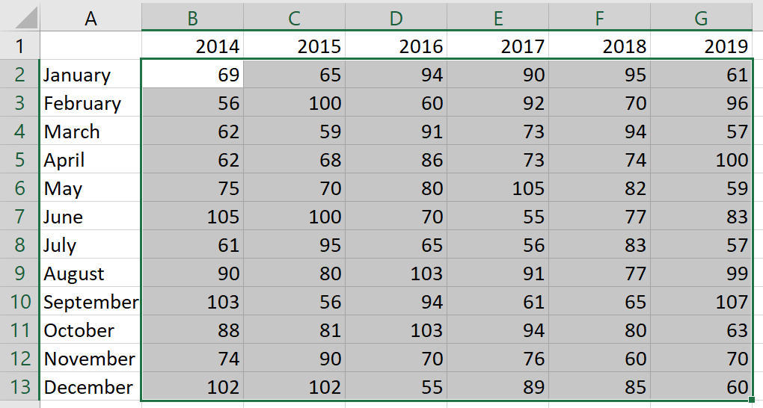  
Figure 1: A range of cells selected for conditional formatting

Next, select the Home tab, and then in the Styles group, select Conditional Formatting to access the conditional formatting options. The following screenshot is of Conditional Formatting options.

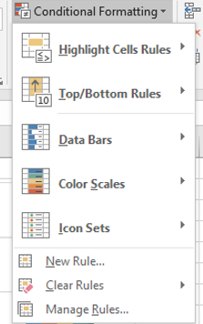

Figure 2: Conditional Formatting options

To draw attention to the highest (Top) or lowest (Bottom) numbers in your selected range, select Top/Bottom Rules, and then select Top 10 Items to open the Top 10 Items dialog box, as in the following screenshot.

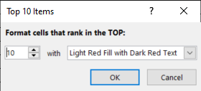

Figure 3: Top 10 Items dialog box

The number lets you select how many cells to format, which is set to 10 by default. The with options allow you to choose different ways to emphasize the cells. The depicted options will find the top 10 values and format their cells with Light Red Fill and Dark Red Text. Select OK to apply the conditional formatting. The following screenshot depicts conditional formatted used to highlight the top 10 numbers.

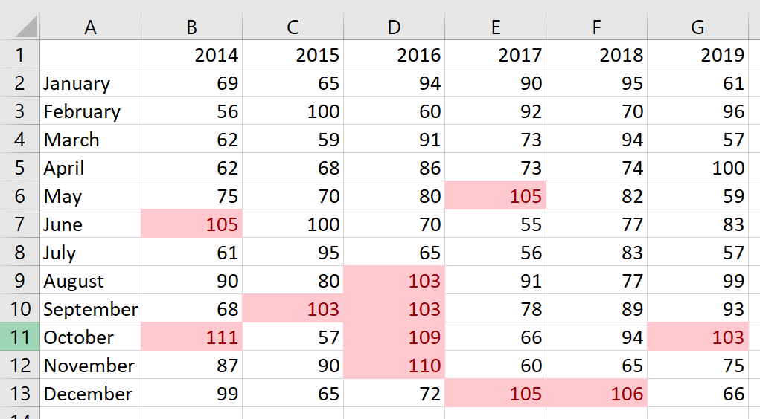

Figure 4: Conditional formatting highlights the top 10 numbers

### Show variances with data bars

The conditional formatting options also include a pre-defined setting for using data bars to demonstrate variances between data within a range. This is useful for providing a visual representation of how the values compare to each other.

To add data bars, select the range of cells you want to format. Select Home, and then in the Styles group, select Conditional Formatting to access the conditional formatting options. From those options, select Data Bars to bring up the options for data bars. The options include a variety of colors with both gradient and solid fills. The following screenshot depicts the Data Bars options.

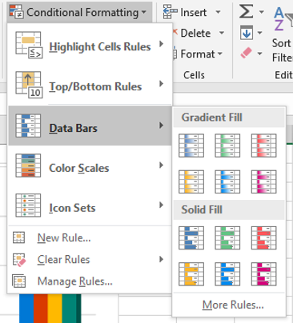

Figure 5: The Data Bars options

Select the color you want to apply the data bars to your data. The following screenshot depicts data bars with a solid blue fill.

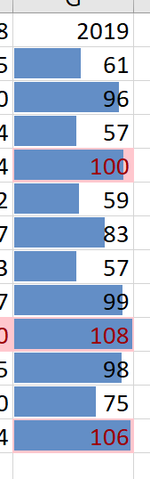

Figure 6: Data Bars with solid blue fill

|  |  |
| --- | --- |
|  | Additional information  For more information about applying conditional formatting, go to: [Use conditional formatting to highlight information](https://aka.ms/Apply-conditional-formatting-in-Excel) |
|  | Video  To review the video on conditional formatting, go to: [Use conditional formatting](https://aka.ms/Conditional_formatting) |

### Activity: Teacher demo and switch

In this activity, your teacher will demonstrate how to apply conditional formatting. Next, you’ll move from computer to computer trying different conditional formatting settings as directed by the teacher, before returning to your original computer to review how your data is displayed.

#### Resources required

You will need the following resource for this activity:

* Open L1_T1_act_daily_cell_production.xlsx in this lesson’s Learning Activity Resources.

#### Activity instructions

Participate in the activity by following these instructions:

1. Observe the teacher demonstrating how to apply conditional formatting to a range of cells.
2. Ask clarifying questions.
3. On your own computer, apply the conditional formatting rule as directed by the teacher.
4. Switch to a new computer as instructed by the teacher. Observe the formatting applied by the previous student. As directed by the teacher, add an additional conditional formatting rule to the data range.
5. Continue to switch and apply new conditional formatting as directed by the teacher.
6. Return to your original computer. Note the conditional formatting rules currently in place.

### Try-it: Apply conditional formatting

 In this leveled try-it activity, you’ll apply several different conditional formatting rules to a workbook to make the data easier to understand and analyze.

Note: Kilowatt hours (kWh) is a measure of energy often used to measure electrical energy used or produced. 1 kWh is equivalent to 1,000 watts of power for one hour.

### Try-it 1

In this try-it, you’ll add data bars to one column of values.

#### Resources

You will need the following resource for this try-it:

* Open L1_T1_try1_energy_needs_met_starter.xlsx in this lesson’s Learning Activity Resources.

#### Instructions

During this try-it you’ll perform the following task:

* Apply solid orange data bars to the range B4:B9.

### Try-it 2

In this try-it, you’ll apply conditional formatting to emphasize the lowest values in the data.

#### Resources

You will need the following resource for this try-it:

* Open L1_T1_try2_energy_needs_met_starter.xlsx.

#### Instructions

During this try-it you’ll perform the following task:

* Select range B4:H9 and apply conditional formatting that displays the bottom five items with light red fill, and without changing the text color.

### Try-it 3

In this try-it, you’ll add icons to emphasize the variance between cell values.

#### Resources

You will need the following resource for this try-it:

* Open L1_T1_try3_energy_needs_met_starter.xlsx.

#### Instructions

During this try-it you’ll perform the following task:

* Apply three traffic lights (unrimmed) to the range I4:I9.

## Topic 2: Remove conditional formatting

 Excel gives you many options for conditional formatting on a range of cells, and because you can apply multiple rules to the same set of data, there are thousands of combinations available. That means you might find yourself experimenting to find the best way to make your data clear and easy to analyze. This means you’ll need to be able to remove formatting to try different approaches.

### Remove conditional formatting with the Conditional Formatting Rules Manager

Begin by selecting the cells that contain the conditional formatting you wish to remove. On the Home tab of the ribbon, in the Styles group, select Conditional Formatting. From the conditional formatting options, select Manage Rules, as indicated in the following screenshot.

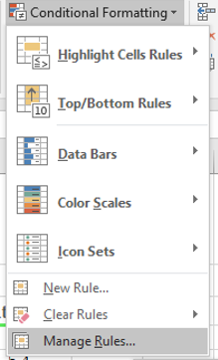

Figure 7: Conditional formatting options with Manage Rules selected

Selecting Manage Rules will open the Conditional Formatting Rules Manager dialog box, as in the following screenshot.

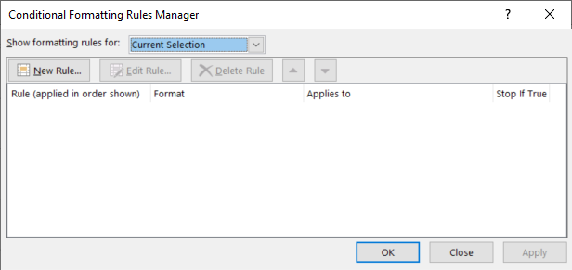

Figure 8: The Conditional Formatting Rules Manager dialog box

This dialog box will list all the conditional formatting rules currently applied to any cells within your range. Select the rule you want to remove, and then select Delete Rule. Repeat this process for any additional rules you want to remove.

|  |  |
| --- | --- |
|  | Did you know?  The Conditional Formatting Rules Managers also allows you to adjust the order in which multiple rules are applied. Simply select a rule you wish to move, and then use the up and down arrows to move it to where you want. |

### Remove conditional formatting with Clear Rules

If you want to clear all conditional formatting rules for a selection of cells, you can use the Clear Rules feature. Select Home, and then in the Styles group, select Conditional Formatting. On the conditional formatting options that display, select Clear Rules, as in the following screenshot.

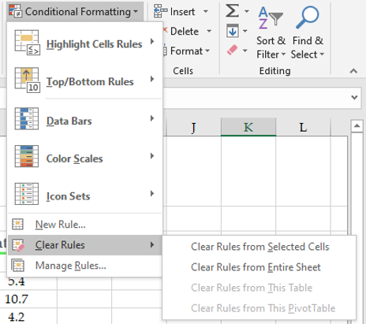

Figure 9: The conditional formatting options with Clear Rules selected

To clear the conditional rules for all cells, select Clear Rules from Entire Sheet. If you want to remove conditional formatting from only the selected cells, select Clear Rules from Selected Cells.

|  |  |
| --- | --- |
|  | Additional information  For more information on removing conditional formatting, refer to the Clear conditional formatting sub-section in: [Use conditional formatting to highlight information](https://aka.ms/Remove-conditional-formatting) |

### Activity: Pose a challenge

The teacher will direct you to complete a challenge to learn how efficient you are at removing conditional formatting.

#### Resources required

You will need the following resource for this activity:

* Any worksheet with conditional formatting applied.

#### Activity instructions

Participate in the activity by following these instructions:

1. As directed by the teacher, remove conditional formatting from your worksheet.
2. Be prepared to share how you removed the conditional formatting.

### Try-it: Remove conditional formatting

 In this leveled try-it activity, you’ll practice removing conditional formatting that has been applied to different parts of a worksheet.

### Try-it 1

In this try-it, you’ll remove conditional formatting from a range of cells.

#### Resources

You will need the following resource for this try-it:

* Open L1_T2_try1_energy_needs_met_starter.xlsx in this lesson’s Learning Activity Resources.

#### Instructions

During this try-it, you’ll perform the following task:

* Remove conditional formatting from cells B4:H9.

### Try-it 2

In this try-it, you’ll remove conditional formatting from a single cell, and from an entire worksheet.

#### Resources

You will need the following resource for this try-it:

* Open L1_T2_try2_ energy_needs_met_starter.xlsx in this lesson’s Learning Activity Resources.

#### Instructions

The following steps are the general tasks that you need to perform during this try-it:

1. Remove conditional formatting from only cell I6.
2. Remove conditional formatting from the entire worksheet.

## Wrap-up

Use these questions to check what you learned in this lesson:

1. Which of the following conditional formatting rules is the best option for emphasizing the variance between values in a data range?

Select the correct option.

1. Top 10%
2. Bottom 10 items
3. Duplicate Values
4. Color Scales
5. Which features can you use to remove conditional formatting?

Select all that apply.

1. New Rule
2. Manage Rules
3. Clear Rules
4. Data Bars
5. Color Scales
6. 3 Signs is an option for the ____________________ conditional formatting rule.

Select all that apply.

1. Color Scales
2. Icon Sets
3. Highlight Between
4. Data Bars
5. Conditional formatting with the Select here to enter text. option will shade every selected cell based on how its value compares to the average.
6. What happens if multiple conditional formatting rules are applied to the same cell?

Select the correct option.

1. None of the rules are evaluated, and the cell is left unformatted.
2. Only the first rule is applied, and the cell is formatted accordingly.
3. All rules are applied in order, formatting the cell with every rule.
4. Only the last rule is applied, and the cell is formatted accordingly.

# Lesson 2: Using charts

## Overview

In this lesson, you’ll explore one of the most useful tools for visualizing your spreadsheet data: charts. The activities in this lesson show you how to create charts, add Alt Text to make your worksheets more accessible, and position your charts exactly where you want them.

|  |  |
| --- | --- |
|  | Video  What are the different ways in which you can visualize data to present data effectively? Review the video [Data visualization](https://aka.ms/video-data-visualization). What are the two things that stood out for you? |

## Warm-up

Use these questions to find out what you already know about this lesson’s topics:

1. If you want Microsoft Excel to suggest a chart for your data, use the Select here to enter text. feature.
2. Which of the following best describes the role of Alt Text?

Select the correct option.

1. Allows data to be translated into different languages.
2. Assists users with a screen reader who are accessing the workbook.
3. Provides additional information for a chart’s legend.
4. Enables users to input text quickly.

1. Which of the following actions can be done with the Move Chart dialog box?

Select all that apply.

1. Make a duplicate copy of a chart.
2. Move a chart to a new worksheet.
3. Move a chart to an existing worksheet.
4. Move a chart to a Microsoft PowerPoint presentation.
5. How does Excel determine what data to use when creating a chart?

Select the correct option.

1. It uses all data on the current worksheet.
2. It uses all data in the current workbook.
3. It uses the selected cell and all adjacent cells.
4. It uses only the selected cells.

## Topic 1: Create charts

 The right chart can represent your data in a way that helps you or your audience understand the bigger picture that the data has to offer. Often, it’s great to view all the numbers, but many times we just want to know what it all means. What am I spending my money on? Is my energy usage getting better or worse over time? How big of an impact is that exam going to have on my grade? A good chart can make these kinds of evaluations more obvious.

|  |  |
| --- | --- |
|  | Did you know?  You can create charts in Excel with chart elements that better support your users' accessibility needs. For further information, refer to [Create more accessible charts in Excel](https://aka.ms/Video-Create-more-accessible-charts-in-Excel). |

### Create a chart with recommended charts

With so many ways to present your data in a chart, it can be difficult to know which to choose. Luckily, Excel offers Recommended Charts to give you a great starting point. Select the data for which you want to create a chart. On the ribbon, select Insert, and then in the Charts group, select Recommended Charts. This opens the Insert Chart dialog box, as depicted in the following screenshot.

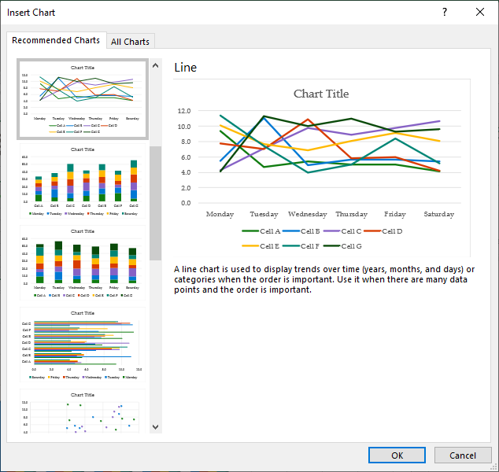

Figure 10: The Insert Chart dialog box

The Insert Chart dialog box offers you a variety of choices based on how your data is arranged. Select the chart type you want, and then select OK. The following screenshot depicts an example of a line chart added with recommended charts.

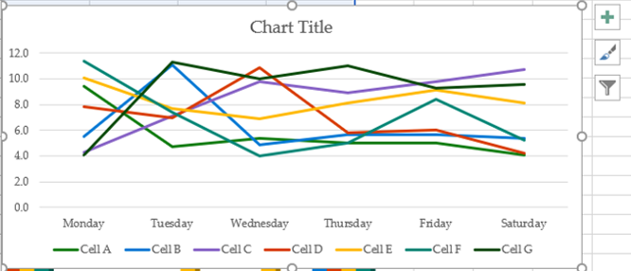

Figure 11: Example of a line chart added with recommended charts

|  |  |
| --- | --- |
|  | Additional information  For more information about the recommended charts feature, go to: [Create a chart with recommended charts](https://aka.ms/Create-a-chart-with-recommended-charts) |

### Create a pie chart

One of the most common and useful charts is the pie chart. Pie charts work well when you have one row or one column of data. To create a pie chart, select the data you want to include in your pie chart. On the ribbon, select Insert. In the Charts group, select Insert Pie or Doughnut Chart, and then select the chart you want. The following screenshot depicts the choices after selecting Insert Pie or Doughnut Chart.

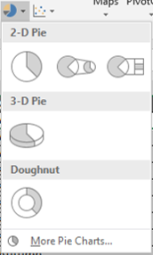

Figure 12: Choices after selecting Insert Pie or Doughnut Chart

A pie chart such as the following example 2-D Pie chart will be placed in the worksheet.

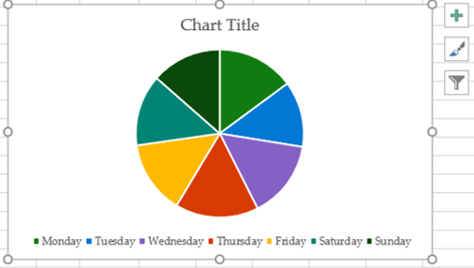

Figure 13: An example pie chart

|  |  |
| --- | --- |
|  | Additional information  For more information on creating a pie chart, go to: [Add a pie chart](https://aka.ms/add-a-pie-chart)  For more information on the different chart types in Excel, go to: [Available chart types in Office](https://aka.ms/available-chart-types-in-office)  For more information on selecting the correct data for a different chart types, go to: [Select data for a chart](https://aka.ms/select-data-for-a-chart) |
|  | Video  To review the video on creating a chart and adding a trend line, go to: [Create a chart from start to finish](https://aka.ms/Create-a-chart-from-start-to-finish) |

### Activity: Show and learn

In this activity, the teacher will show you how to create two different charts. You’ll then have the chance to try creating the same charts yourself.

#### Resources required

You will need the following resource for this activity:

* Open L2_T1_act_daily_cell_production.xlsx in this lesson’s Learning Activity Resources.

#### Activity instructions

Participate in the activity by following these instructions:

1. Observe as the teacher demonstrates how to create a pie chart on the PieChart worksheet.
2. Ask the teacher any clarifying questions you might have.
3. Create a pie chart from the same data as in the demonstration.
4. Observe as the teacher switches to the Column worksheet and adds a column chart.
5. Ask the teacher any clarifying questions you might have.
6. Create a column chart on the Column worksheet using the same data ranges as the teacher.

### Try-it: Create charts

 A colleague at Munson’s Pickles and Preserves Farm would like some assistance analyzing the farm’s electricity consumption. This is a series of leveled try-it activities that will ask you to create charts to represent different types of data.

### Try-it 1

In this try-it you’ll select two ranges of data and create a line chart.

#### Resources

You will need the following resource for this try-it:

* Open L2_T1_try1_monthly_usage_starter.xlsx in this lesson’s Learning Activity Resources.

#### Instructions

The following steps are the general tasks that you need to perform during this try-it:

1. On the Monthly worksheet, select the monthly energy usages data for all months and years.
2. Create a Clustered Column Chart using the selected data.

### Try-it 2

In this try-it you’ll select two ranges of data and create a line chart.

#### Resources

You will need the following resource for this try-it:

* Open L2_T1_try2_monthly_usage_starter.xlsx in this lesson’s Learning Activity Resources.

#### Instructions

The following steps are the general tasks that you need to perform during this try-it:

1. On the Summary worksheet, select the average energy usage for each month, listed in kWh.
2. Create a 3D Pie Chart using the selected data.

## Topic 2: Add alternative text

 Alternative text, or Alt Text, is critical for ensuring that all users can access your content. Many users with visual impairments use a screen reader such as Microsoft Narrator, which reads information aloud from the screen and enables users to interact with a computer without using a mouse. In such a situation, it’s easy to miss critical information, or experience frustration when content includes visual items such as images and infographics.

Where does Alt Text fit in? When a screen reader encounters graphical content, the user will hear the Alt Text read aloud. If there’s no Alt Text, they will only know that there’s a piece of visual information, but not be able to discern anything about what it shows!

In all kinds of documents, adding Alt Text for images and infographics is helpful; in Excel, it’s especially critical to include Alt Text for charts and other visualizations that are intended to help us understand data.

### Add Alt Text using the context menu

To add Alt Text, right-click or access the context menu for the object, and then select Edit Alt Text. If you’re adding Alt Text to a chart or SmartArt graphic, be sure to select the border of the graphic rather than an individual piece of the graphic. The following screenshot depicts a chart’s context menu with Edit Alt Text selected.

Screenshot of the context menu with Edit Alt Text selected


Figure 14: **Context** menu with Edit Alt Text selected

In the Alt Text pane, enter your alternative text describing the item. In general, your description should be one or two sentences describing the object for someone who can’t see it. The following screenshot depicts the Alt Text pane with an example of an Alt Text description.

Screenshot of the Alt Text pane with an example of an Alt Text description


Figure 15: The Alt Text pane with an example of an Alt Text description

|  |  |
| --- | --- |
|  | Did you know?  You can also access the Alt Text pane from the ribbon. Select the chart, and then on the Chart Tools ribbon, select Format. In the Accessibility group, select Alt Text. |

### Mark a visual object as decorative

A worksheet might include visual elements that are simply added to increase visual interest but do not contain any information. Examples of this might include a stylistic border or decorative item. You can mark these objects so that people using screen readers will hear that they are decorative and will know they aren’t missing any information.

To mark an element as decorative, right-click or access the context menu of the object, and then select Edit Alt Text. In the Alt Text pane, select the Mark as Decorative check box, as demonstrated in the following screenshot.

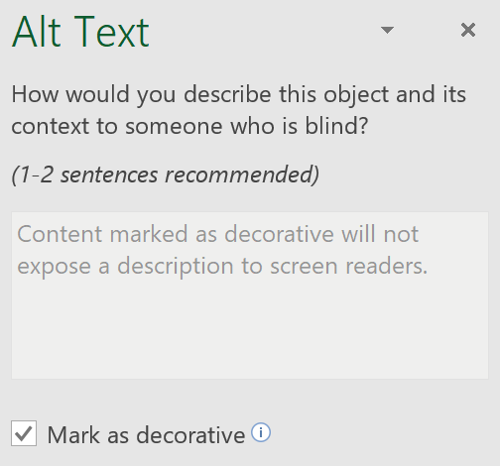

Figure 16: The Alt Text pane with the Mark as Decorative check box selected

|  |  |
| --- | --- |
|  | Additional information  For additional information on adding Alt Text, go to: [Add alternative text to a shape, picture, chart, SmartArt graphic, or other object](https://aka.ms/add-alternative-text-to-a-shape-picture-chart-smartart-graphic-or-other-object) |

### Activity: Discussion

In this activity, you’ll participate in a teacher-led discussion about the function and importance of Alt Text.

#### Resources required

You will not need any resource for this activity.

#### Activity instructions

Participate in the activity by following these instructions:

1. Respond to the discussion prompt as directed by the teacher.
2. Ask any clarifying questions.

### Try-it: Add Alt Text

 In this series of leveled try-it activities, you’ll practice using the Alt Text pane to improves the workbook’s accessibility. You’ll add Alt Text to a chart, and you’ll also mark a chart as decorative.

### Try-it 1

In this try-it, you’ll mark a chart in an Excel workbook as decorative, for people using a screen reader.

#### Resources

You will need the following resource for this try-it:

* Open L2_T2_try1_monthly_usage_starter.xlsx in this lesson’s Learning Activity Resources.

#### Instructions

The following steps are the general tasks that you need to perform during this try-it:

1. Select the Summary worksheet.
2. Mark the 3D pie chart as decorative.

### Try-it 2

In this try-it, you’ll add appropriate Alt Text to a chart in an Excel workbook so people using screen readers understand what information the chart conveys.

#### Resources

You will need the following resource for this try-it:

* Open L2_T2_try2_monthly_usage_starter.xlsx in this lesson’s Learning Activity Resources.

#### Instructions

The following steps are the general tasks that you need to perform during this try-it:

1. Select the Monthly worksheet.
2. Add Alt Text describing the general content of the chart. Try to limit yourself to one or two sentences.

## Topic 3: Move charts

 Excel allows you to move a chart to any location on a worksheet, which enables you to place it where it will have the most impact, and where it won’t cover any other information. You can also move a chart to a different worksheet within the same workbook, or to a new worksheet.

### Move a chart on the worksheet

To move a chart to a new location on the same worksheet, drag it to the desired location. When selecting the chart to move, take care to select the entire chart and not an individual element within the chart. Search for an empty space, or simply select the border of the chart.

|  |  |
| --- | --- |
|  | Did you know?  You can move a chart with the keyboard. Select the chart, then use the arrow keys to move the chart around. This can be especially useful for making small adjustments to a chart’s position. |

### Move a chart to a different worksheet

If you want to move the chart to a different worksheet in the workbook, first select the chart. On the ribbon, under Chart Tools, select the Design tab. In the Location group, select Move Chart to access the Move Chart dialog box. This dialog box is depicted in the following screenshot.

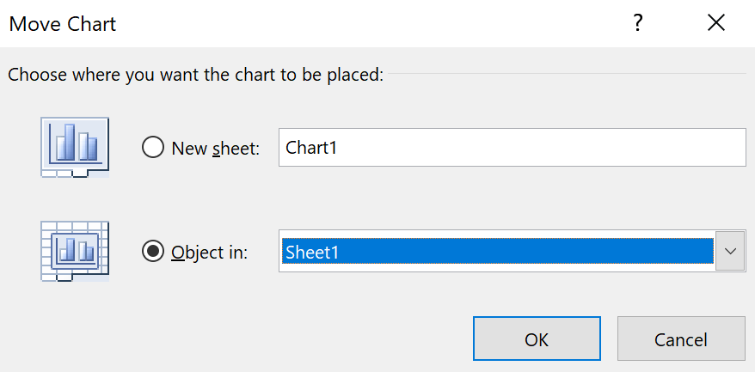

Figure 17: The Move Chart dialog box

If you want to create a new worksheet for the chart, select New sheet, and then enter a name for the worksheet. If you want to move the chart into an existing worksheet, select Object in, and then in the Object in box, select the destination worksheet.

|  |  |
| --- | --- |
|  | Additional information  For more information on moving a chart, go to: [Move or resize a chart](https://aka.ms/Move-or-resize-a-chart) |

### Activity: Discuss and learn

In this activity, you’ll participate in a teacher-led discussion on different ways to move a chart.

#### Resources required

You will need the following resource for this activity:

* Open L2_T3_act_daily_cell_production.xlsx in this lesson’s Learning Activity Resources.

#### Activity instructions

Participate in the activity by following these instructions:

1. Participate in the discussion about different ways to move a chart.
2. Use one of the methods discussed to move the chart on the Monthly worksheet to a location below the data.
3. Use another of the methods to move the chart on the Summary worksheet to a location next to the data.

### Try-it: Move charts

 This leveled try-it activity gives you practice moving charts with a variety of methods.

### Try-it 1

In this try-it, you’ll use Cut and Paste to move a chart.

#### Resources

You will need the following resource for this try-it:

* Open L2_T3_try1_monthly_usage_starter.xlsx in this lesson’s Learning Activity Resources.

#### Instructions

The following steps are the general tasks that you need to perform during this try-it:

1. Create a new worksheet with the name SummaryChart.
2. Use Cut to remove the 3D pie chart from the Summary worksheet, and then use Paste to place it on the SummaryChart worksheet.

### Try-it 2

In this try-it, you’ll move a chart to an existing worksheet, and then position it so it doesn’t cover any data.

#### Resources

You will need the following resource for this try-it:

* Open L2_T3_try2_monthly_usage_starter.xlsx in this lesson’s Learning Activity Resources.

#### Instructions

The following steps are the general tasks that you need to perform during this try-it:

1. Use the Move Chart dialog box to move the line chart on the Monthly worksheet to the Summary worksheet.
2. Position the chart next to the data table on the Summary chart in a location that doesn’t cover any data, such as cell C2.

### Try-it 3

This try-it will direct you to move a chart to a new worksheet using the Move Chart dialog box.

#### Resources

You will need the following resource for this try-it:

* Open L2_T3_try3_monthly_usage_starter.xlsx in this lesson’s Learning Activity Resources.

#### Instructions

The following steps are the general tasks that you need to perform during this try-it:

* Use the Move Chart dialog box to move the line chart on the Summary worksheet to a new worksheet with the name DetailChart.

## Wrap-up

Use these questions to check what you learned in this lesson:

1. What is the effect of marking a graphic element as “decorative”?

Select the correct option.

1. The object is locked and cannot be altered.
2. Data is disconnected from the chart so that it does not update.
3. The object becomes part of the workbook’s template.
4. Screen readers will notify users that it doesn’t contain information.
5. Which data arrangement is ideal for a pie chart?

Select the correct option.

1. Multiple rows and columns of data
2. A single row or column of data
3. A single cell of conditionally formatted data
4. Any number of rows and columns; however, data must be in a table
5. What is the preferred length of Alt Text?

Select the correct option.

1. A few words
2. One or two sentences
3. One or two paragraphs
4. To remove a chart from the current worksheet and place it on a newly created worksheet, use the Select here to enter text. dialog box.
5. Visual elements that do not contain any information should be marked as Select here to enter text..

|  |  |
| --- | --- |
|  | Additional information  For more information on writing effective Alt Text, go to: [Everything you need to know to write effective alt text](https://aka.ms/everything-you-need-to-know-to-write-effective-alt-text) |

# Lesson 3: Editing charts

## Overview

This lesson will focus on how to edit a chart after you’ve created it. You’ll learn how to add a data series to an existing chart, and you’ll find out how to switch between rows and columns in your charts.

## Warm-up

Use these questions to find out what you already know about this lesson’s topics:

1. Which of the following terms refers to a row or column of data in a worksheet that is plotted in a chart?

Select the correct option.

1. A data series
2. Axis
3. Data label
4. Data table
5. You added data to the worksheet after the chart was created. Why might you need to add more data to a chart?

Select all that apply.

1. You didn’t select all the data when you created the chart.
2. You want to switch the rows and columns in the chart.
3. You want to move the chart to another worksheet.
4. You want to add the chart to a PowerPoint presentation or Microsoft Word document.
5. You added data to the worksheet after the chart was created.

1. Which of the following explanations are reasons to switch the rows and columns on a chart?

Select all that apply.

1. To change to a different chart type.
2. To move the chart to a different worksheet.
3. To check if you prefer to orient the chart differently.
4. To correct a column chart only rendering one column.
5. To correct a pie chart that is only displaying a category name.
6. The Select here to enter text.button allows you exclude some data from a chart.

## Topic 1: Add a data series

 A workbook in Excel is often a living document. That is, you can continue to use the same workbook over a long period of time, adding more and more data. For example, if you use a spreadsheet to keep track of your personal budget for the month, you’ll want to keep using it when the month ends. Instead of creating a new workbook, you can just add a column of data for the new month. However, any charts you made to visualize your past months’ budgets are now missing the new month! Or perhaps you just made a mistake when you created the chart, leaving out a row or column of data you intended to include. For these reasons and more, you need to be able to change which pieces of data are included in a chart.

### Add a data series to your chart

A data series is a row or column of values in a worksheet. When you select the rows and columns of numbers to include in a chart, you’re selecting the data series you want to visualize.

Next, you select a chart style. The data currently used as a source for the chart is indicated on the worksheet with sizing handles at the corners. The following screenshot depicts the source data for a selected pie chart.

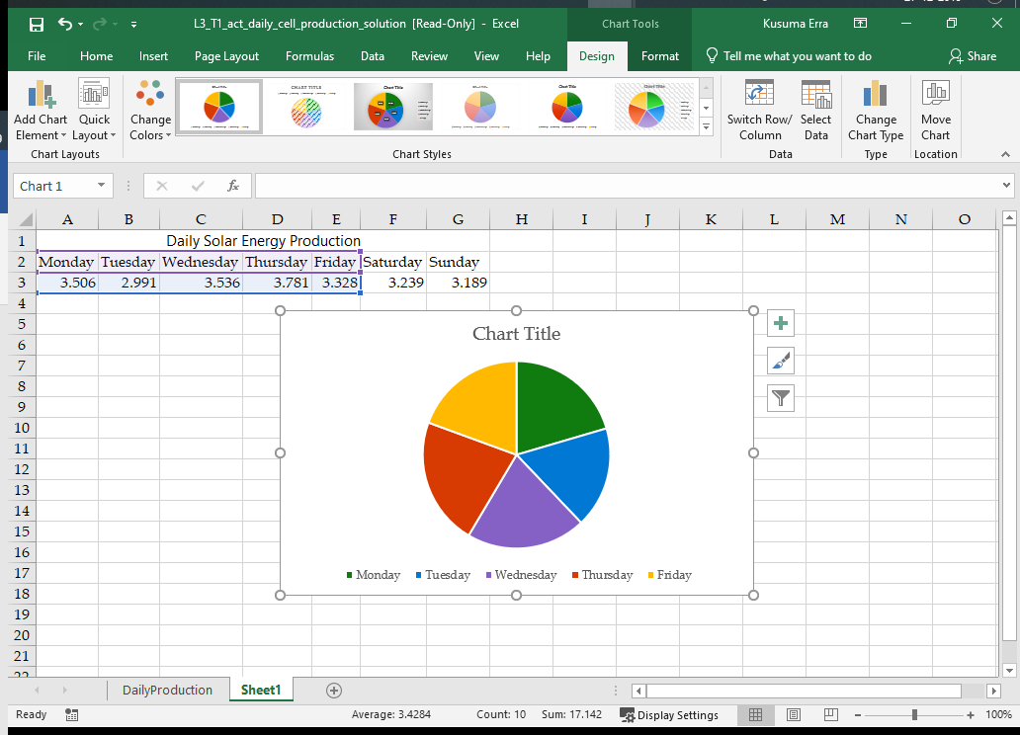

Figure 18: The source data for a pie chart

In this example, the chart includes only data for Monday through Friday; Saturday and Sunday are not reflected. Select and drag the sizing handles to include all the data you want included in the chart. Alternatively, right-click or access the context menu on the chart and choose Select Data from the context menu. Then, edit the Chart data range box to the correct range. The following screenshot depicts the same chart with the new data included.

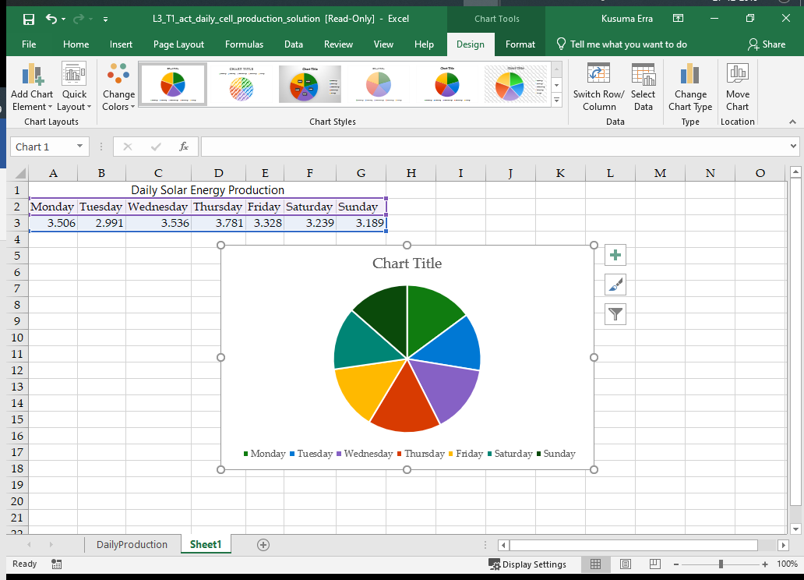

Figure 19: Source data for a pie chart that includes the two additional columns of data

### Use select data to add and remove source data

If you wish to exclude some data from your chart, or if your chart is on a separate worksheet from your data, you can use the Select Data Source dialog box. To access the dialog box, right-click or access the context menu on the chart, and then select Data Source. The Select Data Source dialog box is depicted in the following screenshot.

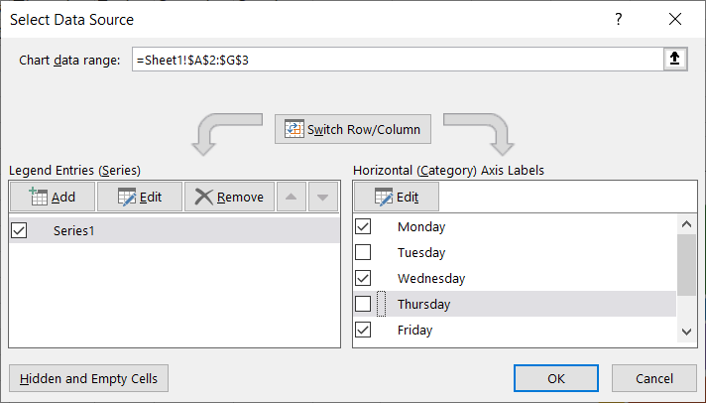

Figure 20: Select Data Source dialog box with data for Tuesday and Thursday excluded

Leave the dialog box open, and select the worksheet. Then select and drag to select the data to include in the chart. Alternatively, you can edit the Chart data range box to include the correct cell range. Use the check boxes to select each data series you want to include, and unselect each data series you want to exclude. In the previous example, data for Tuesday and Thursday are excluded from the chart. After selecting the data you want included and excluded, select OK.

|  |  |
| --- | --- |
|  | Did you know?  You can also access the Select Data Source dialog box through a chart’s context menu. Right-click or access the context menu on the chart, and then choose Select Data. |
|  | Additional information  For more information on adding a data series to a chart, go to: [Add a data series to your chart](https://aka.ms/Add-a-data-series-to-your-chart) |

### Activity: Demonstration

In this activity, the teacher will demonstrate different ways to add or remove a data series in an existing chart.

#### Resources required

You will need the following resource for this activity:

* Open L3_T1_act_daily_cell_production.xlsx in this lesson’s Learning Activity Resources.

#### Activity instructions

Participate in the activity by following these instructions:

1. Observe the teacher as they demonstrate how to add a data series to a chart by adjusting the borders indicated in the worksheet.
2. Ask clarifying questions.
3. On your computer, add a data series to a chart as directed by the teacher.
4. Observe the teacher as they demonstrate the Select Data Source dialog box.
5. Ask clarifying questions.
6. On your computer, use the Select Data Source dialog box as directed by the teacher.

### Try-it: Add data series

 In this leveled try-it activity, you’ll add a data series to an existing chart using two different methods.

### Try-it 1

In this try-it, you’ll add data to a chart by expanding the border to include all necessary data.

#### Resources

You will need the following resource for this try-it:

* Open L3_T1_try1_energy_needs_met_starter.xlsx in this lesson’s Learning Activity Resources.

#### Instructions

The following steps are the general tasks that you need to perform during this try-it:

1. Select the Monthly worksheet.
2. Inspect the source data for the line chart and note the two sets of data that are not included. Drag the bordering line to include all data in the worksheet, or right-click or access the context menu on the chart and choose Select Data from the context menu. Then, edit the Chart data range box to the correct cell range.

### Try-it 2

This try-it activity will have you exclude some data from a chart.

#### Resources

You will need the following resource for this try-it:

* Open L3_T1_try2_energy_needs_met_starter.xlsx in this lesson’s Learning Activity Resources.

#### Instructions

The following steps are the general tasks that you need to perform during this try-it:

1. Select the Monthly worksheet.
2. Modify the data source for the line chart so that the Air Conditioning data series is not displayed in the chart.

## Topic 2: Switch between rows and columns

 Depending on how your data is arranged in a worksheet, a chart might not plot the data with the orientation you prefer. For example, rows of numbers might display on the horizontal axis when you want them on the vertical axis. In some cases, the orientation could result in the chart displaying category names and no numeric values—which is likely to be useless. In other cases, either orientation might be acceptable, but you might want to try them both to determine which is better for your needs.

To switch rows and columns on a chart, select the chart, which will add Chart Tools to the ribbon. Within Chart Tools, select Design, and then in the Data group, select Switch Row/Column. The chart will re-draw in the new orientation. Selecting Switch Row/Column again will return the chart to its previous orientation. The following screenshot depicts the Switch Row/Column button.

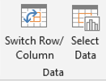

Figure 21: The Switch Row/Column button

|  |  |
| --- | --- |
|  | Additional information  To learn more about how rows and columns are plotted on a chart, go to: [Change how rows and columns of data are plotted in a chart](https://aka.ms/change-how-rows-and-columns-of-data-are-plotted-in-a-chart) |

### Activity: Demonstration

This activity is a teacher-led demonstration on how to switch rows and columns in a chart.

#### Resources required

You will need the following resource for this activity:

* Open L3_T2_act_daily_cell_production.xlsx in this lesson’s Learning Activity Resources.

#### Activity instructions

Participate in the activity by following these instructions:

1. Observe as the teacher demonstrates switching rows and columns on a pie chart.
2. Ask clarifying questions.
3. On your computer, select the pie chart and switch the rows and columns. Note the difference in how the data is plotted.
4. Switch the orientation back and forth a couple of times to observe how the feature works.

### Try-it: Switch between rows and columns

 In this standalone Try-it, you’ll correct a chart that is oriented incorrectly.

#### Resources

You will need the following resource for this try-it:

* Continue with the Energy Needs Met workbook from the Try-it activity in Topic 1. Alternatively, open L3_T2_try_energy_needs_met_starter.xlsx in this lesson’s Learning Activity Resources.

#### Instructions

The following steps are the general tasks that you need to perform during this try-it:

1. Select the Averages worksheet. Observe that the pie chart is not useful because it’s displaying a category name rather than data values.
2. Switch rows and columns for the chart so that it displays values for all six categories.

## Wrap-up

Use these questions to check what you learned in this lesson:

1. The Select Data Source dialog box allows you to do which of the following?

Select all that apply.

1. Delete data from a selection
2. Select an entirely new range of data
3. Select what color is used for each data series on the chart
4. Change to a new type of chart
5. Exclude some data from the chart
6. What does the Switch Row/Column button do?

Select the correct option.

1. Paste row data into a column
2. Rearrange data in a range of cells
3. Change the orientation of axes in a chart
4. Toggle Axis Titles off and on
5. A Select here to enter text.is a row or column of numbers in a worksheet that are plotted in a chart.

# Lesson 4: Understanding chart elements

## Overview

In this lesson, you’ll work with the individual components that make up an Excel chart. You’ll learn to change these chart elements to make your visualizations clearer, such as making the title of the chart more descriptive. You’ll also learn to add and remove elements, including a legend and data labels.

## Warm-up

Use these questions to find out what you already know about this lesson’s topics:

1. A Microsoft Excel chart is made up of multiple Select here to enter text. which can be added, removed, and modified to customize the chart.
2. Which of the following terms describes a grid at the bottom of a chart that displays the values represented in the chart?

Select the correct option.

1. Axes
2. Data label
3. Data table
4. Legend
5. A Microsoft Excel chart can contain the following titles:

Select all that apply.

1. Axis title(s)
2. Chart title(s)
3. Column and row title(s)
4. Data title(s)
5. Legend title(s)
6. A Select here to enter text.indicates the general pattern of a data series.

## Topic 1: Add chart elements

 While the primary function of a chart is to display the data itself, Excel offers a variety of elements that you can add to a chart to make it more interesting and easier to understand. Titles, labels, legends, and more, can all be added, removed, and modified to make your chart more effective.

To add new elements, begin by selecting the chart. Then, next to the chart select the Chart Elements button, as highlighted in the following screenshot.

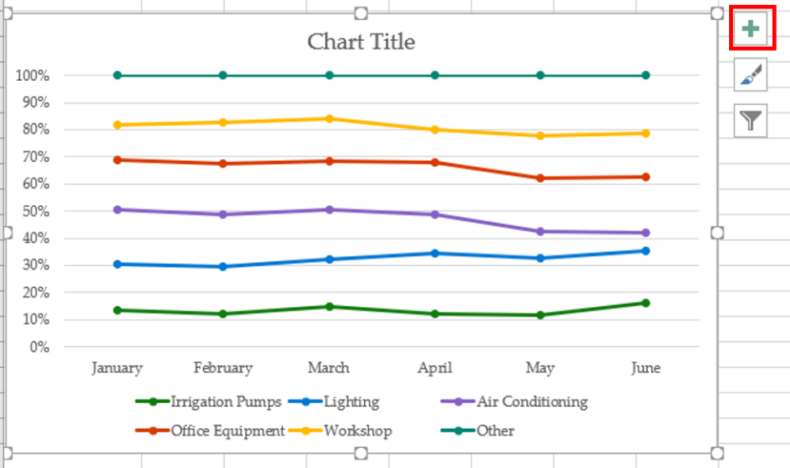

Figure 22: The Chart Elements button

After selecting the Chart Elements button, you’re presented with the list of chart elements you can add, as in the following screenshot.

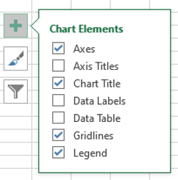

Figure 23: A list of available Chart Elements options

Select the check boxes for all elements you want to add to the chart.

|  |  |
| --- | --- |
|  | Additional information  For more information on adding chart elements, go to: [Add a legend to a chart](https://aka.ms/Add-a-legend-to-a-chart) |

### Activity: Show and Tell

In this activity, students in the group will add a variety of elements to a chart on the teacher’s computer.

#### Resources required

You will need the following resource for this activity:

* Open L4_T1_act_daily_cell_production.xlsx in this lesson’s Learning Activity Resources.

#### Activity instructions

Participate in the activity by following these instructions:

* As directed by the teacher, participate when it’s your turn to add a single element to the chart on the teacher’s computer.

### Try-it: Add chart elements

 In this leveled try-it activity, you’ll add a variety of chart elements to different charts.

### Try-it 1

This try-it activity asks you to add a single element to a chart.

#### Resources

You will need the following resource for this try-it:

* Open L4_T1_try1_maintenance_costs_starter.xlsx in this lesson’s Learning Activity Resources.

#### Instructions

You’ll need to perform the following task during this try-it:

* Add data labels to the 3D pie chart.

### Try-it 2

This try-it activity has you to add a single element to a chart.

#### Resources

You will need the following resource for this try-it:

* Open L4_T1_try2_monthly_usage_starter.xlsx in this lesson’s Learning Activity Resources.

#### Instructions

The following steps are the general tasks that you need to perform during this try-it:

1. Add a data table to the chart. Include legend keys in the data table.
2. Remove the legend now that the information is now provided by the data table.

### Try-it 3

This try-it activity asks you to add a single element to a chart.

#### Resources

You will need the following resource for this try-it:

* Open L4_T1_try3_daily_cell_production_starter.xlsx in this lesson’s Learning Activity Resources.

#### Instructions

The following steps are the general tasks that you need to perform during this try-it:

1. Add a data table (with legend keys) to the line chart.
2. Remove the legend from the chart.
3. Add a linear trend line based on the Friday data series.

## Topic 2: Modify chart elements

 After you’ve added the necessary elements to your chart, you might notice Excel is not display them in the manner you want. For example, the chart title might just display “Chart Title”. Likewise, visual elements such as grid lines might need to be adjusted. Excel manages each element of a chart individually, allowing you to modify those individual components as you wish. Learning how to modify the individual elements of your charts will enable you to create charts that say and demonstrate exactly what you want.

You modify different types of elements in different ways. You can change the text of a chart or axis title to say whatever you want, for instance, but you can’t change the value of a data label.

### Edit the text of a title in a chart

To change the contents of a chart or axis title, begin by selecting the title you wish to modify, and then select the title again to switch the title to editing mode. Now you can select the text you want to change, and enter the new text. You can place a line break in a title by pressing ENTER while in editing mode. The following screenshot has a chart title in editing mode with the existing text selected.

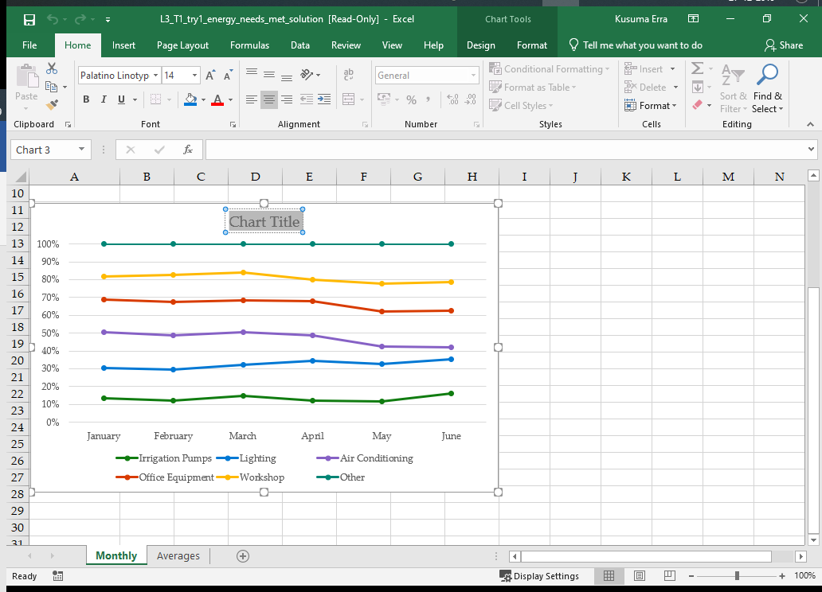

Figure 24: A chart title in editing mode with the existing text selected

Titles for the chart and each axis can be edited independently by repeating this process.

|  |  |
| --- | --- |
|  | Video  To review the video on editing chart titles, go to: [Add or remove titles in a chart](https://aka.ms/Add-or-remove-titles-in-a-chart) |

### Format a chart element with the Format task pane

Not every chart element has editable text—or any text at all! But every element can be formatted. One way to format an element is to use the Format task pane. To access it right-click or access the context menu on a chart element, and then select Format <chart element>. Notice that the context menu will indicate which type of element you’re modifying. For example, if you right-click or access the context menu on a chart title, the context menu will list Format Chart Title as an option. This changes to Format Data Labels if you right-click or access the context menu on a data label.

After the Format task pane opens, you can select any element in the chart and the task pane will automatically update to reflect the new element. The following screenshot depicts the Format task pane when an axis title is selected.

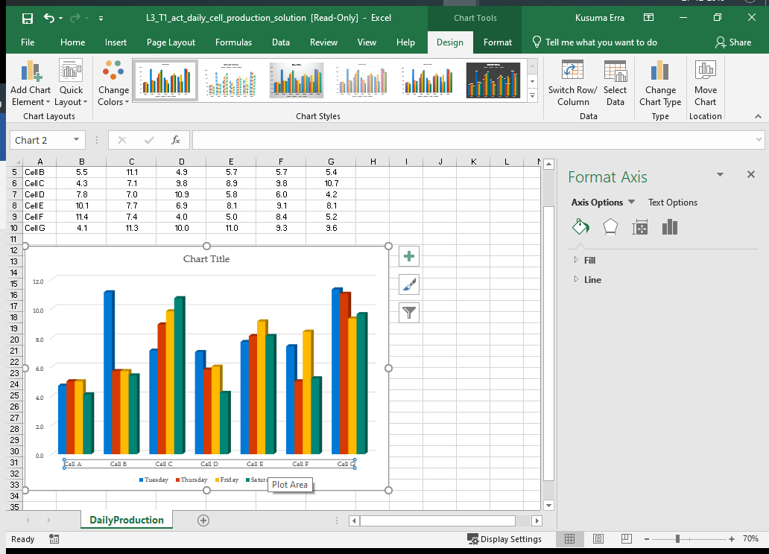

Figure 25: The Format task pane when an axis title is selected

Selecting the small icons at the top of the Format task pane presents corresponding options for formatting the element. After you finish your formatting, you can close the Format task pane, or leave it open if you’re going to format other elements.

### Format a chart element with the Chart Tools tab

In addition to the Format task pane, you can also modify a chart element using the ribbon. Select the element you want to modify, which will add the Chart Tools tab if it was not already available. Within the Chart Tools tab, select Format. The ribbon now presents a variety of tools for modifying the selected chart element. For example, the Shape Styles group includes the Shape Fill, Shape Outline, and Shape Effects buttons within the Shape Styles group, as depicted in the following screenshot.

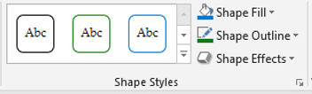

Figure 26: The Shape Fill, Shape Outline, and Shape Effects buttons within the Shape Styles group

Use the tools the Shapes Styles group to modify the fill, outline, or effects individually, or choose one of the predefined shape styles.

|  |  |
| --- | --- |
|  | Additional information  For more information on formatting chart elements, go to: [Format elements of a chart](https://aka.ms/Format-elements-of-a-chart) |

### Activity: Discuss and Learn

Engage in the discussion with the teacher about selecting chart elements.

#### Resources required

You will need the following resource for this activity:

* Open L4_T2_act_daily_cell_production.xlsx in this lesson’s Learning Activity Resources.

#### Activity instructions

Participate in the teacher-led discussion and make the corresponding adjustments to the chart elements on your computer.

### Try-it: Modify chart elements

 In this series of leveled try-it activities, you’ll modify a variety of chart elements.

### Try-it 1

In this try-it activity, you’ll edit the text of a chart title.

#### Resources

You will need the following resource for this try-it:

* Open L4_T2_try1_energy_needs_met_starter.xlsx in this lesson’s Learning Activity Resources.

#### Instructions

The following steps are the general tasks that you need to perform during this try-it:

1. On the Monthly worksheet, change the text of the line chart title to Percentage of Electrical Needs Met by Solar Array.
2. On the Averages worksheet, change the text of the 3D pie chart title to Average Percentage of Needs Met.

### Try-it 2

This activity will prompt you to remove chart elements and edit title text.

#### Resources

You will need the following resource for this try-it:

* Open L4_T2_try2_energy_needs_met_starter.xlsx in this lesson’s Learning Activity Resources.

#### Instructions

The following steps are the general tasks that you need to perform during this try-it:

1. On the Monthly worksheet, remove the data labels from the line chart.
2. Change the text of the vertical axis title to Percentage Met.
3. Change the horizontal axis title text to Month.
4. Remove the trendline.

### Try-it 3

In this try-it activity, you’ll change data labels.

#### Resources

You will need the following resource for this try-it:

* Open L4_T2_try3_energy_needs_met_starter.xlsx in this lesson’s Learning Activity Resources.

#### Instructions

The following steps are the general tasks that you need to perform during this try-it:

1. Select the Averages worksheet.
2. Change the data labels on the 3D pie chart to display only the percentage on the outside end.

## Wrap-up

Use these questions to check what you learned in this lesson:

1. Which chart element displays a grid of the chart’s underlying data?

Select the correct option.

1. Legend
2. Data table
3. Data labels
4. Trendline
5. Which chart element displays details about a data series and/or individual data points?

Select the correct option.

1. Trendline
2. Axes
3. Chart Title
4. Data labels
5. Data titles
6. Which of the following options allow you to modify chart elements?

Select all that apply.

1. The Format task pane
2. The Data tab on the ribbon
3. The Page Layout tab on the ribbon
4. The Chart Tools tab
5. The Chart Elements task pane

1. Select here to enter text. make a chart easier to read by providing regularly spaced reference lines for comparison.

# Lesson 5: Understanding chart styles and layouts

## Overview

In this lesson, you’ll focus on making your charts impactful and attractive by changing their layout and appearance. You’ll learn how to use layouts and styles that are predefined in Excel, and you’ll also discover how to change the color scheme of chart.

## Warm-up

Use these questions to find out what you already know about this lesson’s topics:

1. A Select here to enter text.is an arrangement of chart elements within a chart.
2. Which of the following are not changed when you select a style?

Select the correct option.

1. The font(s) used in text elements
2. The position of elements
3. Shadows and glows
4. Which of the following statements is true about predefined chart layouts?

Select the correct option.

1. They can only be applied to a chart once.
2. They must be created by the user.
3. They can only be applied to column charts.
4. They arrange the position of chart elements.
5. Excel offers predefined Select here to enter text. for charts rather than forcing you to pick individual colors.

## Topic 1: Apply layouts

 A chart can consist of many individual chart elements, each of which you can modify and customize extensively. While this gives you a great deal of flexibility, it can also lead to endless tinkering as you try different combinations in search of just the right arrangement. To help with this, Excel offers a variety of predefined layouts that you can use to quickly view different ways of organizing chart elements. After you select the quick layout that you like, you can still adjust individual elements to get exactly the layout you want.

|  |  |
| --- | --- |
|  | Did you know?  In Excel, chart layout refers to which chart elements are included, and the position of those elements. Fonts and colors are not part of the chart layout and are applied separately. |

You access the Quick Layout tool from the ribbon. First, select the chart you want to edit. This will make Chart Tools available on the ribbon. Select the Design tab, and then in the Chart Layouts group, select Quick Layout. This will make the predefined Quick Layout options available, which are in the following screenshot.

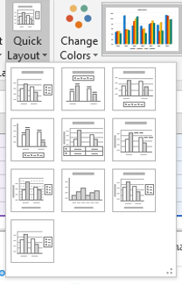

Figure 27: The Quick Layout options for a chart

As you navigate over the choices, Excel updates your chart to display a preview of the layout. It also displays a window with the layout number, and a list of elements included in the layout. From here you can select the layout you want.

|  |  |
| --- | --- |
|  | Additional information  For more information on changing the layout of a chart, go to: [Change the layout or style of a chart](https://aka.ms/Change-the-layout-or-style-of-a-chart) |

### Activity: Demo

In this activity, the teacher will demonstrate the Quick Layout tool.

#### Resources required

You will need the following resource for this activity:

* Open L5_T1_act_daily_cell_production.xlsx in this lesson’s Learning Activity Resources.

#### Activity instructions

Follow along as the teacher demonstrates a variety of layouts.

### Try-it: Apply layouts

 This standalone try-it activity allows you to practice applying a predefined layout to a chart.

#### Resources

You will need the following resource for this try-it:

* Open L5_T1_try_energy_needs_met_starter.xlsx in this lesson’s Learning Activity Resources.

#### Instructions

The following steps are the general tasks that you need to perform during this try-it:

1. On the Monthly worksheet, apply Layout 5 to the line chart.
2. On the Averages worksheet, apply Layout 1 to the 3D pie chart.

## Topic 2: Apply styles and colors

 After you’ve chosen a chart layout, including the chart elements you’ll include and their positions within the chart, you’ll want to add the finishing touches. To make sure your chart is eye-catching, you can apply a style and colors.

A chart’s style determines the fonts used for text elements, and how the color scheme is applied to all elements.

|  |  |
| --- | --- |
|  | Did you know?  A chart makes use of many different colors—they are a big part of what makes a chart so useful! Rather than requiring you to choose each of the individual colors to use in your chart, Excel allows you to pick a color scheme. A color scheme is a collection of colors specifically chosen to look great and offer enough contrast to make your charts easy to see. |

### Apply a Quick Style from the ribbon

You can access predefined chart styles from the ribbon. Begin by selecting the chart you want to adjust so that Chart Tools is added to the ribbon. From there, select the Design tab, and then in the Chart Styles group, select a predefined Chart Quick Style. Select More to display all available styles, as called out in the following screenshot.

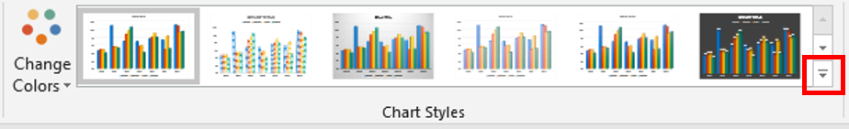

Figure 28: The gallery of Chart Quick Style options with the More icon highlighted

As you navigate over the choices, Excel updates your chart and displays a preview of the style along with a tooltip containing the style number. Select the style you want.

### Apply a quick style with Chart Styles

You can also apply a predetermined style using Chart Styles. First, select the chart. Then select Chart Styles next to the chart, as called out in the following screenshot.

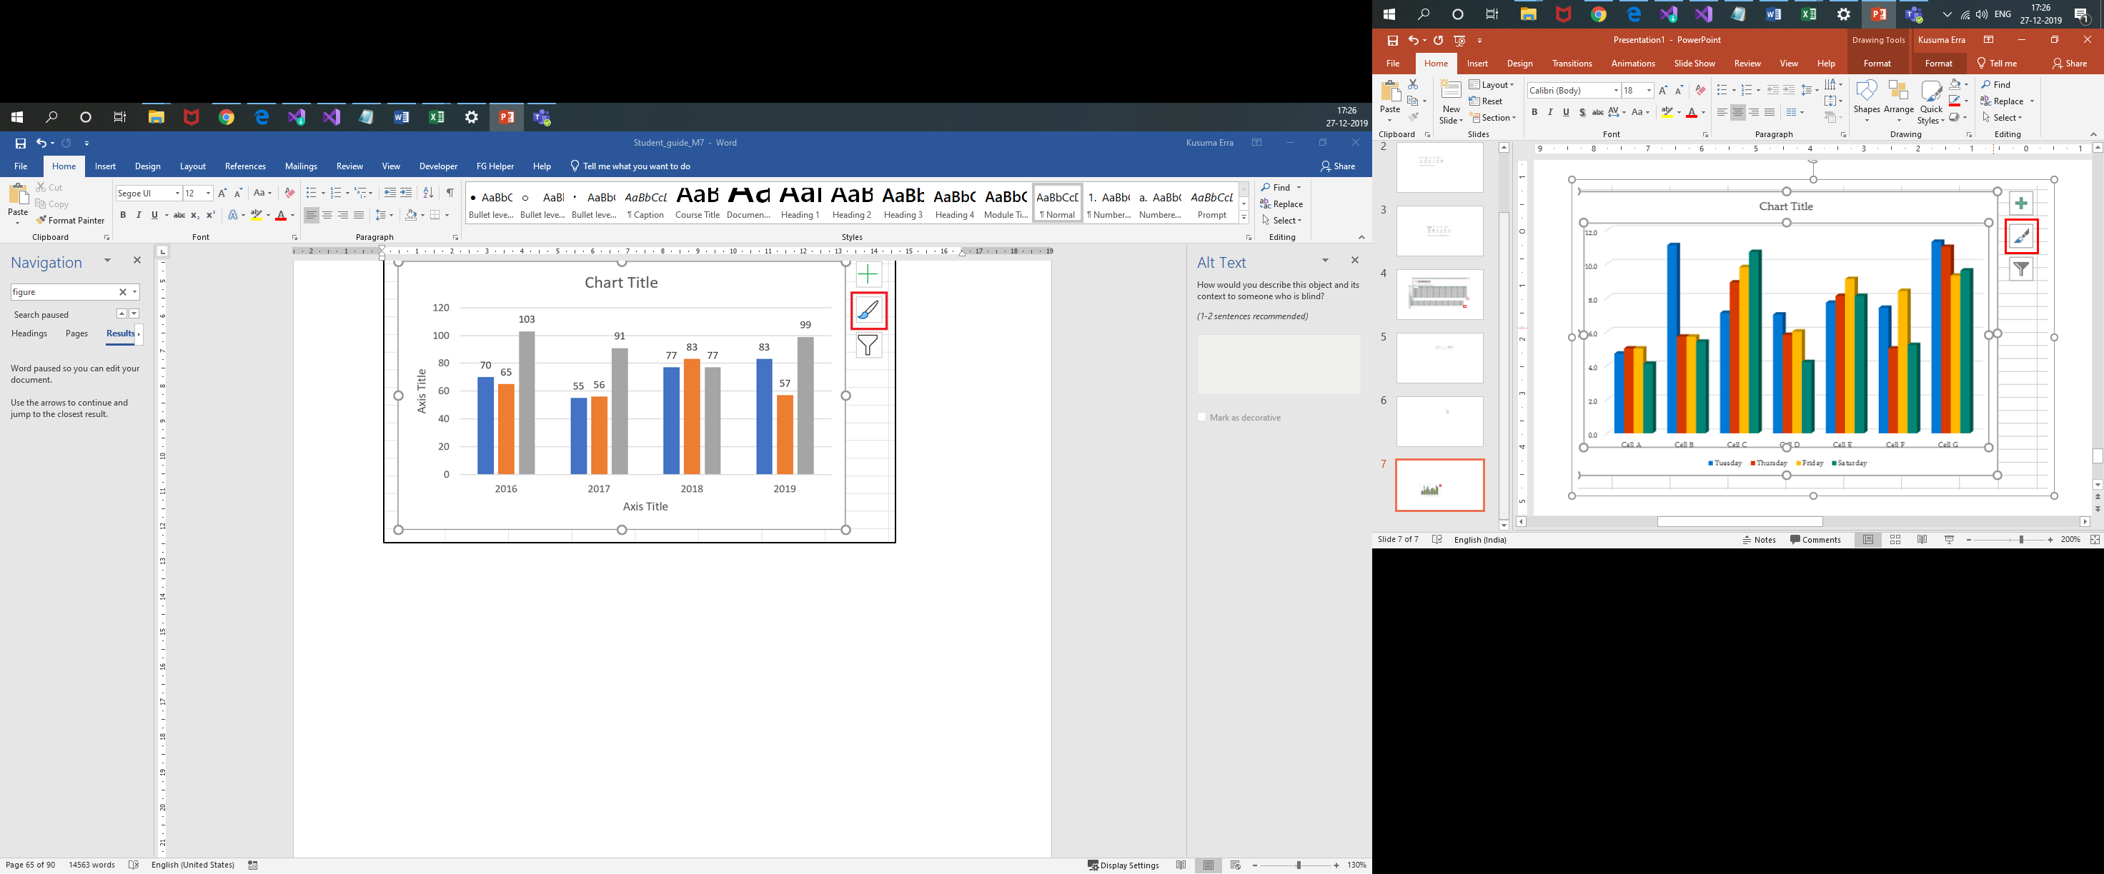

Figure 29: The Chart Styles button, highlighted in red

A window will display with a gallery of Quick Style choices. As you navigate over the choices, Excel updates your chart to show a preview of the style and displays a tooltip with the style number. Select the style you want.

### Apply a color scheme from the ribbon

To select a color scheme from the ribbon, begin by selecting the chart you want to adjust so that Chart Tools is added to the ribbon. Then select the Design tab, and then in the Chart Styles group, select Change Colors. The following screenshot depicts the gallery of color schemes.

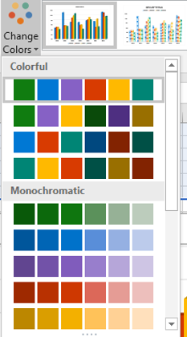

Figure 30: The gallery of color schemes

As you navigate over the choices, Excel updates your chart to display a preview of the scheme and displays a tooltip identifying the scheme palette number. Select the scheme you want.

### Apply a color scheme with Chart Styles

You can also apply a color scheme using Chart Styles. First, select the chart. Next, select the Chart Styles icon next to the chart, and select the Color option, as in the following screenshot.

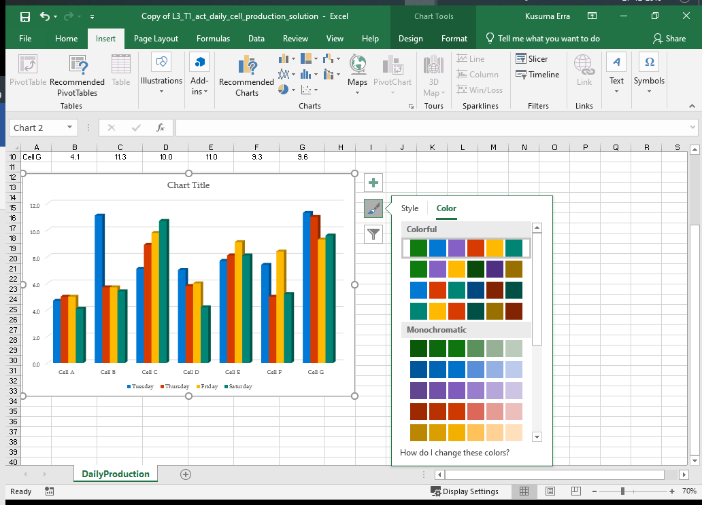

Figure 31: Chart Styles with the Color option selected

A window will display with a gallery of color scheme choices. As you navigate over the choices, Excel updates your chart to display a preview of the color scheme, in addition to a tooltip identifying the name of the color scheme. Select the scheme you want.

### Activity: Discuss and learn

Engage in the discussion with the teacher about applying colors and styles to a chart.

#### Resources required

You will need the following resource for this activity:

* Open L5_T2_act_daily_cell_production.xlsx in this lesson’s Learning Activity Resources.

#### Activity instructions

Participate in the teacher-led discussion, and then apply the styles and color schemes to the chart on your computer.

### Try-it: Apply styles and colors

 In this leveled try-it activity, you’ll apply predefined styles and color schemes to charts.

### Try-it 1

In this activity, you’ll practice applying a Quick Style and a color scheme to a chart.

#### Resources

You will need the following resource for this try-it:

* Open L5_T2_try1_energy_needs_met_starter.xlsx in this lesson’s Learning Activity Resources.

#### Instructions

The following steps are the general tasks that you need to perform during this try-it:

1. On the Averages worksheet, choose a predefined style and apply it to the 3D pie chart.
2. Choose and apply a predefined color scheme to the 3D pie chart.

### Try-it 2

In this activity, you’ll practice applying a Quick Style and a color scheme to a chart.

#### Resources

You will need the following resource for this try-it:

* Open L5_T2_try2_energy_needs_met_starter.xlsx in this lesson’s Learning Activity Resources.

#### Instructions

The following steps are the general tasks that you need to perform during this try-it:

1. On the Monthly worksheet, apply Style 11 to the line chart.
2. Apply Monochromatic Palette 2 to the line chart.

## Wrap-up

Use these questions to check what you learned in this lesson:

1. How can you find the name of a predefined chart layout?

Select the correct option.

1. By opening the Format task pane
2. By viewing the workbook properties
3. By opening Chart Elements
4. By hovering over a selection in the gallery
5. A Select here to enter text.rearranges chart elements but does not alter their appearance.
6. Where can you access Chart Styles?

Select all that apply.

1. As a button to the right of a selected chart.
2. On the context menu after selecting a chart.
3. In the Data tab of the ribbon
4. In the Chart Tools Format tab in the ribbon
5. In the Chart Tools Design tab in the ribbon

# Lesson 6: Understanding sparklines

## Overview

In this lesson, you’ll learn how to insert sparklines to give a visual representation of a trend in your data. You’ll also explore the different chart types available as sparklines, and you’ll learn how to modify the format of a sparkline.

## Warm-up

Use these questions to find out what you already know about this lesson’s topics:

1. What are the different chart types for sparklines?

Select all that apply.

1. Bar
2. Column
3. Line
4. Pie
5. Win/Loss
6. Sparklines are often used to emphasize a(n) Select here to enter text.in a data series.
7. Which of the following options can you use to emphasize data points on a sparkline?

Select the correct option.

1. Data labels
2. Markers
3. Callouts
4. Gridlines
5. Use a predefined Select here to enter text.to quickly modify settings related to the appearance of sparklines.

## Topic 1: Insert sparklines

 Charts provide a valuable tool for displaying data in a large, easy-to-read format, which can present a great deal of information. However, a chart does take up a large space on a worksheet, and there are times when you’ll just want a simple, clear indication of one aspect of your data. Excel allows you to add a sparkline, which is a small visualization of data—so small, in fact, that it fits in a single cell! Sparklines are most useful when they are used to demonstrate a trend in your data, and work best when placed near the data they represent.

Imagine tracking your grades each week for each of your classes. Each course could fill a row, with a column for each week. Sparklines would be a great way to display how your grade is trending over the weeks in each course. With just a glance, you could find which grades are improving and which classes need more attention.

To insert a sparkline, select an empty cell near the data you want to represent. On the ribbon, select the Insert tab, and then in the Sparklines group, select the type of sparkline you want: Line, Column, or Win/Loss, as in the following screenshot.

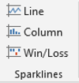

Figure 32: The Sparklines group

The Create Sparklines dialog box prompts you for the information to create the sparkline. In the Data Range box, enter the range of cells with data for the sparkline. The Location Range specifies the cell or cells in which the sparklines will be placed, and will already be populated with the cell you selected. After the Data Range box is selected, you can either enter the cell range or you can select the desired cell range in the worksheet. The following screenshot depicts the Create Sparklines dialog box next to a selected range of data.

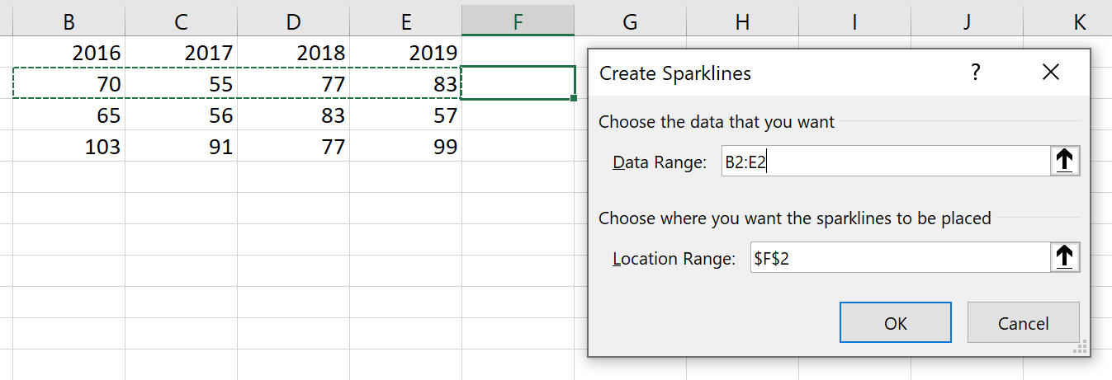

Figure 33: The Create Sparklines dialog box next to a selected range of data

If you want sparklines for additional rows of data, you can select and drag the autofill handle to the additional rows. Alternatively, you can select the sparkline plus the additional cells and press Ctrl+D to fill the other sparklines.

|  |  |  |
| --- | --- | --- |
|  | | Did you know?  If you place a sparkline in a cell with text, the sparkline will serve as a background for that cell. While this can be useful, you must be careful: background sparklines can make text difficult to read! |
|  | Additional information  For additional information on sparklines, go to: [Analyze trends in data using sparklines](https://aka.ms/analyze-trends-in-data-using-sparklines) | |
|  | Video  To review the video on sparklines, go to: [Use sparklines to show data trends](https://aka.ms/Use_spark_lines_to_show_data_trends) | |

### Activity: Tell a story

In this activity, the teacher will lead you through inserting sparklines to emphasize data trends.

#### Resources required

You will need the following resource for this activity:

* Open L6_T1_act_daily_cell_production.xlsx in this lesson’s Learning Activity Resources.

#### Activity instructions

Add sparklines to the worksheets as directed by the teacher.

### Try-it: Insert sparklines

 In this leveled try-it activity, you’ll add two different types of sparklines to a workbook.

### Try-it 1

This activity will have you practice inserting Line sparklines to emphasize data trends.

#### Resources

You will need the following resource for this try-it:

* Open L6_T1_try1_weekly_cell_production_starter.xlsx in this lesson’s Learning Activity Resources.

#### Instructions

The following are the general tasks that you need to perform during this try-it:

1. On the AngleAdjustments worksheet, create a Line sparkline in cell H4. Include the data in cells B4:G4.
2. Fill the sparkline down to the rest of the rows of data on the worksheet.
3. In cell H3, enter the text Performance.

### Try-it 2

This activity will have you practice inserting Win/Loss sparklines to emphasize data trends.

#### Resources

You will need the following resource for this try-it:

* Open L6_T1_try2_weekly_cell_production_starter.xlsx in this lesson’s Learning Activity Resources.

#### Instructions

The following steps are the general tasks that you need to perform during this try-it:

1. On the SurplusEnergy worksheet, create a Win/Loss sparkline in cell H4. Include the data in cells B4:G4.
2. Fill the sparkline in the rest of the rows of data on the worksheet.
3. In cell H3, enter the text Surplus/Deficit.

## Topic 2: Modify sparklines

 Due to their small size and their focus on single sets of data, you can’t customize sparklines to the same degree as charts. However, Excel does offer a robust set of options for customizing sparklines. As with charts, familiarizing yourself with these options will help you create effective sparklines.

### Show sparkline markers and highlights

Sparklines don’t have enough space to label data with values, but you do have some options for emphasizing particularly significant individual values, such as the highest and lowest values.

Select the sparklines you want to modify to add the Sparkline tab to the ribbon, and then select the Design tab. A series of check boxes in the Show group allow you to select which individual data points to emphasize. In Line sparklines, selecting Markers will add a marker to all datapoints; this option is not available for Column and Win/Loss sparklines. High Point and Low Point add markers or highlights to the highest and lowest values, respectively. First Point and Last Point emphasize the first and last data points in the series, respectively, and Negative Points will highlight and values below zero. The following screenshot depicts the Show group with High Point and Low Point selected.

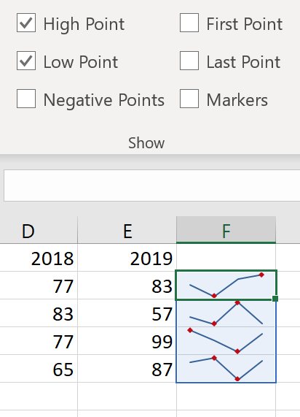

Figure 34: The Show group with High Point and Low Point selected

### Apply a style to sparklines

Excel includes predefined sparklines styles to help you find just the right appearance for your sparklines. You can also modify their colors. Select the sparklines you want to modify to add the Sparkline tab to the ribbon, and then select the Design tab. The Style group includes a gallery of Quick Styles. Navigating to a quick style will update the sparklines on your worksheet and display a preview of the settings.

The Style group (displayed in the following screenshot) also includes a Sparkline Color option to change the primary color of your sparklines, and a Marker Color option to customize how markers and highlights are presented.

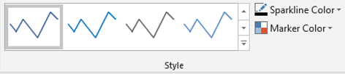

Figure 35: The Style group within the Design tab in Sparkline Tools

|  |  |
| --- | --- |
|  | Did you know?  When you copy a sparkline to other rows, Excel groups those sparklines together. This grouping allows you to modify all related sparklines at once, making it easier to ensure that your sparklines are consistent. If you want to modify the sparklines individually, use Ungroup from the Group group, on the Design tab in Sparkline Tools. |

### Activity: Continue the story

This teacher-led activity will guide you as you explore some of the options available for modifying sparklines.

#### Resources required

You will need the following resource for this activity:

* Open L6_T2_act_monthly_cell_production.xlsx in this lesson’s Learning Activity Resources.

#### Activity instructions

Modify the sparklines in the workbook as directed by the teacher.

### Try-it: Modify sparklines

 This series of leveled Try-It activities will prompt you to practice modifying sparklines.

### Try-it 1

In this activity, you’ll apply markers to sparklines.

#### Resources

You will need the following resource for this try-it:

* Open L6_T2_try1_weekly_cell_production_starter.xlsx in this lesson’s Learning Activity Resources.

#### Instructions

The following steps are the general tasks that you need to perform during this try-it:

* On the AngleAdjustments worksheet, add High Point markers to the Line sparklines.

### Try-it 2

This activity will give you the opportunity to practice customizing sparkline markers.

#### Resources

You will need the following resource for this try-it:

* Open L6_T2_try2_weekly_cell_production_starter.xlsx in this lesson’s Learning Activity Resources.

#### Instructions

The following steps are the general tasks that you need to perform during this try-it:

1. On the AngleAdjustments worksheet, add Low Point markers to the Line sparklines.
2. On the same sparklines, change High Point markers to green, and set the Low Point markers to red.

### Try-it 3

In this try-it activity, you’ll practice modifying individual sparklines.

#### Resources

You will need the following resource for this try-it:

* Open L6_T2_try3_weekly_cell_production_starter.xlsx in this lesson’s Learning Activity Resources.

#### Instructions

The following steps are the general tasks that you need to perform during this try-it:

1. On the AngleAdjustments worksheet, remove the High Point and Low Point markers to the Line sparklines.
2. Ungroup the first three Line sparklines so that you can modify them individually.
3. Apply orange High Point markers to each of the first three sparklines.
4. Apply black markers to all datapoints in the remaining four sparklines.

## Wrap-up

Use these questions to check what you learned in this lesson:

1. By default, related sparklines are managed together in a Select here to enter text..
2. Which of the following options is used to emphasize the largest value in a data series?

Select the correct option.

1. First Point
2. High Point
3. Last Point
4. Low Point
5. To modify an individual sparkline, you must first __________________ it.

Select all that apply.

1. Clear
2. Detach
3. Select
4. Ungroup
5. The Select here to enter text. chart type emphasizes the difference between positive and negative values in the data series.

# Lesson 7: Understanding the Quick Analysis feature

## Overview

This lesson will explore a useful tool for quickly and easily transforming, visualizing, and analyzing data. The Quick Analysis feature lets you add visualizations such as charts, sparklines, and conditional formatting. It also automates the process of adding useful formulas to total or average your data.

## Warm-up

Use these questions to find out what you already know about this lesson’s topics:

1. How can you access the Quick Analysis tool?

Select the correct option.

1. Navigate to the Data tab on the ribbon.
2. Right-click or access the context menu on a chart or sparkline.
3. Select a range of cells.
4. Select Conditional Formatting from the Home tab on the ribbon.
5. Which of the following can you add using Quick Analysis?

Select all that apply.

1. A color scale
2. A chart
3. A trendline
4. A predefined color scheme

1. Where are Totals calculations placed when added using the Quick Analysis feature?

Select all that apply.

1. On a new worksheet
2. Beginning at cell A1
3. On the last row visible on the screen
4. Adjacent to the data range
5. Which of the following options best describes the role of the Quick Analysis feature?

Select the correct option.

1. Quickly generate new values based on existing data.
2. Forecast or project a future value.
3. Analyze data and generate a text-based report.
4. Quickly generate totals and visualizations.

## Topic 1: Use Quick Analysis to format data

There are many options for visualizing and analyzing data in a spreadsheet, and Excel gives you a large variety of tools to present your data in exactly the right way. The Quick Analysis feature gives you a speedy way to do some of the most common analysis and visualization tasks in Excel. You might use Quick Analysis to answer a quick question in a workbook, then delete those additions from the workbook. With data that you are sharing with other people, Quick Analysis can give you a jump start when adding visualizations to make the data easier for others to understand.

To use the Quick Analysis feature, select a range of cells you want to analyze; this will make the Quick Analysis icon available at the bottom, right corner of your selected range, as called out in the following.

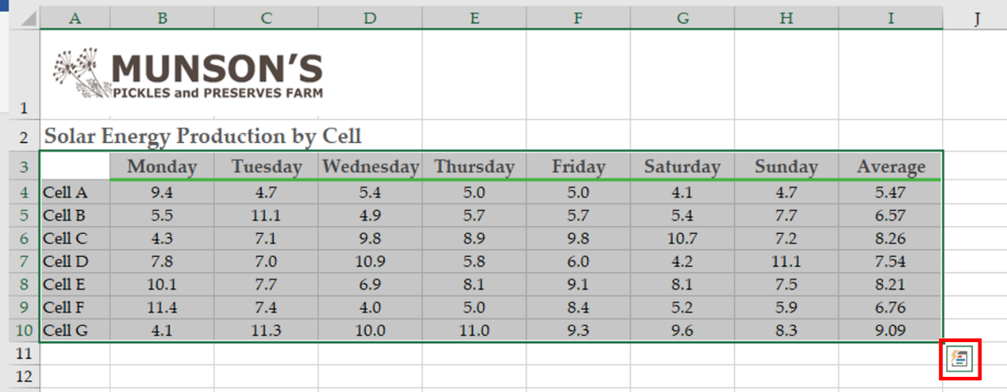

Figure 36: A selection of cells with the Quick Analysis icon highlighted in red

### Add conditional formatting using Quick Analysis

To add conditional formatting, select a range of data, select the Quick Analysis icon, and then select the Formatting tab. By navigating to an option in the gallery, the worksheet updates to display a preview of using the formatting option you chose. The following screenshot depicts the Formatting options in Quick Analysis.

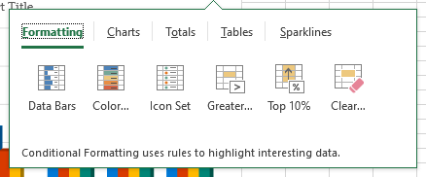

Figure 37: Formatting tab options in Quick Analysis

Select a choice to add that conditional formatting to the data range.

### Add a chart or sparklines using Quick Analysis

To add a chart or sparklines, select a range of data, select the Quick Analysis icon, and then select either the Charts or Sparklines tab. As you navigate to options, the worksheet updates to display a preview of the choice. Note that the options offered in the gallery are based on the Recommended Charts feature and could vary from the example in the following screenshot.

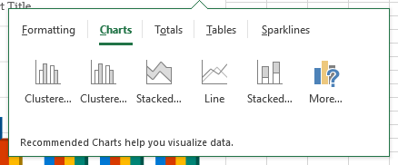

Figure 38: Charts tab options in Quick Analysis

Select your desired chart or sparklines to insert it into the worksheet.

### Add totals for data using Quick Analysis

The Totals tab options in Quick Analysis makes calculations based on your numbers and adds the results in the cells next to or below your data.

To add totals for data, select a range of data, select Quick Analysis, and then select the Totals option. By navigating to a calculations option in the gallery (as displayed in the following screenshot), the worksheet updates to display a preview of the choice.

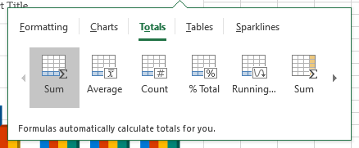

Figure 39: Totals tab options in Quick Analysis

Select a calculation to add the corresponding formulas to your worksheet.

|  |  |  |
| --- | --- | --- |
|  | | Did you know?  Everything added with Quick Analysis is just like any other part of your workbook. For example, a chart created with Quick Analysis is just like a chart created from the ribbon—you can modify it just like any other chart. This is true for everything Quick Analysis offers. |
|  | Video  To review the video on Quick Analysis, go to: [Analyze your data instantly](https://aka.ms/Analyze_your_data_quickly) | |

### Activity: Demo and experiment

In this activity, the teacher will demonstrate the Quick Analysis feature. After the demonstration, you’ll practice using Quick Analysis.

#### Resources required

You will need the following resource for this activity:

* Open L7_T1_act_monthly_cell_production.xlsx in this lesson’s Learning Activity Resources.

#### Activity instructions

Participate in the activity by following these instructions:

1. Participate in the demonstration led by the teacher.
2. Try out a variety of Quick Analysis tools. Be sure to try different selections to observe how the options change.

### Try-it: Quick Analysis

 In these leveled Try-It activities, you’ll practice using different Quick Analysis tools.

### Try-it 1

In this try-it, you’ll use Quick Analysis to add averages to a range of data.

#### Resources

You will need the following resource for this try-it:

* Open L7_T1_try1_weekly_cell_production_starter.xlsx in this lesson’s Learning Activity Resources.

#### Instructions

The following steps are the general tasks that you need to perform during this try-it:

1. On the AngleAdjustments worksheet, use Quick Analysis to add averages to row 11 for columns B through G.
2. On the SurplusEnergy worksheet, use Quick Analysis to add averages to the right of each row of data.

### Try-it 2

In this try-it activity, you’ll practice adding visualizations using Quick Analysis.

#### Resources

You will need the following resource for this try-it:

* Open L7_T1_try2_weekly_cell_production_starter.xlsx in this lesson’s Learning Activity Resources.

#### Instructions

The following steps are the general tasks that you need to perform during this try-it:

1. On the AngleAdjustments worksheet, use Quick Analysis to highlight all cells with values greater than 3.0. Use a yellow fill with dark yellow text.
2. On the SurplusEnergy worksheet, use Quick Analysis to add a color scale to the data.

## Topic 2: Disable the Quick Analysis feature

 Part of the flexibility available to Excel users is the ability to customize which tools you use and how you implement them. While Quick Analysis makes it convenient to access some commonly used features, you might want to disable it.

The setting to disable Quick Analysis is in the Excel Options window. Select File on the ribbon, and then select Options. The Show Quick Analysis options on selection check box allows you to enable or disable the feature. The following screenshot depicts the Options window with the Show Quick Analysis options on selection check box selected.

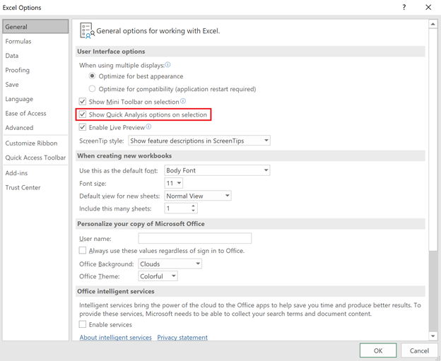

Figure 40: The Options window with the Show Quick Analysis options on selection check box selected

To disable the feature, ensure that the check box is cleared.

### Activity: Discuss

In this activity, the teacher will lead a discussion about Quick Analysis.

#### Resources required

You will not need any resources for this try-it.

#### Activity instructions

Participate in the group discussion.

### Try-it: Disable the Quick Analysis feature

 In this activity, the teacher will present the group with a challenge. Do your best to complete the challenge as directed.

#### Resources

You will not need any resources for this try-it.

#### Instructions

Complete the group challenge as directed by the teacher.

## Wrap-up

Use these questions to check what you learned in this lesson:

1. Which of the following statements is true of Quick Analysis charts?

Select the correct option.

1. Chart type choices vary depending on the selection.
2. Only a few of the most popular charts types are available.
3. Generated charts cannot be customized.
4. The list of chart types can be customized in the Options window.
5. Which of the following cannot be added using Quick Analysis?

Select the correct option.

1. Charts
2. Cell styles
3. Sparklines
4. Conditional formatting
5. Averages
6. You can disable the Quick Analysis feature from the Select here to enter text. window.

# Glossary

|  |  |
| --- | --- |
| Alt Text | A description of a graphic element used by screen readers to describe the information included in a visual object. |
| Chart | A visual representation of one or more data series. |
| Chart element | An individual element of a chart, such as a title or legend. |
| Conditional Formatting | A feature that applies cell formatting based on the value of that cell. |
| Data series | A row or column of related values in a worksheet. |
| Rules Manager | A tool that allows you to add, remove, edit, and prioritize conditional formatting rules. |
| Quick Analysis | A feature that provides previews of analysis and visualization tools. |
| Quick Style | A predefined collection of settings used to configure a visual element, such as a chart or sparkline. |
| Quick Layout | A predefined arrangement of chart elements. |
| Sparkline | A miniature chart that occupies a single cell and provides a visual representation of data. |

Table 2: Glossary terms and definitions

# Cornerstone

## Overview

In this cornerstone, you’ll improve on and add to visualizations in a workbook with data related to the solar array installed last year at Munson’s Pickles and Preserves Farm. You’ll remove and add conditional formatting, add charts and sparklines, and make changes to a chart already in the workbook. You’ll also use layouts, styles, and colors to alter the appearance of these visualizations.

## Objectives

The following table outlines the Cornerstone objectives and their corresponding MOS exam objectives.

|  |  |
| --- | --- |
| Apply and remove conditional formatting | 2.4.2: Apply built-in conditional formatting  2.4.3: Remove conditional formatting |
| Create and move charts | 5.1.1: Create charts  5.1.2: Create chart sheets  5.3.3: Add alternative text to charts for accessibility |
| Add a data series to a chart | 5.2.1: Add data series to charts  5.2.2: Switch between rows and columns in source data |
| Add and remove chart elements from a chart | 5.2.3: Add and modify chart elements |
| Apply layouts, styles, and colors to charts | 5.3.1: Apply chart layouts  5.3.2: Apply chart styles  5.3.3: Add alternative text to charts for accessibility |
| Insert and modify sparklines | 2.4.1: Insert Sparklines |

Table 3: Cornerstone objectives

## Duration

50 minutes

## Instructions

Complete the following tasks for each file:

1. When saving your file, add your name to the end of the filename, for example: “Cornerstone_Solar_Array_Data_Dwayne_Espino.” Follow your teacher’s directions for where to save your files.
2. When you’re done with the Cornerstone, assess your completed product, and enter the points you think you earned within the task lists below. You can take the help of your teacher if required.

## Tasks

You’ll work with one file in this Cornerstone. The following steps are the tasks you need to complete within the file.

### File 1: Cornerstone_solar_array_data_starter.xlslx

#### Task: Apply and remove conditional formatting (4 points)

1. Open Cornerstone_solar_array_data_starter.xlslx and select the MonthlyUsage worksheet. Remove all the conditional formatting. (2 points) (Exam objective 2.4.3)
2. Apply a conditional formatting rule that adds a Red - Yellow - Green color scale, so that the months with the highest usage are shaded red. (2 points) (Exam objective 2.4.2)

Points scored: Select here to enter text./4

#### Task: Insert sparklines (5 points)

1. On the MonthlyUsage worksheet, add a Line sparkline to the January row next to the value for 2019. (2 points) (Exam objective 2.4.1)
2. Fill that sparkline through the December row. (1 point) (Exam objective 2.4.1)
3. Modify all sparklines to indicate the high point for each row. (2 points) (Exam objective 2.4.1)

Points scored: Select here to enter text./5

#### Task: Add a data series to a chart (3 points)

1. On the MonthlySurplus worksheet, switch the row and column on the pie chart. (1 point) (Exam objective 5.2.2)
2. Add the data for October, November, and December to the pie chart. (2 point) (Exam objective 5.2.1)

Points scored: Select here to enter text./3

#### Task: Modify a chart (4 points)

1. Move the pie chart to a new chart worksheet named SurplusEnergy. (2 points) (Exam objective 5.1.2)
2. Change the color scheme for the chart to Colorful Palette 3. (2 point)

Points scored: Select here to enter text./4

#### Task: Create and modify a chart (4 points)

1. On the MonthlyUsage worksheet, create a clustered column chart with all the numeric data on the worksheet. Position it below the data. (2 points) (Exam objective 5.1.1)
2. Apply Layout 2. (1 point) (Exam objective 5.3.1)
3. Edit the chart title to Monthly Usage. (1 points) (Exam objective 5.2.3)

Points scored: Select here to enter text./4

#### Task: Add and remove chart elements from a chart (7 points)

1. On the MonthlyUsage worksheet, remove the data labels from the clustered column chart. (2 points) (Exam objective 5.2.3)
2. Add primary major horizontal gridlines. (3 points) (Exam objective 5.2.3)
3. On the SurplusEnergy worksheet, add data labels with data callouts. Remove the legend. (2 points) (Exam objective 5.2.3)

Points scored: Select here to enter text./7

#### Task: Add Alt Text (2 points)

1. On the MonthlyUsage worksheet, add Alt Text to the clustered column chart. (1 points) (Exam objective 5.3.3)
2. On the SurplusEnergy worksheet, add Alt Text to the pie chart. (1 points) (Exam objective 5.3.3)

Points scored: Select here to enter text./2

FILE 1 TOTAL POINTS: Select here to enter text./29