

Student guide

40567A  
Microsoft Excel associate 2019

Module 8: Preparing to print and checking for issues

Contents

Contents 2

Module overview 4

Description 4

Scenario 5

Cornerstone 6

Lesson 1: Preparing to print 7

Overview 7

Warm-up 7

Topic 1: Understand the print settings 8

Access print settings 8

Settings 9

Set the print area 12

Print 13

Activity: Discuss and learn 14

Try-it: Understanding the print settings 14

Try-It 1 14

Try-It 2 15

Try-It 3 15

Topic 2: Understand page setup 16

Page Setup dialog box 18

Set margins 18

Sheet settings 19

Activity: Question time 20

Try-it: Understand page setup 21

Try-It 1 21

Try-It 2 21

Wrap-up 22

Lesson 2: Using headers and footers 24

Overview 24

Warm-up 24

Topic 1: Add headers and footers 25

Add headers or footers by using the Insert tab 25

Add headers or footers by using the Page Setup dialog box 26

Activity: Discuss and learn 28

Try-it: Add headers or footers 29

Try-It 1 29

Try-It 2 29

Topic 2: Edit headers and footers 30

Edit a header or footer using Page Layout view 30

Edit a header or footer using the Page Setup dialog box 31

Remove all headers and footers 32

Activity: Switch 32

Try-it: Edit headers and footers 33

Try-It 1 33

Try-It 2 33

Wrap-up 34

Lesson 3: Checking for issues 36

Overview 36

Warm-up 36

Topic 1: Modify the basic workbook properties 37

Workbook properties 38

Activity: Pose a question 40

Try-it: Modify basic workbook properties 40

Try-It 1 40

Try-It 2 41

Topic 2: Inspect workbooks for issues 41

Inspect a workbook 42

Check accessibility 45

Compatibility issues 47

Activity: What’s the correct category? 49

Try-it: Inspect workbooks for issues 49

Try-It 1 49

Try-It 2 50

Wrap-up 51

Glossary 53

Cornerstone 54

Overview 54

Objectives 54

Duration 55

Instructions 55

Tasks 55

File 1: Cornerstone_membership_starter.xlsx 55

File 2: Cornerstone2_finances_starter.xlsx 56

# Module overview

## Description

Welcome to the last module in this course. Now that you have gained a vast collection of skills, it’s time to finalize your workbooks in preparation for printing and presenting to third parties. Finalizing workbooks can be time consuming. However, it is always worth taking the time to add the final changes to your workbooks. It’s also important to ensure that your workbooks are as accessible as possible for everyone that needs to access the data. In this module, you will set the page and print settings of a workbook, add headers and footers, and check for any accessibility issues and personal information contained within your workbooks.

On completion of this module, there will be a Capstone that will give you the chance to flaunt your Microsoft Excel skills to your fellow classmates and the teacher. You might even impress yourself with your amazing skills!

|  |  |  |
| --- | --- | --- |
| Lesson | Learning objective | Exam objective(s) |
| Preparing to print | Configure a workbook’s print settings and page setup. | 1.5.1  1.5.3  1.3.1 |
| Using headers and footers | Add and edit headers and footers in a worksheet. | 1.3.3 |
| Checking for issues | Modify basic workbook properties and inspect a workbook for issues. | 1.4.5  1.5.4 |
| Cornerstone:  Preparing a financial workbook for printing | Finalizing workbooks to present to third parties | All of these |

Table 1: Objectives by lesson

## Scenario

The farm would like to start using drones to track crop health. Eventually, the data from the drones will help make the farm much more productive. But the initial development cost is high. To help with the costs, farm management executives will meet with a potential investor next week. Because you’ve gained so much Excel experience during your internship so far, they’d like your help in finalizing a couple of important workbooks to print and present to the investor.

## Cornerstone

The farm is trying to find money to fund drone technology to track crop health. The owners have a meeting with a potential investor tomorrow.

You need to prep the workbooks for printing, which includes adding headers and footers, changing the print settings, and inspecting the workbooks for any accessibility and compatibility issues. In addition to that, you need to edit the worksheets to ensure that there is no missing data.

# Lesson 1: Preparing to print

## Overview

In this lesson, you will learn how to configure a workbook for printing using the options within page setup and changing the print settings. Sometimes, how you imagine the workbook on paper is nothing like it in reality. A workbook that prints on several sheets of paper can often be set to print on fewer sheets or on one sheet of paper.

## Warm-up

Take a minute or two to reflect with your classmates on the most valuable skills that you have learned so far in the previous modules. Has there been any topic that has helped you in any of your other classes? Then use these questions to find out what you already know about this lesson’s topics:

1. Which of the following keyboard shortcuts opens the Print menu?

Select the correct option.

1. Ctrl+V
2. Ctrl+P
3. Windows+P
4. Windows+E
5. Which of the following can you use to access the Page Setup dialog box?

Select all that apply.

1. Ctrl+P
2. Any dialog launcher on the Page Layout tab
3. Any dialog launcher on the Home tab
4. Windows+P
5. On which tab in the Page Setup dialog box can you change the page orientation?

Select the correct option.

1. Sheet
2. Header/Footers
3. Margins
4. Page
5. There are Select here to enter text. tabs on the Page Setup dialog box.

## Topic 1: Understand the print settings

 At Munson’s Pickles and Preserves Farm, the goal is to print on as little paper as possible and wherever possible not to print at all. However, sometimes there is no other option than to print a workbook. By default, Excel will print all data entered into a worksheet, and that can often waste a lot of paper. Before sending anything to the printer, it’s always a good idea to observe how it will print. When you select Print, you are in the Print Preview mode, which means you get a preview of how it will print. From here, you will be able to set many print options.

### Access print settings

To alter any print settings, you will need to access the Print dialog box (refer to Figure 1):

* From File, select Print, or
* Select Ctrl+P on your keyboard.

There are many print settings available to customize and print your workbook according to your preferences.

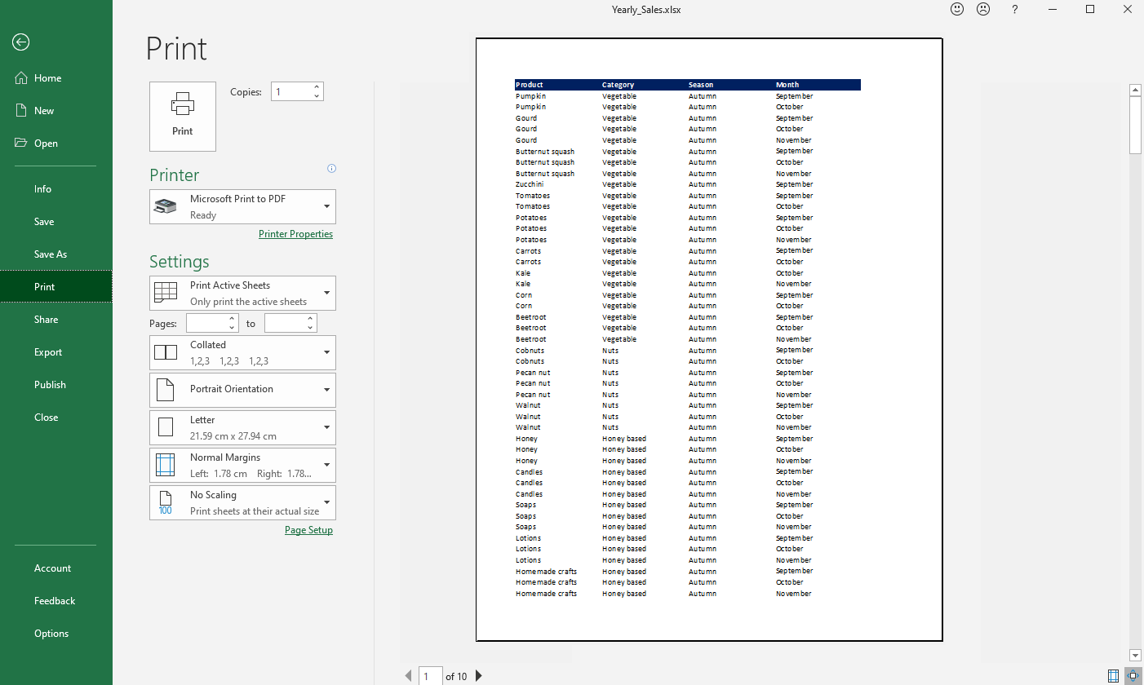

Figure 1: Print dialog box

### Settings

Under Settings, you can set the following options prior to printing: which worksheets and pages to print, collation, orientation, paper size, margins, and scaling.

Go to Settings to set which worksheets within the workbook you would like to print (refer to Figure 2).

|  |  |
| --- | --- |
| Active sheets | Select to print all sheets that are currently selected. |
| Entire workbook | Select to print every worksheet within the workbook. |
| Print Selection | Select to print the area you have currently selected on the worksheet. |
| Print selected table | This option will be available if you have selected a formatted table in your worksheet. |
| Ignore print area | Select if you have set a print area previously and you don’t want to clear it. |

Table 2: What to print options

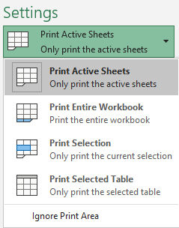

Figure 2: Print settings

|  |  |
| --- | --- |
| Pages | Enter the page number you would like to print in the Pages box and the to box if you want to print a selection of pages in the worksheet; for example, pages 1 to 3 (refer to Figure 3). |
| Collation | Select Collated to switch between collated and uncollated. If you were to print 10 copies of a three-page worksheet, collated would print pages 1 to 10 three times, uncollated would print three copies of page 1, three copies of page 2, etc. (refer to Figure 3). |
| Orientation | Select Portrait Orientation to switch between portrait or landscape orientation (refer to Figure 3). |
| Page size | Select Letter to select the paper size such as A4, A3, or Letter (refer to Figure 3). |
| Margins | Select Normal to select a different margin setting (refer to Figure 3, covered in more detail in Topic 2). |
| Scaling | Select No Scaling to set one of the following options:   * No Scaling will print all data on the necessary amount of paper. * Fit Sheet on One Page will reduce the font size to fit all the data onto one sheet of paper (although you might not be able to read it!). * Fit All Columns on One Page will reduce all the columns to fit onto one page. Additional rows will print onto more pages. * Fit all Rows on One page will reduce all the rows to fit onto one page. Additional columns will print onto more pages. |

Table 3: Print Setting options

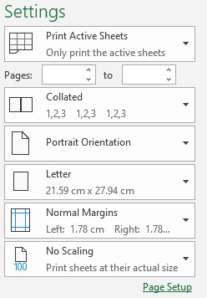

Figure 3: Default print settings

|  |  |
| --- | --- |
|  | Additional information  To review the article on scaling a worksheet, go to: [Scale a worksheet](https://aka.ms/Scale-a-worksheet) |

If the options on the Print screen are not enough to set up the page exactly to your preferences or needs, select Page Setup at the bottom of the list. This will open the Page Setup dialog box (refer to Figure 4). Here, you will find four tabs with much more detail to work with: Page, Margins, Headers/Footers, and Sheet.

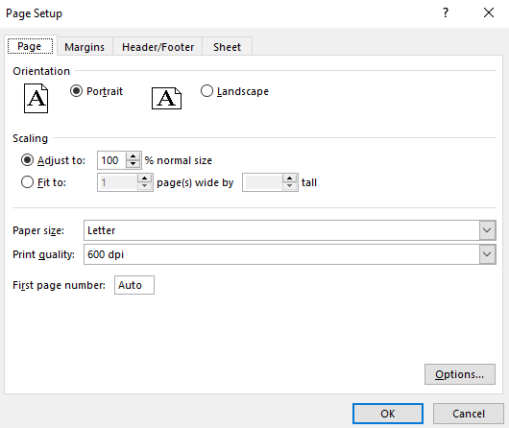

Figure 4: Page Setup dialog box

|  |  |
| --- | --- |
|  | Did you know?  If you entered data in every cell in column A through the last row in the worksheet, and if you tried to print the workbook without changing the settings, you would print over twenty-two thousand pages. Please don’t try it out!! |

### Set the print area

Sometimes there are areas on the worksheet that have reference data that you don’t intend to print. If that is the case, you might find it useful to set a print area. The print area that you set will remain until you change or clear it.

To set a specific print area:

* Select the data you wish to print.
* Select Print Area on the Page Layout group.
* Select Set Print Area.

To add further print areas:

* Select the data you wish to print.
* Select Print Area on the Page Layout group.
* Select Add to Print Area.

To clear a print area:

* Select Print Area on the Page Layout group.
* Select Clear Print Area.

|  |  |
| --- | --- |
|  | Additional information  To review the article on setting the print area on a worksheet, go to: [Set or clear a print area on a worksheet](https://aka.ms/Set-or-clear-a-print-area-on-a-worksheet) |

### Print

When you are ready to print, select the Print button. Before printing, you can set the number of copies to print in the Copies box and select the specific printer or PDF in the Printer box (refer to Figure 5).

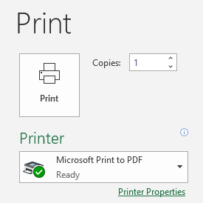

Figure 5: Print button

### Activity: Discuss and learn

In this activity, you will participate in a teacher-led discussion about why it is important to consider the page and print settings before you print a workbook.

#### Resources required

You will need the following resources for this activity:

* Open L1_T1_act_annual_produce.xlsx in this lesson’s Learning Activity Resources.

#### Activity instructions

Participate in the activity by following these instructions:

1. Open L1_T1_act_annual_produce.xlsx.
2. Select File, and then select Print.
3. Offer suggestions about how to make the data print more effectively.
4. Work with a partner to edit the print settings. Review the results of your changes as you work.

### Try-it: Understanding the print settings

In this leveled try-it, you will set the print area on a worksheet and print to PDF.

### Try-It 1

You have recently been tracking honey sales and you need to print a selection of the worksheet for a colleague.

#### Resources

You will need the following resources for this try-it:

* Open L1_T1_try1_annual_produce_starter.xlsx in this lesson’s Learning Activity Resources.

#### Instructions

The following are the general tasks to perform during this try-it:

1. Open L1_T1_try1_annual_produce_starter.xlsx.
2. Set the print area to print only the Honey products.
3. Print the area to PDF using the name Honey_Plus your initials.pdf.

### Try-It 2

You have been tracking Nuts and Homemade items for Summer and Autumn and need to only print two portions of the worksheet to hand off to a colleague.

#### Resources

You will need the following resources for this try-it:

* Open L1_T1_try2_annual_produce_starter.xlsx in this lesson’s Learning Activity Resources.

#### Instructions

The following are the general tasks to perform during this try-it:

1. Open L1_T1_try2_annual_produce_starter.xlsx.

2. Set the print area for all the Nuts.

3. Add the Homemade Crafts to the current print area.

1. Set the worksheet to print all columns in landscape orientation.
2. Print both areas to PDF using the name Nuts_&_Crafts_Plus your initials.pdf.

### Try-It 3

You need to fit the entire worksheet onto one sheet to prepare it as a PDF for emailing it to your colleague.

#### Resources

You will need the following resources for this try-it:

* Open L1_T1_try3_annual_produce_starter.xlsx in this lesson’s Learning Activity Resources.

#### Instructions

The following are the general tasks to perform during this try-it:

1. Open L1_T1_try3_annual_produce_starter.xlsx.
2. Clear any print areas that have been set.
3. Set the worksheet to print all columns landscape on one sheet.
4. Print the entire worksheet to PDF using the name Annual_Produce_Plus your initials.pdf.

## Topic 2: Understand page setup

 If the thought of all the options in the Page Setup dialog box is overwhelming, you might prefer to work with the three groups of buttons on the Page Layout tab on the ribbon: Page Setup, Scale to Fit, and Sheet Options (refer to Figure 6).

Each of these groups has a dialog launcher in the corner that you can use to access the Page Setup dialog box.

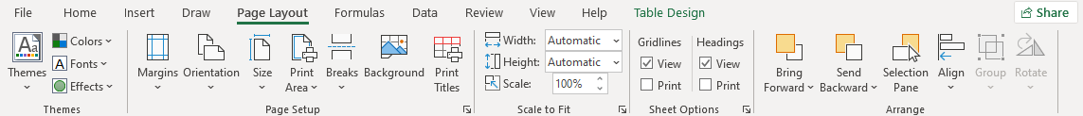

Figure 6: Page Layout tab

|  |  |
| --- | --- |
| Margins | Select Margins to choose one of the following options:   * Normal is the default setting. * Select Wide to add more space between the edge of the paper and your data. * Select Narrow to leave less space between the edge of the paper and your data. * Select Custom to open the Page Setup dialog box, which will allow you to set the margins exactly as you want them. |
| Orientation | Portrait is the default setting and useful for narrow data.  Landscape is useful for wider data. |
| Size | Select Size to change to a different paper size. |
| Print Area | Select Print Area to set the print area, clear, or add more print areas. |
| Breaks | Select Breaks to display where the pages break on the current worksheet. |
| Background | Select Background to insert a picture to print in the background on the worksheet. |
| Print Titles | Select Print Titles to set which rows to repeat at the top of every printed page or columns to repeat on the left side of every printed page. |

Table 4: Page Setup options

|  |  |
| --- | --- |
| Width | Enter the number of pages to shrink the width of your data in the Width box, for example 1 page wide. |
| Height | Enter the number of pages to shrink the height of your data in the Height box, for example 1 page tall. |
| Scale | Enter the percentage to shrink or increase the size of your data in the Scale box. Leave the width and height set on Automatic to use this feature. |

Table 5: Scale to Fit options

|  |  |
| --- | --- |
| Gridlines | Select the View box to display the gridlines on screen  Select the Print box to print gridlines around your data, meaning you don’t need to manually add borders. |
| Headings | Select the View box to display the column and row headers on screen.  Select the Print box to print the columns and row headers around your data. |

Table 6: Sheet Options

|  |  |
| --- | --- |
|  | Additional information  To review the article on editing the page setup of a worksheet, go to: [Page Setup](https://aka.ms/page-setup) |

### Page Setup dialog box

As already mentioned, in this lesson, you can access the print and page setup options via File > Print or via the Page Layout tab on the ribbon. However, you might occasionally need to access the Page Setup dialog box for further options. To do that, either:

* Go to File, then Print (Ctrl+P) and select the Page Setup link at the bottom of the settings panel, or
* Select any dialog launcher on the Page Layout tab.
* Select the tab in which would like to work.

### Set margins

To alter the margins in a worksheet (refer to Figure 7):

* Select the Margins tab in the Page Setup dialog box.
* Set the Top, Header, Left, Right, Bottom, and Footer with your preferences.
* Select to center on the page Horizontally or Vertically as per your requirements.
* Select OK to return to the Print screen.

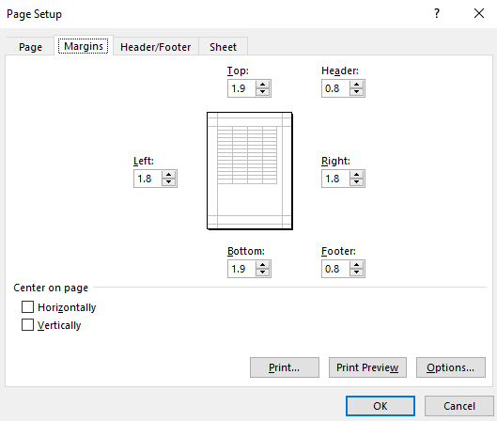

Figure 7: Margins tab in Page Setup dialog box

Alternatively, select Print on the File tab, select Show Margins at the bottom of the print window, and then move any of the margins to a new position (refer to Figure 8).

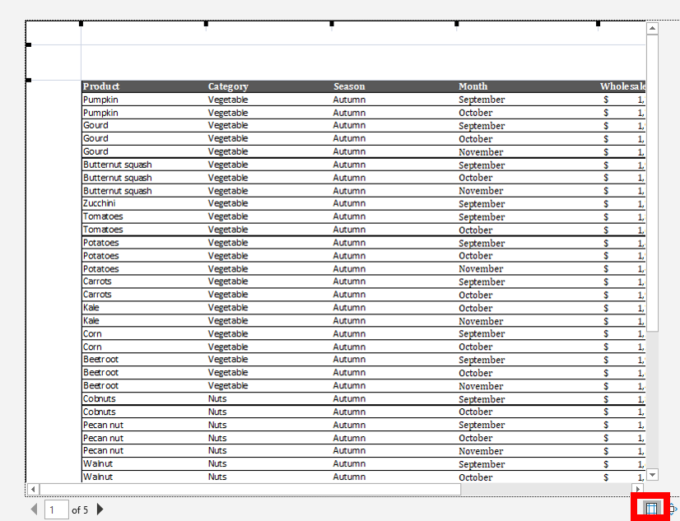

Figure 8: Show Margins in Print dialog box.

### Sheet settings

When you need to print your data across multiple pages, you might find it useful to edit the sheet settings. For example, you might want to print the headings on every worksheet to make it easier to identify what has been printed. It’s like freezing worksheet titles, a topic covered in Module 2, except that the headings will be printed.

To alter the sheet settings in a worksheet (refer to Figure 9):

* Select the Sheet tab in the Page Setup dialog box.
* From Print area, select any area on the worksheet to add it to the print area.
* From Rows to repeat at top, select any rows on the worksheet behind that you would like to print at the top of every printed page.
* From Columns to repeat at left select any columns on the worksheet that you would like to print on the left side of every printed page.
* Under Print, check Gridlines to add borders around your data.
* Select OK to return to your worksheet.

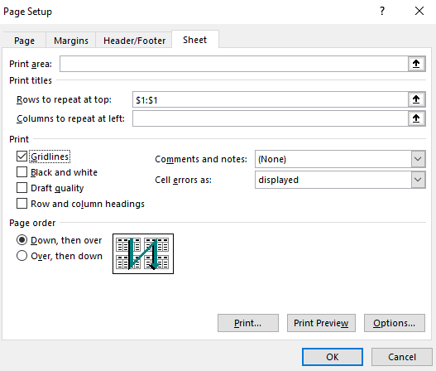

Figure 9: Sheet tab in Page Setup dialog box

|  |  |
| --- | --- |
|  | Additional information  For more information on configuring print settings, go to: [Print a worksheet or workbook](https://aka.ms/print-a-worksheet-or-workbook) |

### Activity: Question time

In this activity, you will consider the questions asked by your teacher about the many ways in which you can access the Page Setup dialog box and what options are available in the dialog box that are not available elsewhere.

#### Resources required

You will need the following resources for this activity:

* Open L1_T2_act_summary.xlsx in this lesson’s Learning Activity Resources.

#### Activity instructions

Participate in the activity by following these instructions:

1. Open L1_T2_act_summary.xlsx.
2. Use any method suggested to access the Page Setup dialog box.
3. Work with a partner to compare the Page Layout, Print, and Page Setup options.
4. Experiment with any of the Page Setup options and observe the results using Print Preview.
5. Close the workbook without saving it.

### Try-it: Understand page setup

 In this try-it, you will set the paper size, orientation, and margins.

### Try-It 1

You are preparing a worksheet to print to PDF on A4 paper.

#### Resources

You will need the following resources for this try-it:

* Open L1_T2_try1_summary_starter.xlsx in this lesson’s Learning Activity Resources.

#### Instructions

The following are the general tasks to perform during this try-it:

1. Open L1_T2_try1_summary_starter.xlsx.

2. Set the worksheet to print to PDF on A4 in the portrait orientation.

3. Save the workbook with its original name and append your initials on the end.

### Try-It 2

You are preparing data to print as large as possible to make it easier for your colleagues to follow.

#### Resources

You will need the following resources for this try-it:

* Open L1_T2_try2_summary_starter.xlsx in this lesson’s Learning Activity Resources.

#### Instructions

The following are the general tasks to perform during this try-it:

1. Open L1_T2_try2_summary_starter.xlsx and set the workbook to print to PDF.
2. Use the Page Setup dialog box to set the following:
3. Set the Summary worksheet to print on A4 in the landscape orientation.
4. Set the left margin to 1.0 and the right margin to 1.0.
5. Set the worksheet to print in the center horizontally and vertically.
6. Scale the worksheet to increase the Print Scale to 140%.

## Wrap-up

Use these questions to check what you learned in this lesson:

1. Select Select here to enter text. to set rows to repeat at the top.
2. Which method can you use to force data to print on one sheet width?

Select all that apply.

1. From Scale to Fit group, set width to one page.
2. From Scale to Fit group set height to one page.
3. Select File, then select Print. Select Scaling, and then select Fit all Columns on One page.
4. Select File, and then select Print. Select Scaling, and then select Fit Sheet on One page.
5. From the left side of the box to right side of the box, indicate the order in which the tabs are in the Page Setup dialog box.

Indicate the correct sequence by adding numbers 1-4 next to the following items.

1. Sheet
2. Header/Footer
3. Page
4. Margins
5. On which group will you find these commands?
6. Scale to Fit
7. Sheet Options
8. Page Setup

Categorize the following items by adding the appropriate group name next to each item.

1. Gridlines Select here to enter text.
2. Width Select here to enter text.
3. Size Select here to enter text.

# Lesson 2: Using headers and footers

## Overview

In this lesson, you will learn how to add and edit headers and footers that will repeat on each printed page, in preparation for printing. Similar to Word, you can add page numbers, the date, time, text, and graphics. When you add headers and footers to a worksheet, they are hidden from view unless you are in the Page Layout view, while in Word they are faded out when you are working in the main document.

You can access the Header and Footer via the Insert tab on the ribbon or via Page Setup.

## Warm-up

Challenge your neighbor to find any command, within 10 seconds, to help with the print or page settings. For example, where do you go to have the headings repeated on every page, or which command can you select to change the page to landscape? Then, use these questions to find out what you already know about this lesson’s topics:

1. Which of the following statements is true?

Select all that apply.

1. You normally enter a workbook header into the first row of a worksheet.
2. Normal view hides a workbook header from display.
3. You can observe a workbook header by selecting File, and then Print.
4. A workbook header appears on screen when you are working in Page Break Preview.
5. Which of the following methods can you use to access the footer in a worksheet?

Select all that apply.

1. Select Header & Footer on the Insert tab.
2. Select File > Print > Page Setup.
3. Select the dialog launcher in the Scale to Fit group on the Page Layout tab.
4. Select the dialog launcher in the Sheet Options group on the Page Layout tab.
5. There are three sections in the header: Select here to enter text., center, and Select here to enter text..
6. The Header & Footer command can be found in the Select here to enter text. group on the Insert tab.

## Topic 1: Add headers and footers

There are two main methods of entering data into the header or footer in a workbook. You can select Header/Footer from the Text group on the Insert tab or you can access the header and footer via the Page Setup dialog box. As you know, there are many ways to access the Page Setup dialog box.

When you are preparing a workbook to print, you should allow space for the header or footer if you are going to add content.

### Add headers or footers by using the Insert tab

1. Select Header & Footer in the Text group. This will take you into Page Layout view.
2. The hidden header and footer areas will appear, and the Header & Footer Tools Design tab will open on the ribbon (refer to Figure 10).

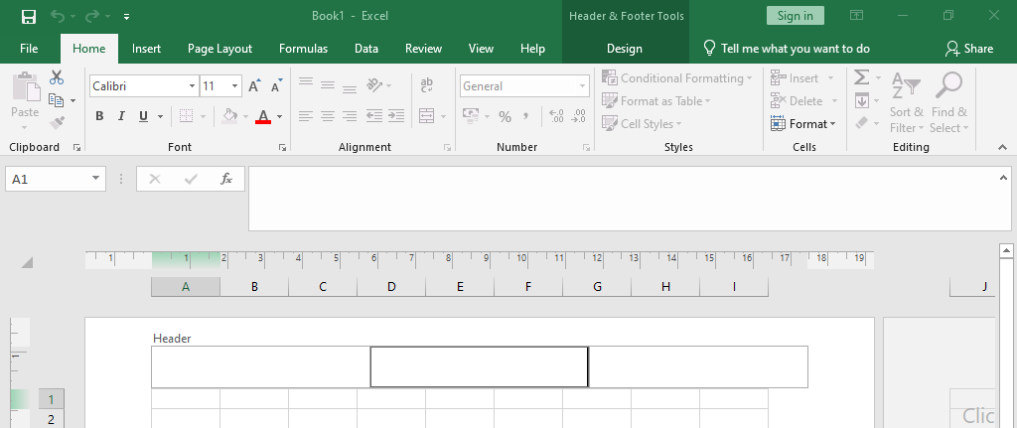

Figure 10: Header & Footer Tools Design contextual tab

1. Select either the Left, Center, or Right section under Header and begin entering text or numbers, or select any of the commands on the Header & Footer Tools Design tab in the Header & Footer Elements group such as Page Number, Current Date, or File Path.
2. Select Go to Footer in the Navigation group to view the footer area.
3. When you have finished editing the header or footer, select any cell outside the of the header or footer and select the Normal view command next to the Zoom tool’s slider at the bottom of the screen.

|  |  |
| --- | --- |
|  | Did you know?  The electronic spreadsheet was invented in the mid 1960s. Who’d have thought it was so old! |

### Add headers or footers by using the Page Setup dialog box

1. Select File > Print or select Ctrl+P on the keyboard, and then select the link to Page Setup, or use any dialog box on the Page Layout tab.
2. Select the Header/Footer tab in the Page Setup dialog box (refer to Figure 11).

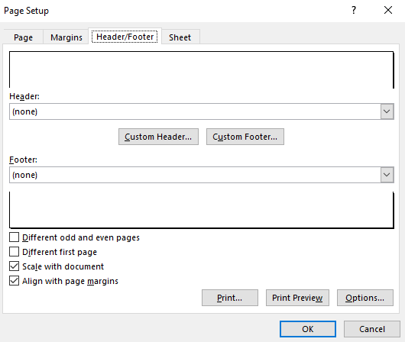

Figure 11: Page Setup dialog box, Header/Footer tab

1. Select the drop-down arrow under Header to select a pre-populated field, or
2. Select the drop-down arrow under Footer to select a pre-populated field, or
3. Select Custom Header or Custom Footer to specify where to place the fields or text in the header or footer.

When you select Custom Header or Custom Footer, the options are the same, except that one will be at the top of each page and the other at the bottom of each page as shown in the following figure:

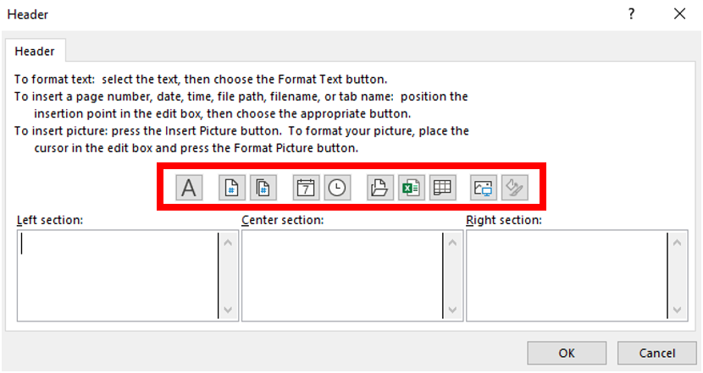

Figure 12: Custom Header dialog box

1. Select the Left section, the Center section, or the Right section, and then select the command you want from the small bar across the top of the sections.
2. Select Insert Page Number to have automatic page numbers applied to each page.
3. Select any other field such as Number of Pages, Date, Time, File Path, or File Name. Remember to include a space between fields or they will appear to connect when printed.
4. Select OK to close the dialog box and OK again to close the Page Setup dialog box.

|  |  |
| --- | --- |
|  | Additional information  To review the article on adding headers and footers into a workbook, go to: [Headers and footers in a worksheet](https://aka.ms/Headers-and-footers-in-a-worksheet) |

### Activity: Discuss and learn

Your teacher will open L2_T1_act_summary.xlsx and ask anyone with a printed copy if there is additional information that would help them understand the data.

#### Resources required

You will need the following resources for this activity:

* Open L2_T1_act_summary.xlsx in this lesson’s Learning Activity Resources.

#### Activity instructions

Participate in the activity by following these instructions:

1. Open L2_T1_act_summary.xlsx.
2. Select File, and then select Print.
3. Follow along in the discussion and offer suggestions.

### Try-it: Add headers or footers

 A workbook created by your colleague needs information added to the header and footer prior to printing.

### Try-It 1

You need to add the date and time into the footer of a workbook and a heading into the header.

#### Resources

You will need the following resources for this try-it:

* Open L2_T1_try1_summary_starter.xlsx in this lesson’s Learning Activity Resources.

#### Instructions

The following are the general tasks to perform during this try-it:

1. Use the Insert tab to add Sales this Year in the center of the header on the Summary worksheet.
2. Apply size 12 and bold formatting to the text.
3. Then add the date and time to automatically update in the right section of the footer.
4. Save the workbook with its original name and append your initials on the end.

### Try-It 2

You need to add information into the header and footer, including inserting the Munson’s logo into the header in preparation for an important meeting.

#### Resources

You will need the following resources for this try-it:

* Open L2_T1_try2_summary_starter.xlsx in this lesson’s Learning Activity Resources.

#### Instructions

The following are the general tasks to perform during this try-it:

1. Use the Page Setup dialog box to add the following into the All Year worksheet:
2. Add page numbers to the left section of the footer.
3. Add the File Path to the right section of the footer.
4. Enter Munson’s Pickles and Preserves Farm into the center header.
5. Insert the Munson’s logo into the right section of the header on the Summary worksheet.
6. Save the workbook with its original name and append your initials on the end.

## Topic 2: Edit headers and footers

 Now that you know how to add headers and footers, you will need to know how to edit them. Imagine you inherited a workbook that already contained data in the header or footer that was incorrect, in the wrong place, or had the wrong type of font color applied, and you did not know how to edit them.

### Edit a header or footer using Page Layout view

1. Either select Header & Footer on the Insert tab, or, select the Page Layout View button on the status bar beside the Zoom tool.
2. Select the header or footer text you want to change.
3. Set the formatting options that you want to apply from the Font group on the Home tab or use one of the options available on the mini toolbar that appears when you select the text (refer to Figure 13).

A screenshot of the Header & Footer mini toolbar

Figure 13: Header & Footer mini formatting toolbar

By default, data entered into the header or footer sections will be scaled according to how you have scaled the worksheet to print. You can change the options as follows (refer to Figure 14):

1. Clear the Scale with Document box in the Options group on the Header & Footer tab.
2. Select the Different First Page box if you would like to have a different header or footer on the first page of the worksheet that you print.
3. Select Different Odd & Even Pages if you would like every printed odd page to be different to every printed even page.

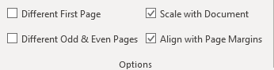

Figure 14: Options group on the Header & Footer tab

Note that you can use your cut, copy, and paste skills to move data from one section to another in the header or footer (you covered these skills in detail in Module 2).

When you finish making your edits, select any cell outside of the header or footer area, and then select the Normal button on the status bar or select Normal on the View tab.

### Edit a header or footer using the Page Setup dialog box

1. Use any method to access the Page Setup dialog box, select Custom Header or Custom Footer.
2. Select any text or field that you want to edit, and then select Format text to open the Format Cells dialog box (refer to figure 15).
3. Select any formatting you would like to apply, and then select OK.

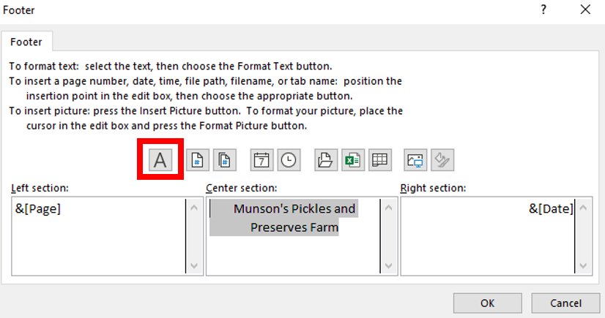

Figure 15: Custom Footer dialog box

### Remove all headers and footers

1. To quickly clear all the data contained within a header, access the Page Setup dialog box.
2. Select the drop-down arrow under Header, and then select (none) from the list of choices.
3. Select the drop-down arrow under Footer, and then select (none) from the list of choices.
4. Select OK to close the dialog box.
5. Select OK again to close the Page Setup dialog box.

|  |  |
| --- | --- |
|  | Additional information  To information on formatting text in a header or footer, go to: [Format text in headers or footers](https://aka.ms/Format-text-in-headers-or-footers) |

### Activity: Switch

This activity will be a switch activity where you will make a change on your own device and then move to the next device to make a change. (Note: An accessibility alternative is included in the Teaching Guide.)

#### Resources required

You will need the following resources for this activity:

* Open L2_T2_act_summary.xlsx in this lesson’s Learning Activity Resources.

#### Activity instructions

Participate in the activity by following these instructions:

1. Open L2_T2_act_summary.xlsx.
2. Make any alteration to the header or footer or page setup that you think is appropriate.
3. When the teacher calls, “switch,” move to the computer to the right of your own computer and make another edit.
4. Return to your own computer when instructed and examine the worksheet in Print Preview.

### Try-it: Edit headers and footers

 Edit the headers and footers in a worksheet to improve the printed display.

### Try-It 1

In this try-it, you will delete and switch information from a workbook’s header into the footer.

#### Resources

You will need the following resources for this try-it:

* Open L2_T2_try1_summary_starter.xlsx in this lesson’s Learning Activity Resources.

#### Instructions

The following are the general tasks to perform during this try-it:

1. Delete the image in the center section of the header and the unnecessary row.
2. Apply a bold size 14 font to the text in the center of the header.
3. Switch the date and time from the header to the left section of the footer.
4. Switch the page numbers from the header into the right section of the footer.

### Try-It 2

Edit the information in a workbook’s header and footer.

#### Resources

You will need the following resources for this try-it:

* Open L2_T2_try2_summary_starter.xlsx in this lesson’s Learning Activity Resources.

#### Instructions

The following are the general tasks to perform during this try-it:

1. Use the Page Setup dialog box to switch the Munson’s logo from the center section to the right section of the header.
2. Switch the content of the center section of the footer into the right section and edit it so that the page number displays “Page 1 of 4” instead of “Page 1.”
3. Apply regular size 10 formatting to all the data in the footer.

## Wrap-up

K-W-L: Create a three-column list. In the K column, write what you know about the day’s topic. In the W column, write what you wonder about the topic. In the L column, write what you need to learn to be proficient in the topic. Then, use these questions to observe what you learned in this lesson:

1. When you insert a page number into a workbook, how is the code for the field displayed?

Select the correct option.

1. & [Pages]
2. &[Pages]
3. & [Page]
4. &[Page]
5. Which tab in the Page Setup dialog box can you use to change the page orientation?

Select the correct option.

1. Sheet
2. Headers & Footers
3. Margins
4. Page
5. Which workbook view can you use to display the headers or footers while you are editing a worksheet?

Select the correct option.

1. Normal
2. Page Break Preview
3. Page Layout
4. Custom Views
5. The Page Setup dialog box has four tabs. From left to right, what is the order of the tabs?

Indicate the correct sequence by adding numbers 1-4 next to the following items.

1. Header/Footer
2. Page
3. Sheet
4. Margins

# Lesson 3: Checking for issues

## Overview

In this lesson, you will learn about the importance of checking your workbooks for issues, such as removing personal information and workbook properties, ensuring your workbooks are as inclusive as possible for people with disabilities, and confirming compatibility with earlier versions of Excel.

## Warm-up

Ask your neighbor what they found most useful from the previous two lessons in this module. Then use these questions to find out what you already know about this lesson’s topics:

1. Where would you go to review the properties of any workbook?

Select the correct option.

1. File > Account
2. File > Options
3. File > Save As
4. File > Info
5. Which of the following items can you find within workbook properties?

Select all that apply.

1. Size
2. Tags
3. Last Modified
4. Version History
5. To inspect a workbook, select File > Info and then select Select here to enter text..
6. Which of the following methods can you use to check for any compatibility issues?

Select all that apply.

1. File > Info > Check for Issues > Check Compatibility.
2. File > Info > Manage Workbook.
3. Select Check Compatibility from the Review tab.
4. Select Smart Lookup from the Review tab.

## Topic 1: Modify the basic workbook properties

 Every time you create a new workbook, edit a workbook, or print a workbook, Backstage logs a behind-the-scenes record of that action. There are many properties stored on your behalf as you’re working on your documents, such as the file size, the author, and the date last modified. Have you ever encountered the term “metadata?” The properties stored in your workbook are metadata.

You can add further information to the properties that help describe or identify your documents. This could be helpful when you need to search through hundreds of documents for files. Workbook properties can also help manage and organize your files.

### Workbook properties

At any time, you can add additional data to a workbook’s properties (refer to Figure 16). For example, you might want to add tags (also known as keywords), comments, categories, or author names.

1. To access workbook properties, select File and then Info. The right side of the Info window will list Properties.

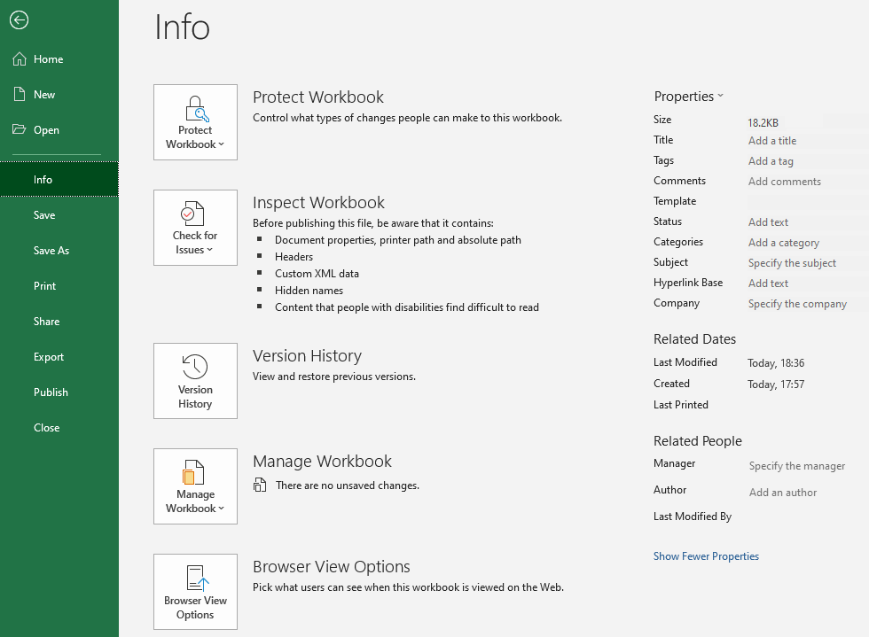

Figure 16: File > Info window

1. Select any property field and enter the data you would like to store. You will not be able to add to or edit all properties listed, such as the workbook size and the creation date. (Refer to Figure 17.)
2. Select Enter or select anywhere outside of the property field to finish the entry.

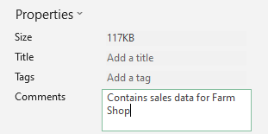

Figure 17: Comments field

1. At the bottom of the panel, you can switch between Show Fewer Properties and Show All Properties.
2. Select Properties at the top of the panel and select Advanced Properties to open the Properties dialog box (refer to Figure 18). There are five tabs to work with: General, Summary, Statistics, Contents, and Custom.

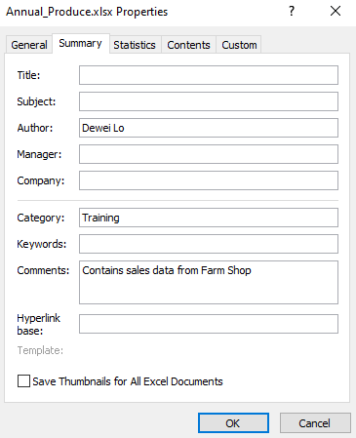

Figure 18: Properties dialog box

Alternatively:

1. Select Windows+E to open File Explorer.
2. Locate any file in which you would like to edit the properties, right-click or access the context menu, and then select Properties. The Properties dialog box will open.
3. Make your alterations and select OK to close the dialog box.

|  |  |
| --- | --- |
|  | Additional information  To review the article on modifying workbook properties, go to: [View or change the properties for an Office file](https://aka.ms/View-or-change-the-properties-for-an-Office-file) |

### Activity: Pose a question

Your teacher will ask a question about why anyone might need to edit or remove the information in the workbook properties.

#### Resources required

You will need the following resources for this activity:

* Open L3_T1_act_membership_revenue.xlsx in this lesson’s Learning Activity Resources.

#### Activity instructions

Participate in the activity by following these instructions:

1. Select File, and then select Info.
2. Examine workbook properties and ask or answer questions when prompted.

### Try-it: Modify basic workbook properties

 At Munson’s Pickles and Preserves Farm, you should add information to a document’s properties to make it easier to search for files. Many interns come and go at the farm and they often switch departments. It is helpful to know what information documents have without having to open and examine them.

### Try-It 1

Add your name as the workbook author and information into the comments field.

#### Resources

You will need the following resources for this try-it:

* Open L3_T1_try1_membership_revenue_starter.xlsx in this lesson’s Learning Activity Resources.

#### Instructions

The following are the general tasks to perform during this try-it:

1. Add your name as author.
2. In the Comments field, enter New and renewed memberships last year.
3. In the Company field, add Munson’s.
4. Save the workbook with its original name and append your initials on the end.

### Try-It 2

Add the information into the tags and subject fields and remove the current author name.

#### Resources

You will need the following resources for this try-it:

* Open L3_T1_try2_membership_revenue_starter.xlsx in this lesson’s Learning Activity Resources.

#### Instructions

The following are the general tasks to perform during this try-it:

1. Remove the current author name and add your own.
2. Add the Membership Revenue for Title.
3. Add New Members, Renewed Members for the Tags.
4. In the Status field, add Finance team to check totals.
5. Edit the comment so that is has the four-digit number for last year: 2020 instead of last year.
6. Save the workbook with its original name and append your initials on the end.

## Topic 2: Inspect workbooks for issues

 When you inspect a workbook for issues, there are three main things to ask yourself:

* Is the data accessible to people with disabilities?
  + People who are blind or have low vision can understand your data more easily if you consider accessibility when you create your workbooks. For example, always add alternative text to all images such as charts and pictures and consider contrast when applying color to text or backgrounds.
* Is it compatible for people using earlier versions of Office?
  + There are some fantastic features in Excel 2019, but will any feature you use make a significant difference to anyone that might be using an earlier version of Excel?
* Is there any personal information or hidden data that you should remove before sharing the workbook with others?
  + When you share workbooks internally or externally, it’s a good idea to review the document for hidden data or personal information. In a digital world, identity theft is a serious matter. Always be aware of the information that people can find out about you, your friends and family, your colleagues, and your company.

Luckily, Excel can help you inspect your workbooks for accessibility, compatibility, and hidden data.

### Inspect a workbook

There are many hidden items in the background of a workbook. When you inspect a workbook, you can remove any issues. However, prior to inspecting the workbook it might be worth saving a copy because sometimes actions cannot be undone when removing properties.

To observe what is going on behind the scenes of a workbook:

1. Select File, and then select Info.
2. Select Check for Issues on the Info window, and then select Inspect Document from the drop-down list (refer to Figure 19).

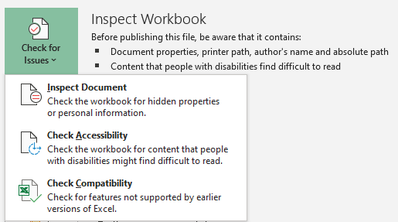

Figure 19: Check for Issues button in File > Info

1. Scroll through the list of content and select or clear any item listed. (Refer to Figure 20.)

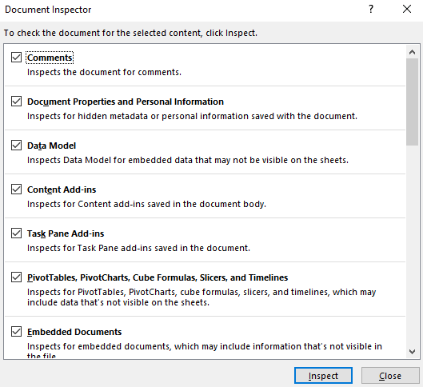

Figure 20: Document Inspector dialog box

1. Select Inspect to inspect the document for possible issues as shown in the following figure.

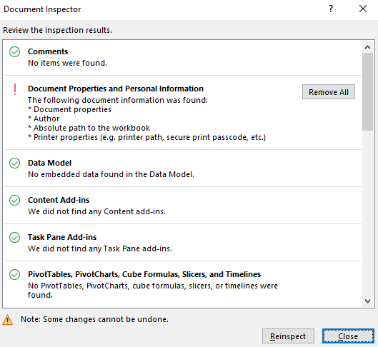

Figure 21: Document Inspector results

1. Select Remove All if you would like to remove any issues that were found by the inspector.
2. Select Reinspect if you wish to reinspect the workbook.
3. Select Close when you finish with the inspector.

The Document Inspector can check for the following potential issues:

* Comments
* Document properties and personal information
* Data models
* Content add-ins
* Task Pane add-ins
* PivotTables, PivotCharts, cube formulas, slicers, and timelines
* Embedded documents
* Macros, forms, and active X controls
* Links to other files
* Real time data functions
* Excel surveys
* Defined scenarios
* Active filters
* Custom worksheet properties
* Hidden names
* Ink
* Long external references
* Custom XML data
* Headers and footers
* Hidden rows, columns, and worksheets
* Invisible content

|  |  |  |
| --- | --- | --- |
|  | Additional information  For more information on removing hidden data and personal information, go to: [Remove hidden data and personal information by inspecting documents, presentations, or workbooks](https://aka.ms/Remove-hidden-data-and-personal-information-by-inspecting-documents-presentations-or-workbooks) | |
|  | | Did you know?  There are some important regulations in place for data protection inside and outside of the European Union, known as General Data Protection Regulations (GDPR). You don’t need to worry about that now, but this is something that could affect you in your future career when working with European companies or clients. In the meantime, remember, if you don’t want anyone to have access to any personal information, remove it before you send out documents. |

### Check accessibility

It’s always a good idea to check any file you are working on for accessibility issues. It’s a great habit to develop as you never know who will need to access the data in the future. The data might be fine for you, but is it okay for everyone that has access to it? To assist in your understanding of these concepts, we have created a short video that emphasizes the importance of inclusivity and accessibility.

|  |  |
| --- | --- |
|  | Video  To review the video on inclusivity and accessibility, go to: [Creating for everyone](https://aka.ms/video-creating-for-everyone) |

To check for accessibility issues:

1. Select File, and then select Info.
2. Select Check for Issues on the Info window, and then Check Accessibility from the drop-down list.
3. Alternatively, select Check Accessibility from the Review tab. An Accessibility Checker pane will open on the screen and it will list any issues found during the accessibility check (refer to Figure 22).

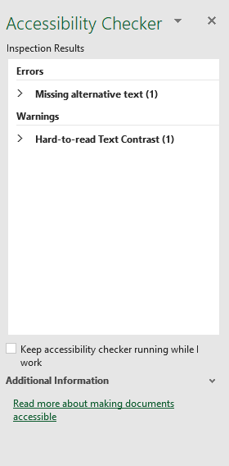

Figure 22: Accessibility Checker pane

1. Check the Keep accessibility checker running while I work check box if you would like to know about any new issues while you work.

If there are any issues, there will be an Investigate warning in the status bar. If there are no issues, there will be a Good to go message.

Here are some typical issues to avoid:

* Using default worksheet names
* Hard to read text contrast
* Merging cells
* Missing alt text

|  |  |
| --- | --- |
|  | Additional information  To review the article on workbook accessibility, go to: [Make your Excel documents accessible to people with disabilities](https://aka.ms/make-your-excel-documents-accessible-to-people-with-disabilities) |

### Compatibility issues

You might recall from Module 1, that there is sometimes a need to save a file in an earlier version of Excel. As you know, this can result in a significant loss of functionality.

However, compatibility issues not only affect files saved as an Excel 97-2003, they can also affect files opened in Excel 2007, Excel 2010, or other versions.

Imagine you have created a wonderful workbook that has various images, such as SmartArt, Charts and Sparklines, but when you open it in an earlier version of Excel some of the features have been removed or are not editable. How disappointing would that be? If anyone else needs to access the workbook, and they are using an earlier version of Excel, this is something you need to consider. As usual, Excel can help!

To check for compatibility issues:

1. Select File, and then select Info.
2. Select Check for Issues on the Info window, and then Check Compatibility from the drop-down list. The Compatibility Checker will summarize any issues (refer to Figure 23).

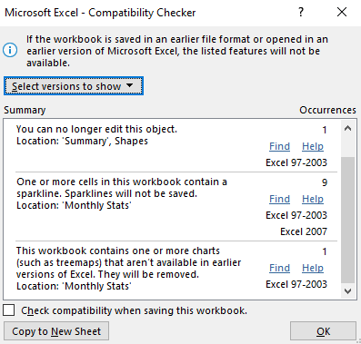

Figure 23: Compatibility Checker dialog box

1. Select Find to navigate directly to the worksheet that has the issue.
2. Select the arrow against Select versions to show to choose which versions of Excel you want to check for compatibility.
3. Select Copy to New Sheet if you would like a summary of all issues listed on a separate worksheet.
4. Select OK to close the dialog box.

|  |  |
| --- | --- |
|  | Additional information  To review the article on workbook compatibility, go to: [Worksheet compatibility issues](https://aka.ms/Worksheet-compatibility-issues) |

Here are some typical issues that Excel can find:

* Fonts that earlier versions do not recognize
* Graphics such as SmartArt, Charts, and Sparklines
* Data formatted as a table

|  |  |
| --- | --- |
|  | Did you know?  Files saved as Excel 97-2003 only had 65,536 rows and 256 columns. How did we ever cope with such as small spreadsheet? |

### Activity: What’s the correct category?

In this activity, you will mark whether the items listed are workbook properties that you can remove, whether they have compatibility or accessibility issues, or whether they are workbook properties than you cannot edit or remove.

#### Resources required

You will need the following resources for this activity:

* Open L3_T2_act_categories.docx in this lesson’s Learning Activity Resources. You can also open L3_T2_act_soil_testing.xlsx for reference, if necessary.

#### Activity instructions

Participate in the activity by following these instructions:

1. In the second column of L3_T2_act_categories.docx work with a partner to enter the following:
   * R if the item in the first column is a property that you can remove
   * A if the item in the first column is a potential accessibility or compatibility issue
   * P if the item in the first column is a property that you cannot remove
2. Compare your answers with another pair.
3. Then, open L3_T2_act_categories_solution.docx, and check your answers.

### Try-it: Inspect workbooks for issues

 At Munson’s, all employees, interns, and volunteers should check every document for accessibility issues and personal information.

### Try-It 1

Note how many accessibility issues there are in the entire workbook.

#### Resources

You will need the following resources for this try-it:

* Open L3_T2_try1_soil_testing_starter.xlsx in this lesson’s Learning Activity Resources.

#### Instructions

The following are the general tasks to perform during this try-it:

1. Inspect the workbook for accessibility issues.
2. Enter the number of issues in cell B18, B19, and B20 on the Comparisons worksheet.
3. Save the workbook with its original name and append your initials on the end.

### Try-It 2

Check workbook for accessibility and compatibility issues. Make changes to clear any issues and remove any personal information.

#### Resources

You will need the following resources for this try-it:

* Open L3_T2_try2_soil_testing_starter.xlsx in this lesson’s Learning Activity Resources.

#### Instructions

The following are the general tasks to perform during this try-it:

1. Inspect the workbook for accessibility issues.
2. Make any alterations as appropriate. With color contrast issues, apply any formatting that the accessibility checker accepts or use the automatic font color.
3. Remove all personal information from the document properties. Leave the headers and footers as they are.
4. Copy any compatibility issues to a new worksheet.
5. Save the workbook with its original name and append your initials on the end.

## Wrap-up

Create a concept map: draw a circle in the middle of a piece of paper and write the word that represents the main concept you learned about in this lesson. Add lines and more circles to add supporting concepts and even more lines and circles to add other sub-concepts, if necessary. Compare your map with your neighbor.

Accessibility Alternative:

Teach a friend: select one thing you learned today and reteach it to a classmate.

If time permits, use these questions to check what you learned in this lesson:

1. Which of the following may contain metadata that can help describe or identify a file, including the author?

Select all that apply.

1. Name Manager
2. Workbook Properties
3. Header
4. Page Setup
5. Which of the following information can the Document Inspector check for?

Select all that apply.

1. Personal information
2. Hidden columns and rows
3. Comments
4. Headers and Footers
5. On which tab on the ribbon can you find the Check Accessibility command?

Select the correct option.

1. Insert
2. Page Layout
3. View
4. Review
5. Which of the following issues can the compatibility checker detect?

Select all that apply

1. Merged cells
2. Table formats
3. Data beyond 256 columns
4. Default worksheet names

# Glossary

|  |  |
| --- | --- |
| Header | An area on a worksheet reserved for adding data to appear at the top of every printed page, such as a document title. |
| Footer | An area on a worksheet reserved for adding data to appear at the bottom of every printed page, such as the page number, date, time, or file path (where a workbook is stored). |
| Document properties | Metadata included in the background of a workbook, such as the author’s name, date created, and date last modified. |
| Accessibility | Making your workbooks as inclusive as possible for people with disabilities and readable by a screen reader. |
| Compatibility | Ensuring your workbooks can be opened in earlier versions without losing content or functionality. |
| Field | A computer code that adds data to a workbook, for example, a document property or the date field in a header or footer. |

Table 7: Glossary terms and definitions

|  |  |
| --- | --- |
|  | Additional information  For more information on General Data Protection Regulations (GDPR), go to: [Data protection](https://aka.ms/data-protection), courtesy the EU. |

# Cornerstone

## Overview

The farm is trying to find money to fund drone technology to track crop health. Tomorrow, the owners have a meeting with a potential investor.

You need to prep the workbooks for printing including adding headers and footers, modifying the print settings, and inspecting the workbook for any accessibility and compatibility issues. In addition, you need to edit the worksheets to ensure there is no missing data.

## Objectives

The following table outlines the Cornerstone objectives and their corresponding Microsoft Office Specialist (MOS) exam objectives.

|  |  |
| --- | --- |
| Configure a workbook’s print settings and page setup | 1.5.1: Set a print area  1.5.3: Configure print settings  1.3.1: Modify page setup |
| Add and edit headers and footers | 1.3.3: Customize headers and footers |
| Modify workbook properties and inspect workbooks | 1.4.5: Modify basic workbook properties  1.5.4: Inspect workbooks for issues |
| Auto fill data | 2.1.2 Fill cells by using AutoFill |
| Perform calculations | 4.2.1 Perform calculations by using the AVERAGE(), MAX(), MIN(), and SUM() functions |
| Edit chart elements | 5.2.3 Add and modify chart elements |

Table 8: Cornerstone objectives

## Duration

50 minutes

## Instructions

1. Complete the following tasks for each file.
2. When saving your file, add your name to the end of the filename, for example: Cornerstone_Dwayne_Espino. Follow your teacher’s directions for the location to save your files.
3. When you’re done with the Cornerstone, assess your completion and enter the points you think you earned within the following task lists. You can ask your teacher if you need help.

## Tasks

You will work with two files in this Cornerstone. The following are the tasks to perform within each file.

### File 1: Cornerstone_membership_starter.xlsx

#### Task: Set print area (1 point)

* Set the worksheet to print all cells containing data except the data in column K and L. (1 points) (Exam objective 1.5.1)

Points scored: Select here to enter text./1

#### Task: Check for issues (5 points)

1. Remove all personal information and document properties. (2 points) (Exam objective 1.4.5)
2. Check for accessibility issues and fix as necessary. (For any color contrast issues, set the font color to automatic.) (2 points) (Exam objective 1.5.4)
3. Set the workbook to automatically check for compatibility when the workbook is saved. (1 point) (Exam objective 1.5.4)

Points scored: Select here to enter text./5

#### Task: Print and page settings (2 points)

1. Set the worksheet to print landscape on one sheet of paper. (1 point) (Exam objective 1.3.1)
2. Set the worksheet to print in the center of the page horizontally and vertically with gridlines. (1 point) (Exam objective 1.5.3)

Points scored: Select here to enter text./2

#### Task: Headers and footers (2 points)

1. Enter Munson’s Membership This Year with a size 12 bold font in the center section of the header. (2 points) (Exam objective 1.3.3)
2. Save the workbook to include your name in the title.

Points scored: Select here to enter text./2

FILE 1 TOTAL POINTS: Select here to enter text./10

### File 2: Cornerstone2_finances_starter.xlsx

#### Task: Workbook properties (2 point)

* Add the text Sales and donations in the workbook properties comment field. (2 point) (Exam objective 1.4.5)

Points scored: Select here to enter text./2

#### Task: Print and page settings (2 points)

1. In the Sales by Category worksheet, hide gridlines from display. (1 point) (Exam objective 1.3.1)
2. Ensure that the Donations worksheet prints on one page with portrait orientation. (1 point) (Exam objective 1.3.1)

Points scored: Select here to enter text./2

#### Task: AutoFill (2 points)

* In the Donations worksheet, use AutoFill to enter a series of numbers against each name in column A and column E starting at 1 in cell A2. (2 points) (Exam objective 2.1.2)

Points scored: Select here to enter text./2

#### Task: AutoSum (2 points)

* In the Donations worksheet, create a formula in cell H82 that will add all the donations received in column D and H. (2 points) (Exam objective 4.2.1)

Points scored: Select here to enter text./2

#### Task: Edit chart elements (2 points)

1. In the Sales by Category worksheet, edit the chart title to Sales by Category. (1 point) (Exam objective 5.2.3)
2. Position the legend beneath the chart. (1 point) (Exam objective 5.2.3)

Points scored: Select here to enter text./2

#### Task: Remove personal information (2 points)

1. Remove all personal information and document properties. (2 points) (Exam objective 1.4.5)
2. Save the workbook to include your name in the title.

Points scored: Select here to enter text./2

FILE 2 TOTAL POINTS: Select here to enter text./12