Tableau Public Lab

# Before you start:

Create an account on http://bit.ly

Download and install Tableau Public from: <http://www.tableausoftware.com/public/download-steps>

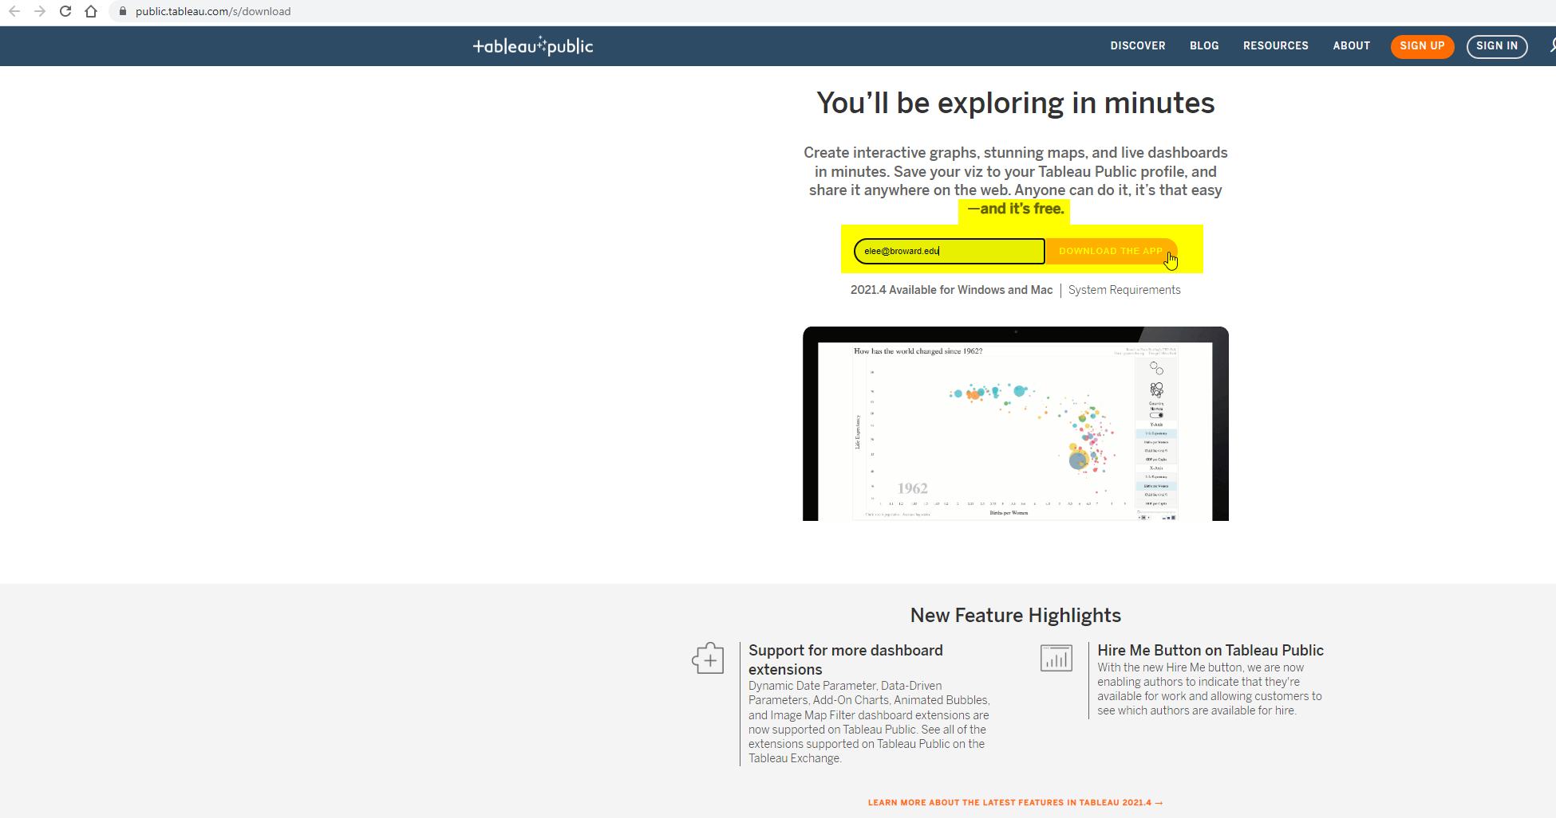

Create a Tableau Public account at: <https://public.tableau.com/s/>

Download the dataset from: <http://www.peteraldhous.com/Data/USDA_activity_dataset.xls>

# The Data:

* Open **USDA_activity_dataset.xls** and examine the contents.
* The data details physical activity, obesity, and other health data in nearly 100 columns, for more than 3000 rows, one for each county in the US.
* After you complete this Lab, as a team – create a public dashboard using this data: <https://bit.ly/3GrTL17> (from MurderData.org )

# Connect to the data:

* Drag and drop **USDA_activity_dataset.xls** on top of the Tableau Public icon on your desktop to open.
* At the dialog box, click OK to connect.
* Tableau automatically recognizes categorical fields, like **“State,”** and numerical measures like “**Adult obesity rate.”**

# Create the first view (a map for each state showing obesity rates at the county level):

* Double click on **“State”** and **“County.”** Tableau Public recognizes they are geographical fields and geocodes them accordingly.
* You may get a warning message; if so, check so that you don’t see it again.
* Notice there is a point at 0 degrees latitude and longitude. These are null values. Select them by clicking to one side of the point, keep the mouse button depressed to draw a rectangle over it, then release. Right click on the selected null values and select **Exclude**.
* Right click on the **Exclusions** in **Filter** and select **Make Global**, so that this will apply to all subsequent views.
* Now you have a map showing a dot for every county where you have a record:

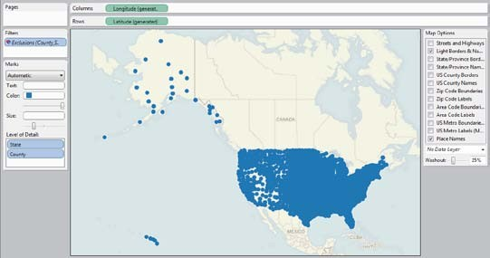

* Drag **“Adult obesity rate”** from the **Measures** panel into **Color**, and copy it into **Size**

shelf to encode counties by those values.

* 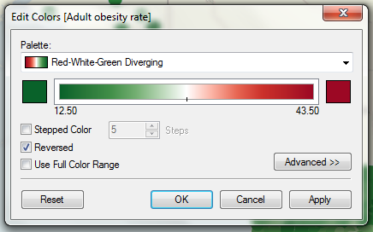Change the **Color** to **Red–White-Green Diverging**, and reverse it:
* Now add a filter to enable the selection of individual states. Click and drag **“State”** into the **Filters** shelf, click OK at the dialog box.
* Right click on **“State”** in the **Filters** shelf and select **Show Quick Filter**. Deselect **All** and then select **Alabama**.
* Rename the worksheet **“Map View”** by right clicking on the tab at the bottom.
* Finished state of first view:

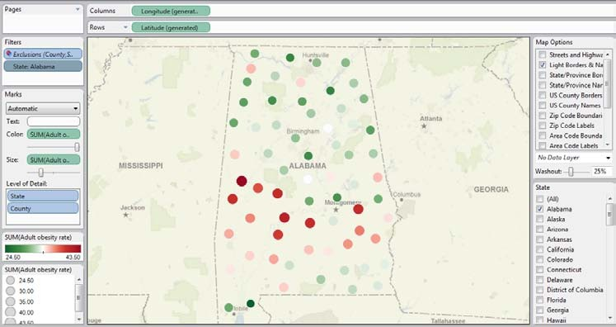

# Add a second view (scatter plots showing the relationship between obesity and health-related behaviors at the county level):

* 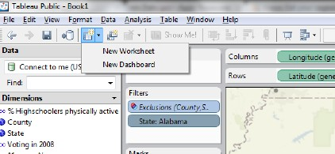Add new worksheet:

# Drag “Adult obesity rate” onto Rows and “% smokers,” “% eating few fruits and vegetables” and “% who do not exercise” into Columns.

* Drag **“County”** and **“State”** into **Level of Detail**. Without this step, Tableau’s default behavior is to sum the values across all the counties and states, which will give you a single data point for each graph, and not the desired scatter plots.
* The view should now look like this:

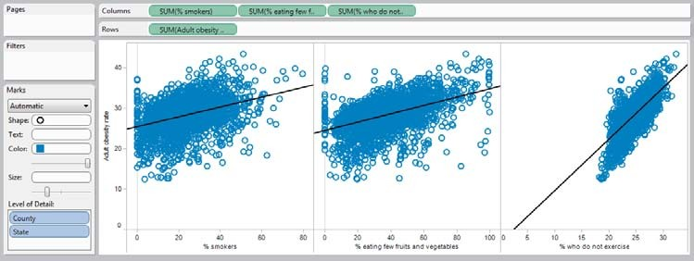

* Change **Color** to purple, open the Drop down menu next to **“Automatic”** and select

**Circle**, then move the slider below to the left to increase transparency of the points.

* Select **Analysis** in the top menu and check **Trend Lines**.
* Rename the worksheet **“Scatterplot View”** by right clicking on the tab at the bottom.
* Finished state of second view:

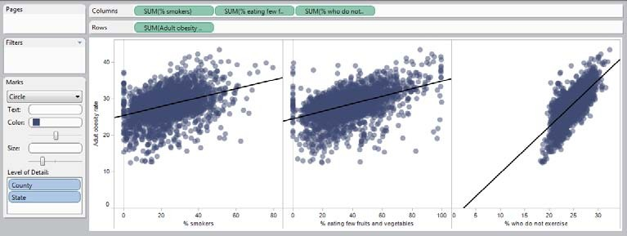

# Create a Dashboard with both views:

* 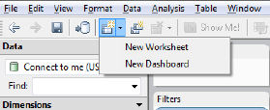Add dashboard:
* Double click on each view to bring both out onto the dashboard. Right click on the **State**

filter, select **Compact list**.

* Right click on this filter again, and select **Make Global**. This will ensure that selecting a state alters both views simultaneously.
* Right click on this filter for a third time, select **Customize** and uncheck **Show “All” Value**. This prevents users from seeing the entire data for all the US.
* Right click on the titles of each view and select **Hide Title**.
* Rename the dashboard **“Obesity by state and county”** by right clicking on the tab at the bottom.
* Double click on **Title** under **Objects**
* The dashboard should now look like this:

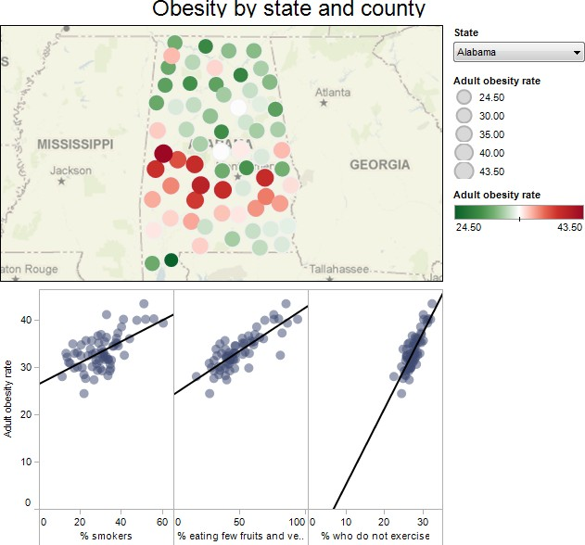

# Save to the web:

* Under **Size**, click **Edit** and select the size and layout best for your website.
* Click **File** on the top menu and select **Save to Web**. You will be asked for your account login at this point.

# Embed on your website/blog:

* In the **Save To Web Results** window that has opened up, scroll down beneath the visualization and click on **Share**.
* Copy and paste the embed code into the html of your web page.

Those were the training wheels. Now take a look with real data: <https://bit.ly/3GrTL17>