**Sorting**  
  
Download this file Sorting_Starter.twbx (on GitHub) and modify the view on Sheet 1 according to the following specification:  
  
**1. View One**

* Use a manual default sort for Department in this folder: Technology, Office Supplies, and Furniture.
* Use a local sort in the view to order Category by SUM (Sales) in descending order.

[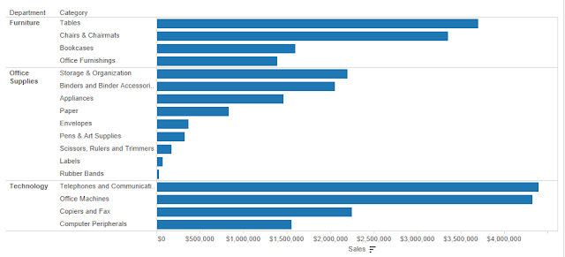](https://2.bp.blogspot.com/-piIdN9Xd3ZA/WpKNEfhtPLI/AAAAAAAABjg/QDFJjJZqVnQWONqokYUXKYZtS1UOEWgMgCLcBGAs/s1600/tableau-Sorting-1.png)

**2. View Two**

* Duplicate of the first worksheet, with bar color encoded by Profit.
* Category sort edited to short by Profit in descending order.

[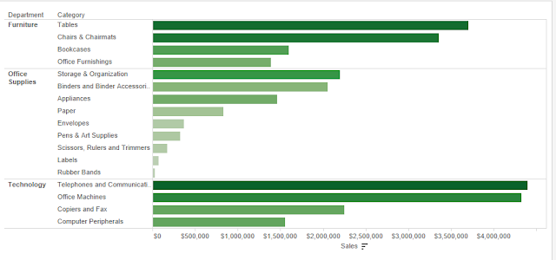](https://4.bp.blogspot.com/-EnMDb5NtC2Q/WpKM7swSbxI/AAAAAAAABjc/3MpjL01pQjcTjdrlP4XK0BVvKEypvDurwCLcBGAs/s1600/tableau-Sorting.png)

**3. Direction Details**

* On the view one tab, create a manual default sort department, with values ordered by Technology, office supplies, and then furniture.
* On the view two tabs, sort category by SUM (Sales) in descending order.
* On the view two tabs, edit the sort applied to category so field selected is sum of profit.