**Practice: Creating Groups and Hierarchies**  
  
Download this file [Creating\_Groups\_and\_Hierarchies\_Starter.twbx](http://www.mediafire.com/file/tv6352zddh5pjme/Creating_Groups_and_Hierarchies_Starter.twbx" \t "_blank) and create a view according to the following specification:

* Has a group named “Desk Supplies” that includes the following members: Envelopes, Pens & Art Supplies, Scissors, Rulers and Trimmers, Labels, Rubber Bands
* Hierarchy named Product with following dimensions in this order: Department Category (Group), Category Item
* Category (group) is drilled down one level so it displays Category in the view.

[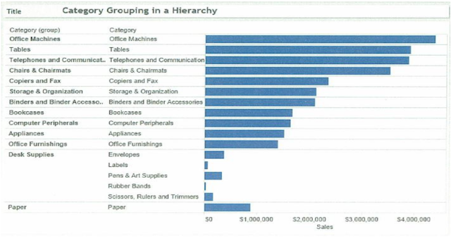](https://2.bp.blogspot.com/-nmDBzzRNHO4/WpYY4jyRw3I/AAAAAAAABlM/r1JwI-xUXEAbFYCmZ963aV1DhPJOCR5UgCLcBGAs/s1600/Tableau-Creating%2BGroups%2Band%2BHierarchies.png)

**1. Direction Details**

* Create a Group from the following items in Category: Envelopes, pens & Art Supplies, Scissors, Rulers and Trimmers, Labels and Rubber Bands.
* Category is replaced on Rows Shelf by Category (group), and a dimension titled “Category (Group)” is added to the Dimensions area of the data window.
* In the view, rename the label for the new group: “Desk Supplies”
* Create a hierarchy called “Products” in the Data window Organized as follows: Department, Category (group), category, items.
* In the view, drill down in the Category (group) to category.

**2. Solution** 

* Download this file [Creating\_Groups\_and\_Hierarchies\_Starter.twbx](http://www.mediafire.com/file/tv6352zddh5pjme/Creating_Groups_and_Hierarchies_Starter.twbx" \t "_blank)
* SHIFT + click to select these items near the bottom of the vertical axis: Envelopes, Pens, & Art Supplies, Scissors, Rulers and Trimmers, Labels, Rubber Bands.
* Right-click the selected items, and select Group
* In the view, right click the new group and click edit Alias
* Type Desk supplies as the name, and click OK
* Select and drag category (group) onto Department in the Data window to create a hierarchy. In the Create hierarchy dialog box enter “Products” and click OK.
* Click and drag category into the products hierarchy, placing it below Category (Group).
* Click and drag item into the products hierarchy, placing it below category.
* On the rows shelf, click plus (+) next to category (group) to expand to Category.

**D. Practice: Creating Visual Groupings**  
  
Download this file [Creating\_Visual\_Grouping\_Starter.twbx](http://www.mediafire.com/file/9l9eic2p92c258j/Creating_Visual_Groupings_Starter.twbx" \t "_blank) and create a view according to the following specification:

* Has a visual group named “Desk Supplies” using the following Category: Envelopes, Pens & Art Supplies, Scissors, Rules and Trimmers, Labels, and Rubber Bands.
* Has a visual group named “Machines” with Office Machines, Copiers and Fax and Computer Peripherals.
* All others are grouped as “Other”.

[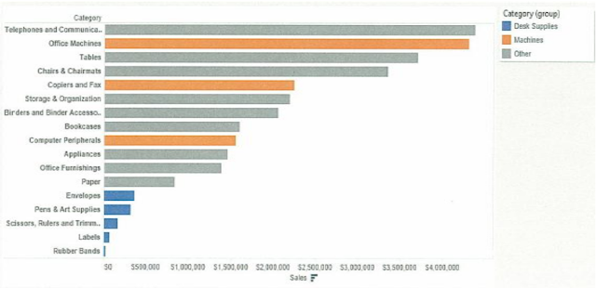](https://3.bp.blogspot.com/-LWk3ERvWbuw/WpYZmWxXwPI/AAAAAAAABlU/x7_9PhQPRpct9RNI-ttOvLafK9PvjwevQCLcBGAs/s1600/Tableau-Creating%2BVisual%2BGroupings.png)

**1. Direction Details**

* Select the bars for Envelopes, Pens & Art Supplies, Scissors, Rules and Trimmers, Labels, and Rubber Bands, and create a group named “Desk Supplies”
* Select the bars for Office Machines, Copiers and Fax and Computer Peripherals, and create another group named “Machines”

**2. Solution**

* Download this file [Creating\_Visual\_Grouping\_Starter.twbx](http://www.mediafire.com/file/9l9eic2p92c258j/Creating_Visual_Groupings_Starter.twbx" \t "_blank)
* CTRL + click each of the following bars: Envelopes, Pens & Art Supplies, Scissors, Rules and Trimmers, Labels, and Rubber Bands. TIP: Make sure to select the bars, not the text.
* With these items selected, right click and choose group.
* CTRL + click to select the bars that represent each of the following: Office machines, copiers and fax, and computer peripherals. TIP: Make sure to unselect the group you just created.
* With these items selected, right click and choose group
* In dimension in the data window, right click category (group), and choose Edit Group.
* In the Edit Group dialog box select Envelopes, labels, Pens & Art Supplies and 2 more; click Rename; type “Desk Supplies” and press Enter.
* In the Edit Group dialog box select Computer Peripherals, Copiers and Fax, Office Machines; click Rename; type “Machines” and press ENTER.
* Click OK

 All of the items not included in another group automatically included in a group named other.

* Add to Phrasebook
  + No wordlists for English -> English...
  + Create a new wordlist...