1. Go to: https://www.atlassian.com/try and select Try Now

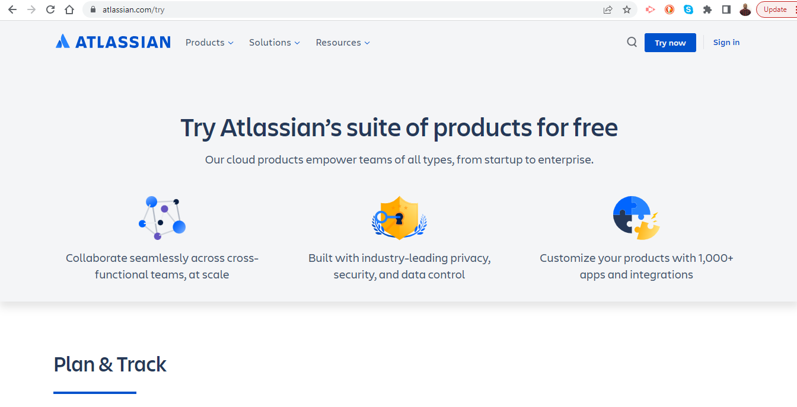

1. Select Jira Work Management with Confluence and select Next

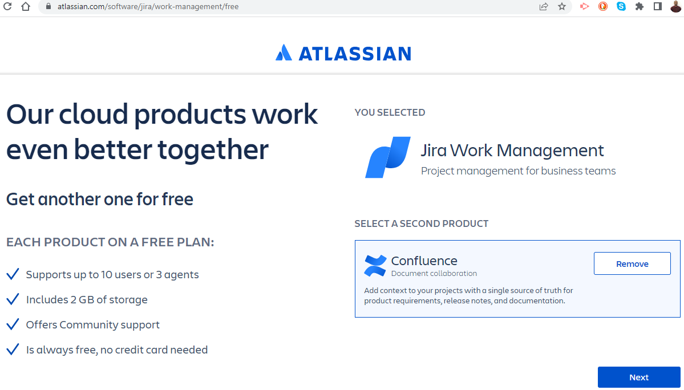

1. Sign up with Google or your email (no credit card required)

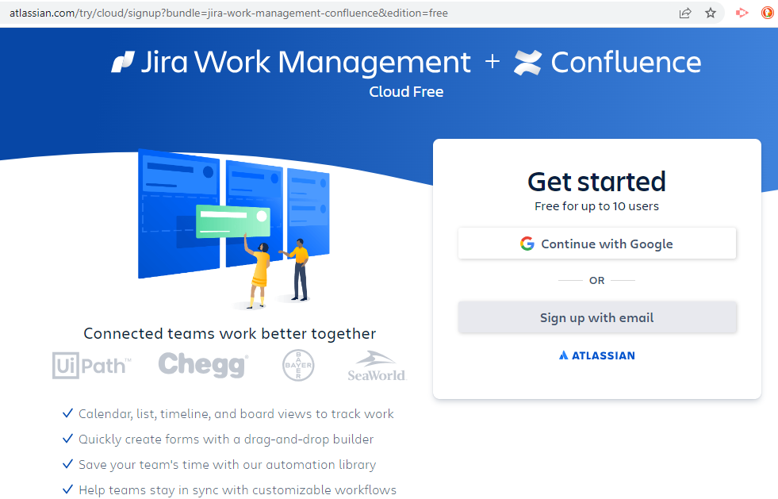

1. Here is an example with email signup:

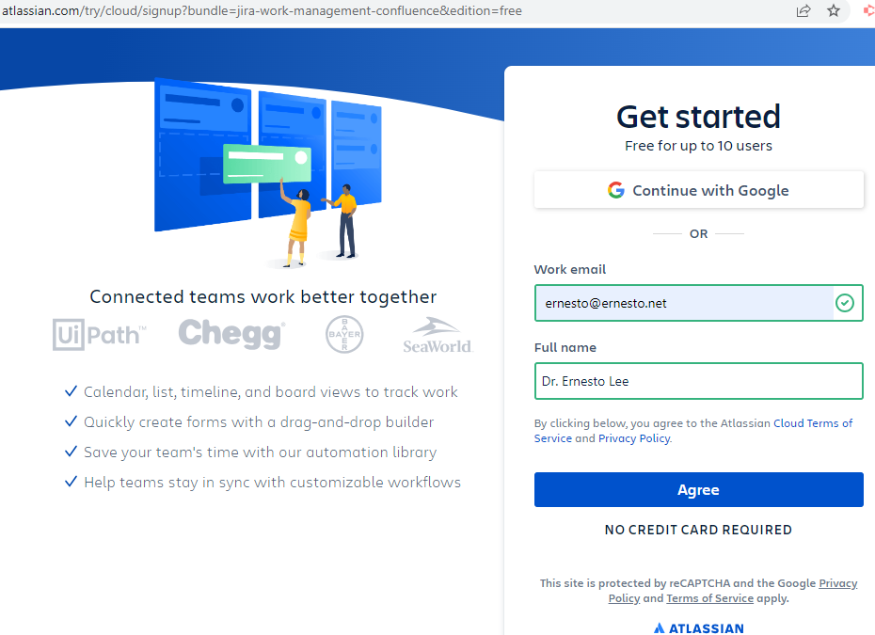

1. Verify your account in email and create your password.

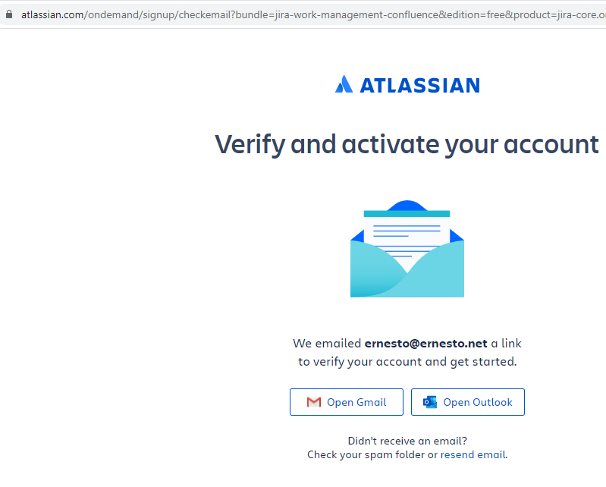

1. Sign in!

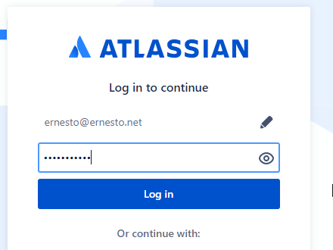

1. From here, this would be a good time to add Jira Software to your free account (follow the same process).

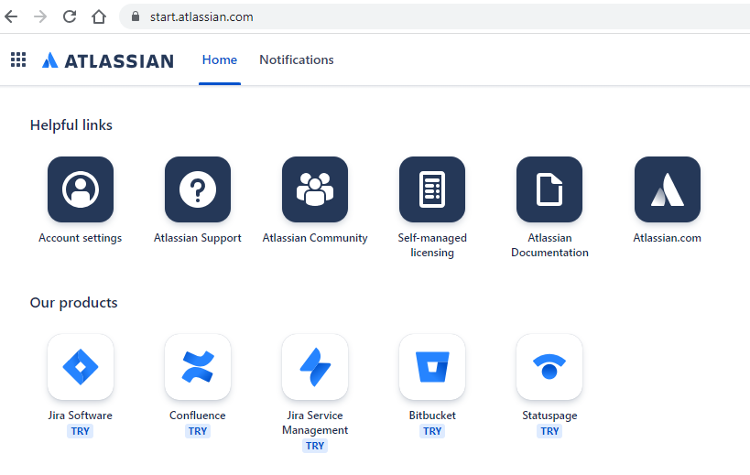

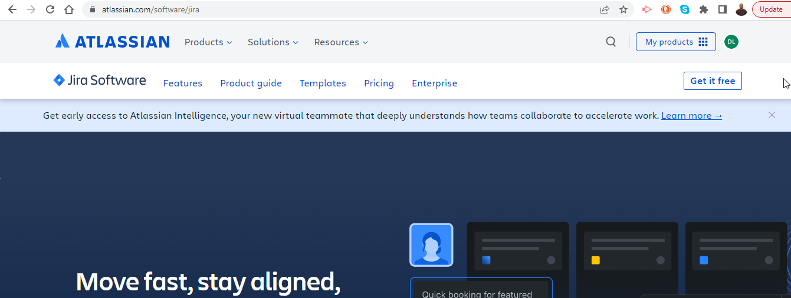

1. It will ask you to create a site. Create your URL and bookmark it!

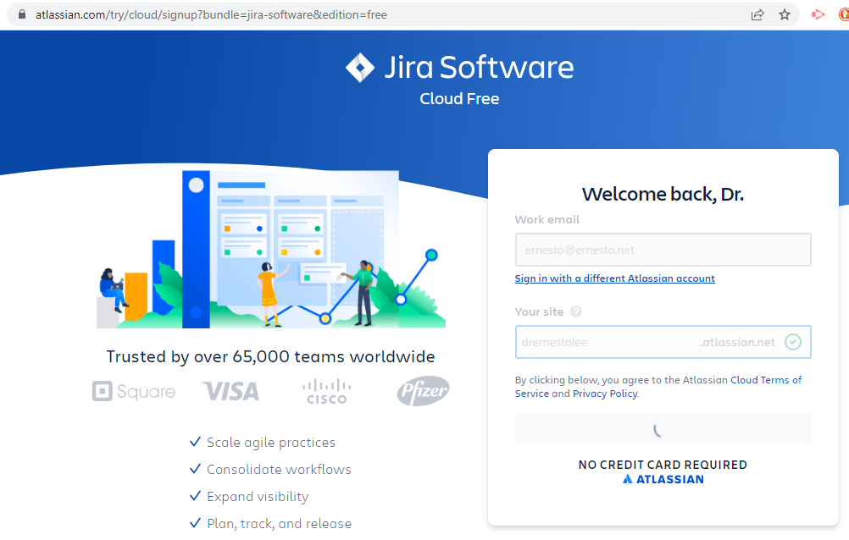

1. Create a Business Project and you are ready!

