**Lab 11: Azure Role Assignments**

To add a role assignment, go to Subscriptions (choose the subscription) 🡪 Access Control (IAM). From there, click on Roles:

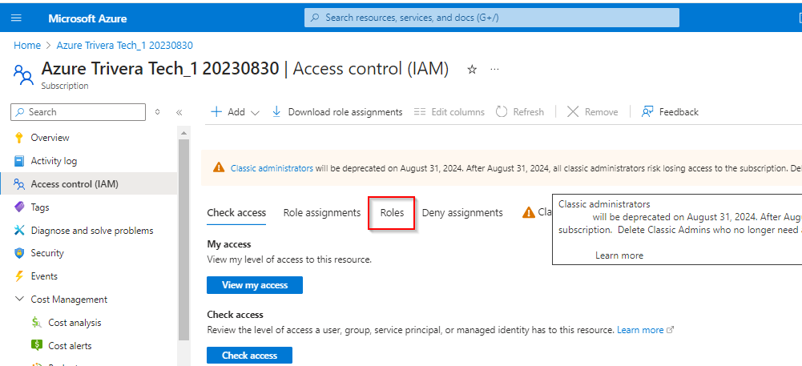

click the **Add Role Assignment** button on the top. Follow the three-step wizard to add your role assignment:

1. The first step is to choose a role. For this example, I will choose **Reader**:

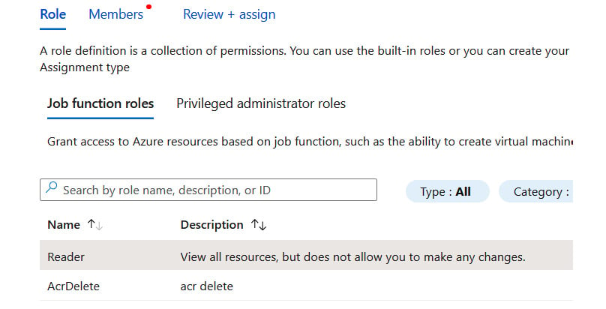

Step 1: Choosing a role

1. The second step is to choose members for the selected role. You can add multiple members by clicking the **Select members** button:

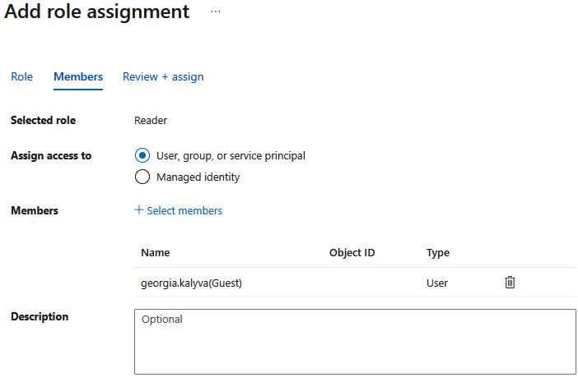

Step 2: Adding members

1. That is it! The final step is to review and complete the assignment.

If you want to use the command-line tools, here is an example in the CLI:

**az role assignment create --role "Reader" --assignee "socr***@*****.com" --subscription "00000000-0000-0000-0000-000000000000"**

Role assignment documentation

To view more options to assign roles using the Azure tools, follow the corresponding link to the tool of your choice:

CLI: <https://learn.microsoft.com/en-us/azure/role-based-access-control/role-assignments-cli>

PowerShell: <https://learn.microsoft.com/en-us/azure/role-based-access-control/role-assignments-powershell>

REST API: <https://learn.microsoft.com/en-us/azure/role-based-access-control/role-assignments-rest>

ARM templates: <https://learn.microsoft.com/en-us/azure/role-based-access-control/role-assignments-template>

Adding role assignments is just one part of the story. Let us see how to review our existing assignments and remove them when necessary.

Challenge:

Go to Resource Group TTAI2820 and create a custom role and Add Permissions for Machine Learning Services ONLY.

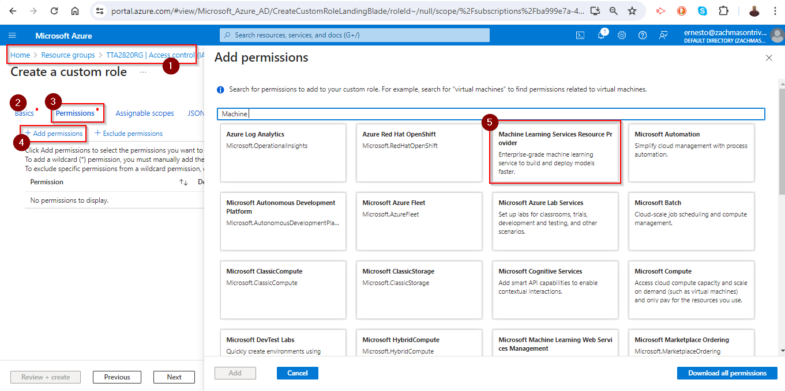

Viewing and removing role assignments ***\*ONLY DO THIS FOR A CUSTOM RULE THAT YOU CREATED***

The process to view and remove role assignments is just as simple. The first step is to visit the resource you want to check the role assignments for and open the **Access control (IAM)** menu. There, on the **Role assignments** tab, you can see existing role assignments, as shown in the following screenshot:

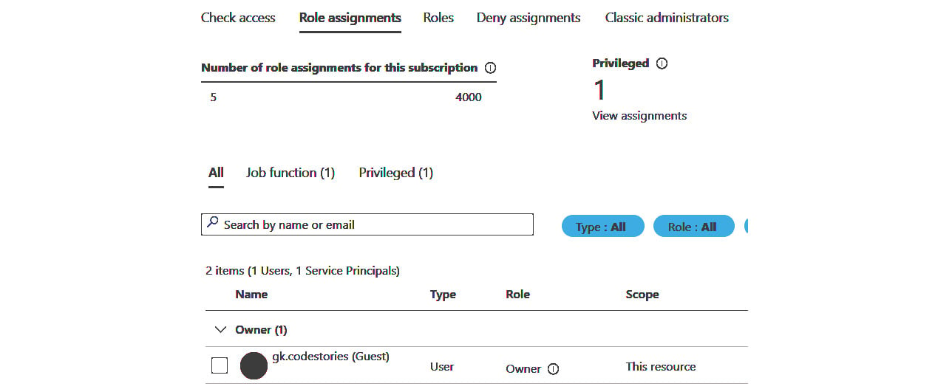

Removing a role assignment

By clicking on the box on the left of the role assignment in the user list, the **Remove** button on the top is enabled. You can click **Remove** and **Confirm** to remove the assignment.

As with adding an assignment, you can use the command-line tools. Here is an example of removing an assignment using the CLI:

az role assignment delete --assignee "socra***@*****.com" \

--role "Reader" \

--subscription "00000000-0000-0000-0000-000000000000"

Role assignment documentation

To view more options to remove role assignments using the Azure tools, follow this link: <https://learn.microsoft.com/en-us/azure/role-based-access-control/role-assignments-remove>

Built-in roles are not the only way to assign permissions. Let us review custom roles.