**Lab 19: Azure DevOps**

Creating a connection to the workspace

Before we work with anything that has to do with the Azure Machine Learning workspace, we need to create a service connection with Azure DevOps. For this, we need to create a new project in Azure DevOps. Here are the steps for it:

1. Open your Azure DevOps project and, under **Project Settings**, look for **Service connections**:

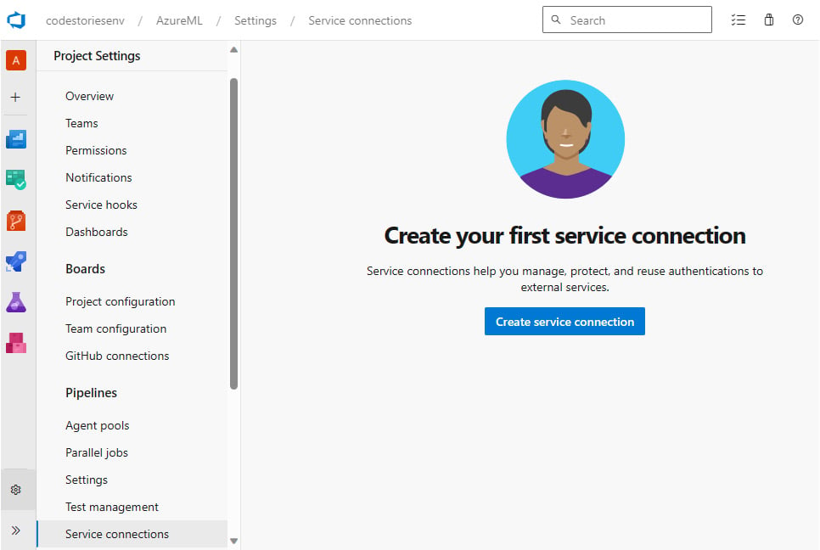

Creating a service connection

1. Click on **Create service connection**, and in the form that follows, choose **Azure Resource Manager**, as shown here:

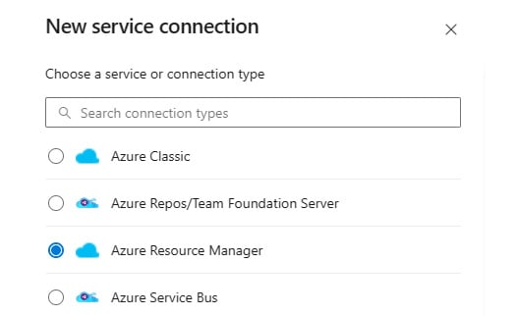

Starting with the Azure Resource Manager option

1. Click **Next** at the bottom of the page, and in the **Authentication method** options, the fastest option is to choose **Service principal (automatic)**because it requires no further configuration from the Azure portal. For better security, you might consider **Managed identity** if you have one created, but if you are not sure, you can just go ahead with the **Service principal (automatic)** option.

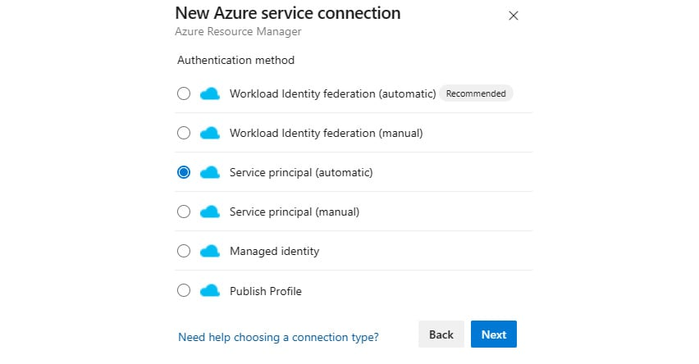

Choosing the Service principal option

1. Then, choose the workspace resource in your **Subscription** level by filling in the details shown in the following screenshot:

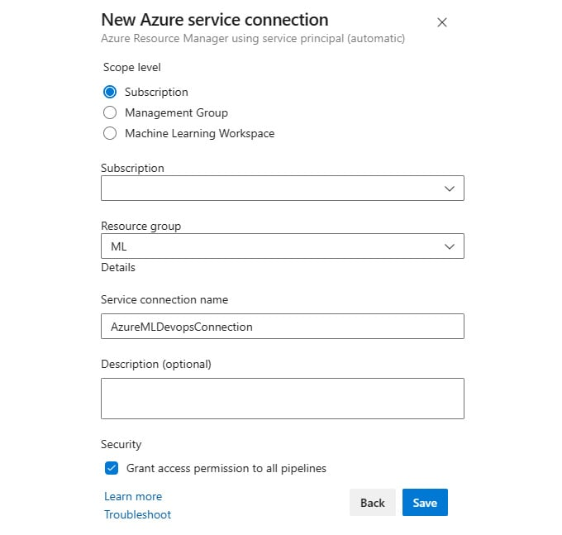

Selecting and connecting to the workspace resource

That is it! Now we have a connection to the workspace, and we can use it to run pipelines. You can still make any updates or see usage data by choosing your connection from the list.

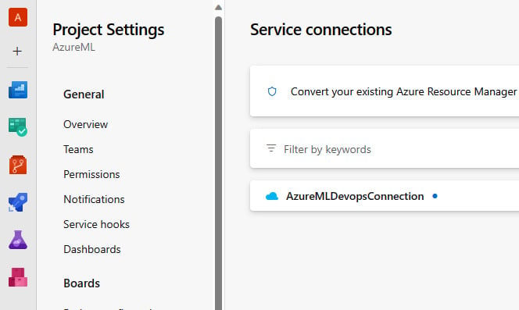

Figure 8.5 – Changing connection properties

Now that we have our connection, we are free to run pipelines. Let us see how in the following section.