**Lab 21: Azure DevOps Events**

Working with events in Azure Machine Learning

We can start the process directly from the Azure portal. Here are the steps to do it:

1. Open the **Azure Machine Learning Resource** blade and find the **Events** section:

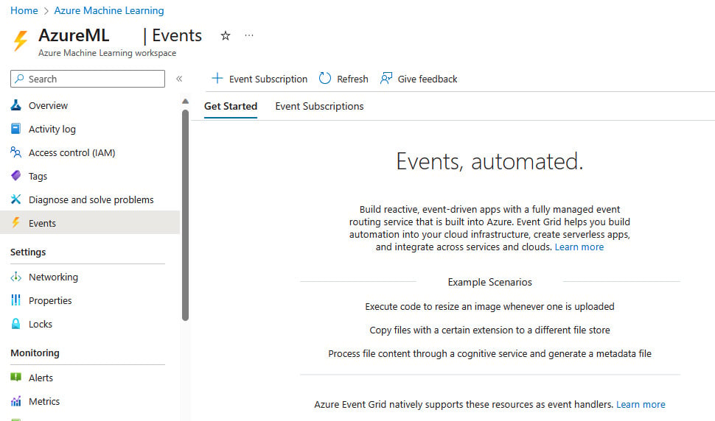

Opening AzureML resource events

1. In the **Get started** tab, if we scroll down, we can see which event handlers are natively supported by Event Grid. Of course, we can always create our own:

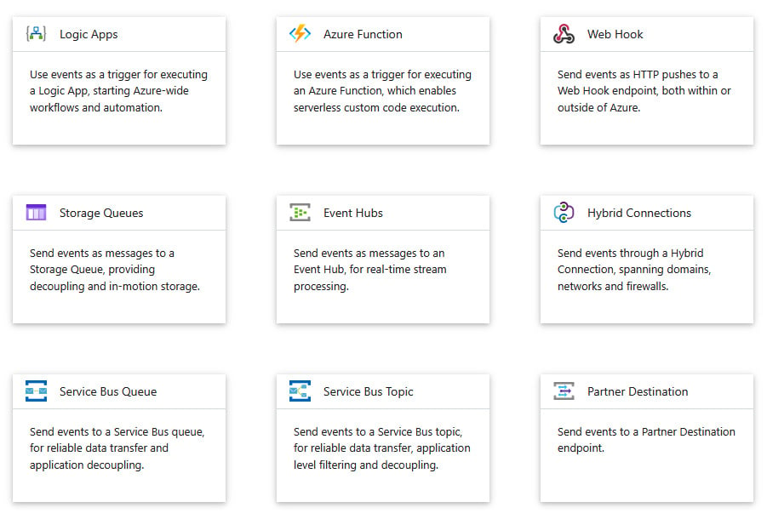

Azure Event Grid handlers

1. At the top of the page, we can click on **+ Event Subscription** to create a new event subscription. Fill in the basic fields, carefully choosing the event we want to monitor, as shown in the following screenshot:

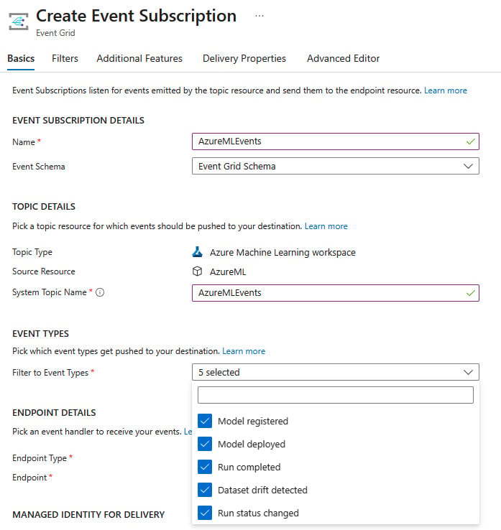

Create Event Subscription

1. Then, we can choose a destination. For this example, we are going to add them to a storage queue for further processing, but always remember that you can trigger simple to complex workflows by using another service such as Azure Functions or Azure Logic Apps. Under **ENDPOINT DETAILS**, select the **Storage Queues** endpoint type and click **Select an endpoint**:

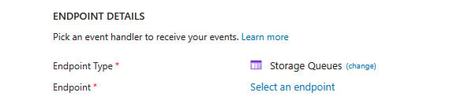

Choosing a storage queue

1. Complete the details and, when prompted, select **Create new queue** and provide a name for it:

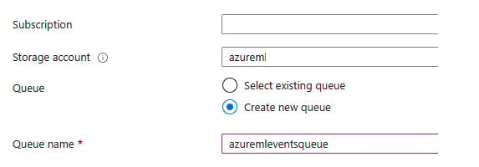

Creating a new queue

1. Under **MANAGED IDENTITY FOR DELIVERY**, select **System Assigned**:

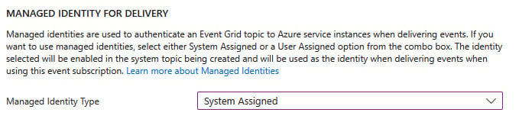

Selecting a managed identity

1. In the **Filters** tab, you can select your desired filters. I will skip this tab for now:

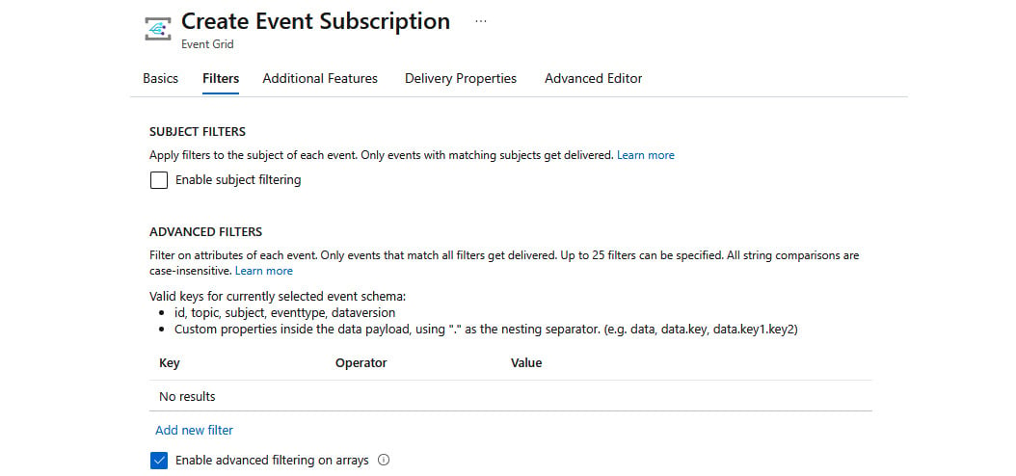

Selecting filters

1. In the **Additional Features** tab, it is wise to select the **Enable dead-lettering** option, and you can choose your desired **RETRY POLICIES** and **EVENT SUBSCRIPTION EXPIRATION TIME** values:

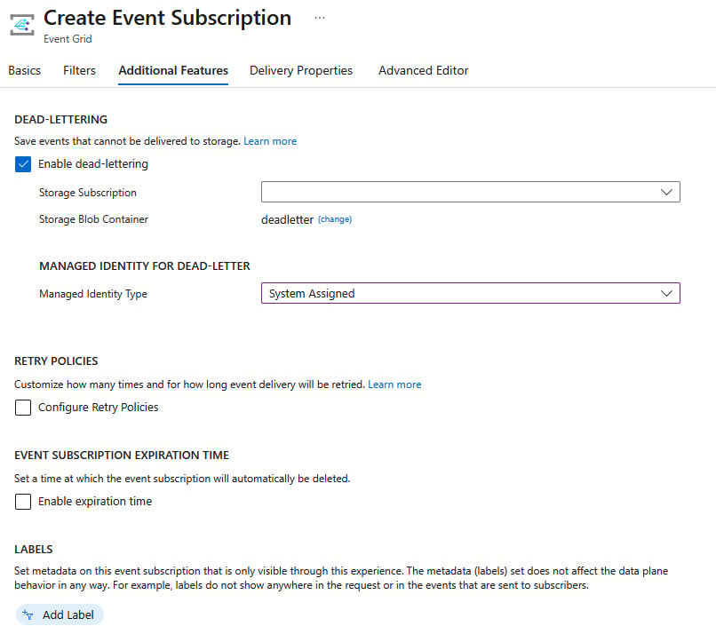

Enabling additional features

1. In the **Delivery Properties** tab, select an appropriate storage queue message **time to live** (**TTL**). The default is **7** days:

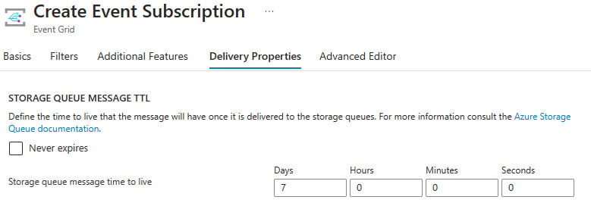

Selecting the message time to live

1. Finally, click on **Create** and that is it. Now, every time an event is logged into the service, it will be saved in the storage queue.

Of course, this is not the only option we have; we can use multiple services as event handlers to capture events from Event Grid. Let us explore those services next.