**Lab 3: Managing Data Assets in Azure Machine Learning Studio**

**Objective**

Download the Telco Customer Churn dataset and upload it as a data asset in Azure Machine Learning Studio, specifying the data type as Tabular.

**Instructions**

1. **Downloading the Dataset:**
   * Visit the [Telco Customer Churn dataset on GitHub](https://github.com/fenago/datasets/blob/main/WA_Fn-UseC_-Telco-Customer-Churn.csv).
   * Click on the **Download** **Raw** button.

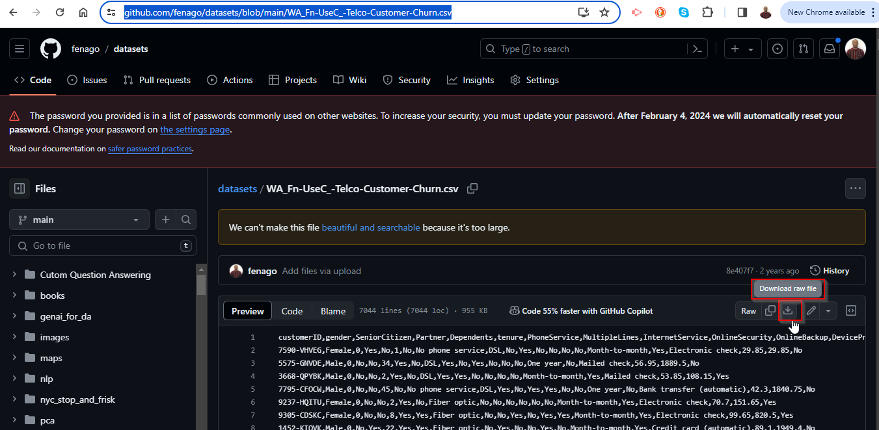.

1. **Uploading the Dataset:**
   * In the dataset creation wizard, on the **Basic info** page, enter the following details:
     + **Name:** Telco Customer Churn
     + **Description:** Dataset containing details about telco customers and their churn status.
     + **Data type:** Tabular

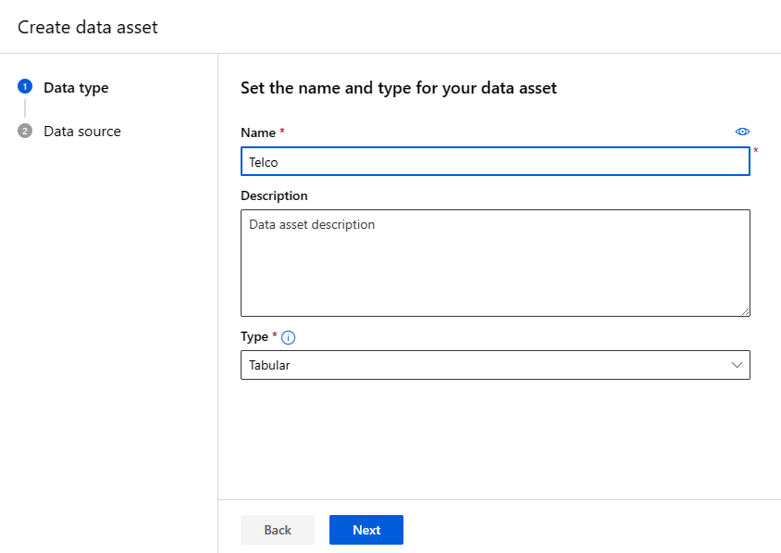

* + - Proceed by clicking **Next**.
  + In the **Datastore and file selection** step, leave the default storage option selected and upload the CSV file you saved earlier.

1. **Creating a New Data Asset in Azure Machine Learning Studio:**
   * Sign in to [Azure Machine Learning Studio](https://ml.azure.com/).
   * Navigate to **Datasets** under the **Data** menu in the left-hand assets panel.
   * Click on **+ Create dataset**, then choose **From local files**.

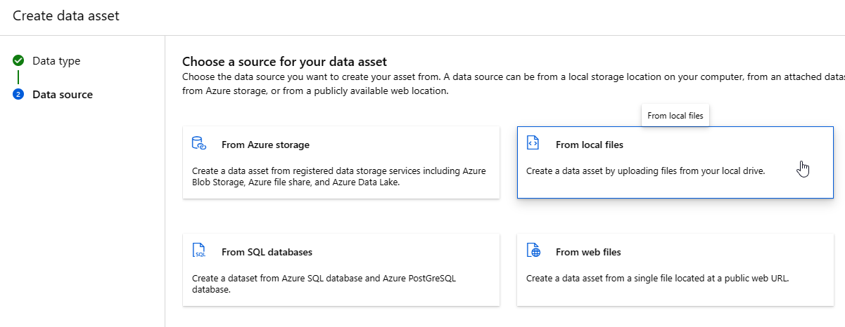

1. **Configuring the Dataset (Go through the wizard and upload your file):**

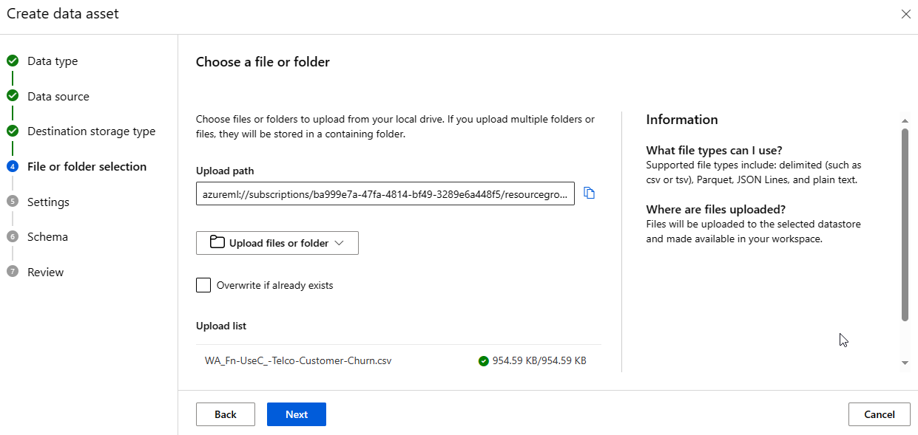

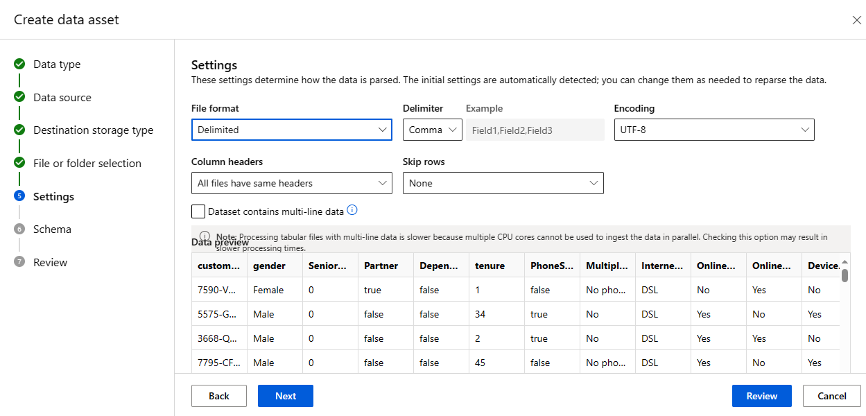

* + On the **Settings and preview** page, verify that the data preview correctly displays the columns and data. Adjust any settings if necessary to ensure the CSV file is parsed correctly.
  + Proceed to the **Schema** step, review the detected schema, exclude the **Path** column if present, and make any necessary adjustments to the other columns or data types.

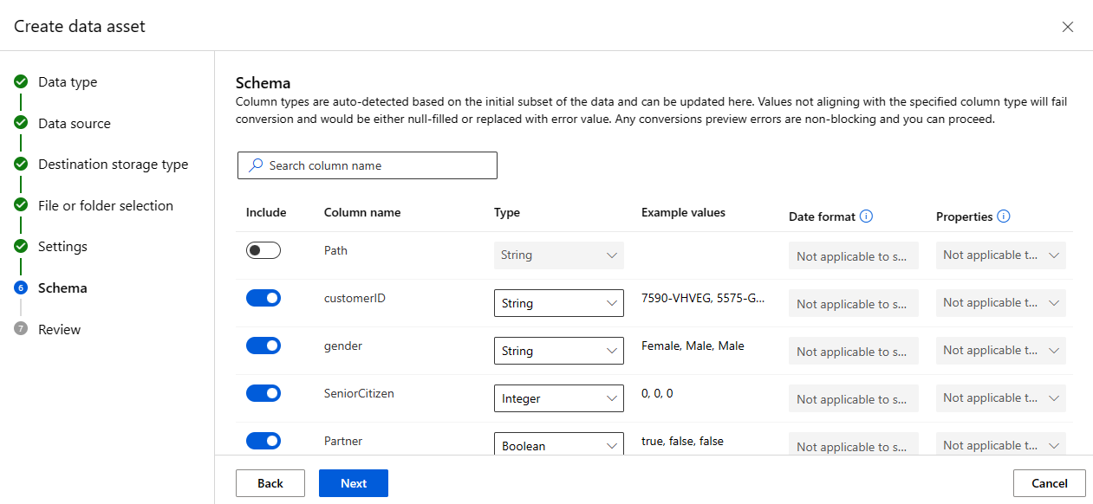

* + Continue to the **Review** step.

1. **Review and Create the Dataset:**
   * Confirm that all details are correct on the **Review** page.
   * Click **Create** to complete the creation of your dataset.
2. **Returning to Azure Machine Learning Studio:**
   * After successfully creating the dataset, navigate back to the **Datasets** section.
   * ***Initiate the creation of a new dataset to practice the process again, reinforcing your understanding of how to manage data within Azure Machine Learning Studio.***