**Lab 6: Setting Up Your Azure Machine Learning Workspace**

Let us see how it works:

1. Open the Azure portal at <http://portal.azure.com/> and type policy in the search box, as seen in the following screenshot:

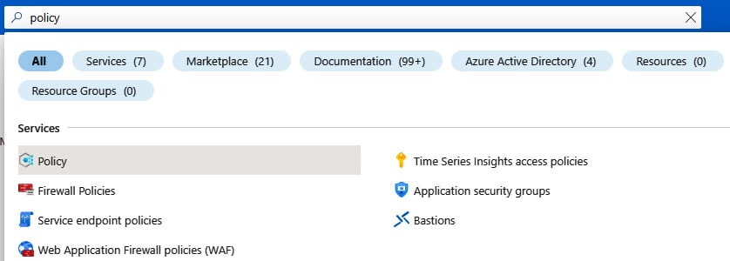

Figure 3.8 – Opening Azure Policy

1. You will find yourself in the **Overview** blade. Here, you can see a summary of your policies and the compliance of your resources:

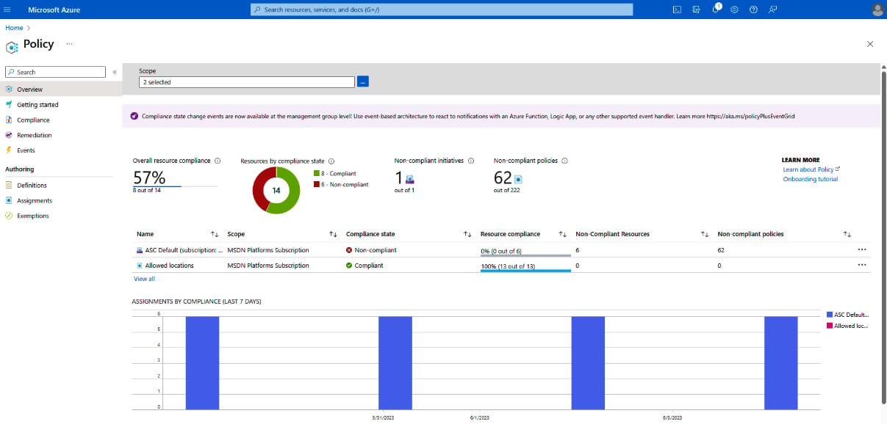

Figure 3.9 – The Azure Policy Overview blade

1. To assign a new policy, head to the **Authoring** menu on the left and click **Assignments**. In this menu, you can assign a policy to your resources:

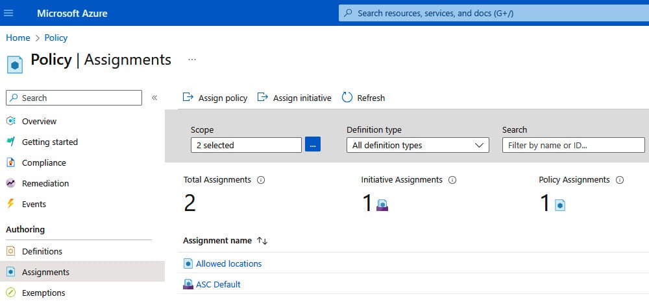

Figure 3.10 – Policy assignments

1. Click the **Assign policy** button and fill in the information as outlined in the next screenshot:

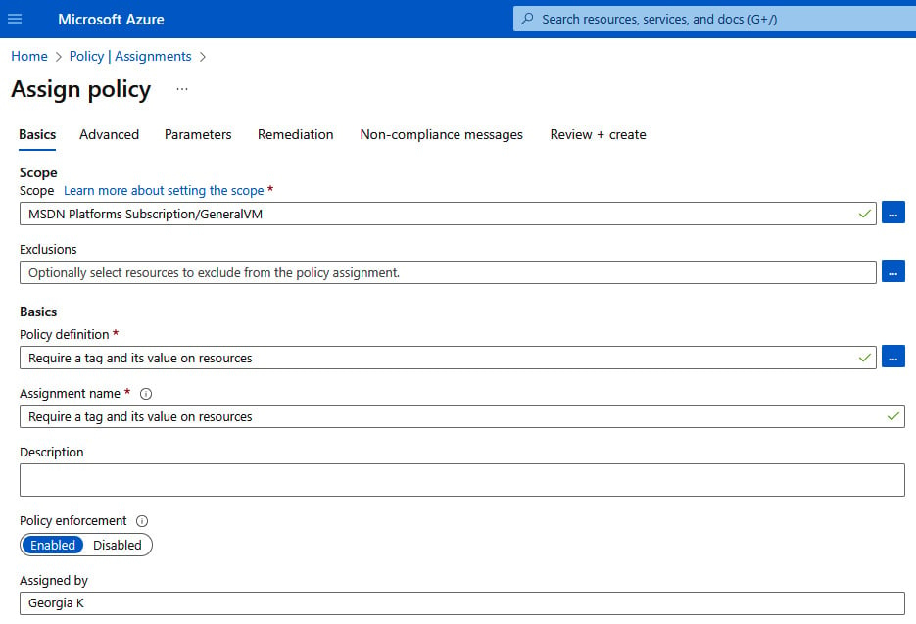

Figure 3.11 – Assign policy basics

1. **Scope** is the space where the policy is applied. You can set the scope as the management group, a subscription, or the resource group your resources exist in. I chose my subscription. If you want to exclude specific resources, you can set an exclusion here. Then, you can choose a policy definition. There are more than 1,000 in the portal; you can find more on GitHub or you can create your own. I chose a simple one that makes a tag required for all resources. If there is remediation available, you can set this up on the **Remediation** tab. The one I chose does not have a remediation for previously created resources.

If you don’t want to put more than the required settings, that is it! The assignment might take up to 15 minutes to become enabled, and then it is enforced at the scope you have set for all new resources.