**Lab 7: Azure Resource Graph Explorer**

Azure Resource Graph Explorer

**Azure Resource Graph Explorer** is a powerful service that gives you the ability to explore, query, and analyze your Azure resources and their properties quickly and efficiently. It’s a very scalable way to retrieve information and get insights. You can create Azure Resource Graph Explorer queries with **Kusto Query Language** (**KQL**) to get information about the policies in your environment.

Let us see how we can run a simple query and extract reports:

1. To get started, open Azure Resource Graph Explorer by typing the name in the top search bar, shown as follows:

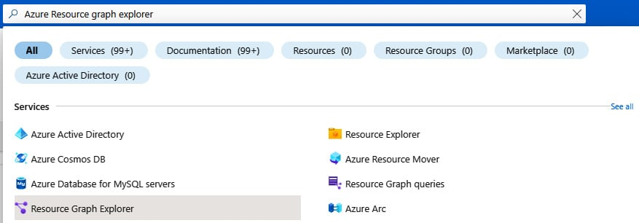

Figure 3.14 – Opening Azure Resource Graph Explorer

1. At the bottom of the page, under **Get started**, filter with the search term policy, as shown here:

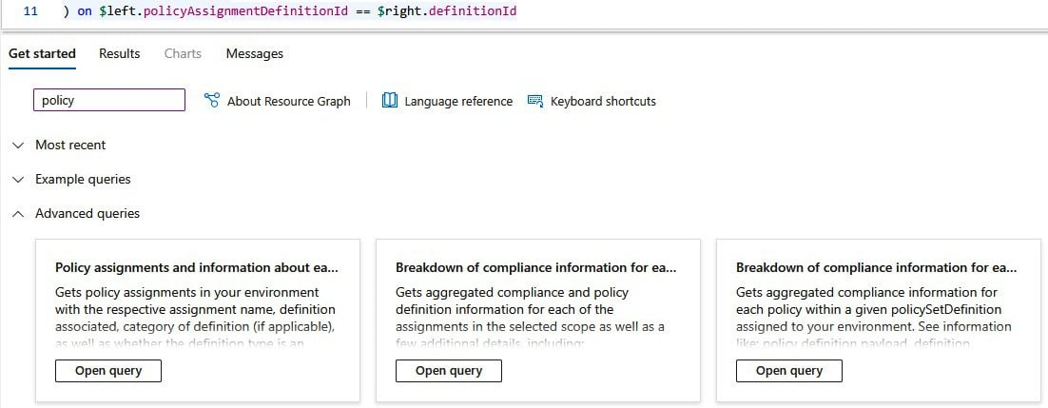

Figure 3.15 – Searching the query templates for policy-related queries

1. Run the leftmost query. You will get the active policy assignments for your subscription:

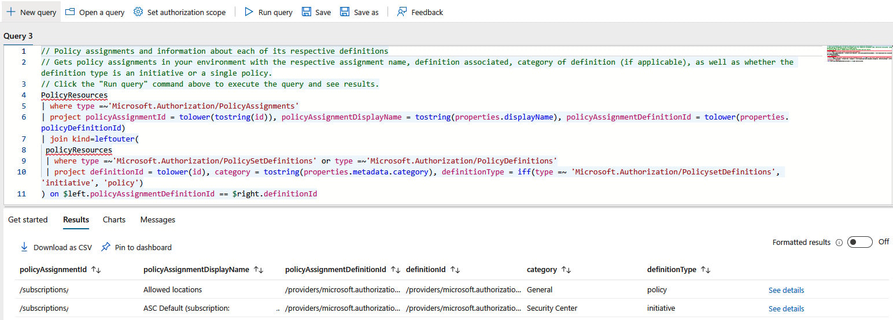

Figure 3.16 – Running a query in Azure Resource Graph Explorer

Now, you can use KQL to tailor the results and the columns to the information you want, export the data as a .csv file, or pin the table to an Azure dashboard.