**Lab 8: Azure Blueprints**

To create a blueprint, you only need to follow two steps:

1. First, you need to assign **Blueprint name** and **Definition location** values, which would be the subscription you want this blueprint applied to. This is shown in the following screenshot:

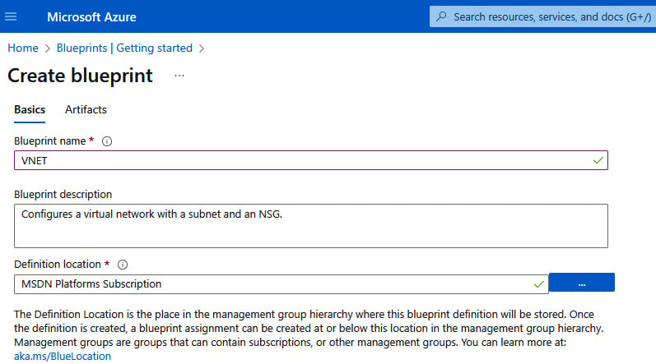

Figure 3.17 – Creating blueprint basic details

1. You need to declare artifacts and their parameters. Artifacts are resource groups, resource templates, RBAC assignments, and policies. Refer to the following screenshot:

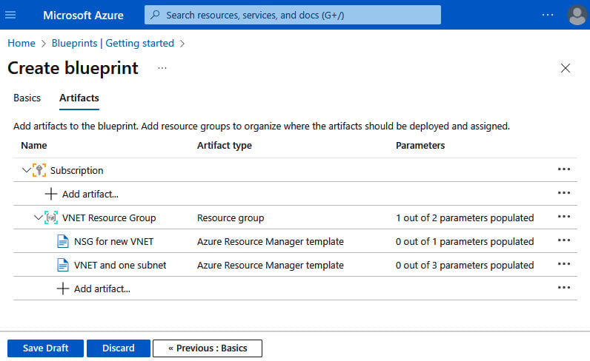

Figure 3.18 – Adding artifacts

While you are working with a blueprint, its mode is set to **Draft**. When you are ready to apply it, you need to publish the blueprint, and it is set as **Published**.