**Lab 9: Azure Fairlearn**

All you need to do is import or create a workbook in the interface, attach a compute target, and then run the cells. Let us see the steps together:

1. Go to the **Notebooks** section and upload or create your file:

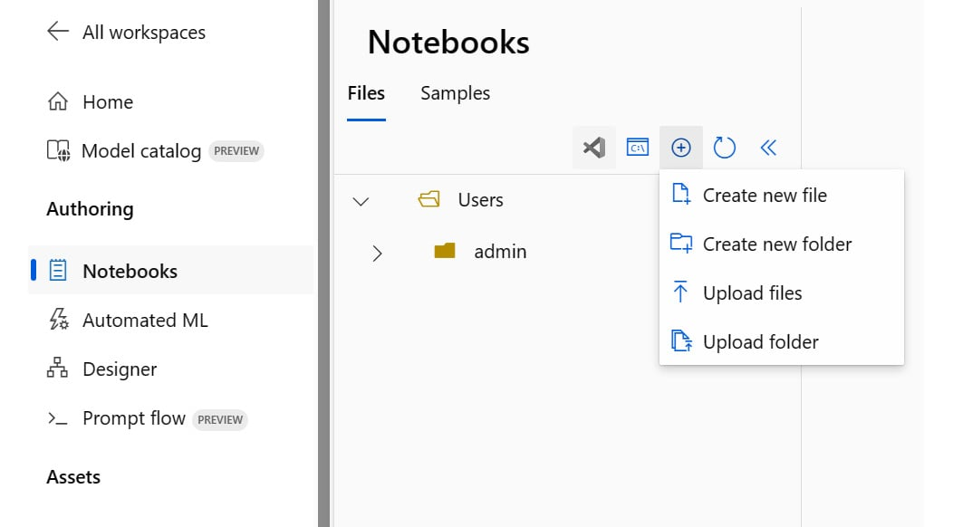

Azure Machine Learning notebooks

1. Open the notebook file and attach a running compute target from the **Compute** dropdown:

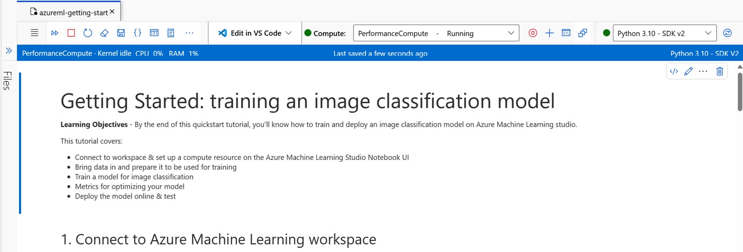

Attaching a compute target to a notebook

1. Run the cells in the notebook as usual.

Installing the SmartNoise SDK

The SmartNoise SDK (<https://smartnoise.org/>) is a differential privacy toolkit that you can use in ML or analytics. Here, we’ll see how we can install the library in order to use it later in this chapter.

To install SmartNoise SQL, run the following command:

pip install smartnoise-sql

To install SmartNoise Synthesizers, run this command:

pip install smartnoise-synth

SmartNoise documentation

Find the complete documentation here: <https://docs.smartnoise.org/>.

Installing Fairlearn

Fairlearn can be installed with pip from PyPI using the following command:

pip install fairlearn

Fairlearn documentation

Find the complete documentation here: <https://fairlearn.org/>.