

# 

# Developing Hadoop Applications

Lab Guide

## Overview:

– Developing Hadoop Applications

– Build Hadoop MapReduce Applications

– Manage and Test Hadoop MapReduce Applications

– Launch Jobs and Advanced Hadoop MapReduce Applications

# Using This Guide

## Overview of Labs

The table below lists the lab exercises included in this guide. Lab exercises are numbered to correspond to the learning goals in the course.

|  |  |
| --- | --- |
| Lessons and Labs |  |
| Lesson 1: Introduction to MapReduce |  |
| * Lab 1.2: Run wordcount |  |
| * Lab 1.3: Examine job metrics in JobHistoryServer |  |
| Lesson 2: Job Execution Framework |  |
| * Lab 2.3 – Run DistributedShell |  |
| * Lab 2.4 – Examine job results |  |
| Lesson 3: Write MapReduce Programs |  |
| * Lab 3.3 – Modify a MapReduce program |  |
| Lesson 4: Use the MapReduce API |  |
| * Lab 4.3 – Write a MapReduce program |  |
| Lesson 5: Manage, Monitor, and Test MapReduce Jobs |  |
| * Lab 5.1a – Examine default job output |  |
| * Lab 5.1b – Use custom counters |  |
| * Lab 5.3a – Use standard output, error, and logging |  |
| * Lab 5.3b – Use the Hadoop CLI to manage jobs |  |
| * Lab 5.4 – Test a MapReduce application |  |
| Lesson 6: Manage Performance |  |
| * Lab 6.3 – De-tune a job and measure performance impact |  |
| Lesson 7: Working with Data |  |
| * Lab 7.3 – Run a MapReduce program using HBase as source |  |
| Lesson 8: Launching Jobs |  |
| * Lab 8.3 – Write a MapReduce driver to launch two jobs |  |
| Lesson 9: Streaming MapReduce |  |
| * Lab 9.3 – Implement a MapReduce streaming application |  |

Developing Hadoop Applications

**Icons Used in This Guide**

This lab guide uses the following icons to draw attention to different types of information:

##### 

**Note**: Additional information that will clarify something, provides details, or helps you avoid mistakes.



**CAUTION**: Details you **must** read to avoid potentially serious problems.



**Q&A**: A question posed to the learner during a lab exercise.



**Try This!** Exercises you can complete after class (or during class if you finish a lab early) to strengthen learning.

Developing Hadoop Applications

## Command Syntax

When command syntax is presented, any arguments that are enclosed in chevrons, <like this>, should be substituted with an appropriate value. For example this:

###### # cp <source file> <destination file>

might be entered by the user as this:

###### # cp /etc/passwd /etc/passwd.bak



**Note**: Sample commands provide guidance, but do not always reflect exactly what you will see on the screen. For example, if there is output associated with a command, it may not be shown.



**Caution**: Code samples in this lab guide may not work correctly when cut and pasted. For best results, type commands in rather than cutting and pasting.

Starting Hadooo

## Start Hadoop Syntax

**Important:** **First switch to user *hdoop* from the terminal before starting hadoop:**

###### hdoop@host: su - hdoop

Hadoop has been already installed. Run following scripts as *hdoop* user to start all the daemons:

###### hdoop@host: $HADOOP_HOME/sbin/start-dfs.sh

###### hdoop@host: $HADOOP_HOME/sbin/start-yarn.sh

###### hdoop@host: $HADOOP_HOME/sbin/mr-jobhistory-daemon.sh start historyserver

### Go to hadoop-2.7.0/sbin directory and start all the daemons.

### To check that all the Hadoop services are up and running, run the below command.

*Command:***jps**



**Note**: ./start-hadoop.sh has been created at /home/hdoop which will run all of the above scripts.

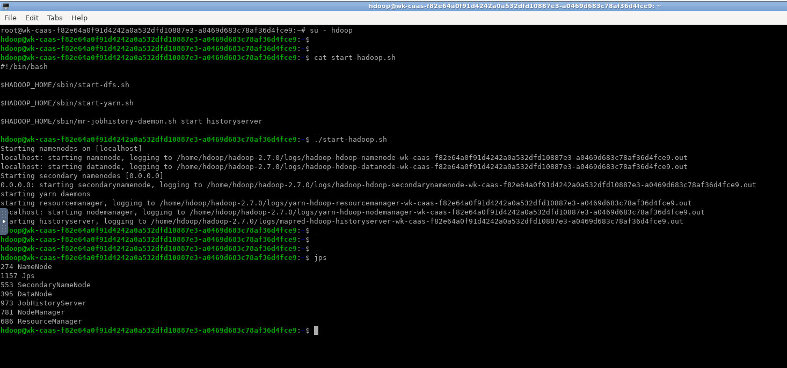

# MapReduce Essentials

Lesson 1: Introduction to MapReduce

**Lab Overview**

In the lesson’s lab exercises, you will run a few MapReduce jobs from the command line and examine job information in the MapR Control System (MCS).

##### 

**Note:** Some commands shown throughout this lab guide are too long to fit on a single line. The backslash character (\) indicates that the command continues on the next line. Do not include the backslash character, or a carriage return, when typing the commands.

**Lab 1.2: Run wordcount**

*Estimated time to complete: 30 minutes*

**Run wordcount against a text file**

1. Log into the cluster as the user hdoop.
2. Create a directory in your home directory as follows:

###### $ cd ~ && mkdir input

1. Create a file in the directory as follows:

###### $ echo "Hello world! Hello" > input/in.txt

###### $ ls -l input



**Note**: Run following command first to put text file in hadoop filesystem:

**$ hadoop fs -mkdir -p input**

**$ hadoop fs -put ./input/in.txt input**

###### Run the wordcount application against the input file.

###### $ hadoop jar /home/hdoop/hadoop-2.7.0/share/hadoop/mapreduce/hadoop-mapreduce-examples-2.7.0.jar wordcount input/in.txt output

1. Check the output of the wordcount application:

Lesson 1: Introduction to MapReduce

###### $ hadoop fs -copyToLocal output .

###### $ ls -ltr output

###### $ cat output/*

**Run wordcount against a set of files**

1. Create a directory in your home directory, and also create a set of files as follows:

###### $ mkdir -p /home/hdoop/Lab1.3/IN2

###### $ cd /home/hdoop/Lab1.3

###### $ cp /etc/*.conf /home/hdoop/Lab1.3/IN2 2>/dev/null



**Note**: Run following command first to put all files in hadoop filesystem:

**$ hadoop fs -mkdir -p IN2**

**$ hadoop fs -put /home/hdoop/Lab1.3/IN2/*.conf IN2**

1. Determine how many files are in that directory:

###### $ ls /home/hdoop/Lab1.3/IN2 | wc -l

1. Run the wordcount application against the directory:

###### $ hadoop jar /home/hdoop/hadoop-2.7.0/share/hadoop/mapreduce/hadoop-mapreduce-examples-2.7.0.jar wordcount IN2 OUT2

###### Check the output of the wordcount application:

###### $ hadoop fs -copyToLocal OUT2 /home/hdoop/Lab1.3/OUT2

###### $ wc -l /home/hdoop/Lab1.3/OUT2/part-r-00000

**$ more /home/hdoop/Lab1.3/OUT2/part-r-00000**

**Run wordcount Against a Binary File**

1. Create a directory in your home directory as follows:

###### $ mkdir -p /home/hdoop/Lab1.3/IN3

1. Create a binary file in that directory as follows:

###### $ cp /bin/cp /home/hdoop/Lab1.3/IN3/mybinary

1. Verify the file is a binary:

###### $ file /home/hdoop/Lab1.3/IN3/mybinary

1. See if there is any readable text in the binary:

###### $ strings /home/hdoop/Lab1.3/IN3/mybinary | more



**Note**: Run following command first to put binary file in hadoop filesystem:

**$ hadoop fs -mkdir -p IN3**

**$ hadoop fs -put /home/hdoop/Lab1.3/IN3/mybinary IN3**

Lesson 1: Introduction to MapReduce

1. Run the wordcount application against the input file.

###### $ hadoop jar /home/hdoop/hadoop-2.7.0/share/hadoop/mapreduce/hadoop-mapreduce-examples-2.7.0.jar wordcount IN3/mybinary \

**/home/hdoop/Lab1.3/OUT3**



**Note**: Run following command first to downloads results to local filesytem from hadoop

filesystem:

**$ hadoop fs -copyToLocal /home/hdoop/Lab1.3/OUT3 /home/hdoop/Lab1.3/OUT3**

1. Check the output of the wordcount application:

###### $ more /home/hdoop/Lab1.3/OUT3/part-r-00000

1. Cross-reference the frequency of the “word” ATUH in the binary and in the wordcount output:

###### $ strings /home/hdoop/Lab1.3/IN3/mybinary | grep -c ATUH

**$ egrep -ac ATUH /home/hdoop/Lab1.3/OUT3/part-r-00000**

**Lab 1.3: Examine Job Metrics in JobHistoryServer**

*Estimated time to complete: 30 minutes*

1. Connect to the JobHistoryServer in your Web browser. Launch Midori Browser by clicking icon on the desktop :

###### https://<IP address>:19888

1. The JobHistory page displays:

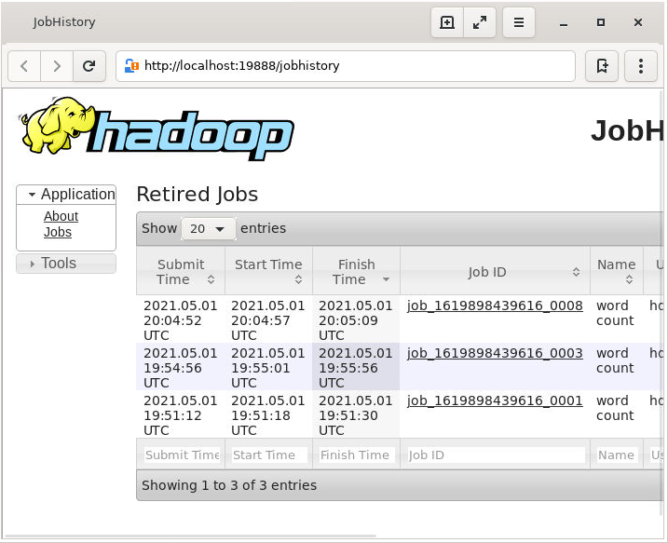

1. In the list of displayed jobs, scroll to the bottom to find your jobs (as a combination of the **Job Name** and **User** fields).
2. Click the link **word count** for one of the jobs you launched.
   1. How many tasks comprised that job?
   2. How long did they each last?
   3. On which node did they run? Note that in a single-node cluster, there's only one machine the job can run on.

# Build Hadoop MapReduce Applications

Lesson 2: Job Execution Framework

**Lab 2.3: Run DistributedShell**

*Estimated time to complete: 20 minutes*

**Run DistributedShell with a shell command**

1. Launch the YARN job using the yarn command:

###### $ yarn jar /home/hdoop/hadoop-2.7.0/share/hadoop/yarn/hadoop-yarn-applications-distributedshell-2.7.0.jar \

###### -shell_command /bin/ls \

###### -shell_args /home/hdoop \

###### -jar /home/hdoop/hadoop-2.7.0/share/hadoop/yarn/hadoop-yarn-applications-distributedshell-2.7.0.jar

###### When the job completes, scroll back through the output to determine your container ID for the shell, as shown in the sample output below:

###### 15/01/21 18:34:07 INFO distributedshell.Client: Got application report from ASM for, appId=1, clientToAMToken=null, appDiagnostics=, appMasterHost=yarn-training/192.168.56.102, appQueue=root.hdoop, appMasterRpcPort=-1, appStartTime=1421894036331, yarnAppState=FINISHED, distributedFinalState=SUCCEEDED, [appTrackingUrl=http://yarn](http://yarn-/)- training:8088/proxy/application_1421893926516_0001/A, appUser=hdoop

**Check Standard Output and Standard Error for Job**

1. Change directory to the output directory for YARN jobs:

###### $ cd $HADOOP_HOME/logs/userlogs

1. List the contents of the directory:

###### $ ls

1. Change directory to your application output directory:

###### $ cd application_<timestamp>_<appid>

1. List the contents of the directory:

###### $ ls

Lesson 2: Job Execution Framework – MapReduce v1 and v2

1. Change directory to the second container output directory:

###### $ cd container_<timestamp>_<appid*>*_01_000002

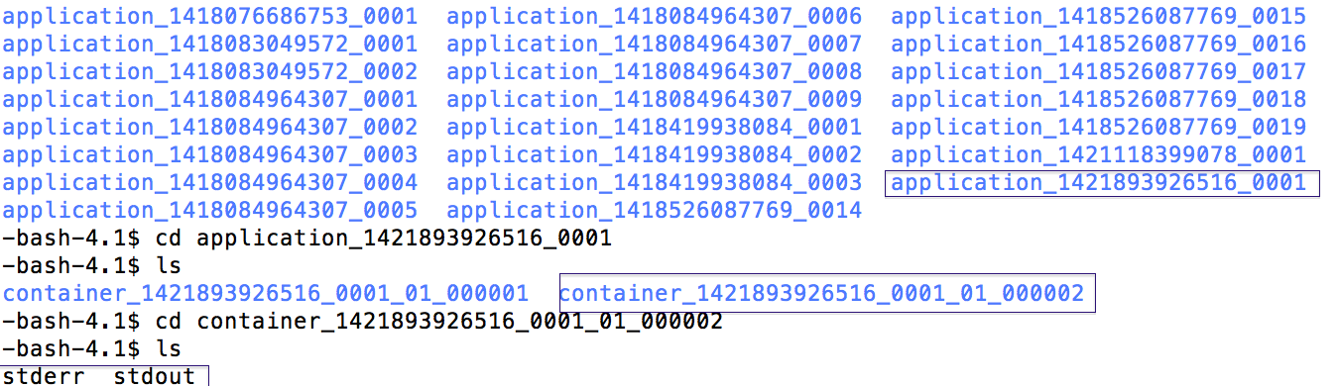

1. Display the contents of the stdout file. You should see a listing of the /home/hdoop directory.

###### $ cat stdout

1. Display the contents of the stderr file. It should be empty.

###### $ cat stderr

**Lab 2.4: Examine Job Results**

*Estimated time to complete: 15 minutes*

In this exercise, you will use the Web UI provided by the History Server to examine information for the job you previously launched.

1. Connect to the History Server in your web browser:

###### http://localhost:8088

###### http://<IP address>:8088

1. Scroll through the applications to find your application ID.
2. Click the link associated with your YARN job. How long did the job take?

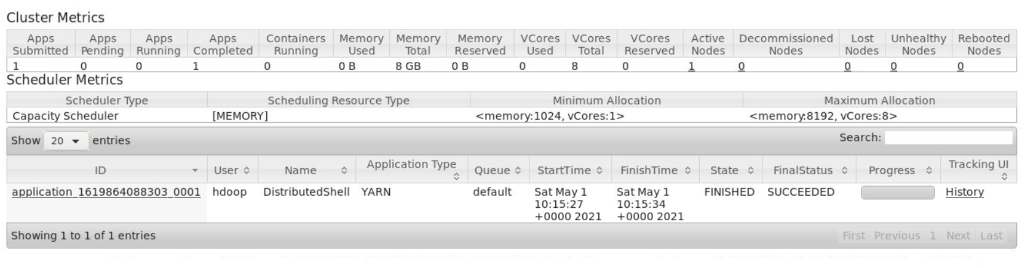

**Note:** Job output will also print appTrackingUrl which can be used to directly access job history

21/05/01 10:15:28 INFO distributedshell.Client: Got application report from ASM for, appId=1, clientToAMToken=null, appDiagnostics=, appMasterHost=N/A, appQueue=default, appMasterRpcPort=-1, appStartTime=1619864127194, yarnAppState=ACCEPTED, distributedFinalState=UNDEFINED, **appTrackingUrl**=http://wk-caas-f82e64a0f91d4242a0a532dfd10887e3-32e66f4f9a589a508f61bc:8088/proxy/application_1619864088303_0001/, appUser=hdoop

# Lesson 3: Write MapReduce Programs

### Lab Overview

The lab for this lesson covers how to make some modifications to an existing MapReduce program, compile it, run it, and examine the output. The existing code calculates minimum and maximum values in the data set. You will modify the code to calculate the mean surplus or deficit.

The data set we’re using is the history of the United States federal budget from the year 1901 to 2012. The data was downloaded from the white house website and has been massaged for this exercise. The existing code calculates minimum and maximum values in the data set. You will modify the code to calculate the mean surplus or deficit.

Here is a sample record from the data set:

###### 1968 152973 178134 -25161 128056 155798 -27742 24917 22336 2581

The fields of interest in this exercise are the first and fourth fields (year and surplus or deficit). The second field is the total income derived from federal income taxes, and the third field is the expenditures for that year. The fourth field is the difference between the second and third fields. A negative value in the fourth field indicates a budget deficit and a positive value indicates a budget surplus.

### Lab 3.3: Modify a MapReduce Program

*Estimated time to complete: 60 minutes*

### Copy the Lab Files

1. Log into the terminal as hdoop.
2. Create a directory for the lab work, and position yourself in that directory:

###### $ su - hdoop

###### $ mkdir /home/hdoop/Lab3

**$ cd /home/hdoop/Lab3**

1. Copy the source code for the lab from Desktop (run as root user):

###### $ cp –r /root/Desktop/apache-hadoop/Lab3/* /home/hdoop/Lab3

###### $ chown –R hdoop /home/hdoop/Lab3

This will create two directories: RECEIPTS_LAB, which contains the source files for the lab, and RECEIPTS_SOLUTION which contains files with the solution correctly implemented. You can review solutions files as needed for help completing the lab.

Lesson 3: Modify a MapReduce Program

### Modify Code in the Driver

1. Change directory into the RECEIPTS_LAB directory.

###### $ cd RECEIPTS_LAB

1. Open the ReceiptsDriver.java source file with your favorite text editor.

###### $ vi ReceiptsDriver.java

1. Look for the string // TODO in the file, and follow the instructions to make the necessary changes.
2. Save the ReceiptsDriver.java file.

**Note: You can also open files in vscode. Open vscode and click “File” > “Open Folder”.**

Other Locations > Computer > home > hdoop > folderName

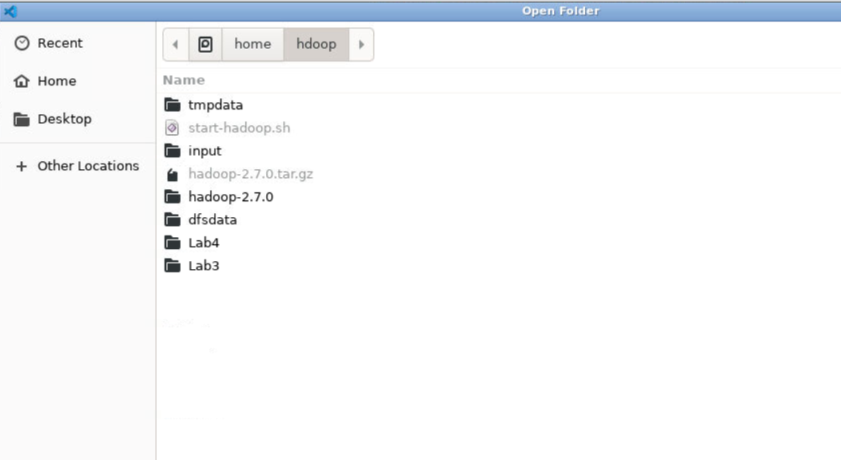

### Compile and Run the MapReduce Program

1. Execute the rebuild.sh script to compile your code.

###### $ ./rebuild.sh

1. Execute the rerun.sh script to run your code.

###### $ ./rerun.sh

1. Examine the output from your MapReduce job. Note you may need to wait a minute before the job output is completely written to the output files. Update path to “RECEIPTS_SOLUTION” if you are running solution.

###### $ cat /home/hdoop/Lab3/RECEIPTS_LAB/OUT/part*

Here is partial output expected for this exercise:

###### summary 1901_63 summary 1902_77 summary 1903_45 summary 1904_-43 summary 1905_-23 summary 1906_25 summary 1907_87 summary 1908_-57 summary 1909_-89 summary 1910_-18 summary 1911_11

Lesson 3: Modify a MapReduce Program

### Implement Code in the Reducer

In this exercise, you will implement code in the reducer to calculate the mean value. The code has already been provided to calculate minimum and maximum values.

Recall that the mapper code you ran above will produce intermediate results. One such record looks like this:

###### summary 1968_-25161

When you execute the code for this lab, there will only be one reducer (since there is only one key – “summary”). That reducer will iterate over all the intermediate results and pull out the year and surplus or deficit. Your reducer will keep track of the minimum and maximum values (as temp variables) as well as the year those values occurred. You will also need to keep track of the sum of the surplus or deficit and count of the records in order to calculate the mean value.

1. Open the ReceiptsReducer.java source file with your favorite text editor.

###### $ vi ReceiptsReducer.java

1. Find the // TODO statements in the file, and make the changes indicated. Refer to the solutions file as needed for help.
2. Save the ReceiptsReducer.java file.
3. Open the ReceiptsDriver.java source file with your favorite text editor. Find the line // TODO comment out the Reducer class definition. Recall that in the previous section, you commented out the Reducer definition – **in this section, you will need to uncomment it so it will be included.**



1. Save the ReceiptsDriver.java file.

### Compile and Run Your Code

1. Execute the rebuild.sh *s*cript to compile your code.

###### $ chmod +x *.sh

###### $ ./rebuild.sh

1. Execute the rerun.sh *s*cript to run your code.

###### $ ./rerun.sh

1. Examine the output from your MapReduce job.

###### $ cat /home/hdoop/Lab3/RECEIPTS_LAB/OUT/part*

Here is the output expected for this exercise:

###### min(2009): -1412688.0

**max(2000): 236241.0**

**mean: -93862.0**

# 

# Manage and Test Hadoop MapReduce Applications

Lesson 4: Write a MapReduce Program

# Lesson 4: Use the MapReduce API

### Lab Overview

The objective of this lab is to write your first complete MapReduce program using the numerical summary pattern we’ve been focusing on. The lab provides generic templates for the map, reduce, and driver classes. This exercise guides you through how to calculate the minimum, maximum, and mean SAT verbal and math scores over the whole data set.

### Summary of Data

This lab examines data sampled from university students across North America. The data set can be downloaded from [http://archive.ics.uci.edu/ml/datasets/University.](http://archive.ics.uci.edu/ml/datasets/University)

Not every record contains the same number of fields, but every record starts with the string (def- instance and ends with the string )). Each record contains information for a single university in the survey. Here is a sample record:

###### (def-instance Adelphi (state newyork) (control private)

**(no-of-students thous:5-10) (male:female ratio:30:70) (student:faculty ratio:15:1) (sat math 475)**

**(expenses thous$:7-10) (percent-financial-aid 60) (no-applicants thous:4-7) (percent-admittance 70)**

**(percent-enrolled 40)**

**(academics scale:1-5 2)**

**(social scale:1-5 2)**

**(sat verbal 500)**

**(quality-of-life scale:1-5 2)**

**(academic-emphasis business-administration) (academic-emphasis biology))**

L4-2

Lesson 4: Write a MapReduce Program

### Lab 4.3: Write a MapReduce Program

*Estimated time to complete: 90 minutes*

### Prepare

1. Log into the terminal as hdoop.
2. Create a directory as follows:

**$ su - hdoop**

**$ mkdir /home/hdoop/Lab4**

**$ cd /home/hdoop/Lab4**

###### Copy the source code for the lab from Desktop (run as root user in other terminal):

**$ cp -r /root/Desktop/apache-hadoop/Lab4/* /home/hdoop/Lab4**

**chown -R hdoop /home/hdoop/Lab4**

This will create two subdirectories: a UNIVERSITY_LAB directory containing the source files, and a UNIVERSITY_SOLUTION directory that contains the modified files with the correct solutions.

You can refer to the files in the UNIVERSITY_SOLUTION directory if you get stuck on a step.

### Implement the Mapper Class

1. Change directory into the UNIVERSITY_LAB directory.

###### $ cd UNIVERSITY_LAB

1. Open the data file with your favorite text editor.

###### $ vi DATA/university.txt

Each record contains an unknown number of fields after the start of the record and before either the sat math or sat verbal field. The sat math field may come before or after the sat verbal field, and one or both of the fields may not be part of the record at all. For example:

###### (def-instance <University Name>

**. . .**

**(sat verbal 500)**

**. . .**

**(sat math 475)**

**. . .))**

Examine the first few records in the file, then skip to line 1000 or so. Note that the data set is not uniform from beginning to end.

1. Close the data file, and open the UniversityMapper.java source file with your favorite text editor.

###### $ vi UniversityMapper.java

Lesson 4: Write a MapReduce Program

1. The UniversityMapper.java file contains a number of TODO directives. Make the changes necessary to address each TODO entry, and then save the file. Compare your results to what is shown in the file in the UNIVERSITY_SOLUTIONS directory.

### Implement the Reducer Class

Recall that one reducer will be given a list of key-value pairs that looks like this:

###### satv 480 500 530 . . .

The other reducer will be given a list of key-value pairs that looks like this:

###### satm 400 500 510 . . .

Perform the following steps to complete this lab:

1. Open the UniversityReducer.java source file with your favorite text editor.

###### $ vi UniversityReducer.java

1. Implement each TODO in the UniversityReducer.java file as follows, just as you did for the UniversityMapper.java file. Save your changes. Compare your changes to the file in the UNIVERSITY_SOLUTIONS directory.

### Implement the Driver Class

1. Open the UniversityDriver.java source file with your favorite text editor.

###### $ vi UniversityDriver.java

1. Implement each TODO in the UniversityDriver.java file, and save your changes. Compare your changes to the file in the UNIVERSITY_SOLUTIONS directory.

### Compile and Run the MapReduce Program

1. Launch the rebuild.sh script to recompile the source code:

###### $ chmod +x *.sh

###### $ ./rebuild.sh

If you get any errors that you can’t resolve, it might help to check the output from your map phase by setting mapred.num.reduce.tasks to 0 in your configuration.

1. Launch the rerun.sh script to execute the code.

###### $ ./rerun.sh

1. Check the output of the program:

###### $ cat OUT/part-r-00000

# Lesson 5: Manage, Monitor, and Test MapReduce Jobs

### Lab 5.1a: Examine Default Job Output

*Estimated time to complete: 40 minutes*

In this exercise, you will run the teragen and terasort MapReduce applications from the examples provided in the Hadoop distribution. You will then examine the records produced from running each one.

### Prepare the lab files

1. Create a directory for the lab files, and position yourself in that directory:

**$ su - hdoop**

**$ mkdir /home/hdoop/Lab5**

**$ cd /home/hdoop/Lab5**

1. Download and unzip the lab files into that directory **(run as root)**

**$ cp –r /root/Desktop/apache-hadoop/Lab5/* /home/hdoop/Lab5**

**$ chown –R hdoop /home/hdoop/Lab5**

You should see three directories created when the lab file is unzipped: SLOW_LAB, VOTER_LAB, and VOTER_SOLUTION.

1. View the csv data file for the VOTER_LAB:

###### $ cat VOTER_LAB/DATA/myvoter.csv

1. Inject some faulty records into your data set. For example:

###### $ echo "0,anna,14,independent,100,100" >> VOTER_LAB/DATA/myvoter.csv

**$ echo "0,anna,25" >> VOTER_LAB/DATA/myvoter.csv**

**Note: Add faulty records in VOTER_SOLUTION if you are running solution.**

###### $ echo "0,anna,14,independent,100,100" >> VOTER_SOLUTION/DATA/myvoter.csv

**$ echo "0,anna,25" >> VOTER_SOLUTION/DATA/myvoter.csv**

**Run teragen**

1. Run the teragen MapReduce application to generate 1000 records:

###### $ hadoop jar /home/hdoop/hadoop-2.7.0/share/hadoop/mapreduce/hadoop-mapreduce-examples-2.7.0.jar teragen 1000 /home/hdoop/Lab5/TERA_IN

Lesson 5: Manage, Monitor, and Test MapReduce Jobs

1. Look at the teragen job output counters.



**Q:** Why are there no input or output records for the reducer in the job output?

**A:** The teragen application is a map-only application.



**Note**: Run following command to download folder to local filesytem from hadoop.

**hadoop fs -copyToLocal /home/hdoop/Lab5/TERA_IN /home/hdoop/Lab5/TERA_IN**

1. Examine the files produced by teragen and answer the questions below.
   1. What type of file is produced?

###### $ file /home/hdoop/Lab5/TERA_IN/part-m-0000*

* 1. Why is the number of records we generated with teragen different than the total number of lines in the files?

###### $ wc -l /home/hdoop/Lab5/TERA_IN/part-m-0000*

* 1. Can you make sense out of the files by looking at them?

###### $ view /home/hdoop/Lab5/TERA_IN/part-m-00000

**Run terasort**

1. Run the terasort application to sort those records you just created and look at the job output.

###### $ hadoop jar /home/hdoop/hadoop-2.7.0/share/hadoop/mapreduce/hadoop-mapreduce-examples-2.7.0.jar terasort /home/hdoop/Lab5/TERA_IN /home/hdoop/Lab5/TERA_OUT

###### $ hadoop fs -copyToLocal /home/hdoop/Lab5/TERA_OUT /home/hdoop/Lab5/TERA_OUT

1. Note the application ID of your job. Connect to JobHistoryServer at port 19888:

###### https://<IP address>:19888

The JobHistory page displays:

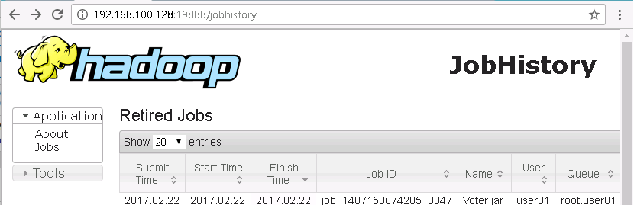

Lesson 5: Manage, Monitor, and Test MapReduce Jobs

1. In the list of displayed jobs, scroll to the bottom to find your job (as a combination of the **Job Name** and **User** fields and **applicationid**). Click the job.
2. Look at the terasort standard output to determine the following:
   1. Look at the number of mappers launched. Is this equal to the number of input files?
   2. Look at the number of map and reduce input and output records. When would the number of map input records be different than the number of map output records?
   3. Look at the number of combine input and output records. What does this imply about the

terasort application?

### Lab 5.1b: Use Custom Counters

*Estimated time to complete: 50 minutes*

In this exercise, you will write the logic to identify a “bad” record in a data set, then define a custom counter to count “bad” records from that data set. This is what a “good” record looks like:

###### 1,david davidson,10,socialist,369.78,5108

There are 6 fields total – a primary key, name, age, party affiliation, and two more fields you don’t care about. You will implement a record checker that validates that there are exactly 6 fields in the record, and that the third field is a “reasonable” age for a voter.

1. Change to the VOTER_LAB directory:

###### $ cd /home/hdoop/Lab5/VOTER_LAB

1. Open the VoterDriver.java file with the view command. What character separates the keys from the values in the records? Close the file.
2. Open the VoterMapper.java file with your favorite editor. Which character is the value of the record tokenizing on? Keep the file open for the next step.
3. Locate the // TODO statements in the file, and implement the changes necessary to validate the record. Then save the file.
4. Compile and execute the code, using rebuild.sh and rerun.sh. Based on the minimum, maximum, and mean values for voter ages, what do you conclude about the nature of the data set?
5. Examine the output in your terminal from the job to determine the number of bad records.
   1. How many records have the wrong number of fields?
   2. How many records have a bad age field?
   3. Does the total number of bad records, plus the total number of reduce input records, equal the total number of map input records?

### Lab 5.3a: Use Standard Output, Error, and Logging

*Estimated time to complete: 50 minutes*

In this exercise, you will generate standard error and log messages and then consume them in the MCS.

Lesson 5: Manage, Monitor, and Test MapReduce Jobs

### Modify the mapper to send messages to standard error

In this task, use standard error instead of job counters to keep track of bad records.

1. Open the VoterMapper.java file with your favorite editor.
2. Implement the following TODOs in the code
   * Instead of incrementing the bad record counter for incorrect number of tokens, write a message to standard error. Include the bad record in the message.

#### HINT: Use System.err.println()

* + Instead of incrementing the bad record counter for invalid age, write a message to standard error. Include the bad record in the message.

#### HINT: Use System.err.println()

1. Save the file.
2. Compile and execute the application.

###### $ ./rebuild.sh

**$ ./rerun.sh "-DXmx1024m"**

1. Examine standard error messages for your job as follows:
2. Log in to the ResourceManager page with:

###### <node IP address>:8088

1. In the list of displayed jobs, click the job using Id.
2. In the opened **Job Overview** page, click the **logs** link. If the page fails to load, replace the string **maprdemo** with the IP address.

### Modify the mapper to write messages to syslog

In this task, you will perform the same logic as in the previous task, except you'll write the message to syslog.

1. Open the VoterMapper.java file with your favorite editor.
2. Implement the following TODOs in the code
   * Instead of incrementing the bad record counter or writing to standard error for incorrect number of tokens, write a message to syslog. Include the bad record in the message.

**HINT**: Use log.error() from Apache Commons Logging

Lesson 5: Manage, Monitor, and Test MapReduce Jobs

* + Instead of incrementing the bad record counter or writing to standard error for invalid age, write a message to syslog. Include the bad record in the message.

**HINT**: Use log.error() from Apache Commons Logging

1. Save the file.
2. Compile and execute the application. Replace the username variable with your login user name.

###### $ ./rebuild.sh

**$ ./rerun.sh "-DXmx1024m"**

**Examine syslog messages for your job in the ResourceManager UI**

In this task, you will use the ResourceManager user interface to consume syslog messages.

1. Log in to the ResourceManager user interface with:

###### <node IP address>:8088

1. In the list of displayed jobs, click the job using Id.
2. In the opened **Job Overview** page, click the **logs** link. If the page fails to load, replace the string

**maprdemo** with the IP address.

### Lab 5.3b: Use the Hadoop CLI to Manage Jobs

*Estimated time to complete: 30 minutes*

### Launch a long-running job

1. Change to the SLOW_LAB directory.

###### $ cd /home/hdoop/Lab5/SLOW_LAB

1. Launch the MapReduce application and specify the sleep time (in ms).

###### $ ./rerun.sh "-DXmx1024m -D my.map.sleep=4000"

**Get counter values for job**

1. Log in to your cluster in a second terminal window.
2. Find the job id for your job:
   1. Go to the ResourceManager page from your browser using:

###### http://localhost:8088/

* 1. Look for the Application Id based on name and user.

Lesson 5: Manage, Monitor, and Test MapReduce Jobs

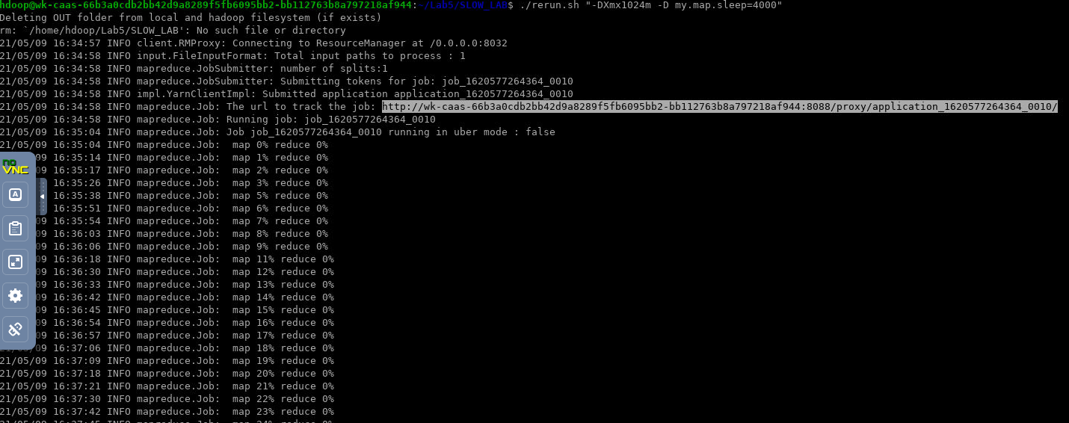

**Note: You can also url displayed to track the job and copy th JobId.**

1. Replace the *jobid* variable using the output from the previous command. NOTE: Wait till you see that the Job has started, before running thiscommand.

$ yarn application -list

$ yarn application -kill <**JobId**>

1. Reload the page to verify that the job no longer exists.

### Display job history

1. Open a browser and navigate to JobHistoryServer at port 19888:

###### <IP address>:19888

1. Scroll through the list and find the job using the **Id**, **Name**, and **User**. Click on the Id to view the job history.

**Lab 5.4: Test a MapReduce Application**

*Estimated time to complete: 45 minutes*

In this exercise, the code to test the mapper is already provided. You will follow that example to implement the reducer test.

Recall the VoterMapper map method emits the key-value pair: (party, age). For example, with input

"1,david davidson,20,socialist,369.78,5108" you should expect output (socialist, 20).

### Test the mapper against different input

1. Change to the VOTER_LAB directory.

###### $ cd /home/hdoop/Lab5/VOTER_LAB

1. View the mymaptest.dat file with the cat command. The first line of the file is the input record. The second line of the file is the output from the map method for the input.

###### $ cat mymaptest.dat

1. Test the map method against the test file – you should get a "success" message.

###### $ ./retest.sh map mymaptest.dat

1. Now edit the test file so that the input and expected output do not match:

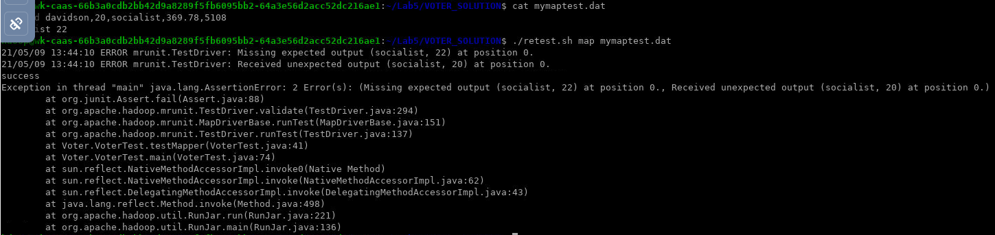

1. Test the map method against the test file – this time you should get an exception

###### $ ./retest.sh map mymaptest.dat

Lesson 5: Manage, Monitor, and Test MapReduce Jobs

**Implement code to test the reducer**

1. View the myreducetest.dat file with the cat command. The first line of the file is the input record (including the key and list of values). The second line of the file is the output from the reduce method for the associated input.

###### $ cat myreducetest.dat

1. Implement the TODO in the *VoterTest.java* file to write the unit test for the reducer.

### Build and execute the unit test for the reducer

1. Open the VoterReducer.java file to verify that only the key-value pair for the mean is emitted. This is because we are only examining the output for mean in our MRUnit test.

###### $ vi VoterReducer.java

1. Rebuild the jar file.

###### $ ./rebuild.sh

1. Run the reduce test against the input file.

###### $ ./retest.sh reduce myreducetest.dat

1. Make a change in the myreducetest.dat file so that the expected output intentionally does not match the expected output. Then retest the reduce method to see what the error looks like.

###### $ ./retest.sh reduce myreducetest.dat

**Lesson 5 Answer Key**

**Lab 5.1a – Run Terasort**

|  |  |  |
| --- | --- | --- |
| **Step** | **Instruction or Question** | **Solution** |
| 4a. | Is the number of mappers equal to the number of input files? | Yes, there are two of each. |
| 4b. | When would the number of map input records be different than the number of map output records? | If the map method is doing any sort of filtering (for example, dropping “bad” records). |
| 4c. | What does this imply about the terasort  application? | The terasort application does not use a combiner. |

Lesson 5: Manage, Monitor, and Test MapReduce Jobs

### Lab 5.1b – Use Custom Counters

|  |  |  |
| --- | --- | --- |
| **Step** | **Instruction or Question** | **Solution** |
| 2 | What character separates the keys from the values in the records? | The field separator character is a comma. |
| 3 | Which character is the value of the record tokenizing on? | A comma. |
| 5 | Based on the minimum, maximum, and mean values for voter ages, what do you conclude about the nature of the data set? | The minimum, maximum, and mean values for all parties (democratic, republican, green, etc.) are exactly the same. This is unlikely, and you should investigate to make sure your data is accurate. |
| 6a. | How many records have the wrong number of fields? | The sample data already has one record with the wrong number of fields; the instructions have you add another. |
| 6b. | How many records have a bad age field? | The sample data already has one record with a bad age field; the instructions have you add another. |
| 6c. | Does the total number of records, plus the total number of reduce input records, equal the total number of map input records? | Yes. |

# Lesson 6: Manage Performance

### Lab 6.3 De-Tune a Job and Measure Performance Impact

*Estimated time to complete: 30 minutes*

### Establish a baseline for CPU time

In this task, you will run the teragen and terasort MapReduce applications from the examples provided in the Hadoop distribution.

1. Create the lab directory.

###### $ mkdir /home/hdoop/Lab6

1. Run the teragen MapReduce application to generate 1,000,000 records.

###### $ hadoop jar /home/hdoop/hadoop-2.7.0/share/hadoop/mapreduce/hadoop-mapreduce-examples-2.7.0.jar teragen 1000000 /home/hdoop/Lab6/TERA_IN

1. Run the terasort application to sort those records you just created.

###### $ hadoop jar /home/hdoop/hadoop-2.7.0/share/hadoop/mapreduce/hadoop-mapreduce-examples-2.7.0.jar terasort –DXmx1024m –Dmapred.reduce.tasks=2 \

**/home/hdoop/Lab6/TERA_IN /home/hdoop/Lab6/TERA_OUT_1**

1. Determine the aggregate map phase run time of the job. Connect to the JobHistoryServer using the IP address of the node:

###### http://<IP address>:19888

1. Run it a few times more to establish a good baseline. Remove the output directory

/home/hdoop/Lab6/TERA_OUT_1 before each run. Here are some values for a few runs. Fill in the aggregate map phase run times for your runs, below the ones given in the table.

|  |  |  |  |
| --- | --- | --- | --- |
| **Run 1** | **Run 2** | **Run 3** | **Run 4** |
| 2m1s=121s | 2m30s=150s | 2m10s=130s | 1m55s=115s |
|  |  |  |  |

### Modify the configuration and determine impact

1. Run the terasort application to sort those records again, but this time with a modification in the job parameters.

###### $ hadoop jar /home/hdoop/hadoop-2.7.0/share/hadoop/mapreduce/hadoop-mapreduce-examples-2.7.0.jar terasort -DXmx1024m -Dmapred.reduce.tasks=2 \

**-Dio.sort.mb=1 /home/hdoop/Lab6/TERA_IN /home/hdoop/Lab6/TERA_OUT_2**

1. Connect to JobHistoryServer at port 19888.
2. Determine the aggregate time spent in the map phase.

Lesson 6: Manage Job Performance

1. Run it a few times more to establish a good test. Change the name of the output directory for each rerun. Here are some values for a few runs: below those, fill in the results for your runs.

|  |  |  |  |
| --- | --- | --- | --- |
| **Run 1** | **Run 2** | **Run 3** | **Run 4** |
| 7m13s=433s | 5m5s=305s | 5m49s=349s | 5m21s=321s |
|  |  |  |  |



**Note**: There is a significant difference in the sample times shown in this table between the first run and the rest of the runs. This is one reason we take several samples when benchmarking. Without a reason for this sample, statistically we would probably discard this outlier.

1. It appears that the change has impacted the amount of time spent in the map phase (which makes sense given we are changing the io.sort.mb parameter). Calculate the change in performance due to the modification. Here is the calculation with the sample numbers provided: perform the same calculation with your test numbers.
   * Average aggregate time, baseline (from step 4 in the previous section):

= (121 + 150 + 130 + 115) / 4 = 129 seconds

* + Average aggregate time, modified (not using outlier from Run 1):

= (305 + 349 + 321 ) / 3 = 325 seconds

* + Performance differential:

= (baseline - modified) / baseline )* 100

= ((129 – 325) / 129) * 100

= (-196 / 129) * 100 = -151%

In other words, the modified job performs 151% slower than the baseline (takes 151% longer). If the result is a positive number, then the modified job is faster than the baseline job.

# Launch Jobs and Advanced Hadoop MapReduce Applications

Lesson 7: Working with Data

# Lesson 7: Working with Data

### Lab 7.3: Run a MapReduce Program Using HBase as Source

*Estimated time to complete: 30 minutes*

In this exercise, you will create and populate a table in HBase to store the voter data from previous exercises. You will then run a MapReduce program to calculate the usual maximum, minimum, and mean values using data read from that table.

### Create an HBase Table Using importtsv

In this task, you will use the importtsv utility to create an HBase table using the tab-separated VOTER data we used in a previous lab. Log in to one of your cluster nodes to perform the steps in this task an use the hbase command to create an empty table in MapR-FS.

1. Log into terminal as hdoop.
2. Create a directory for this lab, and position yourself there.

###### $ mkdir /home/hdoop/Lab7

**$ cd /home/hdoop/Lab7**

1. Copy the source code for the lab from Desktop (run as root user):

###### $ cp –r /root/Desktop/apache-hadoop/Lab7/* /home/hdoop/Lab7

###### $ chown –R hdoop /home/hdoop/Lab7

1. Launch the HBase shell:

###### $ hbase shell

1. Create the table.

###### hbase> create '/home/hdoop/Lab7/myvoter_table', {NAME => 'cf1'},

**{NAME => 'cf2'}, {NAME => 'cf3'}**

1. Verify the file was created in MapR-FS.

###### hbase> quit

**$ ls -l /home/hdoop/Lab7/myvoter_table**

1. Use the importtsv utility to import the data into the HBase table.

###### $ hadoop jar /opt/mapr/hbase/hbase-1.1.1/lib/hbase-server-\ 1.1.1-mapr-1602.jar importtsv -Dimporttsv.columns=\

**HBASE_ROW_KEY,cf1:name,cf2:age,cf2:party,cf3:contribution_amount,\ cf3:voter_number /home/hdoop/Lab7/myvoter_table \**

**/home/hdoop/Lab7/VOTERHBASE_SOLUTION/myvoter.tsv**

Lesson 7: Working with Data

1. Use the hbase command to validate the contents of the new table.

###### $ echo "scan '/home/hdoop/Lab7/myvoter_table'" | hbase shell ROW COLUMN+CELL

**1 column=cf1:name, timestamp=1406142938710, value=david davidson**

**1 column=cf2:age, timestamp=1406142938710, value=49**

**1 column=cf2:party, timestamp=1406142938710, value=socialist**

**1 column=cf3:contribution_amount, timestamp=1406142938710, value=369.78**

**1 column=cf3:voter_number, timestamp=1406142938710, value=5108**

**10 column=cf1:name, timestamp=1406142938710, value=Oscar xylophone**

**. . . <output omitted>**

**1000000 row(s) in 1113.9850 seconds**

**Run the MapReduce Program to Calculate Statistics**

In this task, you will run your MapReduce program and then analyze the results.

1. Change directory to the location of the MapReduce program jar file.

###### $ cd /home/hdoop/Lab7/VOTERHBASE_SOLUTION

1. Run the MapReduce program.

###### $ java -cp /opt/mapr/hadoop/hadoop2.7.0/share/hadoop/common\

**hadoop-common-2.7.0-mapr-1602.jar:’hbase classpath’:VoterHbase.jar \ VoterHbase.VoterHbaseDriver /home/hdoop/Lab7/myvoter_table \**

**/home/hdoop/Lab7/OUT**

1. Analyze the results (min, max, and mean age).

###### $ cat /home/hdoop/Lab7/OUT/part-r-00000 democrat 18.0

**democrat 77.0**

**democrat 47.0**

**green 18.0**

**green 77.0**

**green 47.0**

**independent 18.0**

**independent 77.0**

**independent 47.0**

**libertarian 18.0**

**libertarian 77.0**

Lesson 7: Working with Data

###### libertarian 47.0

**republican 18.0**

**republican 77.0**

**republican 47.0**

**socialist 18.0**

**socialist 77.0**

**socialist 47.0**

# Lesson 8: Launching Jobs

### Lab 8.3: Write a MapReduce Driver to Launch Two Jobs

*Estimated time to complete: 30 minutes*

In this exercise, you will modify a MapReduce driver that launches two jobs. The first job calculates minimum, maximum, and mean values for the SAT verbal and math scores. The second job calculates the numerator and denominator for the Spearman correlation coefficient between the verbal and math scores. The driver then calculates the correlation coefficient by dividing the numerator by the square root of the denominator. The code for both MapReduce jobs has been provided.

### Pearson's Correlation Coefficient

This statistic is used to determine the level of dependence (or correlation) between two variables. The value of the coefficient ranges from -1 to +1, where:

• +1 means the variables are directly proportional (high positive correlation)

* 0 means there is no correlation between the variables
* -1 means the variables are inversely proportional (high negative correlation) The formula to calculate this coefficient is given here:

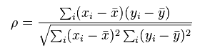

### Programming Objective

Let X represent the SAT verbal scores and Y represent the SAT math scores. The first MapReduce job calculates the mean values for X and Y, and the second MapReduce job calculates the numerator and the squared value of the denominator. The driver you write must configure and launch both jobs and then calculate the Spearman correlation coefficient.

### Copy Lab Files to Cluster

1. Create a directory for this exercise and position yourself in that directory.

###### $ mkdir /home/hdoop/Lab8

**$ cd /home/hdoop/Lab8**

1. Download the lab file to your cluster, and extract the zip file.

###### $ wget <http://course-files.mapr.com/DEV3000/DEV302-v5.1-Lab8.zip>

**$ unzip DEV302-v5.1-Lab8.zip**

Lesson 8: Launch Jobs

### Implement the TODOs and Run the Jobs

In this task, you will configure the WholeJobDriver.java file in the STATISTICS_LAB directory to configure and launch the two MapReduce jobs and then calculate the correlation coefficient.

1. Open the WholeJobDriver.java file with your favorite editor.

###### $ cd DEV302-v5.1-Lab8/STATISTICS_LAB

**$ vi WholeJobDriver.java**

1. Locate the TODO statements in the file, and make the changes necessary to address the instructions.
2. Save the file.
3. Compile the java file using whole_rebuild.sh, and run it using whole_rerun.sh. Your results should be as follows:

###### product_sumofsquares is 243128.0

**var1_sumofsquares is 259871.0**

**var2_sumofsquares is 289679.0**

**spearman's coefficient is 0.886130250066755**

You can examine the file STATISTICS_SOLUTION/WholeJobDriver.java if you need assistance.

# Lab 9: Streaming MapReduce

### Lab 9.3: Implement a MapReduce Streaming Application

*Estimated time to complete: 30 minutes*

In this exercise, you will implement a MapReduce streaming application using the language of your choice (Python or Perl). Guidance will be provided for building the application in the UNIX bash shell. We return to the RECEIPTS data set to calculate the minimum, maximum, mean and the years associated with the those values.

### Copy the Lab Files to Your Cluster

In this task, you will copy and extract the lab files for this exercise.

1. Create a directory for this exercise, and position yourself in that directory.

###### $ mkdir /home/hdoop/Lab9

**$ cd /home/hdoop/Lab9**

1. Download and extract the lab files:

###### $ wget <http://course-files.mapr.com/DEV3000/DEV302-v5.1-Lab9.zip>

**$ unzip DEV302-v5.1-Lab9.zip**

**Implement the Mapper**

Implement the mapper in the language of your choice (Python or Perl) based on the following bash shell implementation of the same logic:

###### #!/bin/bash

**while read record do**

**year=`echo $record | awk '{print $1}'` delta=`echo $record | awk '{print $4}'` printf "summary\t%s_%s\n" "$year" "$delta"**

**done**

**Implement the Reducer**

Implement the reducer in the language of your choice (Python or Perl) based on the following bash shell implementation of the same logic:

###### #!/bin/bash –x count=0

**sum=0**

**max=-2147483647 min=2147483647**

Lesson 9: Using Non-Java Languages for MapReduce Applications

###### minyear="" maxyear="" while read line do

**value=`echo $line | awk '{print $2}'` if [ -n "$value" ]**

**then**

**year=`echo $value | awk -F_ '{print $1}'` delta=`echo $value | awk -F_ '{print $2}'`**

**fi**

**if [ $delta -lt $min ] then**

**min=$delta minyear=$year**

**elif [ $delta -gt $max ] then**

**max=$delta maxyear=$year**

**fi**

**count=$(( count + 1 )) sum=$(( sum + delta ))**

**done**

**mean=$(( sum / count ))**

**printf "min year is %s\n" "$minyear" printf "min value is %s\n" "$min" printf "max year is %s\n" "$maxyear" printf "max value is %s\n" "$max" printf "sum is %s\n" "$sum"**

**printf "count is %s\n" "$count" printf "mean is %d\n" "$mean"**

**Launch the Job**

1. Modify the receipts_driver.sh script to match the paths to your language choice (Python or Perl), naming convention, and locations for input and output.

###### #!/usr/bin/env bash USER=`whoami`

**# 1) test map script**

**echo -e "1901 588 525 63 588 525 63" | ./receipts_mapper.sh | od –c**

**# 2) test reduce script**

**echo -e "summary\t1901_63" | ./receipts_reducer.sh | od –c**

**# 3) map/reduce on Hadoop**

**export JOBHOME=/user/$USER/9/STREAMING_RECEIPTS**

**export CONTRIB=/opt/mapr/hadoop/hadoop-0.20.2/contrib/streaming export STREAMINGJAR=hadoop-*-streaming.jar**

**export THEJARFILE=$CONTRIB/$STREAMINGJAR**

**rm -rf $JOBHOME/OUT**

Lesson 9: Using Non-Java Languages for MapReduce Applications

###### hadoop1 jar $THEJARFILE \

|  |  |  |
| --- | --- | --- |
|  | **-mapper 'receipts_mapper.sh' \** |  |
| **-file receipts_mapper.sh \** |
| **-reducer 'receipts_reducer.sh' \** |
| **-file receipts_reducer.sh \** |
| **-input $JOBHOME/DATA/receipts.txt** | **\** |
| **-output $JOBHOME/OUT** |  |
| 2. | Launch the MapReduce streaming job.  **$ ./receipts_driver.sh** |  |
| 3. | Examine the output. |  |

**$ cat /home/hdoop/Lab9/OUT/part-r-00000**

**min year is 2009**

**min value is -1412688 max year is 2000**

**max value is 236241 sum is -10418784**

**count is 111**

**mean is -93862**