# Snap2

# apex-round-128.pdf

# **Oracle Application Express: Developing Database Web Applications**

# **Hands-On-Labs Guide**

# **Unit 11: Implementing Navigation in your Application**

This hands-on lab includes two sections. In HOL 11-1, you implement navigation in the Demo Projects application.

Breadcrumbs are very common within Web applications to allow users to easily traverse from the current page to a parent page. Use of the Back button is discouraged within Web applications, as this operation may display old ("stale") information to the user. This hands-on lab covers updating the breadcrumb entries for the following pages:

* Demo Proj Team Members
* Demo Projects
* Demo Proj Milestones
* Demo Proj Tasks

The Navigation Menu is defined as a list within Shared Components. In this hands-on lab, you update the Navigation Menu entries, and include icons for each entry.

Oracle APEX enables you to create applications that integrate data from local Oracle Database tables and remote data sources. These remote data sources can be simple HTTP data feeds, and also OAuth2 or Basic Authentication–protected resources, REST services provided by Oracle REST Data Services, or even Oracle cloud applications (SaaS) REST services. In HOL 11-2, you build application that uses the iTunes Search API, which makes a request via HTTP, returns the results in JSON, and parses the results before further manipulating the results via SQL postprocessing.

## **HOL 11-1: Implementing Navigation in your Application**

In this hands-on lab, you update breadcrumb entries for the pages in the Demo Projects application. You also update the Navigation Menu entries and add icons for each entry.

1. Navigate to **App Builder** and run the **Demo Projects** application.  
   In the navigation menu, click **Demo Proj Team Members**.  
   In the Developer Toolbar, click **Edit Page 2**.
2. Update the page properties from Demo Proj Team Members to Team Members. In the Property Editor:

* Identification: Name - enter **Team Members**
* Identification: Title - enter **Team Members**Click **Save**.  
    
  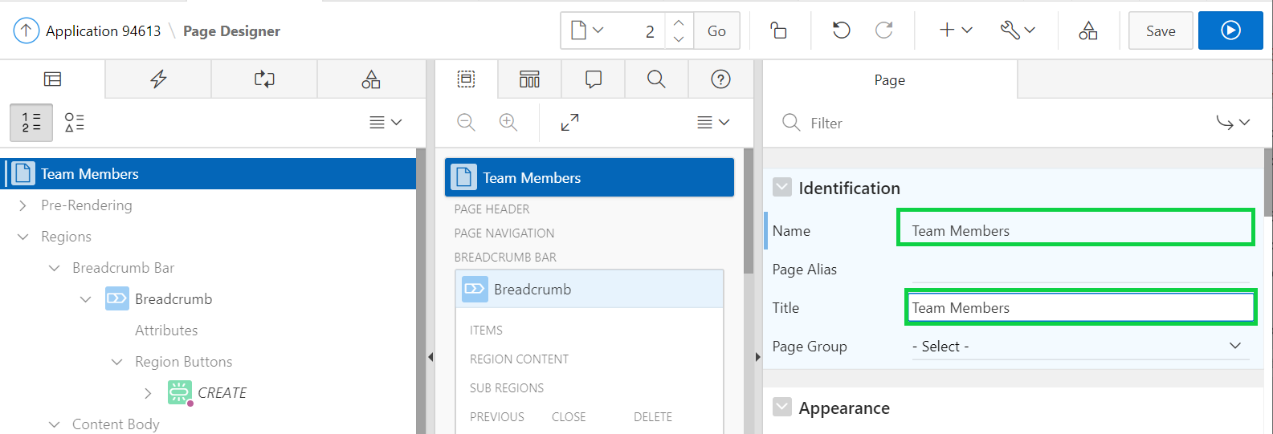

1. Update the breadcrumb entry for the page.  
     
   a) In the Rendering tree, click the **Page Shared Components** tab.  
     
   b) Expand the Breadcrumbs node and click the **Breadcrumb** entry.  
     
   c) In the Property Editor, click the **Edit Component** button.  
     
   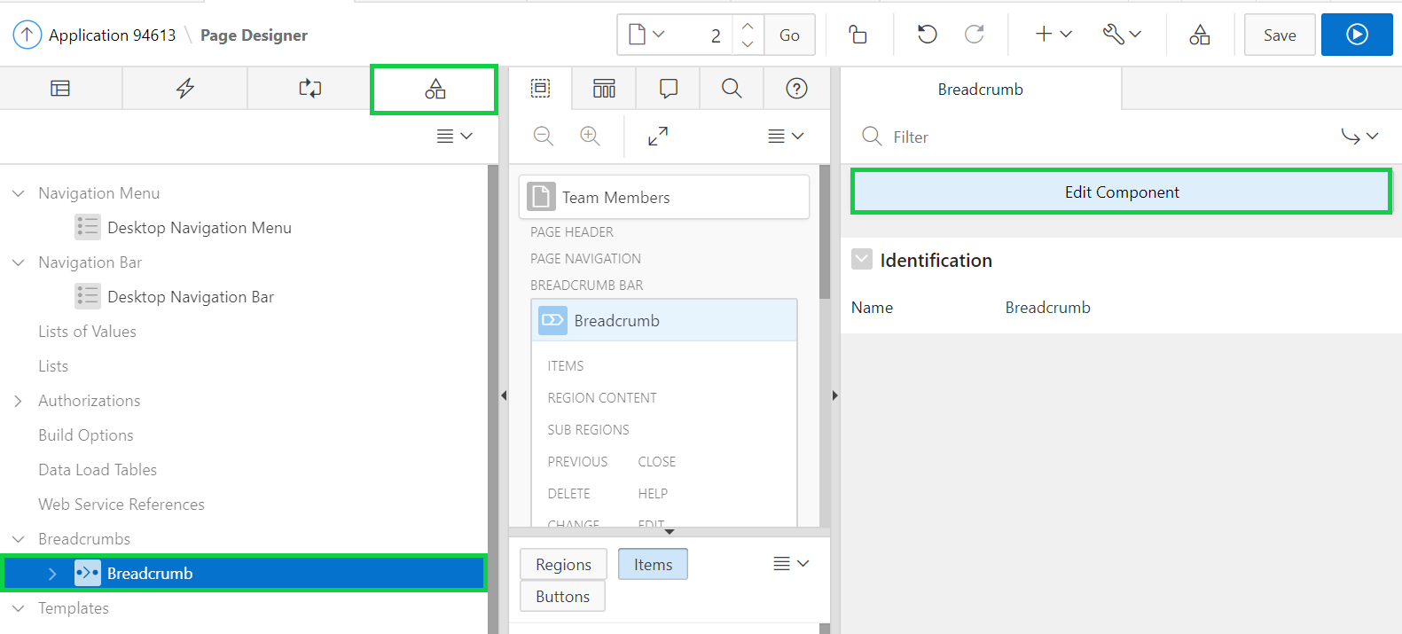
2. Click **DEMO_PROJ_TEAM_MEMBERS** in the breadcrumb entry.
3. For Short Name, enter **Team Members**, and click **Apply Changes**.  
     
   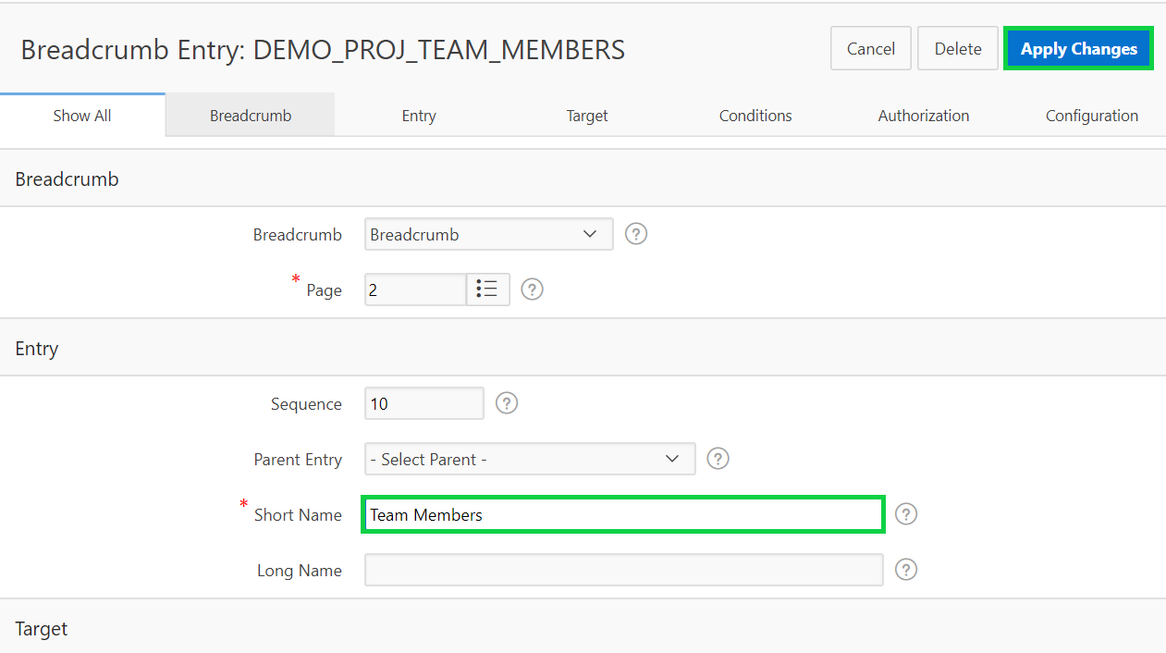
4. To return to page designer, on the toolbar, click **Edit Page 2**.  
     
   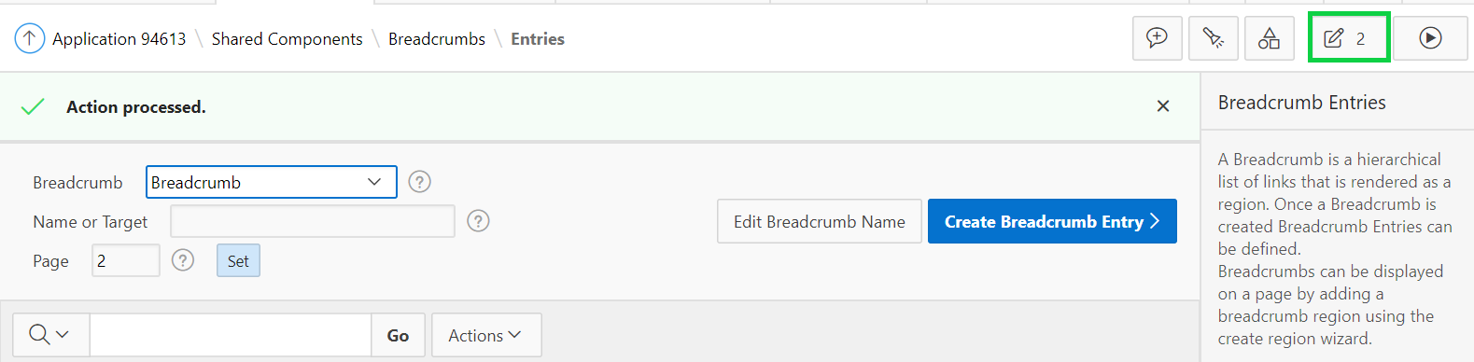
5. The navigation menu is still displayed as Demo Proj Team Members. Update the Navigation Menu entries and include icons for each entry.  
   In the page designer, click Shared Components icon in the toolbar (not the page shared components).  
     
     
   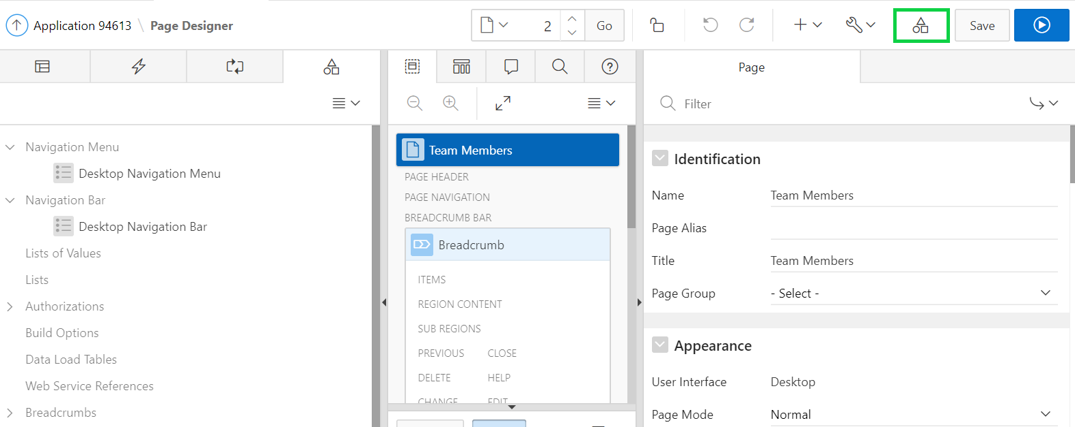
6. Under Shared Components, locate Navigation and click **Lists**.  
     
     
   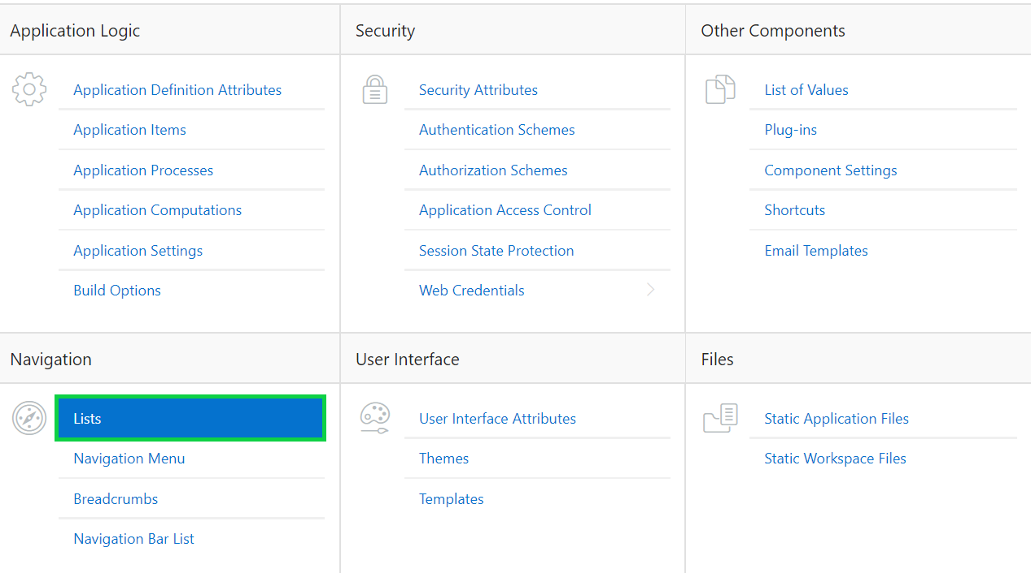
7. In the Lists report, click **Desktop Navigation Menu**.  
     
   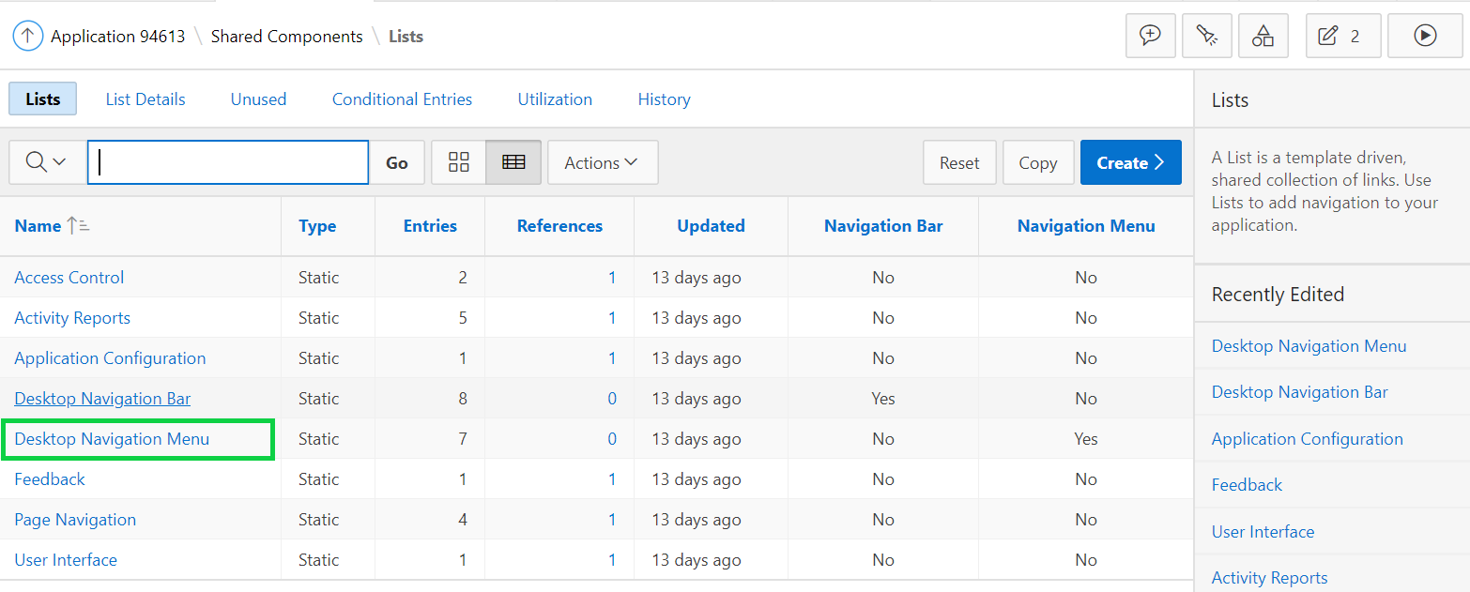
8. Click **DEMO_PROJ_TEAM_MEMBERS**.  
     
   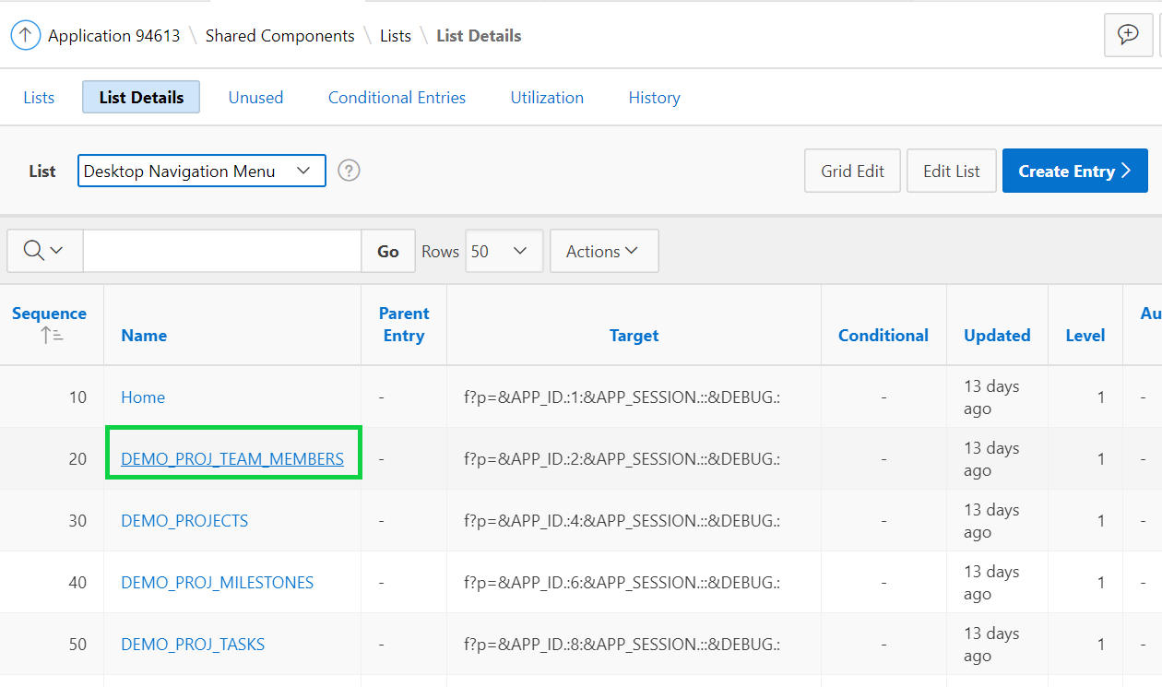
9. On the **DEMO_PROJ_TEAM_MEMBERS** list entry, locate the Image/Class item. Click at the end of the field to display a list of images.  
     
   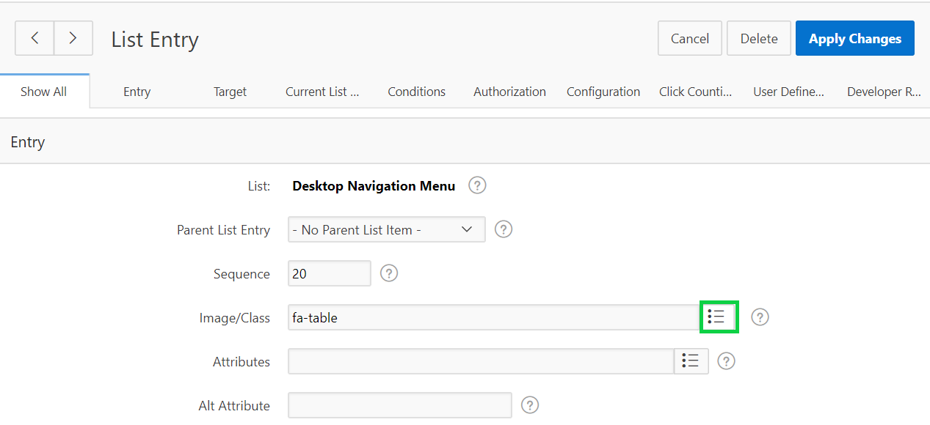
10. Review the library of images, provided by Font APEX. These images can be utilized throughout the application to improve aesthetics, and provide a visual indicator, rather than just text.  
    Locate and select **fa-users**.  
    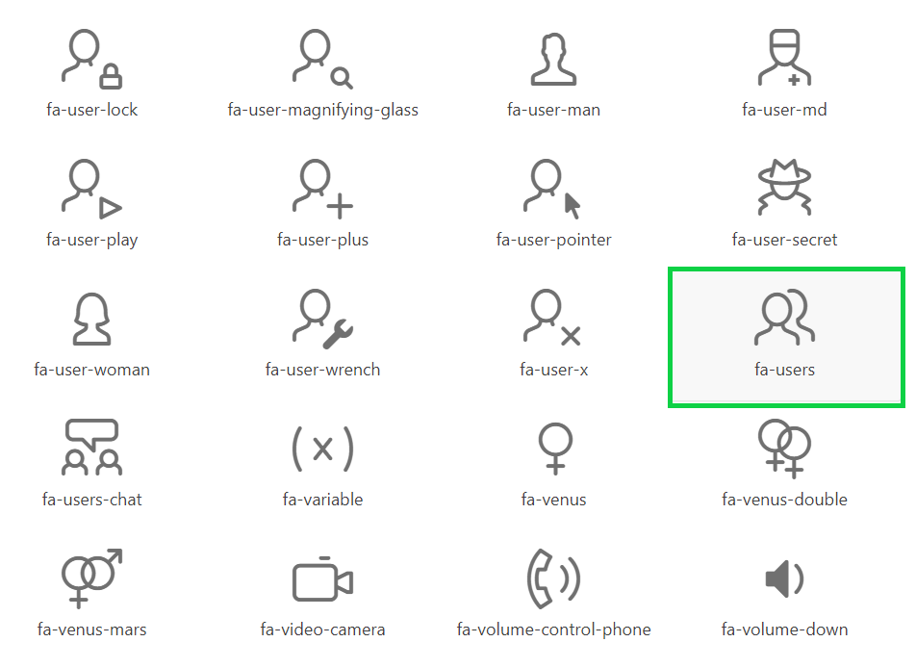
11. For List Entry Label enter **Team Members**.  
    Click the **Next** button (>).  
      
    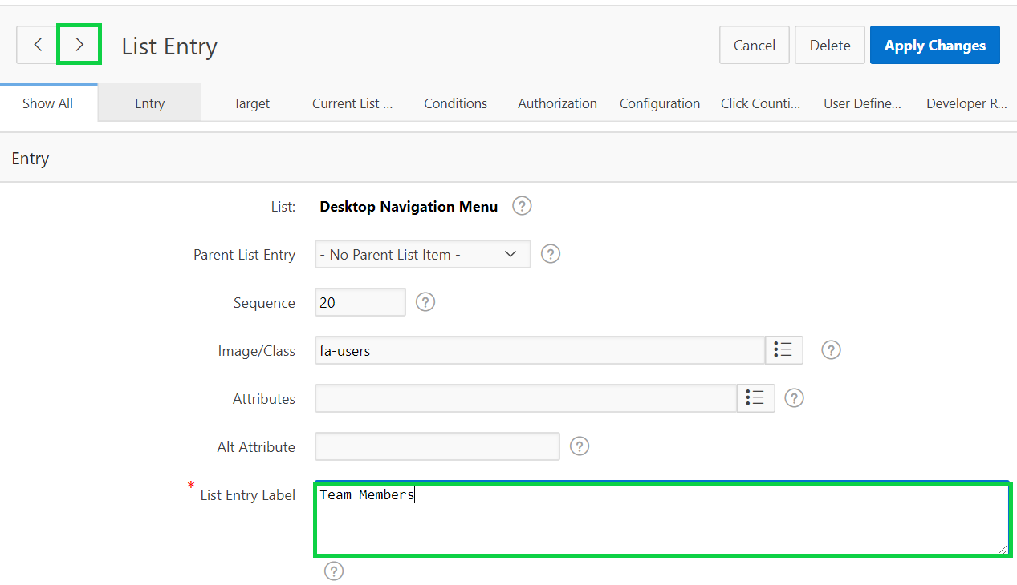
12. On the **DEMO_PROJECTS** list entry, for Image/Class enter **fa-folder**, and for List Entry Label enter **Projects**.  
    Click the **Next** button (>).  
    **Note**: You can simply type in the image name, such as **fa-folder**, directly into the Image/Classs field, rather than bringing up the library of images.
13. On the **DEMO_PROJ_MILESTONES** list entry, for Image/Class enter **fa-flag**, and for List Entry Label enter **Milestones**.  
    Click the **Next** button (>).
14. On the **DEMO_PROJ_TASKS** list entry, for Image/Class enter **fa-check-square-o**, and for List Entry Label enter **Tasks**.  
    Click **Apply Changes**.  
      
    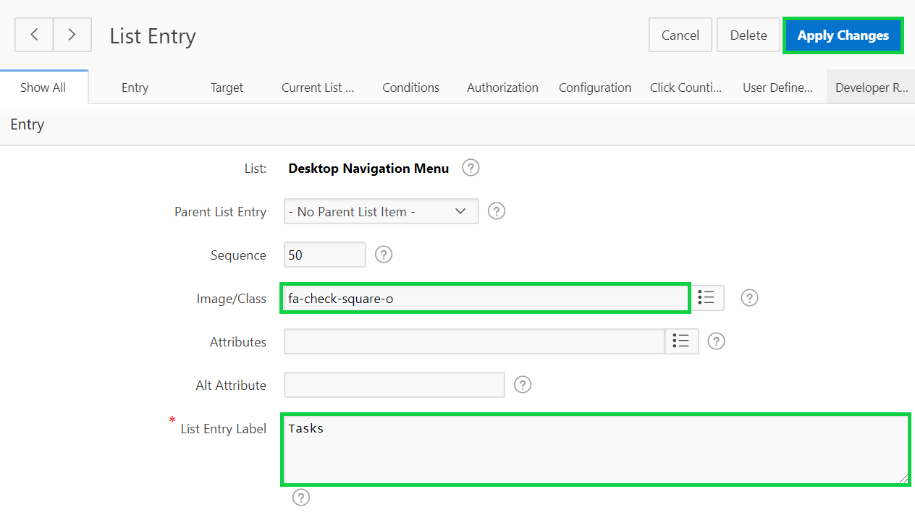
15. Click **Run** on the toolbar to see the updated navigation menu.  
    You still need to update the icon for Dashboard.  
    Navigate to **Shared Components > List Details** page and click **Dashboard**.  
      
    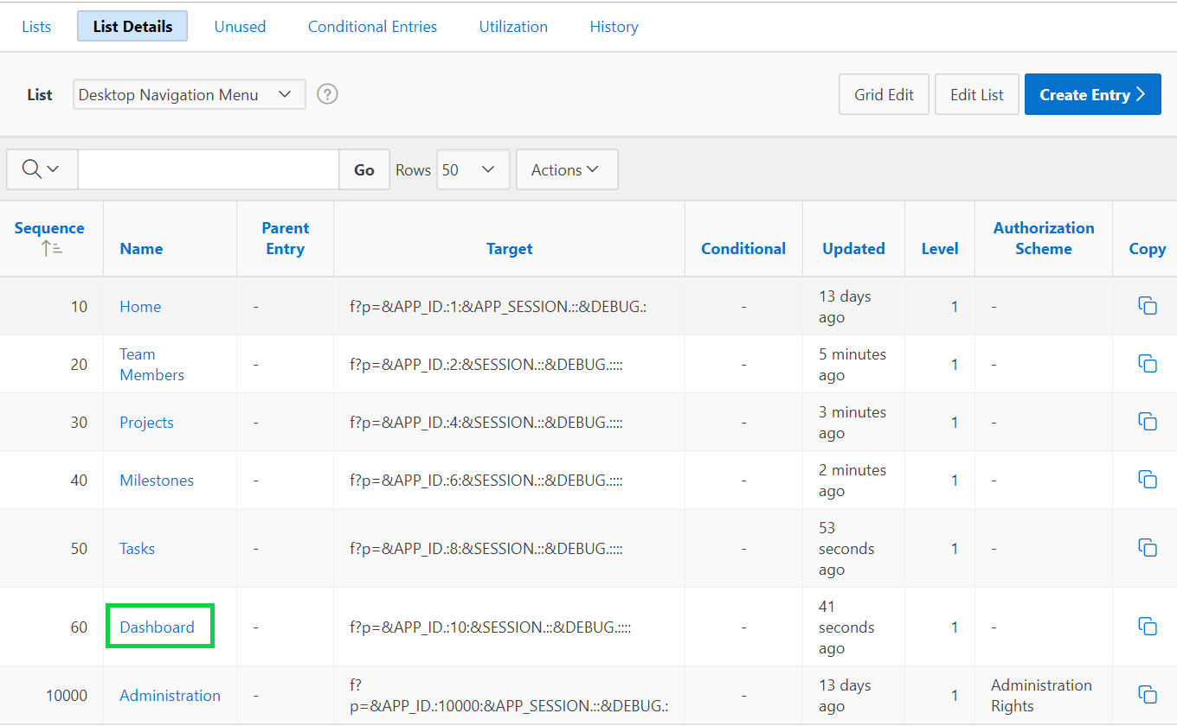
16. For Image/Class enter **fa-dashboard**.  
    Click **Apply Changes**.
17. Click **Run** on the toolbar to see the updated navigation menu.  
      
    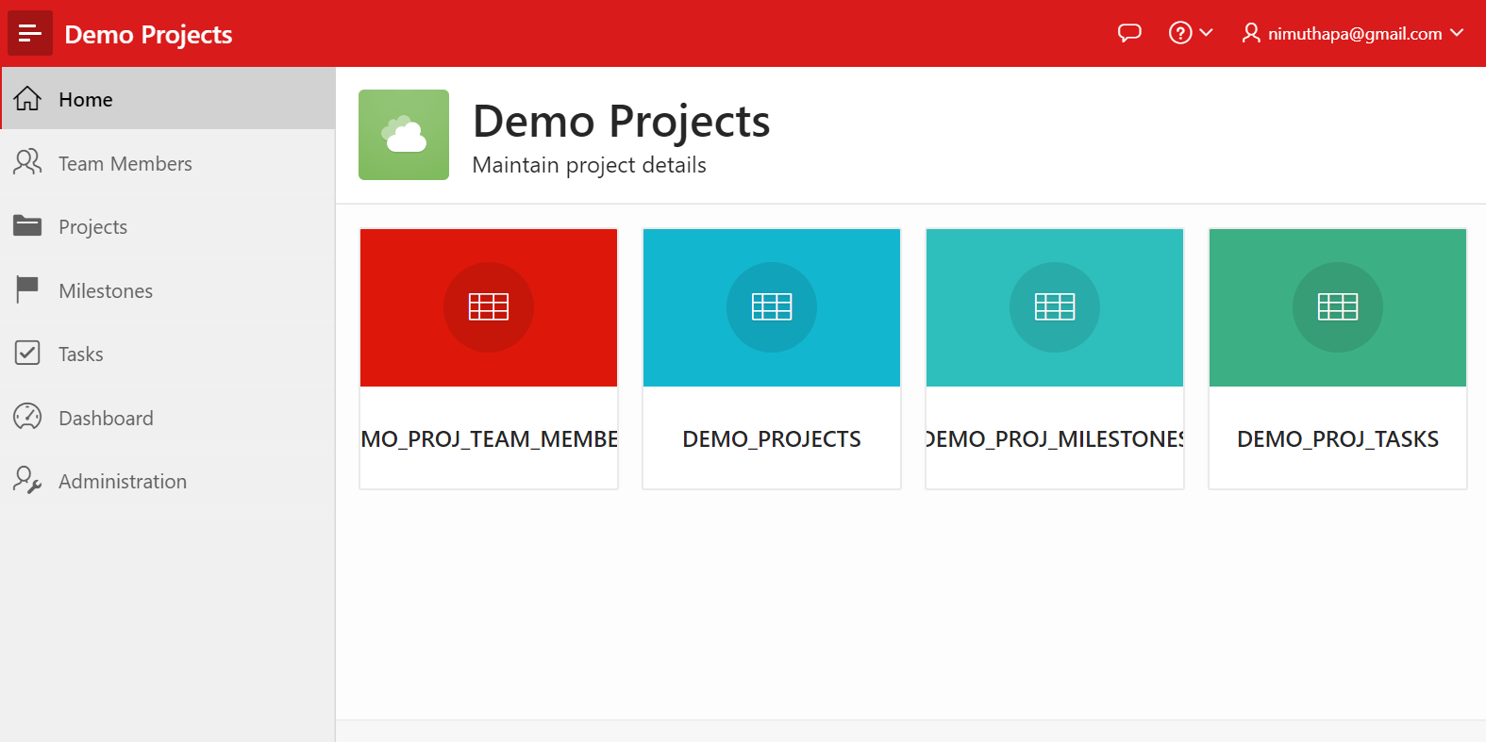
18. In step 3 above, you updated the breadcrumb entry for Team Members page. Now, update the breadcrumb entries for all of the remaining pages. Perform the following steps:  
      
    a) In the Developer Toolbar, click **Edit Page 1**.  
      
    b) Click **Shared Components**.  
      
    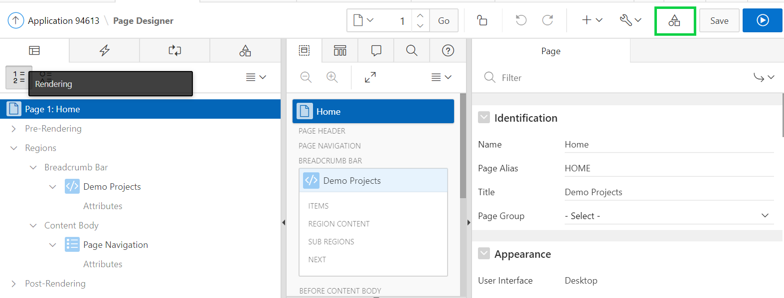  
      
    c) Under Navigation, click **Breadcrumbs**.  
      
    d) Click **Breadcrumb**.  
      
    e) Now, click **DEMO_PROJECTS**.  
      
    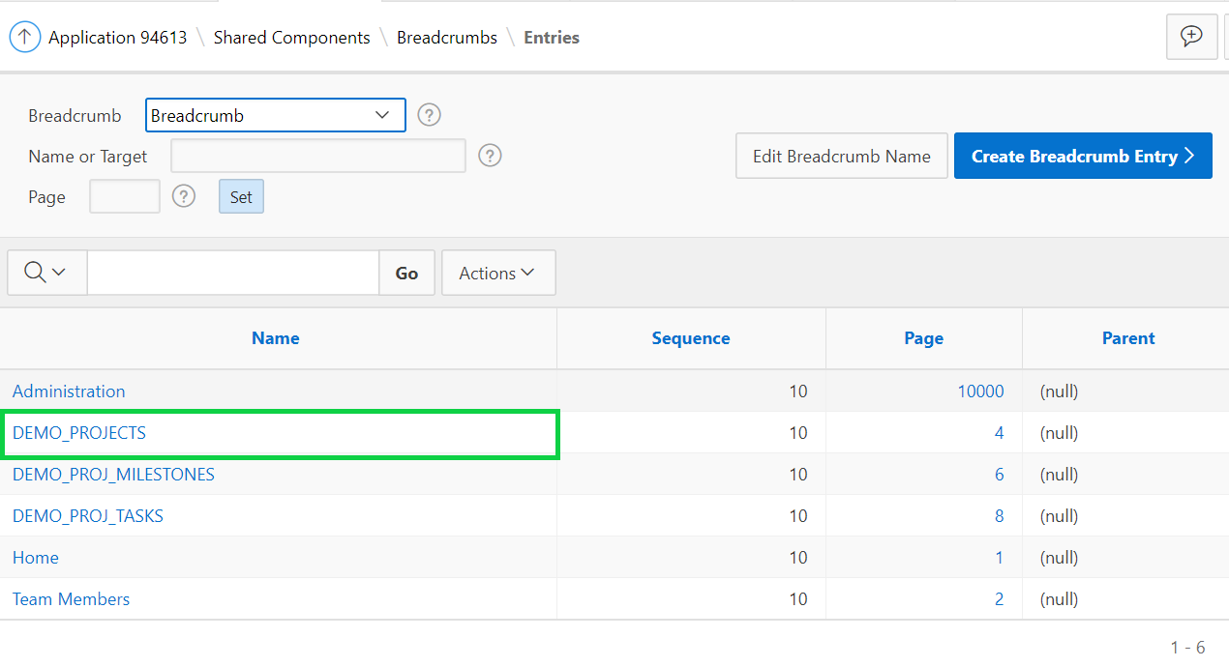  
    f) Enter **Projects** for Short Name and click **Apply Changes**.  
      
    g) Then, click **DEMO_PROJ_MILESTONES**.  
      
    h) Enter **Milestones** for Short Name and click **Apply Changes**.  
      
    i) Click **DEMO_PROJ_TASKS**.  
      
    j) Enter **Tasks** for Short Name and click **Apply Changes**.
19. Click **Run** on the toolbar.  
      
    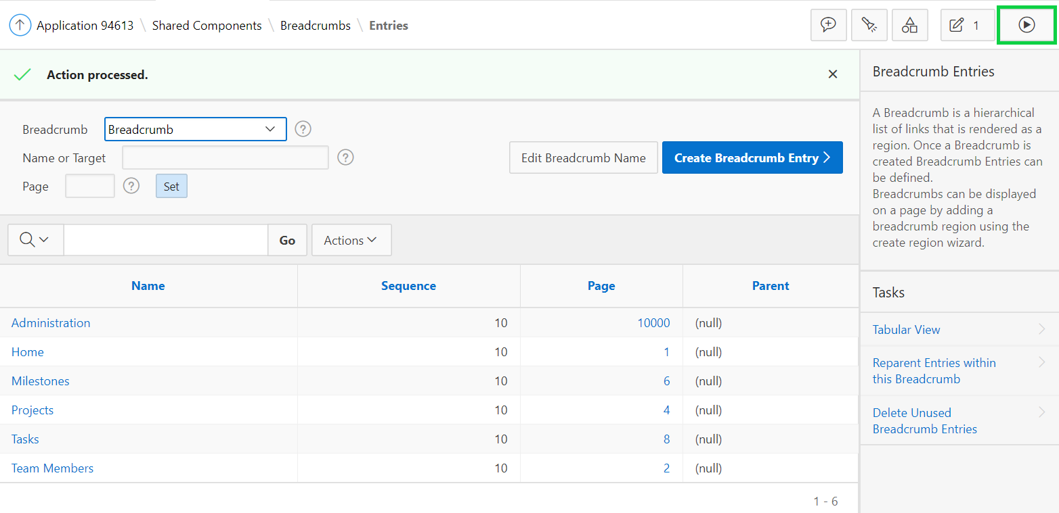
20. Click each of the pages: Projects, Milestones and Tasks to see the updated region titles.
21. Now, update the page properties and the breadcrumb entry for the Projects page. In the navigation menu, click **Projects**.  
      
    In the Developer Toolbar, click **Edit Page 4**.
22. In the Property Editor:

* Identification: Name - enter **Projects**
* Identification: Title - enter **Projects**  
  Click **Save**.

1. Now, update the page properties for the Demo Proj Milestones page.  
   In the navigation menu, click **Milestones**.  
   In the Developer Toolbar, click **Edit Page 6**.
2. In the Property Editor:

* Identification: Name - enter **Milestones**
* Identification: Title - enter **Milestones**  
  Click **Save**.

1. Now, update the page properties and the breadcrumb entry for the Demo Proj Tasks page. In the navigation menu, click **Tasks**.  
   In the Developer Toolbar, click **Edit Page 8**.
2. In the Property Editor:

* Identification: Name - enter **Tasks**
* Identification: Title - enter **Tasks**  
  Click **Save**.

1. Now, run the application. You need to update the Home page. Click **Edit Page 1** in the Developer Toolbar.  
     
   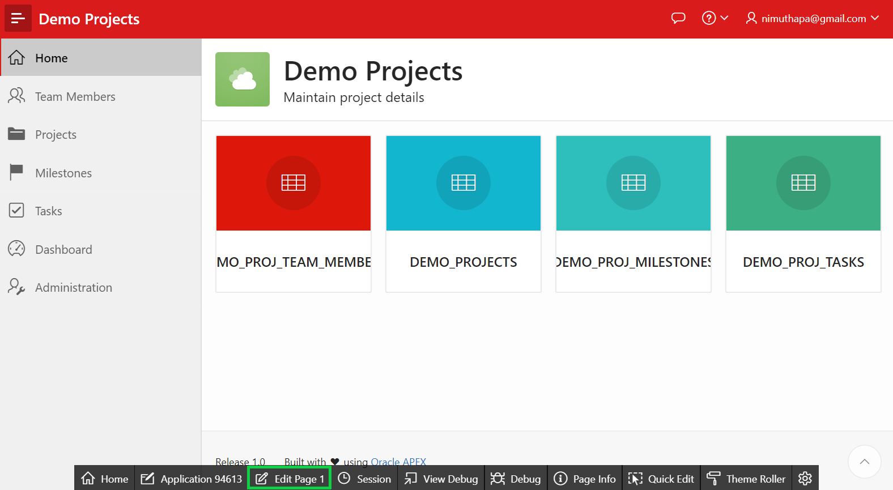
2. In the Page Designer, click **Page Shared Components**.  
     
   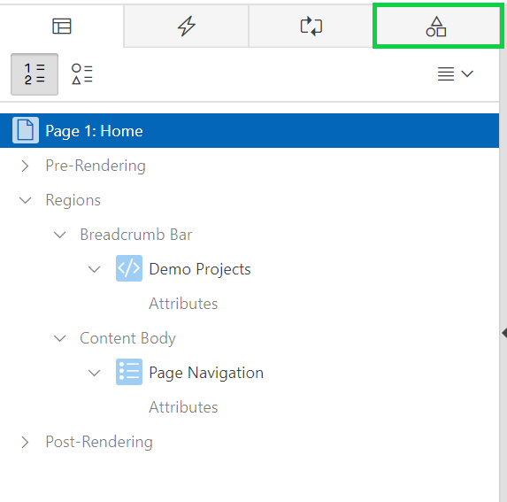
3. Expand **Lists** and click **Page Navigation**.
4. In the Property Editor, click **Edit Component**.  
     
   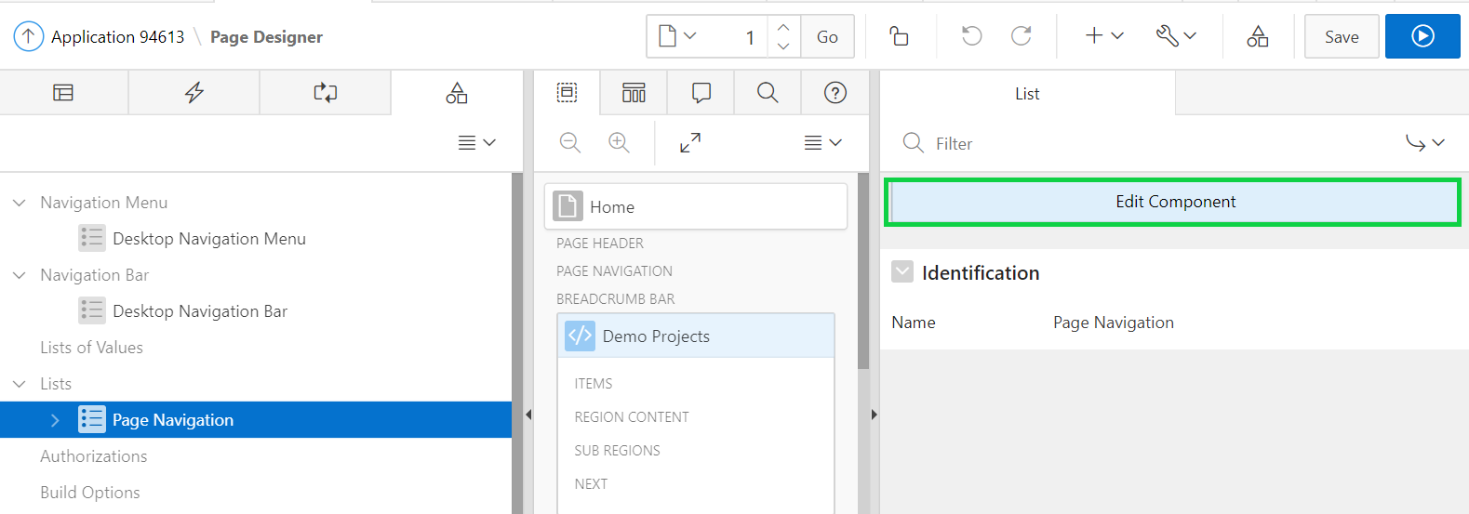
5. Now, you need to edit each of the list entries. First, click **DEMO_PROJ_TEAM_MEMBERS**.  
     
   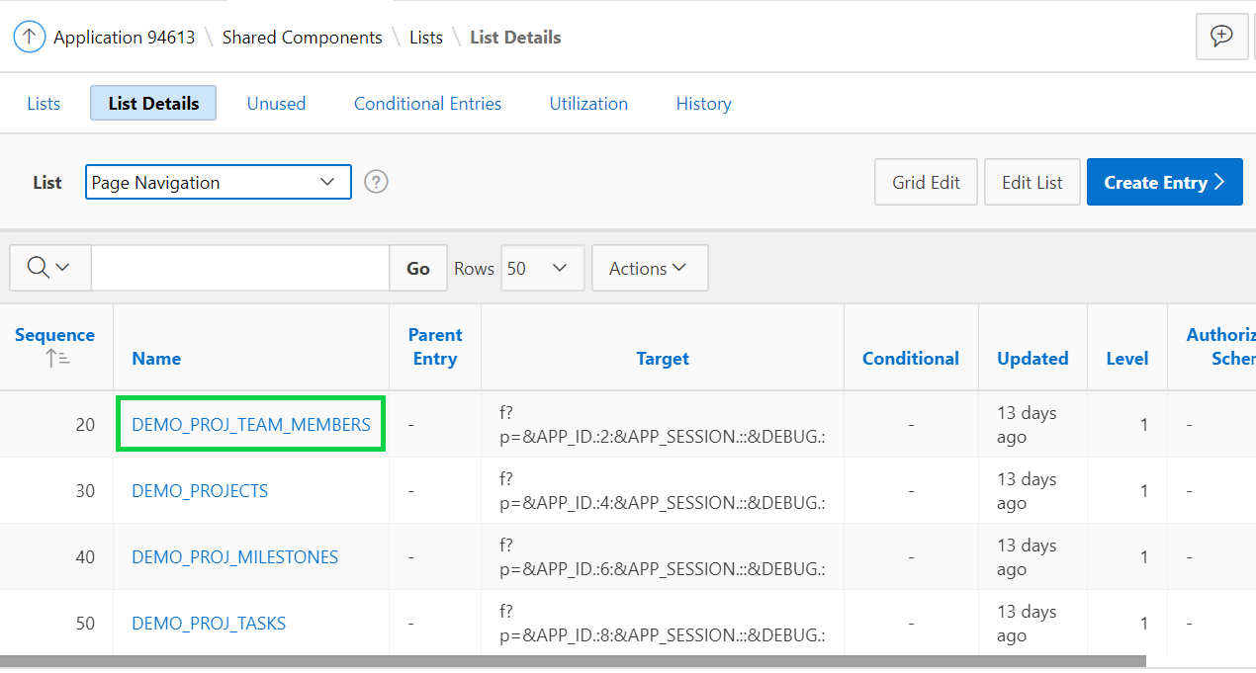
6. Replace the text in the List Entry Label with **Team Members** and click **>**.  
     
   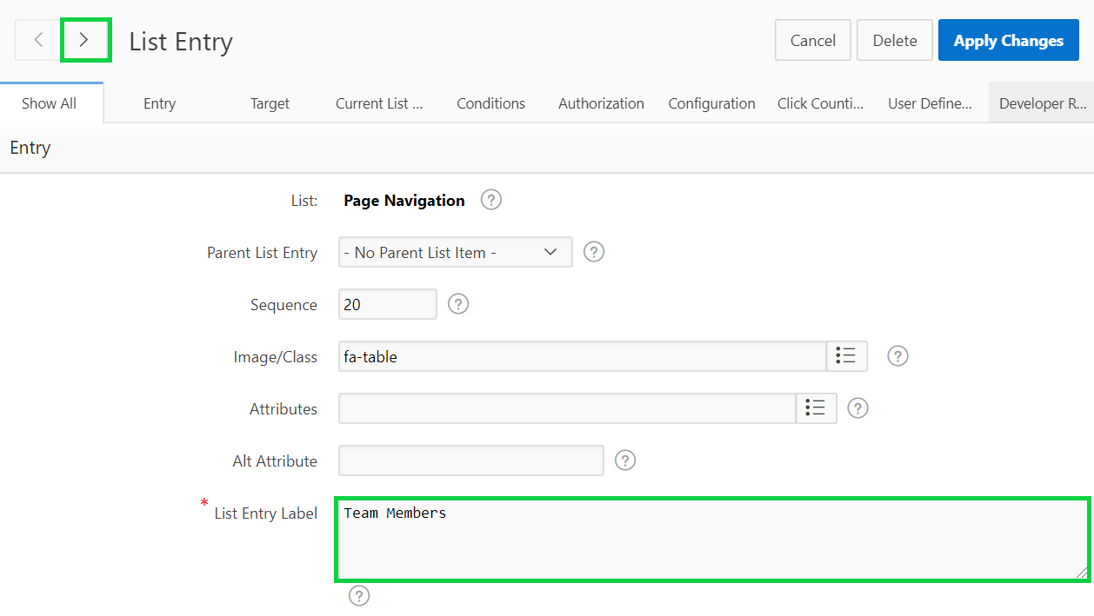
7. Replace the text in the List Entry Label with **Projects** and click **>**.
8. Replace the text in the List Entry Label with **Milestones** and click **>**.
9. Replace the text in the List Entry Label with **Tasks** and click **Apply Changes**.
10. Click **Run Page 1** icon on the toolbar to see the updated Home page.  
      
    A screenshot of a cell phone

    Description automatically generated

## **HOL 11-2: Integrating Application Data from Remote Data Sources**

Oracle APEX allows you to build powerful, feature-rich applications against remote, web, and REST data sources. In this lab, you build a web application on top of the Apple iTunes Search API, which is a simple API over HTTP that takes input arguments via parameters in the URL. First, you create a report against the iTunes music video catalog. Next, you simplify the report to include a preview of the music video and a link to watch a clip of the music video.

1. Navigate to **App Builder** and click **Create**.
2. Click **New Application**.
3. Enter **APEX and REST** for Name and click **Create Application**.
4. In the Application home page, click **Shared Components**.
5. Under **Data Sources**, click **Web Source Modules**.  
     
   A screenshot of a cell phone

   Description automatically generated
6. Click **Create**.  
     
   A screenshot of a cell phone

   Description automatically generated
7. Select **From Scratch** and click **Next**.
8. For Web Source Type accept the default selection of **Simple HTTP**. Enter **iTunes Search** for Name, and for URL End Point, copy and paste the URL **https://itunes.apple.com/search** Click **Next**.  
     
   A screenshot of a cell phone

   Description automatically generated
9. Oracle APEX parses the into its Base URL and Service URL path.   
   Click **Next**.  
     
   A screenshot of a cell phone

   Description automatically generated
10. You do not need authentication for this API. Accept the default selection of **No** and click **Advanced**.  
      
    A screenshot of a cell phone

    Description automatically generated
11. For Parameters, select the following and click **Discover**.

* Parameter Type: **Query String Variable**, Parameter Name: ***term***, Value: ***beyonce***, Is Static: **No**
* Parameter Type: **Query String Variable**, Parameter Name: ***entity***, Value: **musicVideo**, Is Static: **Yes**A screenshot of a cell phone

  Description automatically generated

1. Oracle APEX invokes the REST API and attempts to parse the results and creates a data profile. Click the **Data Profile** subtab to view the entities parsed from the JSON result and see how they will be mapped to specific column names and data types.   
     
   A screenshot of a cell phone

   Description automatically generated
2. Click **Create Web Source**.  
     
   A screenshot of a cell phone

   Description automatically generated
3. Click the **Application <n>** breadcrumb.  
     
   A screenshot of a cell phone

   Description automatically generated
4. Click **Create Page**.
5. Click **Report**. Then, click **Classic Report**.
6. Enter iTunes for Page Name and click **Next**.
7. Select **Create a new navigation menu entry** and click **Next**.
8. For Data Source, select **Web Source**. Then select **iTunes Search** for Web Source Module. Click **Create**.  
     
   A screenshot of a cell phone

   Description automatically generated
9. Click **Create**.  
     
   A screenshot of a cell phone

   Description automatically generated
10. You are now in the page designer. Click **Save and Run Page**. Log in to the application using your Workspace Username and Password.   
    Your screen should look like:  
      
    A screenshot of a computer

    Description automatically generated  
      
    In the Developer Toolbar, click **Edit Page <n>**.
11. Under Rendering, select **Report1**.  
    In the Property Editor, for Local Processing, select **SQL Query**.  
      
    A screenshot of a cell phone

    Description automatically generated
12. In the SQL Query region, replace the existing SQL with the following SQL:

**select ARTISTNAME,**

**TRACKNAME,**

**PREVIEWURL,**

**ARTWORKURL100,**

**COLLECTIONPRICE,**

**RELEASEDATE,**

**COUNTRY,**

**CURRENCY**

**from #APEX$SOURCE_DATA#**  
  
1. In the Property Editor, under Appearance, select **Blank with Attributes** for Template.  
     
   A screenshot of a cell phone

   Description automatically generated
2. Under Rendering, navigate to Report1 and expand **Columns**.
3. Select each of the columns and adjust their corresponding Heading in the property editor.

* ARTISTNAME: Artist
* TRACKNAME: Track
* COLLECTIONPRICE: Price
* RELEASEDATE: Release Date  
    
  A screenshot of a social media post

  Description automatically generated

1. Select **CURRENCY** and in the Property Editor, under Identification > Type, select **Hidden Column**.
2. Select **ARTWORKURL100** and in the Property Editor, under Identification > Type, select **Hidden Column**.  
     
   A screenshot of a social media post

   Description automatically generated
3. Select the PREVIEWURL column. In the property editor, for Heading, replace the existing text with **Preview**.   
   Under Identification > Type, select **Link**.  
     
   A screenshot of a social media post

   Description automatically generated
4. In the property editor, navigate to Link region and click **No Link Defined** for Target.   
     
   A screenshot of a cell phone

   Description automatically generated
5. In the Link Builder – Target dialog, select **URL** for Type.   
   In the URL attribute, enter **#PREVIEWURL#**. This will create an HTML anchor to the value of the Preview URL returned in the REST results.   
   Click **OK**.  
     
   A screenshot of a cell phone

   Description automatically generated
6. For Link Text, enter **<img src="#ARTWORKURL100#"/>**. This will display the image returned in the value of the Artwork column in the REST results.
7. For Link Attributes, enter **target="_new"**. This will cause the video preview to open in a new browser tab when clicked.  
     
   A screenshot of a cell phone

   Description automatically generated
8. Under Rendering, navigate to Report1 > Columns and select **COLLECTIONPRICE**. In the property editor, for Column Formatting > HTML Expression enter **#COLLECTIONPRICE# #CURRENCY#**.  
     
   A screenshot of a cell phone

   Description automatically generated
9. Click **Save and Run Page**.
10. Your application now includes a much-better-looking report, with an image of the video preview. Additionally, if you click the image, it should open a new tab in your browser and start playing the video.

