# Part 1 - Minimum Hardware Requirements

* 64-bit x86 CPU that supports hardware virtualization (Intel-VT or AMD-V).
* Hardware virtualization enabled in the BIOS.
* 3 GB RAM
* 15 GB in the hard disk
* Access to Internet

# Part 2 - Minimum Software Requirements

* Windows 7 (Professional, Enterprise, or Ultimate)
* The following updated web browsers:

𝖮 Chrome

𝖮 Firefox

𝖮 Internet Explorer

* Adobe Acrobat Reader
* Zip extraction utility
* VMWare player
* Apache Maven *
* Eclipse *
* Jenkins *
* GIT *
* JDK *
* Node 6.9.5 *

* - indicates software provided as part of the courseware.

# Part 3 - Software Provided

None. All must be downloaded

# Part 4 - Instructions

## 1. Make sure the account that you are using to install the software has administrative privileges and the student using this machine will have the same rights.

2. Extract and install everything directly to **C:\**

3. Review that the following folders were created:

## C:\LabFiles

## C:\Software\apache-maven-3.3.9

## C:\Software\eclipse

4. Review that the following files were created:

## C:\Software\Git-2.8.1-32-bit.exe

## C:\Software\jdk-8u45-windows-i586.exe

## C:\Software\jenkins-2.89.3-Windows\jenkins.msi

## C:\Software\node-v6.9.5\node-v6.9.5-x86.msi

5. Create the **C:\Workspace** folder.

6. Log in using an administrator user to install the software in the following steps.

7. Make sure **C:\LabFiles (this is on the github), C:\Software** folders are not ready only.

# Part 5 - Installing JDK 8 Update 45

1. Make sure there is no previous Java version already installed on the system. You can check this by using the Windows “Add/Remove Programs” utility. For the best compatibility with the labs it is suggested that all previous versions of Java be uninstalled before proceeding with these instructions. If this is an issue, please contact the setup support person for the course.

2. From the **C:\Software** directory run the following file:

**jdk-8u45-windows-i586**

**Note:** If using prompted by a security prompt allow the installation to continue.

3. When the initial step of the setup appears, press the **Next** button.

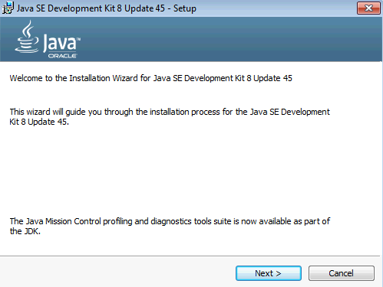

4. Leave the defaults for installation location and options, and press the **Next** button.

**Note:** The installation directory may be slightly different.

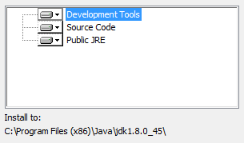

The installation will begin installing files.

5. The Destination Folder will appear, leave the default folder and click **Next**.

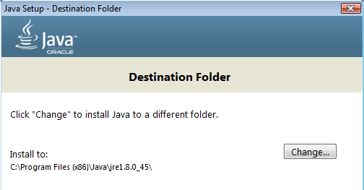

**Note:** The installation directory may be slightly different.

Wait until the software is completely installed.

6. Click **Close**.

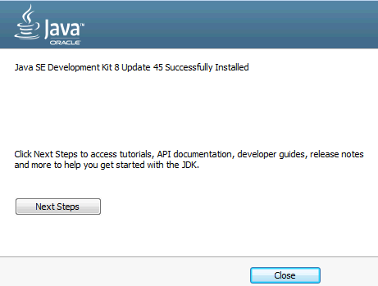

7. Close any browser that appears asking to register the JDK software.

### Set the Environment variables.

1. Open a Command Prompt. You can do this with '**Start → Programs → Accessories → Command Prompt**'.

2. Use the 'cd' command to attempt to switch to the following directory. This will verify the presence of a directory used later so make sure you do not get any errors about not being able to “find the path specified”.

**cd C:\Progra~2\Java\jdk1.8.0_45**

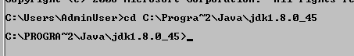

**Note:** The installation directory may be slightly different depending your operating system. You may need to use the following directory instead of the one listed above:

**C:\Progra~1\Java\jdk1.8.0_45**

Some of the remaining steps will use the slightly different directory.

3. Make sure you can reach the java folder and remember the value entered because you will use this value in the following steps.

4. Close the command prompt window.

5. In the Windows Start Menu, right-click on the **Computer** link in the right-hand side of the Start panel, and then select **Properties**.

6. Click on **Advanced system settings**.

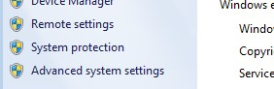

7. The system will display the **System Properties** dialog. Select the **Advanced** tab and click **Environment Variables**.

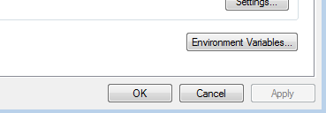

8. Under the **System Variables** list, click the **New** button.

9. Enter **JAVA_HOME** as Variable name.

10. As Variable value enter the following. This should be the value you verified in the

*Set the Environment variables section - step 2*.

**C:\Progra~2\Java\jdk1.8.0_45**

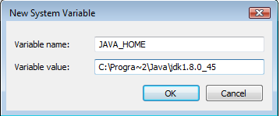

**Note:** If you are using a 32-bit OS you may have to use **C:\Progra~1\Java\jdk1.8.0_45**

11. Click **OK** to create the variable.

12. From the *System Variables* list, select **Path** and click **Edit**.

13. At the beginning of the line enter the following. Make sure to include the semi- colon on the end:

**%JAVA_HOME%\bin;**

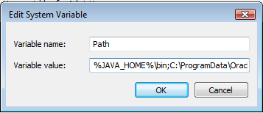

14. Click **OK**.

15. Click **OK** to close the *Environment Variables* window.

16. Click **OK** to close the *System Properties* window.

# Part 6 - Verification of JDK 8 Update 45

1. Open a Windows command prompt. You can do this by selecting '**Start -> Run**', entering '**cmd**', and then pressing the **OK** button. Make sure it is a new command prompt and not one open previously.

2. Enter the following command:

**echo %PATH%**

Make sure you see the Java 'bin' directory listed at the beginning.

Note: You may see **C:\Progra~1\Java\jdk1.8.0_45** or **C:\Progra~2\Java\jdk1.8.0_45**

3. Enter the following command:

**java -version**

Make sure you see the response shown below.

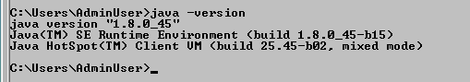

Troubleshooting: If you get an error message means that your Environment variable was incorrectly entered, go back and fix the values.

4. Enter the following command:

**javac**

Verify that you get the options to run the Java compiler:

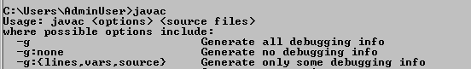

5. Enter the following command:

**java -XshowSettings:all 2>&1 | findstr /c:"sun.arch.data.model"**



Verify that it displays the correct value of 32. This indicates that it is 32-bit java that is installed.

Troubleshooting: If it displays 64 for the value, then you have 64 bit java installed and this will cause issues. Please uninstall the 64-bit java and reinstall the indicated 32-bit jdk.

6. Close the command prompt window and any extra windows that are open. Java has been installed.

# Part 7 - Verification of Eclipse Mars

 1. Run C**:\Software\eclipse\eclipse.exe** Eclipse Mars will start.

2. A Workspace Launcher dialog will appear. Leave the default workspace directory and click **OK**.

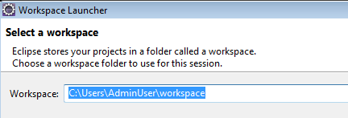

Eclipse will open showing the Welcome page. (The Welcome screen may vary between versions).

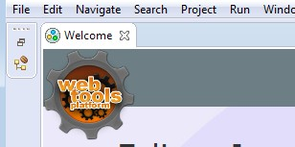

3. From the menu, select **File > Exit** to close Eclipse. Confirm you want to exit Eclipse if prompted.

Eclipse Mars is working fine.

# Part 8 - Install Maven 3.3.9

The following steps are based on Windows 7, other Windows versions instructions may vary.

1. In the Windows Start Menu, right-click on the **Computer** link in the right-hand side of the Start panel, and then select **Properties**.

2. Click on **Advanced system settings**.



3. The system will display the **System Properties** dialog. Select the **Advanced** tab and click **Environment Variables**.



4. Verify the JAVA_HOME variable is set to **C:\Progra~1\Java\jdk1.8.0_45** or similar path.

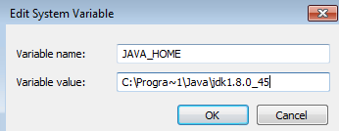

Note: Your path could be different.

5. In the 'System Variables' panel, locate the entry for 'Path' and double-click on it.

6. Add the following to the **end** of the **Variable Value** field (including the semi-colon)

;C:\Software\apache-maven-3.3.9\bin

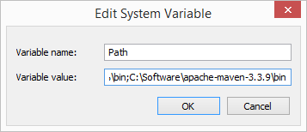

7. Click **OK** on the variable editor dialog.

8. Click **OK** on the **Environment Variables** dialog.

9. Click **OK** in the **System Properties** dialog.

10. Open a command prompt window (in the start menu, click **All Programs --> Accessories --> DOS Prompt**.

11. In the command window, type:

mvn -version

12. You should see output similar to:

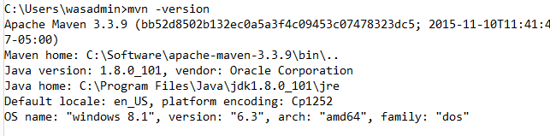

# Part 9 - Setup Maven in Eclipse

1. Use Windows Explorer to navigate to **C:\Software\eclipse**, and then double-click on '**eclipse.exe**' to start up the IDE.

2. You may see a security dialog. If so, un-check the box for “Always ask before opening this file” and then click **Run**.

3. Change the workspace to **C:\Workspace** and click **OK**.

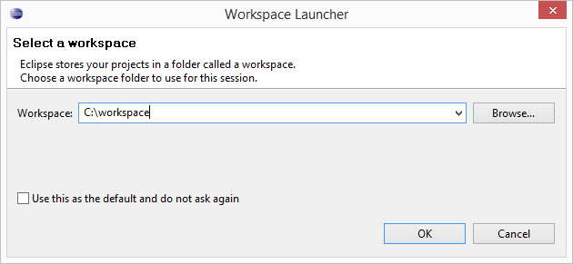

4. Eclipse will start launching.

5. Once started, close Eclipse.

6. Close all.

# Part 10 - Jenkins 2.89.3 Installation

1. Open a command prompt window and ensure that the Java JDK is installed.

java -version



2. In Windows Explorer, navigate to **C:\Software\jenkins-2.89.3-Windows**

3. Double-click on '**jenkins.msi**'. The installer will show the initial dialog. Click **Next**.

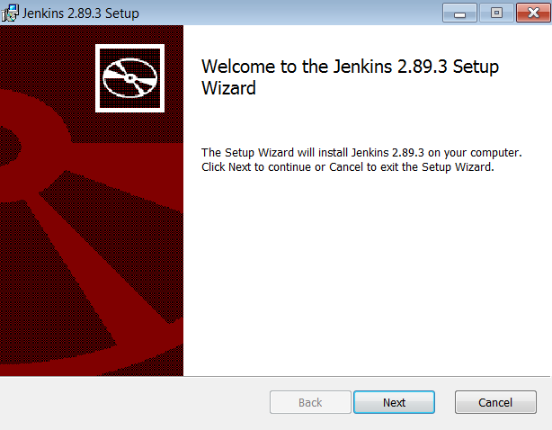

4. On the **Destination Folder** panel, leave the defaults and click **Next**.

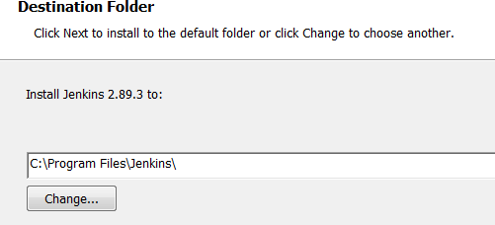

Your destination folder may be different.

5. On the **Ready to Install...** panel, click **Install**.

6. Windows may show a security dialog. If it does, click **Yes**.

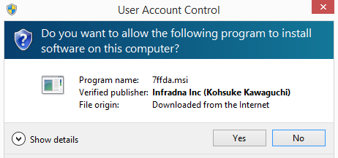

7. In the final dialog panel, click **Finish**.

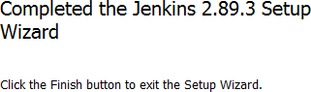

8. If you see the **Create First Admin User** screen then click Jenkins.

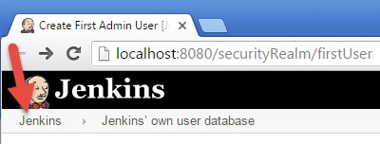

9. If you see the following click **Don't show this message again**.



The installer will open a browser window to the Jenkins home page. The page shows the location of a file where you can find the initial administration password, and also a text box to enter the password into.

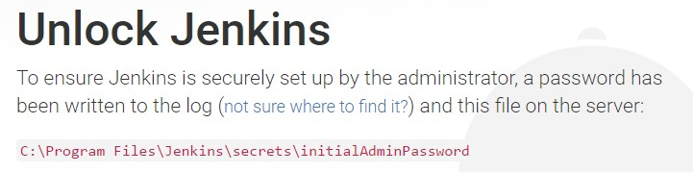

10. Open the indicated file with an editor such as Notepad, and copy the password to the clipboard with Ctrl-C.

11. Paste the password into the **Adminstrator Password** box.

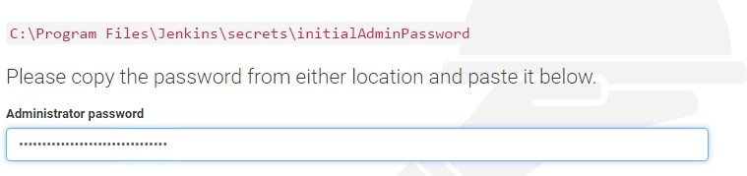

12. Click **Continue**.

13. If you are prompted to save the password just close that window.

14. Click on **Install Suggested Plugins**.

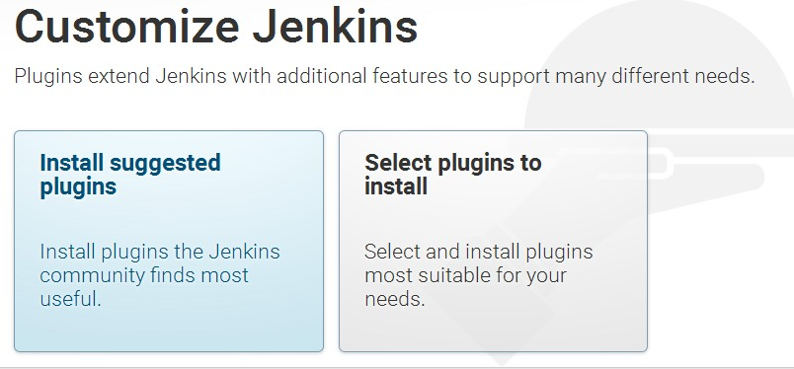

15. Getting Started will begin. Wait until is done.

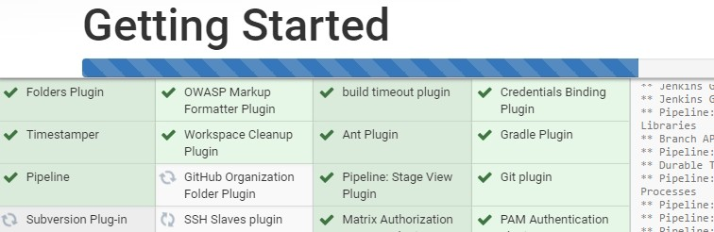

16. In the **Create First Admin User** screen. Enter the following fields:

**Username:** theadmin

**Password:** theadmin **Confirm Password:** theadmin **Full name:** Administrator

**E-mail address:** [user@example.com](mailto:user@example.com)

17. When the input looks like below, click **Save and Finish**.

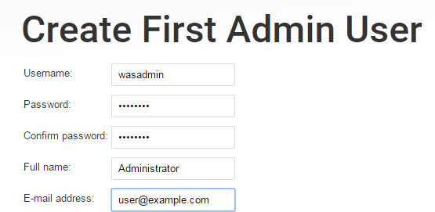

18. If you are prompted to save the password just close that window.

19. You will see that Jenkins is ready. Click **Start using Jenkins**.

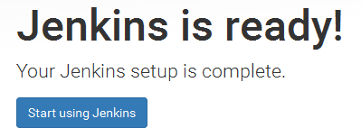

20. Jenkins will open.

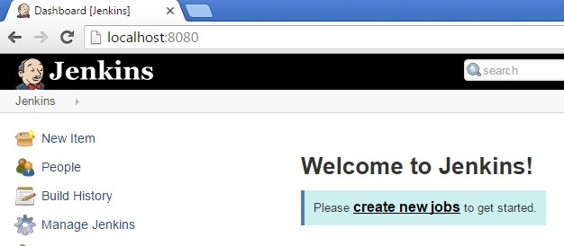

21. Jenkins installation is complete. Close the browser.

22. Close all open windows.

# Part 11 - Installing GIT

## IMPORTANT: Setup is easy but you need to make sure you do the change in Step 7.

1. From the **C:\Software\** directory run the following file:

**Git-2.8.1-32-bit.exe**

2. You may need to allow the program to run.

3. Click **Next**.

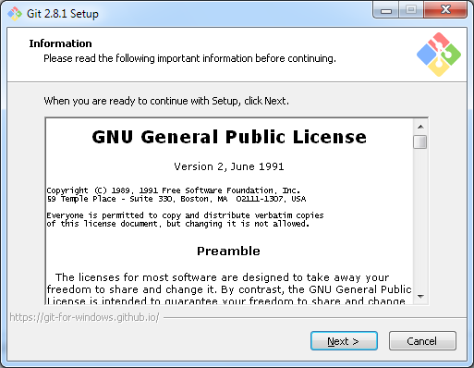

4. Click **Next**.

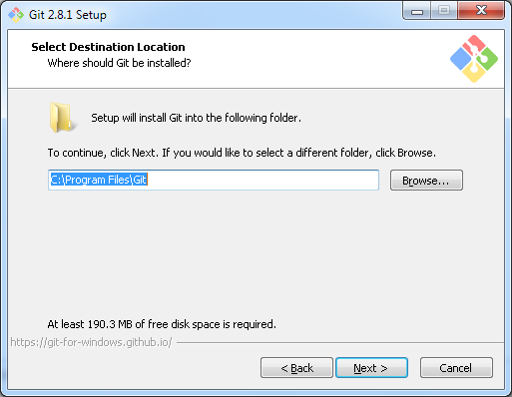

Note. You folder may be different.

5. Click **Next**.

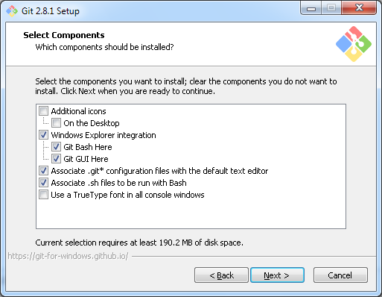

6. Click **Next**.

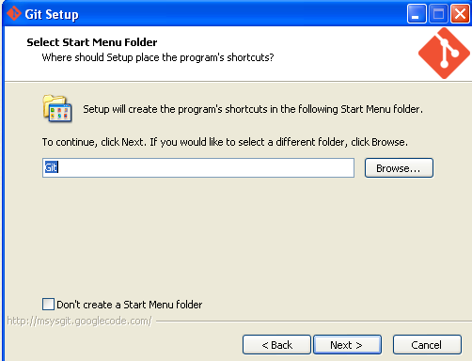

## 7. Select Use Git and Optional Unix tools from the Windows Command Prompt.

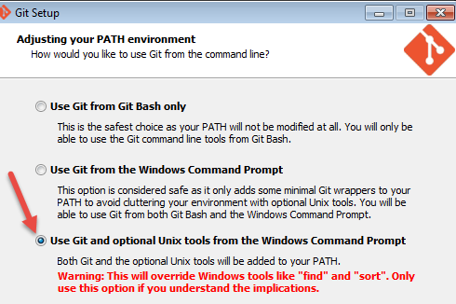

8. Make sure you select the 3rd option as shown above and then click **Next**.

9. Click **Next**.

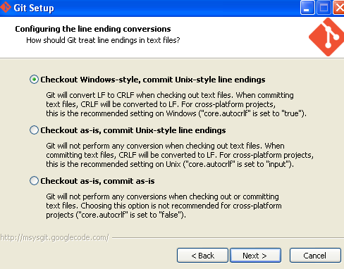

10. Click **Next**.

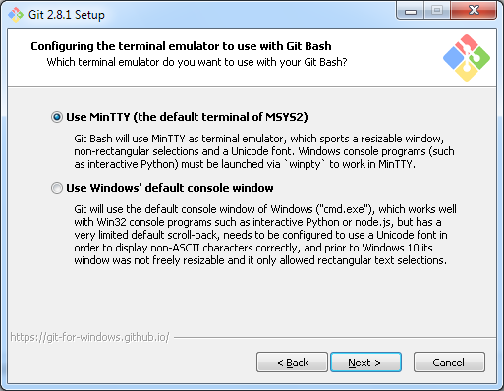

11. Leave defaults and click **Install**.

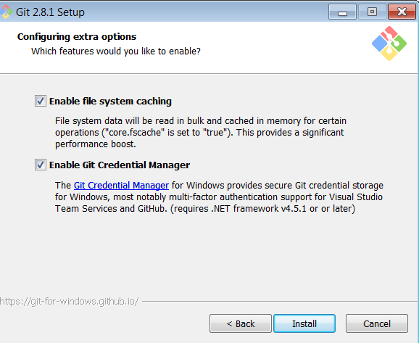

12. De-select **View Release Notes**, and then click **Finish**.

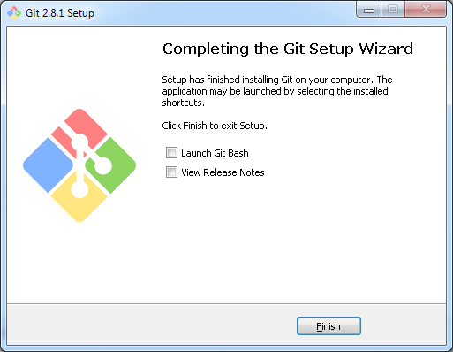

13. Close all open files.

**Part 12 -** **Installing Node.js 6.9.5**

1. Open **C:\Software\node-v6.9.5**

2. Double click **node-v6.9.5-x86.msi** to begin installation.

3. Click **Next**.

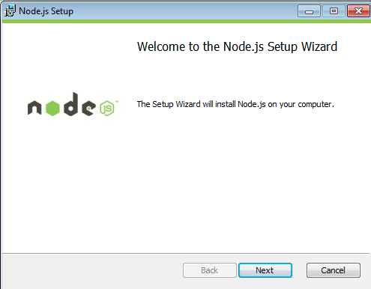

4. Check **I accept the terms...** and click **Next**.

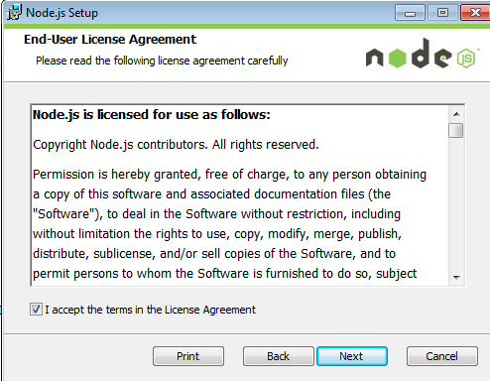

5. Accept default destination folder and click **Next**.

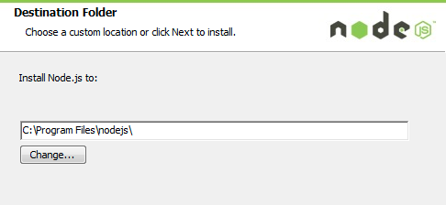

**Note:** Your installation location may be slightly different. Accept whatever the default is.

6. Accept default package selection. Click **Next**.

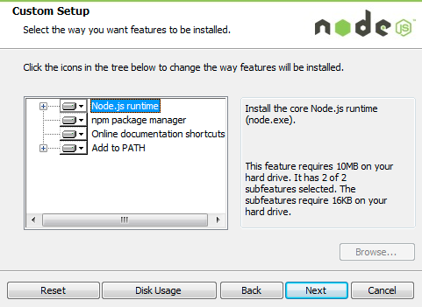

7. Click **Install**.

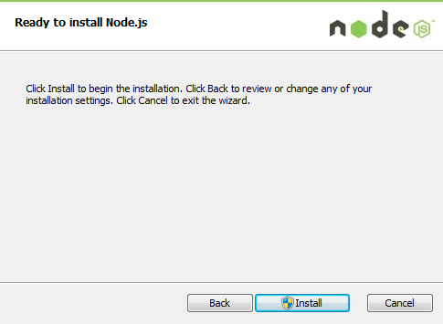

8. A popup window may open asking to install the software. Click Yes to continue.

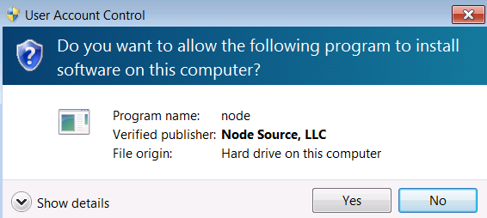

9. Click **Finish**.

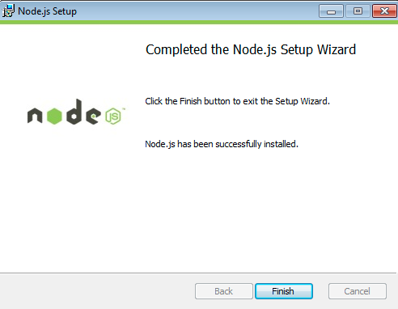

## Installation verification of Node.js

1. Open a command prompt window.

2. Enter the command:

**node --version**

3. Make sure that you see **v6.9.5** as the output.

4. Close all.

# Part 13 - Installing a CentOS VMWare image (Optional)

1. Start VMWare player.

2. Click **Open a Virtual Machine**.

3. Install any CentOS VMWare VM.

4. Select the virtual machine and click **Play virtual machine**.

5. Click "**I moved it**".

The VM will be launch, it may take some minutes.

