**LAB EXERCISE: Confluence Macros in Action**

**Objective**: This lab exercise will walk you through the process of using various Confluence macros, particularly focusing on Page Properties, Page Properties Report, and User List macros. You will learn how to insert, configure, and utilize these macros within your Confluence pages.

**Prerequisites**:

* Access to Confluence with necessary permissions to create and edit pages.
* Basic familiarity with Confluence's page editor interface.

**Exercise 1: Implementing the Page Properties Macro**

**Task 1: Set Up Your Confluence Page**

1. Log in to your Confluence account.
2. Navigate to the space where you wish to create your new page.
3. Click the "Create" button (usually located in the upper right-hand corner).
4. Select "Blank Page" from the template options.
5. Title your page as "Project Status Report."

**Task 2: Insert the Page Properties Macro**

1. With your new page open in edit mode, place your cursor where you want to insert the macro.
2. Type “/” to bring up the macro insertion menu.
3. Start typing “Page Properties” and select the 'Page Properties' macro from the list.
4. You will see a macro placeholder now. Click on it to reveal the 'Edit' button and click 'Edit' to configure your macro.

**Task 3: Configure the Macro with a Table**

1. Inside the macro body, create a two-column table.
2. Define your 'keys' in the left column (e.g., "Project Name," "Project Lead," "Status," "Last Updated").
3. Provide the corresponding 'values' in the right column (e.g., "Website Redesign," "Alex Mercer," "In Progress," "October 17, 2023").
4. Outside the macro, but still on the same page, add a label to categorize this page. Click on the label icon (usually found at the bottom of the editor), and type "status_update" then hit 'Enter'.

**Task 4: Save Your Page**

1. Review the information on your page to ensure accuracy.
2. Click the "Publish" button to save and publish your page.

**Exercise 2: Generating a Report with the Page Properties Report Macro**

**Task 1: Create a Summary Page**

1. Create a new blank page in the relevant Confluence space.
2. Title this page "All Project Statuses."

**Task 2: Insert the Page Properties Report Macro**

1. On your summary page, type “/” to access the macro menu.
2. Type and select 'Page Properties Report' to insert this macro.

**Task 3: Configure the Report Macro**

1. Click the macro placeholder to access the 'Edit' option.
2. In the macro parameters, specify the label "status_update" to aggregate the data from pages tagged with this label.
3. Leave the 'Page Properties ID' field blank to pull all related data.
4. Click "Insert" or "Save" on the macro configuration dialog.

**Task 4: Publish the Summary Page**

1. Verify that all configurations are correct.
2. Click "Publish" to make your summary report available.

**Exercise 3: Listing Confluence Users with the User List Macro**

**Task 1: Start a New Confluence Page**

1. In your Confluence space, start a new page.
2. Give it the title "Registered User List."

**Task 2: Insert and Configure the User List Macro**

1. On the new page, press “/” and then type in “User List.” Select it when it appears.
2. In the macro's settings, set the 'Group(s)' parameter to the user group you want to list (e.g., “confluence-users”).
3. Ignore the 'Display Online/Offline Users' parameter as it’s non-functional in the cloud version.

**Task 3: Finalize Your User List Page**

1. Double-check the macro settings for accuracy.
2. Click "Publish" to save and display your new page containing the user list.

By following these structured exercises, you will gain hands-on experience with crucial Confluence macros, enhancing page content and reporting capabilities. Always ensure you review all configurations and settings before publishing pages to maintain accurate and organized content.

**End of Lab Exercises**

Students should now be familiar with inserting and configuring macros within Confluence, improving their ability to manage and display content effectively.

OPTIONAL / ADDITIONAL INFORMATION

Lab: Macros for reporting info to Confluence Pages

Insert the page properties macro

The Page Properties and Page Properties Report macro work together to show summary information from one page on another page.

Use the Page Properties macro

**To add the Page Properties macro:**

1. When editing, select from the toolbar
2. Find the macro by name and select it
3. Configure it as needed

You can also type / on the page to bring up the same list you'd see by selecting from the toolbar. Continue typing the name of the macro to filter the list.

In the macro body create a two column table:

1. In the left column, list your 'keys' – these will be the column headings in your report table
2. In the right column, list the value for each key – these will populate the rows in your report table
3. Add a **label** to your page (you'll need to specify this label in the page properties report macro)
4. Save your page.

Use the Page Properties Macro horizontally

To do this:

* Create a two *row* rather than two *column* table, and ensure the first row has the heading row style applied.
* List your keys in the first row, and values in the second row.

The Page Properties Report Macro will be able to pull this information accurately even if you're using the Page Properties Macro vertically elsewhere.

Next you need to add the Page Properties Report macro to another page.

Here's an example of the Page Properties macro when editing. Deadline, Current Status, and Team will be column headings in the report.

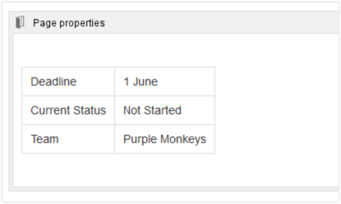

Here's what the example above will look like in the Page Properties Report.

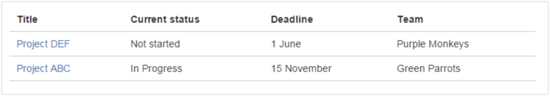

Use multiple Page Properties macros on one page

You can add multiple Page Properties macros on a single page, and choose whether to include all or only specific macros in the report. You might use multiple macros because you want the information in the macro to display in context with the rest of the page, or because you want to be able to report on individual Page Properties macros separately.

The Page Properties macro includes an optional ID parameter that can be used to identify specific Page Properties macros.

To show the contents of**all** Page Properties macros in the report:

1. Add a label to the page containing the Page Properties macros
2. Specify this label in the Page Properties Report macro

To show the contents of **selected** Page Properties macros in the report:

1. Add a label to the page containing the Page Properties macros
2. Specify an ID in the Page Properties macro that you want to report on
3. Specify both the label and ID in the Page Properties Report macro

The Page Properties Report macro can only accept one page label, and one ID.

This powerful macro lets you create a summary page that pulls in information from multiple pages.

**To edit the Page Properties macro:**

1. Select the macro placeholder.
2. Select the Editicon to open the configuration panel.
3. Configure the parameters. Your changes are saved as you go.
4. Resume editing the page, and the panel closes.

You can also select the centered , medium-width , and full-width icons to adjust the width of some macros. Select the trashcan iconto remove the macro.

Parameters

Parameters are options that you can set to control what and how content from the macro appears on the page.

If the parameter name used in Confluence Cloud storage format or wikimarkup is different than the label used when inserting macros using the browser or the slash command, it will be listed below in brackets (example).

|  |  |  |
| --- | --- | --- |
| Parameter | Default | Description |
| **Page Properties ID** | (None) | Optional ID used to identify a particular Page Properties macro on a page. Specify this ID in the Page Properties Report to include summary information from macros with this ID only. |
| **Hidden** | False | Determines whether the data in the Page Properties macro will be displayed on the current page. This setting does not affect the display of the detail in the Page Properties Report macro. |

**Notes**

* You can't use macros in the left column as the data in this column is used to populate the column headings in your Page Properties Report macro.
* It is not possible to reference the metadata using the metadata key from within the page, or anywhere else on a Confluence page.

Insert the page properties report macro

The Page Properties and Page Properties Report macro work together to enable you to show summary information from one page on another page.

This macro was previously known as the Details Summary macro.

Adding the Page Properties Report macro to a page

To add the Page Properties Report macro to a page:

1. In the editor, choose **Insert** > **Other Macros** > **Page Properties Report**.
2. Enter the **Labels** you want to report on - this is the label added to pages containing the Page Properties macro.
3. Further narrow down your search by adding more fields, or specifying a Page Properties ID (more info on this below)
4. Choose **Insert**.

Here's how the macro looks on your page:

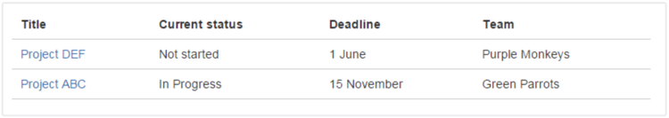

And here's how you set it up:

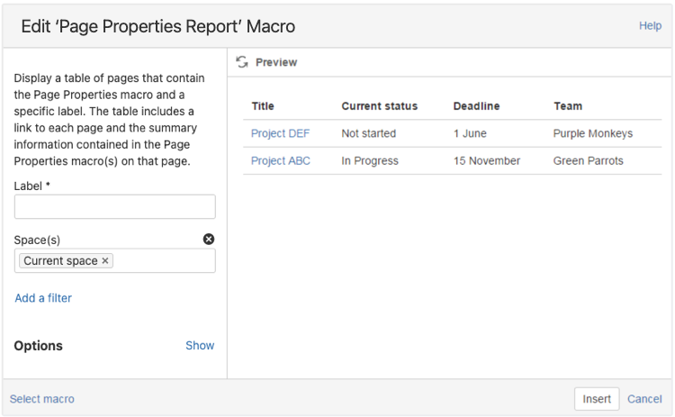

Reporting on specific Page Properties macros

It's possible to add multiple Page Properties macros on a page, and choose whether to include all or only specific macros in the report.  The Page Properties macro includes an optional ID parameter that can be used to identify specific Page Properties macros.

To show the contents of:

* **Selected Page Properties macros** in the report - specify the label for the page and the ID of the particular Page Properties macro (under Options)
* **All Page Properties macros** in the report - specify just the label for the page - leave the Page Properties ID field blank.

The Page Properties Report macro can only accept **one** ID.

CQL fields

|  |  |  |
| --- | --- | --- |
| Filter | Description | Operators |
| **Label\*** | Returns pages, blog posts or attachments with these labels. | OR (multiple values in the same filter)  AND (multiple Label filters) |
| **With ancestor** | Returns pages that live under this page in the page tree.  This allows you to restrict the macro to a single page tree. | OR (multiple values in the same filter) |
| **Contributor\*\*** | Returns pages or blog posts that were created or edited by these people. | OR (multiple values in the same filter) |
| **Creator** | Returns items created by these people. | OR (multiple values in the same filter) |
| **Mentioning user** | Returns pages and blog posts that @mention these people. | OR (multiple values in the same filter) |
| **With parent** | Returns only direct children of this page (further sub-pages won't be included) | EQUALS (one page only) |
| **In space\*\*** | Returns items from these spaces. | OR (multiple values in the same filter) |
| **Including text\*\*** | Returns items that contain this text. | CONTAINS (single word or phrase) |
| **With title** | Returns items that contain this text in the title. | CONTAINS (single word or phrase) |
| **Of type\*\*** | Returns only pages, blogs or attachments. | OR (multiple values in the same filter) |

CQL (Confluence Query Language) is a query language developed for Confluence, which you can use in some macros and the Confluence search. Confluence search and CQL-powered macros allow you to add filters to build up a search query, adding as many filters as you need to narrow down the search results. To add a filter to your query, select the **Add a filter** link.

You can use the following CQL filters:

**AND, OR, and NOT operators**

* For an OR search, specify multiple values in the same field.  
  So to show pages with 'label-a', 'label-b' or both you'd put 'label-a' and 'label-b' in the same Label field

|  |  |  |
| --- | --- | --- |
| Parameter | Default | Description |
| **Page Properties ID** | Blank | If not specified, the report will show data from all Page Properties macros on a page, where there are multiple macros. Specify an ID to include only data from Page Properties macros with the same ID. |
| **Title column heading** | Title | The heading to display on the first column in the report table. This column contains links to pages displayed by the report. The default column heading is 'Title'. |
| **Columns to show** |  | If not specified, the report will show all columns. You can specify a comma separated list of columns to include.  If your column heading includes commas, use double quotes around the column name. If your column heading includes quotes, use double quotes. For example, A column, "My ""new"" column, yes", Third column |
| **Number of items to display** | 30 | Number of items to display in the table before displaying pagination options for additional items. |
| **Sort by** | Modified | Sort the table by a specific column heading. Enter the column name, exactly as it appears in the corresponding Page Properties macro.  Select the **Reverse Sort** check box to sort the table in reverse order. |
| **Show Comments Count** | No | Displays the number of comments for each page in the table. |
| **Show Likes Count** | No | Displays the number of likes for each page in the table. |

* For an AND search, add more than one filter and specify a single value in each.  
  To show only pages with label-a and label-b you'd put 'label-a' in one label field, then add a second Label field to the macro, and put 'label-b' in the second one.  
    
  Put simply, OR values are entered in the same filter, AND values are entered in different filter.   
  Only some filters support AND. If the filter doesn't support the AND operator, you won't be able to add that filter more than once.
* For a NOT search, enter a minus sign (-) before the label. This'll exclude everything with that label.

* This field is required in CQL-powered macros.

** You can add these filters in CQL-powered macros but in search they're part of the standard search filters, so they don't appear in the **Add a filter** menu.

Macro display options

These options control how the macro appears on your page.

Troubleshooting

If your report is empty, check:

* You have entered the label correctly and that the label does appear on pages containing a Page Properties macro.
* The Page Properties macros on each page are configured correctly.
* Any other fields you have specified have not narrowed your search too far (for example there are no pages with that label under the Parent page you've specified).

Insert the user list macro

The User List macro displays a list of Confluence users, based on their group membership.

Use the User List macro

**To add the User List macro:**

1. When editing, select from the toolbar
2. Find the macro by name and select it
3. Configure it as needed

You can also type / on the page to bring up the same list you'd see by selecting from the toolbar. Continue typing the name of the macro to filter the list.

**To edit the User List macro:**

1. Select the macro placeholder.
2. Select the Editicon to open the configuration panel.
3. Configure the parameters. Your changes are saved as you go.
4. Resume editing the page, and the panel closes.

You can also select the centered , medium-width , and full-width icons to adjust the width of some macros. Select the trashcan iconto remove the macro.

Parameters

Parameters are options that you can set to control what and how content from the macro appears on the page.

If the parameter name used in Confluence Cloud storage format or wikimarkup is different than the label used when inserting macros using the browser or the slash command, it will be listed below in brackets (example).

|  |  |  |
| --- | --- | --- |
| Parameter | Default | Description |
| **Group(s)** (groups) | none | Specify the group name. Specify multiple groups separated by a comma, or use * to show all users in Confluence. |
| **Display Online/Offline Users** (online) | All registered users | This parameter is not functional in Confluence Cloud. You should leave this parameter unspecified to display all registered users. |

**Wiki markup example**

Wiki markup is only supported in the legacy editor.

Wiki markup is useful when you need to add a macro outside the editor, for example as custom content in the sidebar, header or footer of a space.

**Macro name:** userlister

**Macro body:** None.

{userlister:groups=confluence-users|online=false}