# Lab: Confluence Cloud

Open following URL in browser and signup for Atlassian Confluence:

<https://www.atlassian.com/try/cloud/signup?bundle=confluence&edition=free>

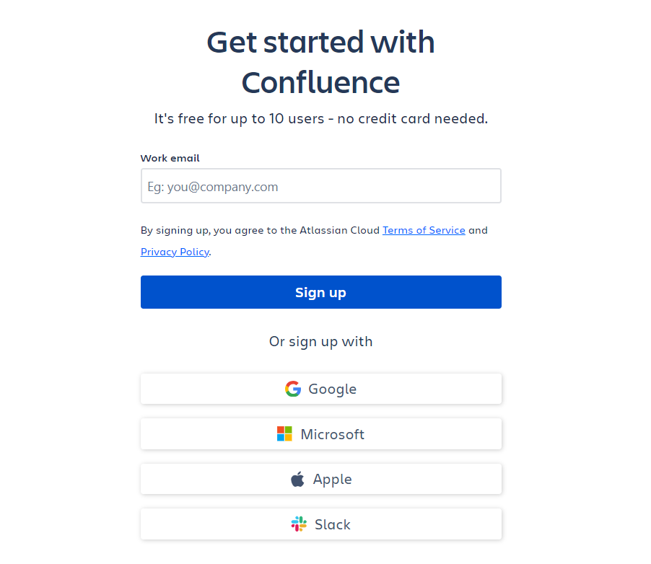

You can signup using multiple options as shown below. After signup. You will need to create site on Attlasian clouds as shown below.

