# Lab: Navigate Confluence

.

Teams in Space



For each tutorial in this section, we'll use a fictional organization known as 'Teams in Space'. Their mission is to:

*"Perform flight research and technology integration to revolutionize aviation and pioneer aerospace technology. Also, land the first humans on Mars by 2020."*

You're an astronaut in the 'See Space EZ' team, which is working on the upcoming colonization of Mars.

## Navigate Confluence

Confluence is pretty simple to use, once you get to know it. This tutorial aims to get you acquainted with the Confluence user interface, and show you how and where to perform some common tasks.

## Teams in Space

In this tutorial, you'll be working with some new Teams in Space recruits.  Let's get to know them.

**Alana Baczewski**  Tech Lead

**Emma Silvetti**  Launch Specialist

**William Vladinov**  Aerospace Engineer

Now that you've met your team, let's take a look at your mission.

## Mission brief

Your mission commander has thrown you a curveball: this week you'll be training new recruits at Teams in Space HQ on your collaboration tool – Confluence. You just need to know the basics, so we'll go through the main things you need to know to complete your mission.

Your mission is broken up into the following components:

* Get to know the dashboard
* Find your way in the space directory
* Master the space sidebar
* Impress everyone with keyboard shortcuts

Those new recruits will be here tomorrow; we better get started!

# The dashboard

The dashboard is the hub of your Confluence site, providing you with access to information and updates that are important to you. It's also the first thing your new recruits will see, so you need to make a good impression on this one.

You can get to the dashboard from anywhere in Confluence by choosing the **site logo** at the left of the Confluence header.

The dashboard has a collapsible sidebar that helps you get around:

* **Discover**  
  Watch the action unfold in real time with **All updates or** check out pages with lots of likes and activity in the **Popular** feed.
* **My Work**Get lightning fast access to your recently created and edited pages in **Recently worked on**, get back to that page you stumbled across yesterday in **Recently viewed**, and have mission critical pages on speed dial under **Saved for later**.
* **My Spaces**  
  This is where you can keep links to the spaces that you hop in and out of several times a day.

If you're a Confluence admin you can give the dashboard some personality by adding useful announcements, links, or a photo from your last mission (or office party). The whole right hand column is ready and waiting for you to customize.

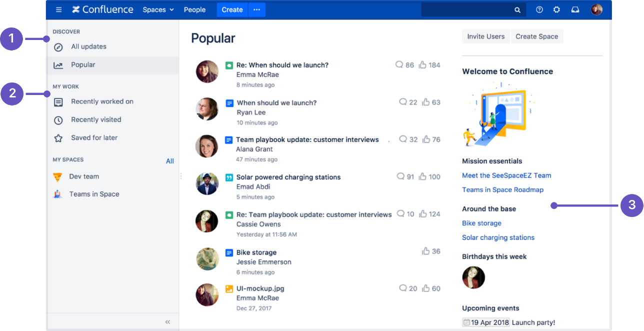

1. **Discover:** see what's happening in your site.
2. **Your work:** get work done with recent and useful pages at your fingertips.
3. **Customize:** admins can add useful content to welcome people to the site.

Try clicking one of the spaces on the sidebar, then return to the dashboard by clicking the **site logo**. Even when your shuttle is spinning out of control, the dashboard is there to orient you.

You'll discover more about the dashboard as you get to know Confluence, but, for now, let's move on to the space directory.

**Pro tips**

You can choose to set any page as your personal home page.

The dashboard is the default landing page when you log into Confluence. It gives you easy access to what's happening in your site, and helps you get back to pages you recently viewed and worked on.

You can choose to personalize your experience. and use an existing space home page as your landing page.

**To set your home page:**

1. Choose**your profile picture**at top right of the screen, then choose **Settings**
2. Choose **Edit**
3. Choose an option from the **Site Homepage** drop down.  
   Only spaces you're allowed to view will appear.
4. Choose **Submit**.

You'll be directed to your new home page the next time you log in. You can change your personal home page at any time.

Alternatively, if your Confluence administrator has set a space home page as the landing page for the whole site, you can choose **Dashboard** from the **Site Homepage** drop down to use the dashboard as your landing page.

*Screenshot: Profile Settings*

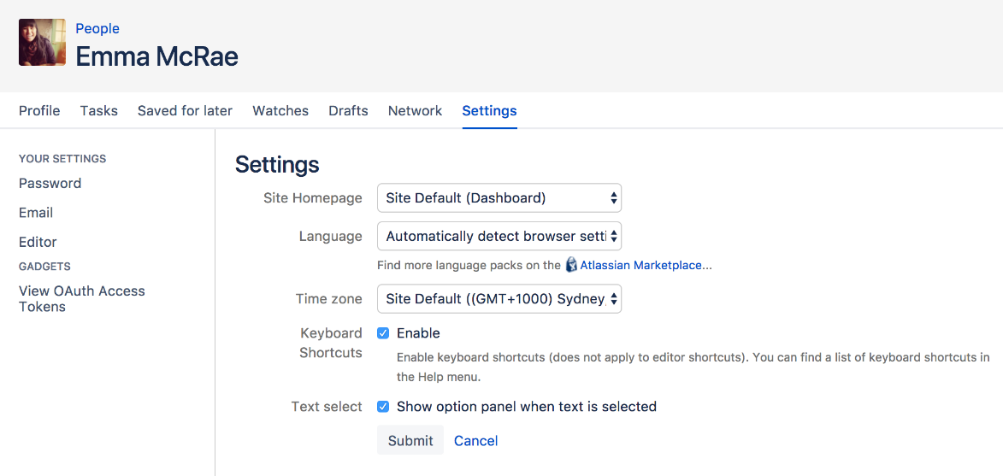

 You can access the dashboard at any time using the dashboard URL. It'll look something like this: https://yoursite.com/wiki/dashboard.action.

# The space directory

The space directory won't let you look up ET in the intergalactic phone book, but it *will* let you see and filter all the spaces in your Confluence site. Spaces are places to collect pages with a common theme – you can create as many spaces as you like – and you can find them all in the space directory.

Here are some tasks to get you comfortable using the space directory:

1. **Visit the space directory** – To get to the space directory, choose **Spaces** > **Space directory** in the Confluence header.
2. **Choose the spaces you'll use the most** – No doubt there'll be a space or two that you'll use on a regular basis. Click the star to the right of a space to make it appear under **My Spaces** on the dashboard.
3. **Choose space categories** – Once you're there, you'll see a list of all the spaces in your Confluence site. Choose the 'My Spaces' category on the left to see only the spaces you marked with a star. Then choose all spaces again.
4. **Filter the list of spaces** – Type part of a space name in the **Filter** field at the top right. That'll quickly narrow down the list of spaces if there are a lot of them.

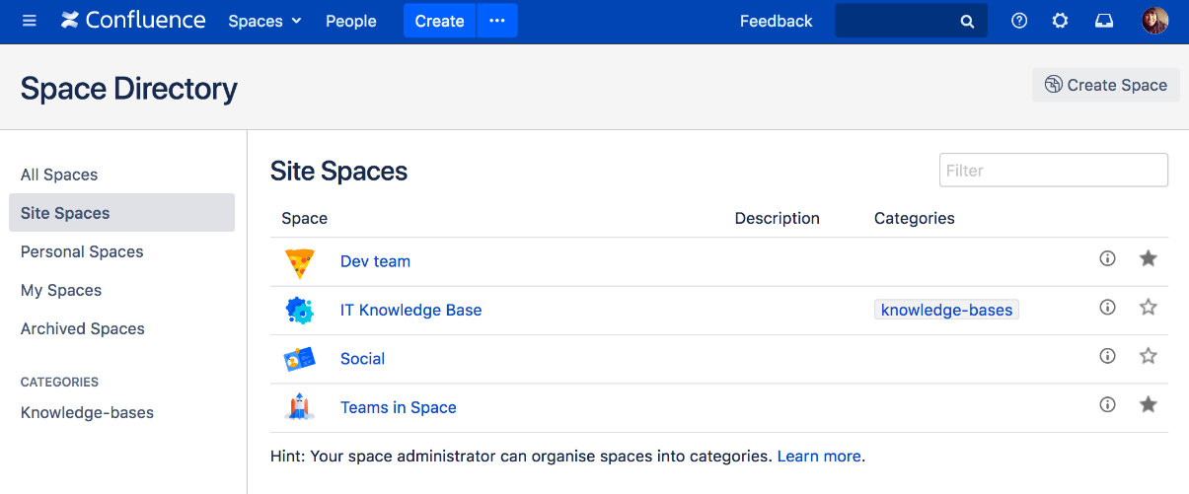

You can also categorize spaces with labels you create yourself.

Understanding and using the space directory will make it much easier to find pages and blog posts that are relevant to you.

You're ready to impress those new recruits with your knowledge of Confluence's space directory; now it's time to sneak a peek at the space sidebar.

# Keyboard shortcuts

Give a person some space food, and they'll eat for a day; teach a person to rehydrate their own space food, and they're set for the whole mission. Or something like that. Keyboard shortcuts fall into this basket. We could give you a list here, but then you'd need to keep referring to this page. The best way to go is to show you how to find the list of keyboard shortcuts within Confluence.

Your recruits also need to work fast, so you'll need to pass this wisdom on to them.

## Find the keyboard shortcuts

To open the list of keyboard shortcuts in Confluence, do any of the following:

* Choose the help icon https://confluence.atlassian.com/doc/files/139456/945098691/1/1517274824250/help-icon.png at top right of the screen, then choose **Keyboard Shortcuts**
* When viewing a page, press **Shift**+**?**
* While editing a page, choose the question mark iconhttps://confluence.atlassian.com/doc/files/139456/945098690/1/1517274824157/editor-help-icon.png in the editor toolbar

What you'll see is a dialog listing the available keyboard shortcuts in Confluence for your specific operating system and browser. Expand the menus below to see the full list.

Screenshot: Keyboard shortcuts menu for Google Chrome on macOS.

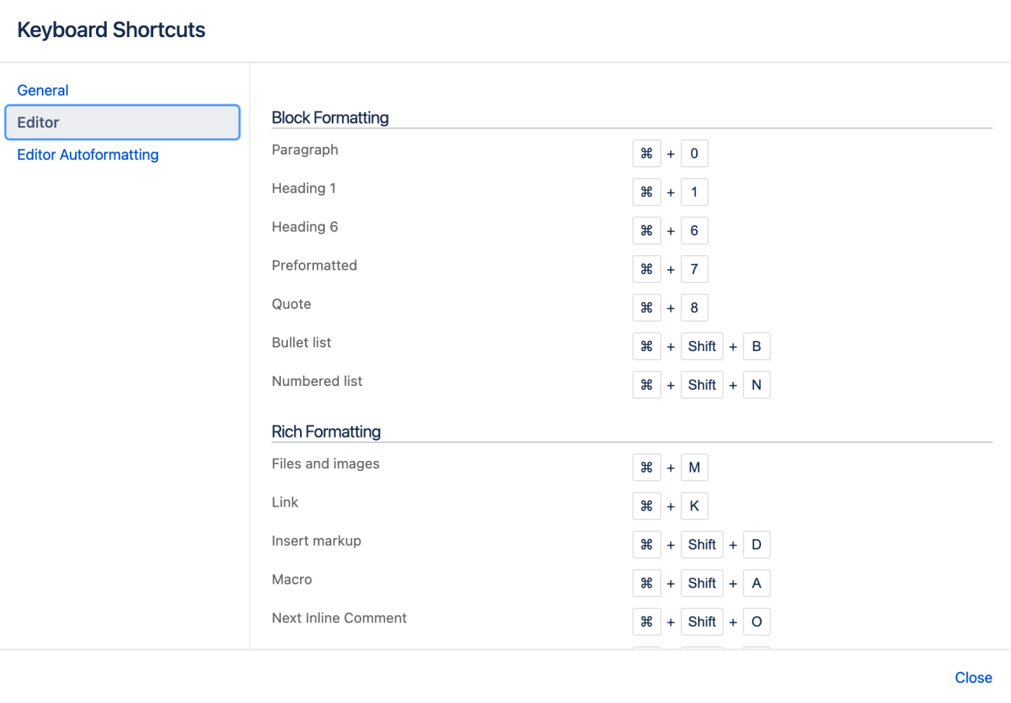

The keyboard shortcuts are broken up into 3 categories:

* **General** – Global, page and blog post shortcuts.
* **Editor** – Text editing and formatting shortcuts.
* **Editor Autoformatting** – Wiki markup and autoformatting shortcuts.

### All screens

|  |  |  |
| --- | --- | --- |
| Windows | Action | Mac |
| c | Add page | c |
| g then d | Go to dashboard | g then d |
| g then n | Open notifications | g then n |
| g then r | Open recently viewed | g then r |
| g then s | Browse current space | g then s |
| ? | Open shortcut help | ? |
| u then 8 | Show skip links | u then 8 |
| g then g / | Quick search | g then g / |
| [ | Toggle space sidebar | [ |
| e | Edit | e |
| s | Share | s |
| b | Add blog | b |
| e | Edit | e |
| m | Comment | m |
| v | View inline comment | v |
| ] | Close inline comment | ] |
| w | Watch page | w |
| l | Edit labels | l |
| s or k | Share | s or k |
| t | View attachments | t |
| f | Favorite page | f |

### Editor

|  |  |  |
| --- | --- | --- |
| Windows | Action | Mac |
| Ctrl + 0 | Paragraph | ⌘ + 0 |
| Ctr+(1–6) | Heading level (of the number chosen) | ⌘ +(1–6) |
| Ctrl + 7 | Preformatted | ⌘ + 7 |
| Ctrl + 8 | Quote | ⌘ + 8 |
| *bold* | Bold text | *bold* |
| +underline+ | Underline text | +underline+ |
| _italic_ | Italic text | _italic_ |
| {{monospace}} | Monospace text | {{monospace}} |
| Ctrl + Shift + V  For Safari only: Ctrl + Shift + Alt + V | Paste text without formatting | ⌘ + Shift + V  For Safari only: ⌘ + Shift + Option + V |
| Ctrl + Shift + B, or * + Space | Add a bullet list | ⌘ + Shift + B, or * + Space |
| Ctrl + Shift + N, or # + space | Add a numbered list | ⌘ + Shift + N, or # + space |
| [] | Add a task | [] |
| Ctrl + K | Link (opens Insert link dialog) | ⌘ + K |
| Ctrl + Shift + D | Insert markup (opens Insert markup dialog) | ⌘ + Shift + D |
| Ctrl + Shift + A | Macro (opens Select macro dialog) | ⌘ + Shift + A |
| Ctrl + Shift + O | Toggle to next inline comment | ⌘ + Shift + O |
| Ctrl + Shift + L | Toggle to previous inline comment | ⌘ + Shift + L |
| Ctrl + Shift + Z | Close inline comment | ⌘ + Shift + Z |
| Ctrl + Shift + E | Preview | ⌘ + Shift + E |
| Ctrl + S | Save / Publish | ⌘ + S |
| Ctrl + Shift + U + 8 | Show skip links | ⌘ + Shift + U + 8 |
| Ctrl + Z | Undo action | ⌘ + Z |
| Ctrl + Y | Redo action | ⌘ + Shift + Y |

### Tables

|  |  |  |
| --- | --- | --- |
| Windows | Action | Mac OS X |
| Ctrl + Shift + i | Add a table (insert a default table with three columns and four rows) | ⌘ + Shift + i |
| ||||| + enter | Add a table with a custom number of columns, as specified by the vertical bars (you can't insert a nested table with this shortcut) | ||||| + enter |
| ||heading||heading||  + enter | Add a table with custom headings as specified by the text (you can't insert a nested table with this shortcut) | ||heading||heading||  + enter |
| Ctrl + Shift + c | Copy the current table row, or the selected rows | ⌘ + Shift + c |
| Ctrl + Shift + y | Paste the table rows from your clipboard, placing them above the current row | ⌘ + Shift + y |
| Ctrl + Shift + x | Cut the current table row, or the selected rows | ⌘ + Shift + x |
| Alt + Up Arrow | Add a row above the current row | Option + Up Arrow |
| Alt + Down Arrow | Add a row below the current row | Option + Down Arrow |

### Autocomplete

|  |  |  |
| --- | --- | --- |
| Windows | Action | Mac |
| ! | File or image suggestions | ! |
| [ | Link suggestions | [ |
| { or / | Macro suggestions | { or / |
| : | Emoji suggestions | : |
| @ | Mention users | @ |

You can turn the 'General' keyboard shortcuts off when you visit the **General** tab in the keyboard shortcuts dialog.

Take some time to open the dialog and take a look at the shortcuts, and maybe find some you'll use a lot. Then, start practising!

Next, we'll wrap up this mission and give you some ideas about where to head from here.

# Complete your mission

Well done, astronaut, you've acquitted yourself admirably. I'm sure those new recruits will be mightily impressed with your knowledge of Confluence.

In this tutorial, we've:

* Explored the anatomy of the dashboard
* Navigated using the space directory and favorited a space
* Taken a look at and customized the space sidebar
* Found a handy list of keyboard shortcuts to help you work faster