# Lab 3: Space ace

This lab will take you on a journey through Confluence to create and customize spaces, and delete them if you want to, so you can achieve the rank of 'Space Ace'!

You'll need to have the 'Create space' and 'Create personal space' permission to complete this tutorial. If you've just set up Confluence, you won't have any trouble; if you're using an existing instance and you're not an admin, speak to your Confluence admin to make sure you have the right permissions.

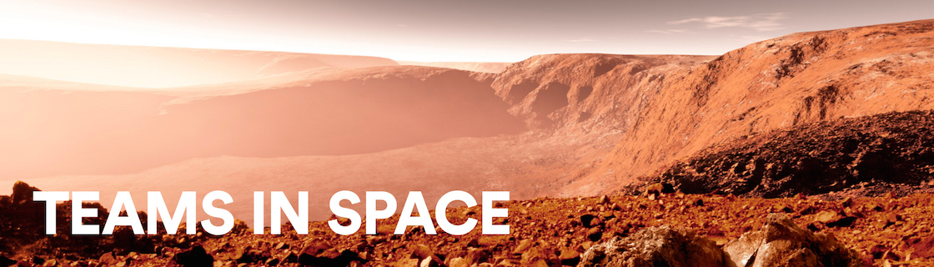

Teams in Space

In this tutorial you're a new recruit on the Teams in Space crew, but, even though you're new, you'll be given a lot of responsibility. You need the power to go with it.

Mission brief

You're in charge of organizing information and resources for the planned mission to Mars. There's going to be plenty of important information, and it must be readily available to the people who need it. Some information, though, will be sensitive, and may be 'for your eyes only.' You'll use the power and flexibility of Confluence spaces to organize information, and make sure it's visible to the right people.

Your mission is broken up into the following components:

* Create a space to house all of the important information related to the mission
* Create your own space to keep yourself organized
* Create a public relations space, where you'll introduce your team the world

What's a space?

Well, being an astronaut, I hope you know what *space* is, but what's a Confluence space all about? It's really just a place to put related things, like information pages and files. But spaces also give you a place to collaborate with groups of people, whether that's your team, people working on a common project, or the whole world.

Every space has its own permissions, allowing you to grant access and other privileges to the right people. They also have a blog, so you can post important messages and updates to whoever can see the space. You can have as many Confluence spaces as you like, and you can archive or delete spaces when you no longer need them.

Enough about that; let's begin.

# Create a project space

The Mars colonization crew needs a place to put all their mission-critical information and resources, and you're charged with setting it up. This part is going to be easy, because the information needs to be viewable by the entire Teams in Space organization. That means we can set up the project space without any special permissions.

If you haven't done so already, open up Confluence and log in so we can get started.

Create the space

1. Choose **Spaces** >**Create space** from the Confluence header
2. Select the **Blank space** option and choose **Next**
3. Enter a**Space name** – for this space, we'll call it 'Mars Colony', as it's being used for the Mars colonization project.
4. Change the **Space key** to 'MARS' – this step isn't absolutely necessary, but it helps people if they're navigating to this space by name. The space key forms part of the URL, so making it a word or name makes it much easier to associate with your project.
5. Click **Create**

You now have a space set up for the Mars colonization project. Because everyone at Teams in Space HQ needs access to the information in this space, you don't need to do anything with the space's default permissions. It's visible to everyone in your organization, but not to the general public.

Every space has a default home page, which you can customize to suit your needs. Add the following image and text to your space's home page to get things started. Just click **Edit** (or press **E** on your keyboard) to edit the home page, and copy and paste the text. For the image it's best to drag it to your desktop and save it there, then drag it into your page. That'll make sure the image is attached directly to the page.

Hit **Save** when you're happy with the home page.

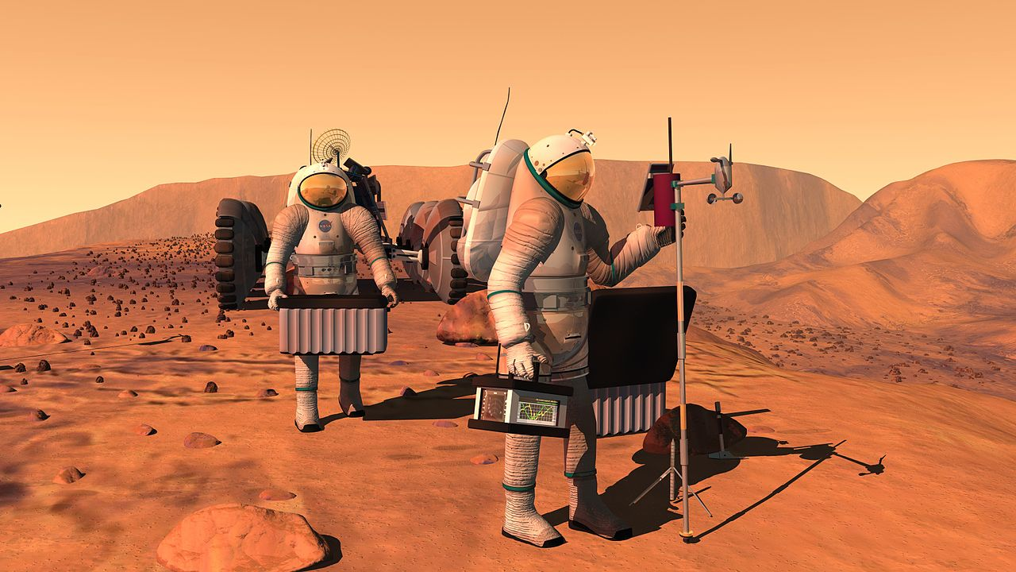

A **human mission to Mars** has been the subject of [science fiction](https://en.wikipedia.org/wiki/Science_fiction), [engineering](https://en.wikipedia.org/wiki/Engineering), and scientific proposals throughout the 20th century and into the 21st century. The plans comprise proposals to land on [Mars](https://en.wikipedia.org/wiki/Mars), eventually [settling on](https://en.wikipedia.org/wiki/Colonization_of_Mars) and [terraforming the planet](https://en.wikipedia.org/wiki/Terraforming_of_Mars), while exploiting its moons, [Phobos](https://en.wikipedia.org/wiki/Phobos_(moon)) and [Deimos](https://en.wikipedia.org/wiki/Deimos_(moon)).

[Exploration of Mars](https://en.wikipedia.org/wiki/Exploration_of_Mars) has been a goal of national space programs for decades. Preliminary work for missions that would involve human explorers has been undertaken since the 1950s, with planned missions typically being cited as taking place 10 to 30 years in the future when they are drafted. The [list of manned Mars mission plans in the 20th century](https://en.wikipedia.org/wiki/List_of_manned_Mars_mission_plans_in_the_20th_century) shows the various mission proposals that have been put forth by multiple organizations and [space agencies](https://en.wikipedia.org/wiki/Space_agency) in this field of [space exploration](https://en.wikipedia.org/wiki/Space_exploration).

Your 'Mars colony' space is ready for your team to add pages to. If you want to find it again, choose **Spaces** in the Confluence header, and select it from the list; to add a page to it, navigate to the space and hit **Create** in the header.

Now it's on to your personal space; a place where you can work in peace, and be sure that no one's looking over your shoulder.

# Create your personal space

As a newbie on the team, you might want to keep some work to yourself until you're ready to present it. There's always the chance your mission commander will also send you some information that's 'for your eyes only,' and you'll need to keep that in a safe place.

For this part of the mission, we'll be creating a special type of space: a personal space. We'll be using your personal space like a sandbox, at least to start with – somewhere you can play around, draft pages, try out features, and generally see what spaces are capable of.

Create your personal space

1. Choose your profile picture at the right side of the Confluence header
2. Select **Add Personal Space...**
3. Hit **Create**  
     
   You've now got a space that you can call your own. But we still need to lock it down to make sure it's only visible to you.  
     
   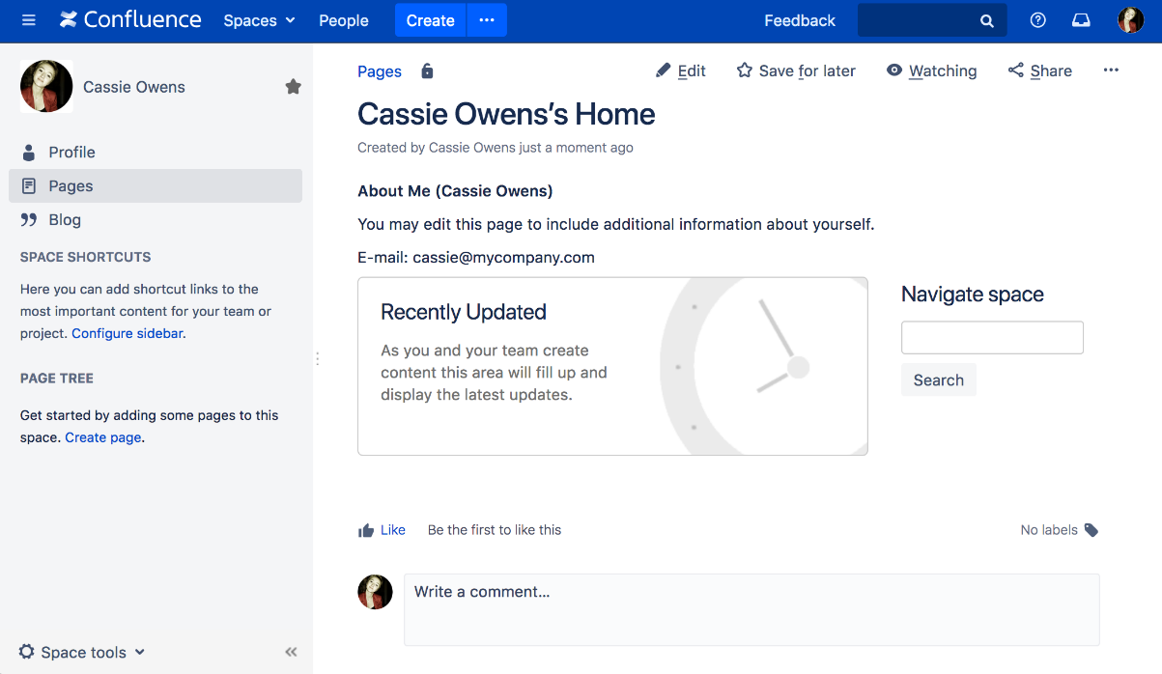
4. Choose **Space tools** > **Permissions** from the bottom of the siderbar
5. Hit **Edit Permissions** (enter your password if prompted)  
     
   You should see the confluence-users group listed under **Groups**. To the left of the list of permissions is the**View** permission, which determines whether everyone in that group can see your space.
6. Uncheck **View** and hit **Save all** at the bottom of the page

You're now the only one that can view this space. Feel free to try anything in this space, and store super secret stuff here.

# Create the team's PR space

Now it's time to go public; the world needs to know about the mission and its brave participants.

In this step, we'll create a team space and open it up to everyone. That's right – you can open Confluence spaces up to anonymous (not logged in) users.

In order to allow anonymous access to your Confluence site, a site admin needs to grant anonymous users the 'Use Confluence' permission. Don't worry if you can't do that, or if it's not done; it's just something to note if you're opening up your Confluence site for real.

Create a Team space

1. Choose **Spaces** > **Create space** from the header
2. Select **Team Space** and hit **Next**
3. Enter a **Space name** (let's call it 'Mars PR')
4. Change the **Space key** to 'MarsPR'
5. If there are other people using Confluence with you, feel free to add them as **Team members** (you can remove them later), or just stick with yourself for now
6. Paste this in as the **Description:** Follow the progress of the brave Teams in Space astronauts as they embark on their mission to colonize Mars.

Great! You now have a team space, again with its own home page. This home page is a little different to the project space and your personal space – you'll see any team members you added, listed on the home page.

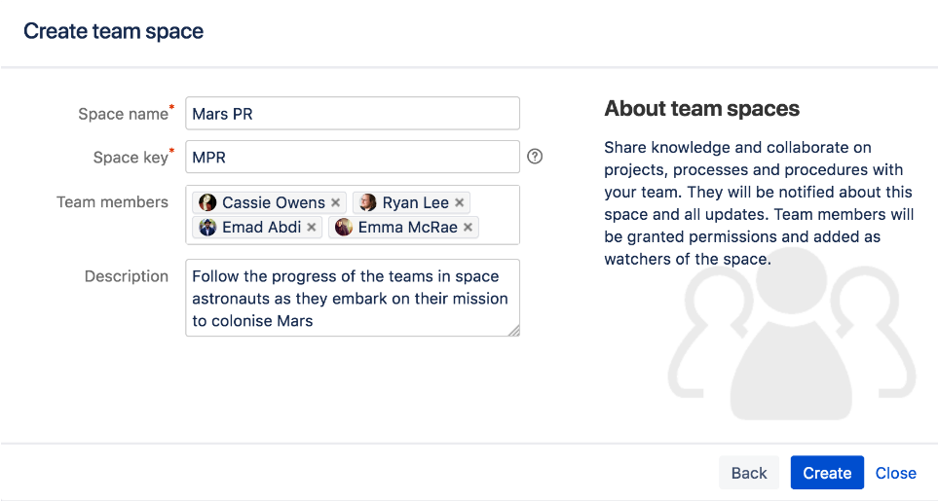

Each space you create also has its own blog, so your social media team will be able to create posts in this space and speak directly to all those adoring fans. But none of those fans can see this space. Yet.

Allow anonymous access

It's time to let the world in by changing the permissions on this space.

1. Choose **Space tools** > **Permissions** from the bottom of the sidebar
2. Scroll down until you see **Anonymous**, then hit **Edit Permissions**
3. Tick the **View** permission for anonymous users and hit **Save all**

That's it. You can now share the space's URL, which will be http(s)://<your_confluence_site>/display/MarsPR. Visitors to that space don't need to log in, or have a license for Confluence.

# Delete and archive spaces

We hope you've had a successful mission, and learned a bit about the power and versatility of Confluence spaces. Flash forward 18 months, and just look how well the colony is coming along!

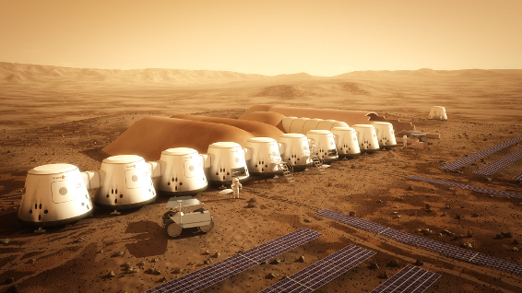

If you need to clean up old spaces (or destroy the evidence of a failed mission!), you can either archive or delete a space. Archiving just means it won't show up in the regular search, whereas deleting is obviously a lot more permanent.

**To archive a space:**

1. Choose **Space tools** > **Overview** from the bottom of the sidebar
2. Click **Edit Space Details**
3. Change the **Status** from 'Current' to 'Archived' and hit **Save**

**To delete a space:**

1. Choose **Space tools** > **Overview** from the bottom of the sidebar
2. Select the **Delete Space** tab