# Lab: Files

Share your team's PDFs, Office documents, images, and more in one place by uploading your files to Confluence. Automatic versioning, instant previews, permissions, and full-text search, means shared network drives can be a thing of the past for your team.

When you upload a file it is *attached* to the current page or blog post. This is why files are often referred to as *attachments* in Confluence.

You can attach anything from project plans and design mockups to video and audio files. You and your colleagues can also collaborate by commenting on files displayed on Confluence pages.

Using Files

* Upload Files
* Display Files and Images
* Manage Files
* Share and Comment on Files

Permissions

The 'Add Attachment' and 'Delete Attachment' permissions are used to control who can upload and delete attachments in a space.

Users with 'Add Page' or 'Add Blog' permissions can insert existing attachments to their pages, but not upload new attachments unless they also have the 'Add Attachment' permission.

There is no permission that controls downloading attachments.

# Upload Files

When you upload a file, such as an image or document, it will be attached to the current page.

You can then choose to display the file on the page as a link, an image or embed it in the page (using a macro).

To upload a file you'll need the 'Add Attachments' space permission.

## Upload a file

There are many ways to attach a file to a page.

In the editor you can:

* Drag the file directly onto the page.
* Go to **Insert** > **Files and images** and upload a file.

When viewing a page you can:

* Drag the file directly onto the page.
* Go to

**More options**https://confluence.atlassian.com/doc/files/704577869/704577870/2/1517274795952/ellipsis.png

> **Attachments** and upload a file.

You can attach multiple files at a time.

Copy and pasting a file from another application doesn't work reliably in many browsers. We recommend you use one of the methods above to make sure the file is uploaded successfully.

## Accepted file types and size

Confluence allows you to attach most file types, but you cannot attach a folder of files (including folders created by applications like Keynote - you'll need to export your presentation to zip or other format).

Although just about any file type can be attached to a page, not all file types can be displayed on or embedded in a page. The maximum file size you can upload to Confluence is set by your system administrator. By default it's 100mb, but your administrator may have increased or reduced this limit.

File versions

If you upload a file with the same name as an existing attachment on the same page, Confluence will overwrite the existing attachment. Version history is kept for all attachments.

Any changes you make to the source file will not affect the copy that was uploaded to Confluence. To update the Confluence copy, you need to upload the new version of the file.

## What happens after a file is uploaded?

### Text extraction and indexing

When a file is uploaded, its text is extracted and indexed. This allows people to search for the content of a file, not just the filename.

### Thumbnail and preview generation

When you insert an uploaded file into a page (for example a Word document, or Excel spreadsheet), Confluence will generate thumbnail images of the file contents, so it can be viewed inline in the page, or in the preview.

Because this process can be very memory intensive, a 30second time limit applies when performing document conversion for complex image or presentation files (such as PPT, PPTX, EMF, WMF). Your administrator can increase or decrease this timeout using the confluence.document.conversion.imaging.convert.timeout or confluence.document.conversion.slides.convert.timeout system properties.

Thumbnails are not generated for TIFF or PSD (Photoshop) files by default. Your administrator can override this behaviour using the confluence.document.conversion.imaging.enabled.tif or confluence.document.conversion.imaging.enabled.psd system properties.

Confluence Data Center externalizes the file conversion process to minimise the impact on individual Confluence nodes.

**Notes**

 We recommend you don't use special characters in page or attachment names, as the page or attachment may not be found by Confluence search, and may cause some Confluence functions to behave unexpectedly.

# Display Files and Images

Files can be displayed on a page as a thumbnail or as a link. There are a few different ways to Upload Files.

You can control how the file appears on your page. The options available depend on the type of file.

## Insert a file into your page

There's a few ways to insert a file into your page:

* Go to **Insert** > **Files** on the editor toolbar and select any of the previously uploaded files, or
* Drag the file directly into the editor (this will upload and insert the file in one step), or
* Type ! and choose an attached file from the autocomplete drop down.

Your file will appear on your page as a thumbnail. Click the thumbnail to resize it or to switch to showing the file as a link.

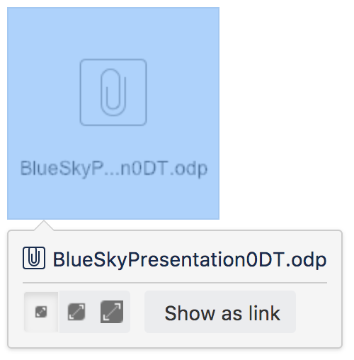

### Insert a file attached to another page

You can display a file that's attached to a different page of the same Confluence site, if you know the name of the file.

**To display an image attached to a different page:**

1. Go to **Insert** > **Files** and choose the **Search on other pages**.
2. Enter the name of the file.
3. Choose whether to search the current space or **All Spaces** and choose **Search**.
4. Select the file from the search results and choose **Insert**.

### Insert an image file from the web

You can display an image from a remote web page on your Confluence page, without needing to attach it to your page. You need to know the URL for the image, not for the web page it appears on.  This is only available for image files, not other types of files (like documents).

**To display an image from a web page:**

1. While editing the page, position the cursor where you want to place the image.
2. Choose **Insert** > **Files** and choose **Images from the web**.
3. Enter a URL for the image. (example: <http://atlassian.wpengine.netdna-cdn.com/wp-content/uploads/AtlassianBushRegeneration-12January2012-083-trunc.jpg>
4. Choose **Preview** to check that the URL and image are correct.
5. Choose **Insert**.

### Delete files from your page

If you delete a file or image in the editor, the attached file will not be deleted. Go to

**More options**https://confluence.atlassian.com/doc/files/704577869/704577870/2/1517274795952/ellipsis.png

> **Attachments** to delete the attachment completely from the page.

Seeing an 'unknown attachment' placeholder on your page? This means that the attached file has been deleted from the page (or another page).

## Preview a file

Click an image, file thumbnail or link when viewing a page to launch the preview.

The preview includes images from the web that are displayed on the page and files that are attached to the page (even if they are not currently displayed on the page).

In the preview you can:

* download the image file
* upload a new version of the file (attached files only)
* comment on the file
* choose to edit the file with a desktop application
* zoom in, out or fit the image to the width of your browser
* browse like a slideshow using the next and back buttons
* see other files attached to the page and select a thumbnail to preview that file
* switch to a full screen presentation mode

Several file types can be previewed, including Office files, PDFs and many image types.

|  |  |  |
| --- | --- | --- |
| Images files | Office files | Other files |
| * JPEG * PNG * TIFF * PSD * WMF * EMF * ICO * ICNS | * DOC * DOCX * PPT * PPTX * XLS * XLSX | * PDF * MP3 * MP4 |

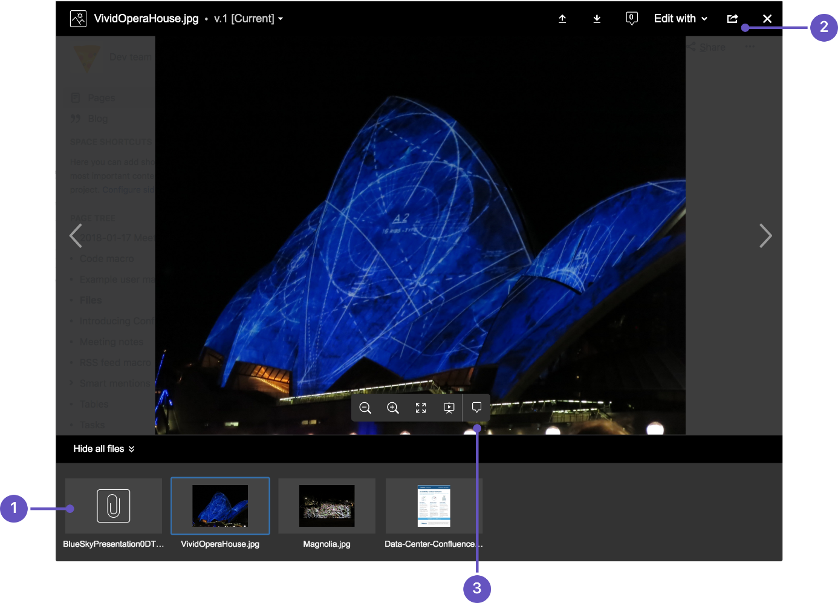

1. **See more files:** see other files also attached to this page.
2. **Manage this file:** download the file, upload a new version or share with your team.
3. **Add a comment:** drag the pin to comment on the file.

## Office and PDF files

Inserting a file in a page is a great way to make useful documents, spreadsheets, presentations and other files available to your team.

As with all file types, you can choose to insert the file as a link, or as a thumbnail. The thumbnail shows a preview of the document's contents, and can be resized.

To view an Office or PDF file, click the link or thumbnail to see the full preview (no need to have Excel, Word or PowerPoint installed). Alternatively, use the Download button in the preview to download the file and view offline.

You can even edit and comment on Office and PDF files.

## Image files

When editing the page, select an image to show the image properties panel. The panel allows you to set the display size, add a border, and effects, link the image to other pages, and provide a caption.

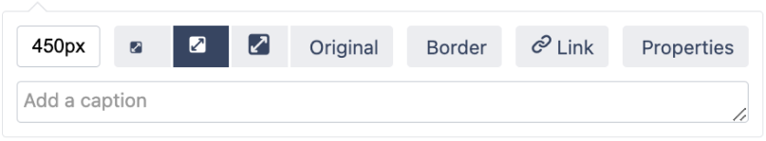

Screenshot: image properties panel

From the image properties panel you can:

* enter a **width** for the image (between 16px and 900px)
* set a **preset size** for the image
* add a **border** around the image
* add a **link** to the image
* add **effects**to the image such as drop shadow or snapshot (go to **Properties** > **Effects**)
* provide **alt text** used by screen readers and when the image can't be shown (go to **Properties** > **Description**)
* give the image a**caption** by typing it into the caption field (also available in **Properties** > **Description**)

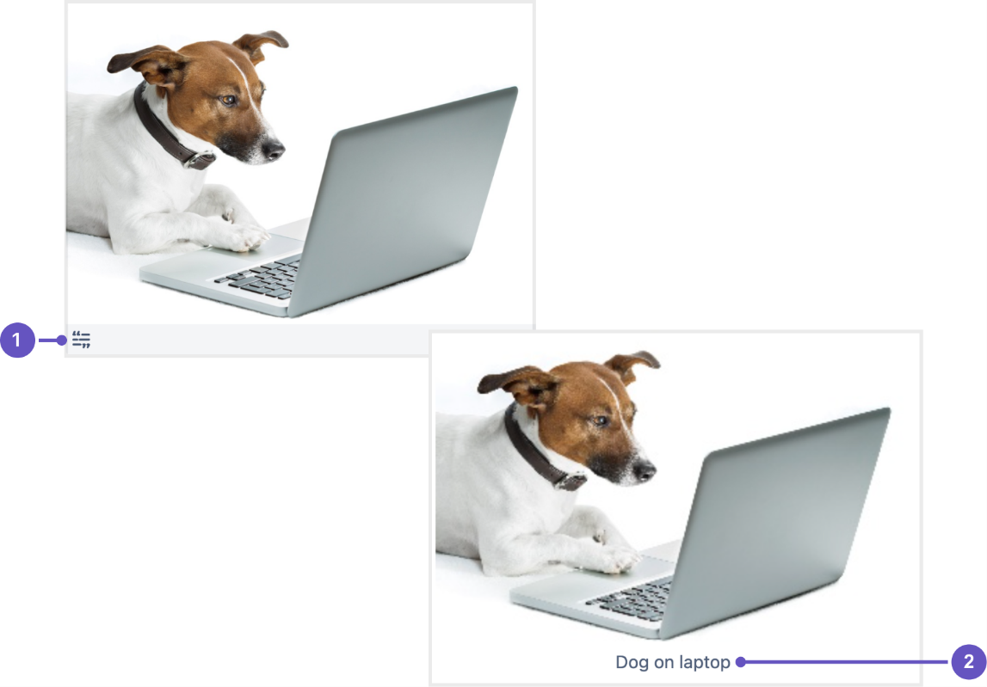

Screenshot: image captions are displayed different in the editor, and in preview or page view.

1. In the editor,image captions are indicated by a label icon  and grey strip below the image.
2. When viewing a page, image captions are displayed.

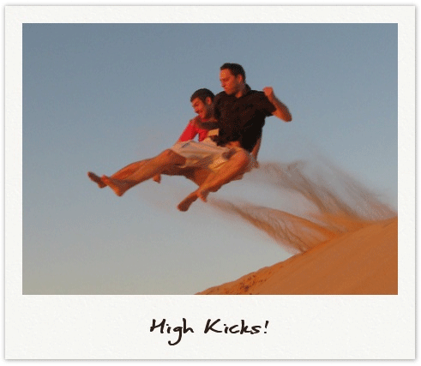

**To add a caption to an image using the Instant Camera effect:**

* Select **Effects** in the image properties panel and choose the **Instant Camera** image effect.
* Save the page.
* Go to

**More options**https://confluence.atlassian.com/doc/files/704577869/704577870/2/1517274795952/ellipsis.png

> **Attachments** to go to the 'Attachments' view of the page.

* Choose **Properties** next to the image file.
* Add a **comment** to the attachment. The text in your comment will appear as the image caption.

You'll need to re-enter the comment each time you upload a new version of the image.

Note: The Instant Camera effect only works with Latin character languages, due to a lack of handwriting style fonts in multi-byte languages.

#### A note on using Image Effects

Displaying image effects can be resource intensive. Confluence will prevent users from applying an image effect if the image is very large (based on data size and dimensions in pixels).

Confluence also limits the threads that are dedicated to displaying image effects so that it does not impact your whole instance. If a thread is not available, Confluence will display the image without the effect.

**To wrap text around an image:**

1. Select the image.
2. Use the left and right align buttons in the editor toolbar to text wrap around the image.
3. Double click on the same align button to remove text alignment (this will align the image without text wrap).
4. **Save** your page.

## Multimedia files

The file preview also supports MP3 audio and MP4 video files. It uses HTML5 to play attached audio and video files. This means the file types people can play in the preview depends on the audio and video formats their browser supports.