# Lab: Manage Files

Files are attached to Confluence pages.

Once attached you can download, delete and edit these files, for example if you need to upload a new version of the file, or change the page it is attached to.

Download attached files

Any user with permission to view a page can also download any files attached to that page.

To download an individual file:

* Click the **Download** button in the file preview, or
* Go to

**More options**https://confluence.atlassian.com/doc/files/704577869/704577870/2/1517274795952/ellipsis.png

> **Attachments**

* and then right click on the file name and save the link.

To download all files attached to a page as a zip file:

1. Go to

**More options**https://confluence.atlassian.com/doc/files/704577869/704577870/2/1517274795952/ellipsis.png

> **Attachments**

1. Click **Download All**.

There's no option to download all attachments in a space.

Delete an attached file

You'll need the 'Delete Attachment' space permission to delete an attached file.

To delete all versions of an attached file:

1. Go to the page that contains the attachment.
2. Go to

**More options**https://confluence.atlassian.com/doc/files/704577869/704577870/2/1517274795952/ellipsis.png

> **Attachments**

1. Choose **Delete** next to the attachment you want to delete.
2. Choose **Delete**to confirm your action.

Deleted files can be restored from the trash. You'll need to be a space admin to do this.

Space Admins can also delete specific versions of an attachment:

1. Go to

**More options**https://confluence.atlassian.com/doc/files/704577869/704577870/2/1517274795952/ellipsis.png

> **Attachments**

1. Click the expand arrow next to the attachment name to see the list of attachment versions
2. Choose **Delete**next to the version you want to delete.

Deleted file versions are not recoverable from the trash.

*Screenshot: Attachments and attachment versions*

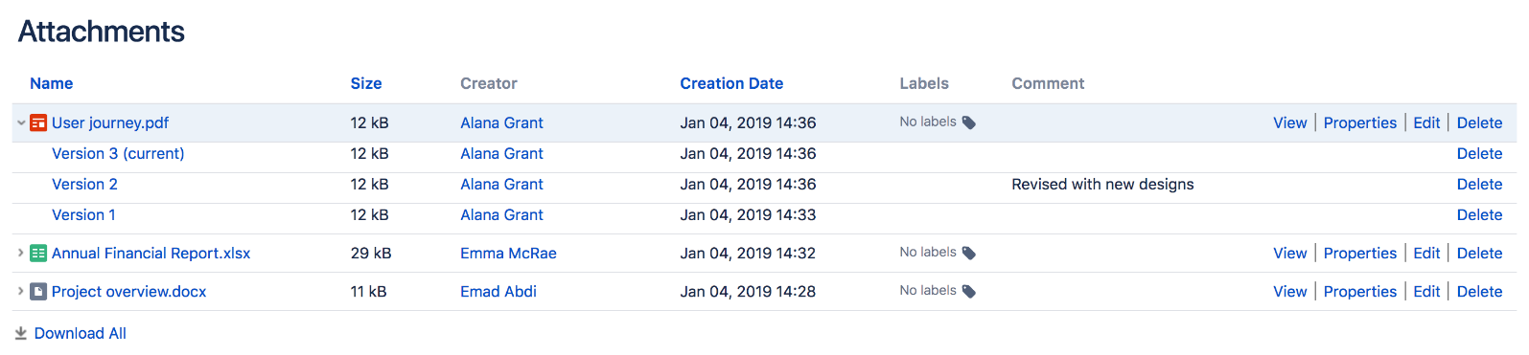

Upload a new version of an attached file

There are two ways up upload a new version of an attached file.  You can:

* Upload a file with the same file name to the page.
* Use the **Upload a new version** https://confluence.atlassian.com/doc/files/139415/704578246/1/1422394240835/Upload-New-File-Version.png button in the file preview to upload a file with a different name (for images and PDFs only).

To view attachment versions:

* Go to

**More options**https://confluence.atlassian.com/doc/files/704577869/704577870/2/1517274795952/ellipsis.png

> **Attachments**

* Click the expand arrow next to the attachment name.

All earlier versions of the file will appear.

You can't revert to an earlier version of the file, but you can choose to remove earlier versions if you have Space Administrator permissions.

Move a file to another page

You'll need the 'Add Page', 'Add Attachment' and 'Remove Attachment' space permissions to move an attached file to another page.

To change the page that a file is attached to:

* Go to

**More options**https://confluence.atlassian.com/doc/files/704577869/704577870/2/1517274795952/ellipsis.png

> **Attachments**

* Choose **Properties** next to the attachment you want to move.
* Enter the name of the page you want to move the attachment to (for example My Destination Page).
* Choose **Save**.

If you want to move the file to a page in another space, add the space key before the page name (for example DOC:My Destination Page).

Edit properties of an attached file

You'll need the 'Add Attachment' permission in the space to edit the file properties.

To edit the properties of an attached file:

* Go to

**More options**https://confluence.atlassian.com/doc/files/704577869/704577870/2/1517274795952/ellipsis.png

> **Attachments**

* Click **Properties** beside the attachment you want to edit.

You can:

* change the file name
* add a comment (used in the version list and also by the Snapshot image effect)
* change the MIME type
* move the attachment to another page
* add a label.

Changing the MIME type may cause your file to display incorrectly.

View all attached files in a space

There are two ways you can view all files in a space.  You can:

* Use the Space Attachments macro to display the list of files on a page.
* Go to the space and choose **Space tools** > **Content Tools** from the bottom of the sidebar Then choose **Attachments**.

You can use the filters to only show files with a particular label or file extension.

*Screenshot: Space attachments macro*

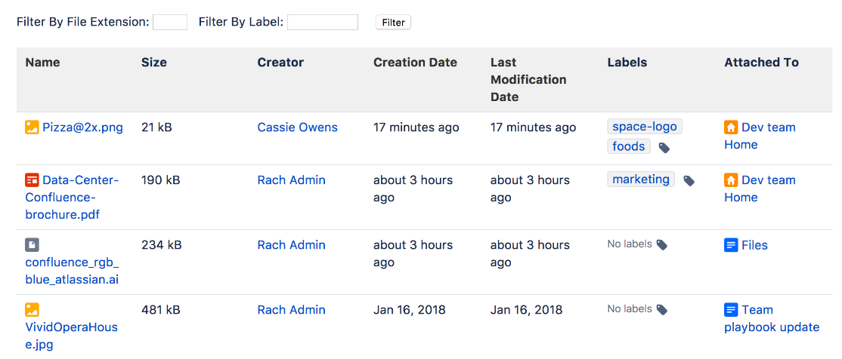

# Share and Comment on Files

Collaboration doesn't just happen on pages; often you'll need to collaborate with your team on documents, presentations, images and spreadsheets. Whether it's mockups for a new marketing campaign or a full project plan, you can simplify your team's feedback loop by working together on files in Confluence.

## Share a file

Do you have lots of files on a page and want to get a team member's input on just one of them? You can share the file with them directly.

It works just like sharing a page:

1. Click the thumbnail or link to preview the file.
2. Choose the **Share** button.
3. Enter an email address, user name or group name, add your message and send.

Your team members will get an email with your message and a link to view the file.

Share notifications are only sent by email, they won't appear in the workbox https://confluence.atlassian.com/doc/files/704578253/704578258/1/1422394441387/workbox.png.

## Comment on a file

Whether it's an image – like a mockup of the new marketing campaign that needs feedback – a PDF, a presentation, or any other file you can preview in Confluence, you can drop a pin anywhere on the preview and add your comment to start a conversation.

To comment on a file:

1. Click the thumbnail or link to preview the file.
2. Drag the pin icon from the bottom of the preview and drop it where you want to comment.
3. Add your comment and **Save**.

Pinned comments work just like inline comments on pages. You can use @mentions and links, and drop as many pins as you need on any part of the file. You can even add simple macros such as the code macro using wiki markup autocomplete. Anyone with permission to add comments to the page can add and reply to comments on a file.

When you preview a file, you'll see pins for any existing comments on that version of the file. Select a pin to view the comment.

Once the conversation is finished, you can resolve the comment to hide it (and any replies) from view. If you need to see resolved comments again, you can reopen them. Go to https://confluence.atlassian.com/doc/files/704578253/704578257/1/1422394441190/PreviewTools.png > **Resolved comments** in the preview.

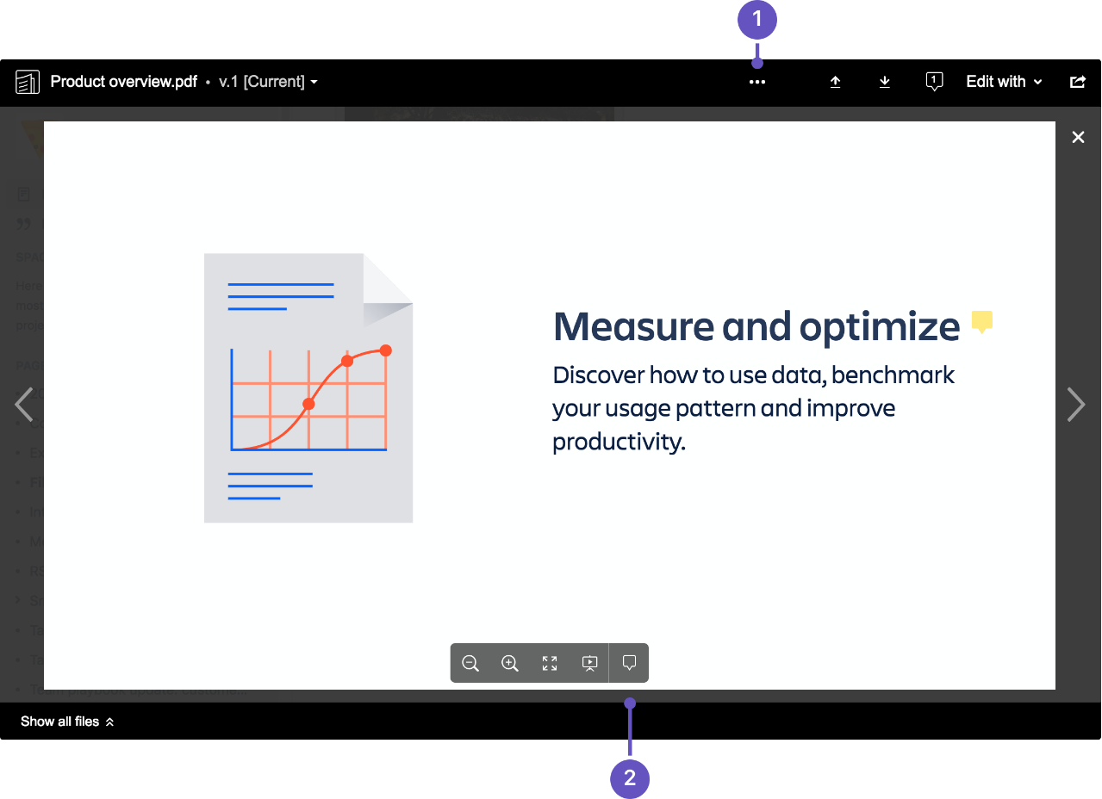

1. **Resolved comments:** Choose the 'more options' button to show or hide resolved comments.
2. **Comments:** Drag a pin onto a file to comment.

You can't comment on files that are hosted on a web server and added to Confluence using their URL, or on files that can't be viewed in the preview (such as videos, zip files, and some other file types).

#### What happens to comments when you upload a new version?

Comments are specific to the version of the file. This is to avoid confusion when the part of the document or image the comment is pinned to has changed significantly.

To see inline comments on a previous version of the file:

1. Click the thumbnail or link to preview the file.
2. Click the filename dropdown in the top left and select a previous version.
3. Comment pins will now be visible, for all comments made on that version.

#### How many comments can you add to one file?

While there is no limit to the number of comments that can be added to a file, Confluence can only display 100 comments.