# **Lab: Search for pages and posts**

Confluence gives you a few ways to find what you're looking for.

Quick search

Use the slash ( / ) shortcut key from anywhere in the application to quickly open the search drawer.

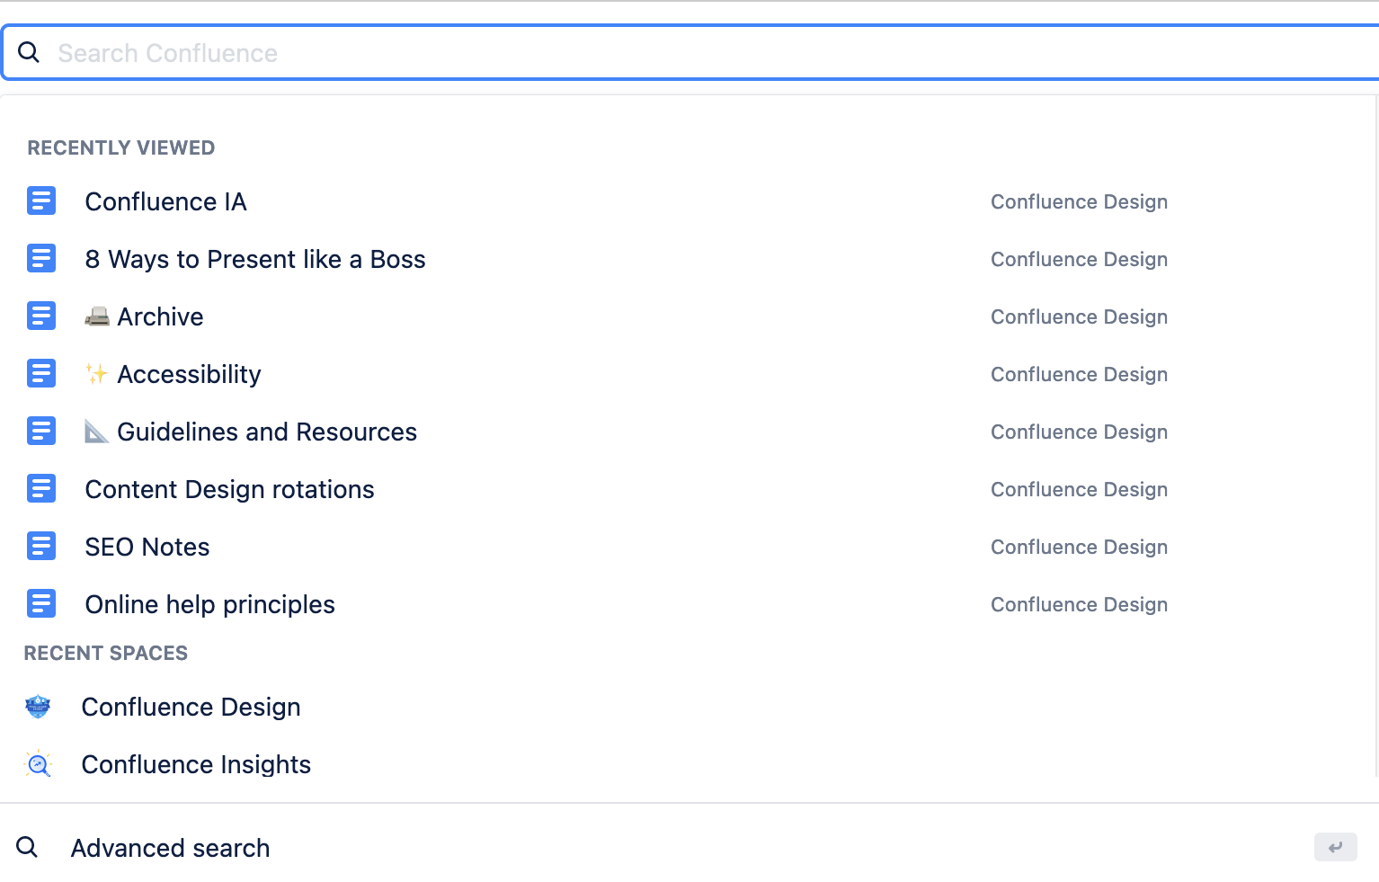

1. To perform a quick search in Confluence, place focus in the search field in the navigation.
2. With focus in the search field, a quick search drawer opens.
3. Enter the name of a page, blog post, person, file/attachment, or space, and choose from the list of options displayed. Items are ordered with the most recently updated first. When selecting a person, you can view their profile.

If you don't immediately see what you need in the quick search, press **Enter** or choose the **Advanced** **search** option at the bottom of the search results to do an advanced search.

Advanced search

Confluence advanced search allows you to search for content across spaces, personal profiles, and attachments.

**To use advanced search:**

1. Place focus in the search bar.
2. Enter your search terms.
3. Select **Advanced search** or press the **Enter/Return** key.

Advanced search results help you better understand if a result is the one you’re looking for by showing you information beyond just the title. View highlighted search terms, check the last updated date, and use clickable breadcrumbs for contextual insight into a page’s location and hierarchy.



You can also add filters to your search to focus your results.

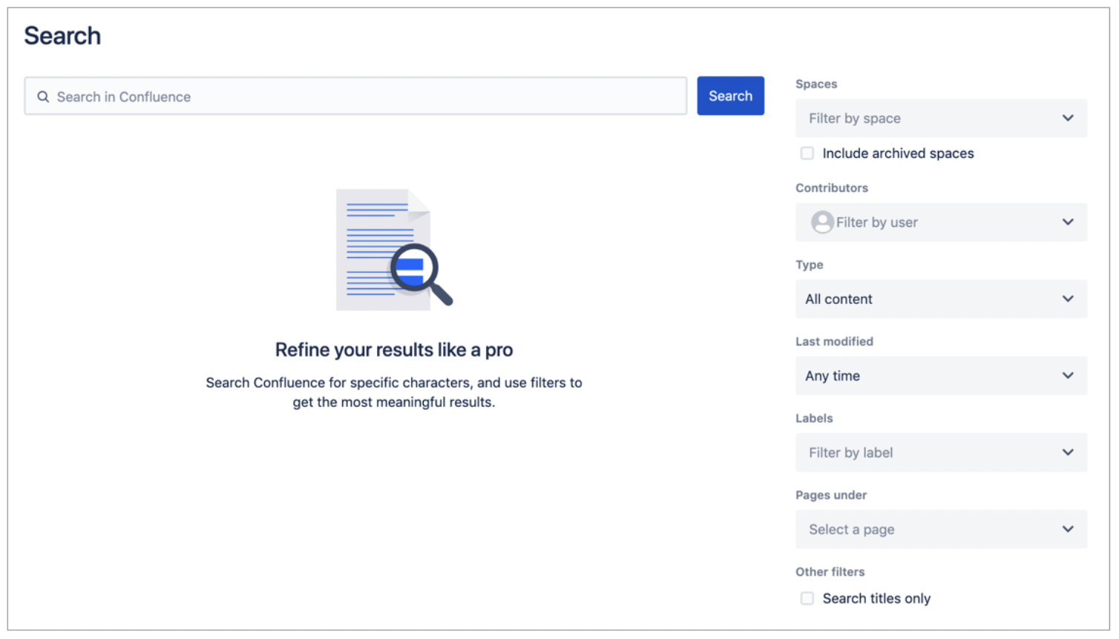

Filter using the following fields**:**

* **Spaces**– Return content from a particular space or list of spaces. Select the checkbox to include archived spaces.
* **Contributors** – Find content that's been modified (created, edited, or commented on) by a particular person or people in any space, including their personal space. When adding multiple contributors to your filter, the operator used between the people is OR. The ability to use the AND operator between people is not supported.
* **Type** – See results of a certain type, like pages, blog posts, attachments, or comments. Results include the following types of attachments: Word, Text, PowerPoint, Excel, PDF, and HTML.
* **Last modified**– Choose or enter a date range to only show results that were updated within a particular period of time.
* **Labels** – See results that contain a specific label or labels. When adding multiple labels to your filter, the operator used between the labels is OR. The ability to use the AND operator between labels is not supported.
* **Pages under** – Return content that exists in pages under the selected page. This is helpful if know generally where the content you’re looking for exists in the page tree but don't know the exact page name.
* **Search titles only** - When selected, your results only contain pages whose titles contain the text entered in the search field.

**PRO TIP**  
In addition to advanced search filters, you can use the Confluence search syntax to really focus your results whichw e will cover in the enxt lab.

Recent activity

There are a few ways to quickly find pages you've recently visited or worked on.

* Recent menu in the navigation
* Home page

**Recent menu**

You can easily get to pages based on your recent interaction with them from anywhere using the navigation. Once you are there, you can use the filter to narrow the list based on characters in the title of the page.

**To see recent pages:**

1. Click **Recent** in the navigation.
2. Choose **Visited**, **Worked on**, **Drafts**, or **Starred**.

Quickly open the Recent menu drawer using the keyboard shortcut.

**Home page**

The Home page is a great place to start your Confluence day. The Recent pages section of that page give you a good reminder about what you were doing last.

**Tabs**

Whether you are using the Recent menu in the navigation or the Recent pages section of the Home page, the tabs used to separate your pages are broken up into the following groups:

1. **Visited** — Pages and blogs you have viewed, including those that you’ve edited and commented on
2. **Worked on** — Pages and blogs you created, edited, and commented on; this includes drafts
3. **Starred** — Pages and blogs you starred so that you can easily get back to them without searching or using browser bookmarks
4. **Drafts** — Pages and blogs you created and closed without publishing

When you add a page comment or an inline comment, those actions result in a page showing up in your *Visited* and *Worked on* lists.  
  
All pages are sorted by date with the most recent page at the top. If you saved a page for later, you’ll see a star next to the page name.

**Filter**

Text entered in the filter field helps you narrow the list of pages already visible on the four tabs by searching the page titles; the filter only shows pages already visible to you in the list of recent pages. It does not search the text of the pages.

If you're looking for a page not visible in any of the tabs, click search in the navigation.

# **Search the people directory**

To view the people directory, select **Teams** in the Confluence navigation. At a glance, you can see your teams and any collaborators you work with often.

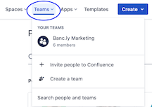

From under **Teams**, select **Search people and teams** to view or search for more people or teams. You can also add new teams or people to Confluence here.

