# Lab: Manage your account - Part 1

Confluence is very flexible — not only in the many ways you can create and share content, but also in how you can tailor your own Confluence experience. Things like your profile picture, starred spaces and pages, and your personal space can say a lot about you, and can also make navigating Confluence much quicker and easier. Even a simple thing like adding shortcut links to the sidebar of your personal space, can save you a lot of time in finding the things you use all the time.

Edit your profile

Your user profile contains basic information about you.

In your own profile, you can access account management features and update information about yourself, like your full name, public name, email address, and password.

Find your profile

To see your profile, tap your profile picture at the right of the navigation, then select **Profile**. To see someone else's profile, tap on their name or profile picture anywhere you see it linked in Confluence.

Edit your profile

Your profile stores information about you, such as your full name, public name, and profile photo, that's used to identify you throughout your Confluence site. It’s also used in certain Atlassian Cloud products and sites.

If you have a managed account, you may need an admin's help to edit your name or email address.

To edit your profile:

1. Tap your profile picture at the right of the navigation, then select **Profile**
2. Tap **Manage your account**
3. Edit your personal details
4. Tap **Save changes**

From here, you can also access your profile information, visibility settings, email, and security, as well as product-specific settings for all the Atlassian products you use (such as your saved and watched pages in Confluence).

**Set your profile picture**

Your profile picture is the image that's used to represent you throughout your site, including on your profile, in the Atlassian People Directory, next to your name in comments, and in the icon for your personal space.

**To upload a new profile picture:**

1. Choose your profile picture at the right side of the navigation, then choose **Profile**
2. Hover over your profile picture, then tap the camera icon that appears
3. Select **Change profile picture** from the dropdown menu
4. Tap **Upload a photo**, then select the image you'd like to use
5. Adjust the size and position of your photo, and tap **Upload**

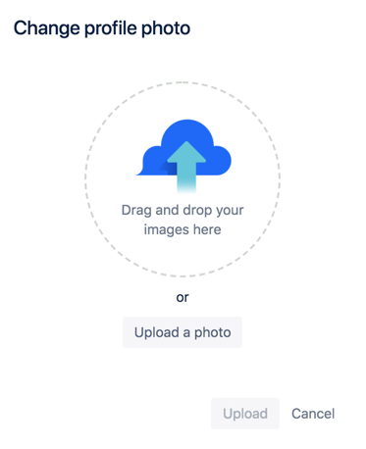

**To remove your profile picture:**

1. Tap your profile picture at the right of the navigation, then select **Profile**
2. Hover over your profile picture, then tap the camera icon that appears
3. Select **Remove** from the dropdown menu

Edit your user settings

Tailor Confluence to fit your needs with personalized settings and preferences, including your:

* Display language, time zone, and other general preferences
* Editor settings, such as autocomplete and autoformatting
* Email notification settings
* OAuth access tokens

This page tells you how to edit your general preferences and editor settings.

Edit your general preferences

**To edit your general preferences:**

1. Tap your profile picture at the right of the navigation, then select **Settings**.
2. Tap **Edit** and make your changes.
3. Tap **Submit**.

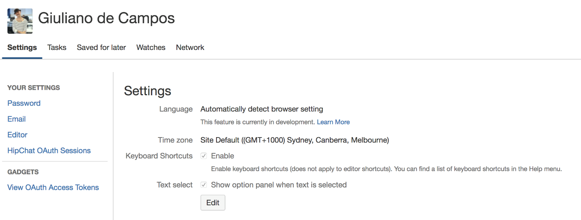

How language settings interact

You can choose your display language for Confluence, but if you don't, Confluence will default to the language you set in your browser. If you don't have a language preference set for Confluence *or* your browser, we'll use the site-wide language preference set by your site administrator.

Edit your editor settings

You can turn on or off some settings that affect how the Confluence editor works for you. The choices you make won't affect how Confluence works for other people on your site.

**To edit your editor settings:**

1. Tap your profile picture at the right of the navigation, then select **Settings**.
2. Choose **Editor** (under **Your settings**) from the panel on the left.
3. Tap **Edit** and make your changes.
4. Tap **Submit**.

# Change your Confluence password

There are a couple of reasons why you’d want to change your Confluence password:

* You're logged in and want or need to change your password
* You've forgotten your password and can't log in, and so need to reset your password

If you have a managed account, you'll need to either go to the system account settings or ask your administrator to change your password.

**To change your password while logged in:**

1. Tap your profile picture at the right of the navigation, then select **Profile**.
2. Tap **Manage your account**, then choose **Security** from the left navigation.
3. Enter your current password and your new password in the form displayed.
4. Tap **Save changes**.

**To reset your password from the login screen:**

1. Go to the login screen for your Confluence site.
2. Choose **Can't log in?** at the bottom of the page.
3. Enter your email address, then tap **Send recovery link**.
4. Click the recovery link in the email to finish the process.

**Password policy**

By default, all Atlassian account passwords must be a minimum of eight characters. There are no other requirements around resets or expiration.