Use Wind Data from Prior Lab

You can use the following code to import it to Python and print a random couple of rows:

import os

import numpy as np

import pandas as pd

import warnings

os.environ['TF_CPP_MIN_LOG_LEVEL'] = '2'

warnings.filterwarnings('ignore')

df = pd.read_csv('data/winequalityN.csv')

df.sample(5)

We’re ignoring the warnings and changing the default TensorFlow log level just so we don’t get overwhelmed with the output.

Here’s how the dataset looks like:

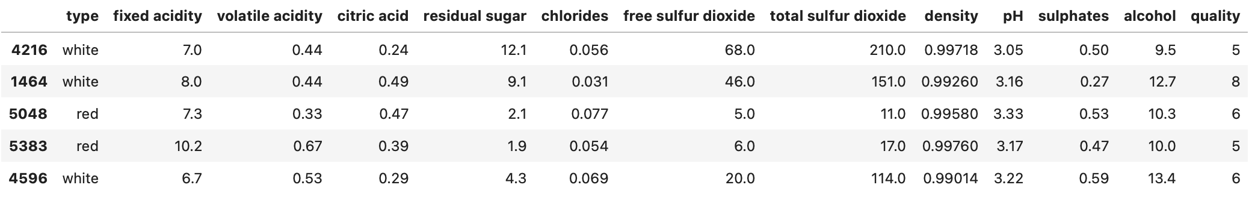Image 2 — A random sample of the wine quality dataset (image by author)

The dataset is mostly clean, but isn’t designed for binary classification by default (good/bad wine). Instead, the wines are rated on a scale. We’ll address that now, with a bunch of other things:

* Delete missing values — There’s only a handful of them so we won’t waste time on imputation.
* Handle categorical features — The only one is type, indicating whether the wine is white or red.
* Convert to a binary classification task — We’ll declare any wine with a grade of 6 and above as *good*, and anything below as *bad*.
* Train/test split — A classic 80:20 split.
* Scale the data — The scale between predictors differs significantly, so we’ll use the StandardScaler to bring the values closer.

Here’s the entire data preprocessing code snippet:

from sklearn.model_selection import train_test_split

from sklearn.preprocessing import StandardScaler

# Prepare the data

df = df.dropna()

df['is_white_wine'] = [

1 if typ == 'white' else 0 for typ in df['type']

]

df['is_good_wine'] = [

1 if quality >= 6 else 0 for quality in df['quality']

]

df.drop(['type', 'quality'], axis=1, inplace=True)

# Train/test split

X = df.drop('is_good_wine', axis=1)

y = df['is_good_wine']

X_train, X_test, y_train, y_test = train_test_split(

X, y,

test_size=0.2, random_state=42

)

# Scaling

scaler = StandardScaler()

X_train_scaled = scaler.fit_transform(X_train)

X_test_scaled = scaler.transform(X_test)

And here’s how the first couple of scaled rows look like:

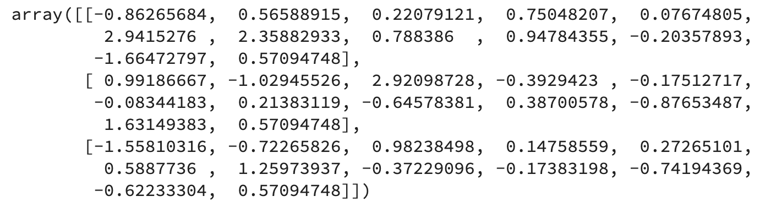Image 3 — Scaled training set (image by author)

Once again, please refer to the [previous article](https://betterdatascience.com/regression-modelling-with-tensorflow-made-easy-train-your-first-model-in-10-minutes/) if you want more detailed insights into the logic behind data preprocessing.

With that out of the way, let’s see how to optimize the learning rate.

## **How to optimize learning rate in TensorFlow**

Optimizing the learning rate is easy once you get the gist of it. The idea is to start small — let’s say with 0.001 and increase the value every epoch. You’ll get terrible accuracy when training the model, but that’s expected. Don’t even mind it, as we’re only interested in how the *loss* changes as we change the learning rate.

Let’s start by importing TensorFlow and setting the seed so you can reproduce the results:

import tensorflow as tf

tf.random.set_seed(42)

We’ll train the model for 100 epochs to test 100 different loss/learning rate combinations. Here’s the range for the learning rate values:

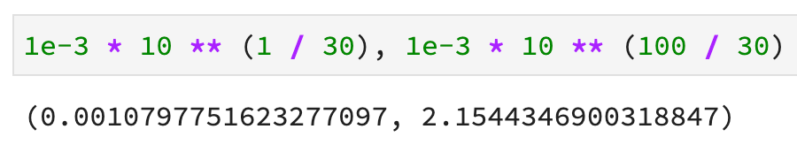Image 4 — Range of learning rate values (image by author)

A learning rate of 0.001 is the default one for, let’s say, Adam optimizer, and 2.15 is definitely too large.

Next, let’s define a neural network model architecture, compile the model, and train it. The only new thing here is the LearningRateScheduler. It allows us to enter the above-declared way to change the learning rate as a lambda function.

Here’s the entire code:

initial_model = tf.keras.Sequential([

tf.keras.layers.Dense(128, activation='relu'),

tf.keras.layers.Dense(256, activation='relu'),

tf.keras.layers.Dense(256, activation='relu'),

tf.keras.layers.Dense(1, activation='sigmoid')

])

initial_model.compile(

loss=tf.keras.losses.binary_crossentropy,

optimizer=tf.keras.optimizers.Adam(),

metrics=[

tf.keras.metrics.BinaryAccuracy(name='accuracy')

]

)

initial_history = initial_model.fit(

X_train_scaled,

y_train,

epochs=100,

callbacks=[

tf.keras.callbacks.LearningRateScheduler(

lambda epoch: 1e-3 * 10 ** (epoch / 30)

)

]

)

The training will start now and you’ll see a decent accuracy immediately — around 75% — but it will drop after 50-something epochs because the learning rate became too large. After 100 epochs, the initial_model had around 60% accuracy:

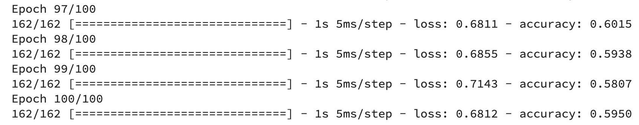Image 5 — Initial model training log (image by author)

The initial_history variable now has information on loss, accuracy, and learning rate. Let’s plot all of them:

import matplotlib.pyplot as plt

from matplotlib import rcParams

rcParams['figure.figsize'] = (18, 8)

rcParams['axes.spines.top'] = False

rcParams['axes.spines.right'] = False

plt.plot(

np.arange(1, 101),

initial_history.history['loss'],

label='Loss', lw=3

)

plt.plot(

np.arange(1, 101),

initial_history.history['accuracy'],

label='Accuracy', lw=3

)

plt.plot(

np.arange(1, 101),

initial_history.history['lr'],

label='Learning rate', color='#000', lw=3, linestyle='--'

)

plt.title('Evaluation metrics', size=20)

plt.xlabel('Epoch', size=14)

plt.legend();

Here’s the chart:

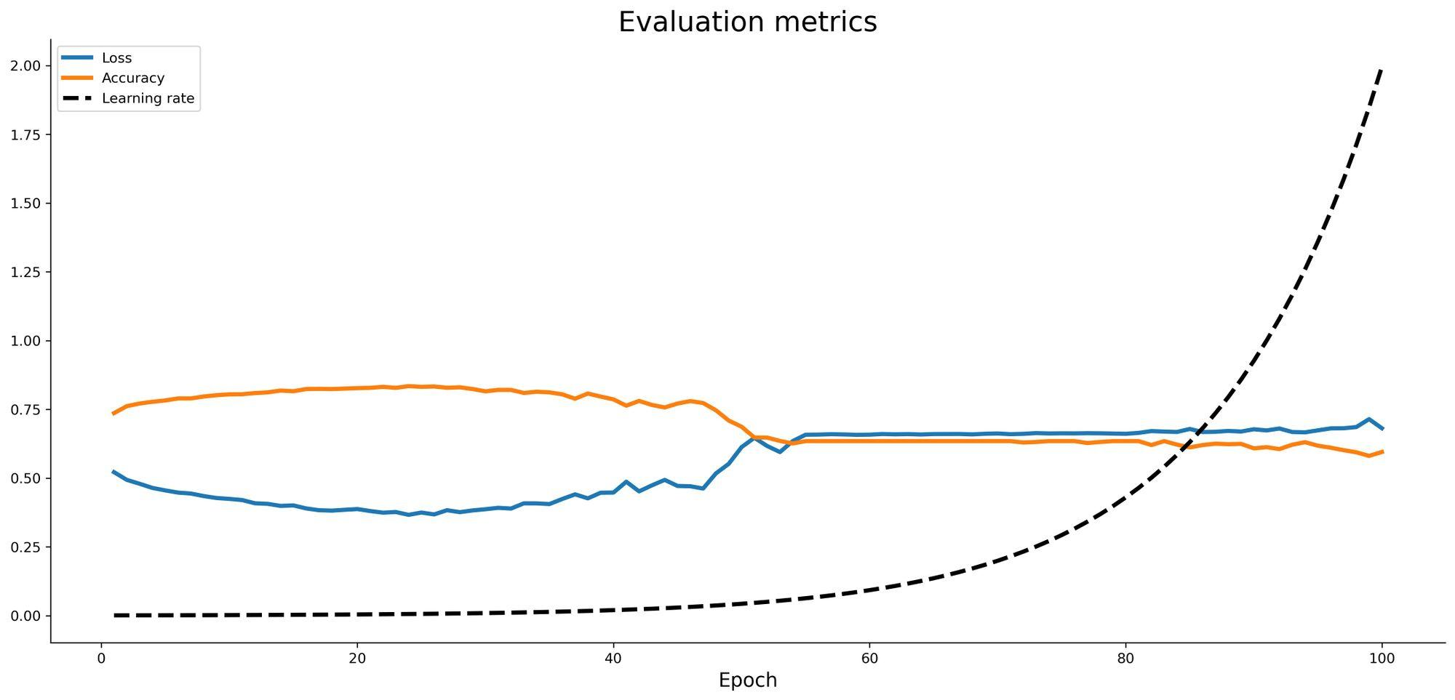Image 6 — Loss vs. accuracy vs. learning rate (image by author)

The accuracy dipped significantly around epoch 50 and flattened for a while, before starting to dip further. The exact opposite happened to loss, which makes sense.

You can now plot the loss against learning rate on a logarithmic scale to eyeball where the minimum loss was achieved:

learning_rates = 1e-3 * (10 ** (np.arange(100) / 30))

plt.semilogx(

learning_rates,

initial_history.history['loss'],

lw=3, color='#000'

)

plt.title('Learning rate vs. loss', size=20)

plt.xlabel('Learning rate', size=14)

plt.ylabel('Loss', size=14);

Here’s the chart:

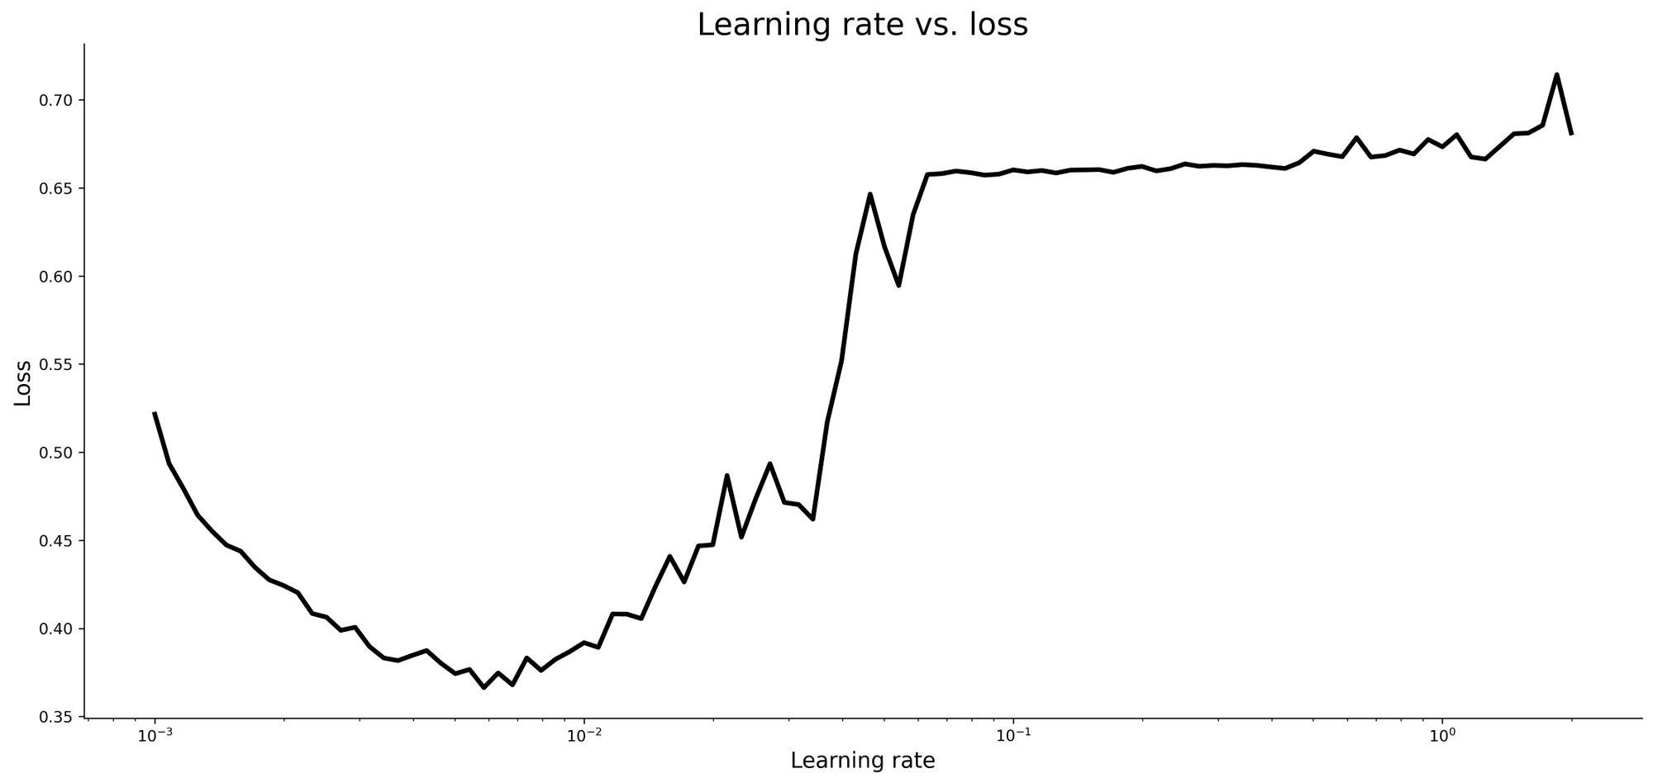Image 7 — Learning rate vs. loss (image by author)

You’ll generally want to select a learning rate that achieves the lowest loss, provided that the values around it aren’t too volatile. Keep in mind that the X-axis is on a logarithmic scale. The optimal learning rate is around 0.007:

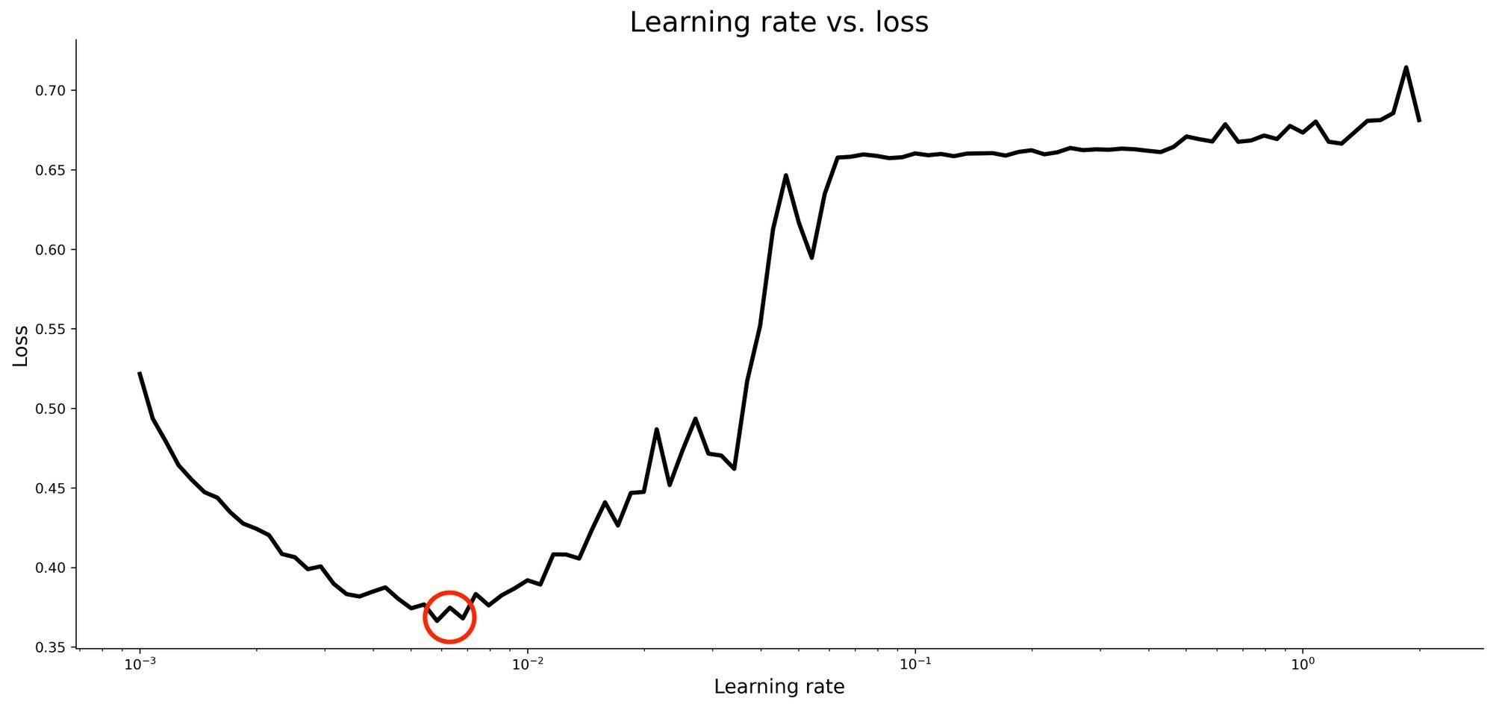Image 8 — Optimal learning rate (image by author)

So let’s train a model with a supposedly optimal learning rate and see if we can outperform the default one.

## **Train a model with optimal learning rate**

With a learning rate of 0.007 in mind, let’s write another neural network model. You won’t need the LearningRateScheduler this time:

model_optimized = tf.keras.Sequential([

tf.keras.layers.Dense(128, activation='relu'),

tf.keras.layers.Dense(256, activation='relu'),

tf.keras.layers.Dense(256, activation='relu'),

tf.keras.layers.Dense(1, activation='sigmoid')

])

model_optimized.compile(

loss=tf.keras.losses.binary_crossentropy,

optimizer=tf.keras.optimizers.Adam(learning_rate=0.007),

metrics=[

tf.keras.metrics.BinaryAccuracy(name='accuracy')

]

)

history_optimized = model_optimized.fit(

X_train_scaled,

y_train,

epochs=100

)

We got 76% accuracy with the default learning rate in the [previous article](https://towardsdatascience.com/how-to-train-a-classification-model-with-tensorflow-in-10-minutes-fd2b7cfba86), so it’ll be interesting to see if learning rate optimization can increase it. The reported accuracy on the train set looks too good to be true, so it’s likely our model is overfitting:

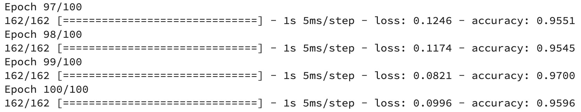Image 9 — Optimized model training log (image by author)

It won’t matter too much if we’ve managed to increase the performance on the test set, but you could save yourself some time by training the model for fewer epochs.

Here’s how the accuracy vs. loss looks like for the optimized model:

plt.plot(

np.arange(1, 101),

history_optimized.history['loss'],

label='Loss', lw=3

)

plt.plot(

np.arange(1, 101),

history_optimized.history['accuracy'],

label='Accuracy', lw=3

)

plt.title('Accuracy vs. Loss per epoch', size=20)

plt.xlabel('Epoch', size=14)

plt.legend()

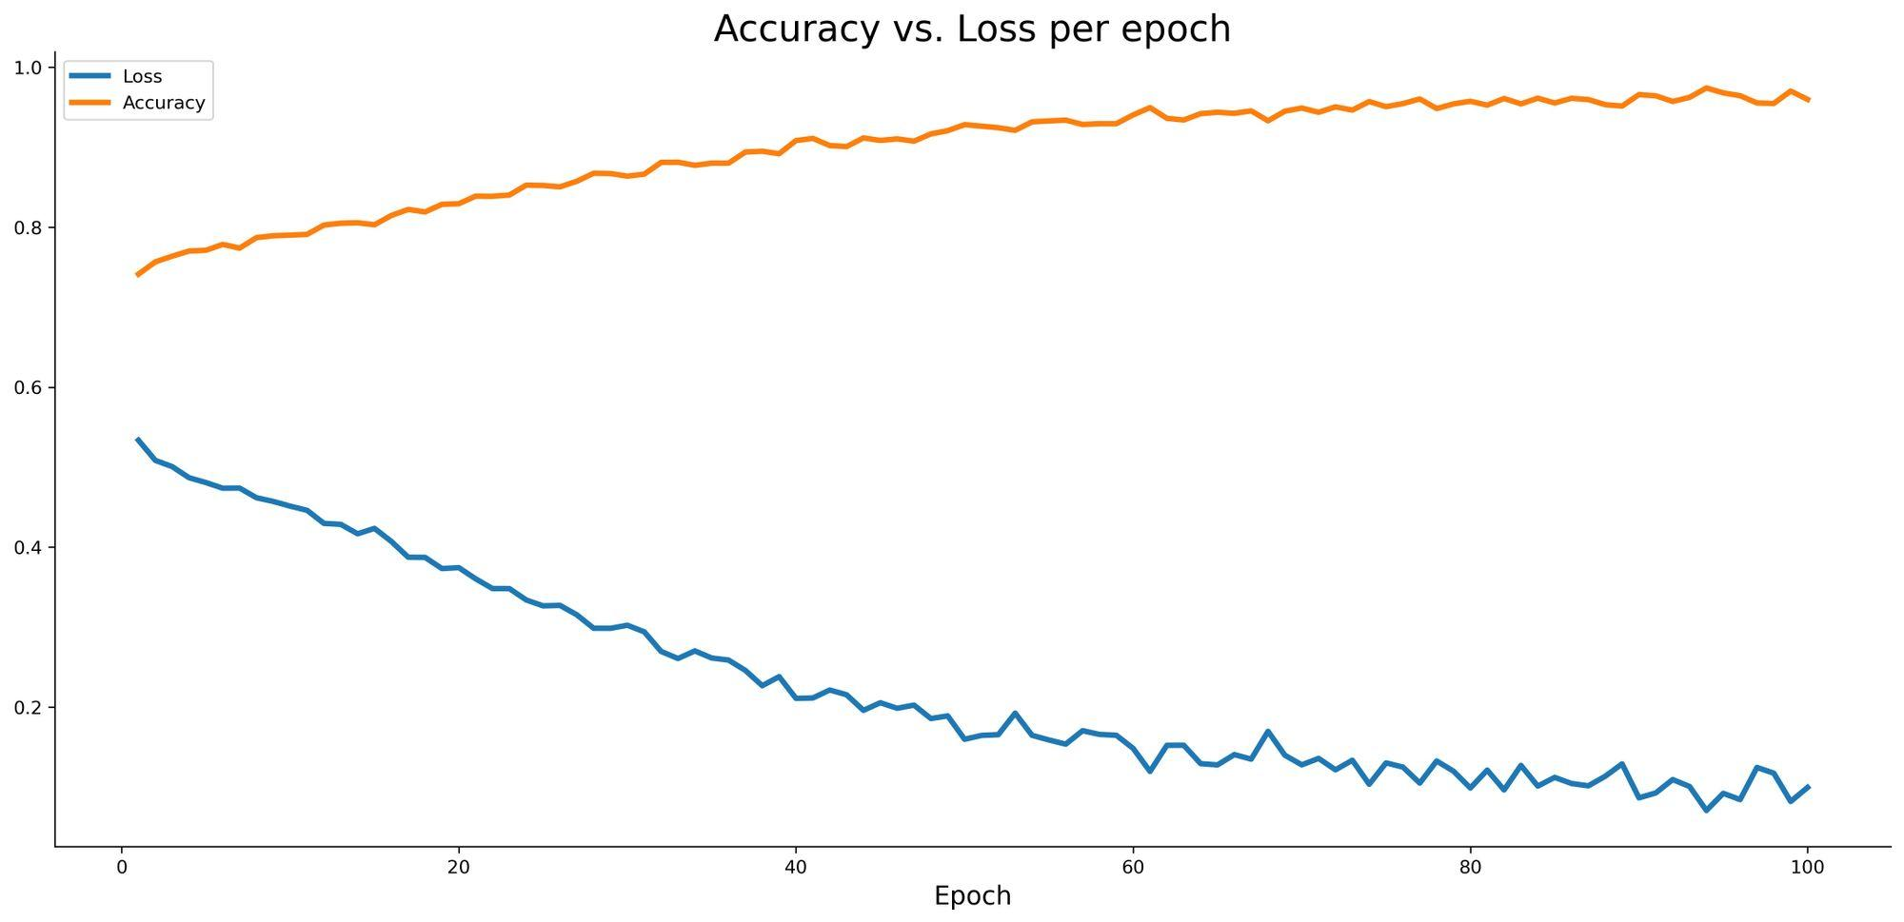Image 10 — Accuracy vs loss on the training set (image by author)

Let’s finally calculate the predictions and evaluate them against the test set. Here’s the code:

from sklearn.metrics import confusion_matrix

from sklearn.metrics import accuracy_score

predictions = model_optimized.predict(X_test_scaled)

prediction_classes = [1 if prob > 0.5 else 0 for prob in np.ravel(predictions)]

print(f'Accuracy on the test set:

{accuracy_score(y_test, prediction_classes):.2f}')

print()

print('Confusion matrix:')

print(confusion_matrix(y_test, prediction_classes))

And here’s the output:

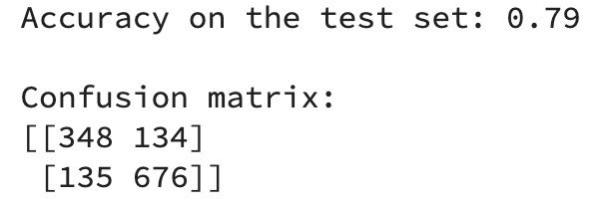Image 11 — Test set evaluation metrics (image by author)

To summarize, optimizing the learning rate alone managed to increase the model accuracy by 3% on the test set. It might not sound huge, but it’s an excellent trade-off for the amount of time it took. Moreover, it’s only the first of many optimizations you can do to a neural network model, and it’s one less hyperparameter you need to worry about.