#Installing and running the project

#Following are the things that are required to run the app

** For running this program , you need to  install Nodejs v8+ and MongoDB v3+

** Follow the following steps to install Nodejs and MongoDB for ubuntu , for other operating system , kindly please look for the official docs!!

1. Install Nodejs

For ubuntu :

Open your terminal and type :

curl -sL https://deb.nodesource.com/setup_8.x | sudo -E bash -

Now press enter

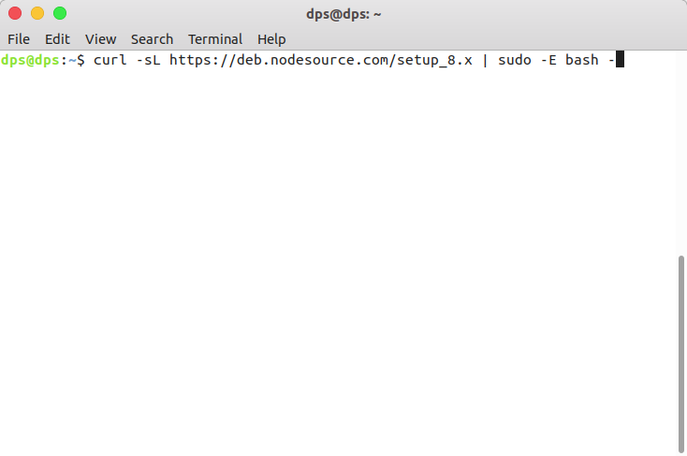

sudo apt-get install -y nodejs

Then press enter

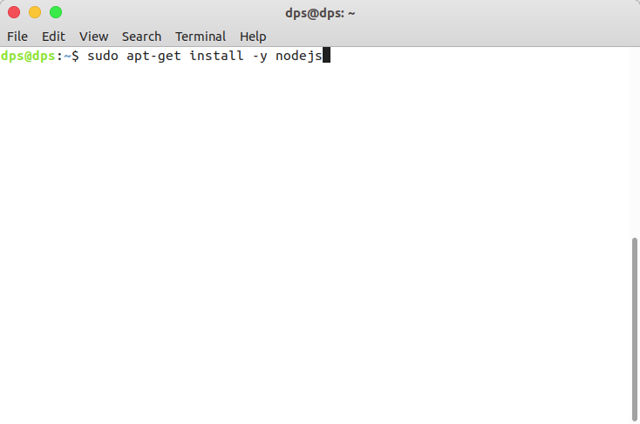

For other operating system , kindly follow Nodejs official docs

2. Install mongodb (Taken from https://docs.mongodb.com/manual/tutorial/install-mongodb-on-ubuntu/)

For ubuntu :

Open terminal and type  :

sudo apt-key adv --keyserver hkp://keyserver.ubuntu.com:80 --recv 9DA31620334BD75D9DCB49F368818C72E52529D4

Now press enter

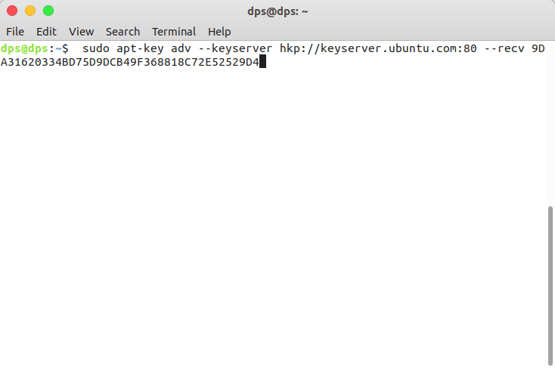

Type : echo "deb [ arch=amd64,arm64 ] https://repo.mongodb.org/apt/ubuntu xenial/mongodb-org/4.0 multiverse" | sudo tee /etc/apt/sources.list.d/mongodb-org-4.0.list

Now press enter

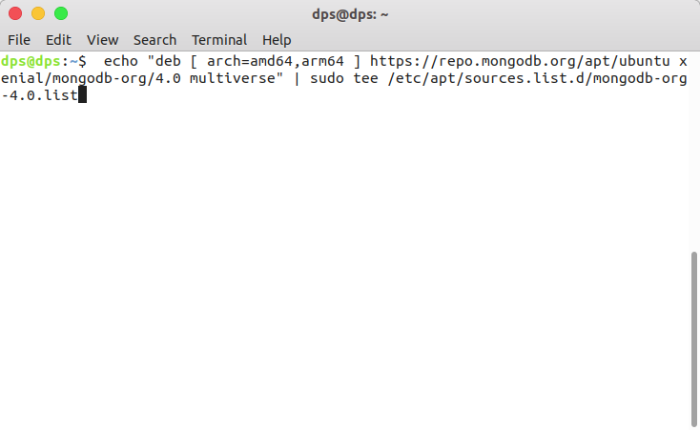

Type : sudo apt-get update

Now press enter

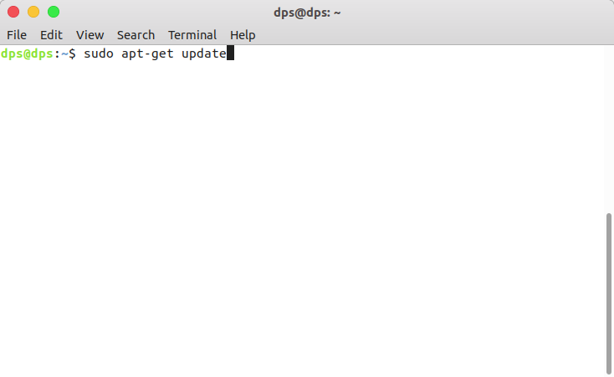

Type : sudo apt-get install -y mongodb-org

Now press enter

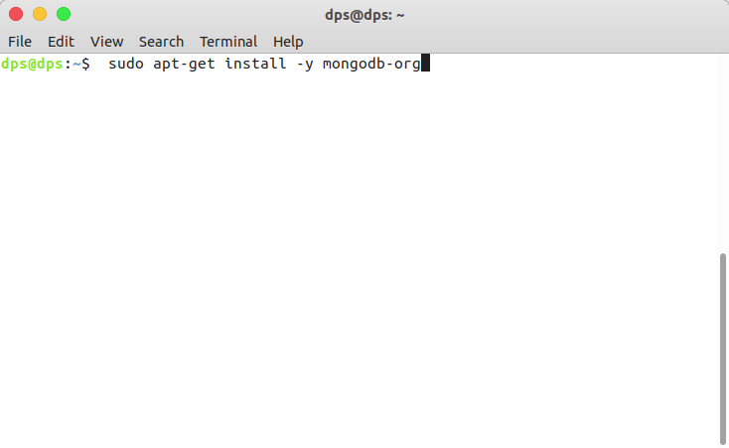

Type : sudo service mongod start

Now press enter

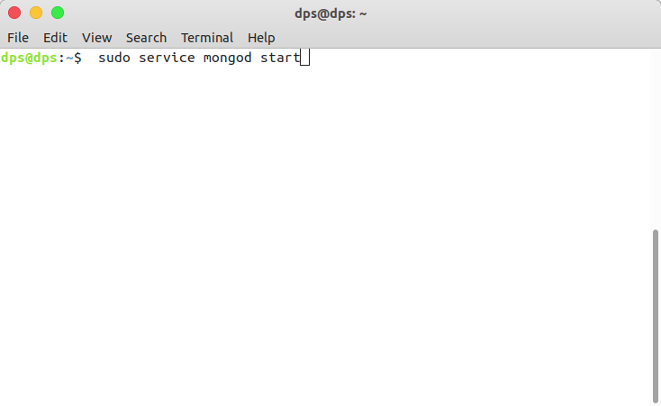

For other operating system, kindly follow mongodb official docs

#Steps to run app

Step 0 : Open your terminal

Step 1 :  Type and press enter :

git clone <https://github.com/fenago/ipfs>

You will see something like this

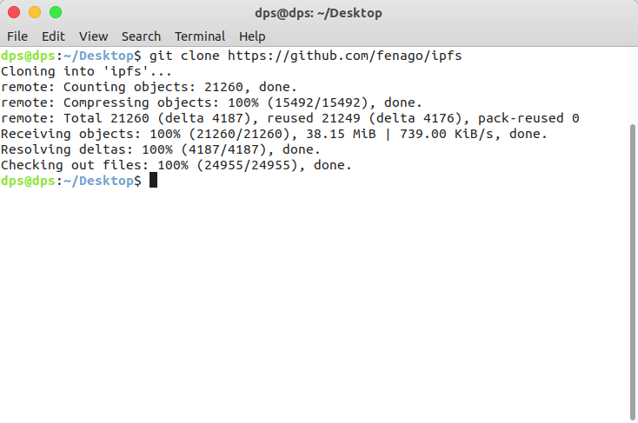

Step 2 : Type and press enter :

cd ipfs

Step 3 : Type and press enter :

node app.js

Now you should see something like this

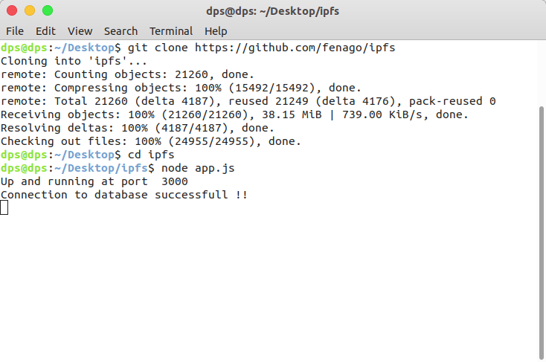

Step 4 : Now , go to http://localhost:3000 and you will see the project running

